Schematics

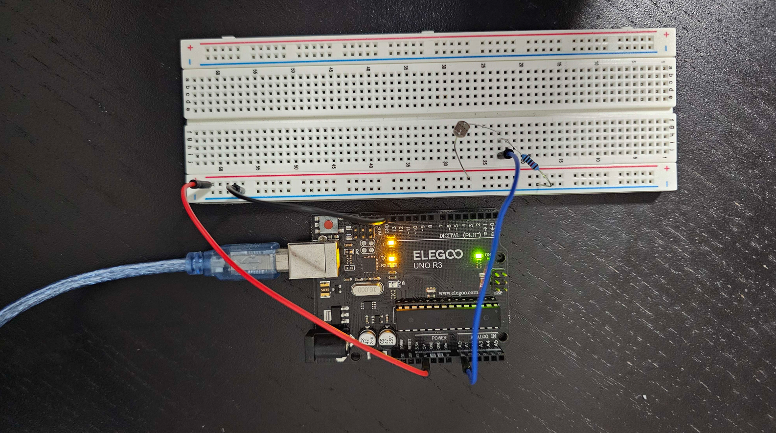

Fig-1: Circuit

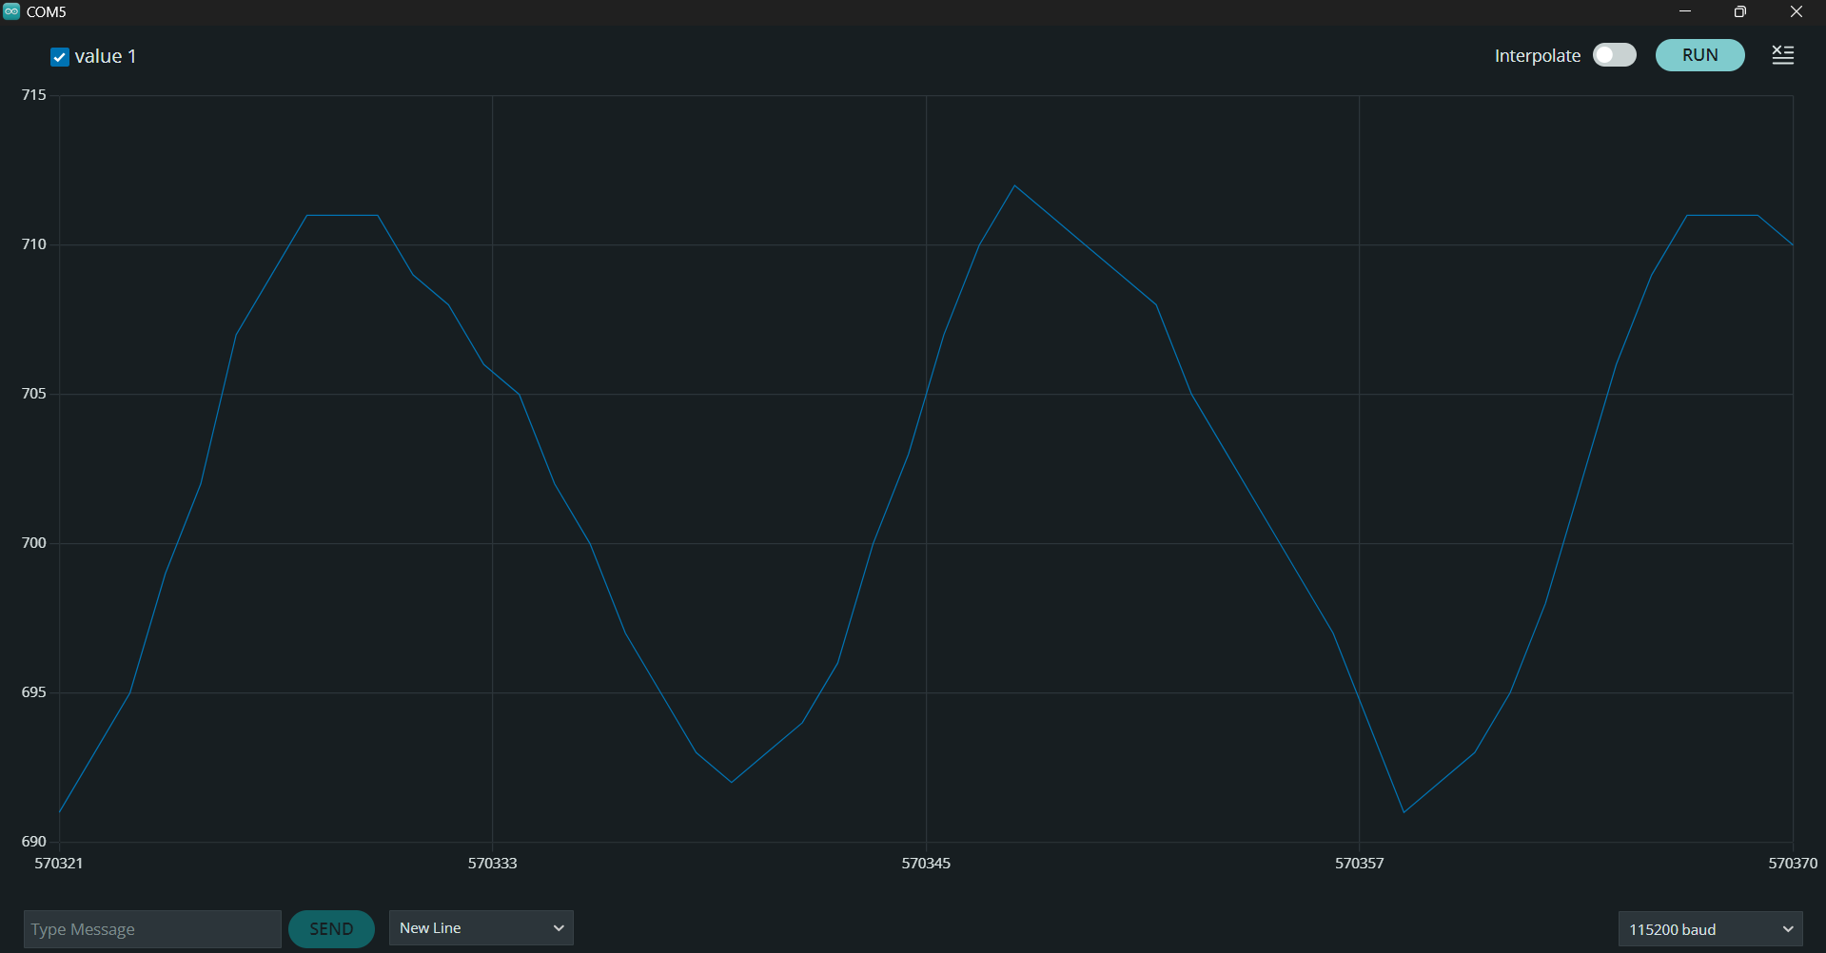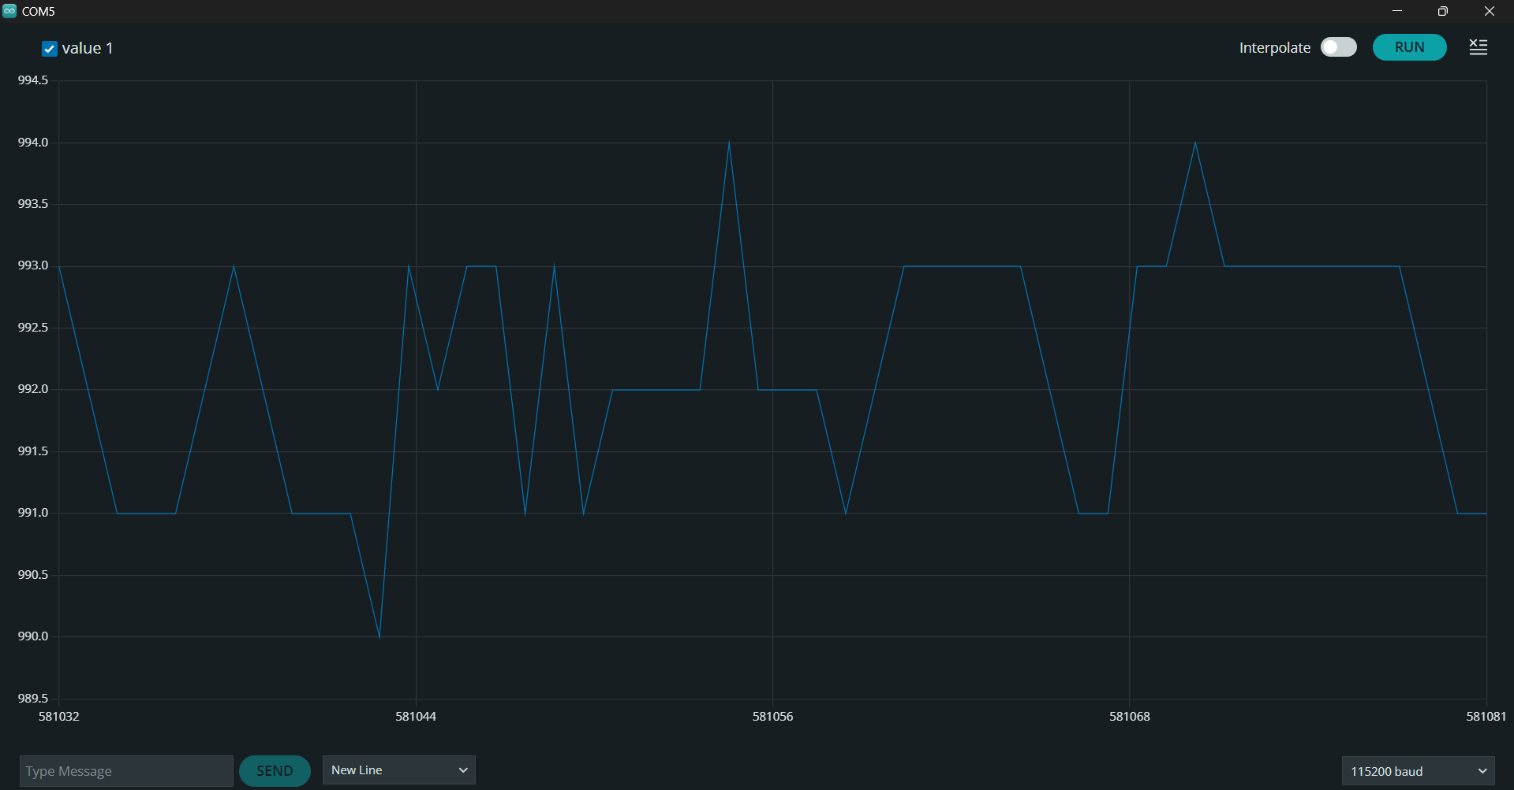

Fig-2(a): Regular frequency diagram Fig-2(b): Frequency diagram in presence of

Flashlight on the photoresistor