**AD Management through OpenCV**

**Internship Report**

Submitted in partial fulfilment of the requirements

For the degree of

**Bachelor of Technology in Computer Science & Engineering**

By

**Aayush Shah**

(19BCE245)

Guided by

**Rupesh Shah**

(CEO, BarodaWeb)



**DEPARTMENT OF COMPUTER SCIENCE & ENGINEERING**

**Ahemdabad 38248**1

**CONTENTS**

|  |  |  |
| --- | --- | --- |
| **Certificate** | | i |
| **Acknowledgement** | | ii |
| **Abstract** | | iii |
| **Chapter 1** | **Introduction** | 1 |
|  | * 1. **General**   2. Brief description about the company (industry internship)   3. **Topic title**   4. **Objectives**   5. **Problem Statement** | 2  3  4  5  6  7  8 |
| **Chapter 2** | **Literature Survey**  This chapter will contain the details of project work. |  |
| **Chapter 3** | **Methodology**  This chapter will contain the details of project work. |  |
| **Chapter 4** | **Result Analysis**  This chapter will contain the details of project work. |  |
| **Chapter F**  (Note: F stands for final chapter) | **Summary Conclusion and Future work**  **Summary**  **Conclusion**  **Future work** |  |
| **References** | | |
| **Appendices**   1. **List of useful websites** 2. **Additional Material** | | |

**CERTIFICATE**

This is to certify that the Internship entitled “**AD management through OpenCV**” submitted by **Aayush Shah (19BCE245)**, towards the partial fulfilment of the requirements for the degree of Bachelor of Technology inComputer Science and Engineering of Nirma University is the record of work carried out by him/her under my supervision and guidance. In my opinion, the submitted work has reached a level required for being accepted for examination.

|  |  |
| --- | --- |
| Rupesh Shah  CEO, BarodaWeb  Vadodara. | Dr. Madhuri Bhavsar,  Professor and HOD,  Computer Science and Engineering Dept.,  Institute of Technology,  Nirma University,  Ahmedabad |

**ACKNOWLEDGEMENT**

First I would like to thank Mr. Rupesh Shah, CEO of BarodaWeb and Harshal Shah for giving me the opportunity to do an internship within the organization.

I also would like all the people that worked along with me Ansh Ray, Preet Patel and Harshal Shah with their patience and openness they created an enjoyable working environment.

It is indeed with a great sense of pleasure and immense sense of gratitude that I acknowledge the help of these individuals.

I am highly indebted to Head of Projects department Kaushal Patel and Director Krupali Shah, for the facilities provided to accomplish this internship.

I would like to thank my Head of the Department Dr. Madhuri Bhavsar for his constructive criticism throughout my internship.

I would like to thank Dr. Shivani Desai, College internship coordinator Anitha Modi internship coordinator Department of CSE for their support and advices to get and complete internship in above said organization.

I am extremely great full to my department staff members and friends who helped me in successful completion of this internship.

**- Aayush Shah (19BCE245)**

**ABSTRACT**

The abstract shall highlight the important details of the Internship work. It should consist of objective of work, scope of work, preliminary work carried out and important findings

**Objective :** The main objective of the project was to do AD management through Computer Vision. We have to analysis various features of person in front of the tab or screen which may be put in restaurants tables or flyers on road. The screen will show various ADs and our task was to detect human emotions, gender, gaze, age and recognition of whether that user is previously showed up in front of any of our existing screens or not.

**Scope :** We have to cover all the screen types from restaurant table tab, Movie theatre poster screen, and Flyers on road. Each and Every person who gives attention to the screen, we add his/her face’s feature in our database if it’s new user for our database. face recognition algorithm will be run first to check whether the user is new or existing.

**Preliminary work :** We gathered the requirements first for analysis what are the important aspects of feedback which contains human interaction and which can be useful to advertising companies. Here we find out that gender, race, age, attention span (gaze tracking) and emotion of the person in front of screen can give proper data for the advertising company that how their product impressed the user and that data can also be useful for us (AD broadcaster) for recommending more related ADs.

**Important Findings :** We searched for various efficient algorithms for face recognition as well as different modules like gaze tracking, gender and age detection. GitHub played a useful role for finding suitable python packages. Also some research papers were also examined before the gathering of all the modules in one. Medium articles and other web resources provided the step-by-step tutorials for some basics of working with camera and images in python.

**INTRODUCTION**

Summer Internship is done as BarodaWeb which is an end-to-end IT outsourcing service provider company. It has proven capabilities and deep domain expertise as they address business changes through their integrated IT and business process outsourcing solutions which tackle critical business functions.

Our project title was AD management through openCV. In which we were assigned the ML/DL part which consists Facial feature recognition module. We have to develop python script for backend server which analyses the following features : Face Detection, Face Recognition and after that, Gender, Age, Emotion and Gaze tracking were also implemented. These provides crucial data for future AD recommendations (For AD broadcaster) and product improvement (for the Product AD company).

**METHODOLOGY**

**1.Programming Language**

There are many programming languages but we used Python to access to great libraries and frameworks for AI and machine learning provided by Python

**2. Libraries**

• CV2 :- we used cv2/openCV to read video through webcam and process that video frame by frame. Moreover, face detection form frames is also done using CV2.

• Deepface :- This library contains trained DL models for analysing face images. We used this library to analyse emotions, age, race and gender of faces captured in frames of video.

• Face_recognition :- This library contains trained models for recognising faces. We used this library to recognise faces in video and provide unique id to new faces

• Gazetracking :- This library have trained models for detecting eyes and analysing position of eyes. We used this library to capture and analyse movement of eyes from faces captured in video

• All of the above libraries used tensorflow library which provides support for machine learning and deep learning tasks

**3. Program flow:**

as shown in flow chart we first read video from webcam using cv2 library then process each frame of the video.

In each frame we detect faces using face cascade and recognise faces then analyse that faces using deepface and track eyes using gazetracking.

All of this data gets displayed in output video in real time.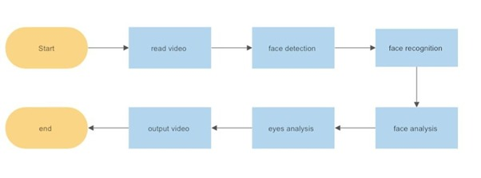

**RESULT ANALYSIS**

**SUMMARY CONCLUSION AND FUTURE WORK**

1. **SUMMARY**

The basic aim of this project was to provide the data to the organization who are currently watching the advertisement. The data which we have collected is age, gender, eye-gazing (currently what is the status of eye whether blinking, looking left, looking centre, etc), emotion, race and recognition of face whether the specific person is new or already exists in the database.

We ensured that every new person’s photo is updated in the database if he resides in front of the camera for certain amount of time otherwise the people who are just passing in front of the camera will also be detected and a new amorphous photo will be stored in the database.

This is the sample photo of the person whose photo is already stored in the database. If any new person came in front of the camera, then his photo will be saved as ‘number.png’, where number is the increasing count of the people whose photo is stored in the database.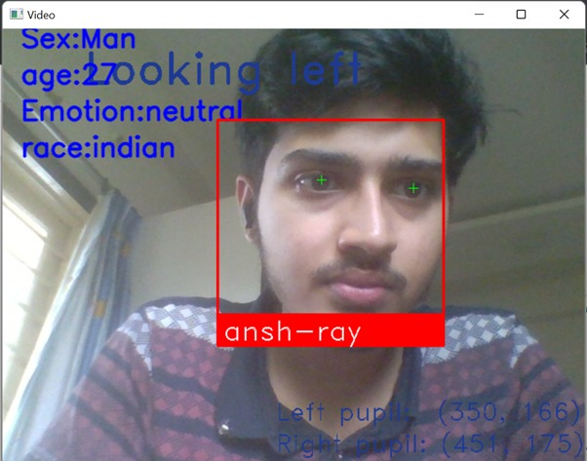

If the photo is not initially stored in the database then the file will be named as 6.png ( a unique id ) as shown below.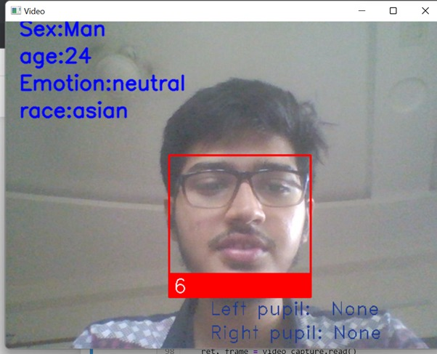

The sample table shown below indicates all the data which is needed to be stored.

1. **CONCLUSION**

We have seen various types of methods for face recognition and eye gazing, and finally decided to accumulate the most accurate method for this project.

The data stored can be helpful for marketing companies.

1. **FUTURE WORK**

We have created a website with the help of Django framework to accommodate the full stack development languages and libraries with python

At present we have the website ready but it can be further modified which can store the data in the database and can be uploaded to cloud.

**REFERENCES**

* Face recognition: A literature survey**,** *Zhao, Wenyi and Chellappa, Rama and Phillips, P Jonathon and Rosenfeld, Azriel, ACM computing surveys (CSUR),* ACM New York, NY, USA -2003
* Real-Time Face Recognition and Detection Using Python, *Tayyaba Zamindar, Shradhatai Gangawane, Shital Kalane, Yogita Kalane,* IJRASET-2022

**APPENDICES**

1. **List of useful websites**

**For Python Script :**

<https://viso.ai/computer-vision/deepface/>

<https://github.com/nevilparmar11/Attendance-Management-System-Using-Face-Recognition/tree/main/Attendance-System-Using-Face-Recognition>

<https://www.analyticsvidhya.com/blog/2021/11/build-face-recognition-attendance-system-using-python/>

<https://github.com/ShubhamSonkesriya/Face-Recognition-Attendance-System>

<https://github.com/Pradyuman7/TrackEyes>

**For Website :**

<https://www.geeksforgeeks.org/how-to-create-a-new-project-in-django-using-firebase-database/>

<https://fedingo.com/how-to-run-python-script-in-django-project/>

**For Mobile App :**

<https://www.geeksforgeeks.org/face-detection-in-flutter-using-firebase-ml-kit/>

<https://github.com/Rajatkalsotra/Face-Recognition-Flutter.git>

<https://becominghuman.ai/detecting-age-and-gender-with-tf-lite-on-android-33997eed6c25>

1. **Additional Material**
   * <https://realpython.com/mobile-app-kivy-python/>
   * <https://medium.com/@umerfarooq_26378/tools-to-run-python-on-android-9060663972b4>

**Internship Certificate is not yet given.**