**PROJECT PROPOSAL**

# INTERNET & INTRANET ARCHITECTURE

# DATA CENTER SECURITY DESIGN

Group Members

**NAME S.ID**

SHAH BEKHSH 7663

COURSE ID : 66275

INSTRUCTOR **:** SIR KASHIF

**TABLE OF CONTENTS**

Title**……….**…………………………………………………………1

Abstract……………………………………………………………3

Project Scope**.**……………………………………………………4

Equipment Required**.**……………………………………………5

Topology Sample**.………………………………………………..**6

**ABSTRACT**

This project aims to design and implement security on a data center. The data center is being accessed by an organization that has branches in 2 different cities. The data center has 3 servers, each of which host different services. The services on each server are DNS, FTP and HTTPS. Each of the servers have unique public IP addresses. There are also 2 network administrators on the network who manage and troubleshoot any issues on the server.

**PROJECT SCOPE**

* The datacenter server and admins would be on different networks.
* The servers would be accessible from the internet using public IP address.
* The servers would also have private IP address using which the admins access the servers.
* Only the required services would be available on the servers for external access. All other services should be blocked.
* The private IP address of the servers should not be accessible from outside the network.
* All communication to the outside network from the server network would be done through their respective public IP addresses.
* External users would be unable to access the LAN network.
* The implementations would be performed using Cisco IOS firewall routers and switches.

**EQUIPMENT REQUIRED**

The entire project would be simulated on the Cisco provided software for network simulation named Cisco Packet Tracer (Version 7.0). The devices used are listed as follows.

2811 Router (Two)

Servers (Three)

Multilayered Switches (Two)

Console Cables for Routing Configuration

Host Devices

**Topology Sample**

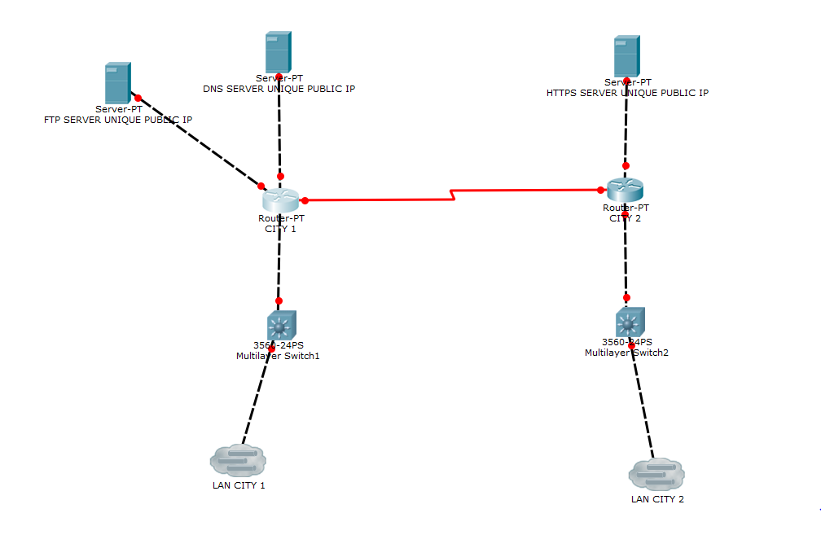

*The topology is subject to change after course instructor review