**Directions to buildings of the FU Berlin**

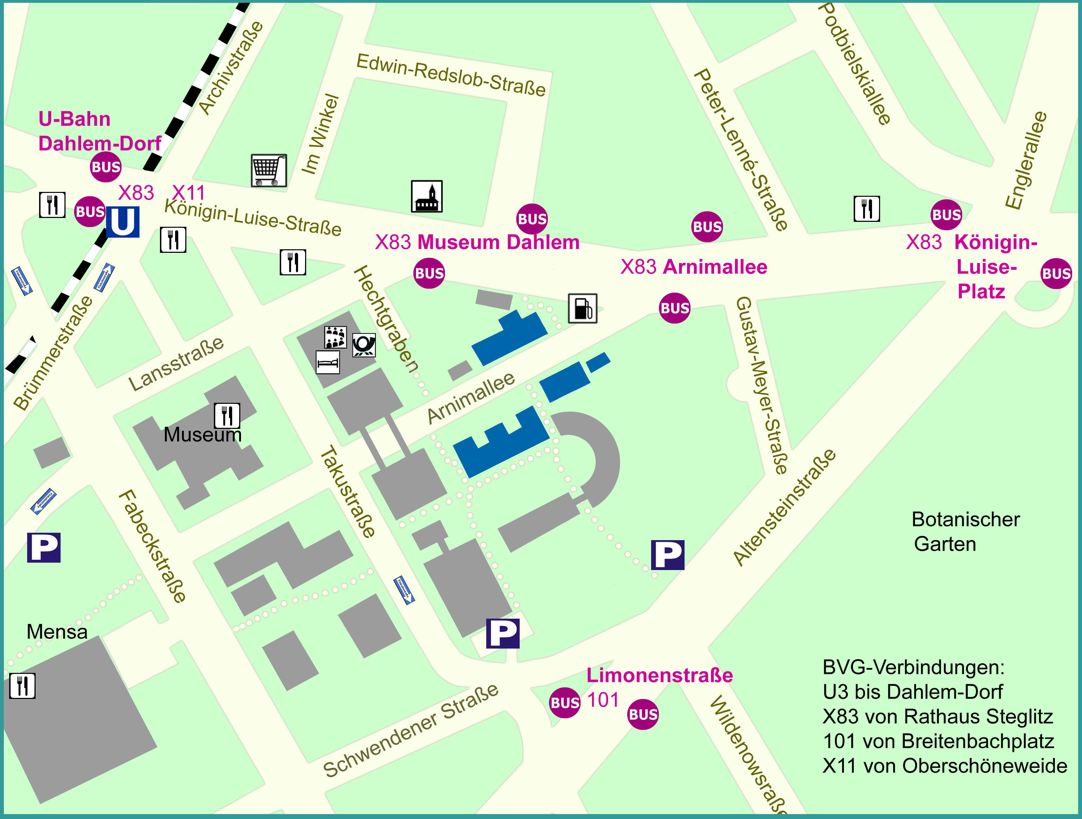

*The buildings of interest at FU Berlin are in blue in the map.*

It can be reached

* from U-Bahnhoff Dahlem-Dorf (line U3) walking 10 minutes.
* from S/U-Bahnhoff Rathaus Steglitz (lines U9, S1), walking 25 minutes, or taking the bus X83, going down at *Arnimallee*, 10 minutes