**Directions to buildings of the HU Berlin**

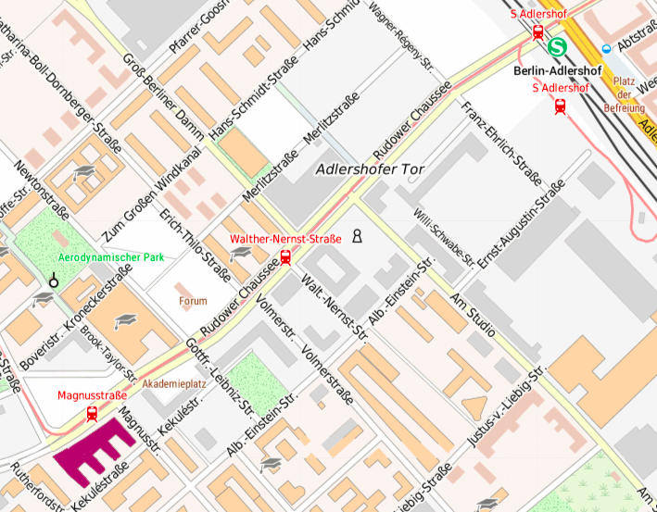

(Copyright map.de)

*The usual building of interest at HU Berlin is in purple in the map.*

One should go to S-Bahnhoff Adlershof by taking one of the S-Bahn lines S8, S9, S45, S46 or S85. From there, it can be reached

* walking 15 minutes.
* taking the Bus 162 or 164 or Tram 61 or 63, going down at *Magnustr.*, in 5 minutes