**Directions to Institut für Mathematik of the TU Berlin**

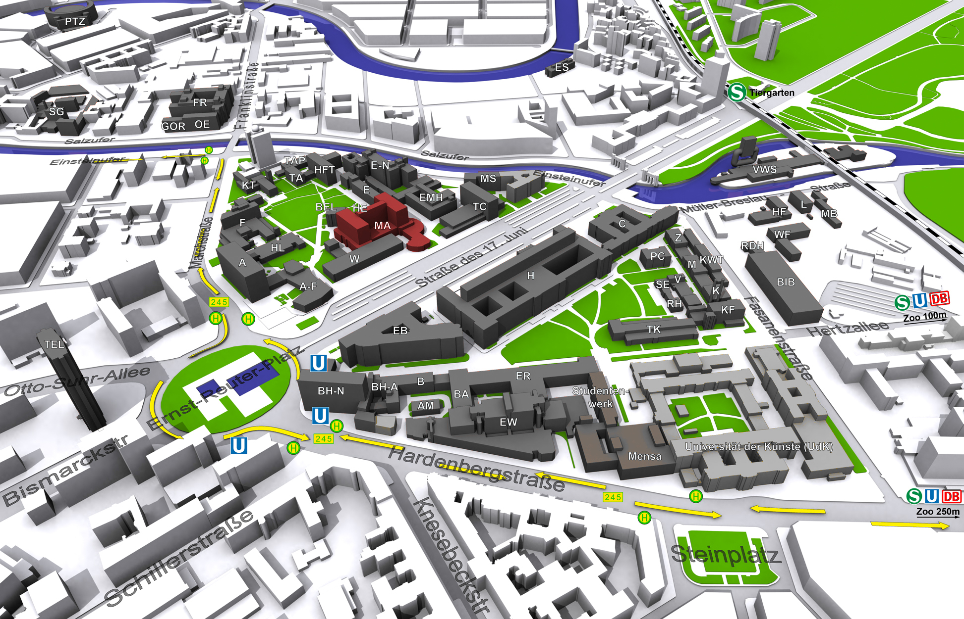

*The Institut für Mathematik is the red building.*

It can be reached

* from U-Bahnhoff Ernst-Reuter-Platz (line U2) walking 5 minutes.
* from S-Bahnhoff Tiergarten (lines S3, S5, S7, S9), walking 15 minutes.
* from S/U-Bahnhoff Zoologischer Garten (lines U2, U9, S3, S5, S7, S9), walking 18 minutes.