Assignment1: Web Development(Resit)

By Shahriar Mahmood

Student ID: 16434476

The aim of this assignment was to build a fully functioning website, which is also to substitute as a personal collection display site for the creator.

The website is consisted of 4 pages: index.html, bio.html, collection.html and contact.html.

All websites are present and correct with appropriate names as required by the teacher, along with a repository created in GitHub named CSY1018_ASS1Resit (<https://github.com/Shah-Mahmood/CSY1018-Ass1Resit> ) , which has 15 commits prior to submission.

The live URL for the GitHub is as follows:

<https://shah-mahmood.github.io/CSY1018-Ass1Resit/>

Contents of each page (body text and images of index, bio, collection) are personal creation, while the form and the CSS stylesheet has been taken from the lectures and the tutor herself for further use and alteration to suit the website’s style. This has been properly referred to the tutor to give her full credit for the originality of the two parts.

The CSS has been changed with recolouring codes and with the adding of grids for the collection.html page’s image gallery.

In order to produce a functioning and gradable website the checklist has been used as much as possible. The following is the checklist, highlighted in green for included, yellow for partially attempted and red for not included for all content regarding website and the README file.

**CSY1018: Web Development**

**Checklist for Assignment 1 RESIT:**

* The README file is in both the assignment-1.zip file and if possible in your GitHub repository. It may be a .doc, .md (with images) or text file.
* The live URL is available on GitHub.
* A discussion that demonstrates the development, originality, code and origins of the interface design.
* Commenting is available and descriptive in both HTML and CSS files.
* Any externally sourced code has been commented and/or referenced in the README file.
* The site structure is correct and the index.html file is in the root directory.
* The Doctype is correct (HTML5)
* HTML5 elements have been used.
* The design layout is aligned and designed as if there is an underlying grid.
* Material Design colour, layout and interactive elements have been considered.
* Only CSS and HTML files are present.
* The Google Webfonts API has been used.
* The font choice has been considered rather than just using the default.
* No filler text or Lorem ipsum has been used.
* Font spacing (letter and line height) has been considered to enable good readability.
* Thumbnail sketches and/or wireframes have been included in the README file.
* File names have no spaces and use lowercase letters; - or _ may be used.
* No frameworks have been used.
* Font size conforms to current conventions/trends.
* Images have been properly resized, optimised are copyright free.
* The code is aligned.
* Regular updates and relevant comments on GitHub throughout the term (5 minimum/10 expected).
* Use of icons.
* Use of some interactivity or CSS transition/transformation.
* Form fields have been included.
* Correct spacing and padding throughout pages.
* Alternative text has been added to all images.
* Discussion of approximate hours taken to complete assignment in README file.
* Font size is expressed using em rather than pixels.
* No absolute URLs used for images except where placeholder images were used.
* Software to generate code has NOT been used. Use will be given a FAIL grade.
* Any extra work over and above the requirements has been explained in the README file so it can be considered by the assessment team.
* CSS Flexbox has been used in at least one place in your files (multiple columns on CV page).
* Your logo, image, or icon, in upper left corner, links back to the landing page (home).
* Is a Favicon available (extra).

After the creation of the website, it was also strongly advised that the website passes the W3 validation for both CSS and HTML. The following are the screenshots as proof of validation pass:

The screenshot for the ‘Home’ page (index.html):

This file returned with 4 errors, which were easily fixed.

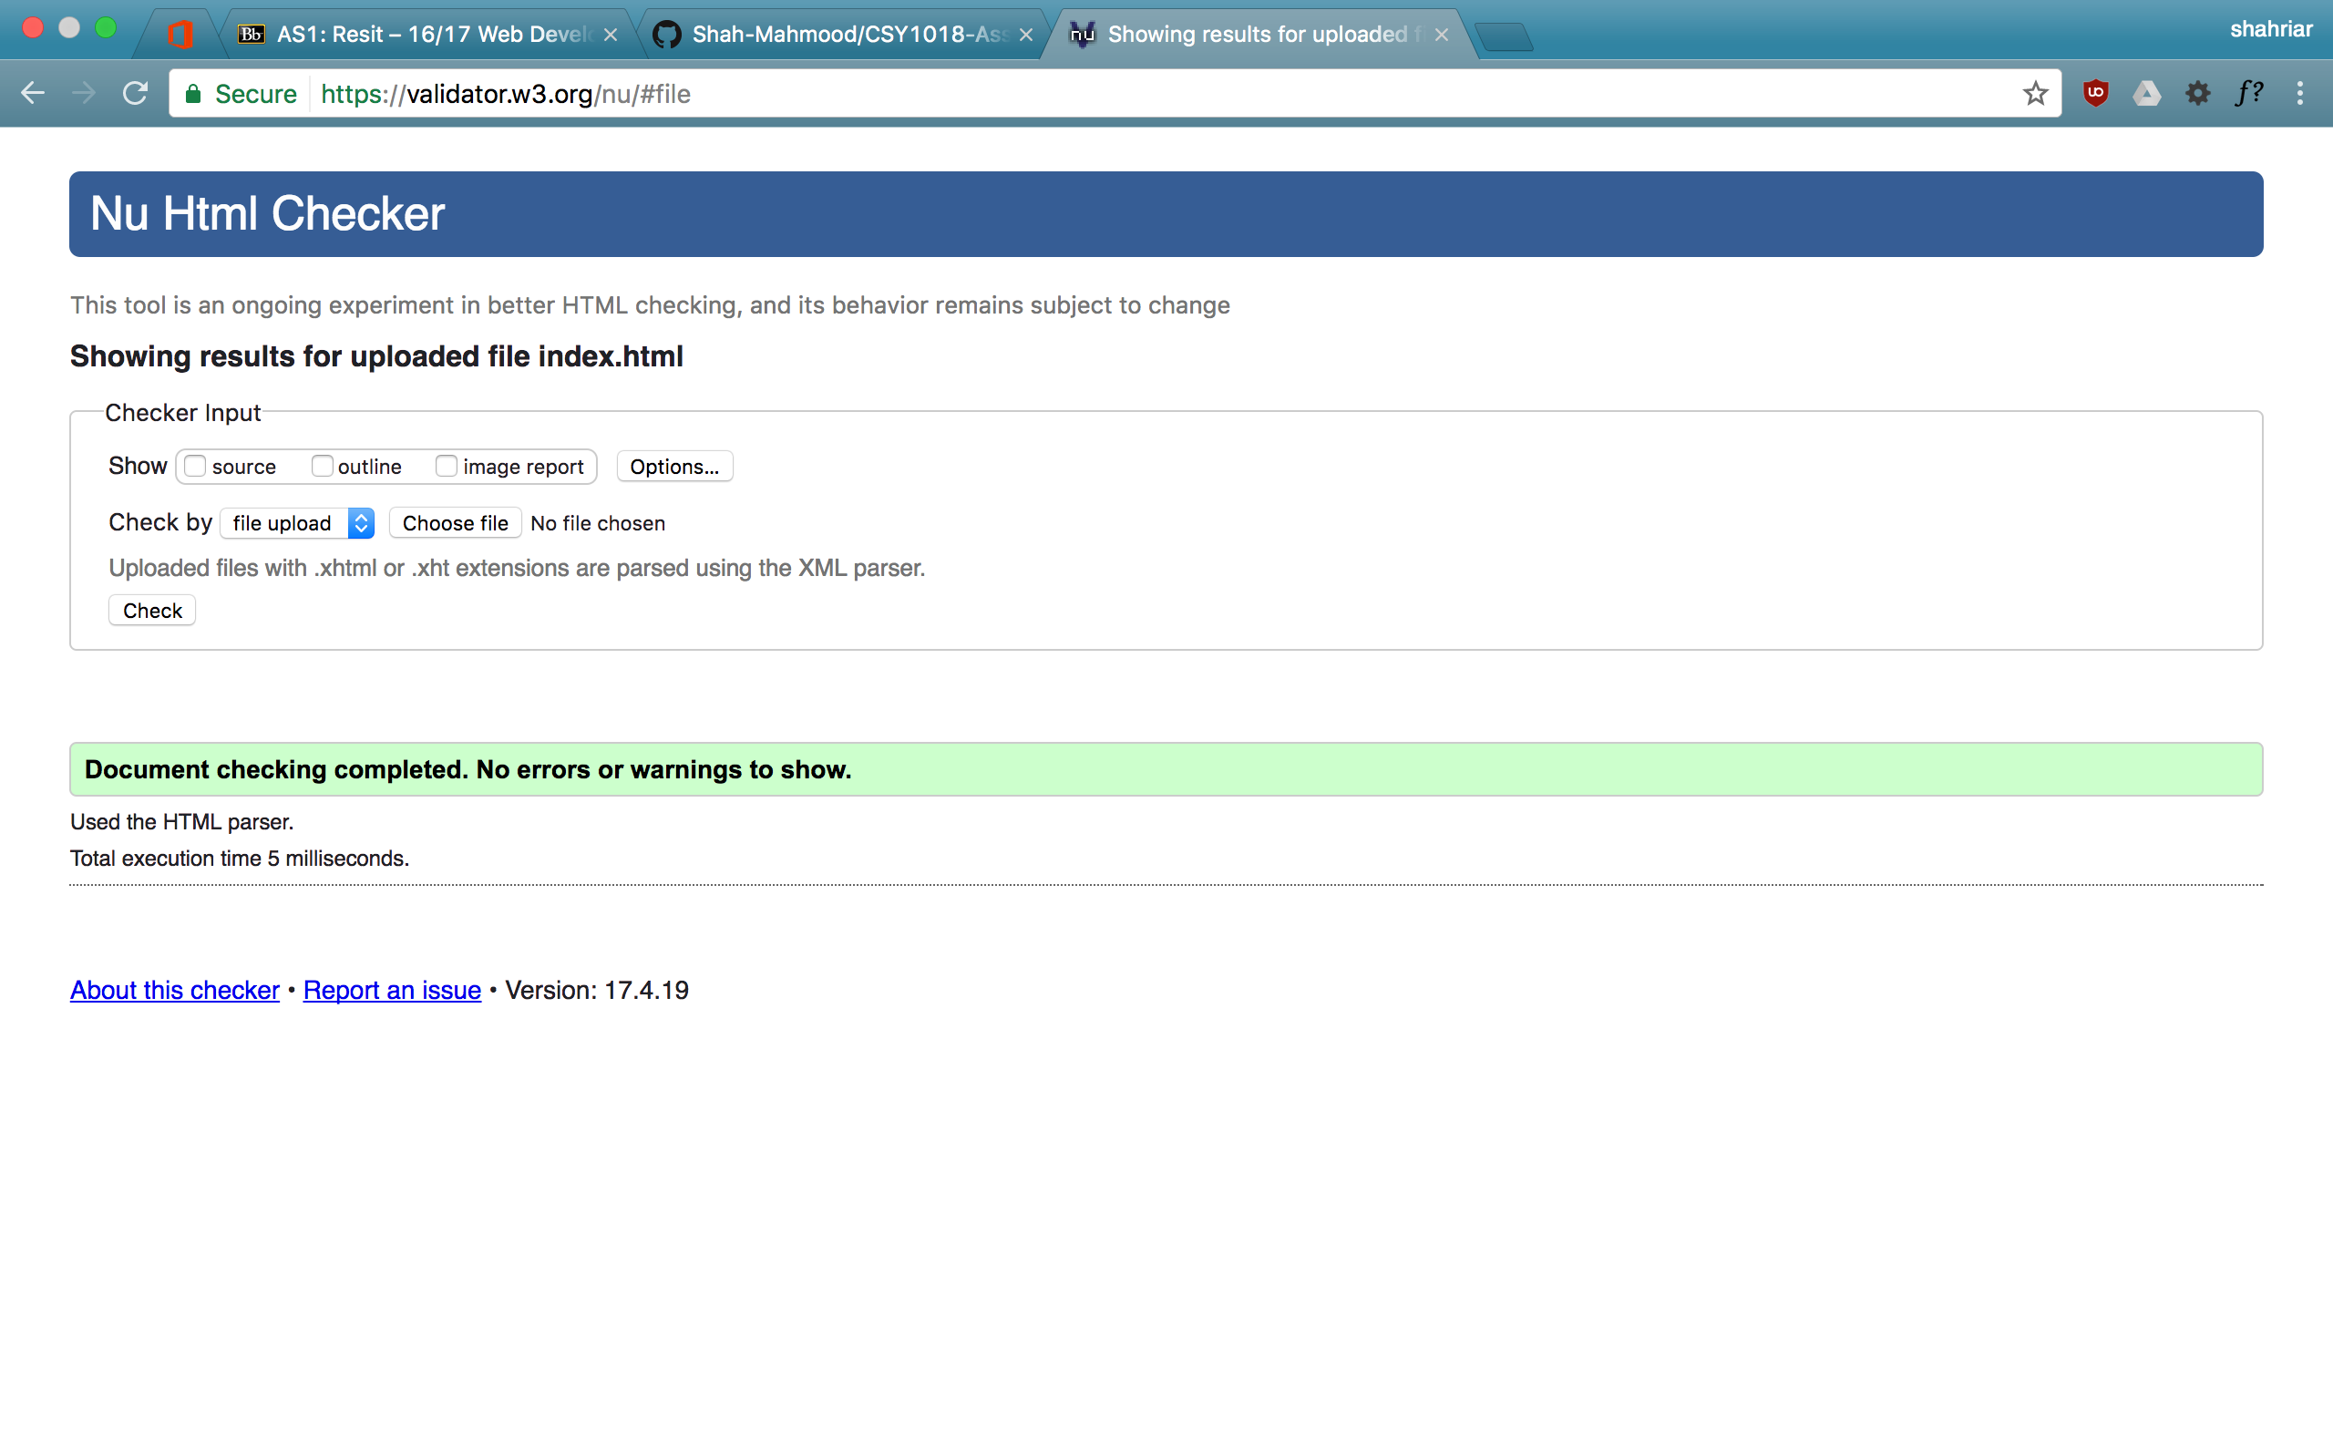

The screenshot for the ‘Biography’ page (bio.html):

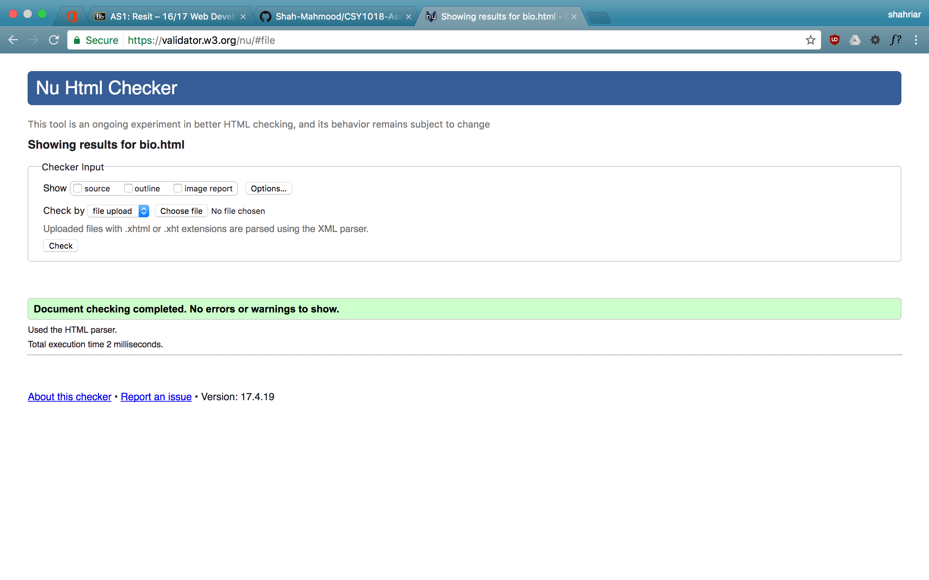

The screenshot for the Collection page (collection.html):

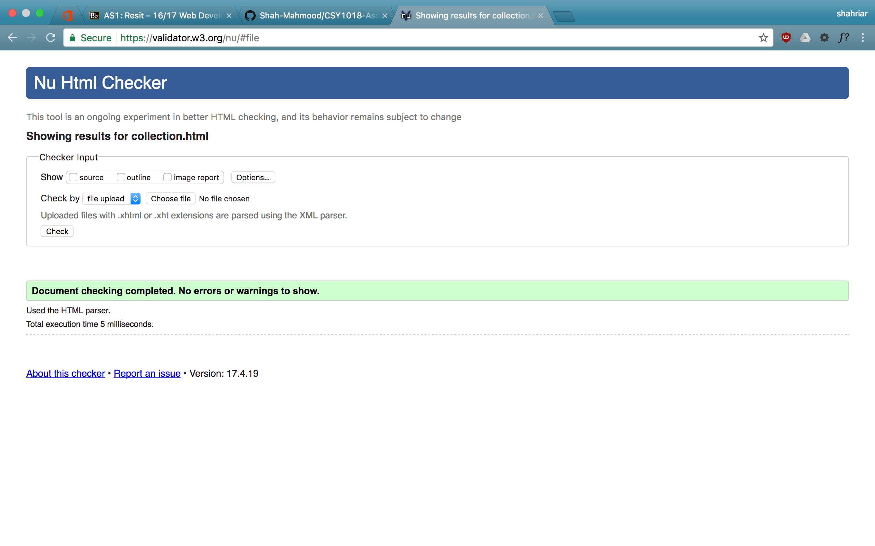

The screenshot for the Contact page (contact.html):

This file returned with some errors on the tutor’s code for the form, which, being an external code, was out of the author’s understanding of what may have been the problem. If this had been studied some more, the fixing of this error may have been an easy task.

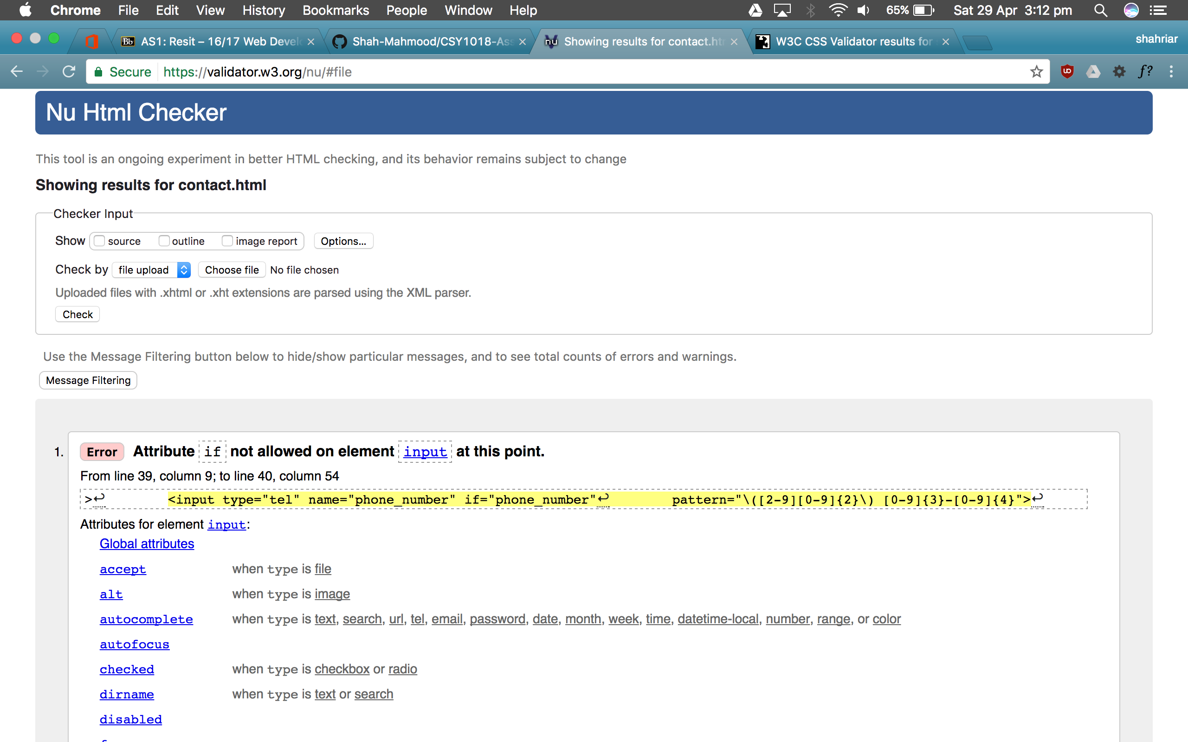

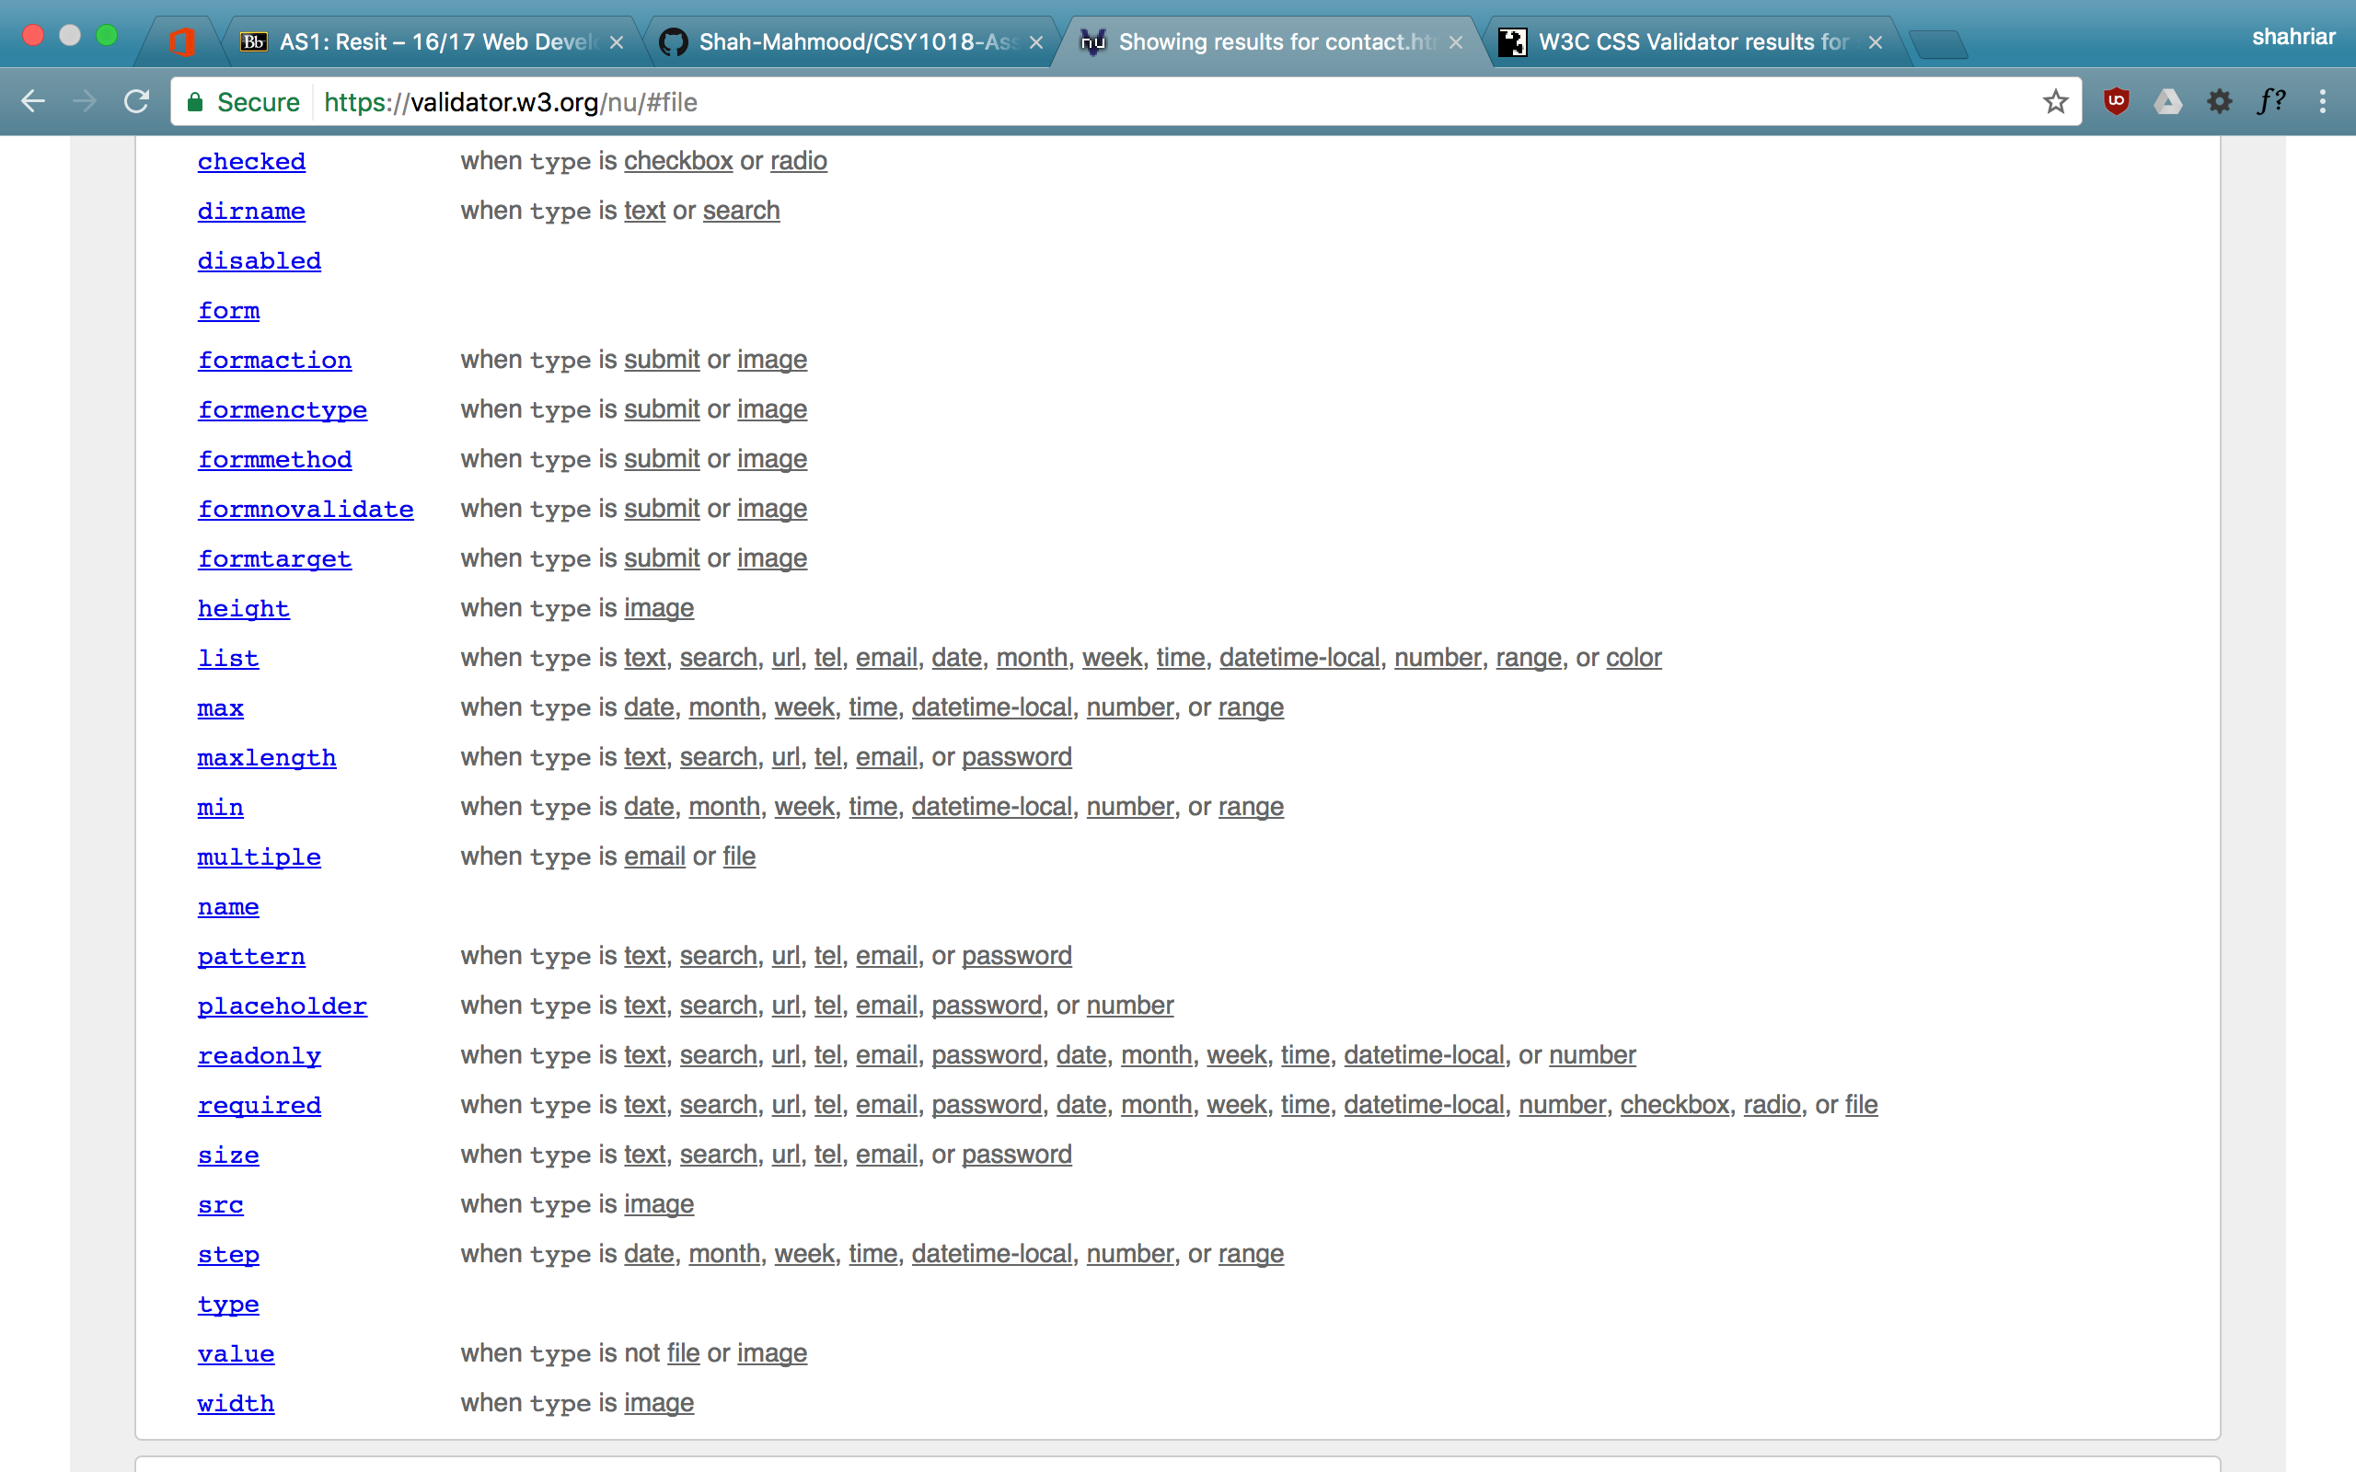

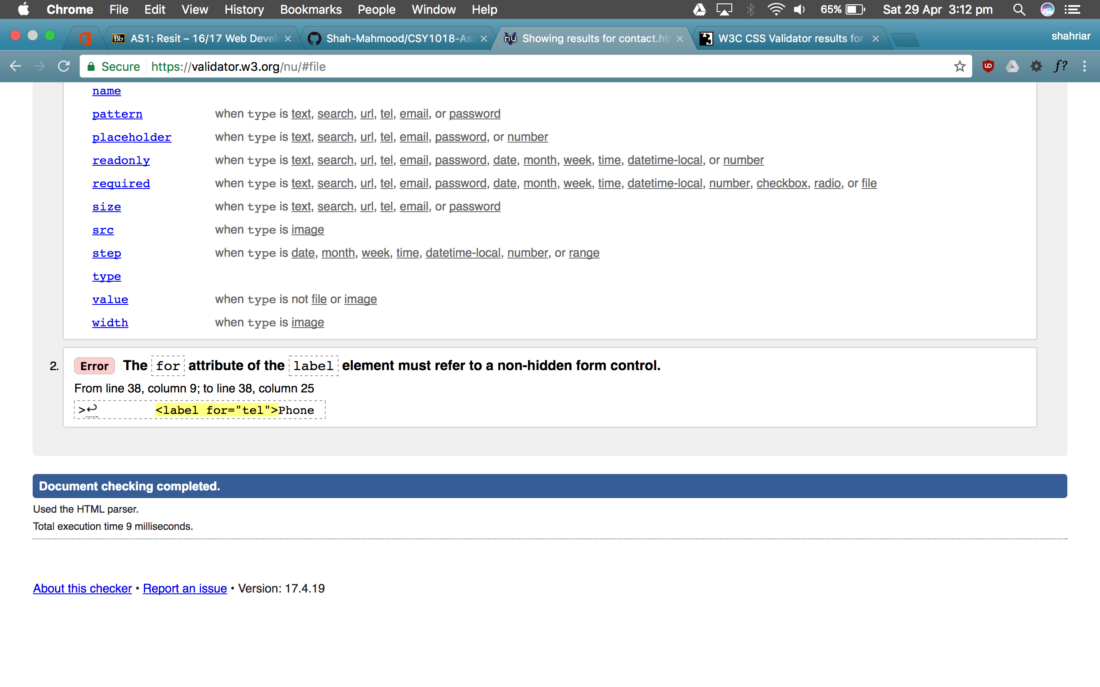

The screenshot for the CSS page (style.CSS):

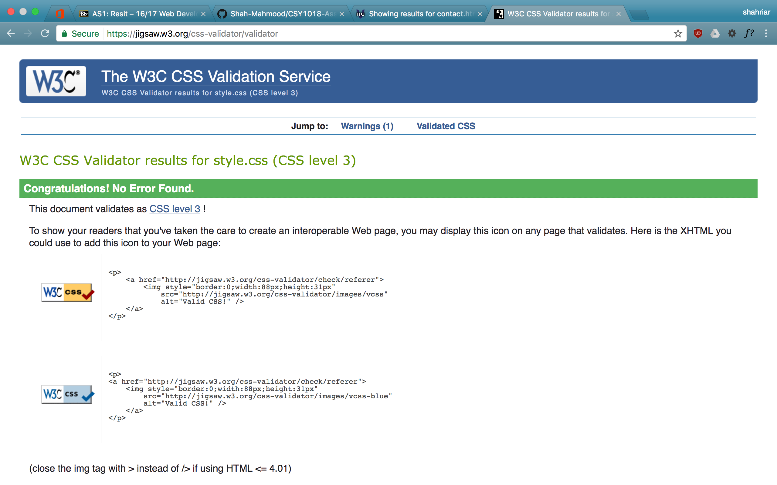

Approximately 14 hours have been spent on the creation of this website. The timeframe is substantially shorter than previous submission as this time the previous website had been scavenged for codes, which had boosted the productivity significantly.

**References:**

Contact.html:

Coulter-Smith, L. (2016) simple form 1, *Codepen* [online]. Available from: <https://codepen.io/lizcoultersmith/> [Accessed 15 January 2017].

Styles.css:

Coulter-Smith, L. (2016) Ottergram Code, htdocs.zip, *Blackboard, University of Northampton* [online]. Available from: <https://nile.northampton.ac.uk/webapps/blackboard/content/listContent.jsp?course_id=_64602_1&content_id=_3127354_1> [Accessed 15 January, 2017].