Shah Wajahat Ejaz

BS-CS

Question #1

Program:

#include<stdio.h>

main()

printf("\t\tIntroduction");

printf("MY name is Shah Wajahat\nI Have Complete my BS Degree in Computer Science\n");

printf("I live in Orangi Town Karachi\nI love Programing Language.\nMy favoriat Programing Language is Python");

}

OutPut:

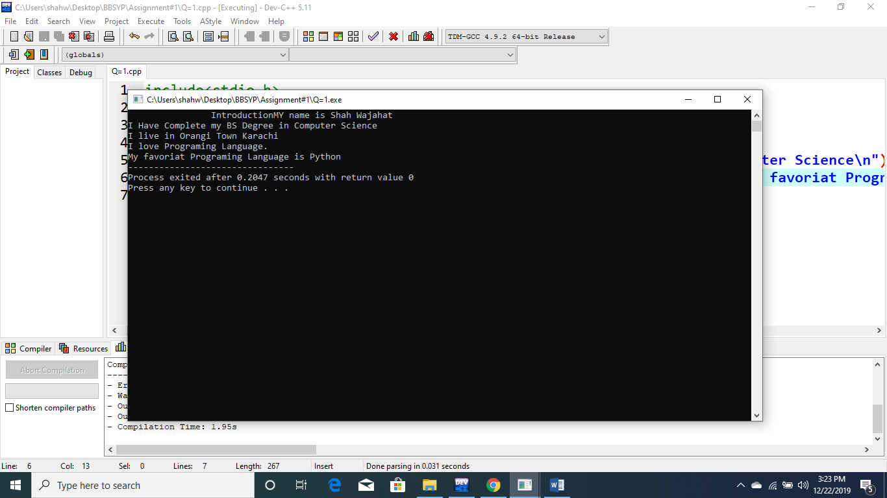

Question #2

Program:

#include<stdio.h>

#include<math.h>

main()

{

/*Q2) Take radius as an input from user in centimeter

and calculate the volume of sphere in centimeter-cube (cm^3) and

also in meter-cube (m^3).Hint: V = (4/3) * pi * r^3

1cm = 0.01m*/

float radius,volume,volume_in_m;

printf("Please Enter the Value of Radius: ");

scanf("%f",&radius);

volume=((4.0/3.0)*3.14)*pow(radius,3);

printf("Volume of Sphere in Centimeter-cube is: %f cm^3",volume);

volume_in_m=volume*0.0001;

printf("\nVolume of Sphere in Centimeter-cube is: %f m^3",volume_in_m);

printf("\nVolume of Sphere in Centimeter-cube is: %e m^3",volume_in_m);

}

OutPut:

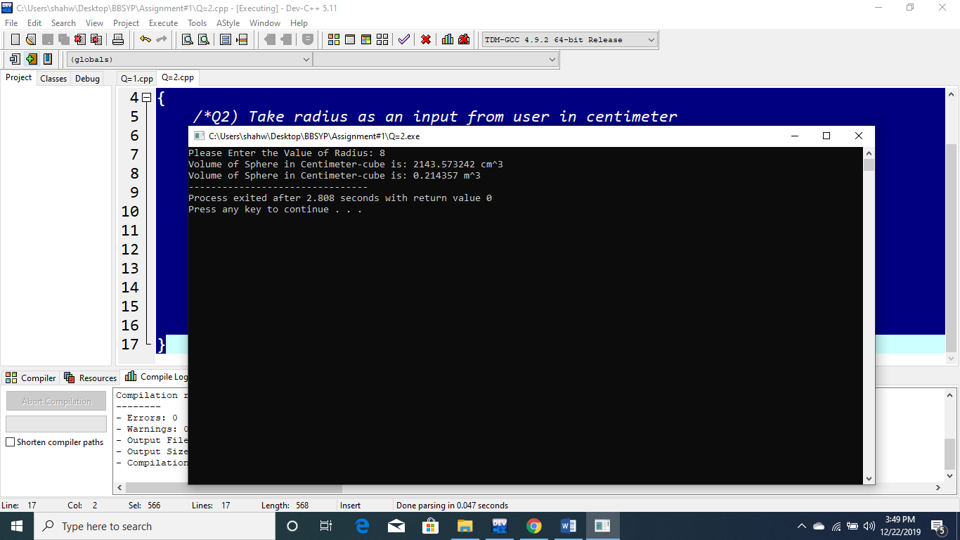

Question #3

Program:

#include<stdio.h>

#include<math.h>

main()

{

/*Q3)Take diameter as an input from user in centimeter and

write a program to calculate the area of a circle in meter-square(m^2).

hint : r = d/2 A = pi * r^2*/

float dia,area,rad,area_in_m;

printf("Enter The Value of Diameter: ");

scanf("%f",&dia);

rad=dia/2.0;

area=3.142*pow(rad,2);

printf("The Area Of a Circle in cm^2 is: %f cm^2\n",area);

area_in_m=area*0.0001;

printf("The Area Of a Circle in m^2 is: %f m^2\n",area_in_m);

printf("The Area Of a Circle in m^2 is: %e m^2\n",area_in_m);

}

Output:

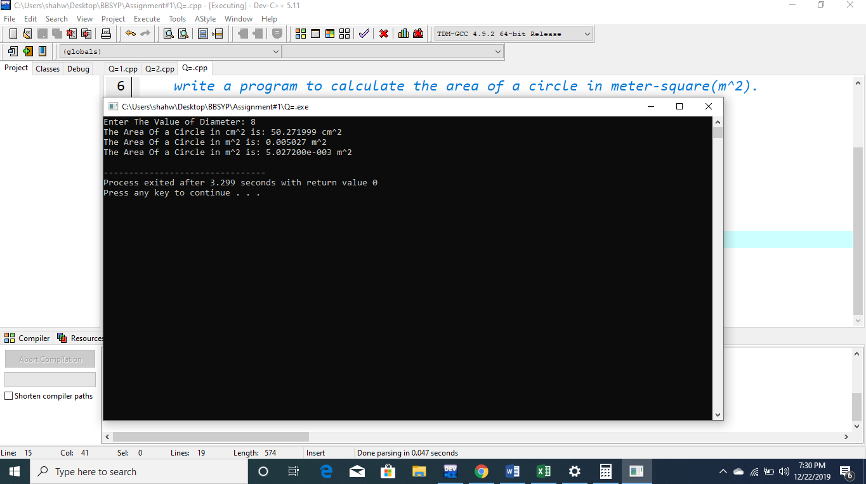

Question #4

Program:

#include<stdio.h>

#include<math.h>

main()

{

/*Q4)Take a value of an angle in degree measure from user

and convert it into radian measure.

calculate the slope of that angle in radian measure.

Hint: 1 rad = deg * pi / 180 m = tan(angle) // m is the slope*/

float deg,rad,m;

printf("Enter angle in Degree: ");

scanf("%f",&deg);

rad=deg*(3.142/180.0);

m=tan(deg);

printf("The Slope of angle: %f rad",m);

printf("\nThe Slope of angle: %e rad",m);

}

Output:

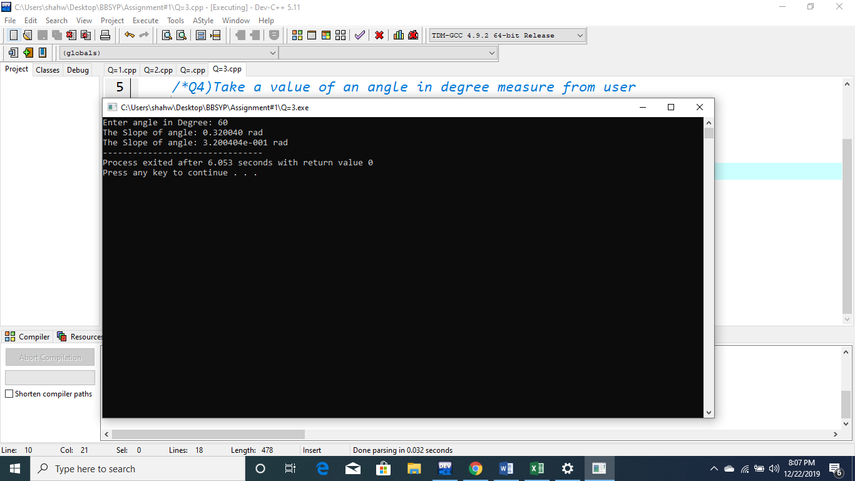

Question #5

Program:

#include<stdio.h>

#include<math.h>

main()

{

/*Q5) Take two coordinates from user and print the values in such format

“1st coordinate = (x1, y1)

2nd coordinate = (x2,y2)”

Also find the distance between two coordinates.*/

int a1,a2,b1,b2,a,b;

float distance=0.0;

printf("Enter The value of 1st coordinate of a1: ");

scanf("%d",&a1);

printf("Enter The value of 1st coordinate of a2: ");

scanf("%d",&a2);

printf("Enter The value of 1st coordinate of b1: ");

scanf("%d",&b1);

printf("Enter The value of 1st coordinate of b2: ");

scanf("%d",&b2);

printf("1st coordinate=(%d,%d)",a1,a2);

printf("\n2nd coordinate=(%d,%d)",b1,b2);

a=pow((a2-a1),2);

b=pow((b2-b1),2);

distance=sqrt((float)a-b);

printf("\nThe distance of given two Coordinate is: %f",distance);

}

Output:

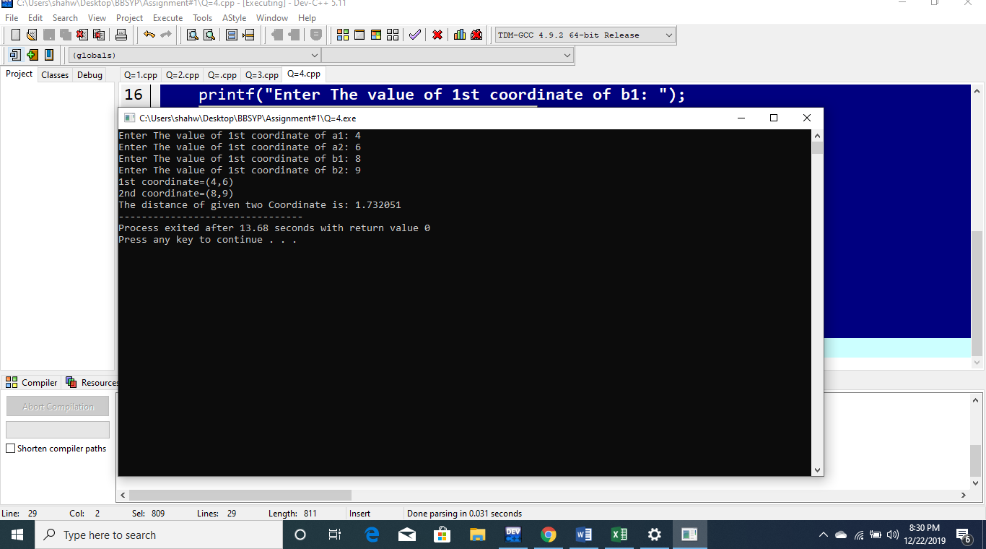

Question #6

Program:

#include<stdio.h>

main()

{

//Q6) Take an input from user and check if it is divisible by 2 or not?

int value,rem;

printf("Enter Any Number: ");

scanf("%d",&value);

rem=value%2;

if(rem==0)

{

printf("%d the given number is divisible by 2",value);

}

else

{

printf("%d the given number is not divisible by 2",value);

}

}

Output:

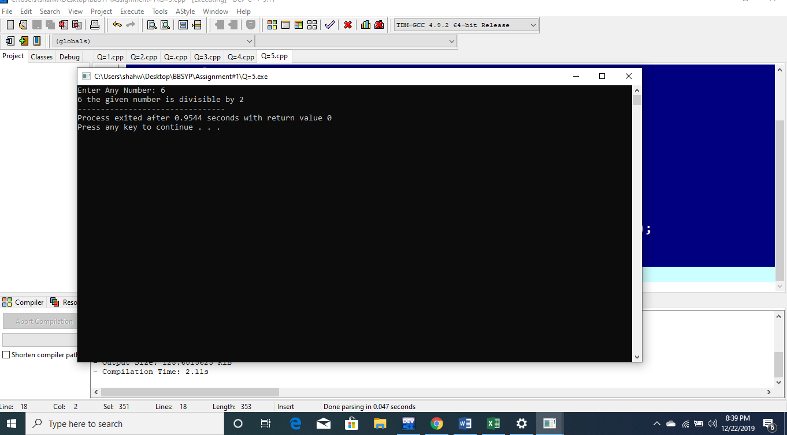

Question #7

Program:

#include<stdio.h>

main()

{

//Take an input from user and check if it is negative or positive?

int value;

printf("Enter a value: ");

scanf("%d",&value);

if(value<=0)

{

printf("%d given number is Negative",value);

}

else

{

printf("%d given number is Positive",value);

}

}

Output:

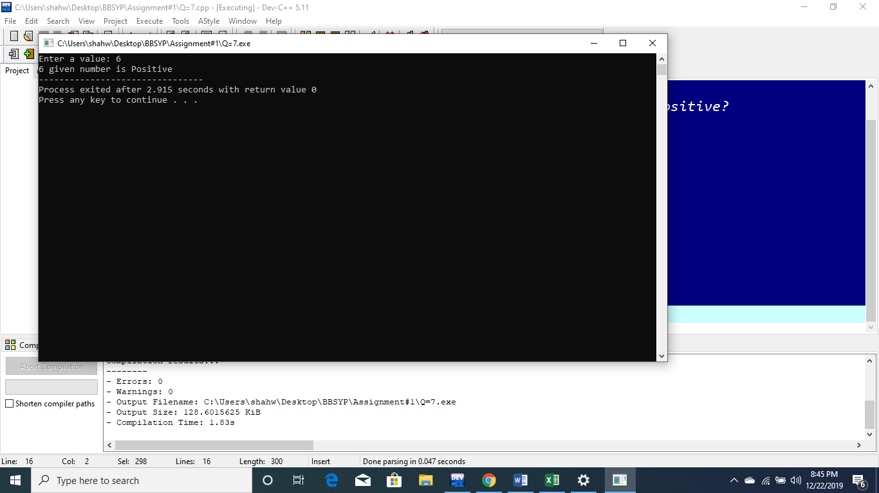

Question #8

Program:

#include<stdio.h>

main()

{

int age;

float maths,physics,urdu,english,islamiat,computer,obtaMarks,per,totalMarks=600.0;

printf("Enter the age of Student: ");

scanf("%d",&age);

printf("Enter the marks of Maths: ");

scanf("%f",&maths);

printf("Enter the marks of Physics: ");

scanf("%f",&physics);

printf("Enter the marks of Urdu: ");

scanf("%f",&urdu);

printf("Enter the marks of English: ");

scanf("%f",&english);

printf("Enter the marks of Islamiat: ");

scanf("%f",&islamiat);

printf("Enter the marks of Computer: ");

scanf("%f",&computer);

obtaMarks=maths+physics+urdu+english+islamiat+computer;

per=(obtaMarks/totalMarks)*100.0;

if(per>=50)

{

printf("--------------------------------------\n");

printf("Name: Shah Wajahat Ejaz\n");

printf("Father Name: Shah Ejaz Ul Haque\n");

printf("Age: %d\n",age);

printf("Institude: Computer Collegiate\n");

printf("--------------------------------------\n");

printf("Maths\t\t\t%f",maths);

printf("\nPhysics\t\t\t%f",physics);

printf("\nUrdu\t\t\t%f",urdu);

printf("\nEnglish\t\t\t%f",english);

printf("\nIslamiat\t\t%f",islamiat);

printf("\nComputer\t\t%f",computer);

printf("\n--------------------------------------\n");

printf("Obtain\t\t\t%f",obtaMarks);

printf("\nTotal Marks\t\t%f",totalMarks);

printf("\nPercentage\t\t%f",per);

printf("\nRemarks\t\t\tPass");

}

else

{

printf("--------------------------------------\n");

printf("Name: Shah Wajahat Ejaz\n");

printf("Father Name: Shah Ejaz Ul Haque\n");

printf("Age: %d\n",age);

printf("Institude: Computer Collegiate\n");

printf("--------------------------------------\n");

printf("Maths\t\t\t%f",maths);

printf("\nPhysics\t\t\t%f",physics);

printf("\nUrdu\t\t\t%f",urdu);

printf("\nEnglish\t\t\t%f",english);

printf("\nIslamiat\t\t%f",islamiat);

printf("\nComputer\t\t%f",computer);

printf("\n--------------------------------------\n");

printf("Obtain\t\t\t%f",obtaMarks);

printf("\nTotal Marks\t\t%f",totalMarks);

printf("\nPercentage\t\t%f",per);

printf("\nRemarks\t\t\tFail");

}

}

Output:

