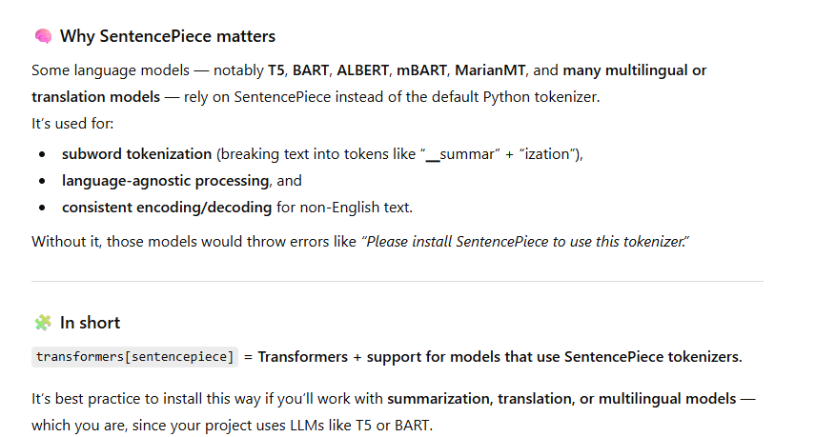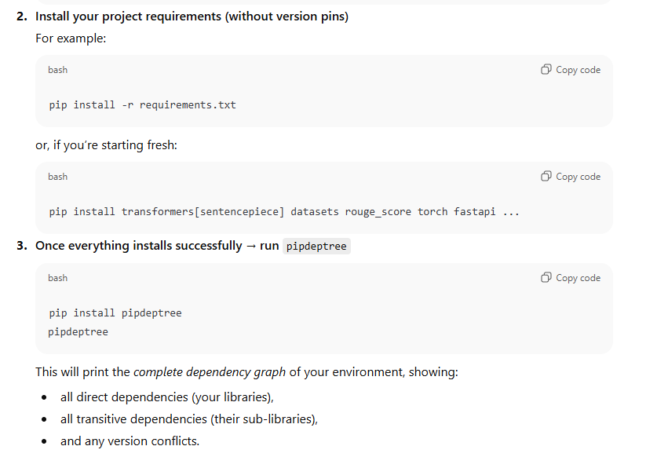

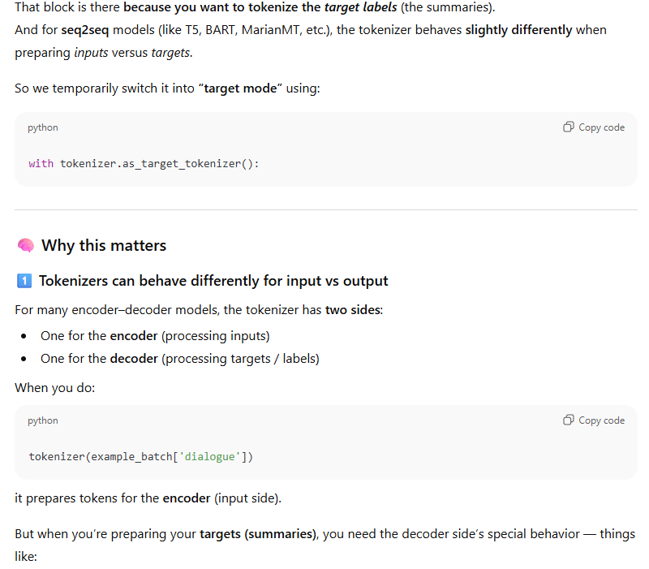
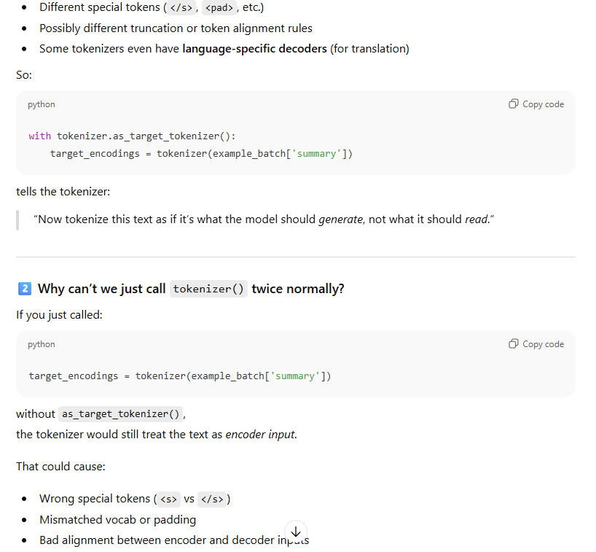

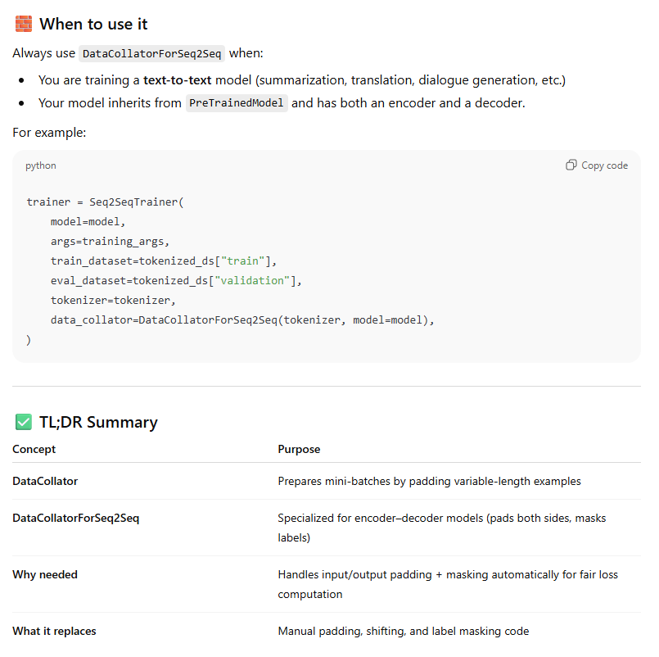
Files in a full-scale project | Purpose
Config.yaml | Every module we create (data ingestion, transformation,…) takes some inputs and creates some outputs (artifacts).  In this file, the path to all sources, input, and output directories is defined.
Entity | Defines a blueprint for input/output of each module, based on the given config for them
Config/configuration | Creates the blueprint defined

