Mining

User Guide

Version 1.0

March 2018

**Redpine Signals, Inc**.

2107 N. First Street, #540

San Jose, CA 95131.

Tel: (408) 748-3385

Fax: (408) 705-2019

Email: [info@redpinesignals.com](mailto:info@redpinesignals.com)

Website: [www.redpinesignals.com](http://www.redpinesignals.com)

**Disclaimer:**

The information in this document pertains to information related to Redpine Signals, Inc. products. This information is provided as a service to our customers, and may be used for information purposes only.

Redpine assumes no liabilities or responsibilities for errors or omissions in this document. This document may be changed at any time at Redpine’s sole discretion without any prior notice to anyone. Redpine is not committed to updating this document in the future.

Copyright © 2018 Redpine Signals, Inc. All rights reserved.

Table of Contents

1 Overview 4

2 Workflow 5

2.1 Asset Management 5

2.2 Map Management 6

2.2.1 Hierarchy Types 6

2.2.2 Hierarchy Levels 7

2.2.3 Maps 7

2.2.4 Zones 8

2.2.5 Danger Spot 8

2.2.6 Restricted Area 9

2.2.7 3D View 10

2.2.8 3D Map Levels 11

2.3 Rules Management 11

2.4 Users and Profiles 13

2.4.1 Users 13

2.4.2 User Roles 14

2.4.3 Roles 15

2.4.4 Role Privileges 15

2.5 Settings 16

2.6 Report 16

2.6.1 3D Location Report 17

2.6.2 3D Trail Report 17

2.6.3 3D Danger Spots Report 18

2.6.4 3D Restricted Area's Report 18

# Overview

This product is an add-on module for Mining industry vertical (AT-M). - The goal of the product is to develop an application that provides location information both on the ground as well as underground for equipment and personnel. With this combination of Location and Identity information at the disposal of the Mine supervisory staff, a number of securities, safety, evacuation and productivity related use cases can be implemented. The AT-M product is implemented in conjunction with Cipherdot WM-6, WM-7 and CPE products. These hardware products make use of 3rd party Access Point infrastructure.

# Workflow

## Asset Management

In order to view the location information of all the assets and personnel of a mine in 3D layout format, navigate as below:

Click **"Asset Management"** present at the left navigation pane of the window. Under this, click **"Locate".**

When finished, **"Locate Assets"** window is displayed. Here you can view the entire mine map in a 3D format.

If you hit the search  button, without entering anything in the search field, it will show you the entire list of the assets as well as the personnel existing in the mine in the **Search Results** tab.

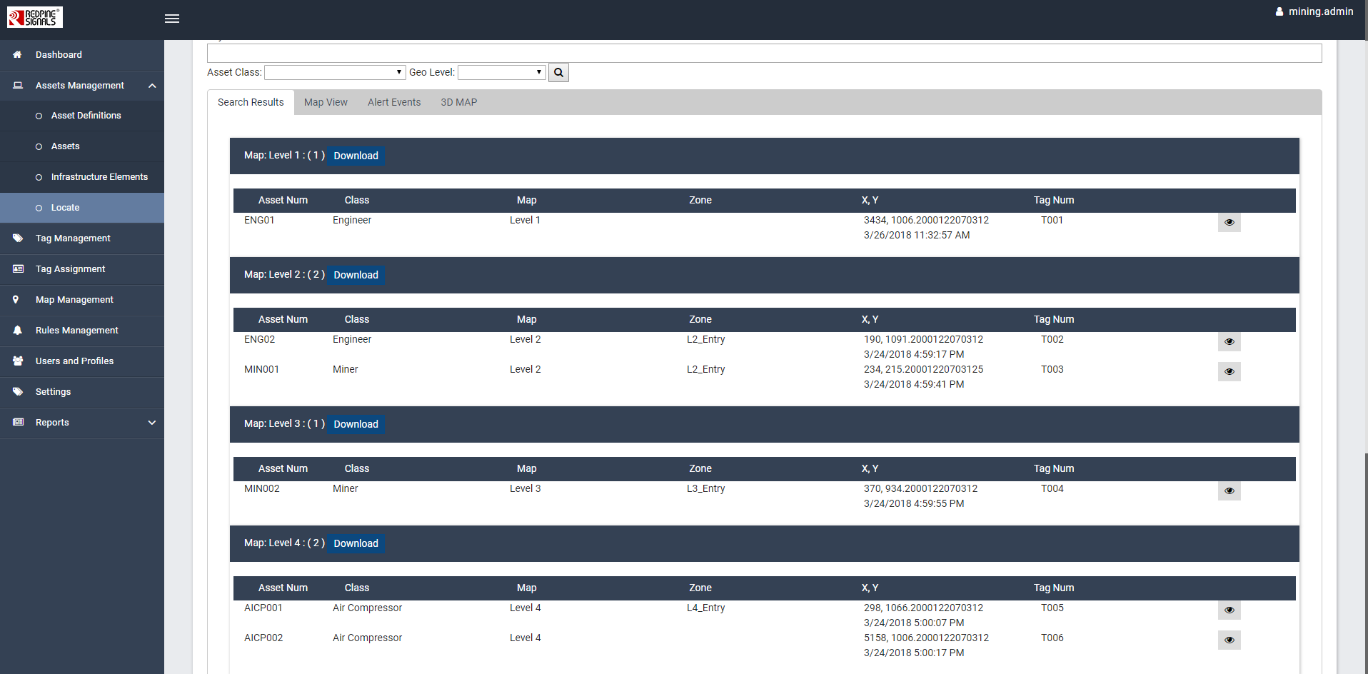

And if you wish to search anything specific such as any particular mine or level or zone, then choose the same from the **Geo Level** dropdown box and hit the **Search** button. You can use **Keyword** or **Asset Class** fields for search purpose.

Under **Map View** tab, select any of the level of your choice from **Map** dropdown box. You will be able to view the corresponding map on the screen.

Under **3D Map** tab, the user can have a 3D view of the whole mine. Choose the map of your choice from the **"Map"** dropdown box. On the map if you click on any of the personnel or asset, you will be able to view the details such as name and location of the particular. Refer to the image below:

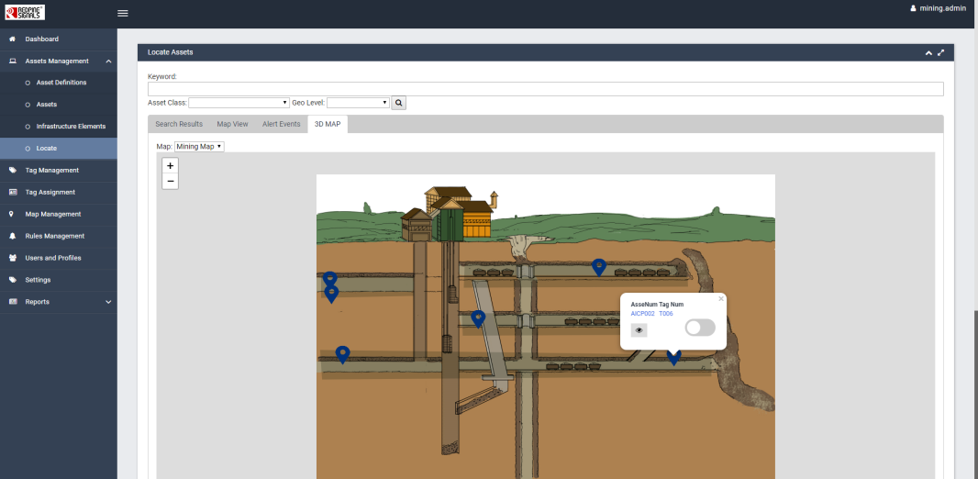

The user can search a particular asset by entering the asset class or any keyword related to it and hit the search button.

## Map Management

### Hierarchy Types

In the Map Management module, under Hierarchy Types, create hierarchy as per the requirement. In order to add a hierarchy, enter the name of the hierarchy type in the **Name** field box. (Please note, the Name field is the mandatory field here.). Under **Description** field, enter any definition or specification related to it. (Please note, this field is an optional for the users). When finished, click the **Add**  button. Refer to the image below:

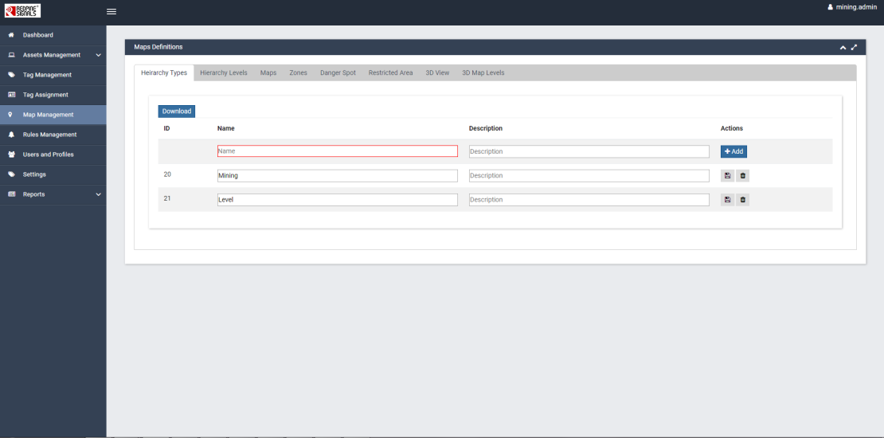

### Hierarchy Levels

This is a widget under Map Management where you define the names of the Hierarchy levels.

Suppose you choose **Tunnel** from the dropdown list. You will notice that the **Select Mine** dropdown box has turned up. Select any **Mine**.

In order to add a level, enter the name of the level in the **Name** field box. (This field is mandatory).

The **Description** field is optional. When finished, click the **Add  button. Refer to the image below:

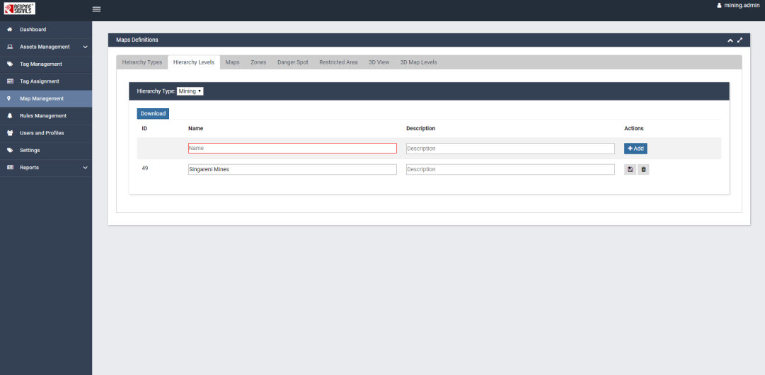

In order to modify the existing details, enter the new details in the fields and click **Save**  to commit the details into the system.

In order to delete any details, click **Delete  to delete the details from the system.

### Maps

Under Map tab, choose the map layer whose map you wish to view.

In order to add a new map layer, enter the **Name, "x, y, z coordinates"** and **Scale value** to their respective field boxes. When finished, click the **Add**  button. Once done, the load button under the map field will be enabled.

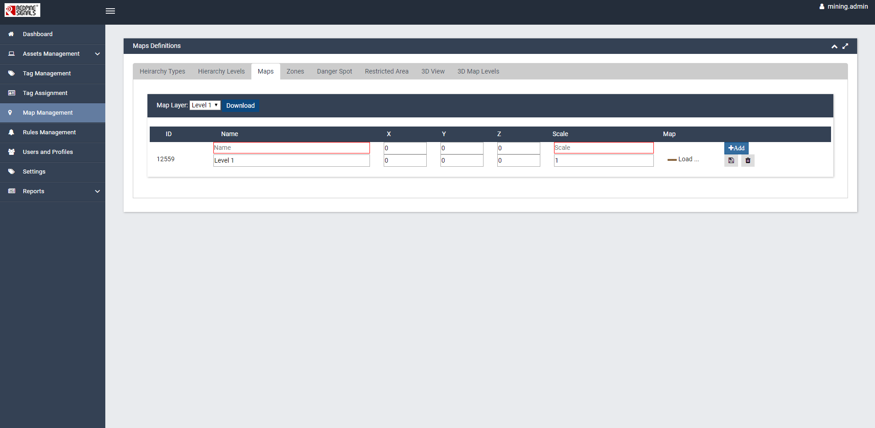

In order to modify the existing details, enter the new details in the fields and click **Save**  to commit the details into the system.

In order to delete any details, click **Delete  to delete the details from the system.

### Zones

Levels can be further segregated into **Zones**. In hierarchy types, Zones can be treated as child of the parent **Level**.

In order to add a new zone, enter the name of the zone and click the **Add**  button.

Also, if you wish to view the particular level on map, then choose the same from the Map drop-down box.

To modify the existing details, click the edit  button, mark the polygon points and then click **Save**  to commit the details into the system.

To delete any details, click **Delete  to delete the details from the system.

### Danger Spot

Based upon the levels and zones in a mine, the user can mark the danger spots in a map. In order to add a new danger spot in a particular level or zone, enter the name of the spot and click the **Add**  button. Refer to the image below:

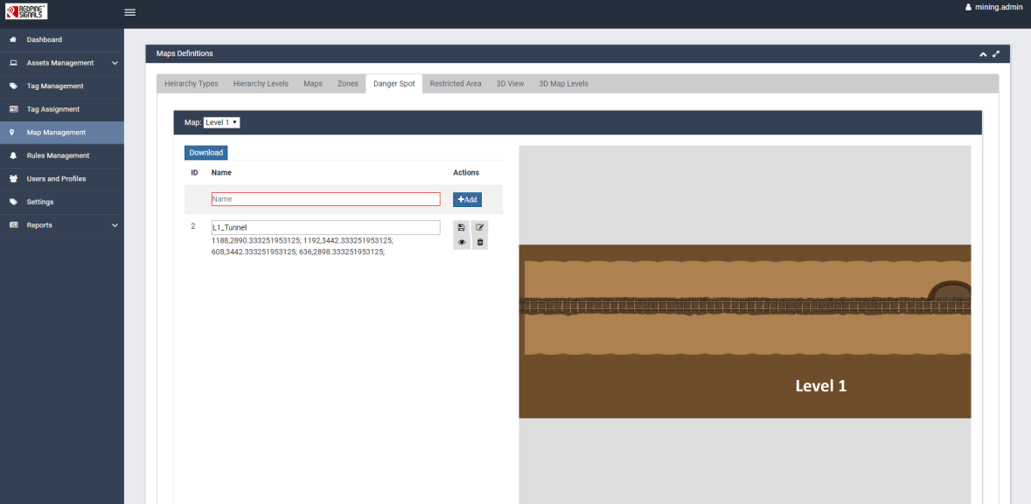

To modify the spot details, click the edit  button, mark the polygon points and then click **Save**  to commit the details into the system.

To delete any details, click **Delete  to delete the details from the system.

Since the person or asset is getting tracked, tracking details of that particular asset will be sent to the server in real-time. The details for the danger spots for the whole mine is available from the admin.

If the vehicle or the person is approaching the danger spot, after a certain distance range, the asset (vehicle) and the person both will be alarmed with the alarm signal configured in **"Settings"**.

### Restricted Area

Like danger spots, **Restricted Areas** of a mine should also be listed into the system. Based upon the levels and zones in a mine, the user can mark the restricted areas in a map. In order to add a new area in a particular level or zone, enter the name of the area and click the **Add**  button.

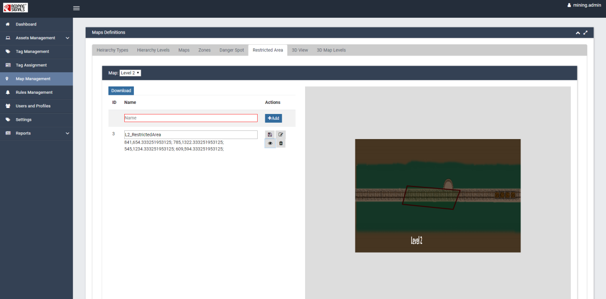

To modify the area details, click the edit  button, mark the polygon points and then click **Save**  to commit the details into the system.

To delete any details, click **Delete  to delete the details from the system.

Since the person or asset is getting tracked, the tracking details of that particular asset will be sent to the server in real-time. The details of the restricted areas for the whole mine is available from the admin.

If the vehicle or person is approaching the restricted area, after a certain distance range, the vehicle or the person will be alarmed with the alarm pattern configured in **"Settings"**.

### 3D View

Here the parent level map is loaded. To add a new parent level map, enter the name of the parent level in the **Name** field box and click the **Add**  button. Once done, the load button under the map field will be enabled.

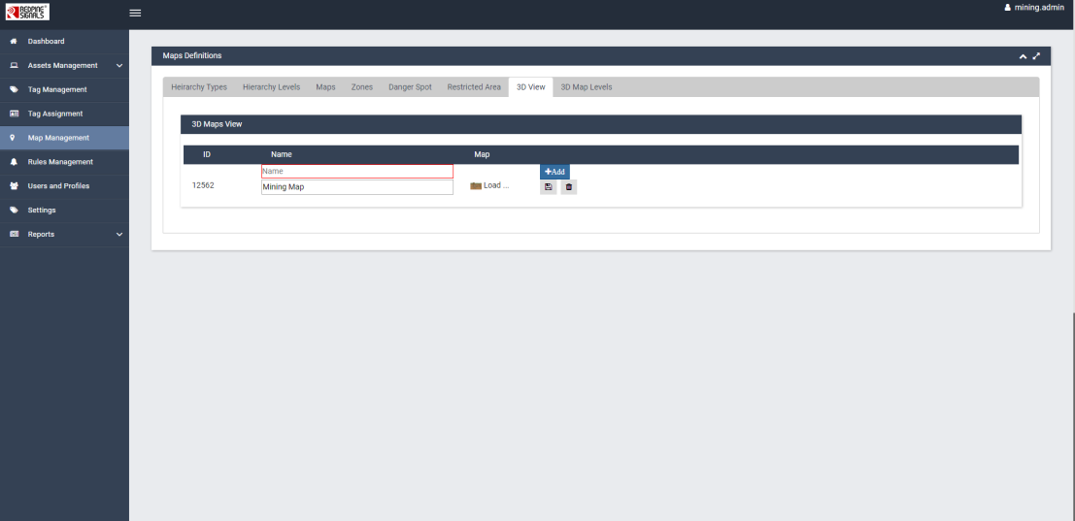

### 3D Map Levels

Under 3D Map Levels, you can view any level in a 3D format on the map.

To add a new child level map, enter the name of the child level in the **Name** field box and click the **Add**  button. Once done, the load button under the map field will be enabled.

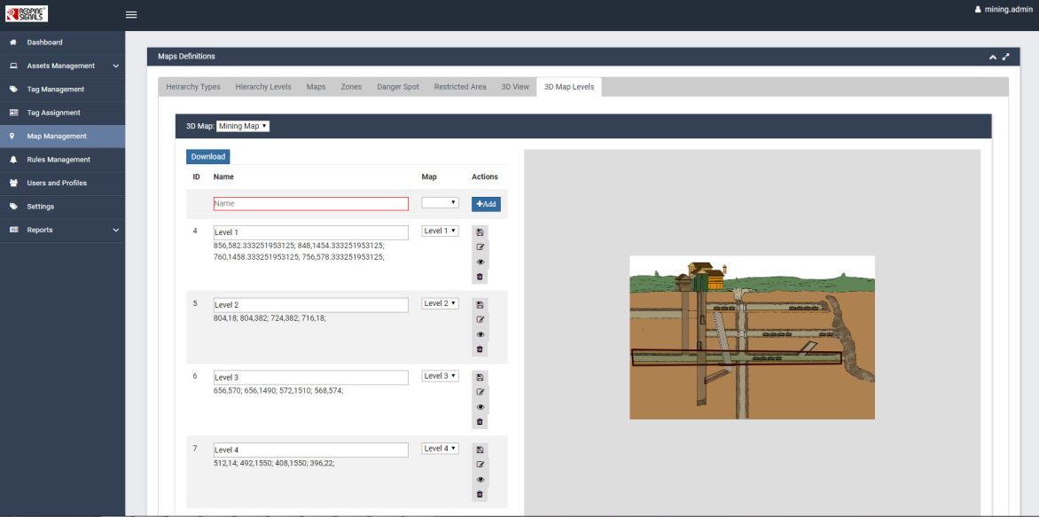

## Rules Management

Rules in asset tracker are created in order to restrict the users and to know the system health updates.

Out of the ten pre-defined rules created in the Asset Tracker system, three of them serve the mining purpose. They are outlined below:

* Danger Spots
* Restricted Area
* No Motion

The steps for creating a rule are outlined below:

1. Click the  button as shown below:
2. Under **Rule Type** dropdown box, select the rule type. Enter the **Rule Name** as per your wish.
3. Define the **Condition** for a particular rule to be triggered. Please note, the conditions vary based on the **Rule** selected.

**Example:**

The **Danger Spots** rule type is applicable if the asset enters the danger spot and the alert is not raised within the given time.

If the conditions are satisfied and no action is taken by the particular group by which the action should be taken, the escalation of the task will be given to that particular group.

Once you are done with entering conditions and their corresponding actions, click **Save**  to commit the details into the system. Refer to the image below:

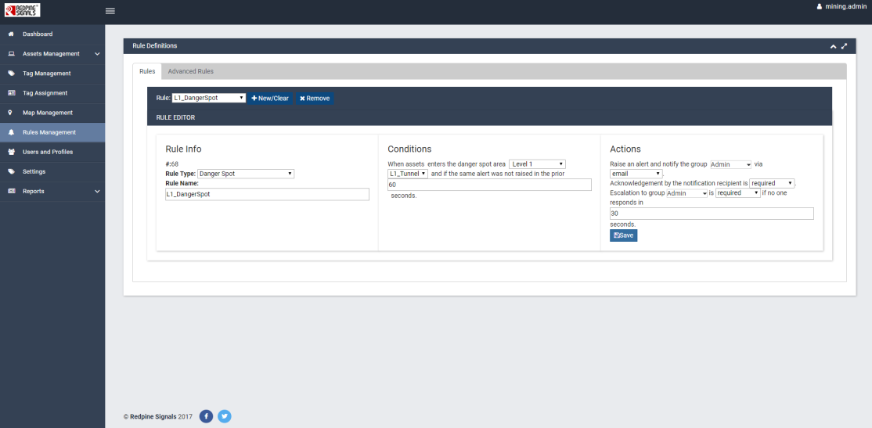

Similarly, **Restricted Area** rule type is applicable if the asset enters the restricted area and the alert is not raised within the given time.

If the conditions are satisfied and no action is taken by the particular group by which the action should be taken, the escalation of the task will be given to that particular group.

Once you are done with entering conditions and their corresponding actions, click **Save**  to commit the details into the system. Refer to the image below:

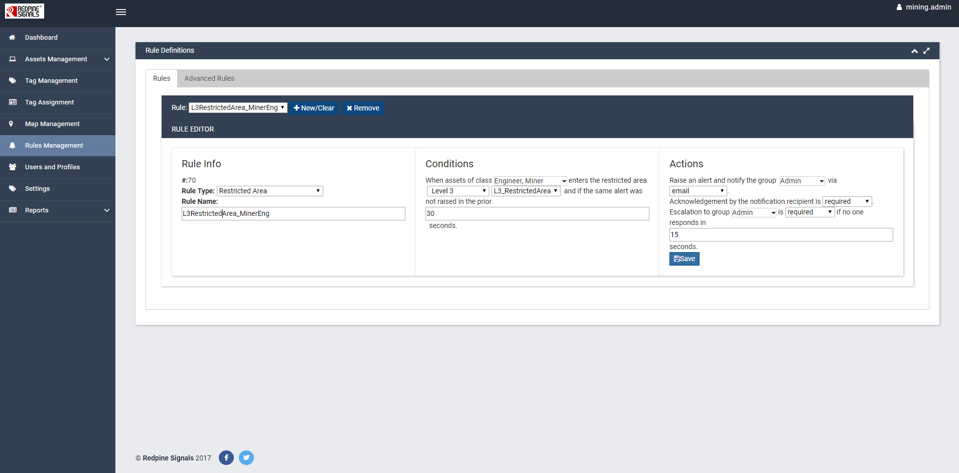

In order to delete any rule from the system, click the **Remove**  button.

**No motion** rule comes into action if there is no update from the asset (vehicles) or personnel (miners) from a long time.

If the conditions are satisfied and no action is taken by the particular group by which the action should be taken, the escalation of the task will be given to that particular group.

Once you are done with entering conditions and their corresponding actions, click **Save**  to commit the details into the system. Refer to the image below:

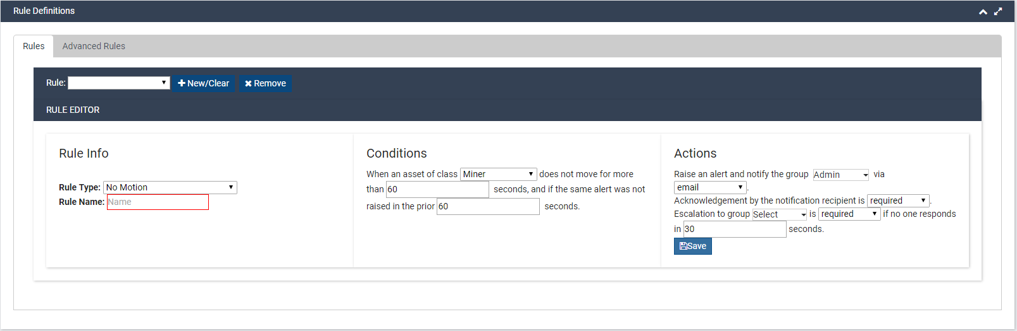

## Users and Profiles

This is the section where addition, deletion, updating of the users and their roles are carried out.

### Users

Under this widget, admin can create, update and delete the user details.

In order to add a user, enter the **Login ID**, **User Name** and **Password**. These fields are mandatory (For Active Directory Users, the password is ignored). Other than these, rest all the fields are optional such as **Dept**, **Email Address** and **Cell Phone#**. Once you are done with entering details, click the **Add** button.

In order to modify the existing details, enter the new details in the fields and click **Save**  to commit the details into the system.

In order to delete any details, click **Delete  to delete the details from the system.

Also, if you wish to search any user, enter any keyword related to that particular user and click the **Search**  button. Refer to the image below:

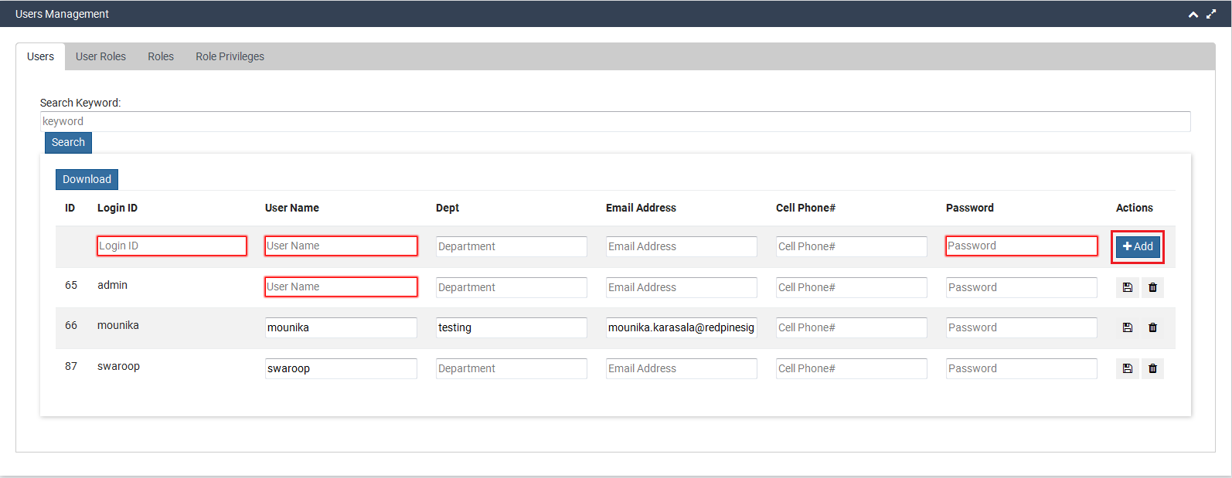

### User Roles

Under this widget, admin can specify the role for the users added in the **Users** widget.

Select the User Login ID from the dropdown provided where the list of added users will be displayed. Select the role from the dropdown and click the **Add** button.

Here, Roles can be of any kind. For ex- If RTLS equipment is used in hospitals, the roles can be defined as doctors, staffs, patients and so on. Refer to the image below:

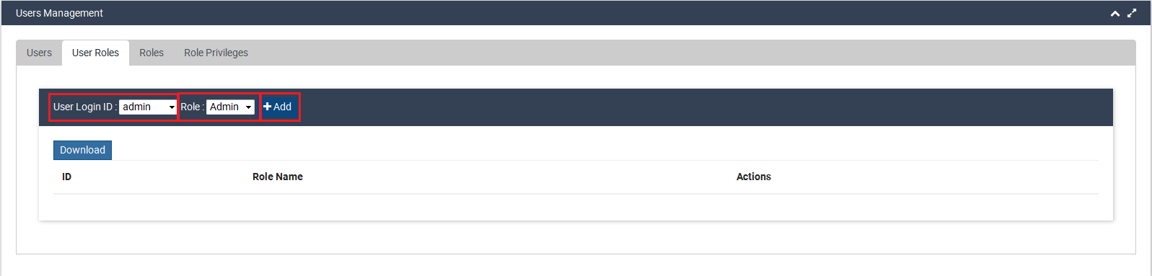

In order to delete any user role assigned to a User, click the **Delete**  icon. Refer to the image below:

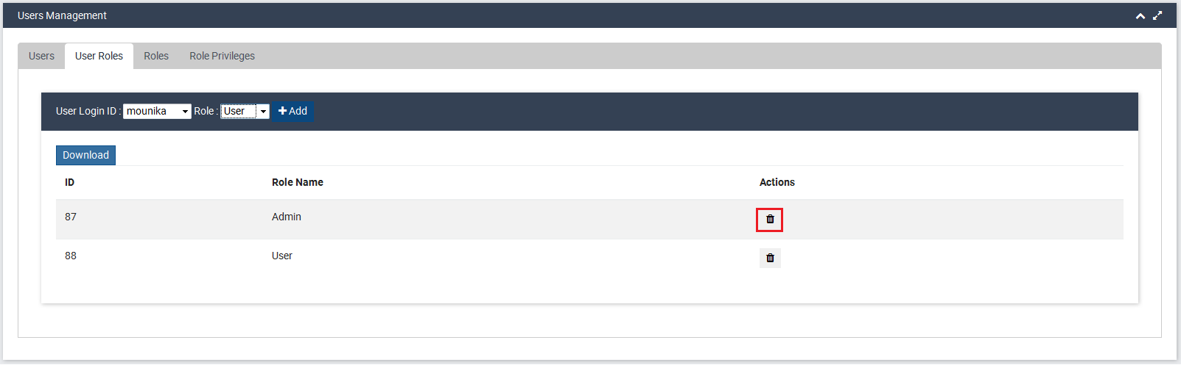

### Roles

Roles are defined by **Admin** based on the area where the asset tracker and the RTLS equipments are used.

If RTLS is used in hospitals, the roles can be defined as doctors, staffs, patients and so on. If the RTLS equipment is used in a school, the roles can be students, teachers, professors and so on.

In order to add a role name, enter the name in the **Role Name** field and click the **Add**  button. Refer to the image below:

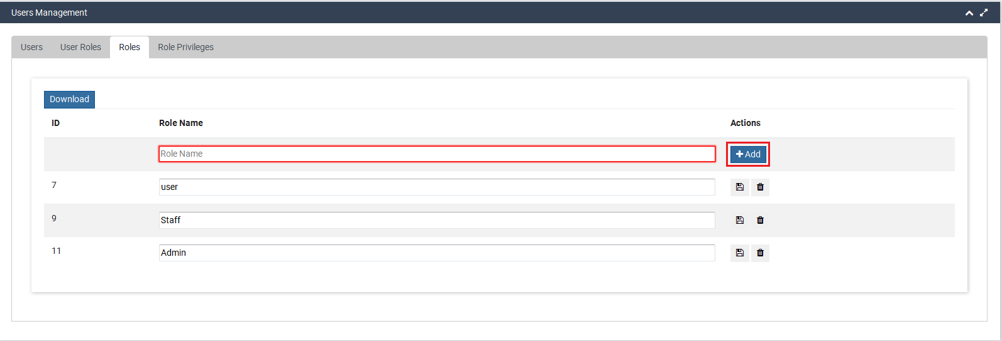

In order to modify the existing details, enter the new details in the fields and click **Save**  to commit the details into the system.

In order to delete any details, click **Delete  to delete the details from the system.

### Role Privileges

Under this section, admin manages the privileges of a particular role i.e. what all the privileges a role can access.

Here, Privileges refer to the modules (such as Asset Management, Tag Management, Tag Assignment and so on) present on the left navigation pane of the Window.

However, by default a new user can access only **"Dashboard"** page unless & until admin allocate any role and define a privilege to it.

In order to add a privilege to a particular role, navigate as below:

1. **Users and Profiles->Role Privileges**
2. Select **Role** and **Privileges** from the drop downs provided.

**Note:**

The roles defined in the Widget **"Roles"** under **User and Profile** privilege will be listed in the dropdown.

1. Once you are done with selecting Role and Privilege, click the **Add**  button.

The privileges allocated to the roles will be listed in the table when you select a role from the dropdown. Refer to the image below:

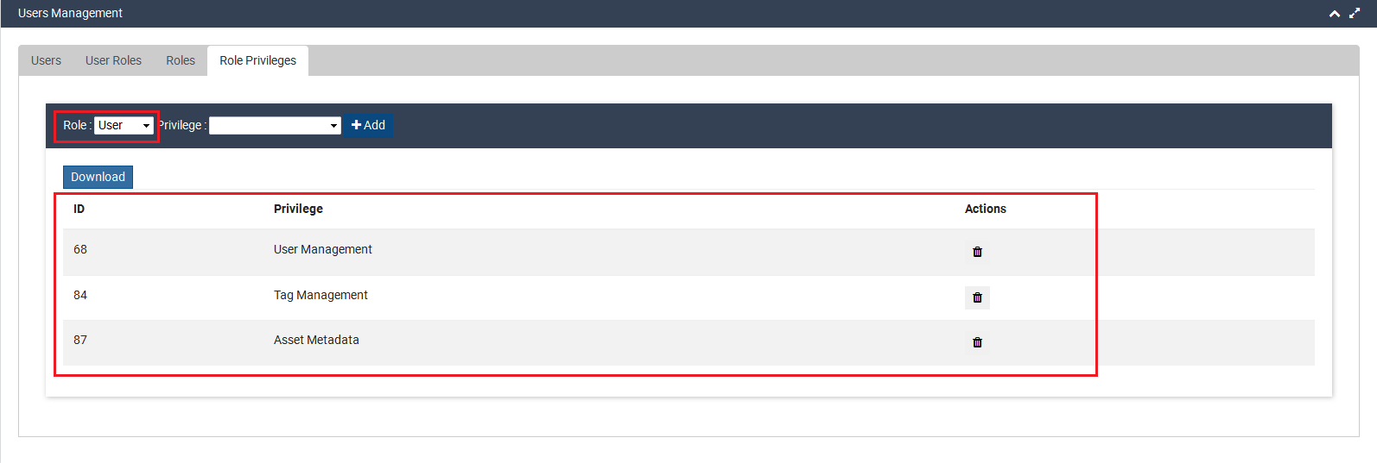

In order to delete any details, click **Delete  to delete the details from the system.

## Settings

Under Settings, configure the vehicle and person alarms as per the requirement. If the vehicle or person is approaching the danger spot or any restricted area, both asset (here is vehicle) and the person (here is miner) will be alarmed with the alarm signal configured in the system.

Configure the details as per the requirement and click the **Save ** button. Refer to the image below:

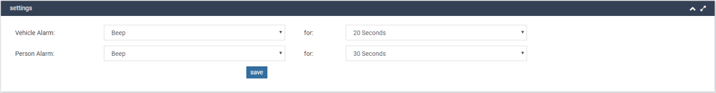

## Report

Reports give us the precise summary of miner/mining related records. Under **Report** following are the categories of reports related to mining. They are:

* 3D Location Report
* 3D Trail Report
* 3D Danger Spots Report
* 3D Restricted Area's Report

### 3D Location Report

Based on the **levels**, **zones** and **Time & Date** range, 3D Location Report can be generated at any point of time.

Please note the user with **"Reports Privilege"** can only generate reports. The generated report comes with the fields like **Asset Name, Asset Group, Zone, Tag Health, Enter Time, Exit Time** and **Time Spent.**

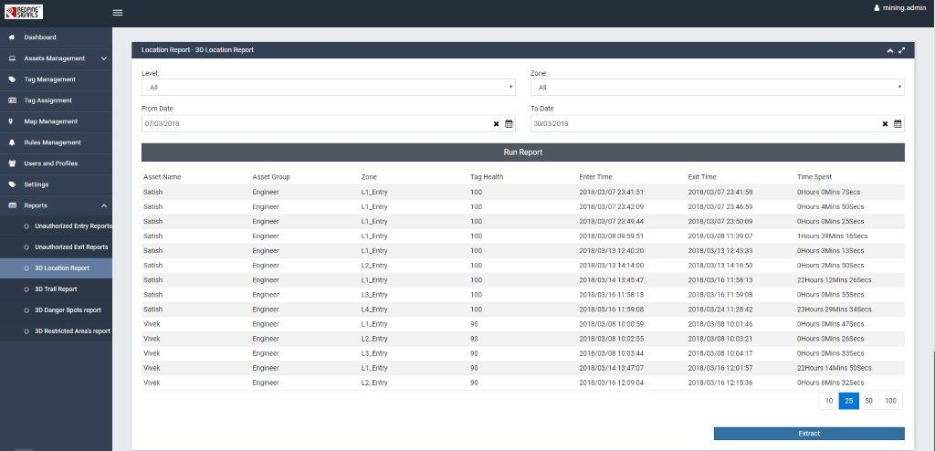

### 3D Trail Report

Based on the **Asset Name** and **Time &Date** range, 3D Trail Report can be generated at any point of time.

Please note the user with **"Reports Privilege"** can only generate reports. The generated report comes with the fields like **Asset Name**, **Asset Group** and **Distance range** (i.e. "From-"To")

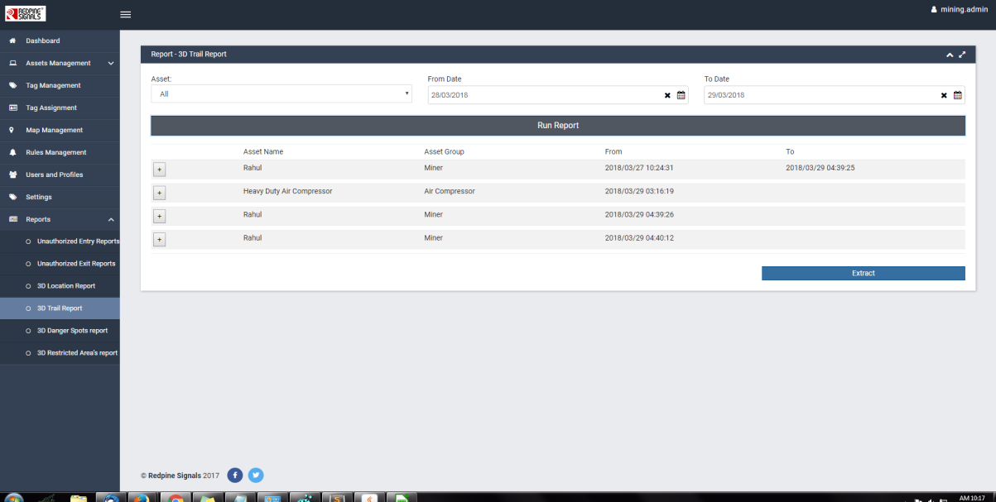

### 3D Danger Spots Report

Based on the levels in a mine, the user can view 3D-Location report of all the danger spots. Please note the user with **"Reports Privilege"** can only generate reports. The generated report comes with the fields like **Danger Spot Name**, **Level** and **Polygon points**.

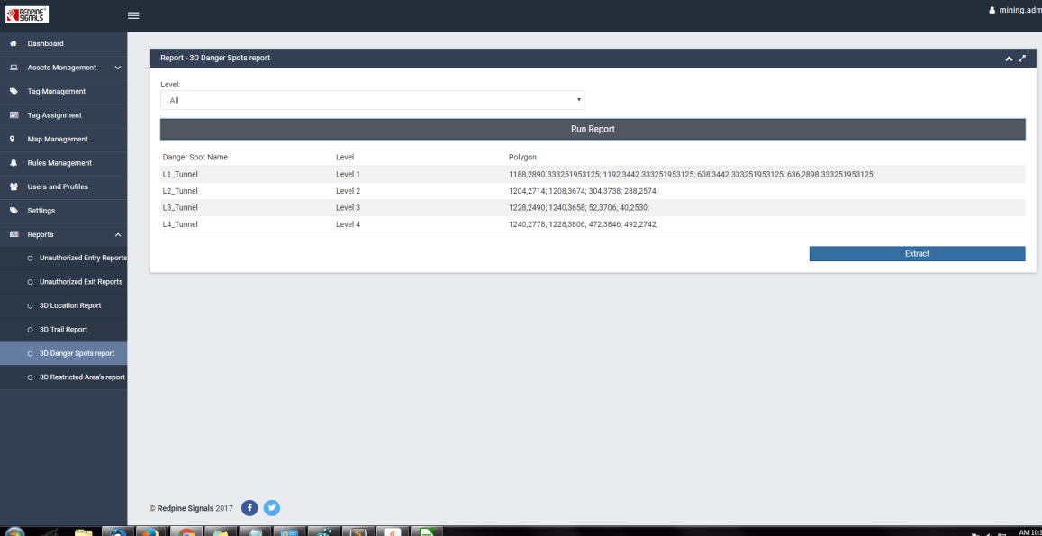

### 3D Restricted Area's Report

Based on the levels in a mine, the user can view the 3D-Location report of all the restricted areas and the assets (vehicles) or personnel (miners) allowed in that restricted area.

Please note the user with **"Reports Privilege"** can only generate reports. The generated report comes with the fields like **Restricted Area Name**, **Level** and **Polygon points**.

