

**Resort Website**

Submitted to the

Department of Master of Computer Applications

in partial fulfilment of the requirements

for Web Programming (MCA17)

**by**

1. **Basavaraj Addnur**

**USN: 1MS23MC017**

1. **Dheeraj pujar**

**USN: 1MS23MC026**

**Under the guidance of**

**Dr. Madhu Bhan**

**Assistant Professor**

**Department of Master of Computer Applications**

**RAMAIAH INSTITUTE OF TECHNOLOGY**

(Autonomous Institute, Affiliated to VTU)

Accredited by National Board of Accreditation & NAAC with ‘A+’ Grade

MSR Nagar, MSRIT Post, Bangalore-560054

[www.msrit.edu](http://www.msrit.edu)

**2024**



**DEPARTMENT OF**

**MASTER OF COMPUTER APPLICATIONS**

**CERTIFICATE**

This is to certify that the project entitled Resort Website is carried out by

1. Basavaraj Addnur bearing USN 1MS23MC017
2. Dheeraj pujar bearing USN 1MS23MC026

students of 1st semester, in partial fulfillment for Web Programming (MCA17) during the academic year 2023-2024.

**Guide Head of the Department**

**_____________________ _____________________**

**Name of Examiners Signature with Date**



# Introduction

# Overview

# Problem Definition

# Requirements

# Functional

# Non-Functional Requirements

# Implementation

# 3.1 Code Snippet

# Results and Discussion

# Conclusion

**1. Introduction**

**1.1 Overview**

In the current digital era, an appealing and functional online presence is essential for any resort aiming to attract and engage potential guests. The homepage of a resort website serves as the initial point of interaction, offering visitors a glimpse of the resort's offerings and facilitating smooth navigation to various sections. This report outlines the development of a resort website homepage using front-end technologies—HTML, CSS, and JavaScript. The homepage features seamless navigation through different sections of the website and includes a registration button linked to Google Forms for collecting and storing user inputs.

**1.2 Problem Definition**

The primary challenge in developing the homepage of a resort website is to create an engaging and visually appealing interface that also provides seamless functionality. The homepage must capture the resort's ambiance and attract potential guests while ensuring easy navigation to other sections such as room details, amenities, booking options, and contact information. Additionally, the integration of a registration button connected to Google Forms needs to be intuitive and secure, ensuring that user data is collected efficiently and stored safely.

**2. Requirements**

**2.1 Functional Requirements**

The functional requirements for the homepage of the resort website include:

1. Navigation Bar: A top navigation bar with links to key sections of the website such as Home, Rooms, Amenities, Booking, Reviews, and Contact.

2. Image Section: A visually appealing hero section with high-quality images of the resort, a tagline, and a call-to-action button.

3. Introduction Section: A brief introduction to the resort, highlighting its unique features and offerings.

4. Rooms and Amenities: Sections showcasing various room types and resort amenities with images and brief descriptions.

5. Customer Reviews: A section displaying customer reviews and testimonials.

6. Contact Information: Easily accessible contact information including phone number, email, and address.

7. Registration Button: A prominently displayed registration button that links to a Google Form for user registration.

8. Footer: A footer with additional navigation links, social media icons, and copyright information.

**2.2 Non-Functional Requirements**

The non-functional requirements for the homepage include:

1. Performance: The homepage should load quickly, ideally within 3 seconds, to ensure a positive user experience.

2. Responsiveness: The design must be responsive, providing an optimal viewing experience across various devices and screen sizes.

3. Usability: The interface should be user-friendly, with clear navigation and accessible design.

4. Security: Ensure that the registration process is secure and that user data collected through Google Forms is protected.

5. Maintainability: The code base should be clean and well-documented to facilitate easy updates and maintenance.

**3. Implementation**

The implementation of the homepage involves several key steps:

**1. Planning:** Define the project scope, allocate resources, and set timelines. Create wireframes and mockups to visualize the layout and design of the homepage.

**2. Development :**

**HTML Structure :** Create the basic structure of the homepage with sections for the navigation bar, hero section, introduction, rooms, amenities, booking information, customer reviews, contact information, and footer.

**CSS Styling** : Apply styles to enhance the visual appeal of the homepage, ensuring a cohesive look and feel that reflects the resort's brand.

**JavaScript Functionality** : Implement JavaScript to enable smooth navigation, handle user interactions, and connect the registration button to Google Forms.

**3.1 Code Snippet**

<!DOCTYPE html>

<html lang="en">

<head>

<link rel="icon" type="image/png" href="logo.png">

<meta charset="UTF-8">

<meta name="viewport" content="width=device-width, initial-scale=1.0">

<title>B Hive Resort</title>

<link rel="stylesheet" href="styles.css">

<style>

.gallery-images {

position:relative;

}

.gallery-item {

position: relative;

display: inline-block;

margin: 5px;

}

.overlay {

position:absolute;

bottom: 0;

background: rgba(0, 0, 0, 0.5);

color: #fff;

width: 100%;

text-align: center;

padding: 5px 0;

visibility: hidden;

}

.gallery-item:hover .overlay {

visibility: visible;

}

</style>

</head>

<body>

<script type="text/javascript">

function thankyou()

{

alert("Thank You for registrtion");

}

</script>

<header>

<div class="loc">

<a href="https://maps.app.goo.gl/R6LUtAWuP2dRrqYP7" style="color:white;">

<img src="loc.png" height="30px" width="30px">&nbsp;&nbsp;

Manjarpai, Londa, Karnataka - 591301</a>

</div><br>

<div class="cont">

<img src="cont.png" height="30px" width="30px">&nbsp;&nbsp;&nbsp;Ramesh:&nbsp;<valign "center">+91 9988776655</valign>

</div>

body {

font-family: 'rockwell';

color:white;

margin: 0;

padding: 0;

background: linear-gradient(to left, #1E90FF, #000000);

}

.loc{text-align:right;margin-right: 40px;padding-bottom:10px;}

.cont{text-align:right;margin-right: 120px;padding-bottom:10px;}

.container {

h1{font-family: 'rockwell';font-size: 40px;}

label{font-size: 20px;}

width: 80%;

margin: auto;

text-align: center;

}

header {

background: radial-gradient(ellipse, #1E90FF, #000000);

color: white;

padding: 25px 0;

}

nav ul {

list-style-type: none;

margin-top: 30px;

padding: 0;

}

**4. Results and Discussion**

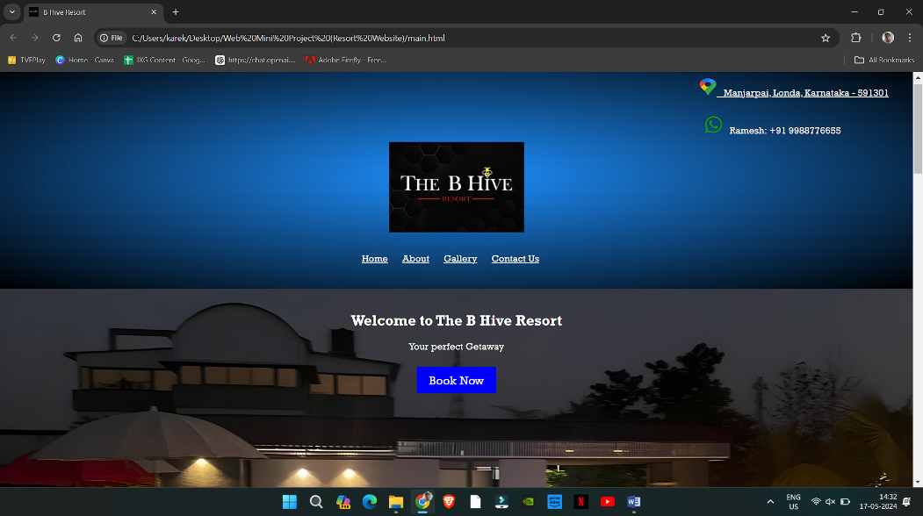

**Fig.1: Home page**

**This figure displays the home page of the website which**

**consists of links that navigate to different sections of the page**

**helping the user to navigate efficiently to the desired**

**section of content**

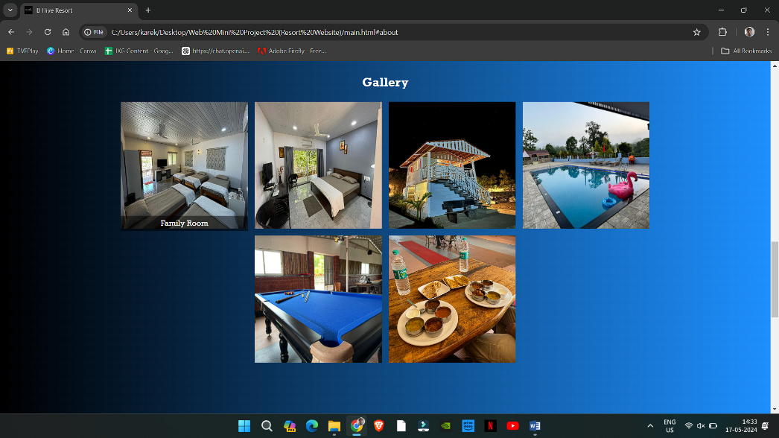

**Fig.2: Gallery**

**This section represents the images of the property and when we hover**

**On the image it gives image description**

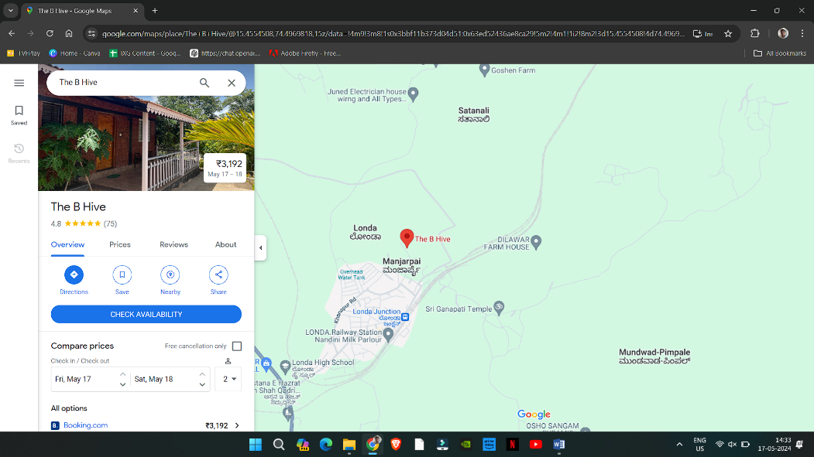

**Fig.3: Google map**

**After clicking on the location hyperlink on the home page it directs the user**

**To the google maps with direction to the resort.**

**5. Conclusion**

The development of the resort website homepage using HTML, CSS, and JavaScript has successfully created a visually appealing, responsive, and functional interface. The homepage effectively engages visitors, provides seamless navigation, and facilitates user registration through a secure Google Forms integration. By addressing both functional and non-functional requirements, the project has achieved its goals of enhancing the resort's online presence and improving user experience. Moving forward, continuous improvements based on user feedback and technological advancements will be essential to maintain the website's effectiveness in attracting and serving guests.