SOFTWARE ENGINEERING Charging Station in Berlin Project

# Question 7: Analyze both geovisualizations: Where do you see demand for additional electric charging stations?

* The areas with the highest population have around 30,000 residents.
* The largest numbers of charging stations are 95 and 82 in specific areas.
* These charging stations are located in highly populated areas, some areas are relatively highly-covered by charging stations.

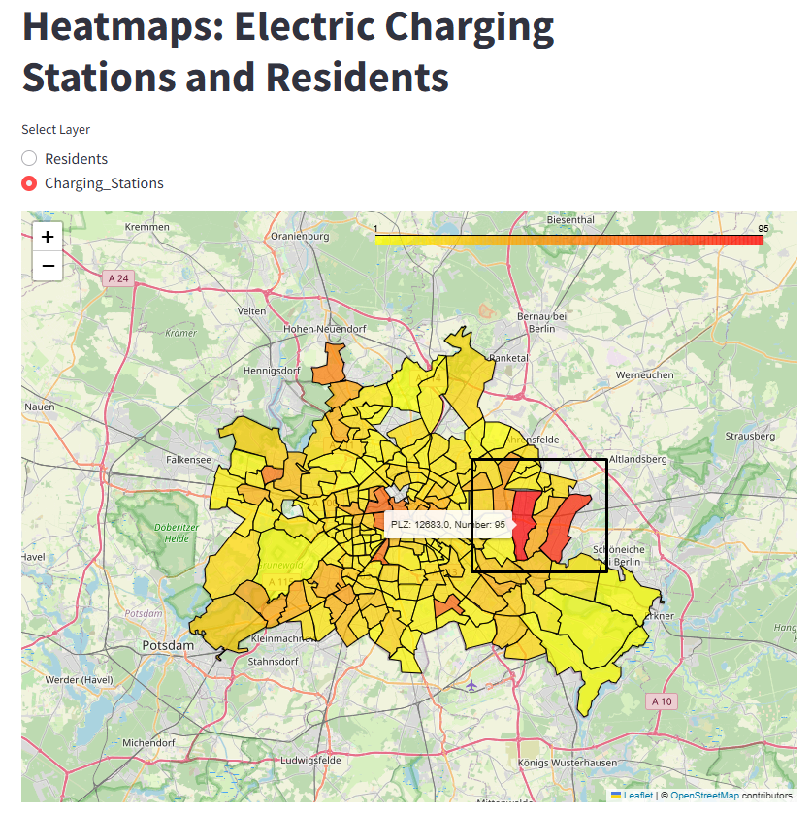

## **Comparison of the distribution of residents and charging stations in postal code areas of Berlin.**

|  |  |
| --- | --- |
| Residents Distribution | Distribution of Charging Stations |
|  |  |
| The distribution of residents in Berlin shows higher density on the eastern side of the city. | There appears to be a high concentration of charging stations in the central parts of Berlin, particularly in areas of the district Mitte. |
| Additionally, there is a noticeable concentration in the northern part of the map with the area of the largest population (Buch). | However, charging Stations also tend to be built on the east side of Berlin; Biesdorf and Mahlsdorf are the areas with the most charging stations. |
| The western side appears to have medium to lower population numbers, while the southern area also exhibits pockets of higher density. | The distribution of stations seems to be comparatively lower in the western, northern outer, and southeast areas. More charging stations could be built in the south region, however, the people of the south can use their neighbours’ stations. |

**Conclusion**: Focusing on key gaps (high population and low charging stations), additional charging stations could be constructed in the northern part of Berlin, benefiting residents in the surrounding neighborhoods as well. These stations should ideally be placed in areas where there are currently no charging facilities or where the number of stations is insufficient. Stepwise one can increase the availability of charging stations in the South and Southeast of Berlin, followed by some districts in the west of Berlin. In the long term, the goal should be to build a charging infrastructure, which is evenly distributed in the entire Berlin.

