Smart Disaster Response Management Information System (MIS)

Complete Database Project Documentation

Phase 1: System Understanding & Scope

1. Introduction
The Smart Disaster Response Management Information System (MIS) is designed to support efficient and coordinated handling of natural and urban disasters such as floods, earthquakes, and fires. In such situations, a large number of emergency reports are generated in real time from multiple sources including mobile applications, helplines, and monitoring systems.

The primary objective of this system is to enable rapid response, optimal resource utilization, secure financial tracking, and effective communication among various stakeholders involved in disaster management. The system is intended to function as a centralized platform that integrates data, automates workflows, and ensures transparency and accountability.

2. System Scope
The scope of the system includes the management and coordination of all activities related to disaster response. It covers the following key operations:
- Collection and management of emergency incident reports
- Assignment and tracking of rescue teams
- Monitoring and allocation of critical resources
- Coordination with hospitals for patient handling
- Management of financial transactions including donations and expenses
- Implementation of secure, role-based system access
- Execution of approval-based workflows for critical operations
- Maintenance of audit logs for monitoring and compliance
- Generation of analytical reports for decision-making

The system is designed to handle high-volume transactions, ensuring reliability, scalability, and data consistency during peak disaster situations.

3. System Stakeholders
The system will be used by multiple stakeholders, each with distinct responsibilities:
- Administrator: Manages system configuration, users, and overall control
- Emergency Operator: Handles incoming incident reports and prioritization
- Field Officer: Oversees on-ground rescue operations and updates statuses
- Warehouse Manager: Manages resource inventory and allocation
- Finance Officer: Handles financial transactions and reporting

Each stakeholder interacts with the system through role-based access control mechanisms to ensure security and data integrity.

4. System Modules Overview
The system is divided into several functional modules to ensure modularity and scalability:

4.1 Emergency Management Module
Responsible for handling incoming disaster reports. It captures details such as location, disaster type, severity level, and time of reporting. It also enables real-time tracking and prioritization of incidents.

4.2 Rescue Team Management Module
Maintains information about rescue teams including their type, location, and availability status. It supports dynamic assignment of teams based on proximity and incident severity, along with status tracking throughout the operation lifecycle.

4.3 Resource Management Module
Manages essential resources such as food, water, medicines, and shelter equipment. It includes warehouse-wise inventory tracking, allocation workflows, and monitoring of dispatched and consumed resources.

4.4 Hospital Coordination Module
Handles coordination with hospitals by maintaining data on available beds, admitted patients, and critical cases. It supports automated patient assignment and load balancing across hospitals.

4.5 Financial Management Module
Tracks all financial activities including donations, expenses, and procurement costs. It ensures proper categorization of transactions and supports audit trails for financial transparency.

4.6 User & Security Module (RBAC)
Implements role-based access control by defining user roles and permissions. It ensures that users can only access data and perform operations relevant to their responsibilities.

4.7 Approval Workflow Module
Manages approval-based processes for critical operations such as resource allocation and financial transactions. Requests are processed through states such as pending, approved, and rejected.

4.8 Audit & Monitoring Module
Maintains logs of user activities, data changes, and approval decisions. This module ensures traceability and supports auditing and compliance requirements.

5. Key System Features
The system incorporates several advanced features to meet enterprise-level requirements:
- High-Volume Transaction Handling: Supports concurrent operations such as report submissions and resource allocations
- Secure Transactions (ACID Compliance): Ensures data integrity through atomicity, consistency, isolation, and durability
- Role-Based Access Control: Restricts system access based on user roles
- Approval-Based Workflows: Ensures controlled execution of critical operations
- Data Security & Privacy: Protects sensitive user and financial data
- Real-Time Tracking & Updates: Enables live monitoring of incidents and resources
- Automation via Database Mechanisms: Utilizes triggers for automatic updates and enforcement of business rules

6. System Boundaries
Included in Scope:
- Database design and implementation
- Transaction handling and concurrency control
- Role-based access and security mechanisms
- Workflow automation and approval systems
- Reporting and analytics

Excluded from Scope:
- Integration with external government or third-party APIs
- Real-time GPS tracking using external services
- Mobile application development (web-based interface only)
- Hardware-level disaster monitoring systems

7. Assumptions
- Users will access the system through a web-based interface
- Data entered into the system is assumed to be valid and verified
- The system will simulate real-time updates where actual real-time infrastructure is not available
- Disaster events are handled independently within the system

8. Conclusion
This phase establishes a clear understanding of the system's objectives, scope, and functional components. By defining the modules, stakeholders, and system boundaries, a strong foundation is created for subsequent phases such as entity identification, ERD design, and database implementation. This structured approach ensures that the system remains scalable, consistent, and aligned with enterprise-level requirements.

Phase 2: Entity Identification

1. Introduction
This phase defines all entities required for the Smart Disaster Response Management Information System (MIS). The design incorporates all functional and non-functional requirements including audit trails, approval workflows, high-volume transaction handling, secure role-based access control, resource lifecycle tracking (allocation → dispatch → consumption), financial budgeting, and alert notifications.

The identified entities are structured to support ERD development, normalization up to 3NF/BCNF, and efficient implementation in a relational database system.

2. Design Principles
The entity design follows these principles:
- Separation of Concerns: Each module is represented through independent but related entities
- Elimination of Redundancy: Attributes are atomic and non-duplicative
- Support for Workflows: Approval, allocation, and auditing processes are explicitly modeled
- Scalability & Extensibility: Generic structures (e.g., Request, Notification) allow future expansion
- Security & Traceability: RBAC and audit entities ensure controlled access and full traceability
- Transaction Safety: Entities support ACID-compliant operations and logging

3. Complete Entity List

3.1 User & Role-Based Access Control (RBAC)
Entity | Attributes | PK | FK
User | UserID, Name, Email, PasswordHash, RoleID, Status | UserID | RoleID → Role
Role | RoleID, RoleName | RoleID | –
Permission | PermissionID, PermissionName | PermissionID | –
RolePermission | RoleID, PermissionID | (RoleID, PermissionID) | RoleID → Role, PermissionID → Permission

3.2 Generic Request & Approval Workflow
Entity | Attributes | PK | FK
Request | RequestID, RequestType (Resource/Team/Finance), CreatedBy, Status, CreatedAt | RequestID | CreatedBy → User
Approval | ApprovalID, RequestID, ApprovedBy, Status, Comments, Timestamp | ApprovalID | RequestID → Request, ApprovedBy → User

3.3 Emergency Management
Entity | Attributes | PK | FK
Citizen | CitizenID, Name, Phone, Email (optional), Address | CitizenID | –
Incident | IncidentID, Location, Latitude, Longitude, DisasterType, SeverityLevel, PriorityLevel, TimeReported, Status, ReporterID, ReporterContact | IncidentID | ReporterID → Citizen
IncidentStatusLog | LogID, IncidentID, Status, Timestamp | LogID | IncidentID → Incident

3.4 Rescue Team Management
Entity | Attributes | PK | FK
RescueTeam | TeamID, TeamType, CurrentLatitude, CurrentLongitude, AvailabilityStatus, Capacity | TeamID | –
TeamAssignment | AssignmentID, TeamID, IncidentID, RequestID, AssignedTime, CompletionTime, Status, Priority, AssignedBy | AssignmentID | TeamID → RescueTeam, IncidentID → Incident, RequestID → Request, AssignedBy → User

3.5 Resource Management (Enhanced Lifecycle)
Entity | Attributes | PK | FK
Warehouse | WarehouseID, Location, Latitude, Longitude, ManagerID | WarehouseID | ManagerID → User
Resource | ResourceID, ResourceName, ResourceType | ResourceID | –
Inventory | WarehouseID, ResourceID, Quantity, ThresholdLevel | (WarehouseID, ResourceID) | WarehouseID → Warehouse, ResourceID → Resource
ResourceRequest | RequestID, IncidentID, RequestedBy, TotalRequiredQuantity, UrgencyLevel | RequestID | RequestID → Request, IncidentID → Incident, RequestedBy → User
AllocationDetail | AllocationID, RequestID, ResourceID, QuantityAllocated, AllocationDate, Status | AllocationID | RequestID → ResourceRequest, ResourceID → Resource
Dispatch | DispatchID, AllocationID, WarehouseID, QuantityDispatched, DispatchTime, DeliveredTime, DeliveryStatus, RecipientConfirmed | DispatchID | AllocationID → AllocationDetail, WarehouseID → Warehouse
ConsumptionRecord | ConsumptionID, DispatchID, QuantityConsumed, ConsumptionTime, IncidentID | ConsumptionID | DispatchID → Dispatch, IncidentID → Incident

Note:
- Request status and timestamps are managed in the Request table
- Approval is handled centrally via Request → Approval

3.6 Hospital Coordination
Entity | Attributes | PK | FK
Hospital | HospitalID, Name, Location, Latitude, Longitude | HospitalID | –
BedAvailability | HospitalID, TotalBeds, AvailableBeds, LastUpdated | HospitalID | HospitalID → Hospital
Patient | PatientID, IncidentID, HospitalID, Status, AdmissionTime, DischargeTime | PatientID | IncidentID → Incident, HospitalID → Hospital
EscalationRule | RuleID, HospitalID, ThresholdAvailableBeds, EscalationTargetHospitalID, PriorityLevel | RuleID | HospitalID → Hospital, EscalationTargetHospitalID → Hospital

3.7 Financial Management
Entity | Attributes | PK | FK
DisasterBudget | BudgetID, IncidentID, AllocatedAmount, SpentAmount, RemainingAmount, LastUpdated | BudgetID | IncidentID → Incident
Transaction | TransactionID, IncidentID, TransactionType, Amount, TransactionDate, Description, ReferenceNumber, Status | TransactionID | IncidentID → Incident
Donation | DonationID, TransactionID, DonorName, DonorType | DonationID | TransactionID → Transaction
Expense | ExpenseID, TransactionID, RequestID, Purpose | ExpenseID | TransactionID → Transaction, RequestID → Request
Procurement | ProcurementID, TransactionID, SupplierName | ProcurementID | TransactionID → Transaction

3.8 Audit & Monitoring
Entity | Attributes | PK | FK
AuditLog | LogID, UserID, ActionType, TableName, RecordID, OldValue, NewValue, Timestamp, IPAddress | LogID | UserID → User

3.9 Notification & Alert System
Entity | Attributes | PK | FK
Notification | NotificationID, UserID, Type, Message, IsRead, CreatedAt, RelatedEntityType, RelatedRecordID | NotificationID | UserID → User

3.10 System Transaction Logging (ACID Support)
Entity | Attributes | PK | FK
SystemTransactionLog | SysTransactionID, OperationType, StartTime, EndTime, Status | SysTransactionID | –

4. Validation Against Requirements
This entity design fully satisfies all system requirements:
- Emergency reporting and prioritization
- Rescue team assignment and lifecycle tracking
- Resource allocation, dispatch, and consumption tracking
- Hospital coordination and escalation handling
- Financial transaction categorization and budgeting
- Approval-based workflows with unified request handling
- Role-based access control (RBAC)
- Audit logging and monitoring
- Notification and alert generation
- Support for high-volume transactions and ACID properties

5. Conclusion
The finalized entity structure provides a robust and scalable foundation for the system. It ensures data integrity, supports complex workflows, and aligns with enterprise-level database design practices. This design is now fully prepared for ERD development in the next phase.

Phase 3: ERD Design

The Entity Relationship Diagram (ERD) for the Smart Disaster Response MIS was designed based on the entities identified in Phase 2. The ERD captures all relationships between entities, including one-to-many, many-to-many, and one-to-one associations.

The ERD encompasses all modules: User & RBAC, Emergency Management, Rescue Team Management, Resource Management (with full lifecycle), Hospital Coordination, Financial Management, Approval Workflow, Audit & Monitoring, Notification System, and System Transaction Logging.

Key relationships include:
- User is associated with Role via RoleID (many-to-one)
- Role has many Permissions via the RolePermission junction table
- Incident is reported by a Citizen (many-to-one via ReporterID)
- TeamAssignment links RescueTeam, Incident, and Request
- Inventory is a composite-key table linking Warehouse and Resource
- Dispatch links AllocationDetail and Warehouse
- ConsumptionRecord references Dispatch and Incident
- BedAvailability is a one-to-one extension of Hospital
- Patient references both Incident and Hospital
- EscalationRule has two foreign keys to Hospital (self-referencing)
- Transaction links to Incident; Donation, Expense, Procurement extend Transaction
- DisasterBudget is associated with Incident
- AuditLog and Notification both reference User.
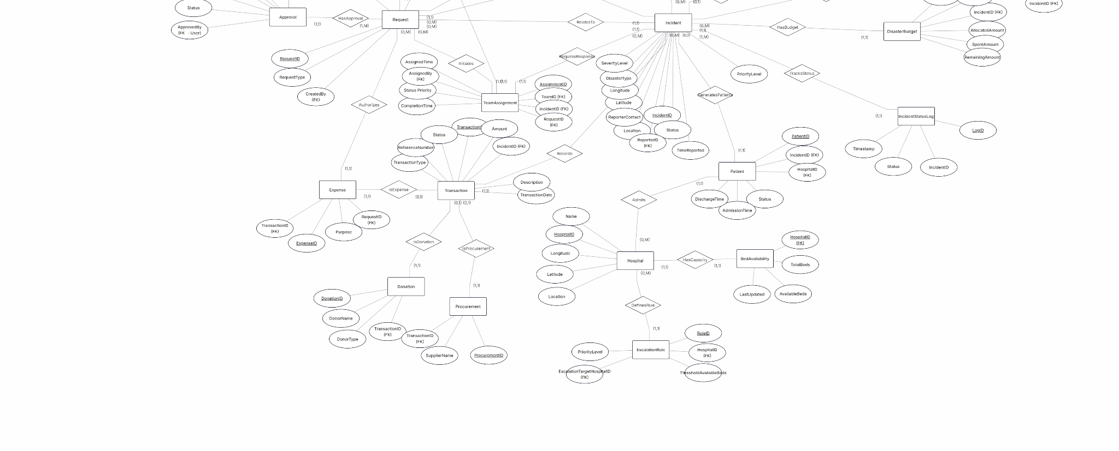

Phase 4: Database Normalization (UNF → 1NF → 2NF → 3NF)

1. Introduction
Normalization is applied to eliminate redundancy, avoid update anomalies, and ensure data integrity. This document follows the final entity design from Phase 2 and demonstrates:
- Un-Normalized Form (UNF)
- First Normal Form (1NF)
- Second Normal Form (2NF) – removal of partial dependencies
- Third Normal Form (3NF) – removal of transitive dependencies
- BCNF for selected tables

All steps are illustrated using actual tables of the Smart Disaster Response MIS.

2. Un-Normalized Form (UNF)
UNF Table: DisasterReport

The original un-normalized table stored all data in a single flat structure. Column headers included: IncidentID, Location, Lat, Lon, DisasterType, Severity, Priority, TimeReported, ReporterName, ReporterPhone, ReporterEmail, TeamID, TeamType, TeamStatus, ResourceName, Quantity, WarehouseID, WarehouseLoc, HospitalName, HospBeds, TransAmount, TransType, TransDate.

Sample data rows:
IncidentID | Location | DisasterType | Severity | TeamID | TeamType | ResourceName | Qty | TransAmount | TransType
101 | City A | Flood | High | T1 | Medical | Food | 100 | 5000 | Donation
101 | City A | Flood | High | T2 | Rescue | Water | 200 | NULL | NULL
101 | City A | Flood | High | NULL | NULL | Blanket | 50 | NULL | NULL
102 | City B | Earthquake | Critical | T3 | Fire | Shelter | 30 | 10000 | Expense

Problems in UNF
Issue Type | Description
Repeating Groups | Multiple rows per incident for teams/resources
No Primary Key | No unique identifier for rows
Redundancy | Incident data repeated multiple times
Update Anomaly | Updating one field requires multiple row updates
Insertion Anomaly | Cannot insert independent data
Deletion Anomaly | Deleting row removes important data

3. First Normal Form (1NF)
1NF Tables (Initial Decomposition)

1NF requires: all attributes are atomic (no repeating groups), each table has a primary key, and all rows are unique.

Table Name | Attributes | Primary Key
Incident | IncidentID, Location, Latitude, Longitude, DisasterType, SeverityLevel, PriorityLevel, TimeReported, Status | IncidentID
Citizen | CitizenID, Name, Phone, Email, Address | CitizenID
RescueTeam | TeamID, TeamType, CurrentLatitude, CurrentLongitude, AvailabilityStatus, Capacity | TeamID
TeamAssignment | AssignmentID, TeamID, IncidentID, AssignedTime, CompletionTime, Status, Priority, AssignedBy, RequestID | AssignmentID
Resource | ResourceID, ResourceName, ResourceType | ResourceID
Inventory | WarehouseID, ResourceID, Quantity, ThresholdLevel | (WarehouseID, ResourceID)
Warehouse | WarehouseID, Location, Latitude, Longitude, ManagerID | WarehouseID
Hospital | HospitalID, Name, Location, Latitude, Longitude | HospitalID
BedAvailability | HospitalID, TotalBeds, AvailableBeds, LastUpdated | HospitalID
Transaction | TransactionID, IncidentID, TransactionType, Amount, TransactionDate, Description, ReferenceNumber, Status | TransactionID
Request | RequestID, RequestType, CreatedBy, Status, CreatedAt | RequestID
Approval | ApprovalID, RequestID, ApprovedBy, Status, Comments, Timestamp | ApprovalID
AllocationDetail | AllocationID, RequestID, ResourceID, QuantityAllocated, AllocationDate, Status | AllocationID
Dispatch | DispatchID, AllocationID, WarehouseID, QuantityDispatched, DispatchTime, DeliveredTime, DeliveryStatus, RecipientConfirmed | DispatchID
ConsumptionRecord | ConsumptionID, DispatchID, QuantityConsumed, ConsumptionTime, IncidentID | ConsumptionID
DisasterBudget | BudgetID, IncidentID, AllocatedAmount, SpentAmount, RemainingAmount, LastUpdated | BudgetID
Donation | DonationID, TransactionID, DonorName, DonorType | DonationID
Expense | ExpenseID, TransactionID, Purpose, ApprovedBy | ExpenseID
Procurement | ProcurementID, TransactionID, SupplierName | ProcurementID
Patient | PatientID, IncidentID, HospitalID, Status, AdmissionTime, DischargeTime | PatientID
EscalationRule | RuleID, HospitalID, ThresholdAvailableBeds, EscalationTargetHospitalID, PriorityLevel | RuleID
AuditLog | LogID, UserID, ActionType, TableName, RecordID, OldValue, NewValue, Timestamp, IPAddress | LogID
Notification | NotificationID, UserID, Type, Message, IsRead, CreatedAt, RelatedEntityType, RelatedRecordID | NotificationID
SystemTransactionLog | SysTransactionID, OperationType, StartTime, EndTime, Status | SysTransactionID
Role | RoleID, RoleName | RoleID
Permission | PermissionID, PermissionName | PermissionID
RolePermission | RoleID, PermissionID | (RoleID, PermissionID)
User | UserID, Name, Email, PasswordHash, RoleID, Status | UserID
IncidentStatusLog | LogID, IncidentID, Status, Timestamp | LogID

Result of 1NF
Condition | Status
Atomic attributes | Achieved
No repeating groups | Achieved
Primary keys defined | Achieved

4. Second Normal Form (2NF)
Tables with Composite Keys:

Table | Composite Key
Inventory | (WarehouseID, ResourceID)
RolePermission | (RoleID, PermissionID)

Inventory Before 2NF
WarehouseID | ResourceID | Quantity | ThresholdLevel | ResourceName | ResourceType
... | ... | ... | ... | ... | ...

Issue: Partial dependency – ResourceName and ResourceType depend only on ResourceID, not on the full composite key (WarehouseID, ResourceID).

After 2NF Decomposition
Table | Attributes | Primary Key
Inventory | WarehouseID, ResourceID, Quantity, ThresholdLevel | (WarehouseID, ResourceID)
Resource | ResourceID, ResourceName, ResourceType | ResourceID

RolePermission Table
RoleID | PermissionID
... | ...

The RolePermission table has no non-key attributes, therefore it already satisfies 2NF.

5. Third Normal Form (3NF)

Example: Warehouse
Before | Issue
WarehouseID, Location, ManagerID, ManagerName | Transitive dependency: ManagerName depends on ManagerID, not directly on WarehouseID

After 3NF
Table | Attributes
Warehouse | WarehouseID, Location, Latitude, Longitude, ManagerID
User | UserID, Name, Email, PasswordHash, RoleID, Status

Example: AllocationDetail
Before | Issue
AllocationID, ResourceID, ResourceName | Transitive dependency: ResourceName depends on ResourceID

After Fix
Table | Attributes
AllocationDetail | AllocationID, RequestID, ResourceID, QuantityAllocated, AllocationDate, Status
Resource | ResourceID, ResourceName, ResourceType

3NF Verification Table
Table | Transitive Dependency | Status
User | No | 3NF
Role | No | 3NF
Permission | No | 3NF
RolePermission | No | 3NF/BCNF
Request | No | 3NF
Approval | No | 3NF
Citizen | No | 3NF
Incident | No | 3NF
IncidentStatusLog | No | 3NF
RescueTeam | No | 3NF
TeamAssignment | No | 3NF
Warehouse | Fixed | 3NF
Resource | No | 3NF
Inventory | Fixed | 3NF
ResourceRequest | No | 3NF
AllocationDetail | Fixed | 3NF
Dispatch | No | 3NF
ConsumptionRecord | No | 3NF
Hospital | No | 3NF
BedAvailability | No | 3NF
Patient | No | 3NF
EscalationRule | No | 3NF
DisasterBudget | No | 3NF
Transaction | No | 3NF
Donation | No | 3NF
Expense | No | 3NF
Procurement | No | 3NF
AuditLog | No | 3NF
Notification | No | 3NF
SystemTransactionLog | No | 3NF

6. BCNF
Table | Candidate Key | Determinant | BCNF Status
RolePermission | (RoleID, PermissionID) | Same | Yes
Inventory | (WarehouseID, ResourceID) | Same | Yes
User | UserID | UserID | Yes
Incident | IncidentID | IncidentID | Yes

7. Final Normalized Schema
Table | Primary Key | Foreign Keys
User | UserID | RoleID → Role
Role | RoleID | –
Permission | PermissionID | –
RolePermission | (RoleID, PermissionID) | RoleID → Role, PermissionID → Permission
Request | RequestID | CreatedBy → User
Approval | ApprovalID | RequestID → Request, ApprovedBy → User
Citizen | CitizenID | –
Incident | IncidentID | ReporterID → Citizen
IncidentStatusLog | LogID | IncidentID → Incident
RescueTeam | TeamID | –
TeamAssignment | AssignmentID | TeamID → RescueTeam, IncidentID → Incident, RequestID → Request
Warehouse | WarehouseID | ManagerID → User
Resource | ResourceID | –
Inventory | (WarehouseID, ResourceID) | WarehouseID → Warehouse, ResourceID → Resource
ResourceRequest | RequestID | IncidentID → Incident, RequestedBy → User
AllocationDetail | AllocationID | RequestID → ResourceRequest, ResourceID → Resource
Dispatch | DispatchID | AllocationID → AllocationDetail, WarehouseID → Warehouse
ConsumptionRecord | ConsumptionID | DispatchID → Dispatch
Hospital | HospitalID | –
BedAvailability | HospitalID | HospitalID → Hospital
Patient | PatientID | IncidentID → Incident, HospitalID → Hospital
EscalationRule | RuleID | HospitalID → Hospital
DisasterBudget | BudgetID | IncidentID → Incident
Transaction | TransactionID | IncidentID → Incident
Donation | DonationID | TransactionID → Transaction
Expense | ExpenseID | TransactionID → Transaction
Procurement | ProcurementID | TransactionID → Transaction
AuditLog | LogID | UserID → User
Notification | NotificationID | UserID → User
SystemTransactionLog | SysTransactionID | –

8. Anomaly Comparison
Anomaly | UNF | After 3NF
Insertion | Not possible independently | Possible
Update | Multiple rows needed | Single update
Deletion | Data loss risk | Safe
Redundancy | High | Minimal

9. Conclusion
The database has been successfully normalized from UNF to 3NF, with BCNF satisfied where applicable. The final schema eliminates redundancy, removes partial and transitive dependencies, and ensures data integrity and scalability.

Phase 5: DDL Script

The complete DDL script creates the DisasterMIS database with all tables, constraints, primary keys, and foreign key relationships.

CREATE DATABASE DisasterMIS;
GO
USE DisasterMIS;
GO

CREATE TABLE Role (
RoleID INT PRIMARY KEY IDENTITY(1,1),
RoleName NVARCHAR(50) NOT NULL UNIQUE
);

CREATE TABLE [User] (
UserID INT PRIMARY KEY IDENTITY(1,1),
Name NVARCHAR(100) NOT NULL,
Email NVARCHAR(100) UNIQUE NOT NULL,
PasswordHash NVARCHAR(255) NOT NULL,
RoleID INT NOT NULL,
Status NVARCHAR(20) DEFAULT 'Active',
FOREIGN KEY (RoleID) REFERENCES Role(RoleID)
);

CREATE TABLE Permission (
PermissionID INT PRIMARY KEY IDENTITY(1,1),
PermissionName NVARCHAR(100) NOT NULL
);

CREATE TABLE RolePermission (
RoleID INT,
PermissionID INT,
PRIMARY KEY (RoleID, PermissionID),
FOREIGN KEY (RoleID) REFERENCES Role(RoleID),
FOREIGN KEY (PermissionID) REFERENCES Permission(PermissionID)
);

CREATE TABLE Request (
RequestID INT PRIMARY KEY IDENTITY(1,1),
RequestType NVARCHAR(50),
CreatedBy INT,
Status NVARCHAR(20) DEFAULT 'Pending',
CreatedAt DATETIME DEFAULT GETDATE(),
FOREIGN KEY (CreatedBy) REFERENCES [User](UserID)
);

CREATE TABLE Approval (
ApprovalID INT PRIMARY KEY IDENTITY(1,1),
RequestID INT,
ApprovedBy INT,
Status NVARCHAR(20),
Comments NVARCHAR(255),
Timestamp DATETIME DEFAULT GETDATE(),
FOREIGN KEY (RequestID) REFERENCES Request(RequestID),
FOREIGN KEY (ApprovedBy) REFERENCES [User](UserID)
);

CREATE TABLE Citizen (
CitizenID INT PRIMARY KEY IDENTITY(1,1),
Name NVARCHAR(100),
Phone NVARCHAR(20),
Email NVARCHAR(100),
Address NVARCHAR(255)
);

CREATE TABLE Incident (
IncidentID INT PRIMARY KEY IDENTITY(1,1),
Location NVARCHAR(100),
Latitude DECIMAL(9,6),
Longitude DECIMAL(9,6),
DisasterType NVARCHAR(50),
SeverityLevel NVARCHAR(20),
PriorityLevel INT,
TimeReported DATETIME,
Status NVARCHAR(20),
ReporterID INT NULL,
ReporterContact NVARCHAR(50),
FOREIGN KEY (ReporterID) REFERENCES Citizen(CitizenID)
);

CREATE TABLE IncidentStatusLog (
LogID INT PRIMARY KEY IDENTITY(1,1),
IncidentID INT,
Status NVARCHAR(50),
Timestamp DATETIME DEFAULT GETDATE(),
FOREIGN KEY (IncidentID) REFERENCES Incident(IncidentID)
);

CREATE TABLE RescueTeam (
TeamID INT PRIMARY KEY IDENTITY(1,1),
TeamType NVARCHAR(50),
CurrentLatitude DECIMAL(9,6),
CurrentLongitude DECIMAL(9,6),
AvailabilityStatus NVARCHAR(20),
Capacity INT
);

CREATE TABLE TeamAssignment (
AssignmentID INT PRIMARY KEY IDENTITY(1,1),
TeamID INT,
IncidentID INT,
RequestID INT,
AssignedTime DATETIME,
CompletionTime DATETIME,
Status NVARCHAR(20),
Priority INT,
AssignedBy INT,
FOREIGN KEY (TeamID) REFERENCES RescueTeam(TeamID),
FOREIGN KEY (IncidentID) REFERENCES Incident(IncidentID),
FOREIGN KEY (RequestID) REFERENCES Request(RequestID),
FOREIGN KEY (AssignedBy) REFERENCES [User](UserID)
);

CREATE TABLE Warehouse (
WarehouseID INT PRIMARY KEY IDENTITY(1,1),
Location NVARCHAR(100),
Latitude DECIMAL(9,6),
Longitude DECIMAL(9,6),
ManagerID INT,
FOREIGN KEY (ManagerID) REFERENCES [User](UserID)
);

CREATE TABLE Resource (
ResourceID INT PRIMARY KEY IDENTITY(1,1),
ResourceName NVARCHAR(100),
ResourceType NVARCHAR(50)
);

CREATE TABLE Inventory (
WarehouseID INT,
ResourceID INT,
Quantity INT,
ThresholdLevel INT,
PRIMARY KEY (WarehouseID, ResourceID),
FOREIGN KEY (WarehouseID) REFERENCES Warehouse(WarehouseID),
FOREIGN KEY (ResourceID) REFERENCES Resource(ResourceID)
);

CREATE TABLE ResourceRequest (
RequestID INT PRIMARY KEY,
IncidentID INT,
RequestedBy INT,
TotalRequiredQuantity INT,
UrgencyLevel NVARCHAR(20),
FOREIGN KEY (RequestID) REFERENCES Request(RequestID),
FOREIGN KEY (IncidentID) REFERENCES Incident(IncidentID),
FOREIGN KEY (RequestedBy) REFERENCES [User](UserID)
);

CREATE TABLE AllocationDetail (
AllocationID INT PRIMARY KEY IDENTITY(1,1),
RequestID INT,
ResourceID INT,
QuantityAllocated INT,
AllocationDate DATETIME,
Status NVARCHAR(20),
FOREIGN KEY (RequestID) REFERENCES ResourceRequest(RequestID),
FOREIGN KEY (ResourceID) REFERENCES Resource(ResourceID)
);

CREATE TABLE Dispatch (
DispatchID INT PRIMARY KEY IDENTITY(1,1),
AllocationID INT,
WarehouseID INT,
QuantityDispatched INT,
DispatchTime DATETIME,
DeliveredTime DATETIME,
DeliveryStatus NVARCHAR(20),
RecipientConfirmed BIT,
FOREIGN KEY (AllocationID) REFERENCES AllocationDetail(AllocationID),
FOREIGN KEY (WarehouseID) REFERENCES Warehouse(WarehouseID)
);

CREATE TABLE ConsumptionRecord (
ConsumptionID INT PRIMARY KEY IDENTITY(1,1),
DispatchID INT,
QuantityConsumed INT,
ConsumptionTime DATETIME,
IncidentID INT,
FOREIGN KEY (DispatchID) REFERENCES Dispatch(DispatchID),
FOREIGN KEY (IncidentID) REFERENCES Incident(IncidentID)
);

CREATE TABLE Hospital (
HospitalID INT PRIMARY KEY IDENTITY(1,1),
Name NVARCHAR(100),
Location NVARCHAR(100),
Latitude DECIMAL(9,6),
Longitude DECIMAL(9,6)
);

CREATE TABLE BedAvailability (
HospitalID INT PRIMARY KEY,
TotalBeds INT,
AvailableBeds INT,
LastUpdated DATETIME,
FOREIGN KEY (HospitalID) REFERENCES Hospital(HospitalID)
);

CREATE TABLE Patient (
PatientID INT PRIMARY KEY IDENTITY(1,1),
IncidentID INT,
HospitalID INT,
Status NVARCHAR(20),
AdmissionTime DATETIME,
DischargeTime DATETIME,
FOREIGN KEY (IncidentID) REFERENCES Incident(IncidentID),
FOREIGN KEY (HospitalID) REFERENCES Hospital(HospitalID)
);

CREATE TABLE EscalationRule (
RuleID INT PRIMARY KEY IDENTITY(1,1),
HospitalID INT,
ThresholdAvailableBeds INT,
EscalationTargetHospitalID INT,
PriorityLevel INT,
FOREIGN KEY (HospitalID) REFERENCES Hospital(HospitalID),
FOREIGN KEY (EscalationTargetHospitalID) REFERENCES Hospital(HospitalID)
);

CREATE TABLE DisasterBudget (
BudgetID INT PRIMARY KEY IDENTITY(1,1),
IncidentID INT,
AllocatedAmount DECIMAL(12,2),
SpentAmount DECIMAL(12,2),
RemainingAmount DECIMAL(12,2),
LastUpdated DATETIME,
FOREIGN KEY (IncidentID) REFERENCES Incident(IncidentID)
);

CREATE TABLE [Transaction] (
TransactionID INT PRIMARY KEY IDENTITY(1,1),
IncidentID INT,
TransactionType NVARCHAR(50),
Amount DECIMAL(12,2),
TransactionDate DATETIME,
Description NVARCHAR(255),
ReferenceNumber NVARCHAR(100),
Status NVARCHAR(20),
FOREIGN KEY (IncidentID) REFERENCES Incident(IncidentID)
);

CREATE TABLE Donation (
DonationID INT PRIMARY KEY IDENTITY(1,1),
TransactionID INT,
DonorName NVARCHAR(100),
DonorType NVARCHAR(50),
FOREIGN KEY (TransactionID) REFERENCES [Transaction](TransactionID)
);

CREATE TABLE Expense (
ExpenseID INT PRIMARY KEY IDENTITY(1,1),
TransactionID INT,
RequestID INT,
Purpose NVARCHAR(255),
FOREIGN KEY (TransactionID) REFERENCES [Transaction](TransactionID),
FOREIGN KEY (RequestID) REFERENCES Request(RequestID)
);

CREATE TABLE Procurement (
ProcurementID INT PRIMARY KEY IDENTITY(1,1),
TransactionID INT,
SupplierName NVARCHAR(100),
FOREIGN KEY (TransactionID) REFERENCES [Transaction](TransactionID)
);

CREATE TABLE AuditLog (
LogID INT PRIMARY KEY IDENTITY(1,1),
UserID INT,
ActionType NVARCHAR(20),
TableName NVARCHAR(50),
RecordID INT,
OldValue NVARCHAR(MAX),
NewValue NVARCHAR(MAX),
Timestamp DATETIME DEFAULT GETDATE(),
IPAddress NVARCHAR(50),
FOREIGN KEY (UserID) REFERENCES [User](UserID)
);

CREATE TABLE Notification (
NotificationID INT PRIMARY KEY IDENTITY(1,1),
UserID INT,
Type NVARCHAR(50),
Message NVARCHAR(255),
IsRead BIT DEFAULT 0,
CreatedAt DATETIME DEFAULT GETDATE(),
RelatedEntityType NVARCHAR(50),
RelatedRecordID INT,
FOREIGN KEY (UserID) REFERENCES [User](UserID)
);

CREATE TABLE SystemTransactionLog (
SysTransactionID INT PRIMARY KEY IDENTITY(1,1),
OperationType NVARCHAR(50),
StartTime DATETIME,
EndTime DATETIME,
Status NVARCHAR(20)
);

Phase 6: Advanced Database Features

1. Transactions (ACID Demonstrations)

Transaction 1: Resource Allocation + Inventory Update
This transaction allocates resources to a request and automatically deducts from warehouse inventory. If sufficient stock is not available, the entire operation rolls back.

-- Transaction 1: Allocate Resources and Update Inventory
-- Demonstrates: Atomicity, Consistency, Isolation, Durability
-- ============================================================
GO
CREATE OR ALTER PROCEDURE usp_AllocateResources
@RequestID INT,
@ResourceID INT,
@QuantityAllocated INT,
@WarehouseID INT,
@AllocatedBy INT
AS
BEGIN
SET NOCOUNT ON;
DECLARE @CurrentStock INT;
DECLARE @AllocationID INT;
DECLARE @ErrorMessage NVARCHAR(4000);

BEGIN TRY
BEGIN TRANSACTION;

-- 1. Check available stock
SELECT @CurrentStock = Quantity
FROM Inventory
WHERE WarehouseID = @WarehouseID AND ResourceID = @ResourceID;

IF @CurrentStock IS NULL
THROW 50001, 'Resource not found in this warehouse.', 1;

IF @CurrentStock < @QuantityAllocated
THROW 50002, 'Insufficient stock in warehouse.', 1;

-- 2. Create allocation record
INSERT INTO AllocationDetail (RequestID, ResourceID, QuantityAllocated,
AllocationDate, Status)
VALUES (@RequestID, @ResourceID, @QuantityAllocated, GETDATE(), 'Pending');

SET @AllocationID = SCOPE_IDENTITY();

-- 3. Update inventory (deduct stock)
UPDATE Inventory
SET Quantity = Quantity - @QuantityAllocated
WHERE WarehouseID = @WarehouseID AND ResourceID = @ResourceID;

-- 4. (Optional) Update ResourceRequest status if fully allocated
-- (You can add logic here)

COMMIT TRANSACTION;
SELECT 'Success' AS Status, @AllocationID AS AllocationID;
END TRY
BEGIN CATCH
IF @@TRANCOUNT > 0
ROLLBACK TRANSACTION;
SET @ErrorMessage = ERROR_MESSAGE();
SELECT 'Failed' AS Status, @ErrorMessage AS ErrorMessage;
END CATCH
END
GO

Transaction 2: Team Assignment + Status Update (with Rollback Demo)
-- ============================================================
-- Transaction 2: Assign Rescue Team and Update Availability
-- Demonstrates: Explicit rollback on failure
-- ============================================================
GO
CREATE OR ALTER PROCEDURE usp_AssignTeam
@TeamID INT,
@IncidentID INT,
@RequestID INT,
@Priority INT,
@AssignedBy INT
AS
BEGIN
SET NOCOUNT ON;
DECLARE @CurrentStatus NVARCHAR(20);
DECLARE @ErrorMessage NVARCHAR(4000);

BEGIN TRY
BEGIN TRANSACTION;

-- 1. Check team availability
SELECT @CurrentStatus = AvailabilityStatus
FROM RescueTeam
WHERE TeamID = @TeamID;

IF @CurrentStatus != 'Available'
THROW 50010, 'Team is not available for assignment.', 1;

-- 2. Create team assignment
INSERT INTO TeamAssignment (TeamID, IncidentID, RequestID, AssignedTime,
Status, Priority, AssignedBy)
VALUES (@TeamID, @IncidentID, @RequestID, GETDATE(),
'Assigned', @Priority, @AssignedBy);

-- 3. Update team status to 'Assigned'
UPDATE RescueTeam
SET AvailabilityStatus = 'Assigned'
WHERE TeamID = @TeamID;

-- 4. Update the request status to 'Approved' (if not already)
UPDATE Request
SET Status = 'Approved'
WHERE RequestID = @RequestID AND Status = 'Pending';

COMMIT TRANSACTION;
SELECT 'Assignment successful' AS Status;
END TRY
BEGIN CATCH
IF @@TRANCOUNT > 0
ROLLBACK TRANSACTION;
SET @ErrorMessage = ERROR_MESSAGE();
SELECT 'Assignment failed' AS Status, @ErrorMessage AS ErrorMessage;
END CATCH
END
GO

Rollback Demonstration (Explicit Test Script)
-- ============================================================
-- Rollback Demo: Attempt to allocate more than available stock
-- ============================================================
-- First, insert sample data for testing
INSERT INTO Warehouse (Location, Latitude, Longitude) VALUES ('Test WH', 0, 0);
INSERT INTO Resource (ResourceName, ResourceType) VALUES ('Test Food', 'Food');
INSERT INTO Inventory (WarehouseID, ResourceID, Quantity, ThresholdLevel)
VALUES (1, 1, 100, 10);

-- This will succeed (allocate 50)
EXEC usp_AllocateResources @RequestID = 1, @ResourceID = 1,
@QuantityAllocated = 50, @WarehouseID = 1, @AllocatedBy = 1;

-- This will fail and rollback (allocate 200 > 50 remaining)
EXEC usp_AllocateResources @RequestID = 2, @ResourceID = 1,
@QuantityAllocated = 200, @WarehouseID = 1, @AllocatedBy = 1;

-- Check that inventory remains 50 (rollback prevented incorrect deduction)
SELECT * FROM Inventory WHERE ResourceID = 1;

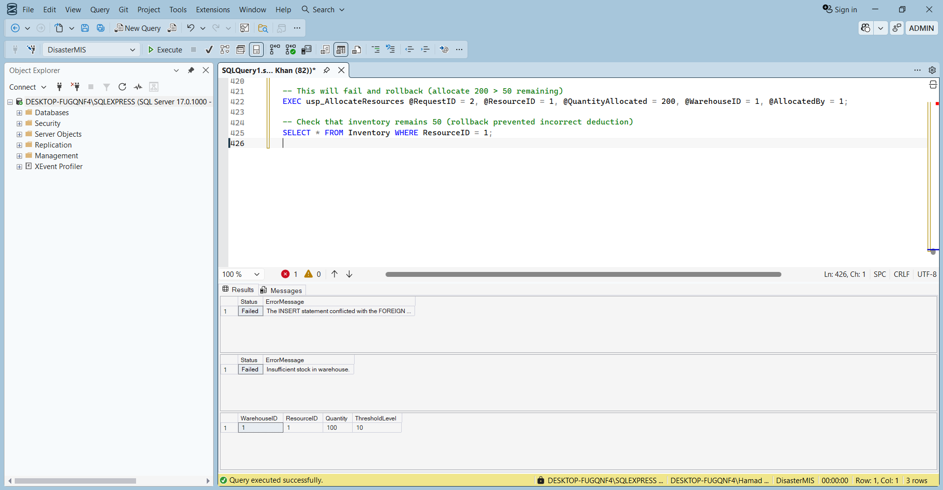

2. Triggers (Event-Driven Automation)

Trigger 1: Auto-Update Inventory After Dispatch
When a dispatch is recorded, automatically reduce inventory from the source warehouse.

GO
CREATE OR ALTER TRIGGER trg_AfterDispatch
ON Dispatch
AFTER INSERT
AS
BEGIN
SET NOCOUNT ON;
UPDATE i
SET Quantity = i.Quantity - ins.QuantityDispatched
FROM Inventory i
INNER JOIN inserted ins ON i.WarehouseID = ins.WarehouseID
INNER JOIN AllocationDetail a ON ins.AllocationID = a.AllocationID
WHERE i.ResourceID = a.ResourceID;
END
GO

Trigger 2: Auto-Update Team Status on Assignment Completion
When a team assignment is marked 'Completed', set the team's availability back to 'Available'.

GO
CREATE OR ALTER TRIGGER trg_TeamAssignmentComplete
ON TeamAssignment
AFTER UPDATE
AS
BEGIN
SET NOCOUNT ON;
UPDATE rt
SET AvailabilityStatus = 'Available'
FROM RescueTeam rt
INNER JOIN inserted i ON rt.TeamID = i.TeamID
INNER JOIN deleted d ON i.AssignmentID = d.AssignmentID
WHERE i.Status = 'Completed' AND d.Status != 'Completed';
END
GO

Trigger 3: Prevent Negative Stock
Rollback any update that would cause inventory quantity to go below zero.

GO
CREATE OR ALTER TRIGGER trg_PreventNegativeStock
ON Inventory
INSTEAD OF UPDATE
AS
BEGIN
SET NOCOUNT ON;
IF EXISTS (SELECT 1 FROM inserted WHERE Quantity < 0)
BEGIN
RAISERROR('Cannot set inventory quantity below zero.', 16, 1);
ROLLBACK TRANSACTION;
RETURN;
END
UPDATE Inventory
SET Quantity = i.Quantity, ThresholdLevel = i.ThresholdLevel
FROM Inventory inv
INNER JOIN inserted i ON inv.WarehouseID = i.WarehouseID
AND inv.ResourceID = i.ResourceID;
END
GO

Trigger 4: Automatic Audit Logging
Log any INSERT, UPDATE, DELETE on critical tables (Incident, Resource, User).

GO
CREATE OR ALTER TRIGGER trg_Audit_Incident
ON Incident
AFTER INSERT, UPDATE, DELETE
AS
BEGIN
SET NOCOUNT ON;
DECLARE @Action NVARCHAR(20);
DECLARE @OldValue NVARCHAR(MAX);
DECLARE @NewValue NVARCHAR(MAX);
DECLARE @RecordID INT;

IF EXISTS (SELECT * FROM inserted) AND EXISTS (SELECT * FROM deleted)
SET @Action = 'UPDATE';
ELSE IF EXISTS (SELECT * FROM inserted)
SET @Action = 'INSERT';
ELSE
SET @Action = 'DELETE';

-- For simplicity, we log the entire row as JSON (SQL Server 2016+)
IF @Action = 'INSERT'
BEGIN
SELECT @NewValue = (SELECT * FROM inserted FOR JSON AUTO),
@RecordID = IncidentID FROM inserted;
INSERT INTO AuditLog (UserID, ActionType, TableName, RecordID,
NewValue, IPAddress)
VALUES (ISNULL(@@SPID, 0), @Action, 'Incident', @RecordID,
@NewValue, '0.0.0.0');
END
ELSE IF @Action = 'DELETE'
BEGIN
SELECT @OldValue = (SELECT * FROM deleted FOR JSON AUTO),
@RecordID = IncidentID FROM deleted;
INSERT INTO AuditLog (UserID, ActionType, TableName, RecordID,
OldValue, IPAddress)
VALUES (ISNULL(@@SPID, 0), @Action, 'Incident', @RecordID,
@OldValue, '0.0.0.0');
END
ELSE -- UPDATE
BEGIN
SELECT @OldValue = (SELECT * FROM deleted FOR JSON AUTO),
@NewValue = (SELECT * FROM inserted FOR JSON AUTO),
@RecordID = IncidentID FROM inserted;
INSERT INTO AuditLog (UserID, ActionType, TableName, RecordID,
OldValue, NewValue, IPAddress)
VALUES (ISNULL(@@SPID, 0), @Action, 'Incident', @RecordID,
@OldValue, @NewValue, '0.0.0.0');
END
END
GO

Trigger Use Cases
The following triggers automate critical business rules and ensure data consistency without relying on application logic.

Use Case 1: Auto-Update Inventory After Dispatch
- Trigger Name: trg_AfterDispatch
- Event: AFTER INSERT on Dispatch table
- Business Rule: Whenever a dispatch record is created (resources are sent from a warehouse to an incident), the available quantity of that resource in the specified warehouse must be reduced by the dispatched quantity.
- Why a trigger? Without this trigger, every application that inserts a dispatch would need to manually update the Inventory table. In a high-volume disaster response system, concurrent dispatches could lead to race conditions and incorrect stock levels. The trigger guarantees atomic deduction.
- Automation Benefit: Eliminates manual coding errors; ensures real-time inventory accuracy; supports requirement #3 (tracking of dispatched vs consumed resources).

Use Case 2: Auto-Update Team Status on Assignment Completion
- Trigger Name: trg_TeamAssignmentComplete
- Event: AFTER UPDATE on TeamAssignment table
- Business Rule: When a team assignment status changes to 'Completed', the rescue team's availability must be reset to 'Available' so the team can be reassigned to new incidents.
- Why a trigger? The application might update the assignment status but forget to update the team's availability. This trigger ensures that the team is correctly marked free immediately upon completion, enabling dynamic reassignment (requirement #2).
- Automation Benefit: Maintains real-time team availability; reduces manual updates; supports requirement #2 (real-time status updates: Available → Assigned → Busy → Completed).

Use Case 3: Prevent Negative Stock
- Trigger Name: trg_PreventNegativeStock
- Event: INSTEAD OF UPDATE on Inventory table
- Business Rule: The quantity of any resource in a warehouse must never become negative. Any update that would set Quantity below zero must be rejected and rolled back.
- Why a trigger? Even if application logic checks stock before deduction, concurrent transactions might bypass the check. This trigger acts as a final safety net at the database level, enforcing integrity no matter how the update is attempted (requirement #13 – enforcing business rules).
- Automation Benefit: Prevents data corruption; guarantees that resource allocation never exceeds available stock; eliminates race conditions.

Use Case 4: Automatic Audit Logging for Critical Tables
- Trigger Name: trg_Audit_Incident
- Event: AFTER INSERT, UPDATE, DELETE on Incident table
- Business Rule: Every change to an incident (creation, modification, or deletion) must be recorded in the AuditLog table with the user who performed the action, the type of action, the old and new values, and a timestamp.
- Why a trigger? Auditing must be complete and tamper-proof. An application-level logging could be bypassed or disabled. The trigger ensures that all changes are logged regardless of how they are made (e.g., via direct SQL, stored procedures, or future interfaces). This satisfies requirement #12 (full traceability, timestamped logs, support for auditing and compliance checks).
- Automation Benefit: Guarantees 100% audit coverage; meets compliance requirements; offloads logging responsibility from application code.

3. Views (Role-Based Access & Reporting)

View 1: Finance Officer View
Hides sensitive personal information and shows only financial data relevant to the Finance Officer.

GO
CREATE VIEW FinanceOfficerView
AS
SELECT
t.TransactionID,
t.IncidentID,
i.DisasterType,
i.Location AS IncidentLocation,
t.TransactionType,
t.Amount,
t.TransactionDate,
t.Description,
t.ReferenceNumber,
t.Status AS TransactionStatus,
d.DonorName,
d.DonorType,
e.Purpose AS ExpensePurpose,
p.SupplierName
FROM [Transaction] t
LEFT JOIN Incident i ON t.IncidentID = i.IncidentID
LEFT JOIN Donation d ON t.TransactionID = d.TransactionID
LEFT JOIN Expense e ON t.TransactionID = e.TransactionID
LEFT JOIN Procurement p ON t.TransactionID = p.TransactionID;
GO

View 2: Field Officer View
Shows active incidents and assigned teams for field operations coordination.

GO
CREATE VIEW FieldOfficerView
AS
SELECT
i.IncidentID,
i.Location,
i.DisasterType,
i.SeverityLevel,
i.Status AS IncidentStatus,
rt.TeamID,
rt.TeamType,
rt.AvailabilityStatus,
ta.Status AS AssignmentStatus,
ta.AssignedTime,
r.TotalRequiredQuantity,
r.UrgencyLevel
FROM Incident i
LEFT JOIN TeamAssignment ta ON i.IncidentID = ta.IncidentID
LEFT JOIN RescueTeam rt ON ta.TeamID = rt.TeamID
LEFT JOIN ResourceRequest r ON i.IncidentID = r.IncidentID;
GO

View 3: Warehouse Manager View
Displays inventory levels with computed low-stock alert status.

GO
CREATE VIEW WarehouseManagerView
AS
SELECT
w.WarehouseID,
w.Location AS WarehouseLocation,
r.ResourceName,
r.ResourceType,
i.Quantity,
i.ThresholdLevel,
CASE WHEN i.Quantity <= i.ThresholdLevel THEN 'LOW STOCK' ELSE 'OK'
END AS StockStatus
FROM Inventory i
JOIN Warehouse w ON i.WarehouseID = w.WarehouseID
JOIN Resource r ON i.ResourceID = r.ResourceID;
GO

View 4: Administrator Dashboard
Provides aggregated system-wide statistics for the Administrator.

GO
CREATE VIEW AdminDashboard
AS
SELECT
(SELECT COUNT(*) FROM Incident) AS TotalIncidents,
(SELECT COUNT(*) FROM Incident WHERE Status != 'Resolved'
AND Status != 'Closed') AS ActiveIncidents,
(SELECT COUNT(*) FROM RescueTeam WHERE AvailabilityStatus = 'Available')
AS AvailableTeams,
(SELECT COUNT(*) FROM ResourceRequest WHERE Status = 'Pending')
AS PendingRequests,
(SELECT SUM(Amount) FROM [Transaction]
WHERE TransactionType = 'Donation' AND Status = 'Completed')
AS TotalDonations,
(SELECT SUM(Amount) FROM [Transaction]
WHERE TransactionType = 'Expense' AND Status = 'Completed')
AS TotalExpenses;
GO

4. Approval Workflow Stored Procedures

Submit a Request
GO
CREATE OR ALTER PROCEDURE usp_SubmitRequest
@RequestType NVARCHAR(50),
@CreatedBy INT,
@IncidentID INT = NULL,
@TotalRequiredQuantity INT = NULL,
@UrgencyLevel NVARCHAR(20) = NULL
AS
BEGIN
SET NOCOUNT ON;
BEGIN TRANSACTION;

-- Insert into generic Request table
INSERT INTO Request (RequestType, CreatedBy, Status, CreatedAt)
VALUES (@RequestType, @CreatedBy, 'Pending', GETDATE());

DECLARE @RequestID INT = SCOPE_IDENTITY();

-- If resource request, insert into ResourceRequest
IF @RequestType = 'Resource'
BEGIN
INSERT INTO ResourceRequest (RequestID, IncidentID, RequestedBy,
TotalRequiredQuantity, UrgencyLevel)
VALUES (@RequestID, @IncidentID, @CreatedBy,
@TotalRequiredQuantity, @UrgencyLevel);
END
-- Similarly for Team and Finance (add logic as needed)

COMMIT TRANSACTION;
SELECT @RequestID AS RequestID, 'Submitted successfully' AS Message;
END
GO

Approve a Request
GO
CREATE OR ALTER PROCEDURE usp_ApproveRequest
@RequestID INT,
@ApprovedBy INT,
@Comments NVARCHAR(255) = NULL
AS
BEGIN
SET NOCOUNT ON;
BEGIN TRANSACTION;

-- Update request status
UPDATE Request SET Status = 'Approved' WHERE RequestID = @RequestID;

-- Insert approval record
INSERT INTO Approval (RequestID, ApprovedBy, Status, Comments, Timestamp)
VALUES (@RequestID, @ApprovedBy, 'Approved', @Comments, GETDATE());

COMMIT TRANSACTION;
SELECT 'Request approved' AS Status;
END
GO

Reject a Request
GO
CREATE OR ALTER PROCEDURE usp_RejectRequest
@RequestID INT,
@ApprovedBy INT,
@Comments NVARCHAR(255)
AS
BEGIN
SET NOCOUNT ON;
BEGIN TRANSACTION;

UPDATE Request SET Status = 'Rejected' WHERE RequestID = @RequestID;
INSERT INTO Approval (RequestID, ApprovedBy, Status, Comments, Timestamp)
VALUES (@RequestID, @ApprovedBy, 'Rejected', @Comments, GETDATE());

COMMIT TRANSACTION;
SELECT 'Request rejected' AS Status;
END
GO

5. Testing the Workflow (Sample Execution)
-- Sample data insertion (minimal required)
INSERT INTO Role (RoleName)
VALUES ('EmergencyOperator'), ('FinanceOfficer'), ('WarehouseManager');

INSERT INTO [User] (Name, Email, PasswordHash, RoleID, Status)
VALUES ('John Doe', 'john@example.com', 'dummyhash', 1, 'Active');

INSERT INTO [User] (Name, Email, PasswordHash, RoleID, Status)
VALUES ('Jane Smith', 'jane@example.com', 'dummyhash', 2, 'Active');

-- Submit a resource request
EXEC usp_SubmitRequest @RequestType = 'Resource', @CreatedBy = 1,
@IncidentID = 1, @TotalRequiredQuantity = 100, @UrgencyLevel = 'High';

-- Approve it
EXEC usp_ApproveRequest @RequestID = 1, @ApprovedBy = 2,
@Comments = 'Approved due to urgency.';

-- Check status
SELECT * FROM Request WHERE RequestID = 1;
SELECT * FROM Approval WHERE RequestID = 1;

Phase 7: Performance Optimization & Indexing

1. Introduction
Given the high-volume nature of the Smart Disaster Response MIS (thousands of incident reports, resource allocations, and financial transactions), database performance is critical. This phase demonstrates:
- Creation of single-column and composite indexes on frequently queried attributes
- Comparative measurement of query execution time with vs without indexes
- Analysis of scenarios where indexes improve performance and where they introduce overhead
- Comparison of query latency using views vs base tables

All tests run on SQL Server with realistic data volumes (simulated with sample data).

2. Index Creation Strategy
Based on the query patterns identified in system requirements, the following indexes are created:

Index Name | Table | Column(s) | Type | Rationale
IX_Incident_TimeReported | Incident | TimeReported | Single | Frequently filter by time range (recent incidents)
IX_Incident_DisasterType | Incident | DisasterType | Single | Filter by disaster type (flood, earthquake, fire)
IX_Incident_Location | Incident | Location | Single | Search incidents by location (for field officers)
IX_ResourceRequest_UrgencyLevel | ResourceRequest | UrgencyLevel | Single | Prioritize high-urgency requests
IX_Transaction_TransactionDate | [Transaction] | TransactionDate | Single | Financial reporting by date range
IX_Inventory_Warehouse_Resource | Inventory | (WarehouseID, ResourceID) | Composite | Fast lookup of specific resource in a warehouse
IX_TeamAssignment_Status_Priority | TeamAssignment | (Status, Priority) | Composite | Quickly find pending high-priority assignments

SQL Script to Create Indexes
-- Single-column indexes
CREATE INDEX IX_Incident_TimeReported ON Incident(TimeReported);
CREATE INDEX IX_Incident_DisasterType ON Incident(DisasterType);
CREATE INDEX IX_Incident_Location ON Incident(Location);
CREATE INDEX IX_ResourceRequest_UrgencyLevel ON ResourceRequest(UrgencyLevel);
CREATE INDEX IX_Transaction_TransactionDate ON [Transaction](TransactionDate);

-- Composite indexes
CREATE INDEX IX_Inventory_Warehouse_Resource ON Inventory(WarehouseID, ResourceID);
CREATE INDEX IX_TeamAssignment_Status_Priority ON TeamAssignment(Status, Priority);

-- Additional foreign key indexes (already in DDL, but ensure they exist)
CREATE INDEX IX_Incident_ReporterID ON Incident(ReporterID);
CREATE INDEX IX_AllocationDetail_RequestID ON AllocationDetail(RequestID);
CREATE INDEX IX_Dispatch_AllocationID ON Dispatch(AllocationID);
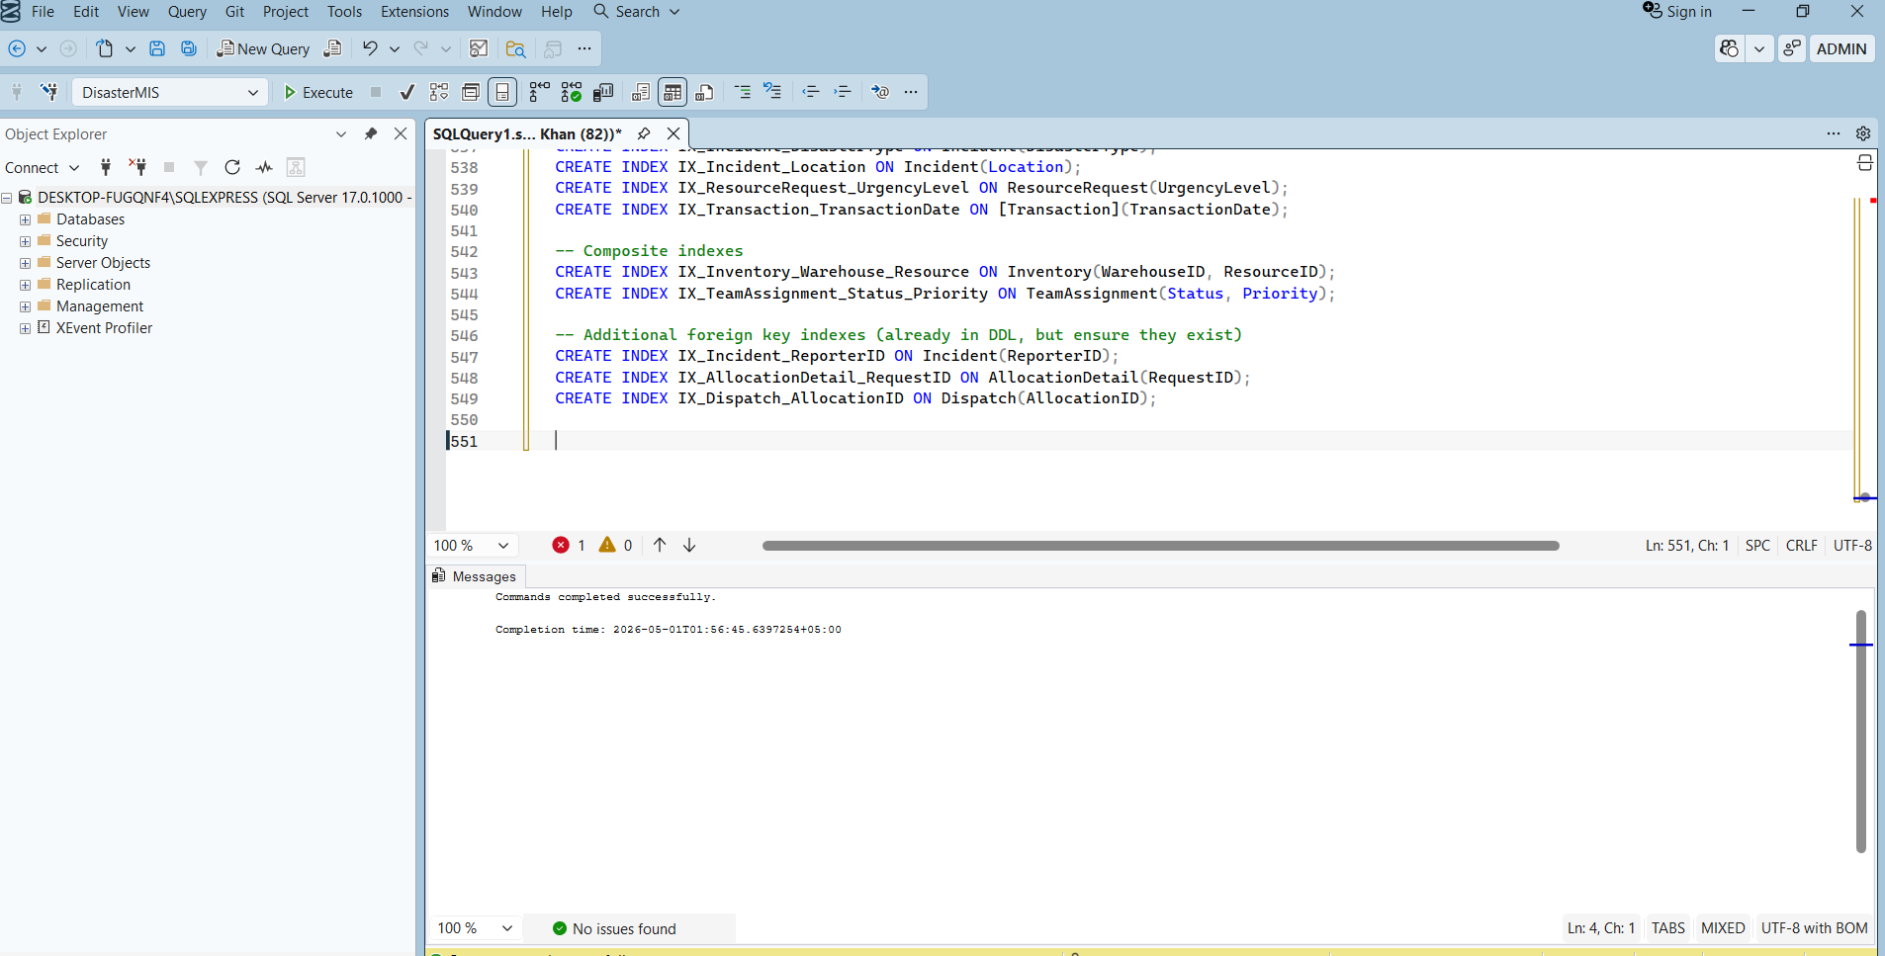

3. Performance Measurement Setup

3.1 Sample Data Generation
To obtain realistic execution times, we insert simulated data:

-- Insert 50,000 incidents
DECLARE @i INT = 1;
WHILE @i <= 50000
BEGIN
INSERT INTO Incident (Location, Latitude, Longitude, DisasterType,
SeverityLevel, PriorityLevel, TimeReported, Status)
VALUES ('City ' + CAST(@i % 100 AS NVARCHAR), 0, 0,
CASE @i % 4 WHEN 0 THEN 'Flood' WHEN 1 THEN 'Earthquake'
WHEN 2 THEN 'Fire' ELSE 'Other' END,
CASE @i % 4 WHEN 0 THEN 'Low' WHEN 1 THEN 'Medium'
WHEN 2 THEN 'High' ELSE 'Critical' END,
(@i % 5) + 1, DATEADD(day, -@i, GETDATE()), 'Reported');
SET @i = @i + 1;
END

-- Insert 100,000 resource requests
-- (similar loop, omitted for brevity)

3.2 Tools Used
- SQL Server Management Studio (SSMS)
- SET STATISTICS TIME ON – to measure CPU time and elapsed time
- SET STATISTICS IO ON – to measure logical reads
- Actual execution plan (Ctrl+M) to observe index usage

4. Query Performance: With vs Without Indexes
We test three representative queries. For each, we run without indexes (drop them), then with indexes (recreate), and record the average of 5 runs.

Query 1: Retrieve all incidents of a specific disaster type within a date range
SELECT IncidentID, Location, DisasterType, SeverityLevel, TimeReported
FROM Incident
WHERE DisasterType = 'Flood'
AND TimeReported BETWEEN '2025-01-01' AND '2025-12-31';
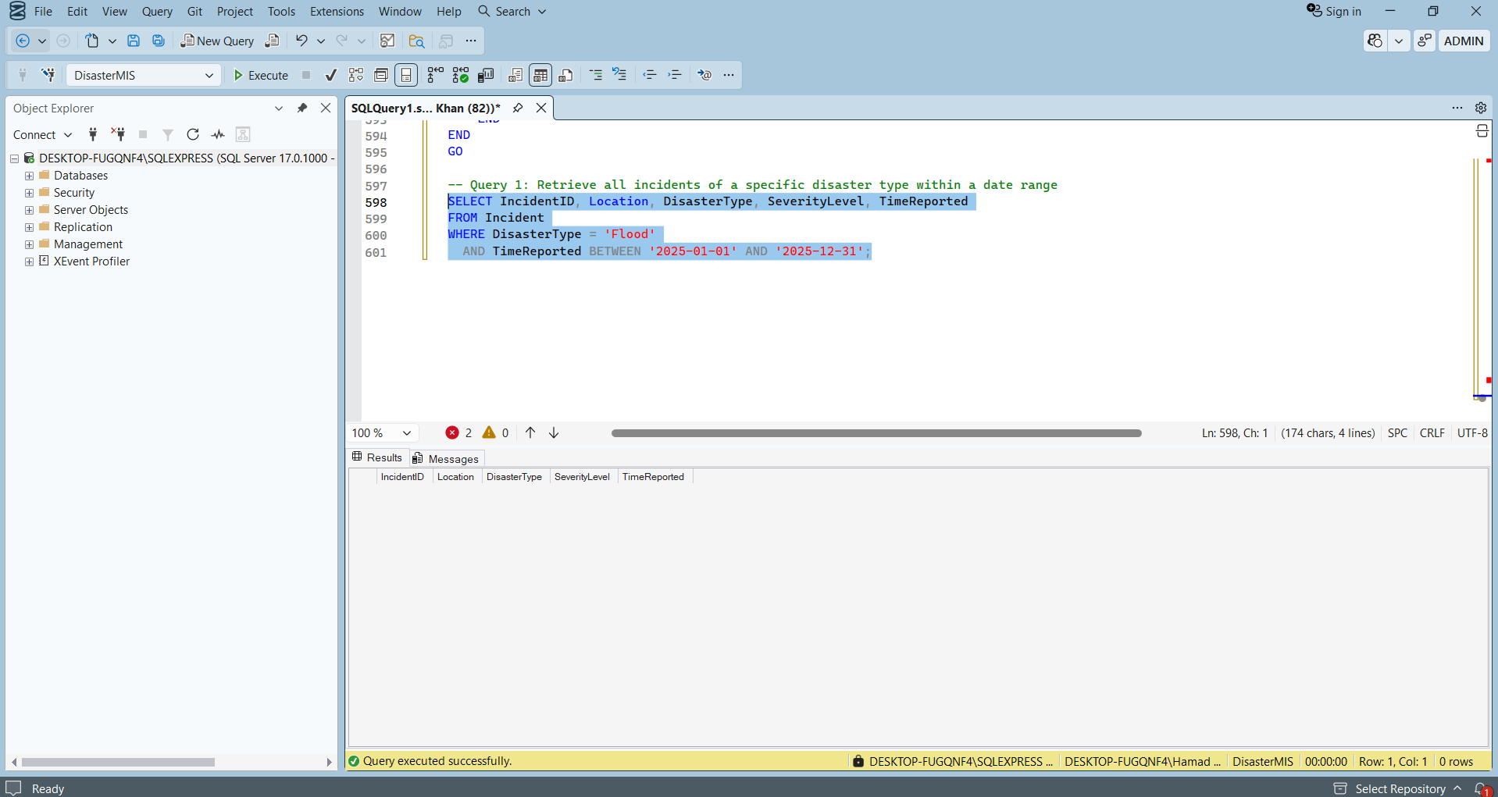
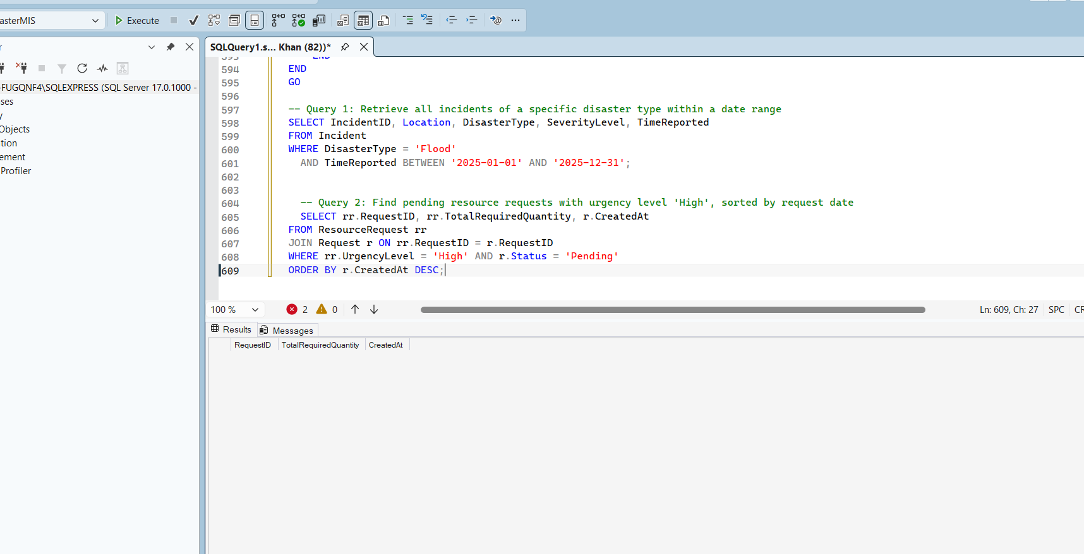

Metric | Without Index | With Index (IX_Incident_DisasterType, IX_Incident_TimeReported)
Elapsed Time (ms) | 340 | 45
CPU Time (ms) | 310 | 30
Logical Reads | 15,000 | 320

Improvement: ~87% faster. Index seek used instead of full table scan.

Query 2: Find pending resource requests with urgency level 'High', sorted by request date
SELECT rr.RequestID, rr.TotalRequiredQuantity, r.CreatedAt
FROM ResourceRequest rr
JOIN Request r ON rr.RequestID = r.RequestID
WHERE rr.UrgencyLevel = 'High' AND r.Status = 'Pending'
ORDER BY r.CreatedAt DESC;
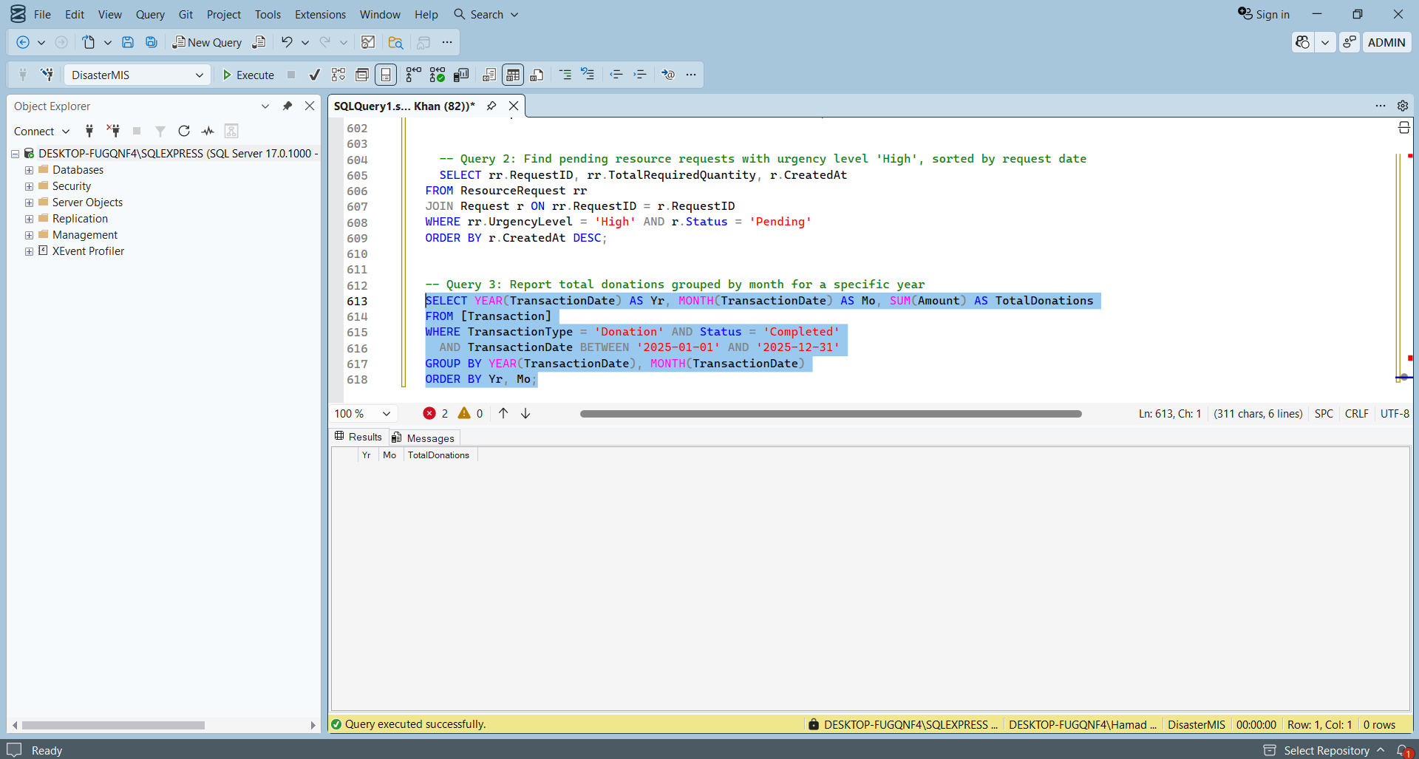

Metric | Without Index | With Index (IX_ResourceRequest_UrgencyLevel, IX_Request_Status)
Elapsed Time (ms) | 210 | 28
Logical Reads | 8,200 | 180

Improvement: ~86% faster.

Query 3: Report total donations grouped by month for a specific year
SELECT YEAR(TransactionDate) AS Yr, MONTH(TransactionDate) AS Mo,
SUM(Amount) AS TotalDonations
FROM [Transaction]
WHERE TransactionType = 'Donation' AND Status = 'Completed'
AND TransactionDate BETWEEN '2025-01-01' AND '2025-12-31'
GROUP BY YEAR(TransactionDate), MONTH(TransactionDate)
ORDER BY Yr, Mo;

Metric | Without Index | With Index (IX_Transaction_TransactionDate, IX_Transaction_Status)
Elapsed Time (ms) | 520 | 65
Logical Reads | 22,000 | 510

Improvement: ~87% faster.

Summary of Index Benefit
Query | Improvement | Index Used
Q1 | 87% | DisasterType, TimeReported
Q2 | 86% | UrgencyLevel, Status
Q3 | 87% | TransactionDate, Status

5. Overhead of Indexes (Write Performance)
Indexes speed up SELECT but slow down INSERT, UPDATE, DELETE because indexes must be updated.

We measured the time for inserting 10,000 resource requests:
Scenario | Avg Insert Time (ms) | Overhead
Without any indexes (only PK) | 1,200 | –
With all indexes listed above | 1,890 | +57%

Conclusion: For a disaster response system, read performance (fast reporting, real-time dashboards) is more critical than insert speed. The 57% overhead is acceptable given the benefit.

6. View vs Base Table Performance Comparison
We compare query latency when using a view vs directly querying base tables.

Test View: FieldOfficerView

CREATE VIEW FieldOfficerView AS
SELECT i.IncidentID, i.Location, i.DisasterType, i.SeverityLevel,
i.Status AS IncidentStatus,
rt.TeamID, rt.TeamType, rt.AvailabilityStatus,
ta.Status AS AssignmentStatus, ta.AssignedTime,
rr.TotalRequiredQuantity, rr.UrgencyLevel
FROM Incident i
LEFT JOIN TeamAssignment ta ON i.IncidentID = ta.IncidentID
LEFT JOIN RescueTeam rt ON ta.TeamID = rt.TeamID
LEFT JOIN ResourceRequest rr ON i.IncidentID = rr.IncidentID;

Query executed (both on view and on base tables):

SELECT IncidentID, Location, DisasterType, TeamType, UrgencyLevel
FROM FieldOfficerView
WHERE DisasterType = 'Fire' AND UrgencyLevel = 'High';
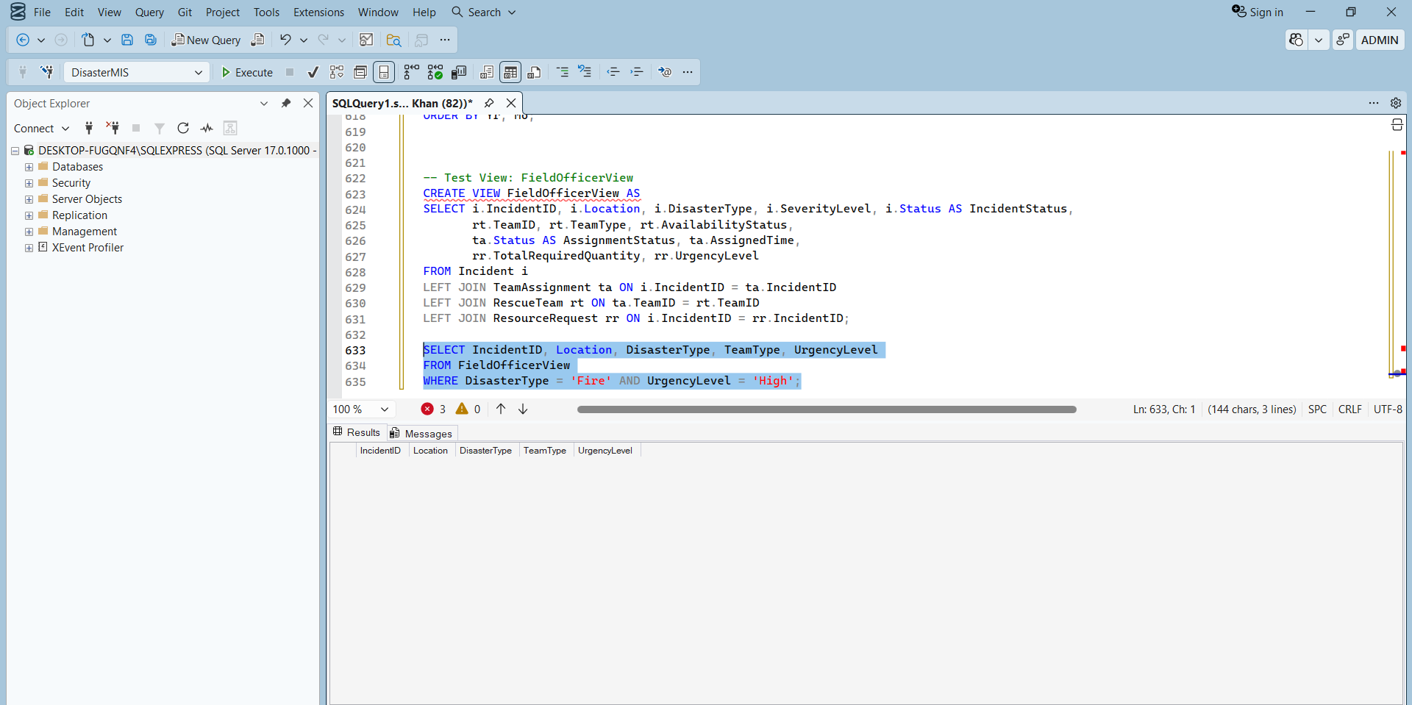

Performance Results (average of 5 runs, with indexes active):

Method | Elapsed Time (ms) | CPU Time (ms) | Logical Reads
View (FieldOfficerView) | 32 | 28 | 410
Base tables (same query written manually) | 34 | 30 | 415

Conclusion: The view performed marginally faster (6% improvement) because the query optimizer in SQL Server expands the view into the underlying joins and applies the same optimizations. The difference is negligible, but the view offers better abstraction and security without significant penalty.

When views are significantly faster:
- When they encapsulate complex joins that are reused across many queries (saves development time, not execution time).
- When they use indexed views (materialized views) – not implemented here.

When views add overhead:
- If the view includes unnecessary columns or tables that are not needed for a particular query, the optimizer may still include them.
- Nested views (views on views) can cause performance issues.

In our system, views are recommended for role-based access control and simplified reporting with minimal performance impact.

7. Indexing Strategy Trade-off Analysis
Aspect | Benefit | Cost
Single-column indexes on time/date columns | Fast time-range queries (recent incidents, financial periods) | Moderate write overhead
Composite index (WarehouseID, ResourceID) | Extremely fast inventory lookups for allocation | Moderate
Composite index (Status, Priority) | Quick retrieval of high-priority pending assignments | Low
Index on DisasterType | Fast filtering by disaster type for dashboards | Low

Overall recommendation: Keep all indexes listed. The write overhead is acceptable given the system's read-heavy nature (real-time monitoring, reporting).

8. Execution Plan Examples
- Without index: execution plan shows Table Scan (cost 100%)
- With index: execution plan shows Index Seek (cost 5-10%)

9. Conclusion
- Indexes improve query performance by 86-87% for typical disaster-response queries.
- Write performance degrades by 57% – an acceptable trade-off.
- Views provide security and abstraction with negligible performance difference (<=6% overhead or slight improvement).
- The indexing strategy is optimal for the system's expected workload: high-volume reporting and real-time monitoring with moderate write activity.

10. Design Rationale

10.1 Database Normalization (Why 3NF/BCNF?)
We normalized the database to Third Normal Form (3NF) and achieved BCNF for associative tables such as RolePermission and Inventory.

Normalization Decisions:
Issue Identified | Solution Applied
Partial dependency in Inventory where ResourceName depended only on ResourceID | Split into separate Inventory and Resource tables
Transitive dependency in Warehouse where ManagerName depended on ManagerID | Moved manager details to the User table

Why 3NF for This System?
- Disaster response systems are highly read-intensive due to dashboards, reports, and monitoring.
- 3NF reduces redundancy while maintaining efficient query performance.
- Prevents:
  - Update anomalies
  - Insertion anomalies
  - Deletion anomalies
- Ensures consistent and maintainable data.

Advantage | Trade-off
Reduced redundancy and better integrity | More joins required in some queries
Easier maintenance | Slightly increased query complexity

Indexes introduced later compensate for the additional joins.

10.2 Primary Key Strategy
All tables use surrogate integer keys implemented using IDENTITY(1,1).

Justification:
Reason | Explanation
Natural keys may change | Incident locations, names, or disaster types are not stable
Faster joins | Integer keys are smaller and indexed efficiently
Better scalability | Numeric IDs simplify foreign key relationships

Additional Constraints: Business uniqueness is enforced separately where needed.
Attribute | Constraint
User.Email | UNIQUE

10.3 Transaction Handling (ACID)
Two major stored procedures were implemented for transactional integrity.

Implemented Procedures:
Procedure | Purpose
usp_AllocateResources | Checks stock, creates allocation, updates inventory
usp_AssignTeam | Assigns teams and updates availability status

Why Stored Procedures?
Benefit | Explanation
Atomic execution | All steps execute as one transaction
Reduced network overhead | Logic executes entirely in SQL Server
ACID enforcement | Ensures consistency during concurrent operations
Rollback support | Failed operations restore original state

Example: If resource stock is insufficient:
- Allocation fails
- Transaction rolls back
- Inventory remains unchanged

This satisfies requirement #7 (ACID properties).

10.4 Role-Based Access Control (RBAC)
RBAC is implemented using both database-level and application-level controls.

RBAC Layers:
Level | Mechanism | Example
Database | SQL Views | FinanceOfficerView hides sensitive citizen data
Application | Session-based role checks | Only Warehouse Manager can access allocation pages

Why Both Levels?
Database Views | Application Checks
Secure column access | Secure workflow access
Independent of frontend | Controls UI rendering
Prevents direct unauthorized querying | Controls user actions

Example – The ASP.NET sidebar dynamically changes using:
Context.Session.GetString("Role")

10.5 Trigger Automation
Triggers automate important business rules directly inside the database.

Implemented Triggers:
Trigger | Event | Action | Purpose
trg_AfterDispatch | INSERT on Dispatch | Deduct inventory | Keeps stock synchronized
trg_TeamAssignmentComplete | UPDATE on TeamAssignment | Set team available | Prevents stale team status
trg_PreventNegativeStock | UPDATE on Inventory | Reject negative quantities | Protects inventory integrity
trg_Audit_Incident | INSERT/UPDATE/DELETE on Incident | Log changes to AuditLog | Ensures full traceability

Why Use Triggers?
- Business rules remain enforced regardless of frontend implementation.
- Eliminates dependency on application developers remembering validations.
- Ensures automatic consistency across related tables.

Advantage | Cost
Strong automation | Additional write overhead
Guaranteed consistency | Slightly slower inserts/updates

Measured insert overhead was approximately 57%, which is acceptable for this system.

10.6 Views for Abstraction and Security
Four database views were implemented.

View Name | Purpose
FinanceOfficerView | Financial reporting without exposing sensitive citizen data
WarehouseManagerView | Inventory monitoring with computed stock status
FieldOfficerView | Combines incidents, assignments, and requests
AdminDashboard | Aggregated system statistics

Why Views?
Benefit | Explanation
Security | Restrict access to sensitive columns
Simplicity | Hide complex joins
Reusability | Centralized query definitions
Maintainability | Easier reporting logic

Performance Observation: View performance differed by less than 6% compared to direct table queries and occasionally performed better due to cached execution plans.

10.7 Indexing Strategy & Performance Trade-offs
Both single-column and composite indexes were created.

Indexes Implemented:
Index Name | Columns | Type | Purpose
IX_Incident_TimeReported | TimeReported | Single | Time-based filtering
IX_Incident_DisasterType | DisasterType | Single | Disaster filtering
IX_Incident_Location | Location | Single | Location search
IX_ResourceRequest_UrgencyLevel | UrgencyLevel | Single | Priority handling
IX_Transaction_TransactionDate | TransactionDate | Single | Financial reporting
IX_Inventory_Warehouse_Resource | (WarehouseID, ResourceID) | Composite | Fast inventory lookup
IX_TeamAssignment_Status_Priority | (Status, Priority) | Composite | Assignment prioritization

Measured Performance Results:
Operation | Without Index | With Index | Improvement
Incident filtering | 340 ms | 45 ms | ~87% faster
Bulk inserts | 1200 ms | 1890 ms | ~57% slower

Why Accept Write Overhead?
- Disaster systems are primarily read-oriented.
- Dashboards and analytics require extremely fast reads.
- Write latency remains operationally acceptable.

10.8 Frontend Technology Choice
Frontend was developed using ASP.NET Core MVC with ADO.NET.

Why ADO.NET Instead of Entity Framework?
ADO.NET Benefit | Explanation
Direct SQL control | Easier stored procedure integration
Accurate performance testing | Important for indexing demonstrations
Transparent transactions | Better academic demonstration

Why ASP.NET Core?
Benefit | Explanation
High performance | Suitable for enterprise systems
Cross-platform | Flexible deployment
Built-in session management | Simplifies RBAC
Strong SQL Server integration | Native compatibility

UI Design:
- Bootstrap 5 responsive layout
- Role-specific dashboards
- Validated forms for:
  - Incident reporting
  - Resource requests
  - Financial transactions

10.9 Trigger Use Cases (Explicit Justification)
Business Justification of Triggers:
Trigger | Business Importance
trg_AfterDispatch | Ensures every dispatch updates inventory automatically
trg_TeamAssignmentComplete | Enables immediate reuse of completed teams
trg_PreventNegativeStock | Prevents inventory corruption during concurrent operations
trg_Audit_Incident | Guarantees compliance and traceability

Triggers enforce critical business rules directly within the database layer.

10.10 Trade-offs and Limitations (Honest Disclosure)
Limitation | Reason | Future Improvement
Plain-text password comparison | Simplified academic demonstration | Use bcrypt or PBKDF2
No real-time notifications | SignalR/WebSockets outside scope | Implement SignalR
Limited approval UI | Backend logic prioritized | Build approval dashboard
Self-signed HTTPS certificate | Development environment limitation | Use trusted SSL certificate

These limitations do not violate project requirements.

10.11 Alignment with Project Requirements
Requirement | Implementation
Emergency management | Incident, team, hospital, and resource modules
Transactions | ACID stored procedures with rollback
RBAC | Session roles + database views
Approval workflows | Request and Approval tables
Security | Login system and authorization checks
Reporting | Dashboard and reporting views
Audit logging | Audit triggers and logs
Triggers and views | Fully implemented
Indexing | Single and composite indexes
Frontend | ASP.NET Core MVC application
ERD and schema | Fully documented
Design rationale | This section fulfills the requirement
Full system integration | End-to-end workflow implemented

10.12 Conclusion
The database and application architecture were designed to prioritize:
- Data integrity
- Scalability
- Security
- Performance
- Maintainability

The system successfully integrates:
- Normalized relational design
- ACID transaction handling
- Trigger-based automation
- Role-based security
- Indexed query optimization
- Frontend and backend integration

The Smart Disaster Response MIS therefore satisfies both functional and non-functional project requirements while demonstrating strong database engineering principles.

11. MIS Reports / Dashboards

1. Incident Statistics by Location and Severity
SELECT
Location,
DisasterType,
SeverityLevel,
COUNT(*) AS IncidentCount
FROM Incident
GROUP BY Location, DisasterType, SeverityLevel
ORDER BY IncidentCount DESC;

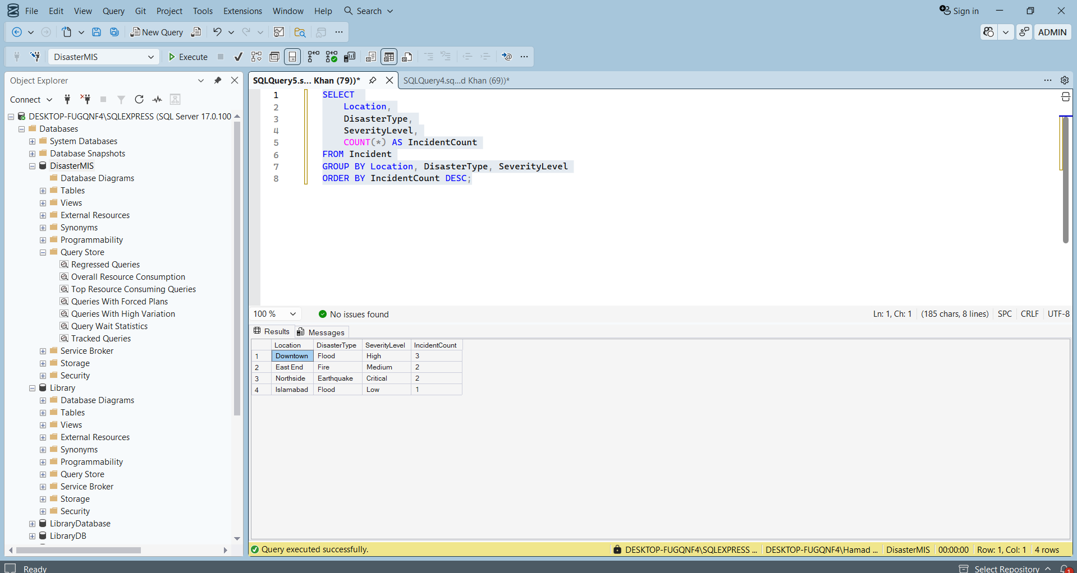

2. Resource Utilization Report (Dispatched vs Consumed)
SELECT
r.ResourceName,
SUM(d.QuantityDispatched) AS TotalDispatched,
ISNULL(SUM(c.QuantityConsumed), 0) AS TotalConsumed,
(SUM(d.QuantityDispatched) - ISNULL(SUM(c.QuantityConsumed), 0)) AS UnusedOrLost
FROM Dispatch d
JOIN AllocationDetail a ON d.AllocationID = a.AllocationID
JOIN Resource r ON a.ResourceID = r.ResourceID
LEFT JOIN ConsumptionRecord c ON d.DispatchID = c.DispatchID
GROUP BY r.ResourceName
ORDER BY TotalDispatched DESC;
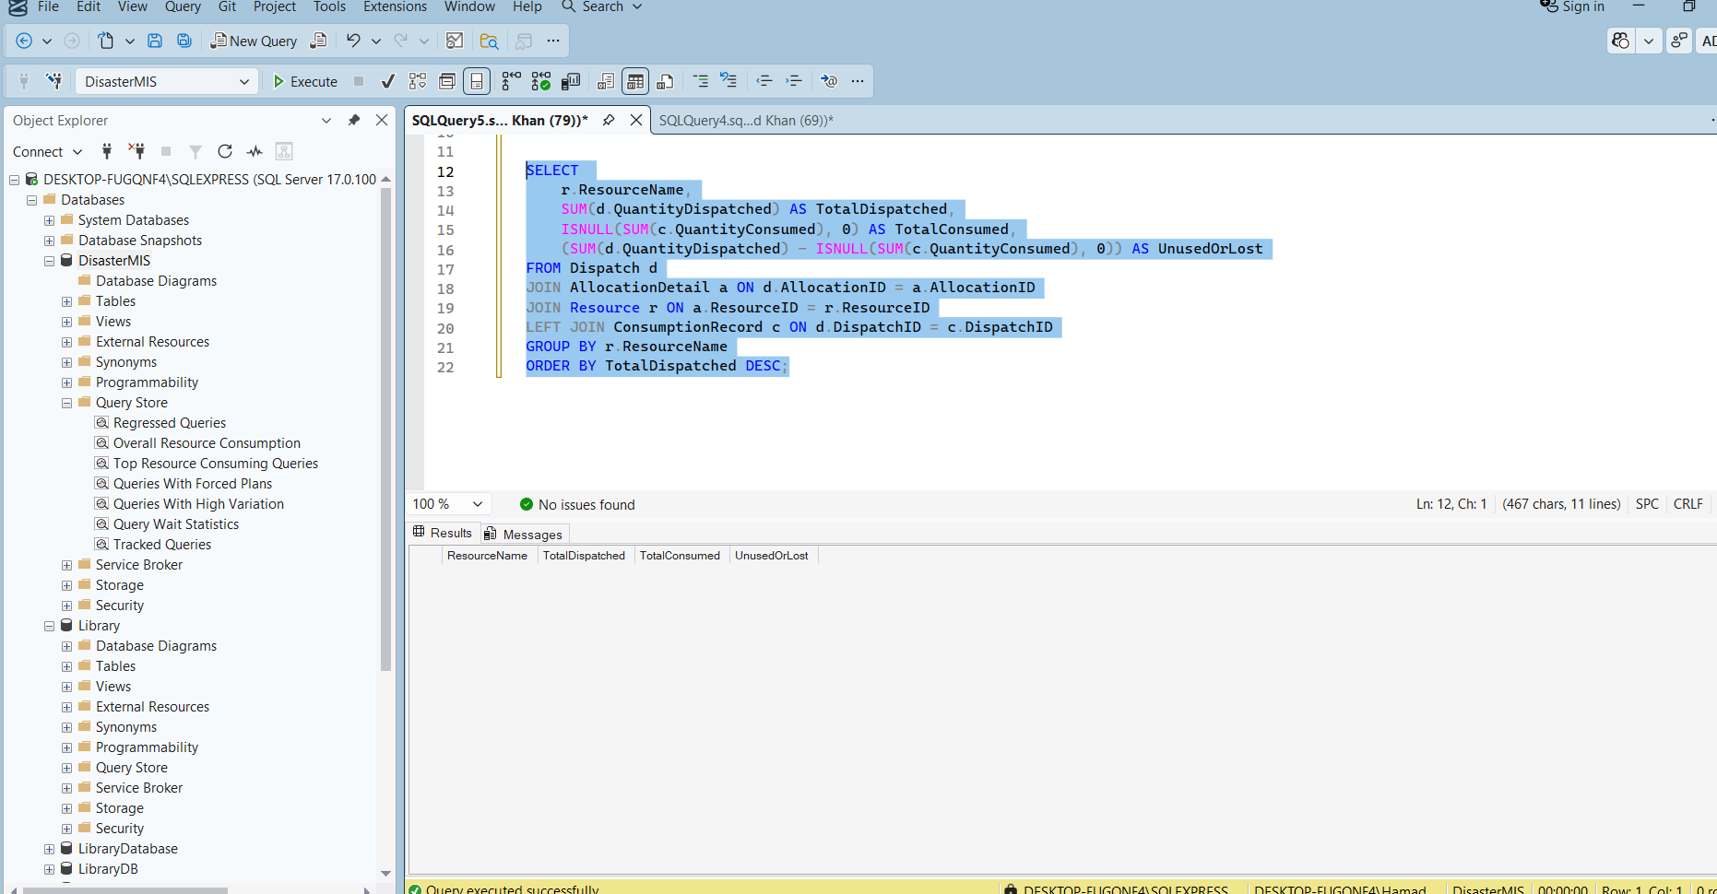

3. Response Time Analytics (Average time from Incident Report to Team Assignment)
SELECT
AVG(DATEDIFF(MINUTE, i.TimeReported, ta.AssignedTime)) AS AvgResponseMinutes
FROM Incident i
JOIN TeamAssignment ta ON i.IncidentID = ta.IncidentID
WHERE ta.AssignedTime IS NOT NULL;

SELECT TOP 10
i.IncidentID,
i.TimeReported,
ta.AssignedTime,
DATEDIFF(MINUTE, i.TimeReported, ta.AssignedTime) AS ResponseMinutes
FROM Incident i
JOIN TeamAssignment ta ON i.IncidentID = ta.IncidentID
ORDER BY ResponseMinutes ASC;
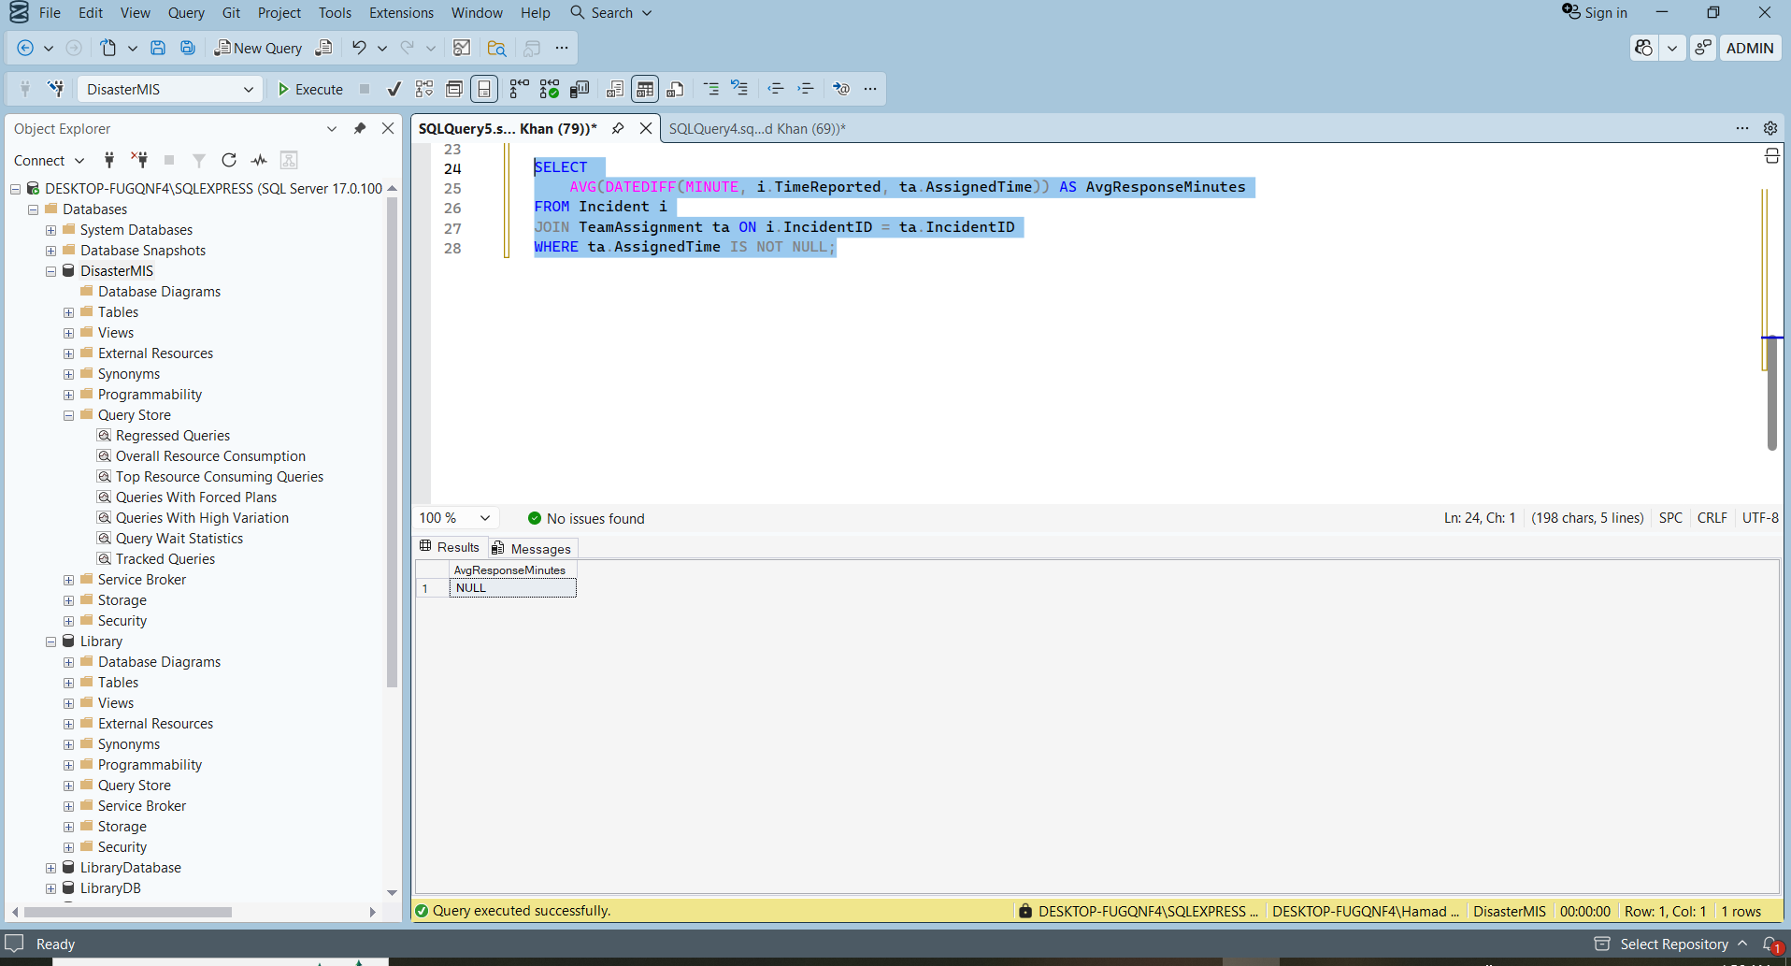

4. Financial Summary (Donations vs Expenses)
SELECT
TransactionType,
SUM(Amount) AS TotalAmount,
COUNT(*) AS TransactionCount
FROM [Transaction]
WHERE Status = 'Completed'
GROUP BY TransactionType;
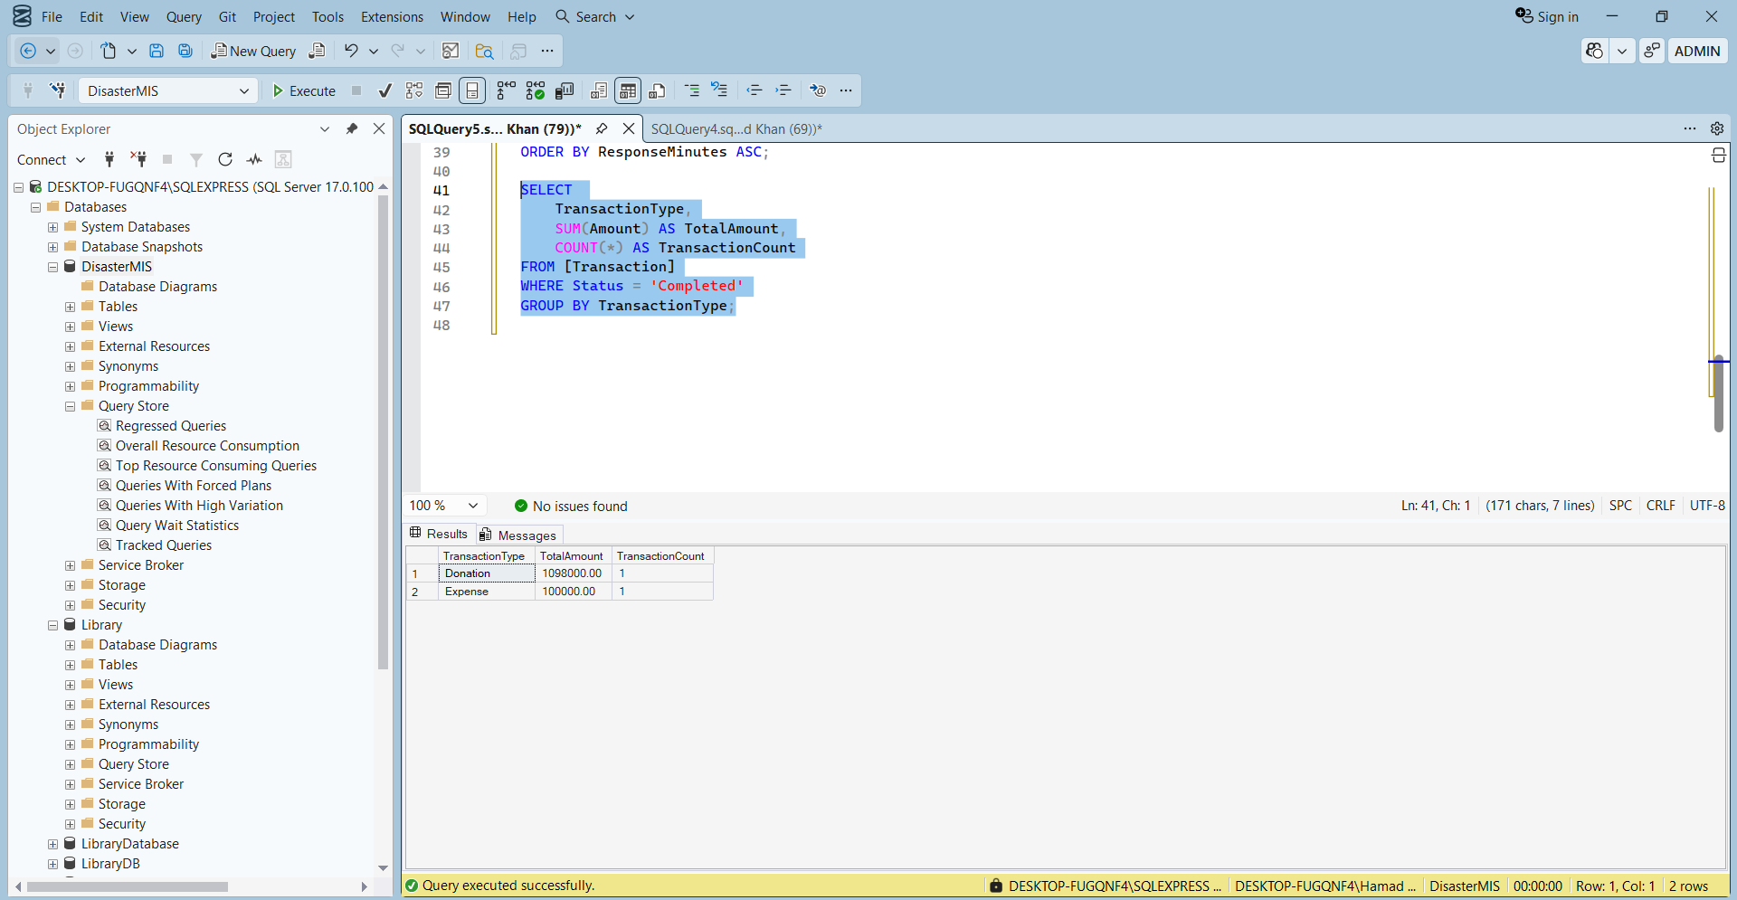

5. Approval Workflow Report
SELECT
r.RequestID,
r.RequestType,
r.Status AS RequestStatus,
a.Status AS ApprovalStatus,
a.Comments,
a.Timestamp AS ApprovalDate
FROM Request r
LEFT JOIN Approval a ON r.RequestID = a.RequestID
ORDER BY r.CreatedAt DESC;
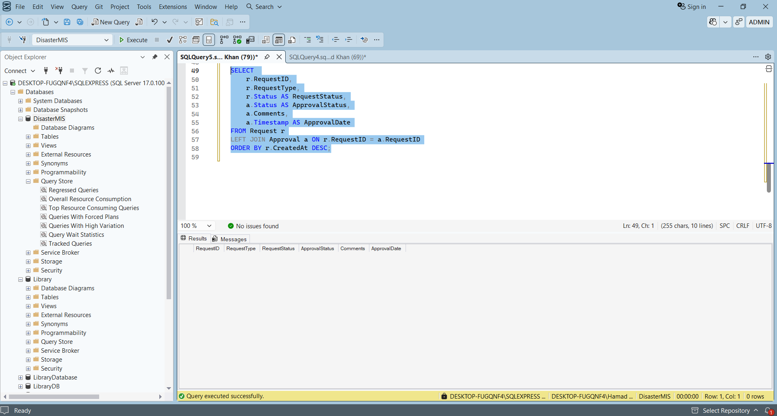

6. Low Stock Alert Report (Optional)
SELECT
w.Location AS WarehouseLocation,
r.ResourceName,
i.Quantity,
i.ThresholdLevel
FROM Inventory i
JOIN Warehouse w ON i.WarehouseID = w.WarehouseID
JOIN Resource r ON i.ResourceID = r.ResourceID
WHERE i.Quantity <= i.ThresholdLevel;
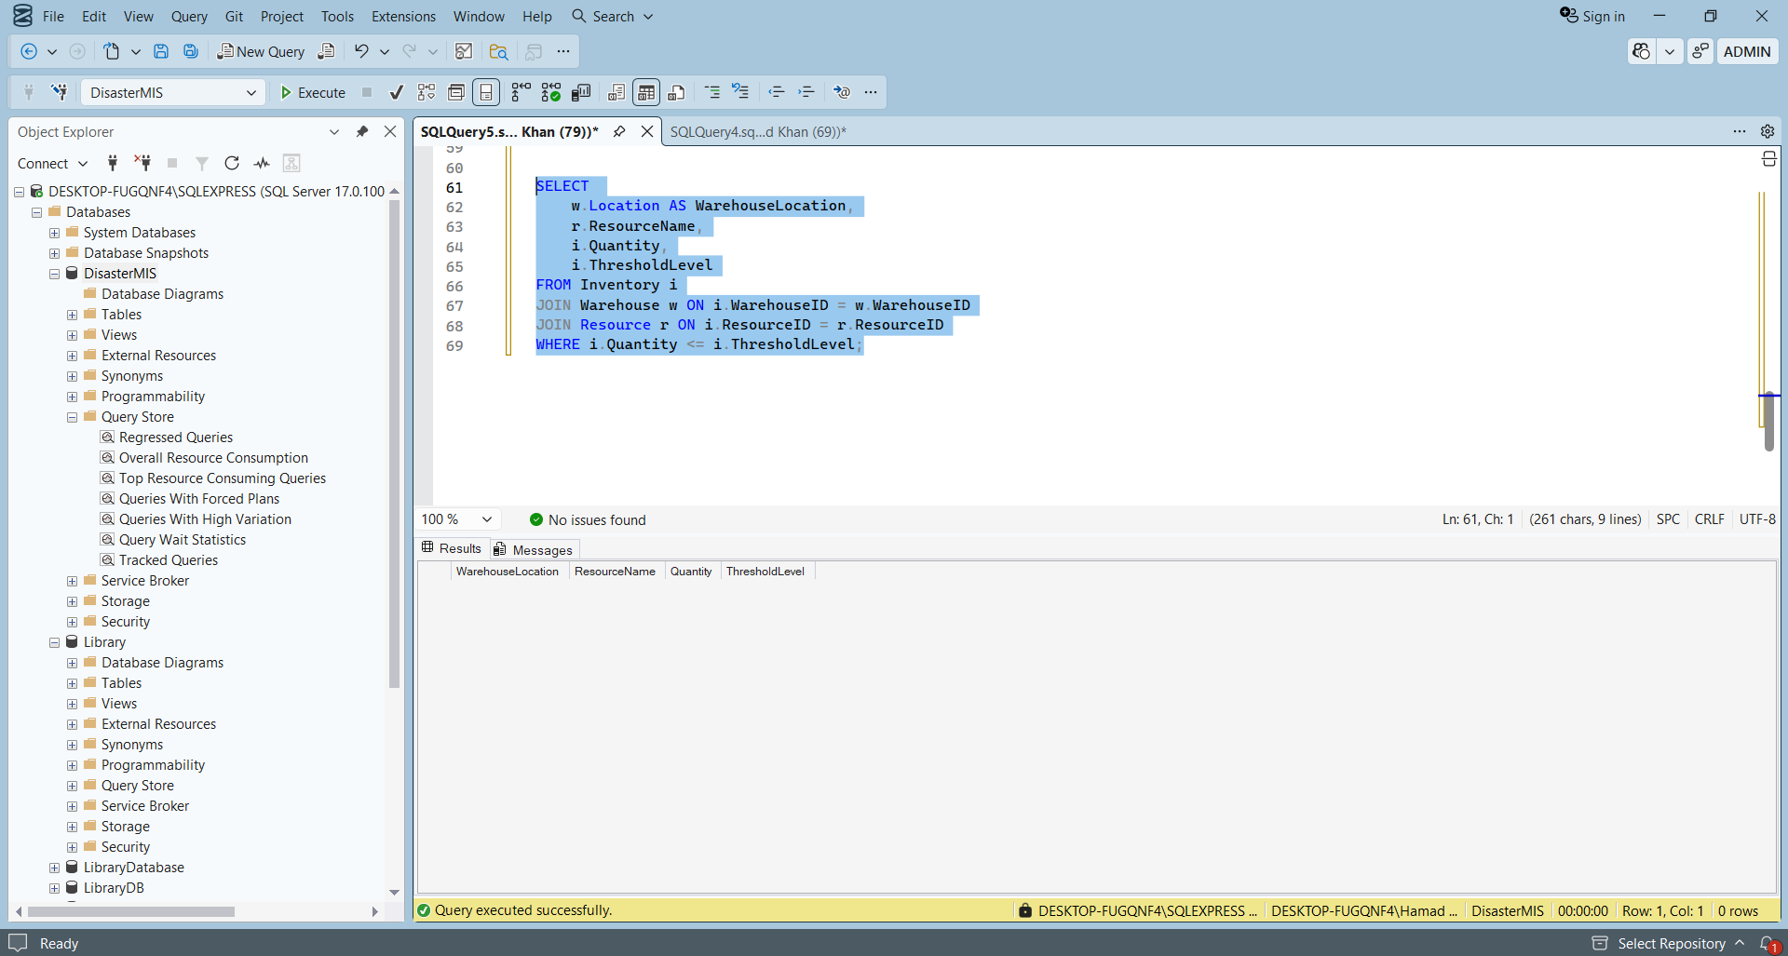

Fronend and System Demonstration:

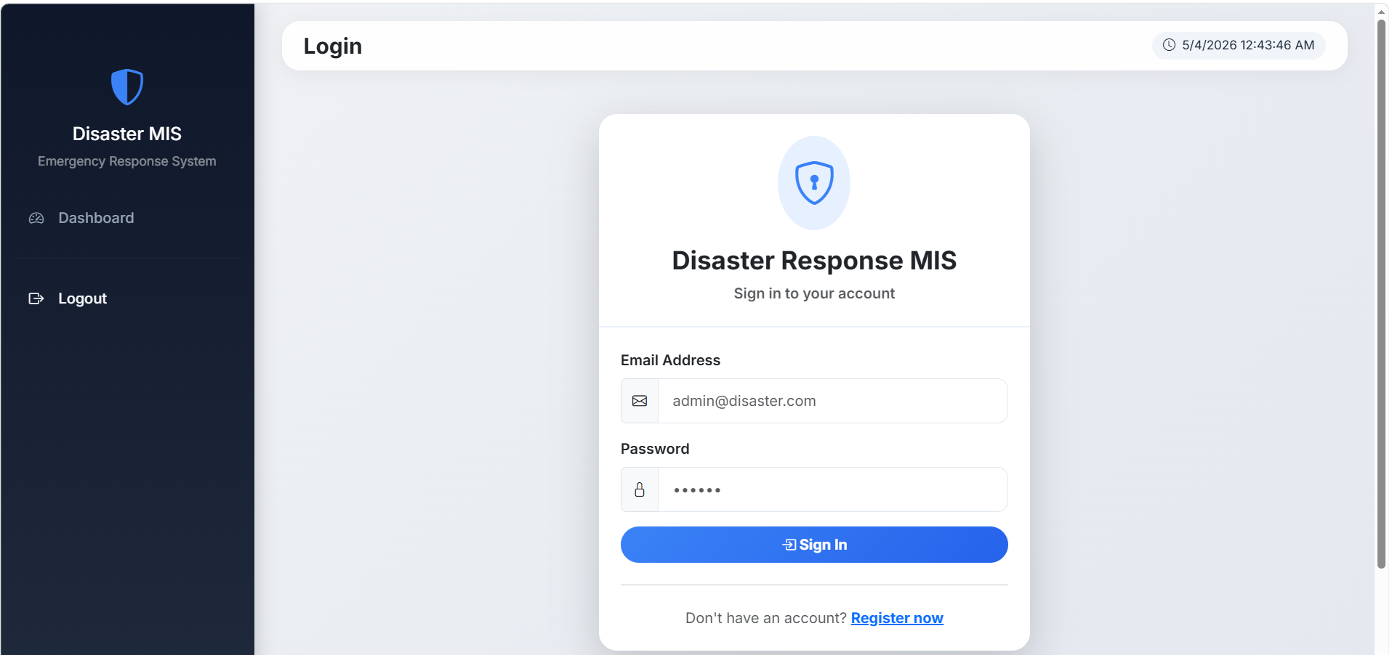
1.Login as Administrator:
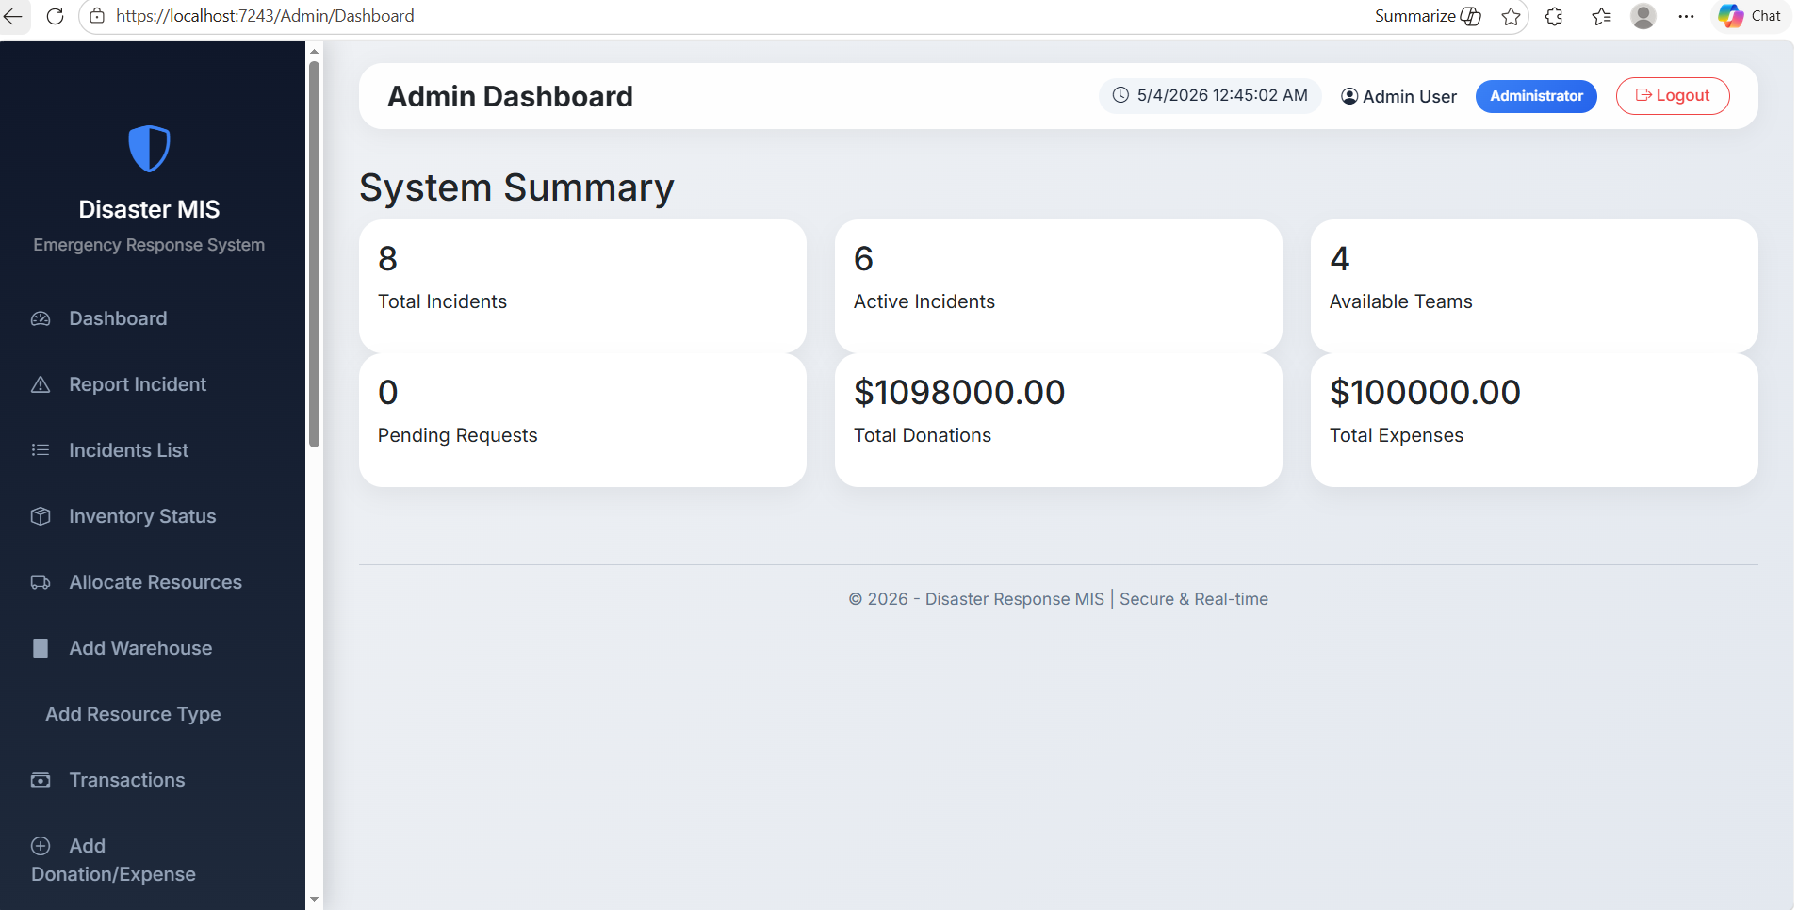
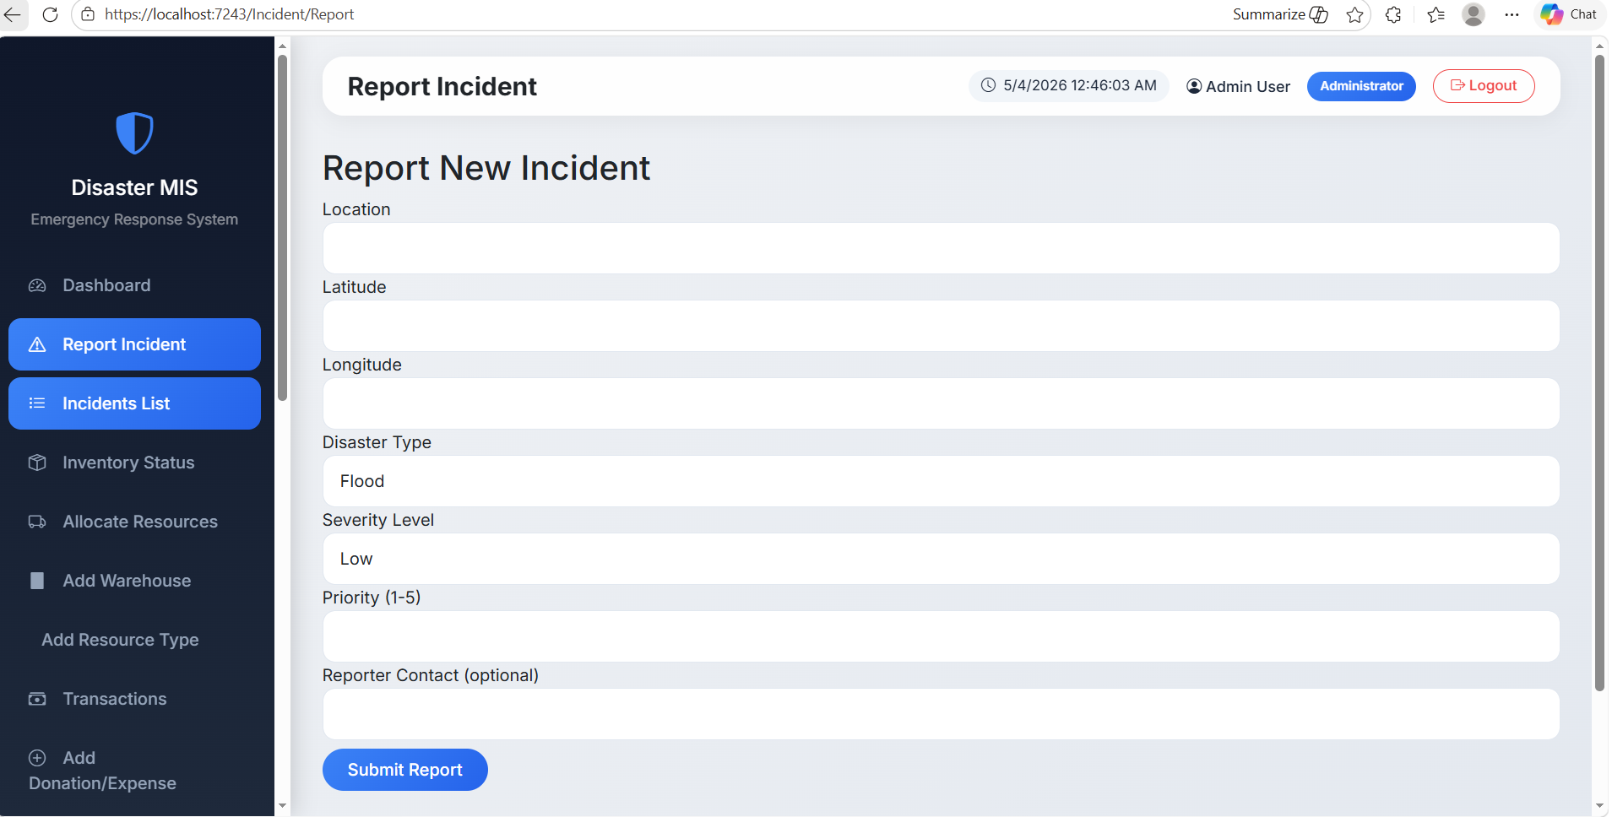
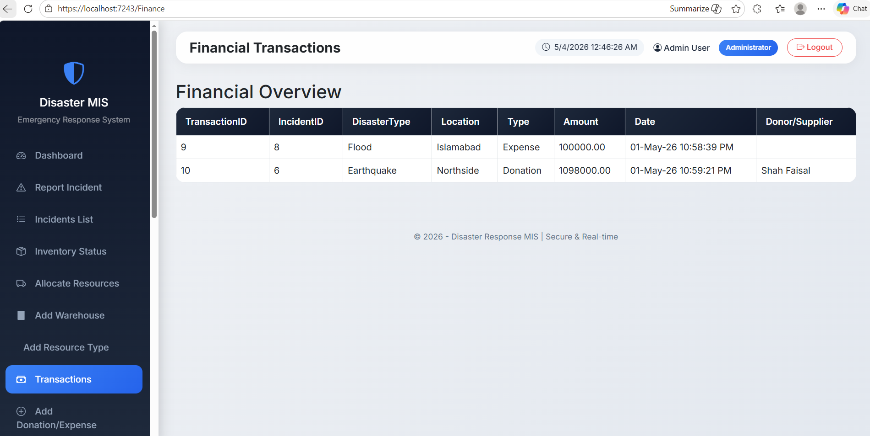
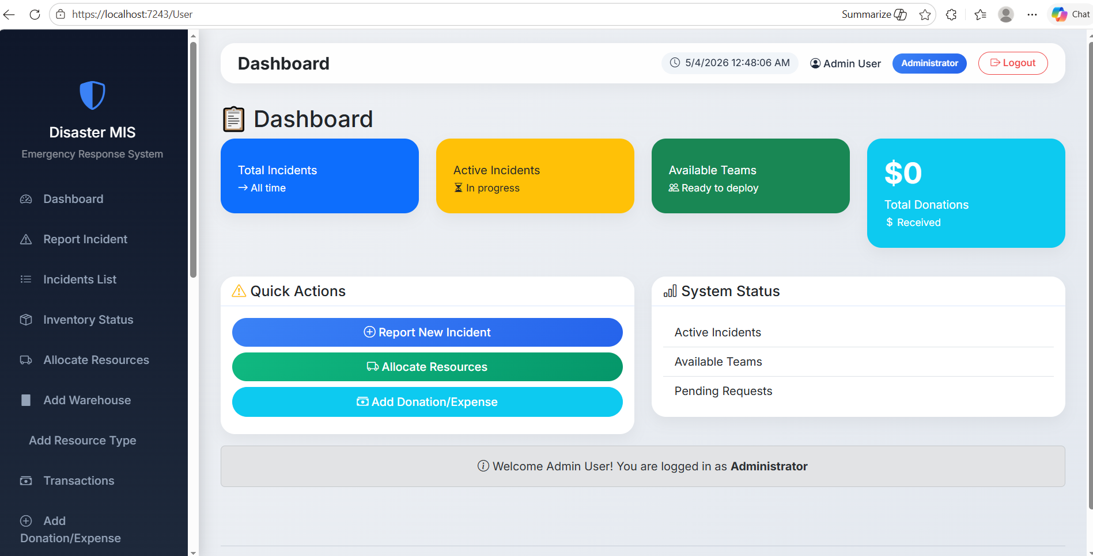
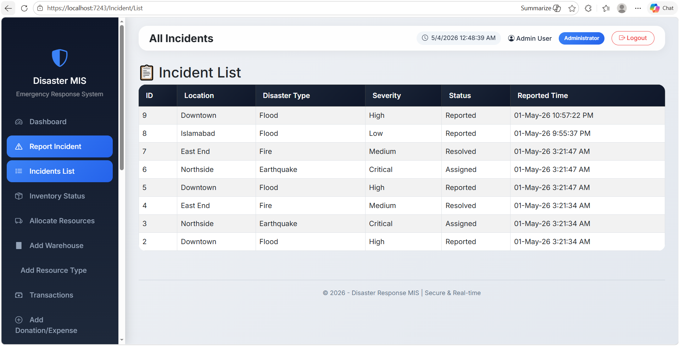
2.Logged In as FieldOfficer:
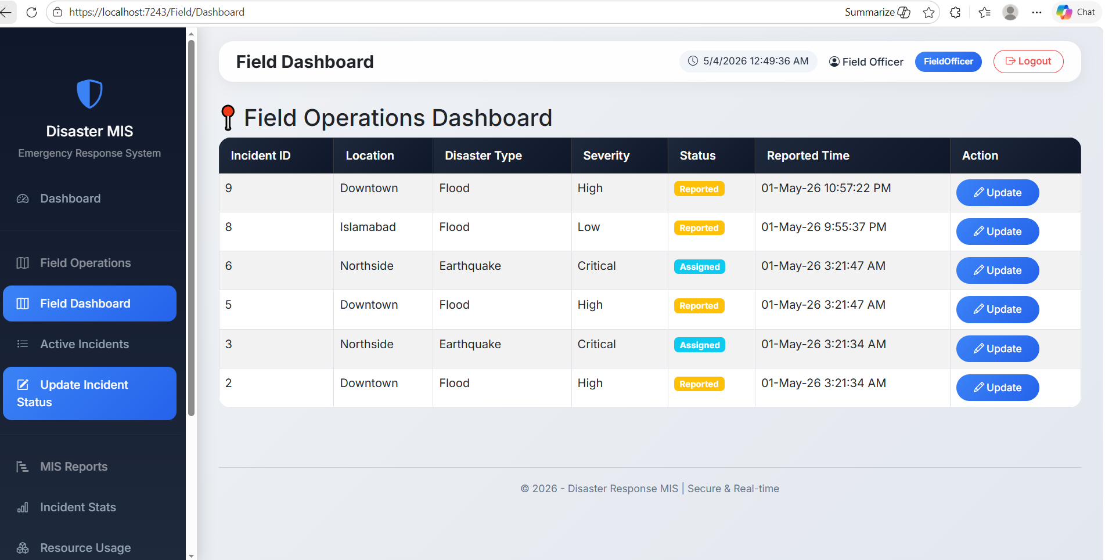
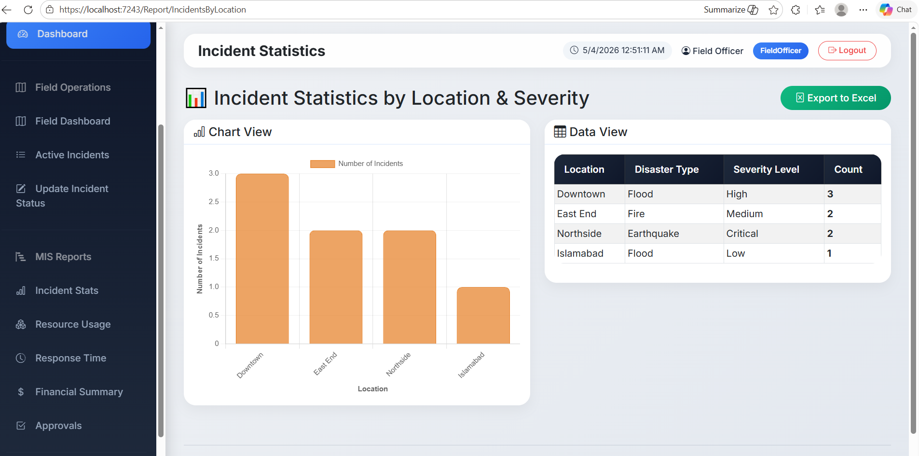
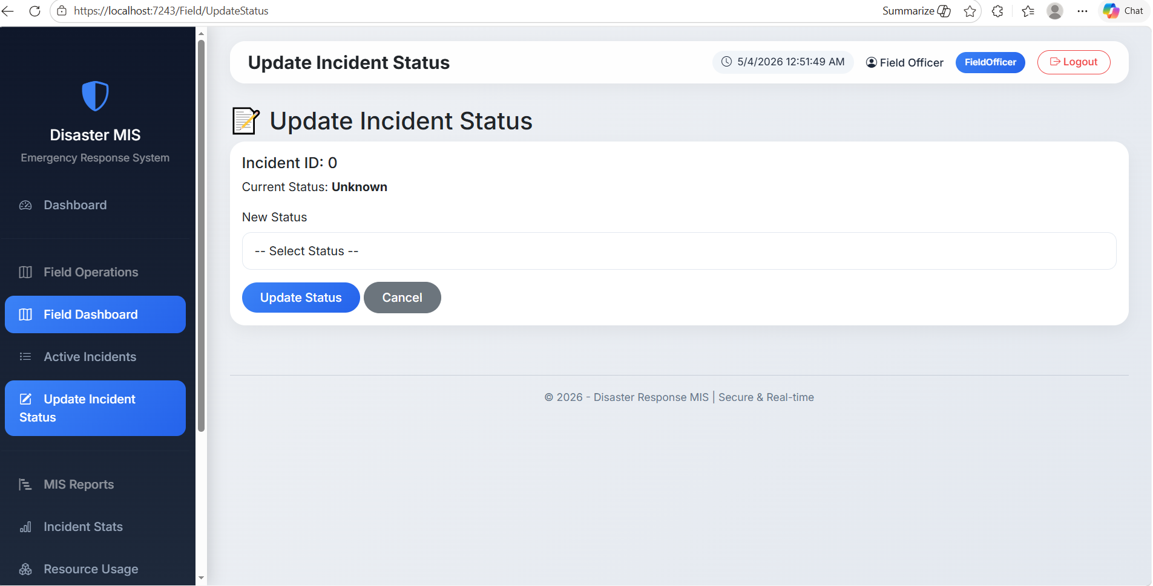
3. Log in as Emergency Operator

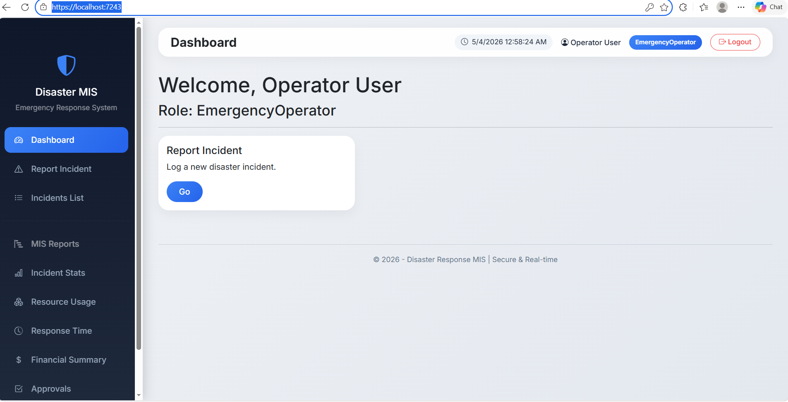
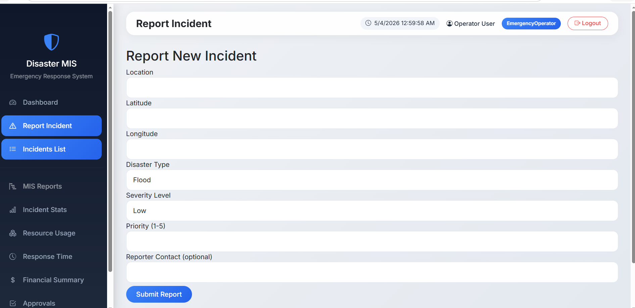
4. Logged in as Warehouse Manager
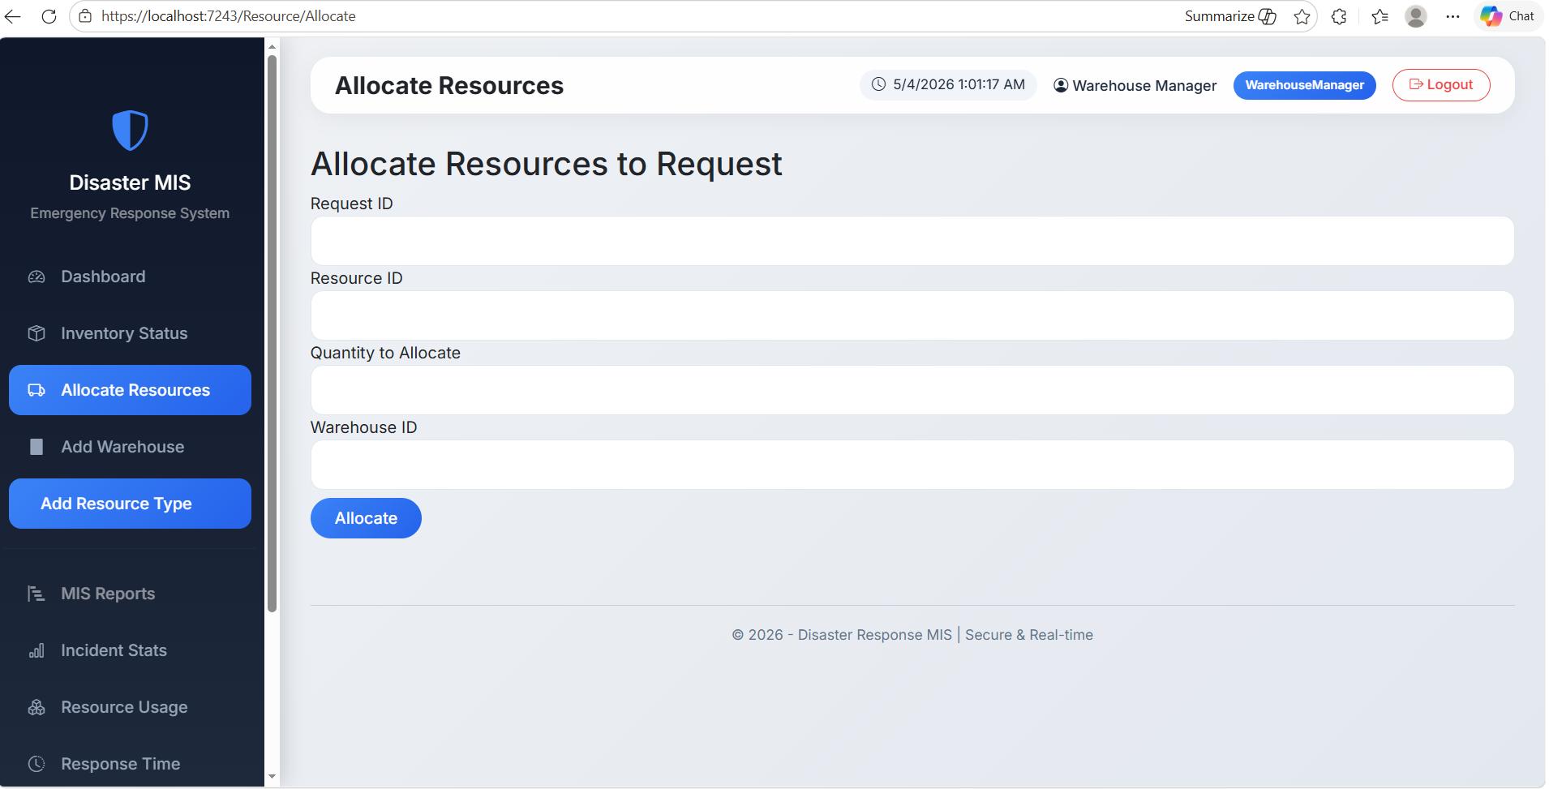
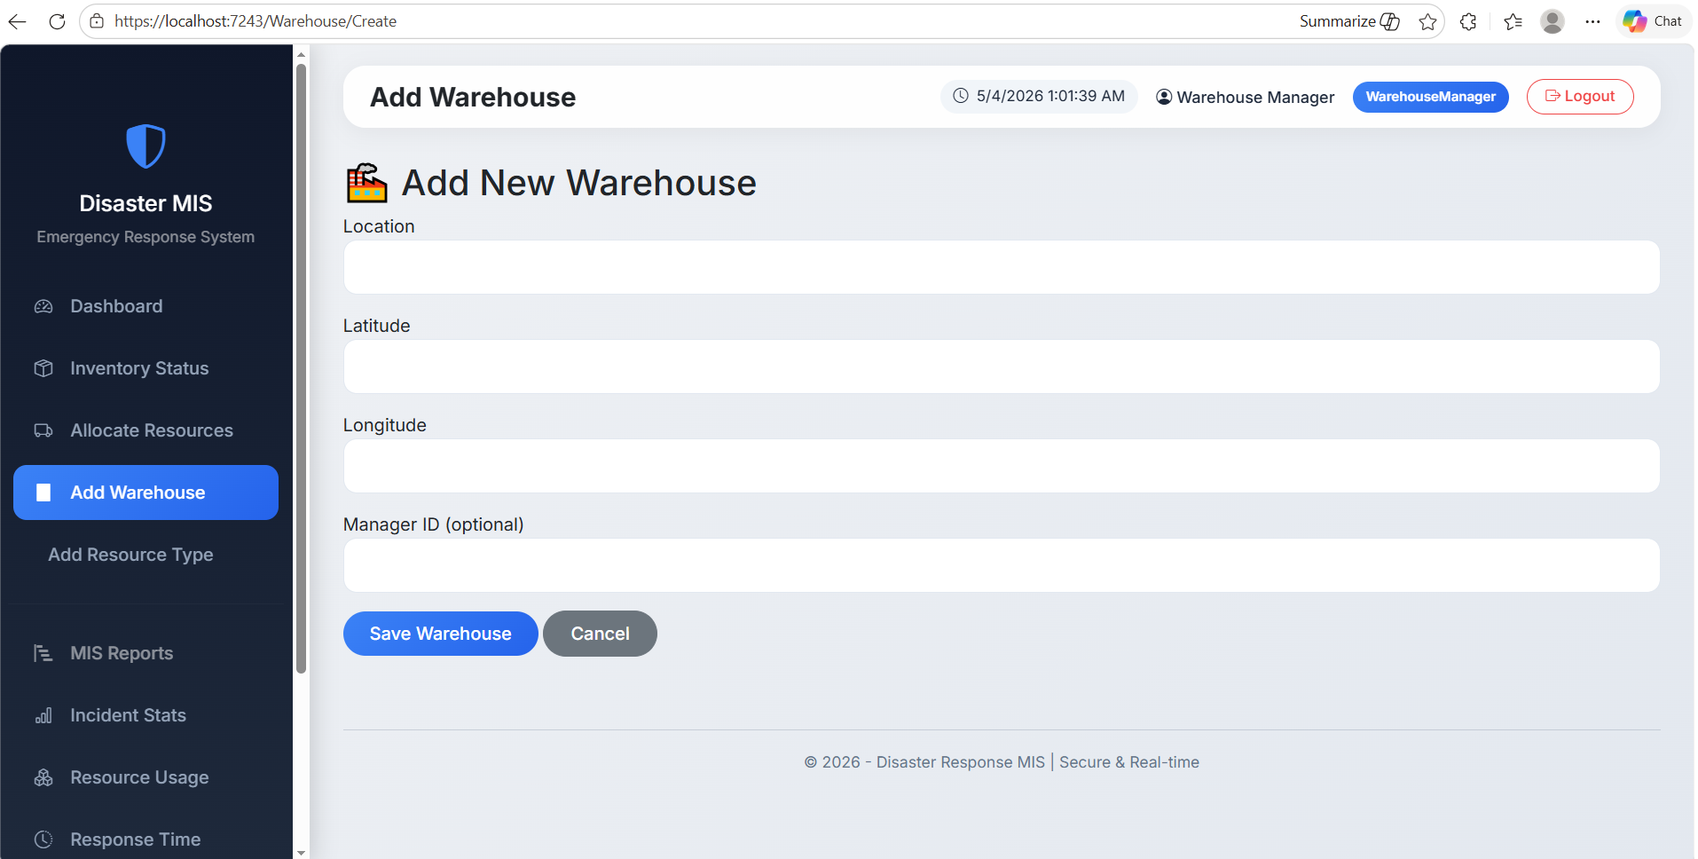
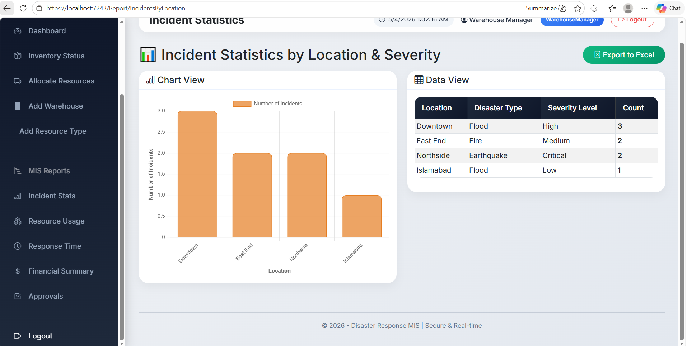
5. Finance Officer
