**EXPERIMENT: 1**

**Aim: Study of UNIX commands with all their important options.**

1. Information Management:
2. cal: **cal** command is a calendar command in Linux which is used to see the calendar of a specific month or a whole year.

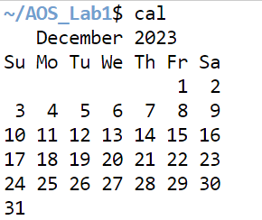

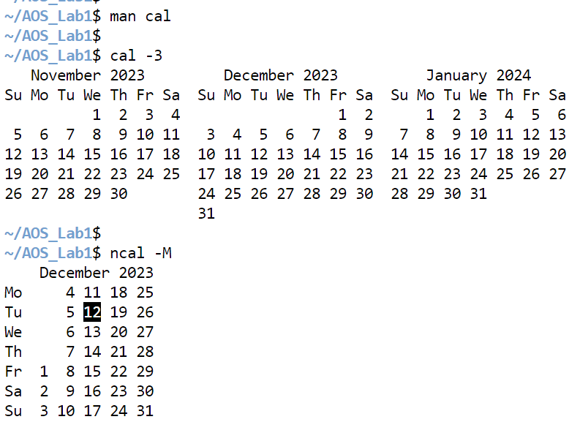

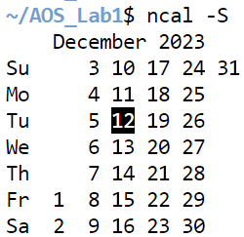

1. date: **date**command is used to display the system date and time. date command is also used to set date and time of the system.

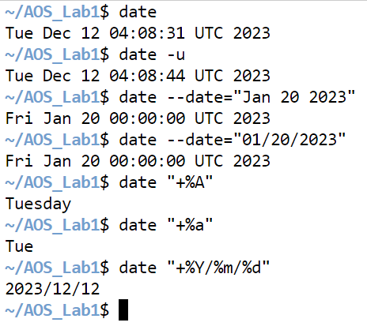

1. tty: The **tty** command of the terminal basically prints the file name of the terminal connected to standard input. **tty** is short for teletype, but popularly known as a terminal it allows you to interact with the system by passing on the data (your input) to the system and displaying the output produced by the system.

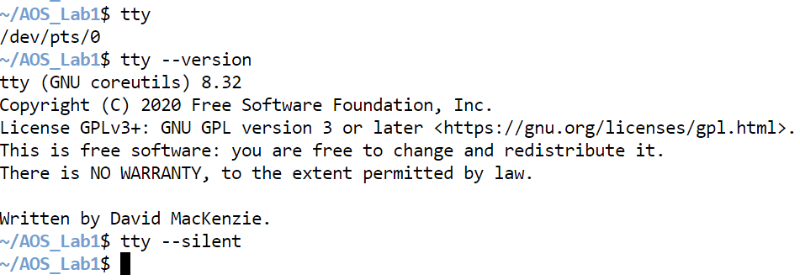

1. sh: **sh** is a command language interpreter that executes commands read from a command line string, the standard input, or a specified file.
2. env: **env** is used to either print environment variables. It is also used to run a utility or command in a custom environment.

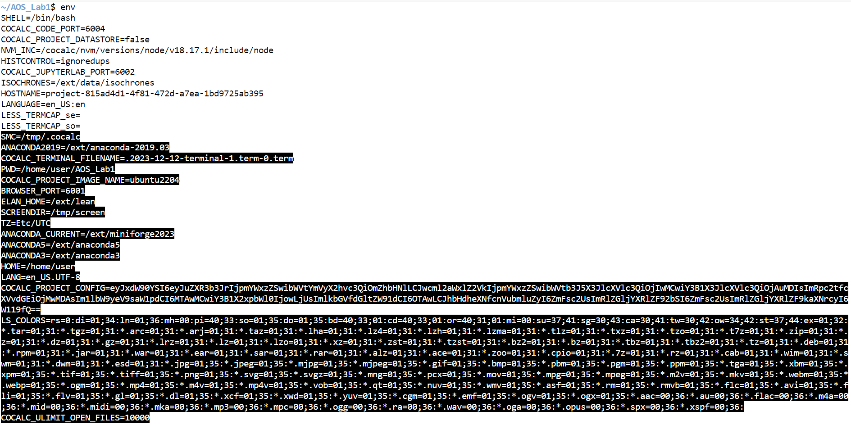

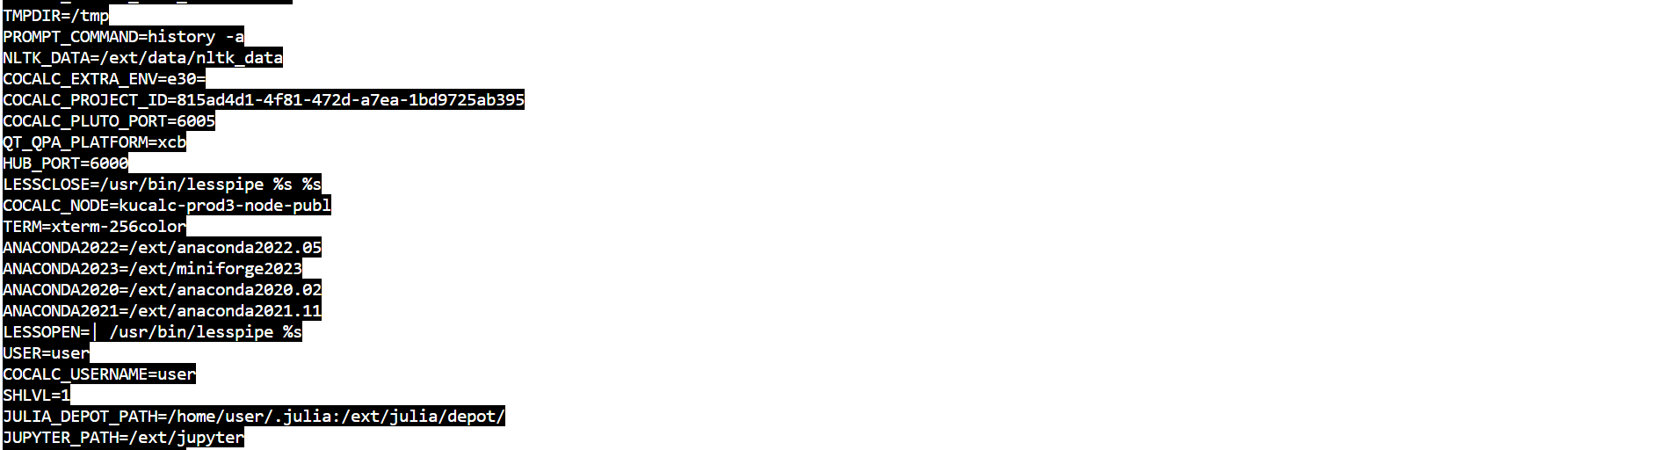

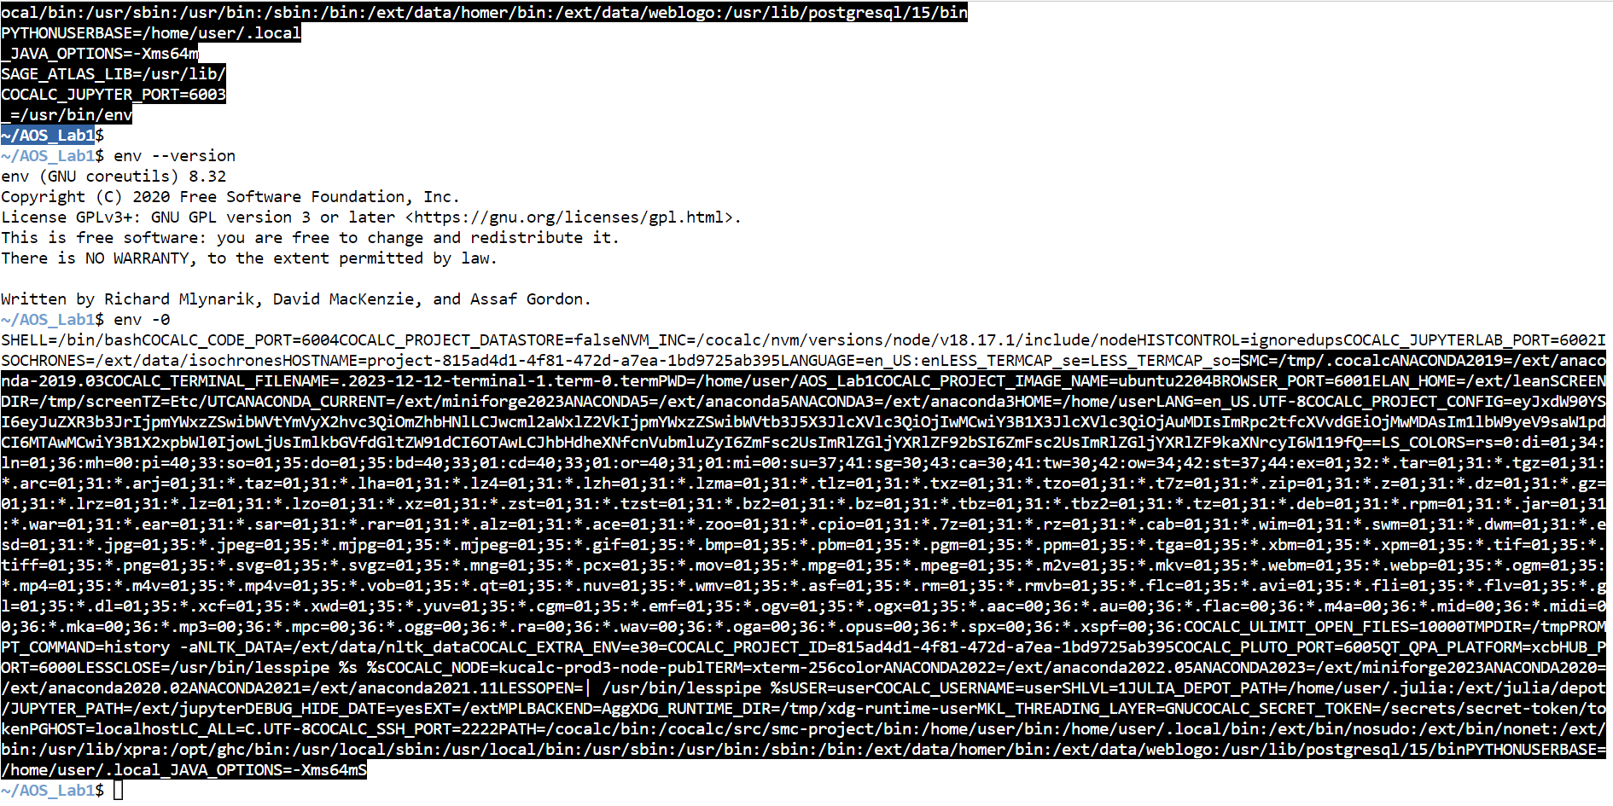

1. set: It is used to set or unset specific flags and settings( determines the behaviour of the script and helps in executing the tasks without any issue.) inside the shell environment. It can be used to change or display the shell attributes and parameters.

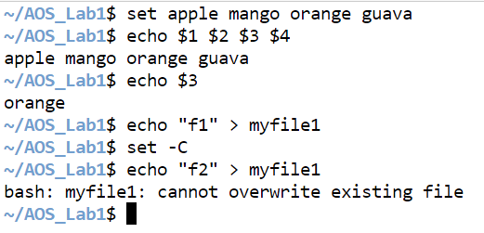

1. man: ***man*** command in Linux is used to display the user manual of any command that we can run on the terminal. It provides a detailed view of the command which includes NAME, SYNOPSIS, DESCRIPTION, OPTIONS, EXIT STATUS, RETURN VALUES, ERRORS, FILES, VERSIONS, EXAMPLES, AUTHORS and SEE ALSO.
2. who: The who command is used to get information about currently logged in user on to system.
3. whoami: **whoami** command is used both in Unix Operating System and as well as in Windows Operating System.

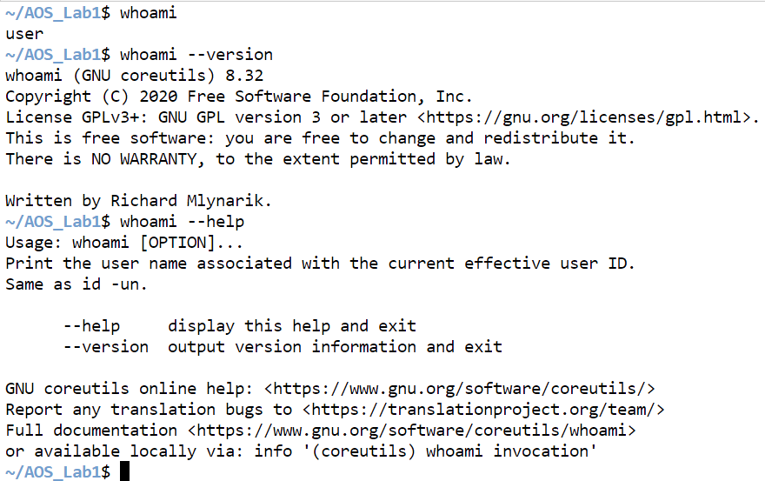

1. Utility Commands:
2. wc: wc stands for **word count**. It is used to find out **number of lines**, **word count**, **byte and characters count** in the files specified in the file arguments. wc stands for **word count**.

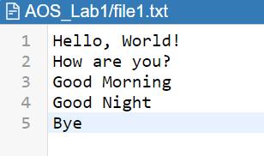 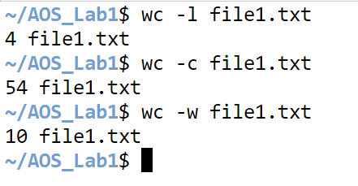

1. echo: The **echo** command in Linux is a built-in command that allows users to display lines of text or strings that are passed as arguments. It is commonly used in shell scripts and batch files to output status text to the screen or a file.

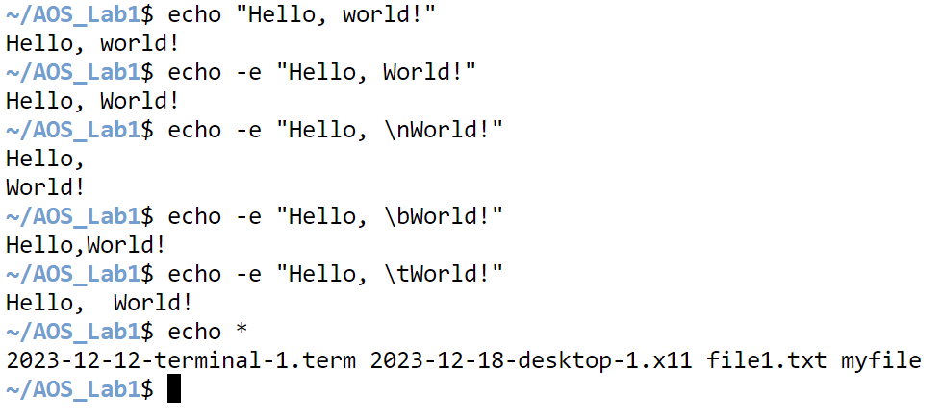

1. tail: The tail command, as the name implies, prints the last N number of data of the given input. By default, it prints the last 10 lines of the specified files. If more than one file name is provided then data from each file is preceded by its file name.

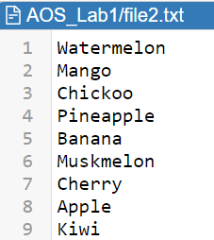

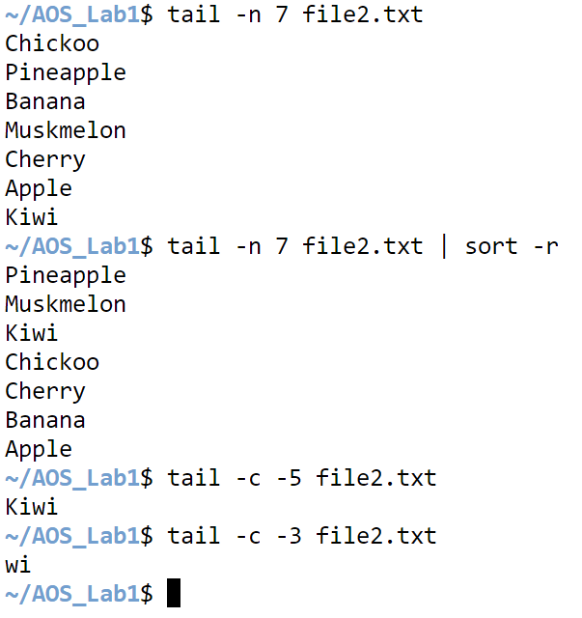

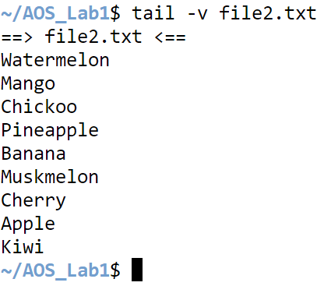

1. less: Less command is a Linux utility that can be used to read the contents of a text file one page (one screen) at a time. It has faster access because if a file is large, it doesn’t access the complete file, but accesses it page by page.
2. **more: more** command is used to view the text files in the command prompt, displaying one screen at a time in case the file is large (For example log files).

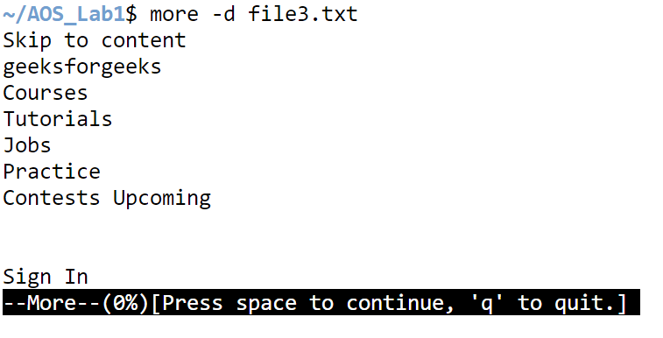

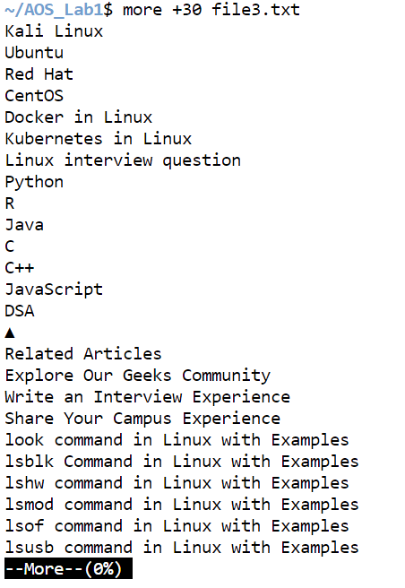

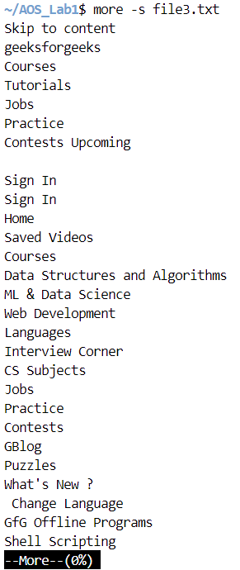

1. sort: SORT command is used to sort a file, arranging the records in a particular order. By default, the sort command sorts file assuming the contents are ASCII. Using options in the sort command can also be used to sort numerically.

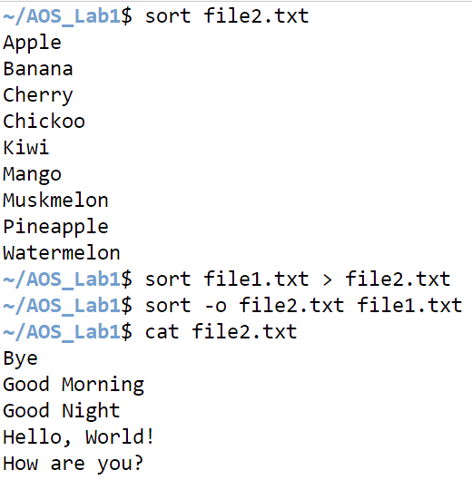

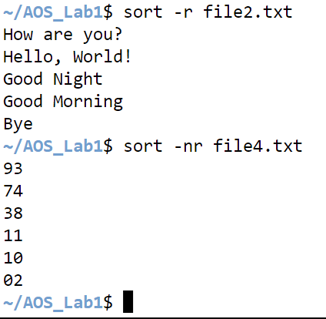

1. grep: The grep filter searches a file for a particular pattern of characters and displays all lines that contain that pattern.

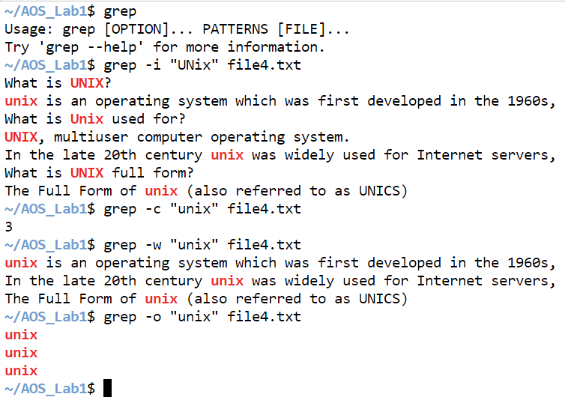

1. bc: **bc** command is used for command line calculator. It is similar to basic calculator by using which we can do basic mathematical calculations.

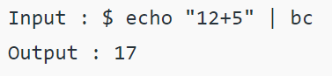

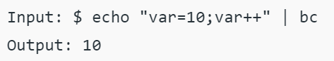

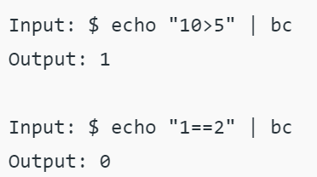

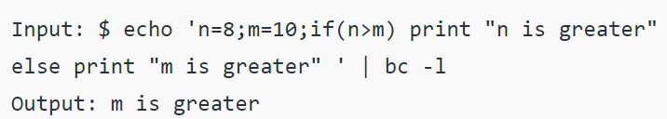

1. cmp: **cmp** command in Linux/UNIX is used to compare the two files byte by byte and helps you to find out whether the two files are identical or not.

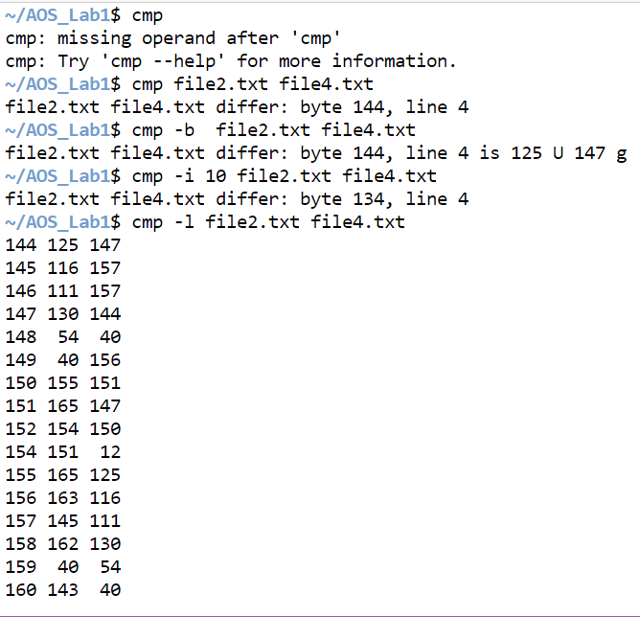

1. comm: comm compare two sorted files line by line and write to standard output; the lines that are common and the lines that are unique.

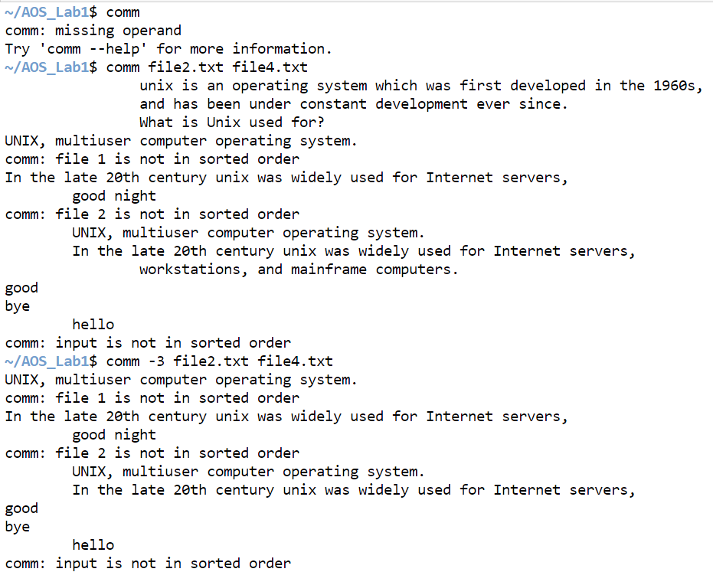

1. File System Managment:
2. ls: **ls** is a Linux shell command that lists directory contents of files and directories.  It provides valuable information about files, directories, and their attributes.

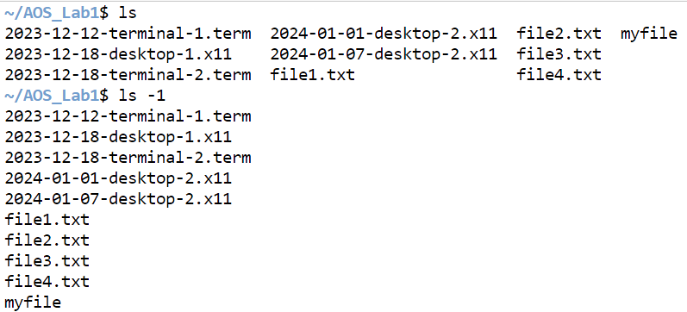

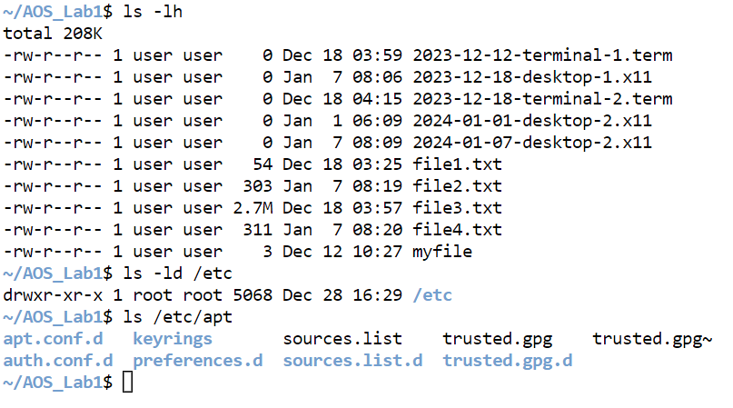

1. ln: The ln command in Unix is used to create hard or symbolic links between files.

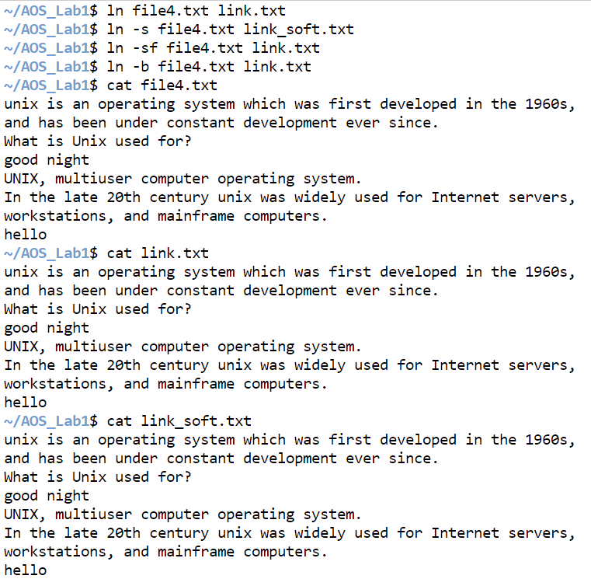

1. rm: rm stands for **remove** here. rm command is used to remove objects such as files, directories, symbolic links and so on from the file system like UNIX.

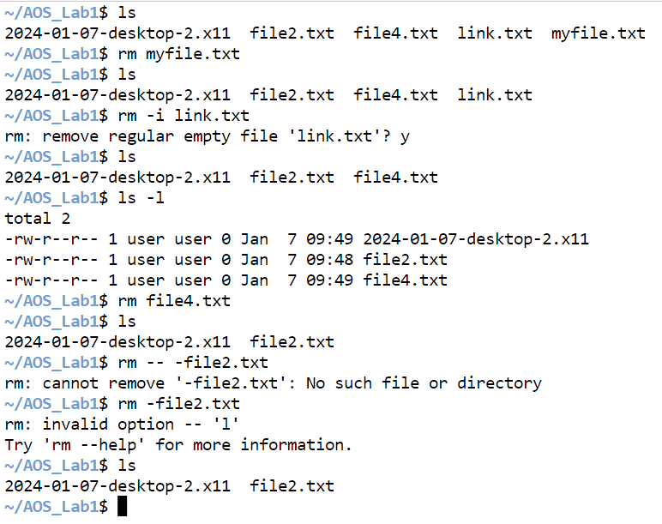

1. rmdir: The **rmdir command** is useful when you want to remove the empty directories from the filesystem in Linux. This command lets you specify the terminal to **remove a particular directory** right from the terminal.

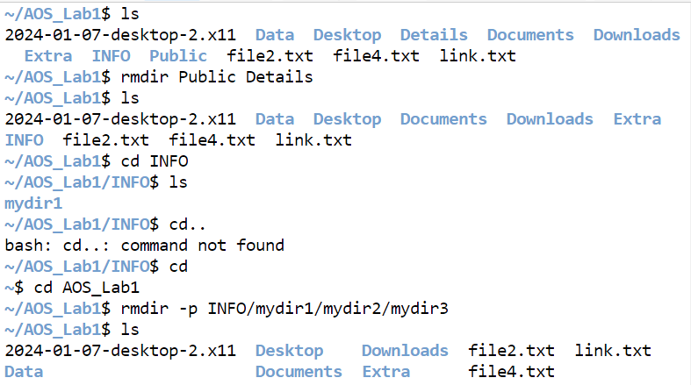

1. mkdir: In Linux, the ‘mkdir’ command is like a magic wand for creating folders super easily. ‘mkdir’ stands for “make directory,” and it helps you organize your computer stuff by creating folders with just one command.

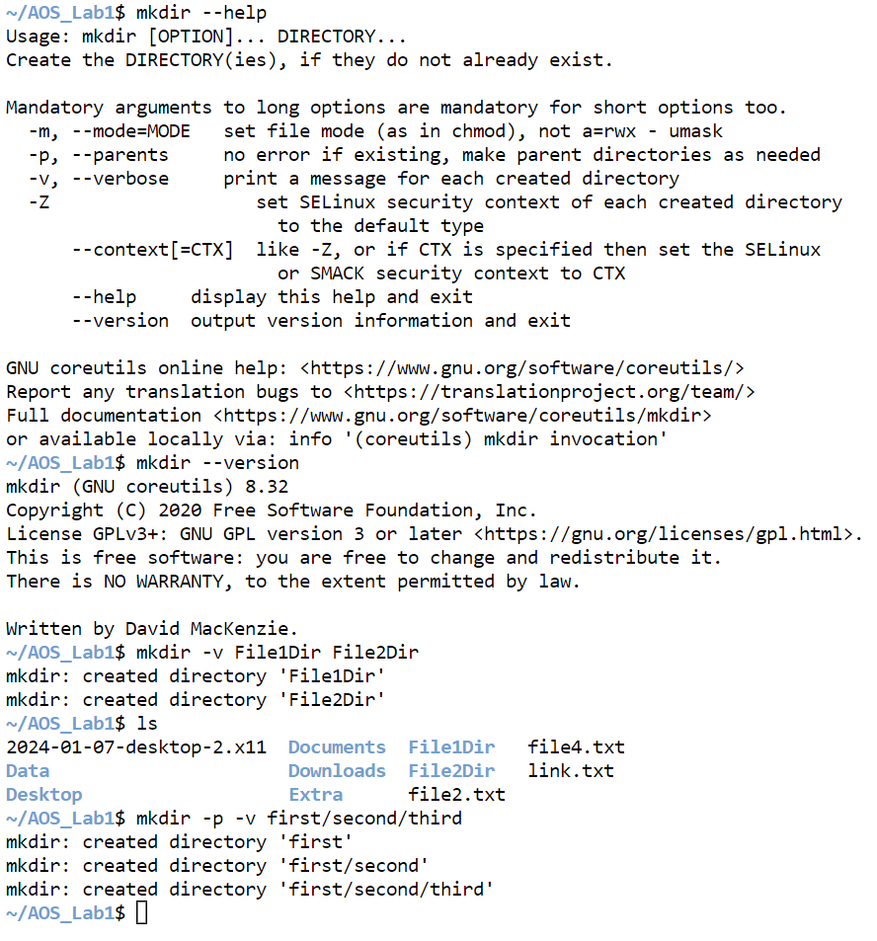

1. file: **file command** is used to determine the type of a file. **.file** type may be of human-readable(e.g. ‘ASCII text’) or MIME type(e.g. ‘text/plain; charset=us-ascii’). This command tests each argument in an attempt to categorize it.

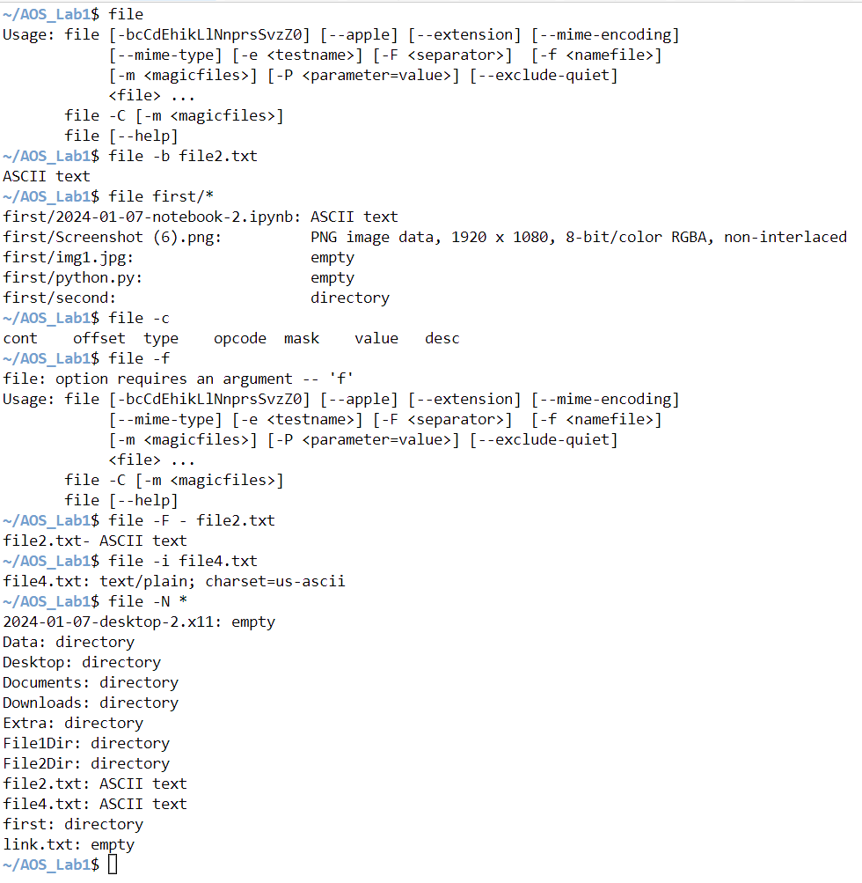

1. chmod: In Unix operating systems, the **chmod** command is used to change the access mode of a file. The name is an abbreviation of **change mode**.

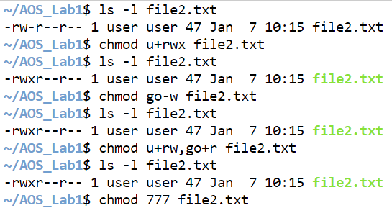

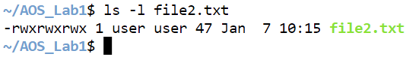

1. find: The find command in Linux is a dynamic utility designed for comprehensive file and directory searches within a hierarchical structure. Its adaptability allows users to search by name, size, modification time, or content, providing a flexible and potent solution.

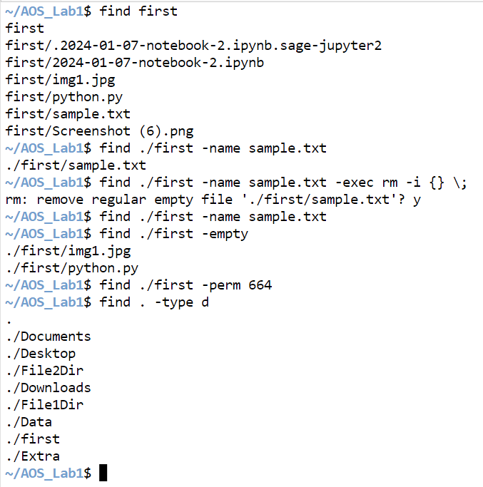

1. od: **od**command in Linux is used to convert the content of input in different formats with octal format as the default format.

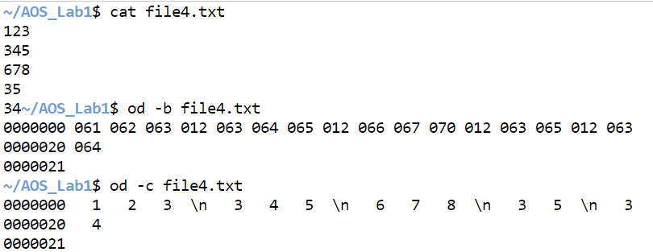

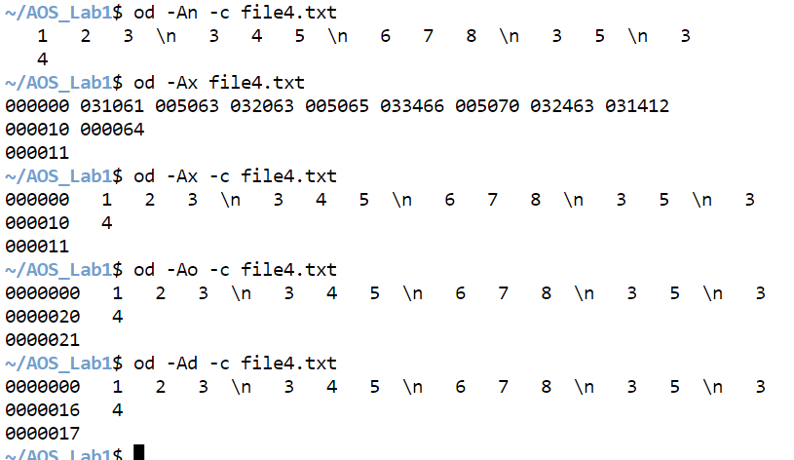

1. pwd: The ‘pwd,’ which stands for “print working directory.” In this article, we will delve into the ‘pwd’ command, exploring its functionality, usage, and various examples.It prints the path of the working directory, starting from the root.

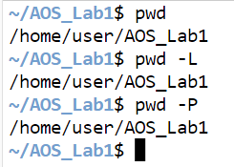

1. locate: locate command in Linux is used to find the files by name. There are two most widely used file-searching utilities accessible to users called to find and locate.

**Syntax of `locate` command in Linux**

**locate [OPTION]... PATTERN...**

1. Updated: The 'update' command for Linux is a fundamental command for system maintenance. To update the package lists for upgrades and new package installations, use 'sudo apt-get update' or 'sudo apt update'. For a complete system update, use the 'upgrade' command after the 'update' command.

Syntax:

'sudo apt-get update' or 'sudo apt update'

1. Mount: **mount** command is used to mount the filesystem found on a device to big tree structure(**Linux** filesystem) rooted at ‘**/**‘.

**Some Important Options:**

* **l** : Lists all the file systems mounted yet.
* **h** : Displays options for command.
* **V** : Displays the version information.
* **a** : Mounts all devices described at **/etc/fstab**.
* **t** : Type of filesystem device uses.
* **T** : Describes an alternative fstab file.
* **r** : Read-only mode mounted.

1. Unmount: The **umount** command detaches the file system(s) mentioned from the file hierarchy. A file system is specified by giving the directory where it has been mounted. Giving the special device on which the file system lives may also work, but is obsolete, mainly because it will fail in case this device was mounted on more than one directory.

**Some Important Options:**

**-V**: Print version information and exit.  
**-h**: Print a help message and exit.  
**-v**: Run in verbose mode.  
**-n**: Unmount without writing in /etc/mtab.  
**-r**: In case unmounting fails, try to remount read-only.  
**-d**: In case the unmounted device was a loop device, also free this loop device.  
**-i**: Don’t call the /sbin/umount.filesystem helper even if it exists. By default /sbin/umount.filesystem helper is called if one exists.  
**-a**: All of the file systems described in /etc/mtab are to be unmounted. (With umount version 2.7 and later, the proc filesystem is not unmounted.)

1. mv: The `mv` command in Linux is like a superhero tool that can do a bunch of cool stuff with your files and folders.

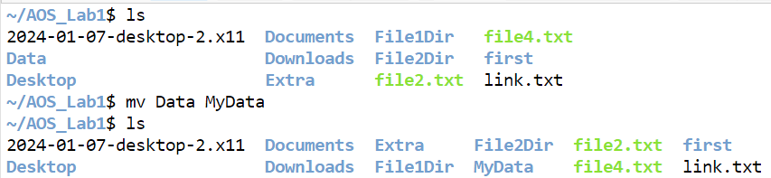

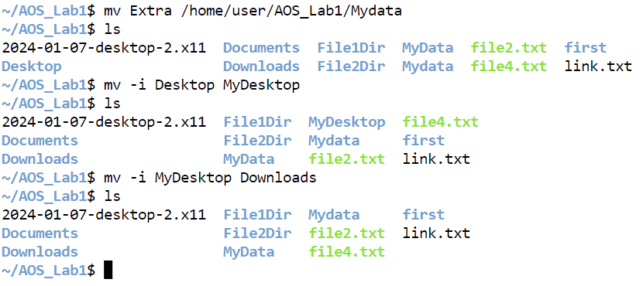

1. Process Managment:
2. ps: The `**ps`** command, which stands for “process status,” is like a computer tool that helps you see what’s happening inside your Linux computer. Imagine your computer is doing several things simultaneously, like running different programs or apps.

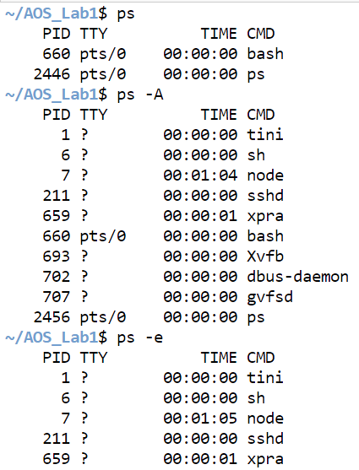

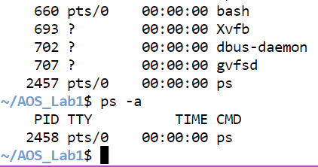

1. kill: kill command in Linux (located in /bin/kill), is a built-in command which is used to terminate processes manually. kill command sends a signal to a process that terminates the process.

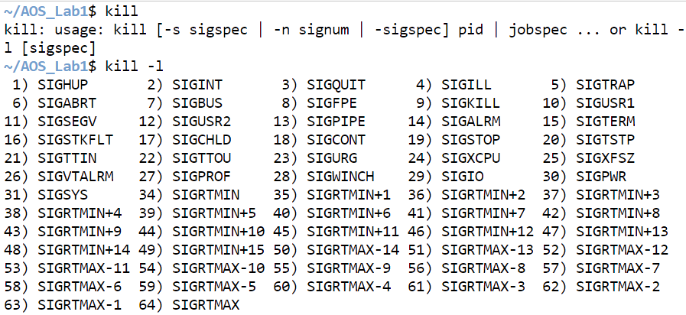

1. Compliation and Debugging:
2. cc: **cc** command is stands for **C Compiler**, usually an alias command to gcc or clang. As the name suggests, executing the cc command will usually call the **gcc** on Linux systems. It is used to compile the C language codes and create executables.

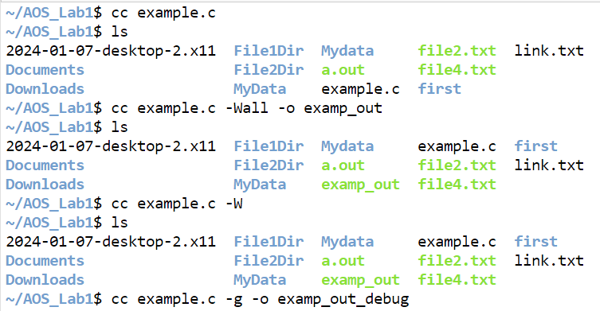

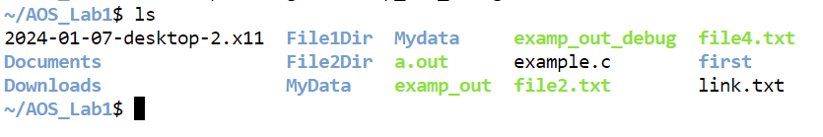

1. gdb: **gdb** is the acronym for GNU Debugger. This tool helps to debug the programs written in C, C++, Ada, Fortran, etc. The console can be opened using the **gdb** command on terminal.

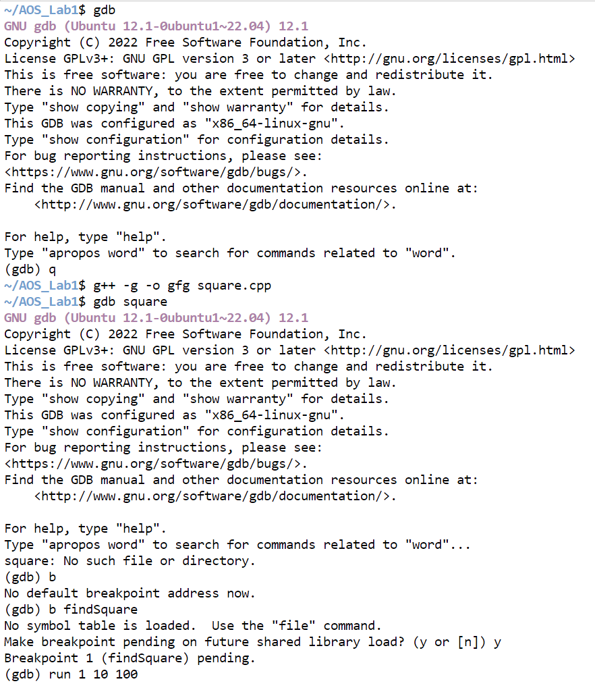

1. Editors:
   1. vi: The default editor that comes with the UNIX operating system is called **vi** (visual editor). Using vi editor, we can edit an existing file or create a new file from scratch. we can also use this editor to just read a text file. The advanced version of the vi editor is the [**vim**](https://www.geeksforgeeks.org/getting-started-with-vim-editor-in-linux/) editor.
   2. joe: JOE was among the default editors in the early popular Linux distributions, which gave it some prominence and helped build a user base. It continues to be included as an option in Linux distributions, sometimes in the critical role as a "rescue mode" editor.
   3. mcedit: mcedit is a link to mc, the main GNU Midnight Commander executable. Executing GNU Midnight Commander under this name requests staring the internal editor and opening the file specified on the command line. The editor is based on the terminal version of cooledit - standalone editor for X Window System.
   4. emac: Emacs is a text editor designed for POSIX operating systems and available on Linux, BSD, macOS, Windows, and more. Users love Emacs because it features efficient commands for common but complex actions and for the plugins and configuration hacks that have developed around it for nearly 40 years.