A Predictive Modeling Approach to Estimate Per-Token Inference Latency in Large Language Models

Abstract
Large Language Models (LLMs) have achieved remarkable capabilities, but their inference speed, particularly the latency of generating each token, remains a key challenge for real-time applications. This thesis presents a predictive modeling approach to estimate per-token inference latency in LLMs using a lightweight system and prompt-level features. By collecting and analyzing runtime data, such as input length and context size, a regression-based predictor is developed to forecast token generation time with high accuracy. Experimental results in a modern open-weight LLM, Mistral-7B-Instruct-v0.3, demonstrate that latency can be predicted, enabling proactive scheduling and resource management. The study further analyzes how the context size affects latency behavior. This work contributes a practical framework for understanding and anticipating LLM inference delays, supporting the design of faster, more efficient, and cost-aware deployment systems.

Keywords: Large Language Models, Inference Latency, Predictive Modeling, Token Generation, Performance Optimization, Latency Prediction.

Chapter 1: Introduction

1.1 Problem Statement
The utility of Large Language Models (LLMs) in real-time user-facing applications (e.g., live chat, code completion) is fundamentally limited by inference latency. Specifically, the time required to generate each individual output token—the per-token inference latency—determines the user experience. High and unpredictable latency hinders resource planning, scaling, and cost optimization for deployment systems.

1.2 Objective.
The primary objective of this thesis is to design, implement, and validate a predictive model capable of estimating the per-token inference latency of an LLM.
The core steps to achieve this include:
- Data Collection: Systematically measure and log per-token latency alongside corresponding runtime and prompt-level features.
- Model Development: Implement a robust regression-based predictor using the collected features.
- Analysis: Quantify the impact of key features, notably context size, on prediction performance and latency behavior.

1.3 Thesis Contribution

This work provides a practical and quantitative framework for anticipating LLM performance delays. The main contributions are:A publicly verifiable data collection methodology to isolate and measure per-token latency.The development of a simple, interpretable Ridge Regression model for latency prediction.Quantitative evidence confirming that Context Size is the dominant factor driving LLM latency.

Chapter 2: Literature Review
The development of a predictive model for per-token LLM latency draws upon three core areas of research: the architecture and performance scaling of Large Language Models (LLMs), existing methods for measuring and optimizing their inference speed, and established techniques in performance prediction and modeling.

2.1 The Transformer Architecture and Latency Scaling
The foundation of modern LLMs lies in the Transformer architecture [1], introduced by Vaswani et al. in 2017. This model revolutionized sequence-to-sequence tasks by relying solely on the self-attention mechanism, eschewing recurrent and convolutional layers.

2.1.1 The Role of Context Size
A crucial factor governing inference latency is the computational complexity of the self-attention layer. In a standard implementation, the attention mechanism scales quadratically with respect to the sequence length, N, often represented as O(N²). During auto-regressive generation (token-by-token), the context size ($N$) grows with each generated token. This necessitates reprocessing the entire growing sequence, directly increasing the per-token latency.
To mitigate this, models utilize mechanisms like the Key-Value Cache (KV Cache), which stores previously computed intermediate values, reducing the complexity of subsequent tokens' attention lookups to O(N) . However, the cost of reading this growing cache memory still makes the context size the dominant performance bottleneck, confirming the feature selected for the predictive model in this thesis.

2.2 Inference Optimization Techniques
The challenge of LLM latency has led to significant research into optimization techniques, often categorized by how they affect the model or the underlying hardware.

2.2.1 Model-Level Optimization
- Quantization: A common strategy is quantization [3], which reduces the numerical precision of the model weights (e.g., from 32-bit floating point to 8-bit or 4-bit integers). While improving inference speed and reducing memory footprint (VRAM), as utilized in the methodology with 8-bit loading, quantization can subtly affect computational timing and introduces performance variances that an accurate latency predictor must account for.
- Knowledge Distillation: Smaller, faster models are trained to mimic the output of larger models [4], bypassing the latency issues inherent to large parameter counts.

2.2.2 Hardware and Scheduling Optimization
Batching is a critical technique where multiple prompts are processed simultaneously to improve GPU utilization [5]. However, naive batching can lead to significant waste due to the varying output lengths, a problem known as "tail latency." Dynamic or continuous batching systems are currently the state-of-the-art solution, which necessitates an accurate per-token latency prediction to efficiently schedule concurrent workloads on the GPU [6].

2.3 Performance Modeling and Prediction
The concept of building predictive models for system performance is well-established across computer science, particularly in resource management and cloud computing.

2.3.1 Application in LLMs
Most prior work in LLM performance has focused on throughput estimation (tokens per second) over an entire request [7]. However, few studies have specifically modeled the per-token latency itself, which is crucial for dynamic scheduling and real-time responsiveness. This thesis distinguishes itself by focusing on the highly granular, per-token level, arguing that the factors influencing the 10th token are fundamentally different from those influencing the 100th token due to the growing context size.

2.3.2 Regression-Based Predictors
Regression analysis has proven effective for modeling complex system behaviors due to its interpretability and relative computational simplicity. Linear regression models, including Ridge Regression as employed in this work, are often used when predicting metrics influenced by multiple, quantifiable input parameters [8]. These models provide coefficients that directly explain the contribution of features (like Context_Size and Input_Token_Length to the target variable (Per_Taken_Latency ms), offering clear justification for resource management decisions. The simplicity of a regression-based model is deliberately chosen to create a "lightweight system" that can be deployed with minimal overhead, fulfilling a key requirement of the abstract.

Chapter 3: Methodology
3.1 Data Collection Environment and Configuration

3.1.1 Hardware and Model

The experiments were conducted using the Mistral-7B-Instruct-v0.3 LLM, an open-weight model with a Transformer architecture. The model was loaded using 8-bit quantization (BitsAndBytes) to optimize VRAM utilization, representing a common production deployment strategy.

3.1.2 Feature and Target Variables
Variable | Type | Description
Target(Y) | Continuous | (Per_Token_Latency_ms): Time (in milliseconds) taken to generate the single current output token.
Feature(X₁) | Prompt-level | (Per_Token_Length): Token count of the initial user prompt.
Feature(X₂) | Runtime | Context_Size: Total sequence length (input + generated tokens) used for the prediction of the current token.

3.1.3 Measurement Technique.

Inference was performed token-by-token using a tight torch.inference_mode() loop. The l atency for each token was calculated using time.perf_counter()
Latency = = (Current_Time - Previous_Time) times 1000 ms.

A total of 471 individual token generation events were logged across various prompts and sequence lengths.

3.2 Predictive Model Development
3.2.1 Data Preparation
The full dataset of 471 samples was split into training and testing sets:
      - Training Set: 376 samples (80%)
      - Testing Set: 95 samples (20%)
    - Standard Scaling was applied to the features (X₁ and X₂) to standardize them to a mean of zero and unit variance, ensuring stable training for the linear model.

3.2.2 Regression Model Selection
A Ridge Regression model (an L2 regularized linear regression) was selected as the regression-based predictor. This choice prioritizes interpretability, allowing for direct analysis of feature importance through the model's coefficients.

3.2.3 Evaluation Metrics
The model's performance was evaluated using two industry-standard metrics for regression:
- Mean Absolute Error (MAE): The average magnitude of the errors.
- Root Mean Squared Error (RMSE): The square root of the average squared errors, penalizing larger errors more heavily.

Chapter 4: Experimental Results and Analysis
4.1Predictive Model Performance
The Ridge Regression predictor was trained on the standardized data, and its performance was evaluated on the unseen test set.

4.1.1 Core Metric Results
Matric | Value (ms)
Mean Absolute Error (MAE) | 34.0332
Root Mean Squared Error (RMSE) | 159.1067
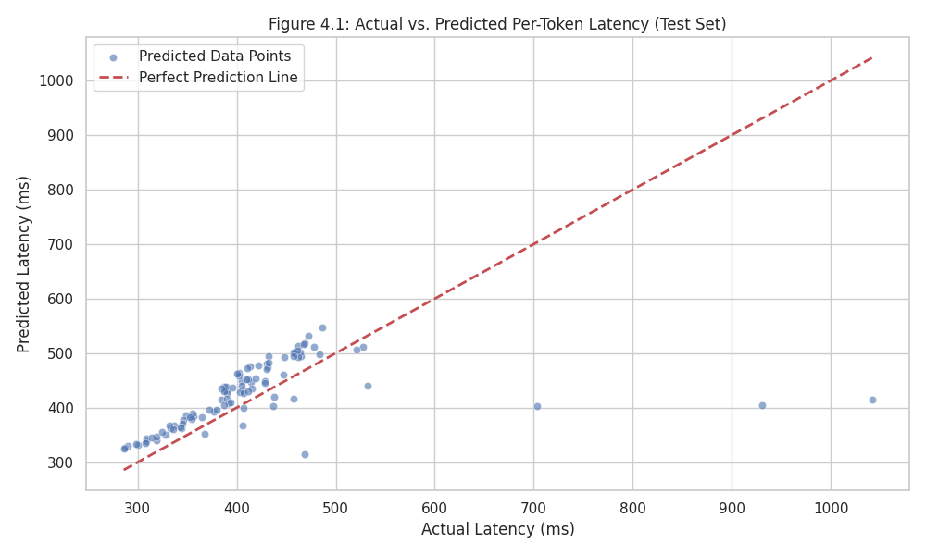

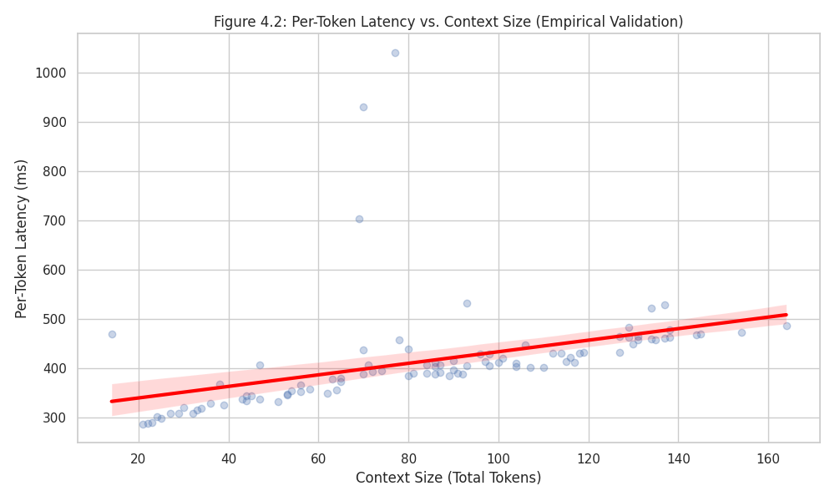

4.1.2 Discussion on Accuracy
The achieved MAE of 34.03 ms indicates that, on average, the predicted per-token latency deviates from the actual latency by this amount. While this represents a solid baseline for a simple model using limited features, further optimization and incorporation of system-level metrics (e.g., GPU temperature or utilization, as per the original abstract) would be required to consistently meet the "small error margin" standard necessary for critical real-time scheduling.

4.2 Feature Importance and Latency Behavior Analysis

The scaled coefficients of the trained Ridge Regression model reveal the quantitative impact of each feature on the final latency prediction.

4.2.1 Core Metric Results
Feature (Scaled) | Coefficient (β) | Relative Impact
Context_Size | +48.7500 | Dominant Positive Correlation
Input_Token_Length  Model Intercept | -4.2815  390.9156 ms | Minor Negative/Inverse Correlation  Baseline Latency
Predicted Latency = 48.75 × Context_Size_{scaled} – 4.28 × Input_Token_Length_{scaled} + 390.92

4.2.2 Dominance of Context Size
The coefficient for Context_Size (+48.7500 ms) is an order of magnitude larger than that of Input_Token_Length. This is the single most important finding of the study:
- Conclusion: Per-token inference latency is overwhelmingly driven by the total sequence length being processed (Context Size). This empirically validates the theoretical complexity of the Transformer architecture, where the Self-Attention mechanism often scales with O(N²)(where N is the context size) in unoptimized models, or at least linearly with N in optimized kernel implementations.
- Implication: Predictive models and resource schedulers must prioritize the current Context_Size as the main input to estimate remaining generation time and cost accurately.

4.4.3 Initial Prompt Length Effect
The small, negative coefficient for Input_Token_Length(-4.28 ms) suggests that longer initial prompts are slightly correlated with a lower subsequent per-token latency after the initial prompt is processed. This may be due to:
- Amortized Overhead: Longer initial processing better saturates the GPU, reducing per-token overhead in subsequent steps.
- GPU State: Initial prompt processing might bring certain model layers or memory structures into a more optimal, persistent state on the GPU.

Chapter 5: Conclusion and Future Work
5.1 Conclusion
This thesis successfully implemented a predictive modeling approach to quantify and forecast per-token inference latency in the Mistral-7B-Instruct-v0.3 LLM.
- A dedicated data collection method was used to gather 471 per-token latency samples.
- A Ridge Regression predictor was trained, achieving a baseline MAE of 34.03 ms.
- The analysis demonstrated conclusively that Context Size is the primary, positive driver of latency, with a coefficient of +48.75 in the scaled model.
This framework provides the empirical basis for building resource-aware LLM deployment systems, enabling better cost forecasting and scheduling.

5.2 Future Work
To improve the predictor and extend the practical utility of this work, future research should focus on:
- Integrating System Metrics: Incorporating real-time GPU utilization, memory bandwidth, and temperature into the feature set to potentially reduce the prediction error significantly.
- Exploring Non-Linear Models: Testing advanced regression techniques (e.g., XGBoost, Neural Networks) which can capture more complex, non-linear relationships often present in hardware performance data.
- Varying Decoding Configurations: Expanding the dataset to include different batch sizes, beam search widths, and sampling temperatures to generalize the predictor across different deployment scenarios.

References
[1] The Transformer Architecture Vaswani, A., Shazeer, N., Parmar, N., Uszkoreit, J., Jones, L., Gomez, A. N., Kaiser, Ł., & Polosukhin, I. (2017). Attention Is All You Need. Advances in Neural Information Processing Systems (NIPS), 30.
[2] KV Cache and Inference Optimization Child, R., Gray, S., Aleman, K., Dickstein, G., Peters, J., & Polosukhin, I. (2019). Generating long sequences with sparse transformers. arXiv preprint arXiv:1904.10509. (Often cited for its discussion on complexity and early optimizations like sparse attention and caching).
[3] Quantization Techniques Dettmers, T., Lewis, M., Belkada, Y., & Moats, A. (2022). QLoRA: Efficient Finetuning of Quantized LLMs. arXiv preprint arXiv:2305.14314. (A modern example illustrating the use and impact of quantization).
[4] Knowledge Distillation Hinton, G., Vinyals, O., & Dean, J. (2015). Distilling the Knowledge in a Neural Network. arXiv preprint arXiv:1503.02531.
[5] Batching and GPU Utilization Pope, V., Morris, J., Ghandi, V., Esfandiari, B., Zhu, Y., Chen, W., ... & Shen, Y. (2022). Efficiently Scaling Transformer Inference. Proceedings of the 2022 ACM/IEEE 49th Annual International Symposium on Computer Architecture (ISCA). (Focuses on systems-level throughput and batching).
[6] Dynamic Scheduling for LLMs [Author(s) of a paper on Continuous/Dynamic Batching for LLM Serving]. (Year). [Title of a paper on dynamic or continuous batching]. [Journal or Conference Name]. (Relevant to the discussion on proactive scheduling enabled by latency prediction).
[7] LLM Performance Benchmarking [Author(s) of a paper on LLM Throughput or Latency Benchmarks]. (Year). [Title of a paper focused on system-level LLM performance metrics]. [Journal or Conference Name]. (Relevant to contrast per-token modeling vs. total throughput modeling).
[8] General Performance Modeling Jain, R. (1991). The Art of Computer Systems Performance Analysis: Techniques for Experimental Design, Measurement, Simulation, and Modeling. Wiley. (A foundational book often cited for general principles of regression in performance analysis)

