

**ML Project proposal**

**Attendance System using One Shot Learning Approach**



May 9, 2022

cs department @Sukkur IBa university

Sukkur IBA University, Nisar Ahmed Siddiqui Road Sukkur, Sindh

**Group Members:**

Shah Muhammad, Syeda Anusha, Farhana Noor

**Supervisor:** Prof. Dr. Sher Muhammad Daudpota

Supervisor Signature: __________________________

Contents

**Title: Attendance System using One Shot Learning Approach** 2

**Abstract:** 2

**1. Introduction:** 2

**2. Problem Statement:** 3

**3. Proposed Methodology:** 3

**4. Dataset Discussion:** 7

**5. Major Outcomes:** 8

**6. Project Timeline:** 8

**7. Conclusion:** 9

**References** 10

# **Title: Attendance System using One Shot Learning Approach**

# **Abstract:**

In this modern era of technology, everyone needs to make things quicker and wants everything easier and just one click away from their commands. Almost in every sector, we want to save our time and want to make things work faster using less efforts. Specifically, if we talk about the attendance system, that is an important activity in any field whether it is educational, administrative or etc, it takes the time of an individual. Further, if we talk about traditional attendance system in schools and colleges, it requires a lot of time and efforts for a teacher such as rolling the names of students or signing off an attendance sheet online. Likewise, in biometric systems, teachers as well as the students need time to enter into such systems. Thus, these factors make both the methods e.g., traditional and bio metric systems unreliable, ineffective and time consuming. However, these can be rectified by using facial recognition systems, because they are less fraudulent and intrusive in nature. Hence, we are going to develop a system that will focus on real time scenarios and will utilise the concept of one shot learning and Siamese model along with the web application as an interface for the user. We aim that our proposed system will tackle these problems while providing the reliable, flexible and scalable attendance system that benefits the teachers as well as the students.

# **1. Introduction:**

**Motivation:**

In every sector or field, saying “Time is very precious for everyone” is not wrong. Everyone wants to utilize it efficiently, if we talk about the education sector, the time is very much important for the students in order to manage their academic activities and for the administration to run smoothly and timely all the student related tasks.

**Problem Identification:**

In addition to this, if we talk about our university, we found that the vigilance system during the entrance of the students is to some extent is time consuming that is, every student must have to show their Identity cards to the vigilance team, and that takes approximately more than 1 to 2 minutes for each student.

**Scope:**

To the best of our knowledge, we found this problem, in every organization especially in the education sector, and we are going to solve this problem, so that it will reduce the time consumption not only for the student/employees but for the administration itself. This is the general problem of every sector so the scope of this project is not just limited to the education sector but most of the business organizations will also use this system for the smooth attendance system and for the reduction of time consumption.

**Objectives:**

In order to solve the aforementioned problem, we are developing the machine learning model which is using the concept of one shot learning along with Siamese network, for which we have three key objectives to be achieved upon the completion of this project.

1. The model will take the single image and our model will learn the key features of human which means that we will use the dataset for the model equal to the persons in the organization.
2. Second objective is that our system must run on the real time data, means the images data of the person to be recognize must be capturing at real time by the system.
3. And the last objective is that the system will be a web application which will be used by anyone from anywhere.

**Contributions:**

We hope that our machine learning based model will solve the common problems for many organizations where the attendance system is used. As our project is solving a problem for the people of our society, so this will add the valuable work to the existing body of knowledge.

# **2. Problem Statement:**

Attendance is the essential activity in the organizations, especially in the educational organizations. No matter how small or big the organization is, the attendance is essential. Traditionally we do the attendance on paper. Nowadays, we have some advance methods for marking the attendance, like biometric and face recognition using machine learning. But the problem with these advance systems is that it uses traditional methods for the classification of images of the employees/ students like Convolutional Neural Network (CNN) etc. These networks like CNN needs a lot of data for the training. For instance, we are making the system for 10 employees in an organization, so we need a lot of different images for those 10 employees which is not possible. Imagine, if we are doing this for thousands of employees. What if a person leaves or join the organization? Then we have to retrain our model which is not possible for large organizations where recruitment and attrition is happening almost every week. So our proposed system will eliminate all these problems by using one shot learning method for face recognition of an employee/student. One Shot Learning method is the method of face recognition which in database, only require one sample image of an employee/student for the recognition, so if we have 10 employees, our database size will be 10 images and so on.

# **3. Proposed Methodology:**

Humans have a remarkable ability to learn and detect new patterns. When presented with stimuli, people appear to be able to swiftly learn new concepts and subsequently distinguish variations on these concepts in future perceptions. Machine learning has aided web search, spam detection, caption production, speech and image recognition. However, when these algorithms are asked to make predictions about data for which there is little supervised knowledge, they frequently fail. We wish to generalize these new categories without requiring extensive retraining, which could be prohibitively expensive or impossible due to a lack of data.

One particularly interesting task is classification. In the case of standard classification, the input image is fed through a series of layers, and the output is a probability distribution over all classes. [1] For example, if we are trying to classify a picture of a dog and a cat, we must consider two factors. To train our model, we'll need as many distinct photos of cats and dogs as possible. Another concern is that if a new image, such as an elephant, is introduced, our model will fail to recognize it. So, in order for our model to understand the elephant image, it must be trained with many elephant images prior to testing. In general, more and more data is required for training in order to achieve good prediction.  However, it is not always viable to obtain more data. So we now have a better answer to this problem. This is a one-shot learning opportunity. One-shot learning is a classification job in which one or a few instances are used to classify a large number of future examples.

Assume that we want to build a face recognition system for a one particular class with only 10 students. Using a traditional classification approach, we might come up with a system that is given in the figure 1.

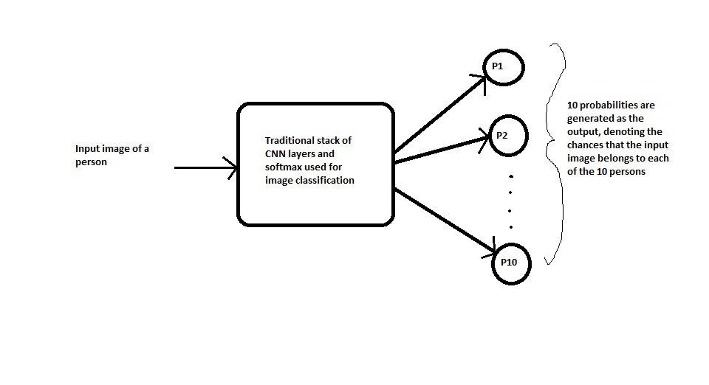

*Figure 1: Block diagram of Traditional classification. [1]*

To train such a system, we first require a lot of different images of each of the 10 persons in the class which might not be feasible. And What if a new person joins or leaves the course? You need to take the pain of collecting data again and re-train the entire model again.

Similarly, there are some issues with employing a convolutional neural network for routine classification. To train our model, we first need a large number of photos of each student. If a new student is added in the middle of the course, the model must be retrained to include that student's information.

So, to eliminate all these problems we are using one-shot learning approach to classify the images of different persons within the organization. One shot learning is the best and modern way for the classification problems which will take very less data unlike traditional Machine Learning models like CNN. One shot learning is the method which is used for many classification problems already and proved the best one. SigNet, Convolutional Siamese Network for Writer Independent Offline Signature Verification **[2]** is the system where the one-shot learning is used for the identification of the signature of the writer offline. Similarly, the One-shot Learning Methods Applied to Drug Discovery with DeepChem **[3]** is using the one shot learning approach for the discovery of the various drugs because of the less data available related to the drugs.

Now, let’s discuss the Siamese neural network.

**Siamese neural network:**

The term Siamese means twins. The two Convolutional Neural Networks are not different networks but are two copies of the same network. If the two input images belong to the same person, then their feature vectors must also be similar, while if the two input images belong to the different persons, then their feature vectors will also be different. Thus the element-wise absolute difference between the two feature vectors must be very different in both the above cases. And hence the similarity score generated by the output sigmoid layer must also be different in these two cases. This is the central idea behind the Siamese Networks

The "Siamese neural network" architecture is the key to one-shot learning. In terms of functionality, the Siamese neural network is similar to other convolutional neural networks. It accepts photos as input and converts their features into a numerical representation. The distinction is in how the output is processed. Classic CNNs tune their settings throughout the training phase so that they can associate each image with its correct class. While on the other hand, The Siamese neural network is trained to calculate the distance between two input images. The figure 2 shows the block diagram of Siamese neural network.

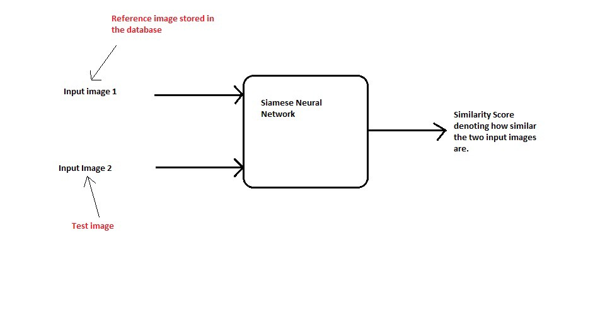*Figure 2: Block diagram of Siamese neural network* ***[1]***

**How Siamese Neural Network works?**

Let take the above example of 10 people in the class, instead of directly classifying an input (test) image to one of the 10 people in the class, this network instead takes an extra reference image of the person as input and will produce a similarity score denoting the chances that the two input images belong to the same person. Typically, the similarity score is squished between 0 and 1 using a sigmoid function, wherein 0 denotes no similarity and 1 denotes full similarity Notice that this network is not learning to classify an image directly to any of the output classes. **[1]** Rather, it is learning a similarity function, which takes two images as input and expresses how similar they are. The following figure 3 shows the architecture of the Siamese neural network, how they actually work.

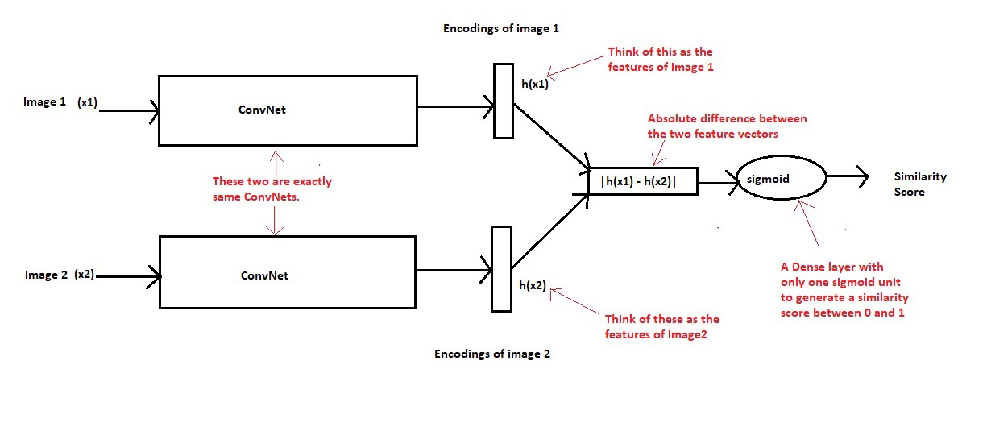

*Figure 3: Architecture of the Siamese Neural Network* ***[1]***

So, for our project, we'd like to construct a one-shot learning-based attendance system in which we recognize the faces of the students of the machine learning class. We will collect at least two pictures of each pupil for this purpose. In our project we employ Siamese neural networks to learn picture representations using a supervised metric-based technique, then reuse those features for one-shot learning without retraining. In our project, we just focus on facial recognition. We use large Siamese convolutional neural networks for this domain, which are capable of learning generic image features useful for making predictions about unknown class distributions even when only a few examples from these new distributions are available and can be easily trained using standard optimization techniques on pairs sampled from the source data and provide a competitive approach that does not rely on.

In one shot learning, we used a pair of photographs from each student as input and compared the similarity score, which tells us how similar the two images are. A similarity score is typically squashed between 0 and 1, with 0 denoting no similarity and 1 denoting full similarity, using the sigmoid function.

# **4. Dataset Discussion:**

Data is the new oil nowadays. It is not always possible to collect significant amounts of data because data is very expensive these days. As we have described above that we will use one-shot learning approach for our project to get around this issue. For the dataset of images for the model, we will be using Python to create our own real image dataset using deep learning. In our project, we will be using a dataset that only contains one or two photographs of each student in a machine learning class. Each image is 28x28 pixels in size.

To begin, we must first gather the necessary photos for our data set from the set of students or most probably the students of our class. Then we must import the relevant libraries for our dataset creation process such as OpenCV. OpenCV is a great tool for image processing. It is an open-source library that can be used to perform tasks like face detection. Then we must specify the path to the directory containing our image files. Then, using cv2.cvtColor() method, we can convert our BGR photos to RGB. Then appends the image file to the Python list. To scale each image to 28x28 pixels, we can utilize the cv2.resize() technique. Finally, we must convert the above list to a numpy array and save it to the supplied folder as a .npy file. After converting, we use the np.save() method to save it to a file. We have now successfully constructed a dataset with photographs in the form of a .npy file [4].

# **5. Major Outcomes:**

As we have discussed the major problems in the above problem statement section, so our project is proposed for those major problems to be eliminated through our proposed solution. After successful completion of the project, we would be achieved the following aims.

1. The proposed system will not require huge data for the person identification and verification rather it would take one sample for the training and the recognition of the person.
2. The proposed system will be a web application which can be accessed from anywhere on web.
3. The final system will be working on real time, which means that it will take the real time pictures from the webcam and will be used to recognize it.

# **6. Project Timeline:**

The project timeline has been scheduled and is shown in Table 1. Firstly, we will plan for our project which will be done from 20th of April till the 10th of May in which we will plan for execution of all the activities related to the project. Secondly, we will design the proposed project, which is allotted the time from 11th of May till the 20th of May. In this phase, we will design the complete system and will specify all the tools that will be used for the project development. Similarly, the next phase will be of development in which we will be doing the code of the system. This phase is assigned the time from 21th of May to the 20th of June. After successfully developed the system, we will test our system from 21th of June to the 25th of June and then we will deploy our system from 26th of June to the 30th of June. So, this is how our project development will go on.

|  |  |  |  |  |  |
| --- | --- | --- | --- | --- | --- |
| **Months / Phases** | **20 April-10 May** | **11 May - 20 May** | **21 May - 20 June** | **21 June - 25 June** | **26 June – 30 June** |
| Planning |  |  |  |  |  |
| Design |  |  |  |  |  |
| Coding |  |  |  |  |  |
| Testing |  |  |  |  |  |
| Delivery |  |  |  |  |  |

Table 1: Project Timeline

# **7. Conclusion:**

To reiterate all of the above discussion, we can say that we have reached the point where the technology does everything we need it to do. It has made our life easier by introducing complex but yet user friendly systems. Technology has also reduced the time complexity, by replacing the traditional and conventional systems with the modern, user friendly, fast and efficient ones. Moreover, the new concepts and subjects like AI (Artificial Intelligence), machine learning, deep learning or etc. has come up with the models and systems that work on datasets and learn the patterns itself, thus these factors make it more scalable, flexible, and intelligent. Besides this, we are developing an attendance system using one shot learning and Siamese neural network that require less than 2 images as a data to be learn for the model. In addition to this, our model need only less than 2 images as the dataset to learn the features, thus we are creating our own dataset. Hence we are aiming that our proposed system and model will process the image, learn its features, perform the verification after learning, with the good precision and accuracy and display the results through web application that is going to be built using flask. Lastly, we hope that our attendance system will overcome all the issues and loop holes of traditional system and provide an alternative of attendance using the different concepts of deep learning and increases the knowledge to the exiting body of work.

# References

[1] Lamba, H. (2019, February 17). *One shot learning with Siamese networks using Keras*. Medium. Retrieved May 9, 2022, from https://towardsdatascience.com/one-shot-learning-with-siamese-networks-using-keras-17f34e75bb3d

[2] Dey, S., Dutta, A., Toledo, J. I., Ghosh, S. K., Llados, J., & Pal, U. (2017, September 30). *Signet: Convolutional Siamese Network for writer independent offline signature verification*. arXiv.org. Retrieved May 9, 2022, from https://arxiv.org/abs/1707.02131

[3] *One-shot learning methods applied to drug discovery with DeepChem*. Microway. (2022, April 5). Retrieved May 9, 2022, from https://www.microway.com/hpc-tech-tips/one-shot-learning-methods-applied-drug-discovery-deepchem/

[4] Medium. 2022. *Create Your Own Real Image Dataset with python (Deep Learning)*. [online] Available at: <https://medium.com/analytics-vidhya/create-your-own-real-image-dataset-with-python-deep-learning-b2576b63da1e> [Accessed 12 May 2022].