Semester project

Artificial Intelligence

**Assignment # 2**

**Group Members**

**Shah Muhammad: 051-19-0001**

**Wasid Khan: 021-19-0022**

**Introduction**

The research on the gesture based user interface has been proliferating in the last decade. The main reason behind is that these technologies became more popular in real life applications such as various industries are already utilizing it in various fields of their day-to-day tasks easily and efficiently. To acknowledge some of these, smart home systems, robot manipulation, games, and web-services are some of the broad and common areas where gesture recognition can be applied

This project focuses on the maneuver and various operations of the mouse pointer such as movement and clicking a particular file using Artificial Intelligence. The task of recognizing a gesture for human is simple, however, for machine it’s a complex task that includes various aspects such as modeling of motion, analysis of motion, recognizing a pattern and machine learning.

Keeping in mind all the essential constituents a system has been created that recognizes the various movement of human hand and the different ornaments made by them. It’s an AI based mouse controller where first of all we are detecting the hand landmark and then click based on this point. Additionally, Color caps are used for the finger tips to separate or we can say distinguish it from the background colors of the environment such a skin color. Along with that, some smoothing techniques are used to make it more useable.

**Methodology**

To carry out the aforementioned claims, the technology and approaches used includes openCV, media pipe, along with the library called autopy. The openCV stands for Open Source Computer Vision, a library built to host common infrastructure for computer vision applications and accelerate machine perceptions in products. Moreover, media pipe is open-source framework developed and managed by Google which offers a customizable cross-platform machine learning solutions for live and stream media. Furthermore, autopy is a cross-platform, simple and easy to maintain Graphic User Interface (GUI) automation toolkit of python. It includes various functions for controlling the user interaction with the mouse and keyboard, along with colors and bitmaps on-screen and displaying alerts in a simple and understandable manners. The language used for this project is python along with its various libraries being utilized.

Firstly, the module named *HandTrackingModule.py* is designed and coded which includes various method like handDetector() for detecting a hand in the Region of Interest (ROI), findHand() for sensing the various feature of hand in the ROI, findPosition() for observing the position of hand and fingers, fingersUp() for detecting the fingers using the aforementioned color caps, and ultimately the findDistance() for calculating the distance among any two fingers and collectively the above method will be called inside the main().

Secondly, the module called *VirtualMouse.py* is designed and coded. The module utilizes the *HandTrackingModule.py* module. Here when the live video starts the hand in the ROI will be started marked, in our case the feature will be marked green, and the tips of the finger yellow. When the user will bring the two fingers together the distance will be shown to on the screen in real time and when the two tips are touched the position will be marked red and click will take place on the screen of the computer.

Screenshots

**Evaluations**

To ensure the timely completion of the project, various testing techniques offered by the software development phenomenon were adopted which includes unit testing, integration testing, smoke testing, and system testing. The testing were adopted in the mentioned sequence. Firstly, each module were designed individually and tested on various test cases.

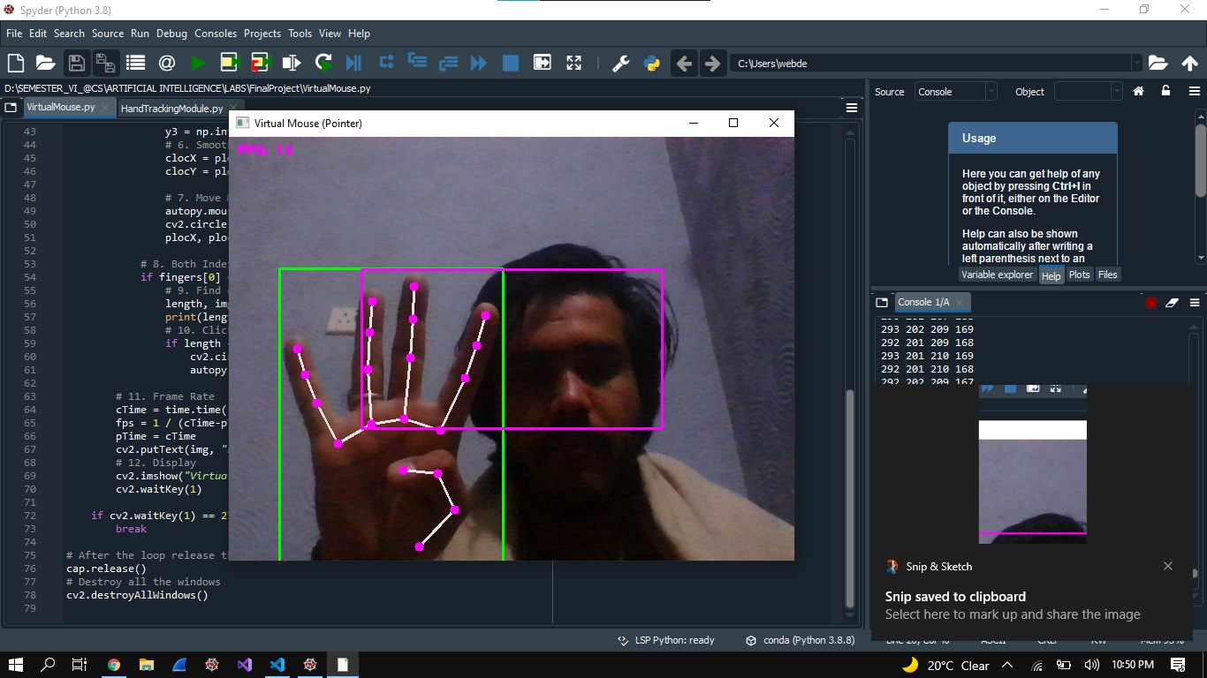

Secondly, on each integration among modules, they were tested comprehensively on various test cases similarly

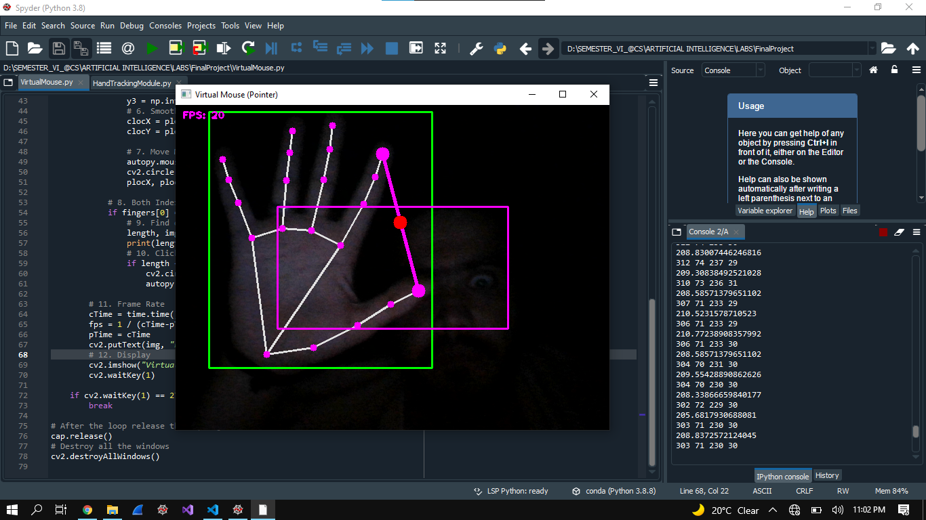

After each integration test success, smoke testing were supposed to be done that allowed to us to move forward with the development and gave us a green flag for further development.

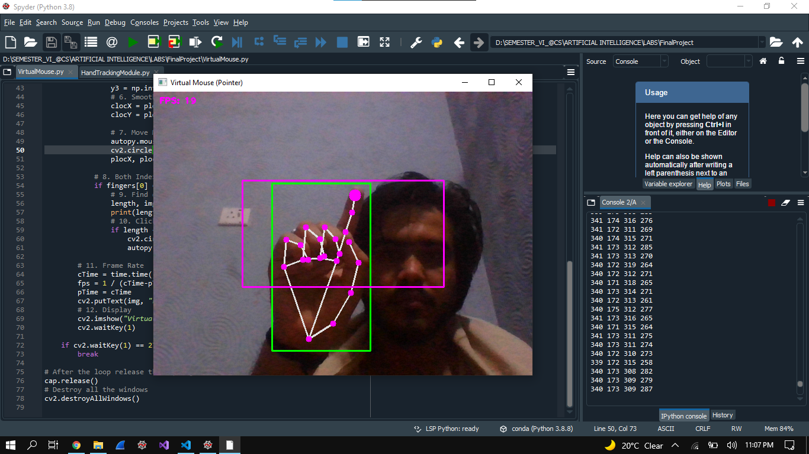

Ultimately, after the completion the system were tested on various environment, like multiple hands in the ROI, movement of multiple hands in the ROI.

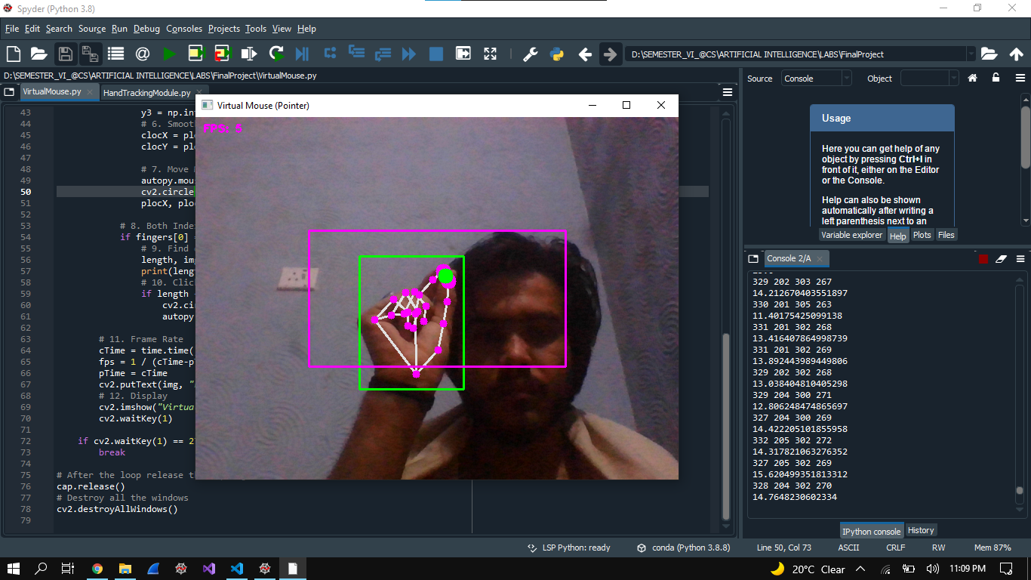

The demo video link is given below:

<https://drive.google.com/file/d/1GAE82yITS7teqXpXhHNH6gBWVB1YpGkE/view?usp=sharing>

**References**

1. [**https://opencv.org/opencv-call-for-area-chairs/**](https://opencv.org/opencv-call-for-area-chairs/)
2. [**https://google.github.io/mediapipe/**](https://google.github.io/mediapipe/)
3. [**https://pypi.org/project/autopy/0.51/#:~:text=AutoPy%20is%20a%20cross%2Dplatform,%2C%20efficient%2C%20and%20simple%20manner**](https://pypi.org/project/autopy/0.51/#:~:text=AutoPy%20is%20a%20cross%2Dplatform,%2C%20efficient%2C%20and%20simple%20manner)**.**
4. [**https://www.geeksforgeeks.org/types-software-testing/**](https://www.geeksforgeeks.org/types-software-testing/)