Background:

University ranking system is a Java Swing Application that handles universities rankings. There are 3 sections i.e. Admin, student, alumni, faculty and Employer. The system enables to enter a University, student, course and faculty information. All this information is linked to each student. The main objective of this management system is to grade various Universities on the parameters such as relevance of the course they took, their employers, final GPA, years of experience, promotion they received and the faculties whose classes they took.

Object Diagram:

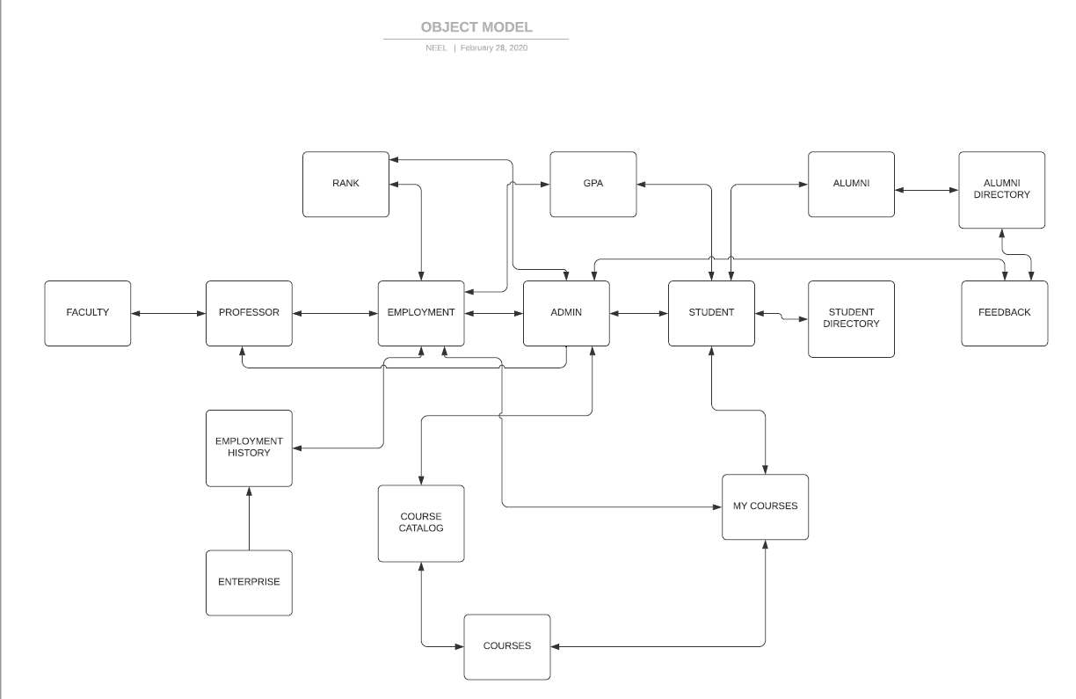

Problem Statement:

The idea is to implement a system that enables college and university administrators to compare the performance of their academic units and to define your own ranking system of educational institutions especially for the developing world.

Functionalities:

Enables admin to login first and then admin can make changes like add student attributes, add courses in course catalog, assign course to a professor in a term.

Enables student to login first and then select course from course catalog provided.

Enables alumnus to login and view their information. Then presents them with a feedback form to rank based on metrics such as: course, GPA, faculties relevance in securing job and getting promotion.

Enables professor to login and view their information such as the courses they are assigned to and students in their class. Also, a professor must grade students and give a GPA based on the performance in assignments, mid term and final exam.

Updating records or GPA of students and if they have completed the course then transferring the information into alumni directory.

Integration of all records of students and alumni.

Workflow:

At first, in the java application, the work area will be displayed, consisting of the work directories implemented.

First Panel:

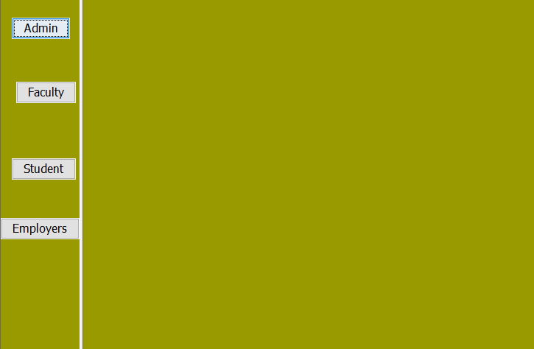

If the user navigates to Admin work directory, then it must enter his credentials.

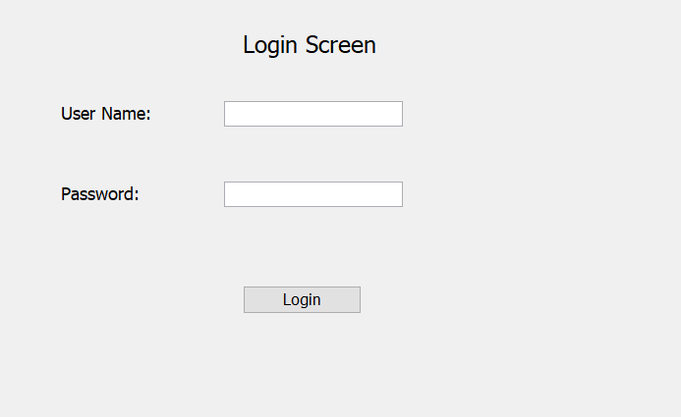

The admin manages the students, courses, faculties and assigns rank to universities.

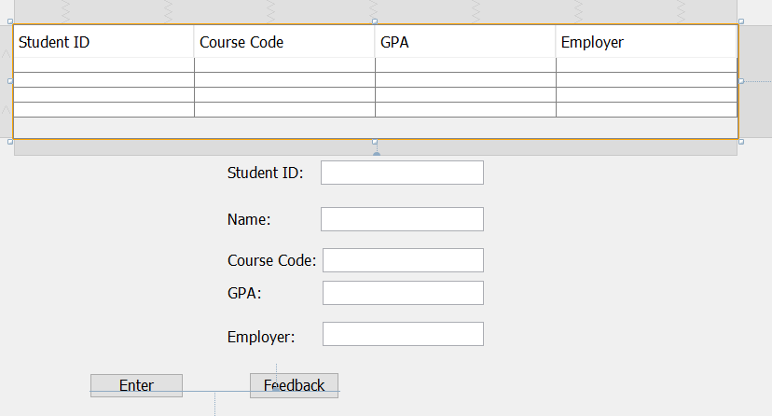

Assigning ranks to universities is done by Admin who takes the feedback given by Alumni on various parameters and then assigns rank.

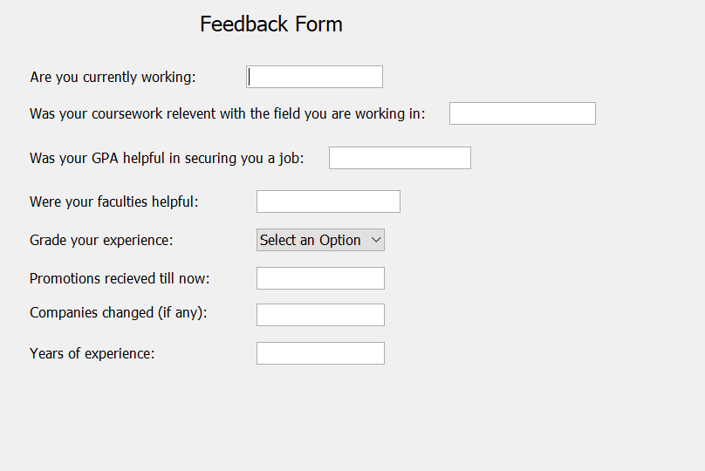

Finally, the admin will rank the universities based on feedback provided by Alumni

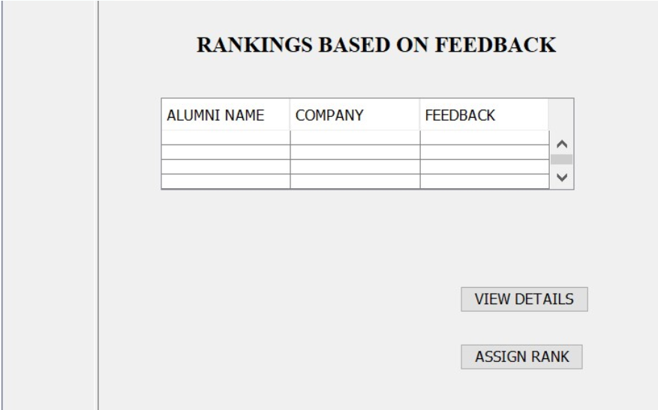

Sequence Diagram:

For Student-

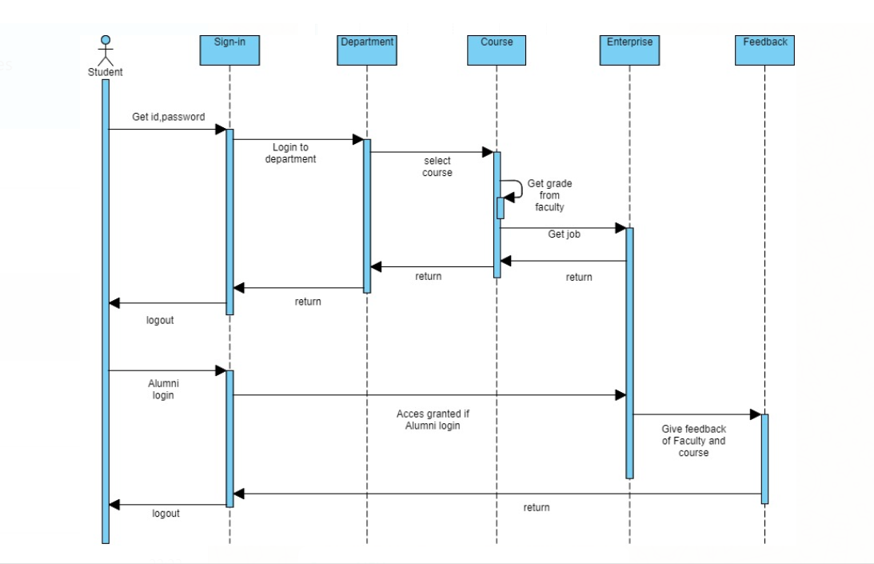

For Admin-

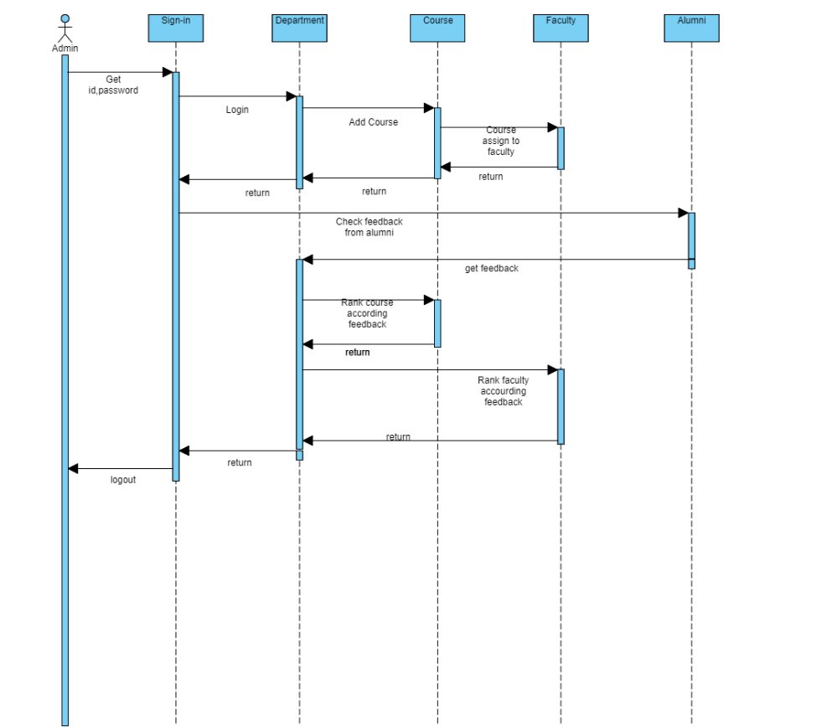

For Faculty-

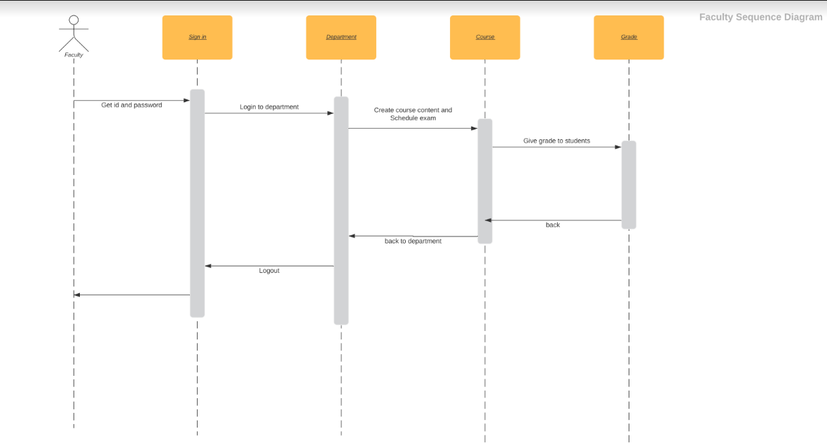

Future Scope:

This system can be implemented in future for K to 12 educational institutions with some enhancements for example extending the same to various Universities, Colleges, Middle Schools, Kindergarten etc. In addition to this, we can add several other parameters with respect to other Universities such as Education Background of faculties, merit of students, total number of student in a particular university etc.

In my opinion, these can be the ways in which the university ranking system can be implemented in the developing countries where it is much needed and needs to be constantly monitored by a non biased administration.