**Project Report**

**Problem Statement:**

Technology is evolving at a rapid phase, to keep up with the demands and needs of people across the globe. One such technical innovation is the rapid expansion in the usage of Drones. Drones are unmanned aerial vehicles that are used mostly to aid the military and combat services. Drones are faster and less prone to human error, and hence have potential to take over industries where speed and accurate delivery is a key criteria. There are several industries such as healthcare and ecommerce industries that are looking to invest in this technology to improve the services that they provide.

The objective of our project is to build a database for a typical ecommerce website which includes the use of drones to deliver their products rather than the traditional methods of delivery.

It includes details about customers using the services of this website, along with the drone details and their related information. It also includes data about products and payment information, which shows the jest of the functionality of this website with this kind of delivery service.

The drones are going to use zip codes to find the exact path that the drone takes from the warehouse address to the customer shipping address. We have added the weather capabilities to the drone as an extra functionality, which might benefit the company in better understanding of the system and overcome certain difficulties.

**Limitations**

* The e-commerce website is assumed to be amazon.com.
* It has vendors and customers from USA only.
* Warehouses includes vendor warehouses and amazon warehouses.
* The product is delivered by a drone present in that product vendor warehouse.
* Customers can order only one product at a time.
* One drone will carry only one order item at one time.
* No cash on delivery option.
* The customer is assumed to get package directly, i.e drop off at the zip code location.
* No partial transactions are taken into consideration.
* The order item is created only after the payment is completed.
* One category is associated to only one department.

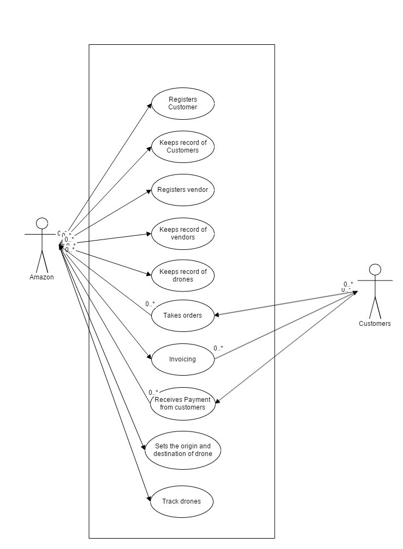**Use Case Diagrams:**

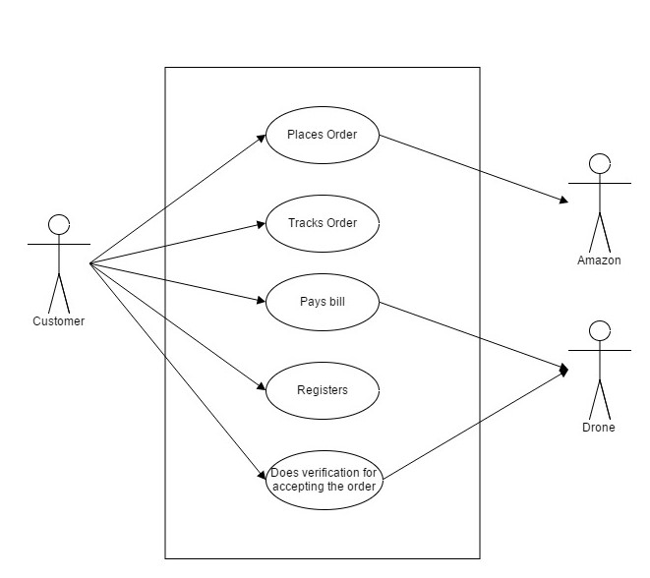

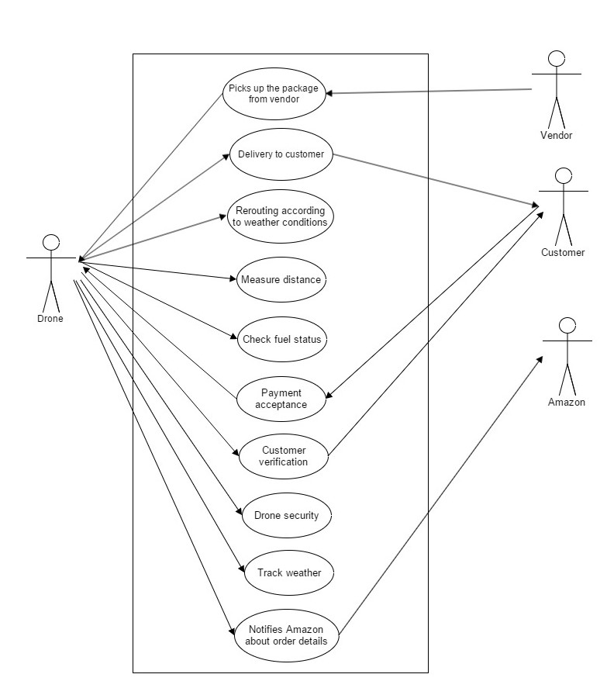

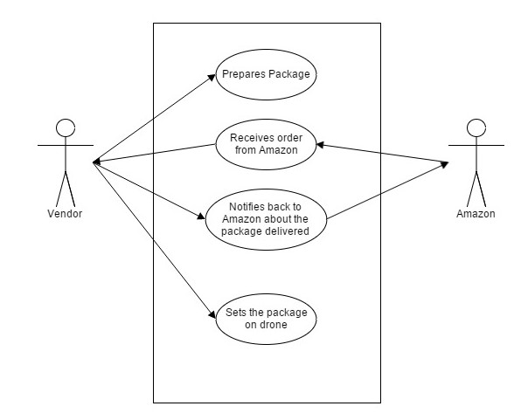

**EER Diagram**

