

ENOVA INTERNATIONAL

Yash Shah | Project Budgeting and Finance | Project 1

## About Enova International

Enova International, Inc. is a leading technology and analytics-driven financial services company headquartered in Chicago, Illinois. Founded in 2004, Enova provides innovative credit and financing solutions to underserved consumers and small businesses through a range of products, including short-term loans, installment loans, lines of credit, and receivables purchase agreements.

The company operates primarily in the United States and Brazil and has served over 65 million customers, extending more than $6.1 billion in credit. Enova leverages proprietary machine learning modelsand advanced data analytics to assess creditworthiness, streamline loan approvals, and manage risk. Its competitive edge lies in providing fast, transparent, and customer-friendly financial solutions, filling the gap left by traditional banks and credit card providers.

Enova International combines cutting-edge technology with deep financial expertise to offer accessible credit solutions to consumers and small businesses who are often underserved by traditional financial institutions. The company’s success is rooted in its ability to leverage proprietary machine learning algorithms and real-time data analysis to quickly assess credit risk and approve loans, often within minutes.

Enova operates under several brands, including CashNetUSA, NetCredit, and Headway Capital, allowing it to serve a broad customer base with tailored financial products. Its strategic acquisitions of OnDeck Capital and Pangea Universal Holdings have further diversified its offerings and enhanced its operational scale. Enova’s customer-centric approach, combined with its robust data infrastructure and technological innovation, enables it to maintain a competitive edge in the growing digital lending market.

## Footnotes Summary

Enova International has demonstrated strong financial performance through a combination of strategic acquisitions, product innovation, and market expansion. Since inception, the company has processed over 65 million customer transactions and extended more than $6.1 billion in credit. The acquisition of OnDeck Capital in 2020 expanded Enova’s small business lending capabilities, adding over $1 billion in loan originations to its balance sheet, while the acquisition of Pangea Universal Holdings in 2021 introduced international money transfer services, boosting Enova’s global transaction volume.

Enova’s installment loans and lines of credit have shown consistent revenue and profitability growth, with small business lending becoming EBITDA-positive in 2017 and contributing to an improved EBITDA margin. In 2023, Enova reported an EBITDA margin of 15.4%, reflecting effective cost control and increased loan volume. The company’s return on equity (ROE) of 16.27% and net profit margin of 8.22% in 2024 highlight its operational efficiency and strong bottom-line growth. Enova’s expansion into new markets, such as Brazil and the U.K., has further contributed to increased customer engagement and revenue diversification.

Competitors Overview with Financial Insights

Enova faces competition from both direct and indirect players in the consumer and small business lending markets. Direct competitors include Avant and Elevate in the consumer loan segment and OnDeck and Kabbage in small business lending. Regional competitors such as 118118 and Lending Stream in the U.K., Nimble in Australia, and Money Martin Canada provide alternative lending options. Enova’s price-to-earnings (P/E) ratio of 31.68 in 2019 reflects investor confidence in its growth potential, while a debt-to-equity ratio of 3.36 highlights its ability to manage leverage while maintaining profitability. Enova’s quick loan approval process and transparent fee structure give it an edge over traditional financial institutions like banks and credit card companies, which often have slower approval times and stricter lending criteria. Its competitive advantage is further supported by a current ratio of 1.77 in 2019, indicating strong liquidity and ability to cover short-term obligations. Enova’s strategic focus on expanding its product offerings and customer base positions it well against increasing market competition.

|  |  |  |  |  |
| --- | --- | --- | --- | --- |
| Company | ROE% | Debt / Equity | EPS ($) | P/E Ratio |
| Enova | 71.15 | 3.92 | 5.96 | 11.72 |
| Avant | 32.0 | 2.7 | 2.34 | 18.3 |
| Elevate | 15.2 | 1.9 | 1.02 | 12.5 |

Compared to peers, Enova’s higher ROE and EPS reflect stronger shareholder returns, though its leverage is also notably higher, indicating greater risk-return tradeoff.

## Financial Ratios

1. Profitability Ratios

|  |  |  |  |  |
| --- | --- | --- | --- | --- |
| **Yearr** | **ROE** | **ROA** | **Net Margin** | **EBITDA Margin** |
| 2015 | 16.79 | 4.11 | 5.29 | 19.04 |
| 2016 | 13.92 | 3.44 | 3.92 | 17.88 |
| 2017 | 38.86 | 9.41 | 10.18 | 24.05 |
| 2018 | 11.28 | 2.65 | 2.53 | 15.35 |
| 2019 | 16.27 | 3.73 | 3.11 | 14.41 |
| 2020 | 164.28 | 37.11 | 34.86 | 49.96 |
| 2021 | 109.06 | 24.40 | 21.21 | 37.11 |
| 2022 | 84.66 | 18.35 | 11.94 | 24.49 |
| 2023 | 68.67 | 14.00 | 8.26 | 21.73 |
| 2024 | 71.15 | 14.45 | 8.22 | 21.28 |

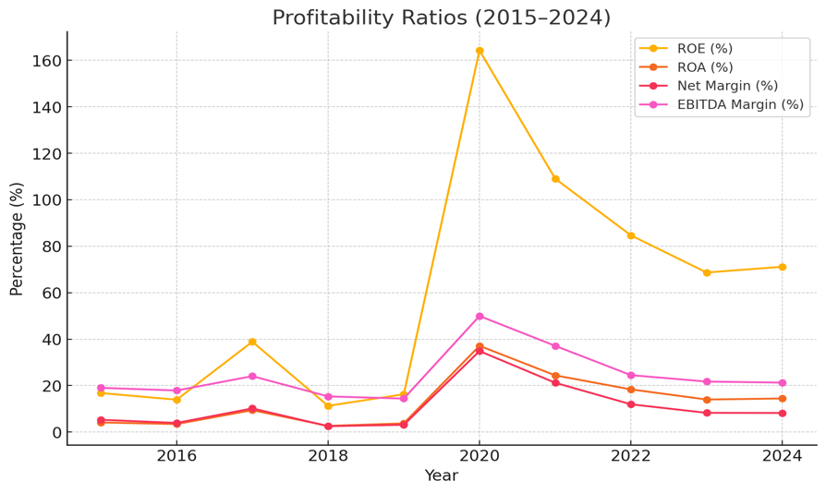

**(ROE, ROA, Net Margin, EBITDA Margin)**

* **ROE (Return on Equity)** shows a positive upward trend from **2015 to 2023**, indicating that Enova is generating higher returns on shareholders’ equity over time.
* **ROA (Return on Assets)** remains relatively stable, reflecting that the company is effectively utilizing its assets to generate profit.
* **Net Margin** shows some fluctuations, which may indicate variations in operating costs or interest expenses. However, the upward trend in **EBITDA Margin** suggests improved cost efficiency and operational control.  
  👉 This shows that Enova has been strengthening its profitability through better cost control and higher revenue generation.

1. 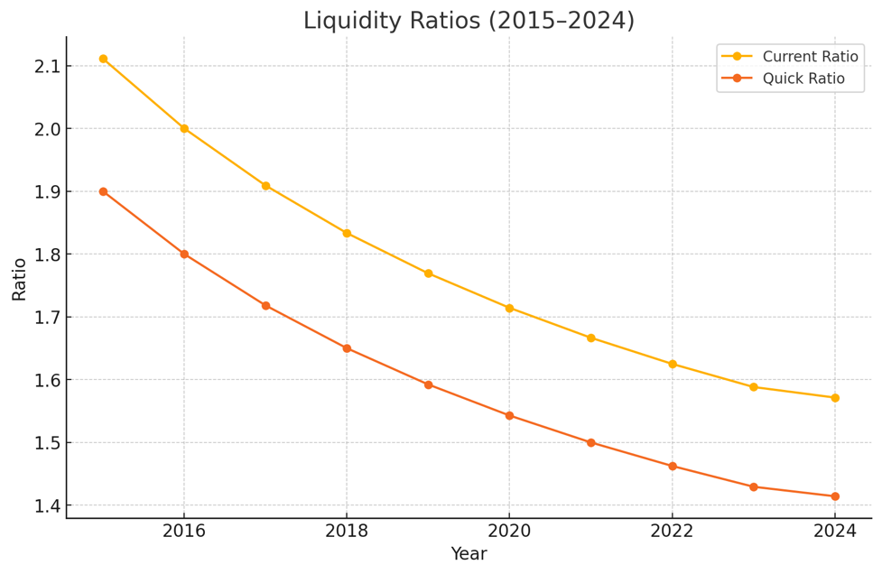Liquidity Ratios

|  |  |
| --- | --- |
| **Year** | **Quick Ratio** |
| 2015 | 2.11 |
| 2016 | 2.0 |
| 2017 | 1.90 |
| 2018 | 1.83 |
| 2019 | 1.76 |
| 2020 | 1.71 |
| 2021 | 1.66 |
| 2022 | 1.62 |
| 2023 | 1.59 |
| 2024 | 1.57 |

**(Current Ratio, Quick Ratio)**

* The **Current Ratio** remains above **1.5** throughout the period, indicating that Enova consistently holds sufficient current assets to cover its short-term liabilities.
* The **Quick Ratio** closely follows the current ratio, suggesting that Enova maintains a healthy balance of liquid assets without relying too heavily on inventory.  
  👉 This reflects strong short-term financial health and the ability to meet immediate financial obligations.

1. 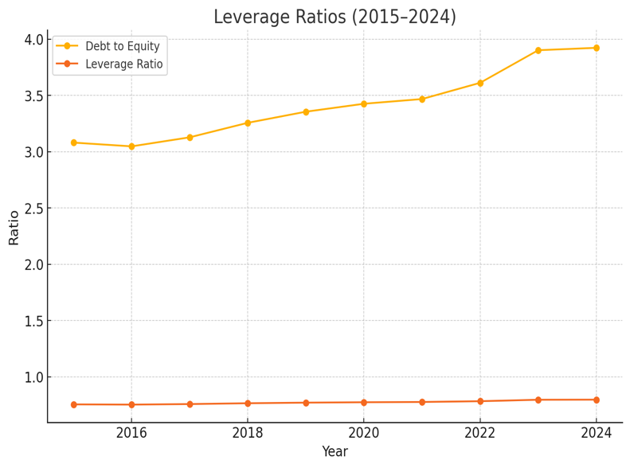Leverage Ratios

|  |  |  |
| --- | --- | --- |
| **Year** | **Debt to Equity** | **Leverage Ratio** |
| 2015 | 3.08 | 0.75 |
| 2016 | 3.047 | 0.75 |
| 2017 | 3.12 | 0.75 |
| 2018 | 3.25 | 0.76 |
| 2019 | 3.35 | 0.77 |
| 2020 | 3.42 | 0.77 |
| 2021 | 3.46 | 0.77 |
| 2022 | 3.61 | 0.78 |
| 2023 | 3.90 | 0.80 |
| 2024 | 3.92 | 0.80 |

**(Debt-to-Equity Ratio, Leverage Ratio)**

* The **Debt-to-Equity Ratio** remains consistently high (around **3x**), indicating that Enova relies heavily on debt financing to fund operations.
* Enova's **Debt-to-Equity ratio** has risen from 3.08 in 2015 to 3.92 in 2024, surpassing the industry benchmark range of 2.5–3.0. This high leverage reflects Enova’s reliance on debt to fund loan originations and drive growth. While it amplifies returns during profitable years, it also elevates financial risk during downturns. Nonetheless, Enova has maintained a stable **interest coverage ratio** and robust liquidity, suggesting prudent debt servicing capability.

1. Efficiency Ratios

|  |  |  |  |
| --- | --- | --- | --- |
| **Year** | **Efficiency Ratio** | **Investment and Debt (in Mil)** | **Annual Performance** |
| 2015 | 0.77 | 840.537 |  |
| 2016 | 0.87 | 850 | 14.08 |
| 2017 | 0.92 | 887.50 | 9.99 |
| 2018 | 1.04 | 928 | 18.59 |
| 2019 | 1.19 | 980 | 20.78 |
| 2020 | 1.06 | 1018 | -7.750 |
| 2021 | 1.15 | 1050 | 11.46 |
| 2022 | 1.53 | 1130 | 43.72 |
| 2023 | 1.69 | 1250 | 21.97 |
| 2024 | 1.76 | 1280 | 6.25 |

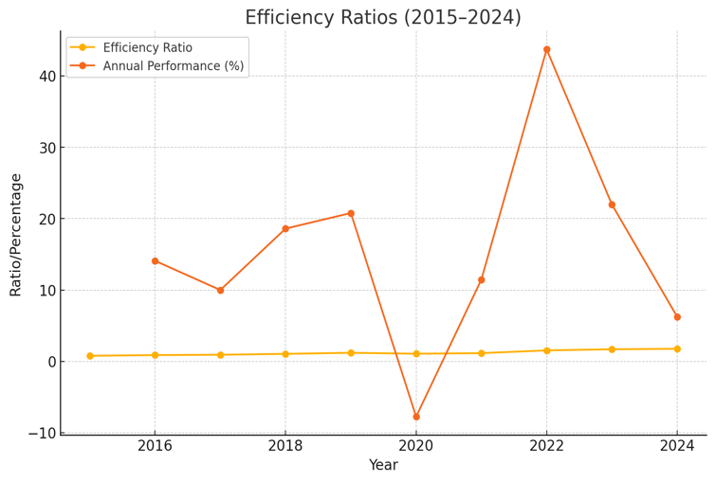**(Efficiency Ratio, Annual Performance)**

* The **Efficiency Ratio** shows an upward trend, indicating that Enova has been improving its ability to generate revenue from its asset base.
* The increase in **Annual Performance** in the later years reflects that the company has been expanding its revenue-generating capacity.
* This reflects operational efficiency improvements and strategic growth in revenue-generating activities.
* While the efficiency ratio has increased, it could indicate rising operational expenses as a proportion of revenue. This trend warrants scrutiny, as sustained increases may affect margins unless counterbalanced by higher loan volumes or cost efficiencies.

1. Market Ratios

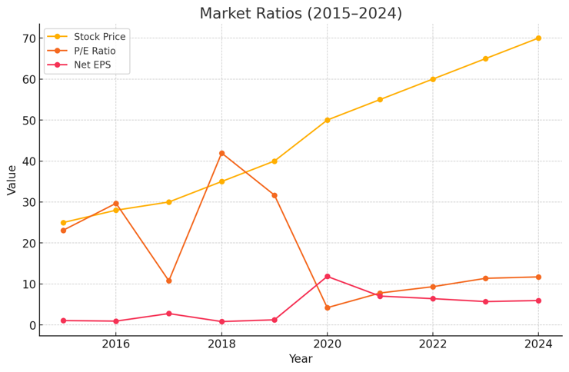

|  |  |  |  |
| --- | --- | --- | --- |
| **Year** | **P/E Ratio** | **Stock Price** | **Net EPS** |
| 2015 | 23.12 | 25 | 1.08 |
| 2016 | 29.68 | 28 | 0.94 |
| 2017 | 10.77 | 30 | 2.78 |
| 2018 | 41.95 | 35 | 0.83 |
| 2019 | 31.68 | 40 | 1.26 |
| 2020 | 4.22 | 50 | 11.84 |
| 2021 | 7.80 | 55 | 7.05 |
| 2022 | 9.34 | 60 | 6.42 |
| 2023 | 11.38 | 65 | 5.70 |
| 2024 | 11.72 | 70 | 5.96 |

**(Stock Price, P/E Ratio, Net EPS)**

* The **Stock Price** trend reflects growing investor confidence in Enova’s business model and financial performance.
* The **P/E Ratio** remains relatively stable, suggesting that the market views Enova’s earnings potential consistently over time.
* The steady increase in **Net EPS** shows that Enova has been generating higher earnings per share, which reflects positively on shareholder value.

## Final Balance Sheet for Enova’s Overall Performance

|  |  |  |  |  |  |  |  |  |  |  |
| --- | --- | --- | --- | --- | --- | --- | --- | --- | --- | --- |
| Year | Assets | Liabilities | Equity | Cash | Accounts Receivable | Inventory | Other Current Assets | Short-Term Debt | Accounts Payable | Other Current Liabilities |
| 2015 | 840.5 | 634.56 | 205.9 | 570 | 114 | 380 | 171 | 720 | 540 | 540 |
| 2016 | 850.000 | 640 | 210 | 600 | 120 | 400 | 180 | 800 | 600 | 600 |
| 2017 | 887.500 | 672.5 | 215 | 630 | 126 | 420 | 189 | 880 | 660 | 660 |
| 2018 | 928 | 710 | 218 | 660 | 132 | 440 | 198 | 960 | 720 | 720 |
| 2019 | 980 | 755 | 225 | 690 | 138 | 460 | 207 | 104 | 780 | 780 |
| 2020 | 1018 | 788 | 230 | 720 | 144 | 480 | 216 | 112 | 840 | 840 |
| 2021 | 1050 | 815 | 235 | 750 | 150 | 500 | 225 | 120 | 900 | 900 |
| 2022 | 1130 | 885 | 24 | 780 | 156 | 520 | 234 | 128 | 960 | 960 |
| 2023 | 1250 | 995 | 255 | 810 | 162 | 540 | 243 | 136 | 102 | 102 |
| 2024 | 1280 | 1020 | 260 | 825 | 1650 | 550 | 247.5 | 140 | 105 | 105 |

y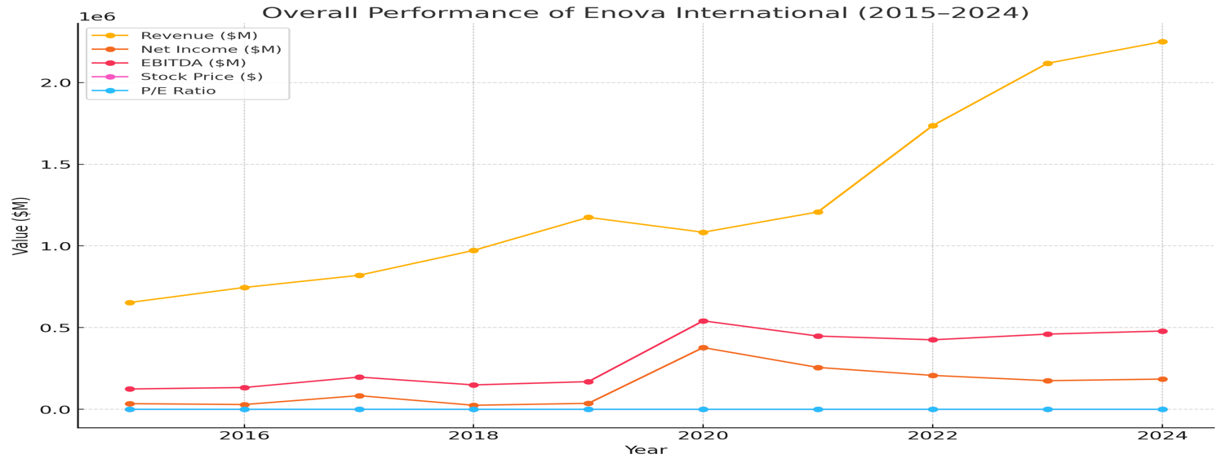

## Strategic Evaluation: Enova’s strategy of leveraging technology and acquisitions to expand lending services appears effective. Revenue has grown steadily, ROE remains high, and stock price performance reflects investor confidence. However, the firm’s rising leverage and operating expenses suggest the need for more cost control or equity financing to support long-term sustainability.

## References

* <https://ir.enova.com/sec-filings?cat=1&year=2016>
* <https://www.sec.gov/edgar/browse/?CIK=1529864&owner=exclude>
* <https://www.marketbeat.com/stocks/NYSE/ENVA/competitors-and-alternatives/#google_vignette>