Logistic Regression – Shah Zafrani

For this assignment I used Dr. Kang’s slides and this website: http://ml-cheatsheet.readthedocs.io/en/latest/logistic_regression.html#introduction

The first step for me was to divide my MNIST data for k-fold cross-validation. To do this I used the SciKitLearn Kfold function from the model_selection module.

from sklearn.model_selection import KFold

I then normalized the pixel data, and rescaled the labels (6 → 0, 8 → 1). Initially I wrote a for-loop to rescale the labels and then later optimized by subtracting everything in the matrix by 6 and then dividing by 2.

The sigmoid function and the predictions were very straightforward.

I got the error cost function from Slide 18 in Dr. Kang’s logistic regression lecture.

The difficult part for me was finding out how to compute the gradient. I had trouble understanding how to do this based on this information in the slides and Dr. Kang’s example code, but I was able to find it on the ml-cheatsheet website.

My average True Positive Rate was:
My average False Positive Rate was:

I wrote my code so that I could also calculate the False Negative and True Negative rates as well.

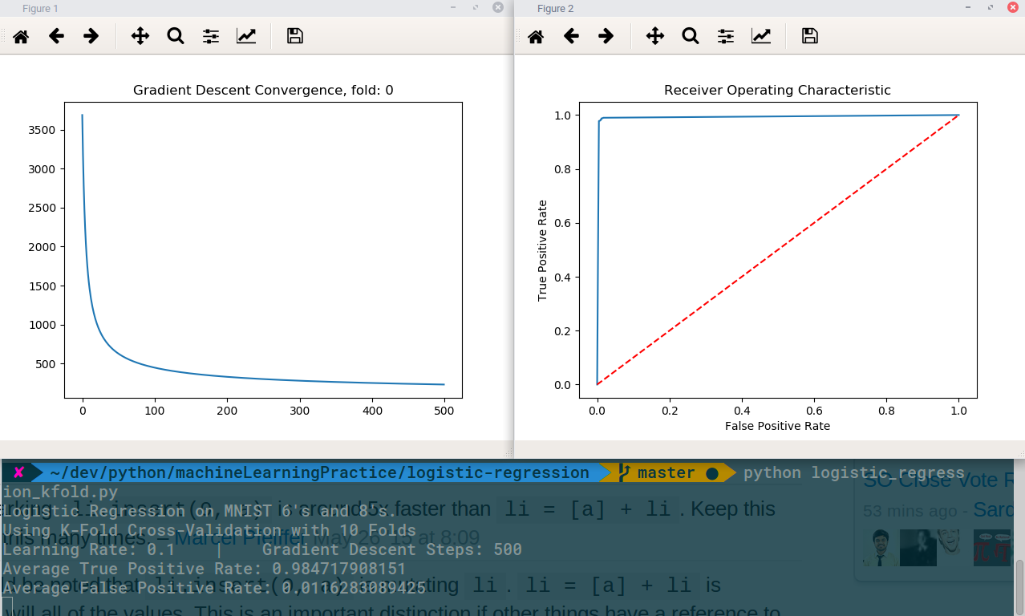
Above is my ROC Curve (with the TPR and FPR rates from all 10 folds), and my Gradient Descnet Convergence. Also I included some informative console output.

