Website link: https://webratron.com/
Keyword: shopify web development company

Shopify Web Development Company | Webratron
Meta Title
Shopify Web Development Company | Webratron
Meta Description
Webratron is a trusted Shopify web development company building fast, user friendly online stores designed to grow your sales and brand.



SHOPIFY WEB DEVELOPMENT COMPANY
Turning Clicks Into Customers, One Smart Store At A Time. Build A Shopify Experience That Looks Good, Loads Fast, And Actually Makes People Want To Buy.
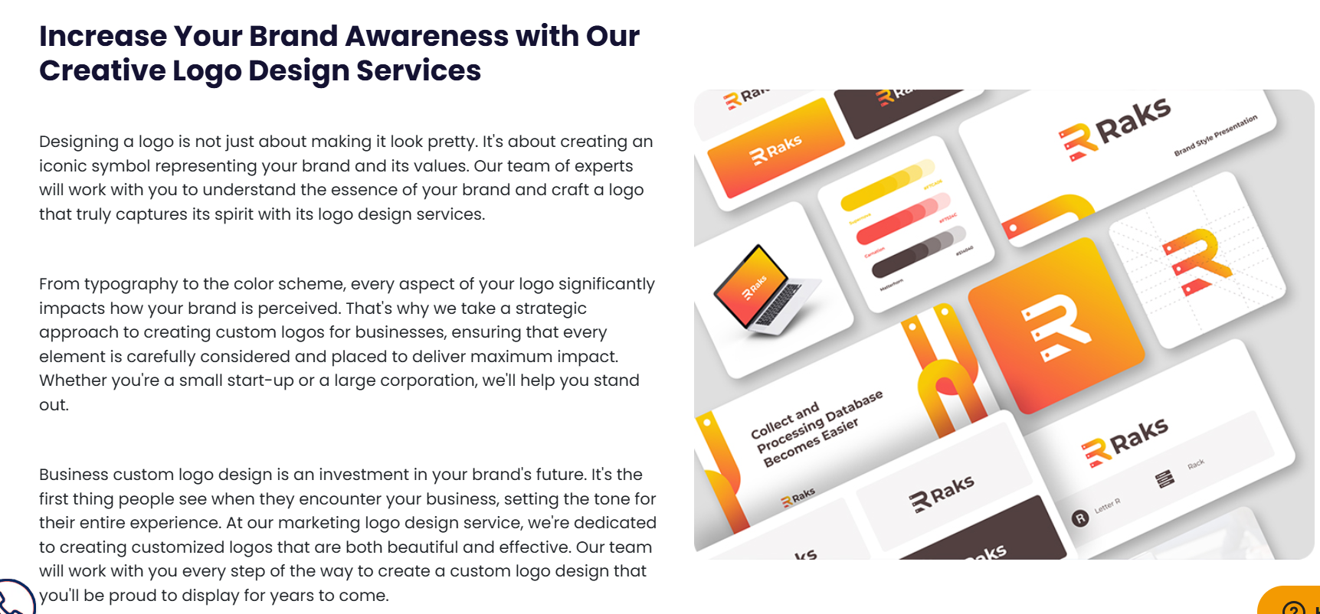
Grow Your Brand with Smart and Creative Shopify Development Company
Selling online is not just about putting products on a website. It is about creating a shopping experience that feels smooth, trustworthy, and easy from the first click to checkout. Our Shopify web development company services focus on building stores that look clean, load quickly, and guide customers naturally toward making a purchase. We take the time to understand your brand so your store reflects who you are, not just what you sell.
Every detail in a Shopify store matters. Layout, product organization, navigation, and checkout flow all play a role in whether a visitor becomes a customer. That is why we approach each project with strategy, not guesswork. We design with real shoppers in mind, keeping pages simple, mobile friendly, and distraction free. The goal is to make browsing effortless and buying feel like the obvious next step.
A well built Shopify store is an investment in your business growth. It becomes your digital storefront, your salesperson, and your brand ambassador all at once. Whether you are launching something new or improving an existing store, we work closely with you to create a setup that supports long term success. The result is a store you feel confident sharing and customers feel comfortable purchasing from.



OUR SHOPIFY WORK
We build Shopify stores that reflect each brand’s personality while keeping performance at the center. The online market is crowded, and standing out takes more than a basic template. We focus on smart layouts, smooth navigation, and designs that feel easy to shop from. Explore our recent Shopify projects or share your vision with us and let’s create a store that truly fits your business.

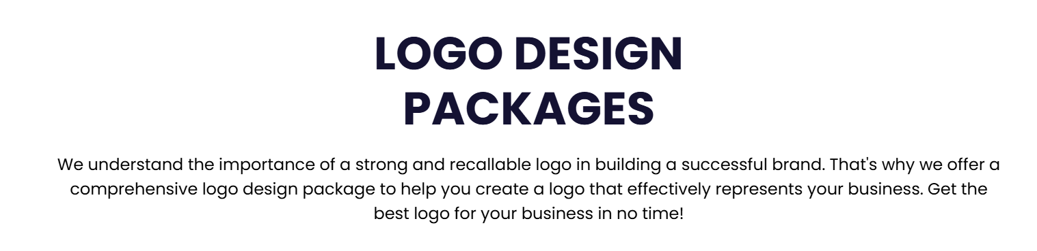

SHOPIFY WEB DEVELOPMENT PACKAGES
We know a successful online store needs more than a nice design. It needs the right structure, smooth performance, and a checkout process that makes buying easy. That is why we offer carefully planned Shopify packages built for different stages of business growth. Whether you are just starting out or ready to scale, we have a solution that helps you sell confidently and grow steadily.

Starter Store Package
For new brands ready to launch
This package is perfect if you are starting fresh and need a clean, professional Shopify store that is ready to sell.
What’s included:
• Shopify store setup
• Premium theme installation and customization
• Up to 15 product uploads
• Basic category structure
• Mobile responsive design
• Payment gateway setup
• Basic shipping setup
• Contact page and policy pages
• Basic on page SEO setup
• 7 days post launch support
This gives you everything you need to open your digital doors and start selling with confidence.

Growth Store Package
For businesses ready to scale
If you already have products and want a more powerful store built for conversions, this package is for you.
What’s included:
• Everything in Starter Package
• Custom homepage layout
• Up to 50 product uploads
• Advanced product filtering
• Conversion focused product pages
• Email marketing integration
• Abandoned cart setup
• App integrations
• Speed optimization
• Basic analytics setup
• 14 days post launch support
This package focuses on structure, performance, and customer flow so your store does more than just exist. It performs.

Pro Store Package
For serious eCommerce brands
This is for businesses that want a fully customized Shopify experience built for long term growth.
What’s included:
• Fully custom Shopify design
• Advanced UI and UX planning
• Unlimited product uploads
• Custom category and navigation system
• Custom product page layout
• Advanced checkout optimization
• CRM integration
• Email automation setup
• Advanced speed optimization
• SEO structure setup
• Training session for your team
• 30 days priority support
This package is built for brands that want to compete seriously and convert consistently.
FAQs

1. How long does it take to build a Shopify store?
It depends on the size and features of your store. A basic Shopify website usually takes 1 to 2 weeks. Larger or custom projects can take 3 to 5 weeks. We always share a clear timeline before starting.

2. Can you redesign my existing Shopify store?
Yes. If your current store feels outdated or is not converting well, we can redesign it with a fresh layout, improved structure, and better performance without losing your existing data.

3. Will my Shopify store be mobile friendly?
Absolutely. Most shoppers use their phones, so we design every Shopify store to work smoothly on mobile, tablet, and desktop devices.

4. Do you help with Shopify apps and integrations?
Yes. We install and configure the right apps for payments, shipping, marketing, analytics, and more. We only recommend tools that actually support your business goals.

5. Do you provide support after the store goes live?
Yes. We offer post launch support to fix issues, guide you through updates, and make sure everything continues running properly. We do not disappear after delivery.

