Keyword: mens gold ring jewelry​

Mens Gold Ring Jewelry: A Statement That Doesn’t Need to Shout
Meta Title
Mens Gold Ring Jewelry | Elite Gracious Living
Meta Description
Mens gold ring jewelry by Elite Gracious Living. Timeless gold rings crafted for confidence, character, and everyday refined style.
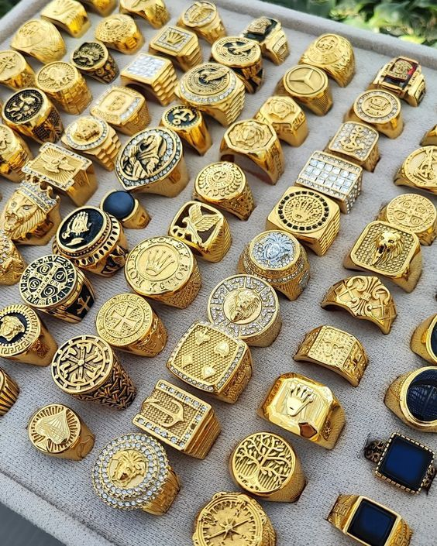
There was a time when men’s jewelry meant one of two things: a wedding band or something overly flashy. Not much in between. That has changed.
Today, mens gold ring jewelry sits in a completely different space. It’s no longer about loud statements or status symbols. It’s about personal style. Subtle confidence. Something that feels solid on your hand and natural in your everyday life.
At Elite Gracious Living, gold rings are seen as more than accessories. They’re finishing touches that quietly define presence.

Why Gold Is Elite
Gold has history. It has weight, not just physically, but symbolically. It doesn’t fade in relevance. It doesn’t go out of season. And when crafted properly, it ages with character rather than wear.
Mens gold ring jewelry works because it feels grounded. A clean gold band, a textured signet, or a minimalist design can elevate even the simplest outfit. You don’t have to build an entire look around it. It fits into your style instead of demanding attention.
That’s part of the appeal.

Everyday Wear, Not Just Occasions
Many men hesitate before buying a gold ring because they think it’s only for formal settings. The truth is the opposite.
A well-designed gold ring can be worn daily, to work, dinner, travel, even casual weekends. The key is choosing the right balance. Not too heavy. Not overly decorative. Just enough detail to feel intentional.
Elite Gracious Living focuses on pieces that blend into real life. Rings that feel comfortable during long hours, that don’t interfere with movement, and that hold their presence without distraction.

The Importance of Design Simplicity
When it comes to mens gold ring jewelry, simplicity often wins.
Clean lines. Balanced proportions. Smooth finishes or subtle textures. These elements make a ring wearable over time. Trends come and go, but understated design holds its place.
A thick, highly polished band might work for some. Others prefer brushed finishes or slight detailing along the edges. The point is not excess. It’s refinement.
And refinement lasts.
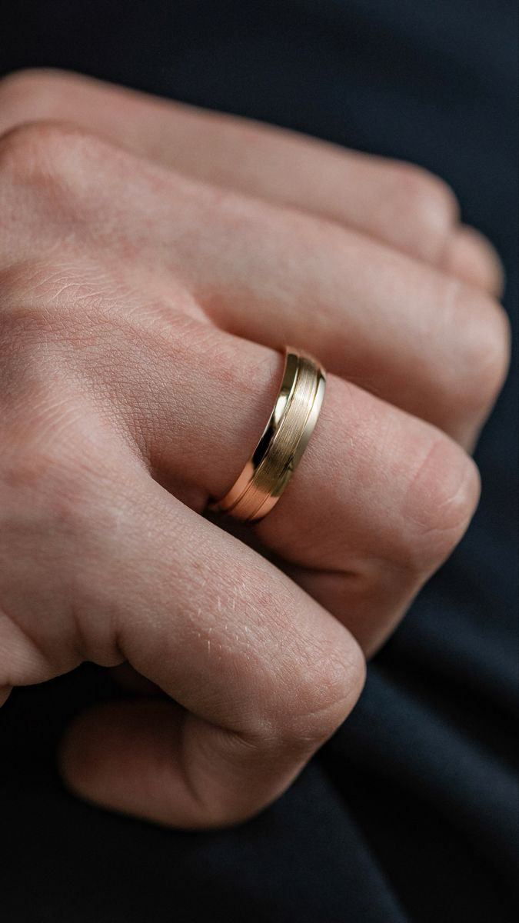

Gold as Identity, Not Decoration
A gold ring can represent many things. A milestone. A shift in personal style. A commitment to quality over quantity.
It doesn’t have to symbolize something dramatic. Sometimes it’s simply about preference, about enjoying something well-crafted and permanent.
Mens gold ring jewelry becomes part of your routine. You stop noticing it in the mirror because it feels natural. That’s when you know you chose correctly.
At Elite Gracious Living, this idea matters. Jewelry should integrate into life, not interrupt it.

Quality Over Flash
Not all gold rings are equal. The purity of the gold, the weight, the finishing, and the craftsmanship all affect how the piece feels over time.
Lower-quality rings lose structure. High-quality rings maintain their form and develop character.
Mens gold ring jewelry that is made with attention to detail will feel different from the moment you wear it. There’s a solidity that can’t be faked.
Elite Gracious Living values that distinction. Luxury is not about exaggeration. It’s about integrity.

Styling a Gold Ring the Right Way
You don’t need multiple rings to make an impression. Often, one is enough.
A single gold ring paired with a clean watch or minimal bracelet creates balance. Avoid stacking too many bold pieces unless that’s truly your style.
Gold works well with neutral tones, black, navy, grey, beige. It also pairs naturally with both formal and casual clothing.
The beauty of mens gold ring jewelry lies in its versatility.

Longevity and Meaning
Unlike fast fashion accessories, gold rings are built to last. They carry stories. They pick up subtle marks over time that reflect your life.
That long-term wear gives gold its depth.
Mens gold ring jewelry isn’t disposable. It becomes part of you.
And that permanence is something Elite Gracious Living stands behind.

FAQs

1. Is mens gold ring jewelry suitable for everyday wear?
Yes. When designed properly, gold rings are durable and comfortable enough for daily use. Choosing the right fit and weight ensures long-term wear without discomfort.

2. How do I choose the right gold ring?
Focus on fit, comfort, and simplicity. Consider your lifestyle and whether you prefer polished or textured finishes. A ring should feel natural on your hand.

3. Does gold scratch easily?
Gold can develop minor surface marks over time, but this adds character. Higher-quality gold maintains structure and can be polished when needed.

4. Is a signet ring considered formal?
Not necessarily. Modern signet designs can be worn casually or formally depending on styling. Simpler versions are highly versatile.

5. Why choose Elite Gracious Living for gold rings?
Elite Gracious Living emphasizes refined craftsmanship, balanced design, and timeless appeal, ensuring each piece complements a distinguished lifestyle.

