 

**Placement Empowerment Program**

***Cloud Computing and DevOps Centre***

Host a Static Website Locally: Set up a Local Server Apache and Host a Simple HTML page with your name

**Name: SHAHANA.MS**

**Department : ADS**



**Introduction and Overview**

In this POC, we will learn how to host a static website locally using the Apache HTTP Server. This process involves setting up a local web server, configuring it correctly, and hosting a simple HTML page. By following these steps, you’ll get hands-on experience with configuring and running a local Apache server, which is a foundational skill for web hosting and server management.

**Objective**

The goal of this project is to:

1. Set up a local web server using Apache.

2. Configure the server to host static files.

3. Create and host a simple HTML page displaying your name.

**Importance of Local Hosting**

Local hosting is an essential skill for developers, as it allows them to test and experiment with web applications in a controlled environment. It offers several advantages, such as:

**Hands-On Learning:** Gain practical experience with server setup and configuration.

**Testing Ground:** Safely test and debug websites before deploying them to a live server.

**Offline Development:** Work on web projects without requiring an active internet connection.

**Step-by-Step Overview**

Step1:

Search for "Apache Lounge" on Google and click the first link to access the official website.

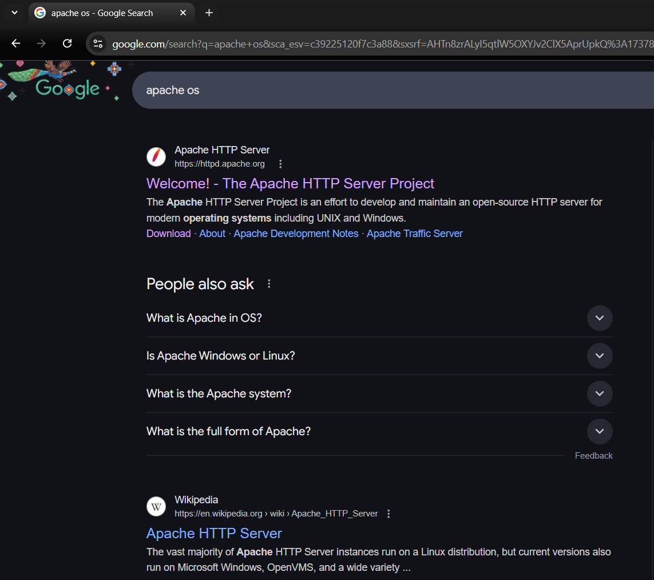

Step 2 :

Click on the "Downloads" option located on the left-hand side of the Apache Lounge website.

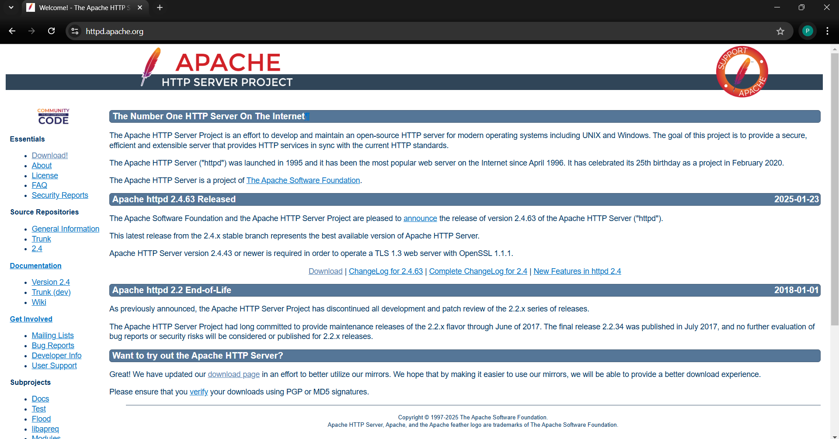

Step 3 :

Click on the link **"Apache 2.4.62-240904 Win64"** (Windows version), download the file, and extract all its contents.

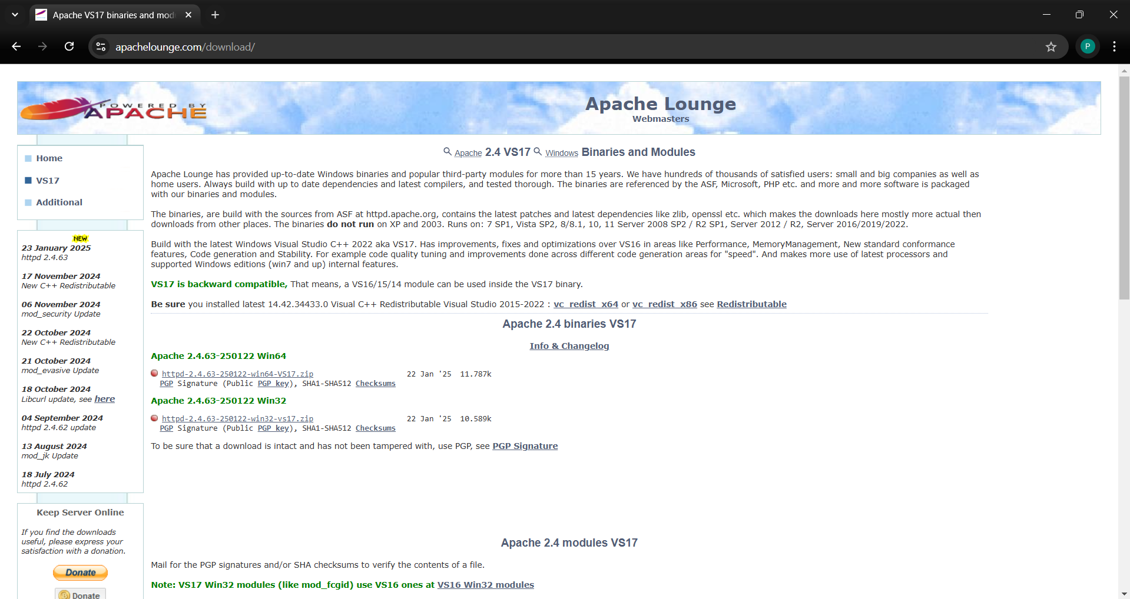

Step 4 :

Open Command Prompt as Administrator (Windows + R, type cmd, right-click and select 'Run as Administrator') and use the command cd C:\path\to\apache\bin to set the path to the Apache bin folder.

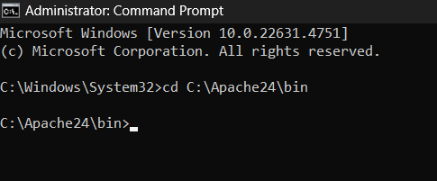

Step 5 :

Then Run the installation command :

**httpd.exe -k install**



Step10:

Go to the Apache folder, navigate to the **htdocs** folder, and find the **index.html** file. Right-click on it and select 'Edit with Notepad'. Create a simple model to display your name in HTML

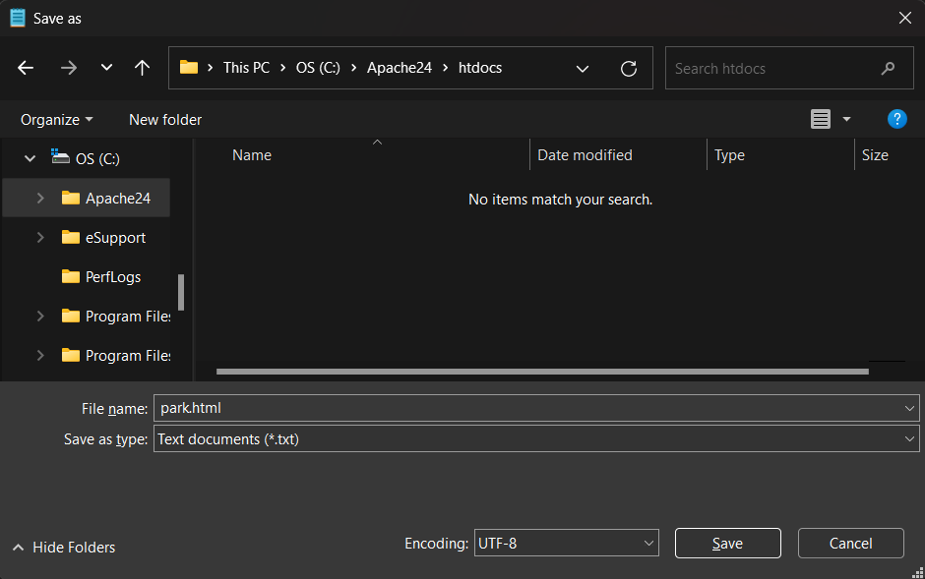

Step 12 :

Open the Chrome browser and type **localhost/index.html** in the address bar. You should be able to see the website hosted successfully.

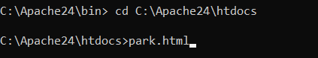

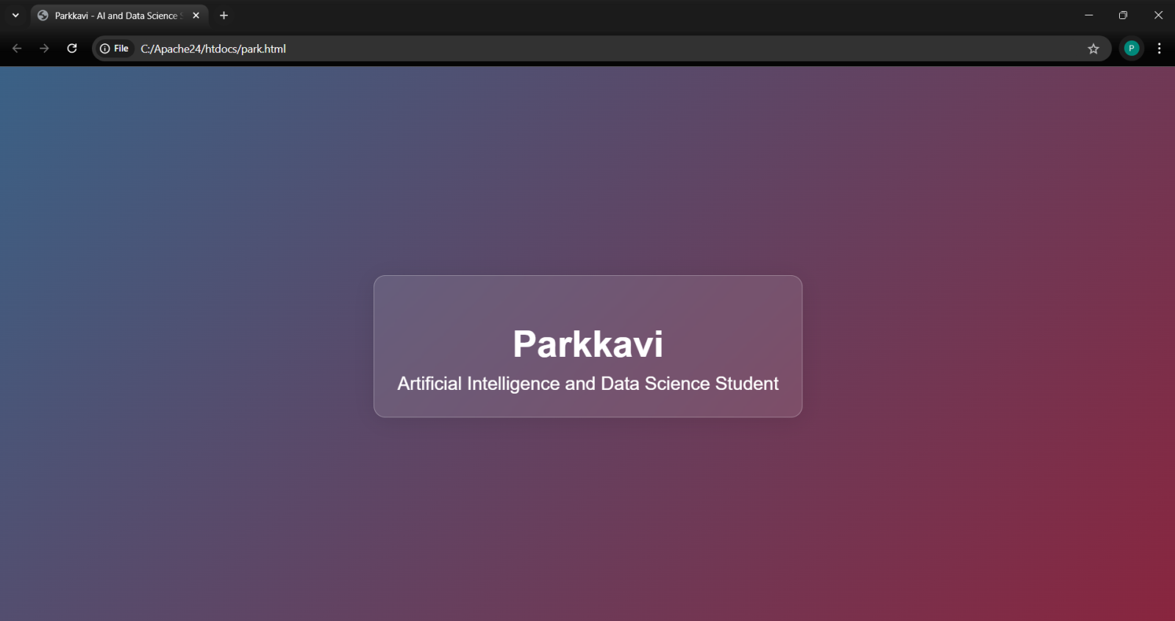

**Expected Outcome**

By completing this POC, you will:

1. Successfully configure and run an Apache server locally.

2. Host a static HTML website that displays your name.

3. Understand the basics of web server configuration and file hosting.