

**Placement Empowerment Program**

***Cloud Computing and DevOps Centre***

Set Up a Virtual Machine in the Cloud : Create a free- tier AWS account. Launch a virtual machine

Name: SHAHANA.M.S Department: ADS



**Introduction**

# The objective of this Proof of Concept (POC) is to explore the process of setting up a virtual machine in the cloud using the AWS Free Tier. A virtual machine (VM) is a crucial component in cloud computing, enabling users to deploy and manage scalable computing resources without requiring physical hardware. This POC serves as a foundational exercise for understanding cloud infrastructure and using AWS EC2 to create a simple and cost-effective computing environment

### **Overview**

## Here's a brief overview:

## Set Up a Virtual Machine in the Cloud using AWS

## Create a free-tier AWS account

## Launch a virtual machine (EC2 instance)

## Connect to your virtual machine

**Objectives**

## Main Objectives

## 1. Create a free-tier AWS account

## 2. Launch a virtual machine (EC2 instance) in the cloud

## 3. Connect to the virtual machine

**Importance**

## Here's the importance:

## 1. Cost-effective: Reduces hardware and maintenance costs.

## 2. Scalability: Easily scale up or down to meet changing demands.

## 3. Flexibility: Choose from various operating systems and configurations.

## 4. Reliability: Built-in redundancy and failover capabilities.

## 5. Accessibility: Accessible from anywhere, on any device.

**Step-by-Step Overview**

Step 1

## GotoAWSManagementConsole . Enter your username and password to log in

Step 2

## Navigate to the AWS Management Console and search for EC2

Step 3

## Click Launch Instances

Step 4

## Choose Amazon Linux 2023 Free Tier AMI or Ubuntu Free Tier AMI.

## Select the t2.micro instance type (free tier).

## Configure security group: Allow SSH(Port 22) from your IP.

## Addakey pair: If you don’t have one, create a new key pair and download it

Step 5

## Check your running instance in the Instances section . Select your Instance and click the Connect Option

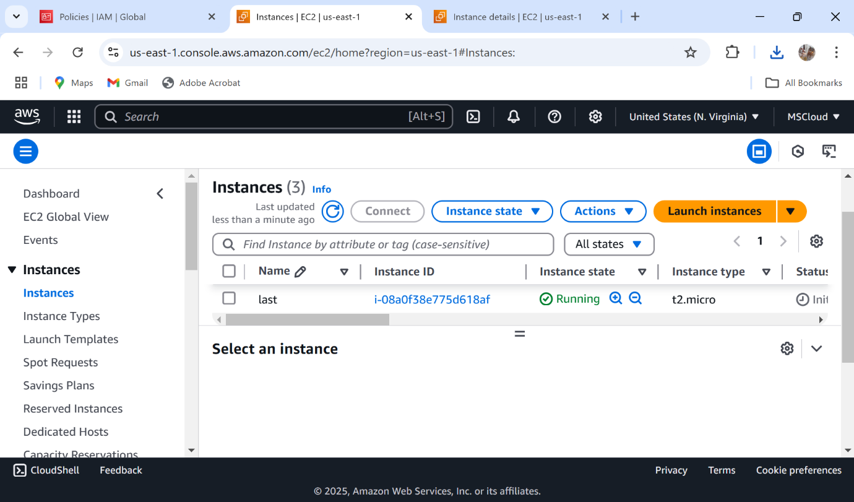

Step 6

## Go to the SSH client section, and copy the command provided under the 'Example' section

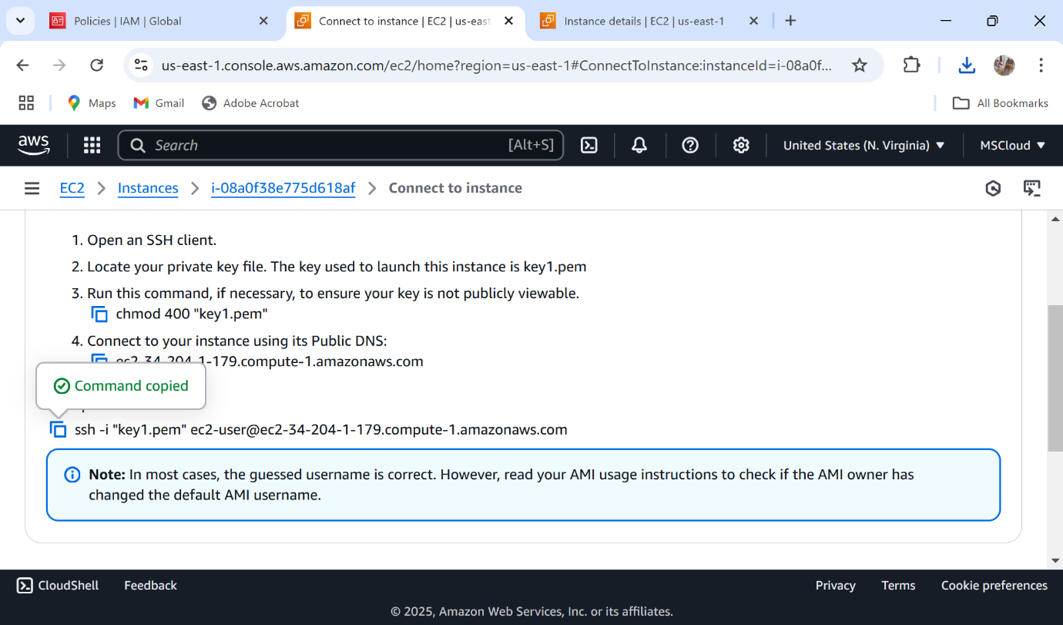

**Output**

### 1. Understand the basics of cloud computing and AWS

### 2. Learn how to create and manage AWS resources

### 3. Gain hands-on experience with launching and connecting to a virtual machine in the cloud