Problem Statement 1: Create Student List Using DOM Manipulation
You are given an HTML <div> element with the following structure:
<div id="container"></div>
Using JavaScript only, perform the following tasks:
- Select the <div> with the id container.
- Create a <ul> element dynamically and append it inside the given <div>.
- Create at least three list items (<li>) inside the <ul>.
- Each <li> should display a student’s name and marks in the following format:
Student Name – Marks
- Using JavaScript DOM manipulation, change the background color of each list item.
Problem statement 2: Dynamic Heading Manipulation Using JavaScript
You are given the following HTML element:
<h1 id="heading"></h1>
Using JavaScript only, perform the following tasks:
- Select the <h1> element using its id.
- Add meaningful text inside the heading dynamically using JavaScript.
- Change the text color of the heading using JavaScript.
- Change the background color of the heading using JavaScript.
- Align the heading text to the center.
- Add a CSS class (e.g. main-heading) to the heading using classList.
- On page load, display a message like:
“Welcome to JavaScript DOM Manipulation”
Problem statement 3: Write a JavaScript function that iterates through an array of integers. The function should evaluate each number in the array:
1. If the number is even, replace it with its square (n^2).
2. If the number is odd, the value should remain unchanged.
Input : [2,3,4,5,6]
Output: [4,3,16,5,36]
Problem statement 4: You are given an array of objects representing a shopping cart. Each object contains an itemName (string) and an itemPrice (number).
The output should be a new array where the items are sorted in ascending order based on itemPrice:
Input : const shoppingCart = [
{ itemName: "Wireless Mouse", itemPrice: 25 },
{ itemName: "Gaming Monitor", itemPrice: 300 },
{ itemName: "USB-C Cable", itemPrice: 15 },
{ itemName: "Mechanical Keyboard", itemPrice: 120 },
{ itemName: "Webcam", itemPrice: 85 }
];
Output :[
{ itemName: "USB-C Cable", itemPrice: 15 },
{ itemName: "Wireless Mouse", itemPrice: 25 },
{ itemName: "Webcam", itemPrice: 85 },
{ itemName: "Mechanical Keyboard", itemPrice: 120 },
{ itemName: "Gaming Monitor", itemPrice: 300 }
]
Problem statement 5: Write a JavaScript function using that processes an array of user objects and returns a new array containing only the users who meet both of the following criteria:
1. The isActive property is true.
2. The membership type is premium.
Input :
const users = [
{ id: 1, name: "Alice", isActive: true, membership: "premium" },
{ id: 2, name: "Bob", isActive: false, membership: "premium" },
{ id: 3, name: "Charlie", isActive: true, membership: "basic" },
{ id: 4, name: "David", isActive: true, membership: "premium" },
{ id: 5, name: "Eve", isActive: false, membership: "basic" }
];
Output:
[
{ id: 1, name: "Alice", isActive: true, membership: "premium" },
{ id: 4, name: "David", isActive: true, membership: "premium" }
]
Problem statement 6:
Consider the following code:
console.log(a);
console.log(b);
var a = 10;
let b = 20;
function test() {
console.log(c);
var c = 30;
}
test();
Tasks
- Predict the output of the above code.
- Explain briefly: 1.Why a prints undefined 2.Why b throws an error 3.Why c is undefined inside the function
- Identify the line that causes the error.

Bonus
Rewrite the code so that:
- No error occurs
- All console.log statements print valid values
Problem statement 7: Write a JavaScript function that creates a counter using closure. 1.Initial counter value should be 0 2.Each time increment() is called, the value should increase by 1 3. The counter value must not be accessible directly 4.The value should be preserved between function calls.
Problem statement 8: Predict Output and explain its output reason
sayHello();
function sayHello() {
console.log("Hello");
}
sayHi();
var sayHi = function () {
console.log("Hi");
};
Problem statement 9: You are given the output design of a product card.Using HTML and CSS, recreate the layout shown in the image as accurately as possible.

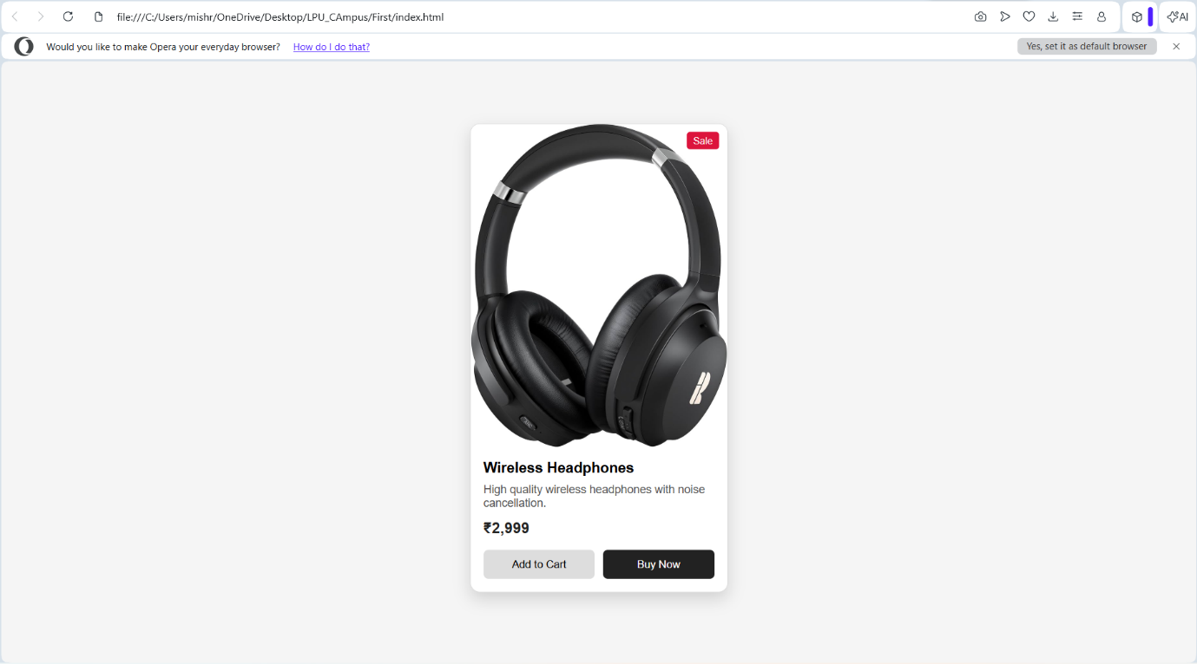
Problem statement 10: User Profile Card
Using HTML and CSS, create the layout
Requirements
- The profile card should be displayed at the center of the page
- The card must include:
  - User profile picture
  - User name
  - Short bio or description
  - Three information sections (e.g., Posts, Followers, Following)
  - A primary action button (e.g., Follow)
- All elements should be properly aligned with balanced spacing
- The card should have a visible boundary and rounded corners
Design & Interaction Expectations
- Information sections should be aligned neatly in a single row
- The profile image should appear visually prominent
- On hovering over the card or button, a subtle visual effect should be visible
- The layout should adapt well on smaller screen sizes

