1. Cat Fact Widget
The Problem: Build a simple widget that displays a random fact about cats. Add a "Get New Fact" button that refreshes the text without reloading the page.
• Key Skills: Simple GET requests, event listeners.
• API: Cat Facts
• Endpoint: https://catfact.ninja/fact
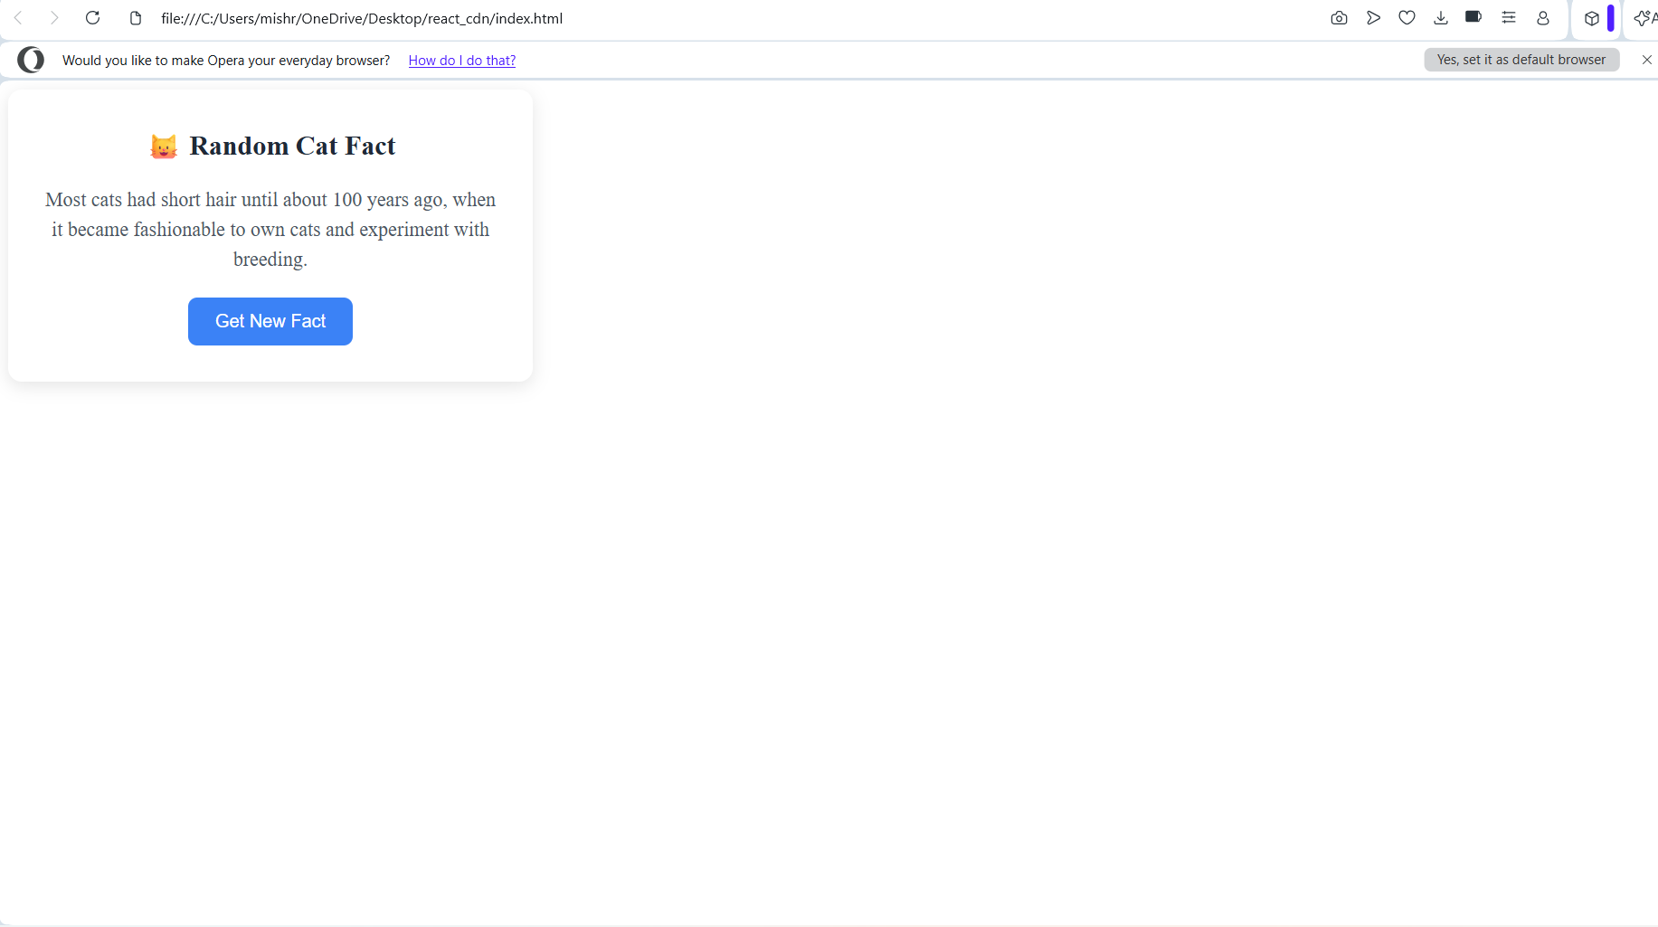
2. GitHub User Search(Bonus)
The Problem: Create a search bar. When a user types a GitHub username and hits enter:
1. Fetch the user's profile info (Avatar, Bio, Follower count).
2. Challenge: Also fetch their latest 5 repositories and list them below the profile.
3. Error Handling: Display a specific error message if the user does not exist (404).
• Key Skills: Chaining promises (or async/await), handling 404s, multiple requests.
• API: GitHub REST API
• User Endpoint: https://api.github.com/users/{username}
• Repos Endpoint: https://api.github.com/users/{username}/repos?sort=created&per_page=5
1.
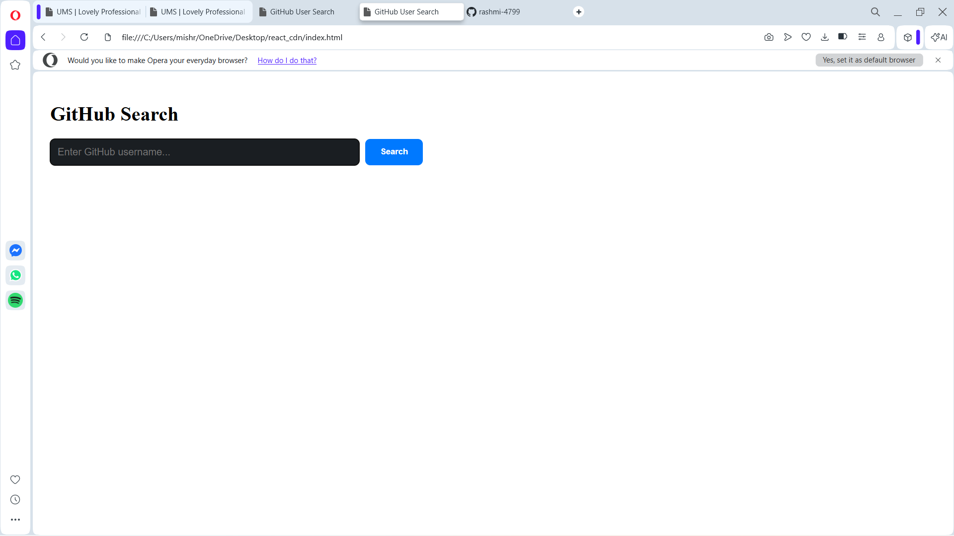
2.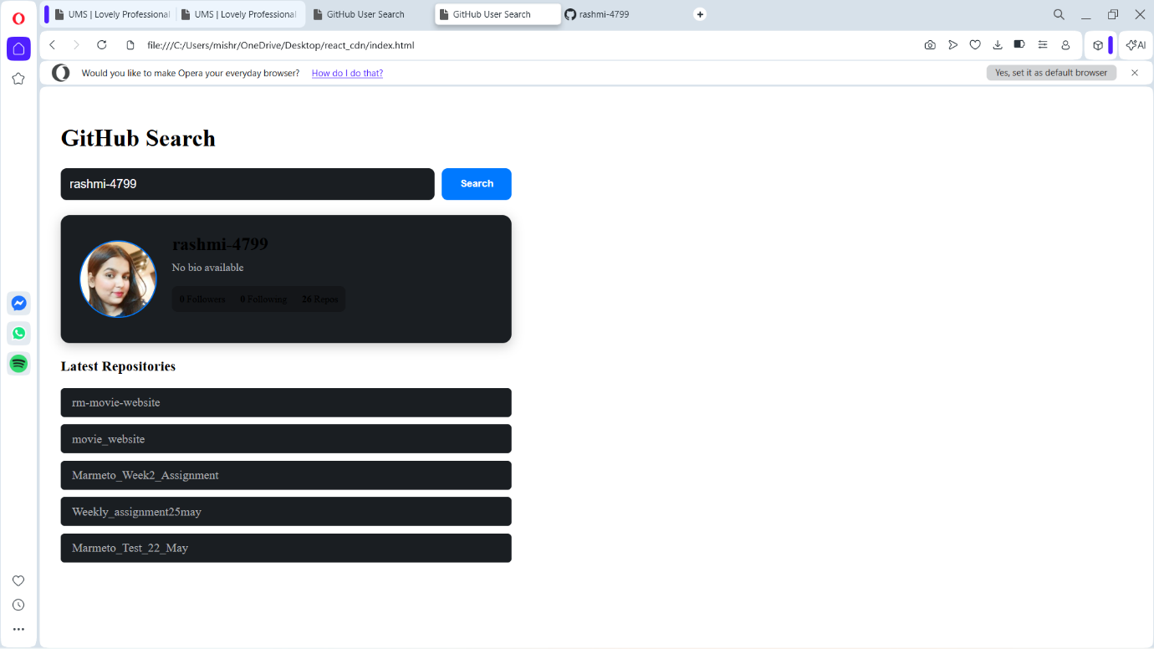

3. The Dynamic Product Dashboard
Objective: Build a React component that displays a list of products and manages a shopping cart's total value in real-time.
Requirements:
1. Data Presentation: Render a table displaying a list of products. Each row must contain:
• Product Name
• Price
• Action Button
2. Cart Logic (Toggle Interaction):
• Initially, the button should read "Add to Cart".
• When clicked, the product price is added to the total, and the button text changes to "Remove from Cart".
• If clicked again, the product is removed, the price is deducted from the total, and the button reverts to "Add to Cart".
3. Total Calculation: Display a distinct heading below the table showing the current Total Cart Value (e.g., "Total: 25000").
Sample Data:
[
{ "id": 1, "name": "Mobile", "price": 15000 },
{ "id": 2, "name": "Fridge", "price": 10000 },
{ "id": 3, "name": "AC", "price": 30000 }
]
1.