**TASK 3**

**GETTING STARTED WITH PYTHON**

**VARIABLES AND DATATYPES:**

**EXERCISE 1:**

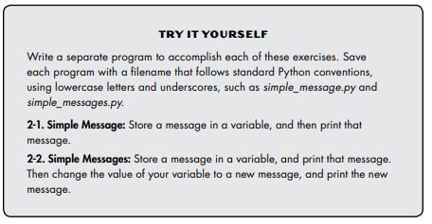

**Solutions of the Above Exercise:**

#==> 2-1

message = "Hello, This the the first message!"

print(message)

#==> 2-2

message_1 = "This is message 1"

print(message_1)

message_1 = "this is message 1 after change"

print(message_1)

**Output Screenshot:**

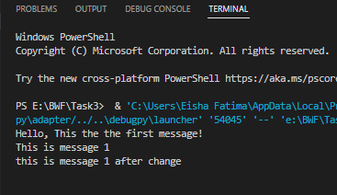

**EXCERSICE:**

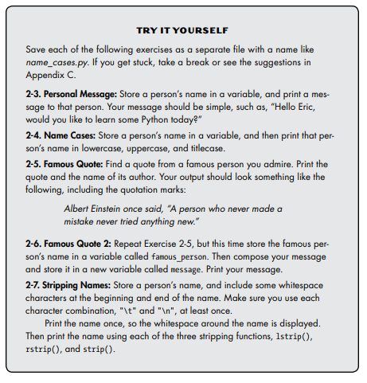

**Solution Code:**

#==> 2-3

name = "Shahab"

print("Hello " + name+ ", would you like to learn some Python today?")

print()

print()

#==> 2-4

person_name = "Simon ghost riley"

print(person_name.lower())

print(person_name.upper())

print(person_name.title())

print()

print()

#==> 2-5

print("Andrew Tate once said, \"There is no sun without rain, no joy without pain.\"")

print()

print()

#==> 2-6

famous_person = "Andrew Tate"

message = famous_person + " once said, \"There is no sun without rain, no joy without pain.\""

print(message)

print()

print()

#==> 2-7

name_person = " Ahmed "

print(name_person)

print(name_person.lstrip())

print(name_person.rstrip())

print(name_person.strip())

print()

#\t and \n combinations practice

variable1 = "Hello"

variable2 = "World"

print(variable1+" "+variable2)

print("\t"+variable1+variable2)

print(variable1+"\n\t"+variable2)

print(variable1+"\n"+variable2)

**OUTPUT SCREENSHOT:**

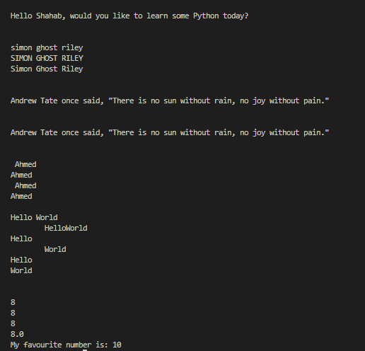

**EXERCISE:**

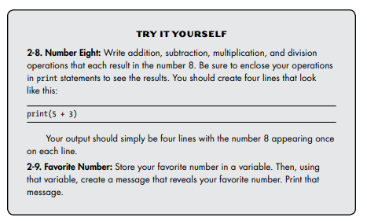

**Solution Code:**

#NUMBERS/INTEGERS DATATYPE

#==> 2-8

#add

print(5+3)

#subtract

print(11-3)

#multiply

print(4*2)

#divide

print(16/2)

#==> 2-9

#favourite number printing

favourite_number = 10

print("My favourite number is: "+str(favourite_number))

**Screenshot:**

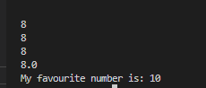

**LISTS:**

**Exercise:**

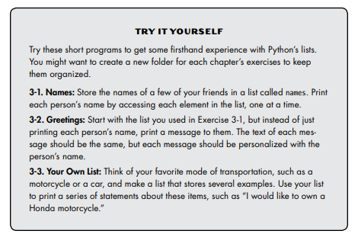

**Solution Code:**

#==> 3-1

names = ['Federer','Novak','Ronaldo','Messi']

print(names[0])

print(names[1])

print(names[2])

print(names[3])

#==> 3-2

print("How are you "+names[0])

print("How are you "+names[1])

print("How are you "+names[2])

print("How are you "+names[3])

print()

print()

#==> 3-3

cars = ['bmw','audi','benz']

print("I would like to own a "+cars[0]+" car")

print("I would like to own a "+cars[1]+" car")

print("I would like to own a "+cars[2]+" car")

**Output Screenshot:**

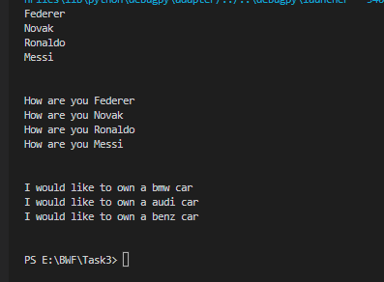

**Exercise:**

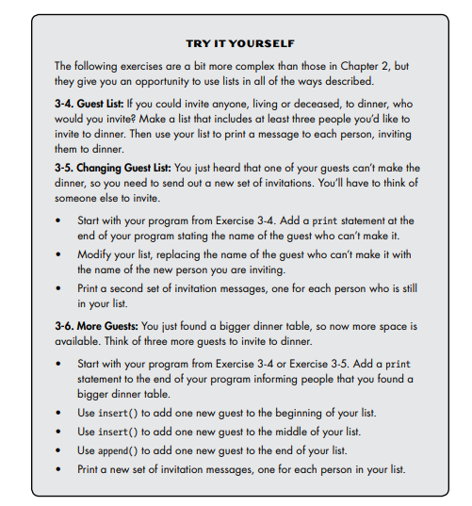

**Solution Code:**

#==> 3-4

guests = ['Ali','Hamza','Bashir']

print(guests[0]+ ", I am inviting you to dinner.")

print(guests[1]+ ", I am inviting you to dinner.")

print(guests[2]+ ", I am inviting you to dinner.")

print()

print()

#==> 3-5

guests = ['Ali','Hamza','Bashir']

print(guests[0]+ ", I am inviting you to dinner.")

print(guests[1]+ ", I am inviting you to dinner.")

print(guests[2]+ ", I am inviting you to dinner.")

#guest who cant make it

print(guests[0]," can't make it to the dinner.")

guests[0] = 'Qais'

#printing new invitation

print(guests[0]+ ", I am inviting you to dinner.")

print(guests[1]+ ", I am inviting you to dinner.")

print(guests[2]+ ", I am inviting you to dinner.")

print()

print()

#==> 3-6

guests = ['Ali','Hamza','Bashir']

print(guests[0]+ ", I am inviting you to dinner.")

print(guests[1]+ ", I am inviting you to dinner.")

print(guests[2]+ ", I am inviting you to dinner.")

print("Okay! So, I found a bigger dinner table.")

#adding at start

guests.insert(0,'Maluk')

#adding at mid

guests.insert((int(len(guests)/2)), 'Taimoor')

#adding at end

guests.append('Abdullah')

print(guests)

print()

print()

#==> 3-7

guests = ['Ali','Hamza','Bashir']

print(guests[0]+ ", I am inviting you to dinner.")

print(guests[1]+ ", I am inviting you to dinner.")

print(guests[2]+ ", I am inviting you to dinner.")

print("Okay! So, I found a bigger dinner table.")

#adding at start

guests.insert(0,'Maluk')

#adding at mid

guests.insert((int(len(guests)/2)), 'Taimoor')

#adding at end

guests.append('Abdullah')

print(guests)

print("Dinner table wont be available in time and Only two people can be invited.")

print()

#poping the names from the list

removed_guest = ""

removed_guest = guests.pop()

print("Sorry "+removed_guest+" I cannot invite you to dinner.")

removed_guest = guests.pop()

print("Sorry "+removed_guest+" I cannot invite you to dinner.")

removed_guest = guests.pop()

print("Sorry "+removed_guest+" I cannot invite you to dinner.")

removed_guest = guests.pop()

print("Sorry "+removed_guest+" I cannot invite you to dinner.")

print()

print(guests[0]+ ", You are still invited.")

print(guests[1]+", You are still invited")

print()

guests.remove(guests[0])

guests.remove(guests[0])

print(guests)

**Output Screenshot:**

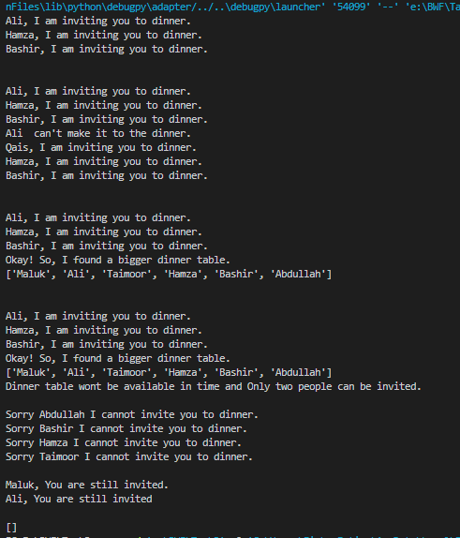

**Exercise:**

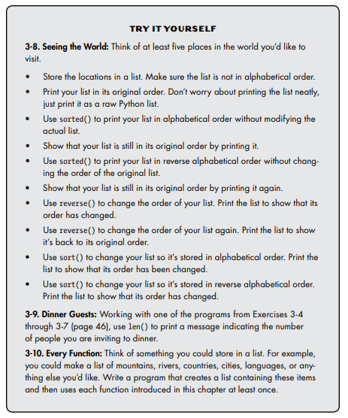

**Solution Code:**

#==> 3-8

places = ['Egypt',"Switzerland","London","Paris","Maldives"]

print(places)

print()

print("The sorted list is: ")

print(sorted(places))

print()

print("Orginal List:")

print(places)

print()

print("The reverse sorted list is: ")

print(sorted(places,reverse=True))

print()

print("Orginal List:")

print(places)

print()

places.reverse()

print("The reversed list is: ")

print(places)

print()

places.reverse()

print("After reversing again, the list is: ")

print(places)

print()

places.sort()

print("Sorted list: ")

print(places)

print()

places.sort(reverse=True)

print("Reverse Sorted List is: ")

print(places)

print()

print()

#==> 3-9

guests = ['Ali','Hamza','Bashir']

print(guests[0]+ ", I am inviting you to dinner.")

print(guests[1]+ ", I am inviting you to dinner.")

print(guests[2]+ ", I am inviting you to dinner.")

print()

print("The number of guests I am inviting to dinner is: "+ str(len(guests)))

print()

print()

#==> 3-10

languages = ['Urdu','English','French','German']

languages.pop()

print(languages)

print()

languages.remove(languages[0])

print(languages)

print()

languages.insert(0,'Pashto')

print(languages)

print()

languages.append('Greek')

print(languages)

print()

languages.sort()

print(languages)

print()

languages.reverse

print(languages)

print()

**Screenshot:**

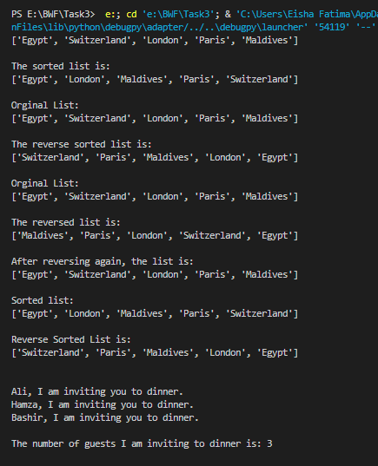

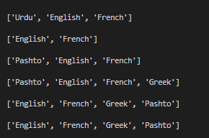

**LOOPS:**

**Exercise:**

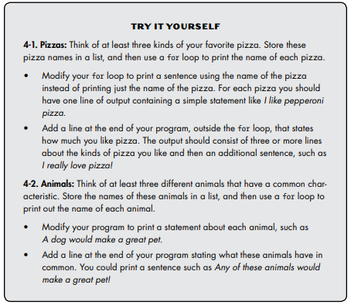

**Solution Code:**

#==> 4-1

pizzas = ['Bbq','Grilled','Fajita']

for pizza in pizzas:

    print(pizza)

print()

for pizza in pizzas:

    print("This pizza flavour is: "+pizza)

print("I like thin crust pizzas.\nI like Chicken Pizzas.\nI like Spicy Pizzas.\nI really love pizza. ")

print()

print()

#==> 4-2

animals = ['Lion','Tiger','Cheetah']

for animal in animals:

    print(animal)

print()

for animal in animals:

    print(animal + " won't be a great pet.")

print("All these animals have 4 legs")

print()

**Screenshot:**

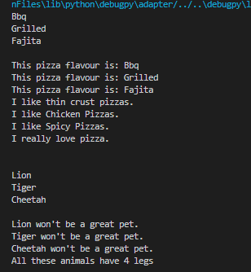

**Exercise:**

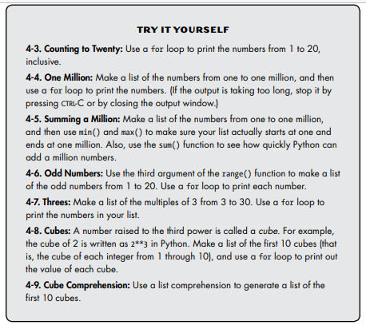

**Solution Code:**

#==> 4-3

for i in range(1,21):

    print(i)

#==> 4-4

num_list = []

for i in range(1,pow(10,6)+1):

    num_list.append(i)

for num in num_list:

   print(num)

#==> 4-5

num_list = []

for i in range(1,pow(10,6)+1):

    num_list.append(i)

print("Max Number of the list is: "+ str(max(num_list)))

print("Min Number is: "+ str(min(num_list)))

print("Sum of the list items is: ")

print(sum(num_list))

print()

#==> 4-6

num_list = []

for i in range(1,21,2):

    num_list.append(i)

for num in num_list:

    print(num)

print()

#==> 4-7

num_list = []

for i in range(3,31,3):

    num_list.append(i)

for num in num_list:

    print(num)

print()

#==> 4-8

num_list = []

for i in range(1,11):

    num_list.append(i**3)

for num in num_list:

    print(num)

#==> 4-9

cubes = [value**3 for value in range(1,11)]

for num in cubes:

    print(num)

**Output Screenshot:**

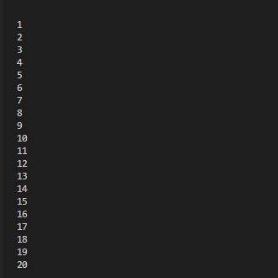

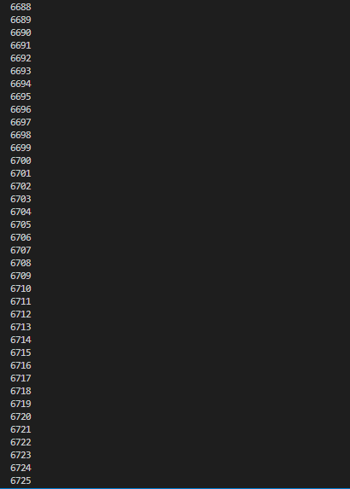

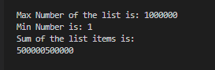

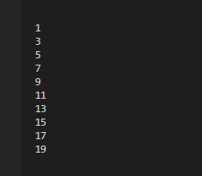

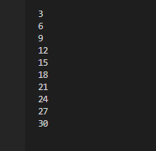

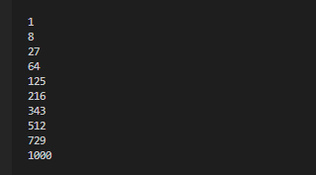

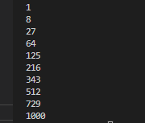

**TUPLE:**

**Exercise:**

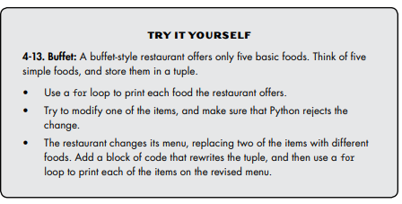

**Solution Code:**

foods = ('bread','pizza','burger','icecream','banana')

for food in foods:

    print(food)

print()

foods[0]="Paratha"

foods = ('brownie','roll paratha','burger','icecream','banana')

print("Foods after replacing two items")

print(foods)

**Screenshot:**



