**Name: Shahab Ali**

**Task 1**

**Topic 1:**

**Starting With Git**

* **CONFIGURATION:**

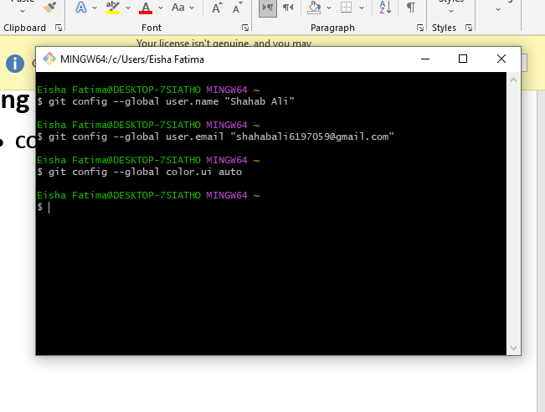

* **Git initialization:**

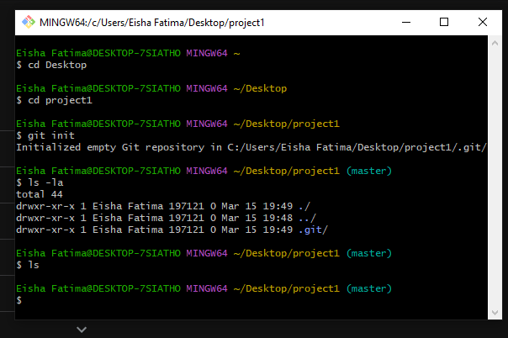

* **GITIGNORE:**

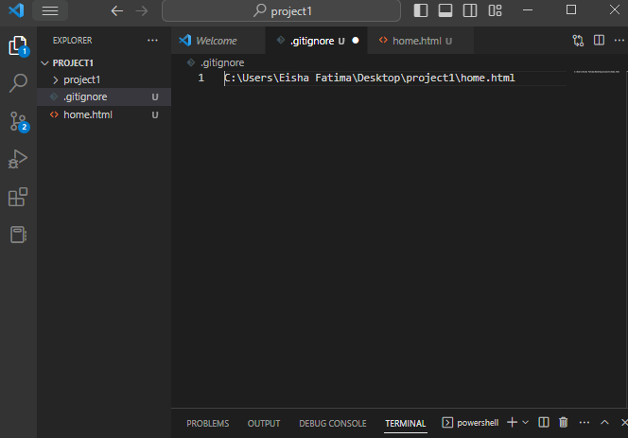

* First, I created the gitignore file. Then, I created a **home.html**. And in the gitignore file I declared the path of html file to ignore it.

**REPOSITORY CLONING:**

I cloned a repository from my own github.

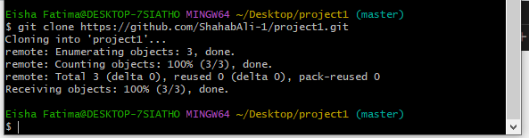

**Now my root folder looks like this after cloning:**

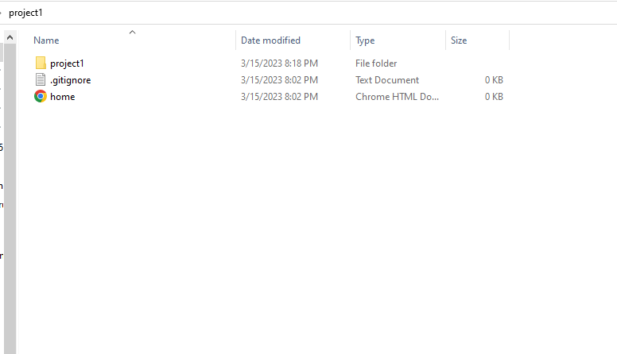

**Shifted to Visual Studio Code and Its terminal for the remaining Practice of Commands.**

* **Git Status:**

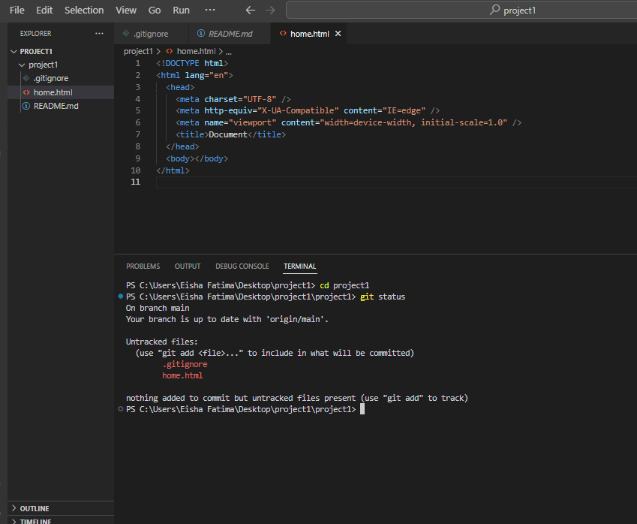

**Added two new files – index.css and index.html -- and then ran the git status command. Screenshot Below:**

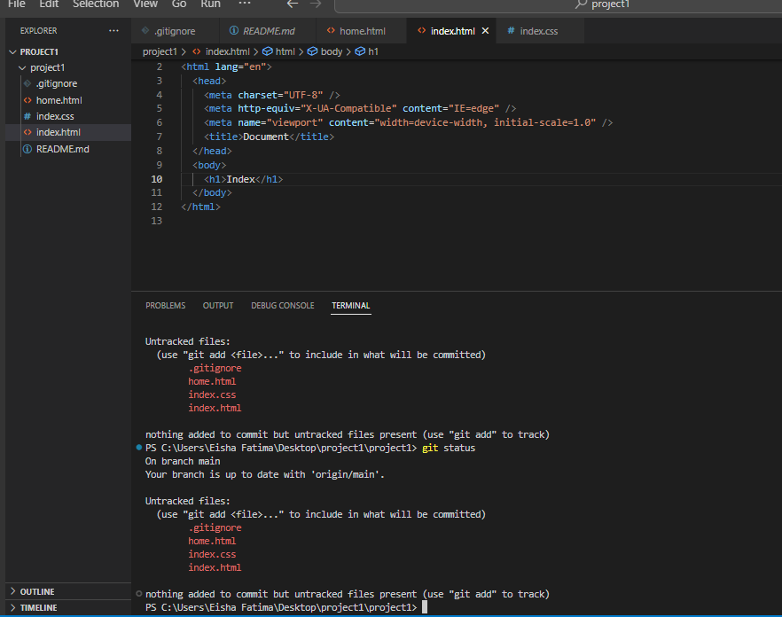

* **Staging the files for commit:**

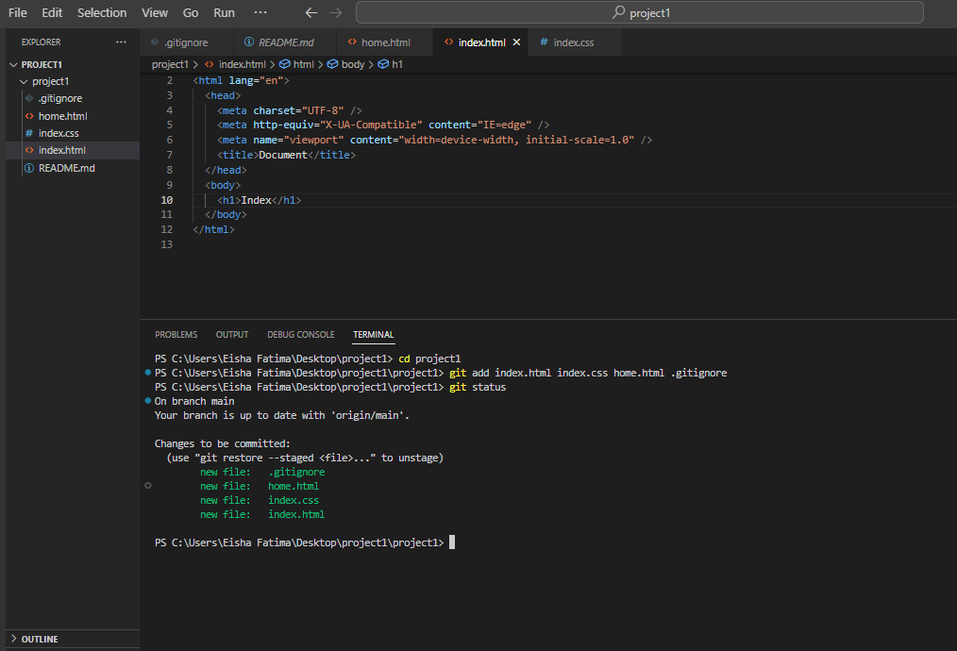

* **Committing the Work:**

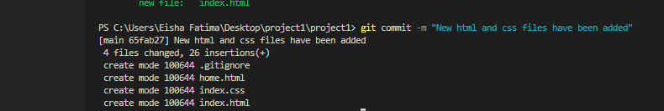

* **Checking the commit Log:**

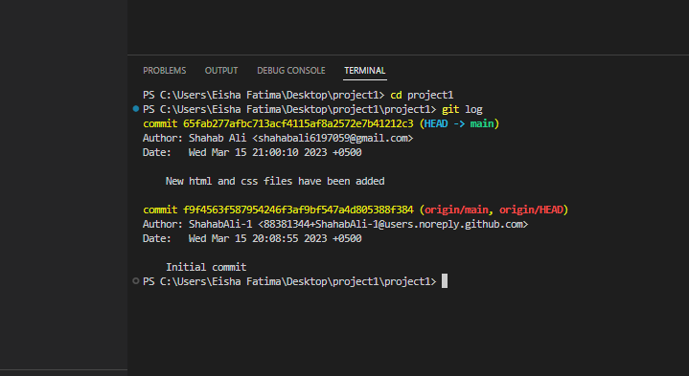

**TOPIC 2**

**BRANCHING AND MERGING:**

* **Adding a new branch**

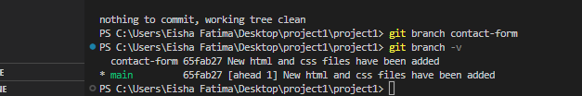

* Git Stash:

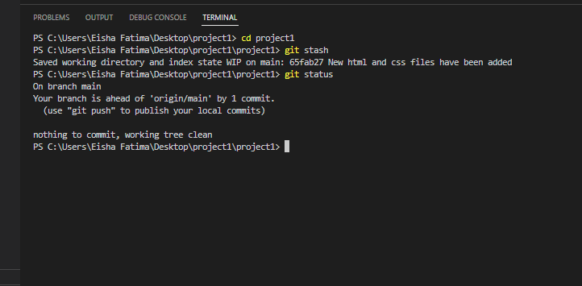

* **Restoring stash**

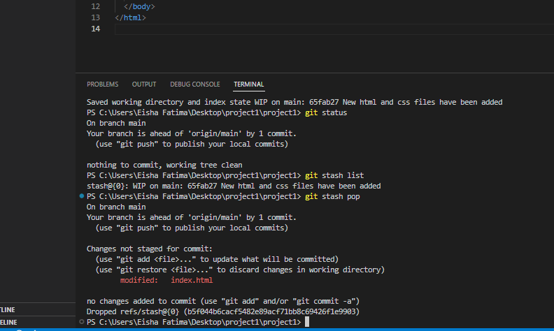

* **Switching to different branch and performing commit in that branch:**

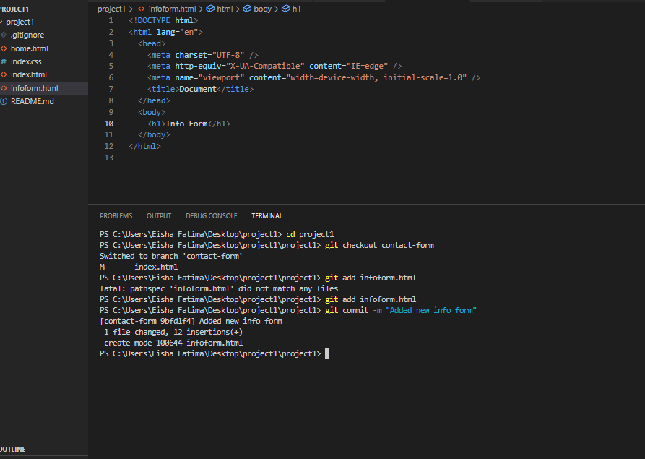

* **Performing the merge on two branches:**

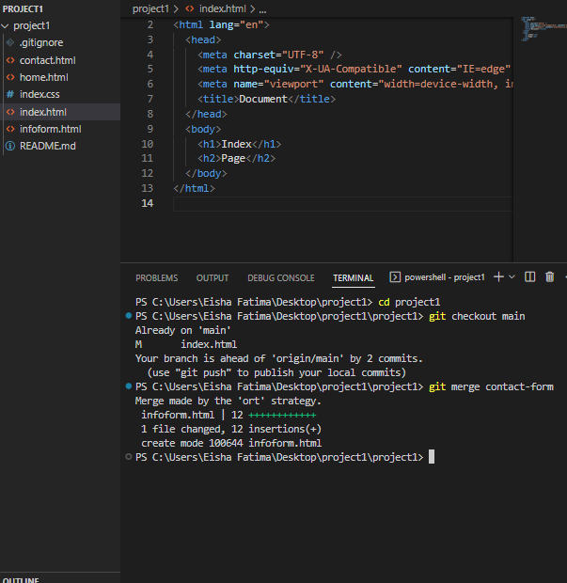

In the screenshot above I stayed in the main branch and merged the contact-form branch into the main branch.