Final Project Report
for
Operating System Dev. In Assembly
Submitted To: Mr. Saleem Raza

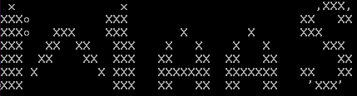
Table of Contents

Table of Contents ii
Group Members ii
1. Final Project Summary i
2. Detailed Information i
2.1 Boot Loader i
2.1.1 Sector Reading iv
2.2 Kernel Code vi
2.2.1 0x09 Function, int 10h vi
2.2.2 0x02 Function, int 10h vi
2.2.3 0x00 Function, int 16h vi
2.2.4 Code vii
2.3 Applications Code: xii
2.3.1 Text Editor xii
2.3.2 Calculator Code xiii
2.3.3 Typing Software xix
2.3.4 HangMan xxiii

Group Members

Name | Reg # | Area of Work
Shahab Khalid | FA13-BCS-041 | Boot Loader + Kernel Programming, Basic OS Modules related to Console and Sector Reading
Abdul Wakeel | FA13-BCS-017 | Boot Loader + Kernel Programming, Arithmetic Programming, Modules Writer
Wasiq Safdar | FA13-BCS-047 | Application Programmer [Hangman]
M. Nofal | FA13-BCS-0213 | Application Programmer [Typing Game]
Ahtesham Khan | FA13-BCS-048 | Application Programmer [Text Editor]

Final Project Summary
The Project is an Operating System [named: WaaS-OS] written form scratch. The Operating System is 16 bit and is currently working on Real Mode means we are
Accessing bios interrupts for I/O.

About Operation System:

Bits | 16
Total Sectors Using | 14
Boot Loc. in Mem. | 0x7c00
Kernel Loc. In Mem. | 0x1000
Apps. Loc In Mem. | 0x5000
Kernel Sectors | 3
Text Editor Sectors | 1
Calculator Sectors | 2
Typing Game Sectors | 2
HangMan Sectors | 3

Detailed Information

Here we are going to discuss about the Code for Each Section.

2.1 Boot Loader
Ok! So How the BIOS Checks If the Drive/Floppy/USB/CD is Bootable or not. It’s very simple at very first time BIOS read the first sector of the Disk and checks whether the last two bytes of sector is 0x55 and 0xAA is true or false. If it’s true the Disk is bootable otherwise it’s not. BIOS write the code on memory at address 0X7C00.

Simple Boot Code:
[BITS 16] ;Code is 16 Bit
[org 0x7c00] ;Tell Assembler that the code will be loaded at 0x7c00, so
maintain address related to 0x7c00

mov si,_Welcome
call PrintString
times 510 – ($-$$) db 0 ;Filling the extra bytes of first sector with zeros
dw 0xaa55 ;last two bytes as 0xaa55
Hexa Code of Bin/Img File:

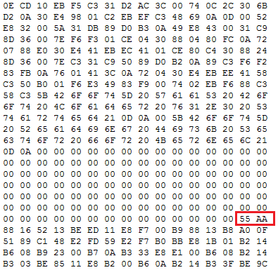

Our Boot Code:

;-----------------------------------------------------

; WaaS Boot Loader v1.0

; ====Written By=====
; # Shahab Khalid #
; # Abdul Wakeel #
; ===================

;-----------------------------------------------------

;------------------------------------------------------
[BITS 16] ;Code is 16 Bits
[ORG 0x7c00] ;Code will be saved at 0x7x00 in memory by bios
;------------------------------------------------------
mov [BOOT_DRIVE],dl ;Saving Boot Drive
mov bp,0xf000 ;Base/Start For Stack
mov sp,bp ;Stack Current Pointing to Base/Start

;Printing Boot Load Message
mov si,_BootLoad
call PrintString

mov cx,1000
mov ax,500
d:
push cx
mov cx,ax
d1:
dec ax
loop d1
pop cx
loop d

;Printing Disk Sector Read Message
mov si,_LoadKernel
call PrintString

mov cx,1000
mov ax,500
delay:
push cx
mov cx,ax
delay1:
dec ax
loop delay1
pop cx
loop delay

mov bx,0x1000 ;Address [es:bx] to write sector in memory
mov dh,0x05
mov [_SectorsToRead],dh ;Sectors To Read
mov dh,0x02
mov [_Sectors],dh ;Sector
call ReadSector

mov dl,[BOOT_DRIVE]
jmp 0x1000 ;Load Kernel

cli
hlt

;-----------------------INCLUDES------------------------
%include "Modules/bDrive.asm"
%include "Modules/PrintString.asm"
;-------------------------------------------------------

;----------------------Declaring Vars----------------
_BootLoad db "[Boot] WaaS Boot Loader v1.0 Started!",0x0d,0x0a,0
_LoadKernel db "[Boot] Reading Disk Sector for Kernel!",0x0d,0x0a,0
_Sectors db 0x00
_SectorsToRead db 0x00
BOOT_DRIVE db 0
;----------------------------------------------------

times 510-($-$$) db 0 ;Filling Free Space
dw 0xAA55 ;Last Part of Sector, That make it Bootable

Sector Reading
As the BIOS only reads the first sector [ 512 Bytes ] of DISK. It’s not enough for an OS. But we that code Sector reading at Boot Sector and then jumps to the location we write the sector. In Our Boot Code we are Loading the kernel [ 2nd sector ] at location 0x1000 and then
Jumping to that location. Now we can load as many as sectors we want and load them to memory.

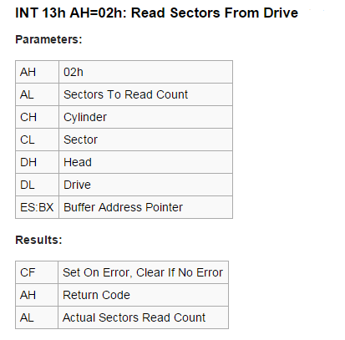

mov bx,0x1000 ;Address [es:bx] to write sector in memory
mov dh,0x05
mov [_SectorsToRead],dh ;Sectors To Read
mov dh,0x02
mov [_Sectors],dh ;Sector
call ReadSector

mov dl,[BOOT_DRIVE]
jmp 0x1000 ;Load Kernel

;--------------------Reading Sector MOdule-----------------
ReadSector:
mov ah,0x02
push dx
mov cx,0x05
ReadSector.L:
push cx
mov al,[_SectorsToRead]
mov ch,0x00
mov dh,0x00
mov cl,[_Sectors]
int 0x13
jnc ReadSector.ReadSectorDone
pop cx
loop ReadSector.L

jmp ReadSector.Error

ReadSector.ReadSectorDone:
pop cx
pop dx
cmp dh,al
mov si,_SRS
call PrintString
jmp ReadSector.EndRad

ReadSector.Error:
mov si,_SecReadError
call PrintString

ReadSector.EndRad:
ret
;----------------End Reading Sector MOdule--------------------

2.2 Kernel Code

Kernel Code includes a UI colored Layout. Using Following Function and Interrupts!

2.2.1 0x09 Function, int 10h
0x09 Function of int 10h is used to print single character at current cursor position with specific color.

2.2.2 0x02 Function, int 10h
For Setting Cursor Position at specific Row and Column.

2.2.3 0x00 Function, int 16h
For reading single key from keyboard.

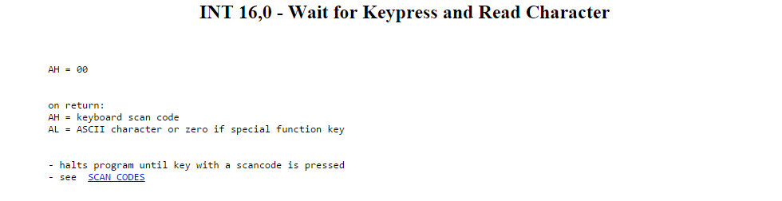

2.2.4 Code
;-----------------------------------------------------

; WaaS Kernel v1.0

; ====Written By=====
; # Shahab Khalid #
; # Abdul Wakeel #
; ===================

;-----------------------------------------------------

;------------------------------------------------------
[bits 16]
[org 0x1000]
;------------------------------------------------------

mov [BOOT_DRIVE],dl ;Saving Boot Drive

mov si,scrMsg
call PrintString

mov cx,5000
mov ax,4000
delay:
push cx
mov cx,ax
delay1:
dec ax
loop delay1
pop cx
loop delay

mov al,0xbb ;BGcolor
call ClearScreen

mov dl,20
mov dh,8
mov cx,35
mov bh,10
mov bl,0x33
call OS_DBox

mov dh,8
mov dl,20
mov bl,0x03
mov si,_Welcome
call cPrintString

mov dh,10
mov dl,20
mov bl,0x3f
mov si,_wcMsg1
call cPrintString

mov dh,11
mov dl,20
mov bl,0x3f
mov si,_wcMsg2
call cPrintString

mov dh,13
mov dl,24
mov bl,0x30
mov si,_wcMsg3
call cPrintString

mov dh,14
mov dl,28
mov bl,0x34
mov si,_wcMsg4
call cPrintString

mov dh,15
mov dl,28
mov si,_wcMsg5
call cPrintString

jmp Part2

;-----------------------INCLUDES------------------------
%include "Modules/Drive.asm"
%include "Modules/cPrintString.asm"
%include "Modules/PrintString.asm"
%include "Modules/OS_DBox.asm"
%include "Modules/ClearScreen.asm"
;-------------------------------------------------------

;----------------------Declaring Vars----------------
_Welcome db "Welcome to WaaS-OS vI!",0
_wcMsg1 db "Thank you User for Switching to",0
_wcMsg2 db "WaaS-OS vI!",0
_wcMsg3 db "Writters:",0
_wcMsg4 db "Shahab Khalid",0
_wcMsg5 db "Abdul Wakeel",0
scrMsg db " x x ,XXX, ",0x0d,0x0a
db "XXX XXX XX XX ",0x0d,0x0a
db "XXX XXX XXX X X XXX ",0x0d,0x0a
db "XXX XX XX XXX X X X X XXX ",0x0d,0x0a
db "XXX XX XX XXX XX XX XX XX XX ",0x0d,0x0a
db "XXX X X XXX XXXXXXX XXXXXXX XX XX ",0x0d,0x0a
db "XXX XXX XX XX XX XX 'XXX' ",0x0d,0x0a
db " ",0
BOOT_DRIVE db 0
;----------------------------------------------------

Part2:
mov dh,17
mov dl,32
mov bl,0x0f
mov si,_b_Cont
call cPrintString

;Wait For Enter To Continue
PressEnter:
mov ah,00h
int 16h
cmp ah,28
jne PressEnter

times 1024 - ($ - $$) db 0

mov al,0xbb ;BGcolor
call ClearScreen

mov dl,20
mov dh,2
mov cx,35
mov bh,20
mov bl,0x33
call OS_DBox

mov dh,2
mov dl,20
mov bl,0x03
mov si,_Menu
call cPrintString

mov ah,0ch
int 10h

;%ifdef COMMENT
call WriteMenu

KeyEvent:
mov ah,00h
int 16h

cmp ah,50h
je dRWM

cmp ah,48h
je uRWM

cmp ah,0x1c
je InitLoadApp

jmp None

dRWM:
mov al,[_mSelected]
cmp al,4
jb movD
jmp None
movD:
inc al
mov [_mSelected],al
call WriteMenu
jmp None

uRWM:
mov al,[_mSelected]
cmp al,1
ja movU
jmp None
movU:
dec al
mov [_mSelected],al
call WriteMenu

None:
jmp KeyEvent

InitLoadApp:
mov al,[_mSelected]
cmp al,0x01 ;TextEditor
je InitTE

cmp al,0x02 ;BAC
je InitBAC

cmp al,0x03 ;TS
je InitTS

cmp al,0x04 ;HM
je InitHM

jmp KeyEvent

InitTE:
mov dh,[_TextEditor_TotSecs]
mov [_SectorsToRead],dh ;Sectors To Read
mov dh,[_TextEditor_Sec]
mov [_Sectors],dh ;Sector
jmp LoadApp

InitBAC:
mov dh,[_Calculator_TotSecs]
mov [_SectorsToRead],dh ;Sectors To Read
mov dh,[_Calculator_Sec]
mov [_Sectors],dh ;Sector
jmp LoadApp

InitTS:
mov dh,[_TS_TotSecs]
mov [_SectorsToRead],dh ;Sectors To Read
mov dh,[_TS_Sec]
mov [_Sectors],dh ;Sector
jmp LoadApp

InitHM:
mov dh,[_HM_TotSecs]
mov [_SectorsToRead],dh ;Sectors To Read
mov dh,[_HM_Sec]
mov [_Sectors],dh ;Sector

LoadApp:
mov dl,[BOOT_DRIVE]
mov bx,0x5000 ;Memory Addr to Tmp load App Sector
call ReadSector

jmp 0x5000

;%endif

cli
hlt

WriteMenu:
pusha
mov bl,0x3f

mov al,[_mSelected]
cmp al,0x01
je s1
jmp _s1
s1:
mov bl,0x0f

_s1:
mov dh,4
mov dl,30
mov si,_TextEditor
call cPrintString

mov bl,0x3f

mov al,[_mSelected]
cmp al,0x02
je s2
jmp _s2
s2:
mov bl,0x0f

_s2:
mov dh,5
mov dl,30
mov si,_Calculator
call cPrintString

mov bl,0x3f

mov al,[_mSelected]
cmp al,0x03
je s3
jmp _s3
s3:
mov bl,0x0f

_s3:
mov dh,6
mov dl,30
mov si,_TS
call cPrintString

mov bl,0x3f

mov al,[_mSelected]
cmp al,0x04
je s4
jmp _s4
s4:
mov bl,0x0f

_s4:
mov dh,7
mov dl,30
mov si,_HM
call cPrintString
popa
ret

;----------------------------------------------------
_b_Cont db "Continue",0
_Menu db "Desktop",0
_mSelected db 0x01

_TextEditor db " Text Editor ",0
_TextEditor_Sec db 0x06
_TextEditor_TotSecs db 0x01

_Calculator db " BAC ",0
_Calculator_Sec db 0x07
_Calculator_TotSecs db 0x02

_TS db " Typing Game ",0
_TS_Sec db 0x09
_TS_TotSecs db 0x02

_HM db " Hangman ",0
_HM_Sec db 0x0b
_HM_TotSecs db 0x03
;----------------------------------------------------

times 1536 - ($ - $$) db 0

2.3 Applications Code:

2.3.1 Text Editor
;------------------------------------------------------
[BITS 16]
[ORG 0x5000]
;------------------------------------------------------

mov al,0x00
call ClearScreen

mov dh,0
mov dl,1
mov bl,0xf0
mov si,_Title
call cPrintString

mov dh,24
mov dl,1
mov bl,0xf0
mov si,_cmdMSg
call cPrintString

mov dh,2
mov dl,1
mov ah,0x02
int 10h

mov bl,0x0f
mov ah,0x09
int 10h

KeyEvent:
xor ah,ah
int 16h

cmp ah,1 ;Escape
je Back

cmp ah,14 ;BackSpace
je BackSpace

cmp ah,28 ;Enter
je NewLine

mov ah,0x09
int 10h

inc dl
mov ah,0x02
int 10h

jmp KeyEvent

BackSpace:
dec dl
mov ah,0x02
int 10h

mov al,' '
mov ah,0x09
int 10h
jmp KeyEvent

NewLine:
inc dh
mov dl,1
mov ah,0x02
int 10h

jmp KeyEvent

Back:
mov esi,0x1000
add esi,512
jmp esi

cli
hlt

;-----------------------INCLUDES------------------------
%include "Modules/cPrintString.asm"
%include "Modules/ClearScreen.asm"
;-------------------------------------------------------

;----------------------Declaring Vars----------------
_Title db "Text Editor",0
_cmdMSg db "Esc - Exit | Clt + S - Save | Clt + N - New File",0
;----------------------------------------------------

times 512 - ($ - $$) db 0

2.3.2 Calculator Code
;------------------------------------------------------
[BITS 16]
[ORG 0x5000]
;------------------------------------------------------
section .bss
_result resb 10
;------------------------------------------------------
section .text
mov al,0xbb
call ClearScreen

mov dl,20
mov dh,4
mov cx,35
mov bh,18
mov bl,0x44
call OS_DBox

;Input Field
mov dl,22
mov dh,6
mov cx,31
mov bh,2
mov bl,0xff
call OS_Box

mov dh,4
mov dl,21
mov bl,0x0f
mov si,_Title
call cPrintString

;7 Num
mov dl,22
mov dh,10
mov cx,5
mov bh,2
mov bl,0x00
push dx
call OS_Box
pop dx
inc dh
mov si,_7
mov bl,0x0f
call cPrintString

;8 Num
mov dl,28
mov dh,10
mov cx,5
mov bh,2
mov bl,0x00
push dx
call OS_Box
pop dx
inc dh
mov si,_8
mov bl,0x0f
call cPrintString

mov dl,34
mov dh,10
mov cx,5
mov bh,2
mov bl,0x00
push dx
call OS_Box
pop dx
inc dh
mov si,_9
mov bl,0x0f
call cPrintString

mov dl,22
mov dh,13
mov cx,5
mov bh,2
mov bl,0x00
push dx
call OS_Box
pop dx
inc dh
mov si,_4
mov bl,0x0f
call cPrintString

mov dl,28
mov dh,13
mov cx,5
mov bh,2
mov bl,0x00
push dx
call OS_Box
pop dx
inc dh
mov si,_5
mov bl,0x0f
call cPrintString

mov dl,34
mov dh,13
mov cx,5
mov bh,2
mov bl,0x00
push dx
call OS_Box
pop dx
inc dh
mov si,_6
mov bl,0x0f
call cPrintString

mov dl,22
mov dh,16
mov cx,5
mov bh,2
mov bl,0x00
push dx
call OS_Box
pop dx
inc dh
mov si,_1
mov bl,0x0f
call cPrintString

mov dl,28
mov dh,16
mov cx,5
mov bh,2
mov bl,0x00
push dx
call OS_Box
pop dx
inc dh
mov si,_2
mov bl,0x0f
call cPrintString

mov dl,34
mov dh,16
mov cx,5
mov bh,2
mov bl,0x00
push dx
call OS_Box
pop dx
inc dh
mov si,_3
mov bl,0x0f
call cPrintString

mov dl,22
mov dh,19
mov cx,5
mov bh,2
mov bl,0x00
push dx
call OS_Box
pop dx
inc dh
mov si,_.
mov bl,0x0f
call cPrintString

mov dl,28
mov dh,19
mov cx,5
mov bh,2
mov bl,0x00
push dx
call OS_Box
pop dx
inc dh
mov si,_0
mov bl,0x0f
call cPrintString

mov dl,34
mov dh,19
mov cx,5
mov bh,2
mov bl,0x00
push dx
call OS_Box
pop dx
inc dh
mov si,_fac
mov bl,0x0f
call cPrintString

;Clear Button
mov dl,40
mov dh,10
mov cx,13
mov bh,2
mov bl,0x00
push dx
call OS_Box
pop dx
inc dh
add dl,3
mov si,_clr
mov bl,0x0f
call cPrintString

;Multiply Btn
mov dl,40
mov dh,13
mov cx,6
mov bh,2
mov bl,0x00
push dx
call OS_Box
pop dx
inc dh
inc dl
mov si,_mul
mov bl,0x0f
call cPrintString

;Divide Btn
mov dl,47
mov dh,13
mov cx,6
mov bh,2
mov bl,0x00
push dx
call OS_Box
pop dx
inc dh
inc dl
mov si,_div
mov bl,0x0f
call cPrintString

;Plus Btn
mov dl,40
mov dh,16
mov cx,6
mov bh,2
mov bl,0x00
push dx
call OS_Box
pop dx
inc dh
inc dl
mov si,_add
mov bl,0x0f
call cPrintString

;Sub Btn
mov dl,47
mov dh,16
mov cx,6
mov bh,2
mov bl,0x00
push dx
call OS_Box
pop dx
inc dh
inc dl
mov si,_sub
mov bl,0x0f
call cPrintString

;Equal Button
mov dl,40
mov dh,19
mov cx,13
mov bh,2
mov bl,0x00
push dx
call OS_Box
pop dx
inc dh
add dl,4
mov si,_equ
mov bl,0x0f
call cPrintString

mov dl,23
mov dh,6

KeyEvent:

mov ah,0x02
int 13h
push dx

xor ah,ah
int 16h

cmp ah,1 ;Escape
je Back

mov bl,0xf0
call cPrintChar

pop dx
inc dl
jmp KeyEvent

BackSpace:
dec dl
mov ah,0x02
int 10h

mov al,' '
mov ah,0x09
int 10h
jmp KeyEvent

Back:
mov esi,0x1000
add esi,512
jmp esi

cli
hlt

;-----------------------INCLUDES------------------------
%include "Modules/cPrintString.asm"
%include "Modules/cPrintChar.asm"
%include "Modules/OS_DBox.asm"
%include "Modules/OS_Box.asm"
%include "Modules/ClearScreen.asm"
;-------------------------------------------------------

;----------------------Declaring Vars----------------
_Title db "BAC",0
_9 db " 9 ",0
_8 db " 8 ",0
_7 db " 7 ",0
_6 db " 6 ",0
_5 db " 5 ",0
_4 db " 4 ",0
_3 db " 3 ",0
_2 db " 2 ",0
_1 db " 1 ",0
_0 db " 0 ",0
_. db " . ",0
_fac db " ! ",0
_clr db " Clr ",0
_mul db "x ",0
_div db " / ",0
_add db "+ ",0
_sub db " - ",0
_equ db " = ",0
_test db "123E"
_testi db 9
;----------------------------------------------------

times 1024 - ($ - $$) db 0

2.3.3 Typing Software
;------------------------------------------------------
[BITS 16]
[ORG 0x5000]
;------------------------------------------------------

mov al,0x00
call ClearScreen

mov dh,0
mov dl,1
mov bl,0xf0
mov si,_Title
call cPrintString

mov dl,0
mov dh,14
mov cx,80
mov bh,1
mov bl,0xff
call OS_Box

mov dl,0
mov dh,15
mov cx,80
mov bh,9
mov bl,0x88
call OS_Box

mov dh,17
mov dl,32
mov bl,0x8f
mov si,_Scores
call cPrintString

GameLoop:
call MovingChars
jmp GameLoop

MovingChars:
call KeyEvent
mov cx,6h
lop:
mov di,cx
dec di
call MoveSChar
Loop lop

;Wait 1/2 sec
pusha
mov cx,00005
mov dx,00000
mov ah,86h
int 15h
popa

ret

MoveSChar:
lea si,[_posY + di]
;add si,di
mov dh,[si]
lea si,[_posX + di]
;add si,di
mov dl,[si]
mov bl,0x00 ;Black

cmp dh,1
jae Draw
jmp NODraw
Draw:
cmp dh,13
ja NODraw
mov al,' '
call cPrintChar

NODraw:

inc dh
cmp dh,30 ;my negative val , hehe
je doZero
jmp noInc
doZero:
mov dh,0
noInc:

cmp dh,1
jae Display
jmp NODisplay
Display:
cmp dh,13
ja NODisplay
;Working Here
push si
push bx
push cx
lea si,[_Chars]
mov bx,si
lea si,[_Char + di]
mov cl,[si]
mov bl,[bx]
add bl,cl
mov al,bl
pop cx
pop bx
pop si

cmp al,[_readChar]
je reSet_
jmp noreSet_

reSet_:
mov BYTE [_readChar],0
add BYTE [_Score],1

pusha
mov dh,17
mov dl,42
mov bl,0x8f
mov al,[_Score]
call cPrintChar
popa

jmp reSet

noreSet_:
mov bl,0x0f
call cPrintChar

NODisplay:
cmp dh,14
je GameOver
jmp noreSet
reSet:
lea si,[_cposY + di]
mov dh,[si]
lea si,[_Char + di]
add BYTE [si],1
cmp BYTE [si],26
jb NoreSetChar

mov BYTE [si],0

NoreSetChar:

noreSet:
lea si,[_posY + di]
;add si,di
mov [si],dh
lea si,[_posX + di]
;add si,di
mov [si],dl

ret

KeyEvent:
mov ah,01h
int 16h
jz noKey

xor ah,ah
int 16h

cmp ah,1 ;Escape
je Back

mov [_readChar],al

noKey:

ret

GameOver:
mov dl,30
mov dh,7
mov cx,20
mov bh,5
mov bl,0x77
call OS_Box

mov dh,8
mov dl,34
mov bl,0x74
mov si,_Over
call cPrintString

mov dh,10
mov dl,32
mov bl,0x70
mov si,_Quit
call cPrintString

GO_Key:
xor ah,ah
int 16h

cmp ah,1 ;Escape
je Back
jmp GO_Key

Back:
mov esi,0x1000
add esi,512
jmp esi

;-----------------------INCLUDES------------------------
%include "Modules/cPrintString.asm"
%include "Modules/cPrintChar.asm"
%include "Modules/OS_Box.asm"
%include "Modules/ClearScreen.asm"
;-------------------------------------------------------

;----------------------Declaring Vars----------------
_Title db "Typing Game",0
_Scores db "Scores : 0",0
_Over db "Game Over!",0
_Quit db "Escape to Quit!",0

_Chars db 'ABCDEFGHIJKLMNOPQRSTUVWXYZ'
__Char db 0,1,2,3,4,5
_Char db 0,1,2,3,4,5
_cposY db 28,25,22,20,18,16
_posY db 28,25,22,20,18,16
_posX db 12,50,35,02,60,15
_readChar db 0
_Score db 0

;----------------------------------------------------

times 1024 - ($-$$) db 0

2.3.4 HangMan
;------------------------------------------------------
[BITS 16]
[ORG 0x5000]
;------------------------------------------------------
section .bss
_cWord resb 20
;------------------------------------------------------
section .text

mov al,0xbb
call ClearScreen

mov dh,0
mov dl,1
mov bl,0xf0
mov si,_Title
call cPrintString

NextLevel:

mov dl,10
mov dh,3
mov cx,35
mov bh,18
mov bl,0x33
call OS_Box

mov dl,12
mov dh,4
mov bl,0x30
mov si,_Ques
call cPrintString

mov dl,12
mov dh,5
mov si,_Ques1
call cPrintString

mov dl,22
mov dh,10
lea si,[_C1]
push dx
mov dl,[_wordCount]
call getWorld
pop dx
mov [_cWord],si
mov si,[_cWord]
;call cPrintString
call CountLength
mov [_wLength],cl
mov BYTE [_gwLength],0
mov al,'_'
lop:
cmp cl,0
je __End
call cPrintChar
dec cl
inc dl
jmp lop

__End:

mov dl,12
mov dh,15
mov bl,0x34
mov si,_Note
call cPrintString

mov dl,16
mov dh,16
mov bl,0x30
mov si,_NoteMsg
call cPrintString

mov dl,16
mov dh,17
mov bl,0x30
mov si,_NoteMsg1
call cPrintString

mov dl,35
mov dh,22
mov bl,0xb0
mov si,_Scores
call cPrintString

mov dl,45
mov dh,22
mov bl,0xb0
mov si,_Score
call cPrintString

mov dl,50
mov dh,3
mov cx,20
mov bh,18
mov bl,0x33
call OS_Box

;---------------Drawing HangMan-------------------------

mov dl,55
mov dh,19
mov bl,0x30
mov al,'_'
call cPrintChar
inc dl
call cPrintChar
inc dl
call cPrintChar
inc dl
call cPrintChar
inc dl
call cPrintChar
inc dl
call cPrintChar
inc dl
call cPrintChar
inc dl
call cPrintChar
inc dl
call cPrintChar
inc dl
call cPrintChar

inc dl
mov al,'|'
call cPrintChar
dec dh
call cPrintChar
dec dh
call cPrintChar
dec dh
call cPrintChar
dec dh
call cPrintChar
dec dh
call cPrintChar
dec dh
call cPrintChar
dec dh
call cPrintChar
dec dh
call cPrintChar
dec dh
call cPrintChar
dec dh
call cPrintChar
dec dh
call cPrintChar
dec dh
call cPrintChar
dec dh
call cPrintChar
dec dh
call cPrintChar

dec dh
dec dl
mov al,'_'
call cPrintChar
dec dl
call cPrintChar
dec dl
call cPrintChar
dec dl
call cPrintChar
dec dl
call cPrintChar

mov [_manPosRow],dh
mov [_manPosCol],dl

;-------------------------------------------------------

KeyEvent:
xor ah,ah
int 16h

cmp ah,1 ;Escape
je Back

mov si,[_cWord]
mov bl,al
call getCharPos

cmp cl,1
je KeyEvent.Current

jmp KeyEvent.Wrong

KeyEvent.Current:

mov dl,22
add dl,ch
mov dh,10

push ax
call cReadChar
pop bx
cmp al,bl
je dontCount

push ax
mov ax,[_gwLength]
inc ax
mov [_gwLength],ax
pop ax

dontCount:
mov ax,bx
mov bl,0x30
call cPrintChar

push ax
mov al,[_wLength]
mov ah,[_gwLength]
cmp al,ah
je KeyEvent.Comp

jmp KeyEvent.None

KeyEvent.Comp:
mov ax,[_wordCount]
inc ax
mov [_wordCount],ax

mov dx,[_Score]
inc dx
mov [_Score],dx

pop ax
jmp NextLevel

KeyEvent.Wrong:
add BYTE [_mistakes],1
call HangMan

KeyEvent.None:
pop ax

jmp KeyEvent

Back:
mov esi,0x1000
add esi,512
jmp esi

EndGame:

mov dl,25
mov dh,8
mov cx,30
mov bh,5
mov bl,0x77
call OS_Box

mov dl,35
mov dh,9
mov bl,0x74
mov si,_GameEnd
call cPrintString

cli
hlt

;-------------------Inner Modules-----------------------

getCharPos:
;bl have char
;si have string
;cl return true/false
;ch return position[index] in string
push ax
xor cx,cx
getCharPos.lop:
lodsb
cmp al,bl
je getCharPos.Found
inc ch
cmp al,0
jne getCharPos.lop

jmp getCharPos.NotFound

getCharPos.Found:
mov cl,1
jmp getCharPos.End

getCharPos.NotFound:
mov cl,0

getCharPos.End:
pop ax
ret

getWorld:
;dl have word's index
;si have word
push dx
xor dh,dh

getWorld.lop:
cmp dl,dh
je getWorld.End

lodsb
cmp al,0x00
jne getWorld.NoNewWorld

inc dh

getWorld.NoNewWorld:
jmp getWorld.lop

getWorld.End:
pop dx
ret

HangMan:
pusha
mov bl,0x30

mov dh,[_manPosRow]
mov dl,[_manPosCol]

cmp BYTE [_mistakes],1
je HangMan.Step1

cmp BYTE [_mistakes],2
je HangMan.Step2

cmp BYTE [_mistakes],3
je HangMan.Step3

cmp BYTE [_mistakes],4
je HangMan.Step4

cmp BYTE [_mistakes],4
je HangMan.Step4

cmp BYTE [_mistakes],5
je HangMan.Step5

cmp BYTE [_mistakes],6
je HangMan.Step6

cmp BYTE [_mistakes],7
je HangMan.Step7

cmp BYTE [_mistakes],8
je HangMan.Step8

jmp HangMan.EndGame

HangMan.Step1:
mov al,'|'
inc dh
dec dl
call cPrintChar
jmp HangMan.End

HangMan.Step2:
inc dh
mov al,'O'
call cPrintChar
jmp HangMan.End

HangMan.Step3:
inc dh
dec dl
mov al,'/'
call cPrintChar
jmp HangMan.End

HangMan.Step4:
inc dl
mov al,'|'
call cPrintChar
jmp HangMan.End

HangMan.Step5:
inc dl
mov al,'\'
call cPrintChar
jmp HangMan.End

HangMan.Step6:
dec dl
inc dh
mov al,'|'
call cPrintChar
jmp HangMan.End

HangMan.Step7:
inc dh
dec dl
mov al,'/'
call cPrintChar
jmp HangMan.End

HangMan.Step8:
inc dl
inc dl
mov al,'\'
call cPrintChar
jmp HangMan.End

HangMan.EndGame:
popa
jmp EndGame

HangMan.End:

mov [_manPosRow],dh
mov [_manPosCol],dl

popa
ret

;-------------------------------------------------------

;-----------------------INCLUDES------------------------
%include "Modules/cPrintString.asm"
%include "Modules/ClearScreen.asm"
%include "Modules/OS_Box.asm"
%include "Modules/cPrintChar.asm"
%include "Modules/cReadChar.asm"
%include "Modules/CountLength.asm"
%include "Modules/StringToInt.asm"
%include "Modules/IntToString.asm"
;-------------------------------------------------------
;----------------------Declaring Vars----------------
_Title db "HangMan",0
_Ques db "Guess the Word name according",0
_Ques1 db "to the blanks given!",0
_Note db "Note:",0
_NoteMsg db "All aplhabets must be small",0
_NoteMsg1 db "i.e Caps Lock Off!",0
_GameEnd db "Game Over!",0
_Scores db "Scores : ",0
_Score db 12
_wLength db 0
_gwLength db 0
_wordCount db 0
_mistakes db 0
_manPosCol db 0
_manPosRow db 0
_C1 db "oxygen",0
db "car",0
db "plane",0
db "flat",0
db "nepal",0
db "water",0
db "gas",0
db "mobile",0
db "pine",0
db "regular",0
db "new",0
db "safe",0
db "hour",0
;----------------------------------------------------

times 1536 - ($ - $$) db 0

Screen Shots

Boot Loader
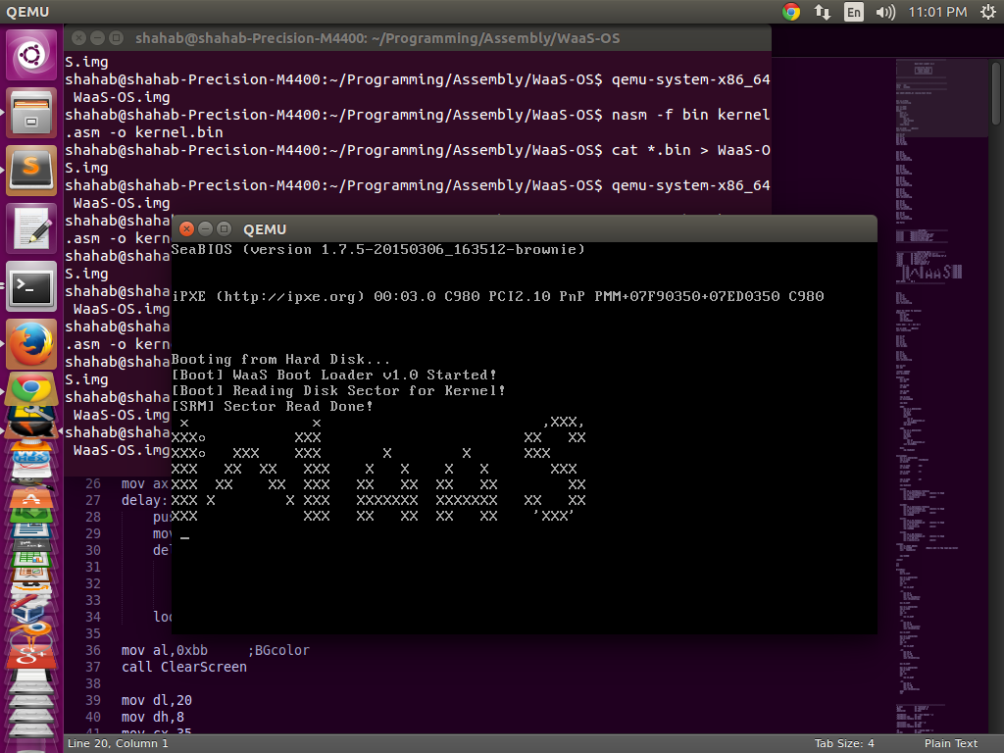

Kernel
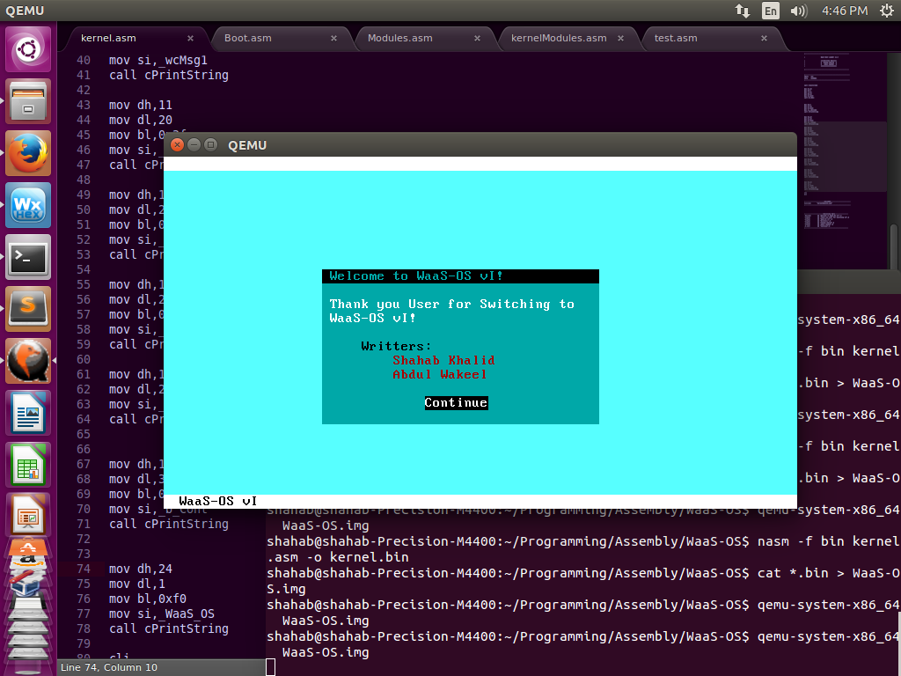

Applications

