The different drivers’ attributes are provided as input to train the network for prediction of charge status. The performance of the different prediction models have been evaluated in terms of precision, recall, f1 score and accuracy for the training and test datasets. The binary cross entropy-based loss function is analyzed in training the neural networks. The accuracy of the model is evaluated for the validation split size as 20%. The simulation results show that the accuracy in the prediction of the charge status for the Adam based optimizer is 84.47% and 84.37% for the training and the testing dataset respectively.
Proposed Prediction Technique
The flow chart for the proposed approach is as shown in the Fig. 1. In the first step the parameter values for the 100 rounds is provided as input. In this work, we have considered 6 parameters as input “driving experience”, “Driving with EV”, “age”, “gender”, “education level” and “income level”. In the next step the dataset is preprocessed by removing the duplicate or missing values and the categorical data is converted into the numeric data. In the third step the entire dataset is split into training and test dataset. We have considered the test size as 30% and 70% for training the neural network. The different learning models have been selected for the performance analysis of the proposed approach. The number of epochs have considered as 1000000. The accuracy of the model is evaluated for the training and test datasets. If the required accuracy is not achieved then the training parameters are updated.
Figure 1: Flow chart of the proposed approach
Simulation Setup and Parameters
The neural network based prediction model have implemented using keras and tensor flow framework in python language.
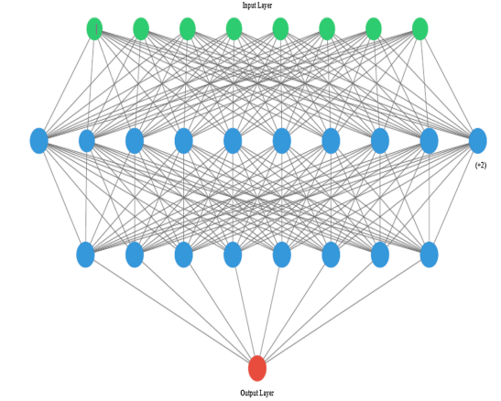
Fig. 2 Neural network architecture
The architecture of the neural network is as shown in the Fig. 2. The considered neural network consist of one input layer, two hidden layers and one output layer. The input layer consists of 8 neurons (shown in green color nodes) corresponding to each input parameter. The hidden layer consists of 12 neurons which is represented in blue color. Due to the space limitation only ten neurons are visible in the figure. The output layer consist of one neuron (shown in read color) which describes the charge status as either “Yes” or No”. The network architecture is considered as dense, which implies that each node in input layer is connected with the each node in the hidden layer and similarly each node in the hidden layer is connected with the each neuron in the output layer neuron. The specification of the neural network implemented are as shown in the Table 1. The summary of the neural network is as shown in the Table 2.
Table 1: Specification of the neural network
Feature | Value
Model | Sequential
No. of neurons in the input layer
No of neurons in the hidden layer
No of neurons in the output layer
Learning rate
Activation function between the input and hidden layer
Activation function between the hidden and the output layer | Sigmoid
Connectivity | Dense
Loss function | Binary cross entropy
Batch size
Number of epochs | 1000000
Validation split | 0.2

Table 2: Summary of neural network
Layer (type) | Output shape | Param#
Dense (dense) | (None, 16) | 464
Dense_1 (dense) | (None, 8) | 136
Dense_2 (dense) | (None, 1) | 9
Total Params | 609
Trainable Params | 609
Non trainable Params | 0

Performance Metrics
The proposed neural network based model predicts the charge status as either yes or no. The classification feature of a neural network is represented by a confusion matrix. A confusion matrix represents a tabular represents of actual and predicted values. The components of a confusion matrix are:
- True Negative—A True Negative is an output which correctly classifies the node in the inactive class.
- False Positive—A False Positive is an output which incorrectly classifies the node in the active class.
- False Negative—A False Negative is an output which incorrectly classifies the inactive class.
- True Positive—A True Negative is an output which correctly classifies the node in the active class.
The confusion matrix is as shown in the Table. 3.
The different performance metrics of a neural network based prediction model are as:
- Precision—Precision represents the number of active class classifications which actually belong to active class. The formula to determine the precision is as follows:
$$Precision=\frac{True Positive}{True Positive+False Positive}$$

Table 3: Example of a confusion matrix
Actual | Predicted
Actual |  | Negative | Positive
Actual | Negative | True Negative | False Negative
Actual | Positive | False Negative | True Positive

- Recall—Recall represents the number of positive class classifications out of all the positive classes in the considered dataset. The formula to represent the recall is as follows:
$$Recall=\frac{True Positive}{True Positive+False Negative}$$

- F1 Score—F1 Score is used to provide the balance between the precision and recall in a single term. The formula to represent the F1 Score is as follows:
$$F1 Score=2×(\frac{Precision×Recall}{Precision+Recall})$$

- Accuracy—Accuracy represents the number of correct classifications with respect to the total number of classifications. The formula to represent the accuracy is as follows:
$$Accuracy=\frac{True Positive+True Negative}{True Positive+False Positive+False Negative+False Positive}$$

Simulation Results and Discussion
The implementation is carried out with the help of the random weights and biases. The learning in the neural network is done by continuously updating these parameters until the maximum iterations have been reached or until the convergence point has been achieved. The optimizer functions aid in determining the mechanism using which the neural network parameters can be adjusted and hence the performance of learning is optimized. T
Adaptive Moment Estimation (Adam) Optimizer—This optimization algorithm introduced the concept of moment and it added the fraction of past gradients to the current gradient.

