NESTWELL · PROTOTYPE
The twelve weeks, followed through
A walkthrough and review guide for the first working prototype
Prepared for Amber Siddiqui and Dr. Sarah Nazir · September 16, 2026
Please read this first
Everything in the prototype is synthetic. It is not a medical device, not a clinical service, and it must never be used with a real patient or hold anyone’s real information.
Every clinical value in it — question wording, screening thresholds, the urgent-symptom list, escalation targets — is a labelled placeholder until a named clinician confirms it. The app keeps saying so on screen until that happens.
This document explains what was built and why, shows it screen by screen, lists what I am unsure about, and ends with the decisions we need from the two of you.

1. Why this exists, and what it is meant to prove
The independent review of the NestWell business case reached a clear conclusion: the maternal-care gap is real, but “AI-enabled, multidisciplinary, mother-focused” is not a position — Maven, Pomelo, Babyscripts, Ovia and Soula already occupy it. What could be defensible is a narrow, verifiable service promise: a woman completes the next appropriate step in her postpartum care, and her practice can verify that it happened. The review recommended validating exactly that with one OB practice, twelve weeks of follow-through, and one operational priority (completed postpartum visits and completed mental-health referrals) before building anything broad.
This prototype is the tool for that validation. Its job is to make the first-30-days discovery conversations concrete: something a postpartum woman can hold in one hand and react to, and something a nurse, an OB, and a practice’s budget owner can walk through and say “we already do this”, “this would cost us minutes we don’t have”, or “this is the gap”. It is judged by whether it sharpens those conversations and de-risks a later pilot — not by outcomes, engagement, or revenue, none of which it can produce.

What it is
- A phone-first patient app, a practice dashboard with four staff views, and an admin panel that runs the demo — all one web page, switched with a role selector.
- Seven synthetic women with scripted twelve-week stories, and a demo clock that moves time forward so a twelve-week program fits inside a meeting.
- Every clinical rule, question, threshold and owner expressed as configuration the clinical safety owner can change, not as code.
- Real emergency resources (911, the 988 Suicide & Crisis Lifeline, the National Domestic Violence Hotline) rendered by non-AI code, byte for byte.

What it is not
- Not the pilot product. Before a real patient is enrolled, the requirements list seventeen gate items (a signed practice, named owners, an FDA clinical-decision-support assessment, HIPAA and FTC posture, an Ohio state-law review, staffed coverage, confirmed content). None of those are resolved by this build.
- Not connected to anything. No server, no account, no text messages, no email, no model calls. Everything lives in the browser it is opened in.
- Not proof of benefit. The review was explicit that a small pilot cannot prove prevention of rare complications, and a prototype proves nothing clinical at all.

2. Get it on your phone (or laptop)
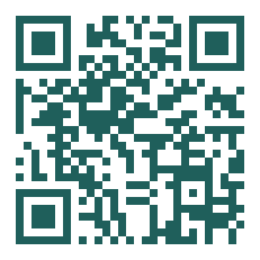 | https://shahablo.github.io/NestWell/  - Scan the code with your phone camera, or type the address into Safari or Chrome.  - iPhone: tap Share, then “Add to Home Screen”. Android: tap the ⋮ menu (or the install prompt), then “Add to Home screen”.  - Open it from the icon. It works offline after the first load.  The address will move to hellonestwell.com once the domain is connected; the old address will keep working.
Two things to know before you tap around
It is one browser, one set of data. The patient app and the practice dashboard share data only inside the browser you are using, so switch roles with the selector in the top banner rather than using two devices. Admin → Reset wipes everything and starts over.
Move the clock, not the calendar. Admin → Clock jumps to any day of any woman’s twelve weeks. Moving forward is what “sends” a check-in, starts an escalation timer, or turns an unopened check-in into a missed one. Moving back un-happens it.

3. The service in one picture
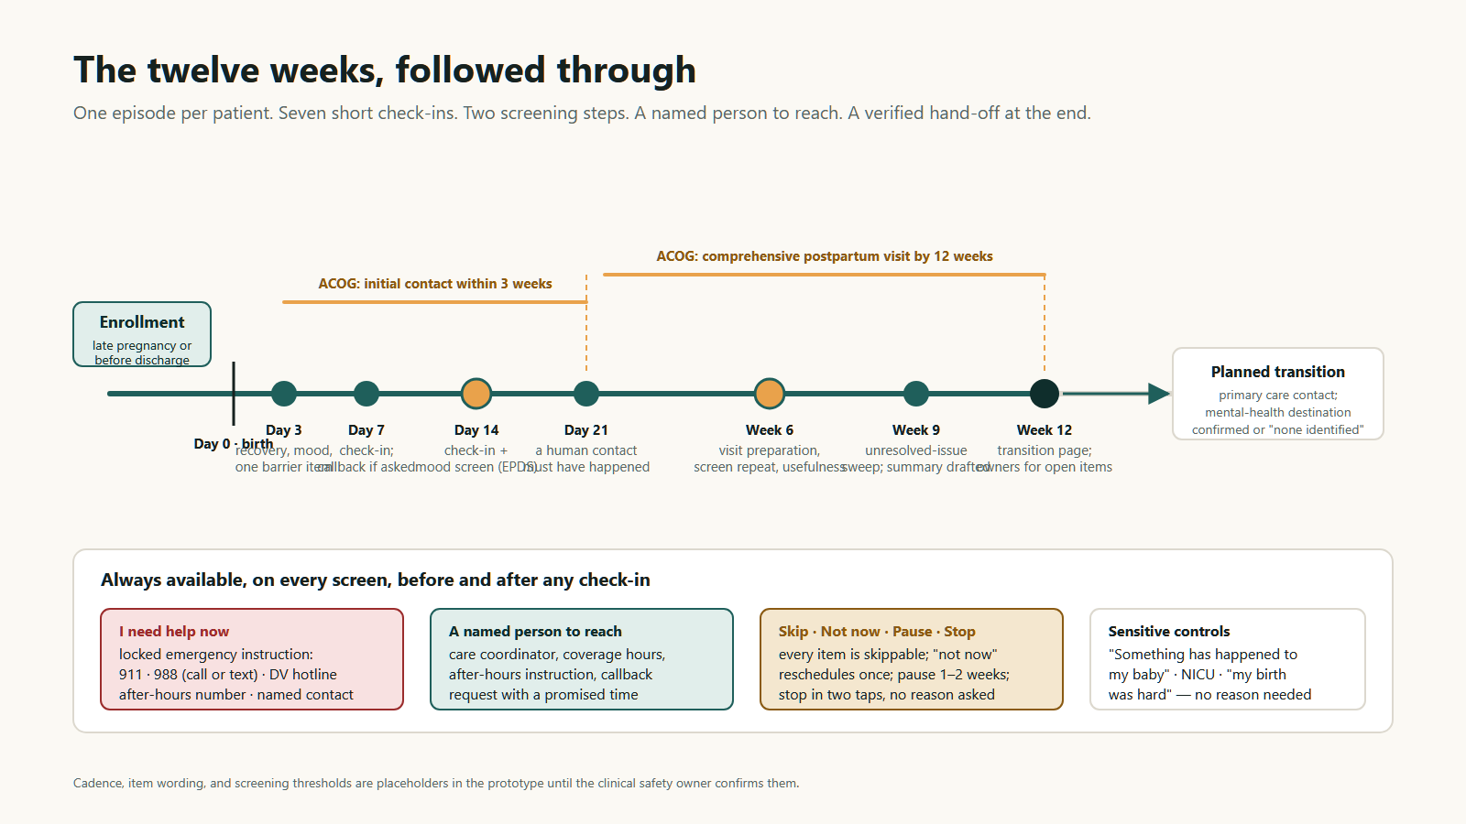
Figure 1. One episode per patient: seven short check-ins, two screening steps, a first human contact by day 21, a comprehensive visit by week 12, and a planned hand-off. The bottom row is on every screen, always.
The cadence follows the timing the review took from ACOG — an initial contact within three weeks and a comprehensive visit by twelve — with three touches placed before the three-week mark. The exact days, the wording of every question, and the two screening points are placeholders for Sarah to confirm; changing them is a configuration edit, not a rebuild.

4. The patient app, screen by screen
Every screen was designed against one sentence from the review: “Avoid excessive tracking that makes an exhausted mother feel she has another job.” Any interaction can be completed one-handed in under two minutes and abandoned without penalty. Nothing scores her, streaks her, or nags her. The app never tells her she is fine, and it never mentions the baby unless she said that is welcome.

Home, and the acknowledgment
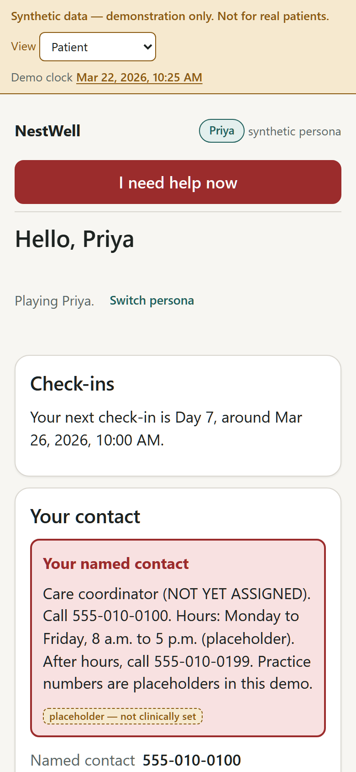  Home: the named contact, coverage hours, the next check-in, pause and stop, and “I need help now” above everything else. | 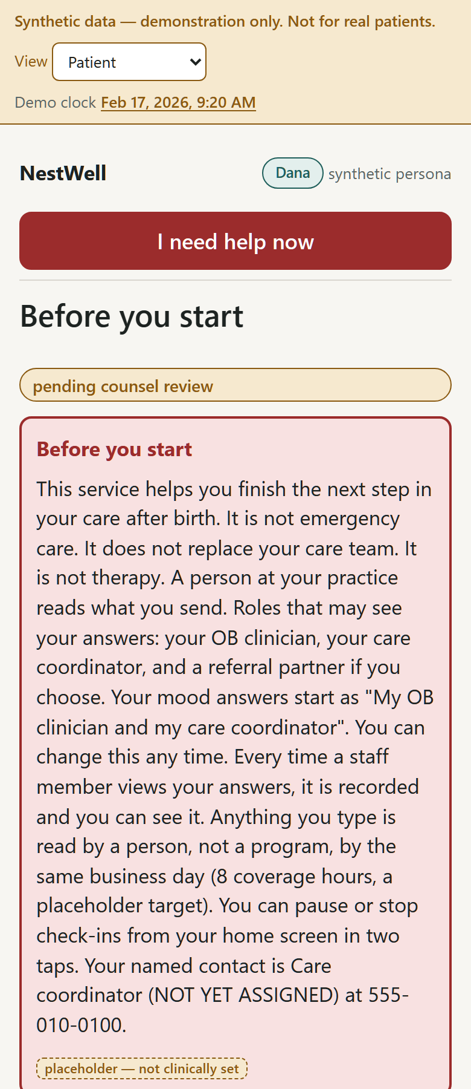  The acknowledgment says in plain words what the service is and is not. Contact and help are reachable before she agrees to anything.
Why: the review asked for “a real connection to help” and honesty about what the app is. The contact card and the emergency instruction are deliberately not gated behind the acknowledgment. The two sentences about free text and the self-harm question are generated from the current policy flags, so they can never drift from what the app actually does.

Preferences and who sees her answers
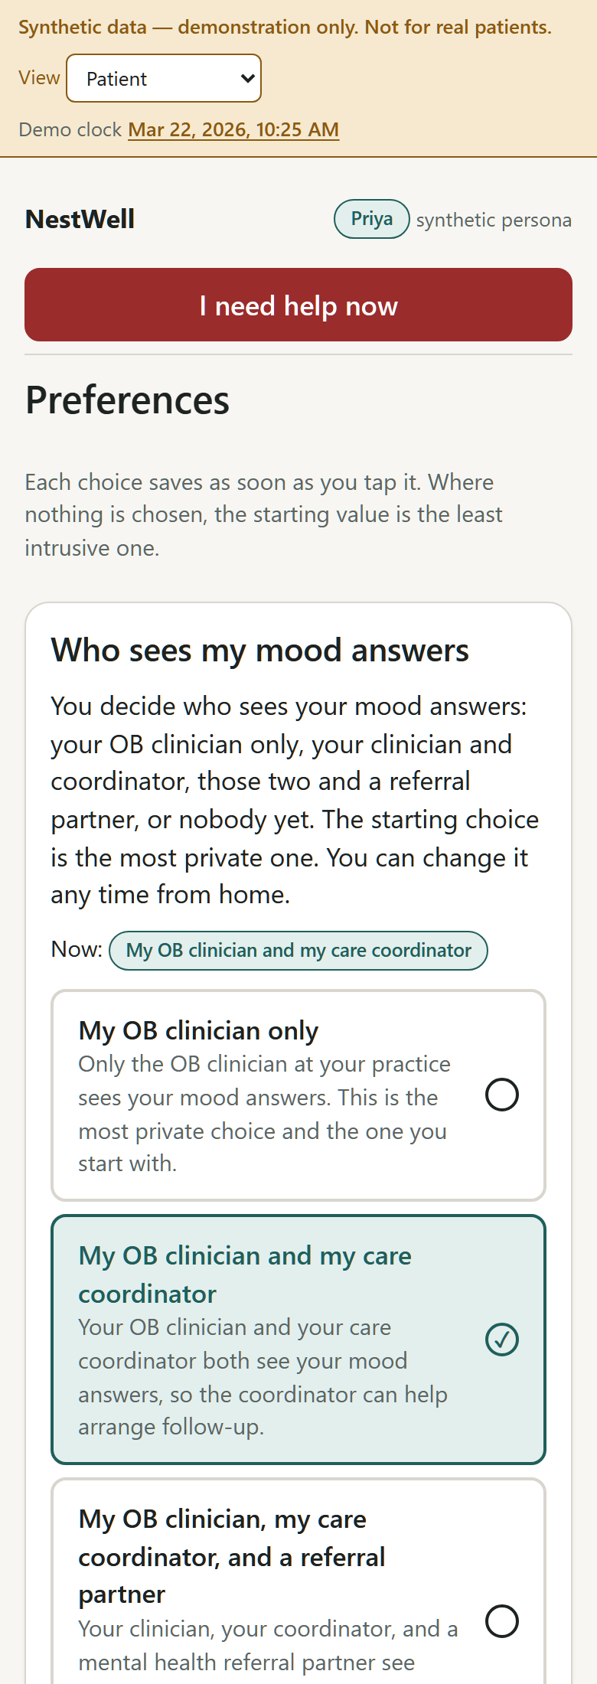  Preferences: contact windows, language, the safety question (“is it safe to text you on this phone?”), baby-reference permission, and the sharing category with a plain explanation. | 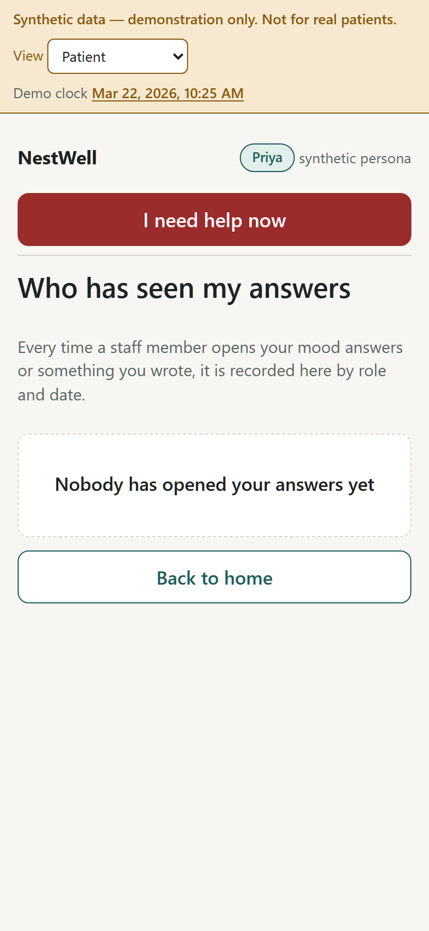  “Who has seen my answers”: every staff view of her screening answers or free text is recorded and shown to her by role and date.
Why: mental health stays inside the program, but sharing stays hers. The categories (clinician only; clinician and coordinator; plus the referral partner; nobody yet) are enforced in the data layer, so a screen the coordinator may not see cannot be fetched by the coordinator’s view even by accident. “Nobody yet” is a real option, and it is re-asked at most once.

The screening step and the help path
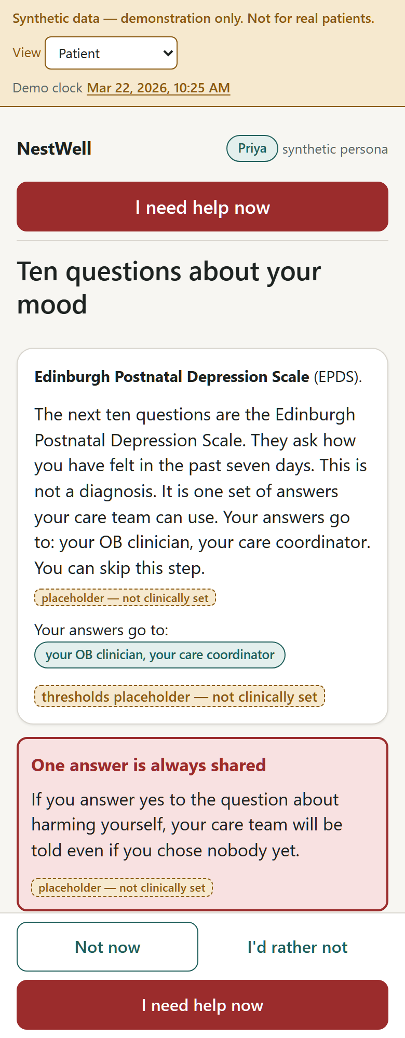  The EPDS as its own attributed step: plain framing, “this is not a diagnosis”, who her answers go to, and the one locked sentence about the self-harm item that is always shared. | 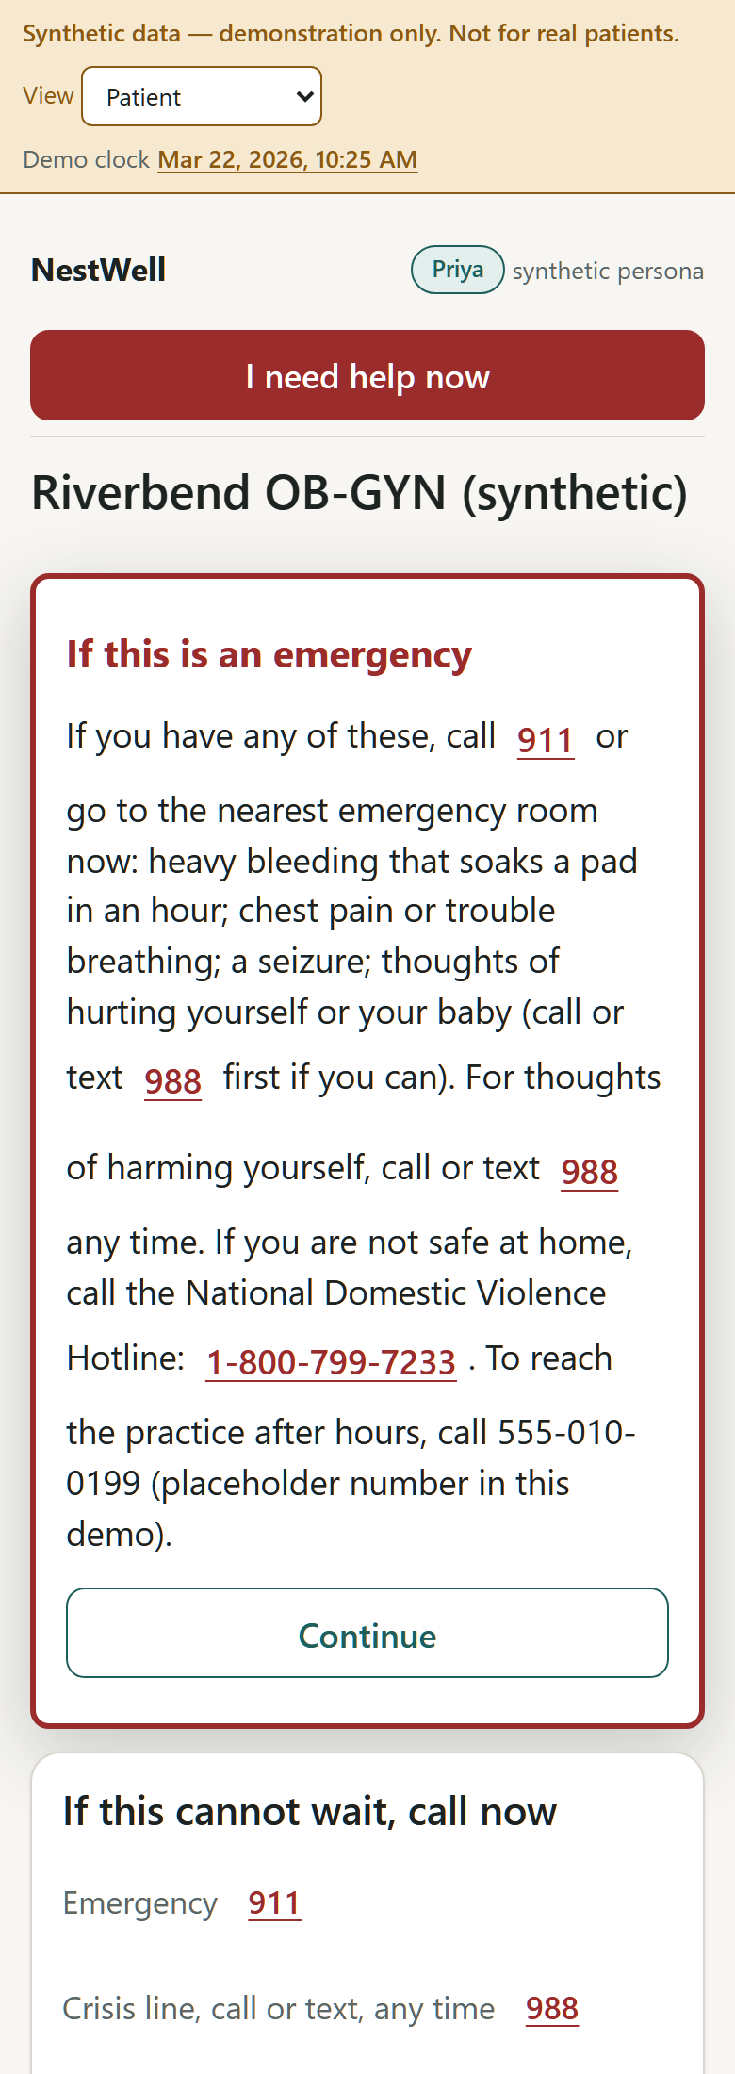  “I need help now”: the locked emergency instruction renders before anything else; 911, 988 and the DV hotline are one tap; a callback can be requested with a promised time.
Why: the review’s rule was that a screen must connect to assessment and follow-up, not just detect a need, and that a model must never override an emergency instruction or reassure. The instrument is configuration (EPDS loaded, PHQ-9 available), thresholds are visibly “placeholder — not clinically set”, and the emergency text is rendered by ordinary code that no AI layer can touch. Every free-text box has that instruction beside it, and anything she types goes to a named person the same business day.

Care plan, transition, and messages
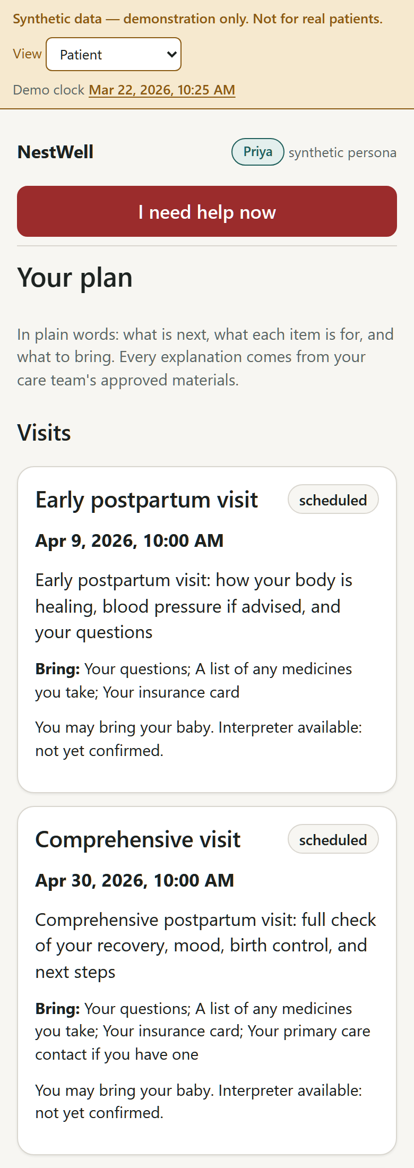  The care plan she can understand: clinician-approved items with a labelled plain-language rewording, visit preparation (date, purpose, what to bring, interpreter line), and her saved questions. | 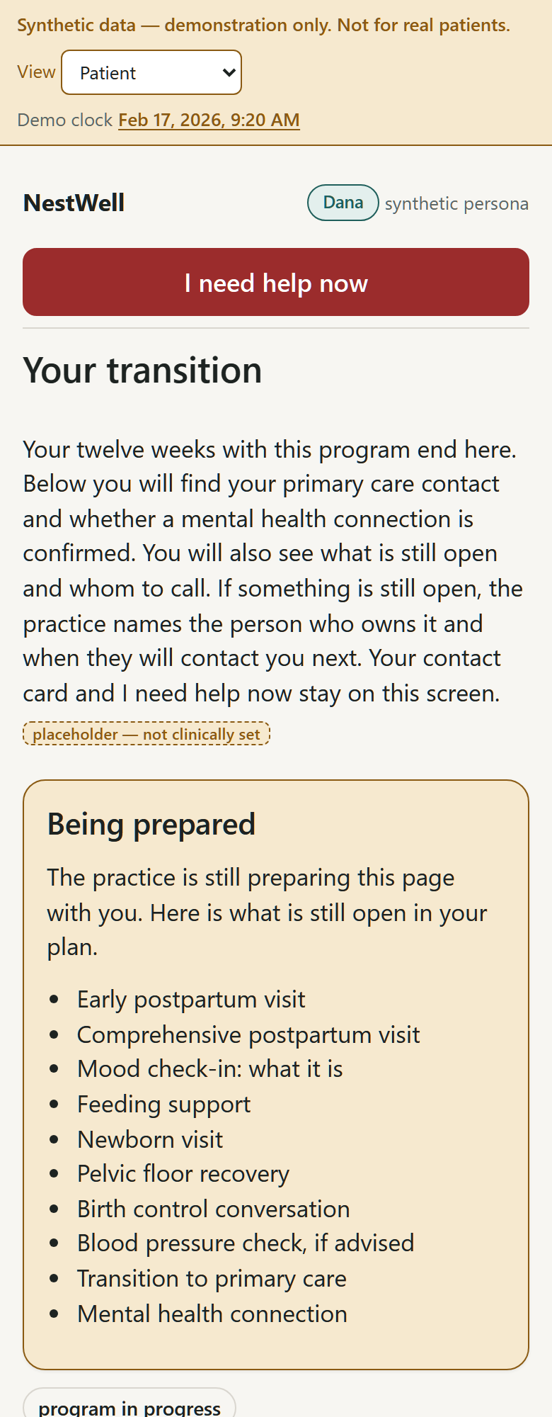  Week 12: the transition page — primary-care contact, whether a mental-health connection is confirmed, what is still open and who owns it.
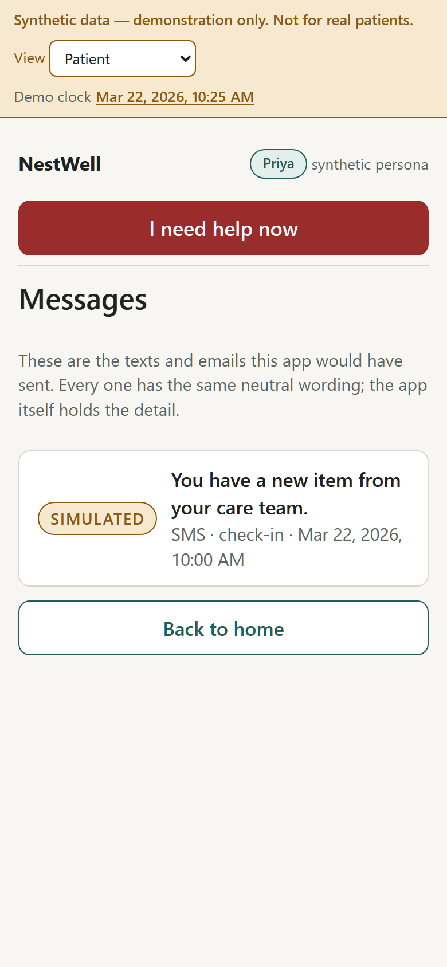
Messages are simulated: every notification body is a neutral “you have a new item from your care team”, never a score or a mood word.

After a loss, a NICU stay, or a hard birth
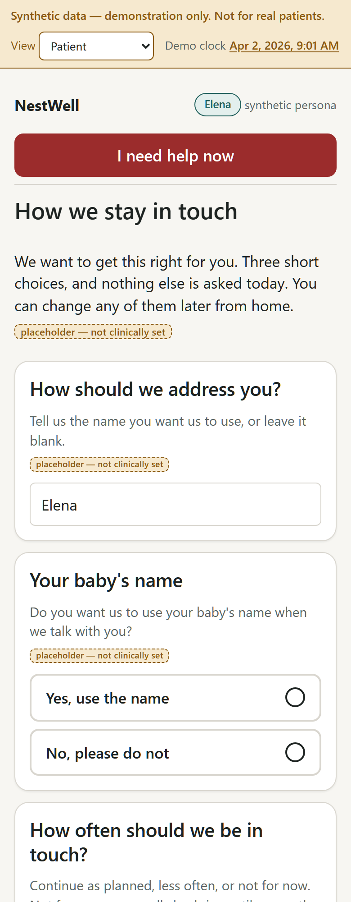
The one dialog, asked once: how she wants to be addressed, whether the baby’s name is used, and how often to be in touch — including “not for now”, which promises one human call within seven days.
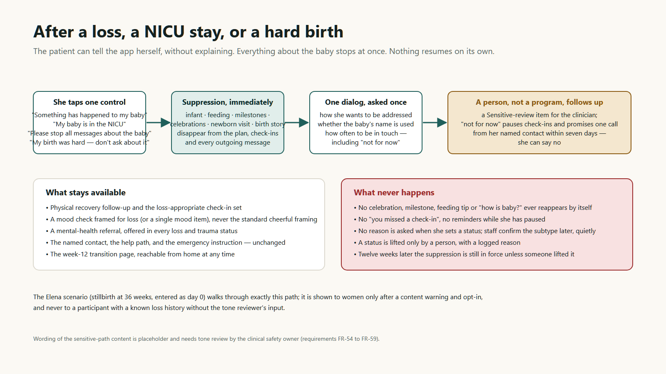
Figure 2. The sensitive path. She can set it herself from home in two taps with no reason asked; suppression is immediate; a person follows up; nothing resumes automatically.

5. The practice dashboard and the accountability loop
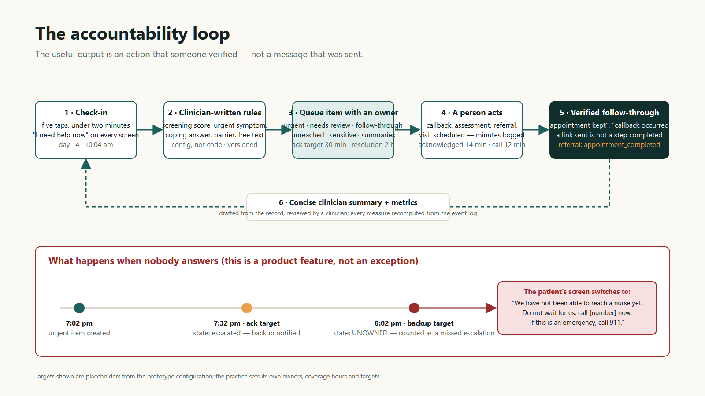
Figure 3. The loop the whole product exists to close, and what happens when nobody answers — which is designed as a feature, because the review named unowned urgent queues as a reason to pause a pilot.

Queues, owners, and coverage
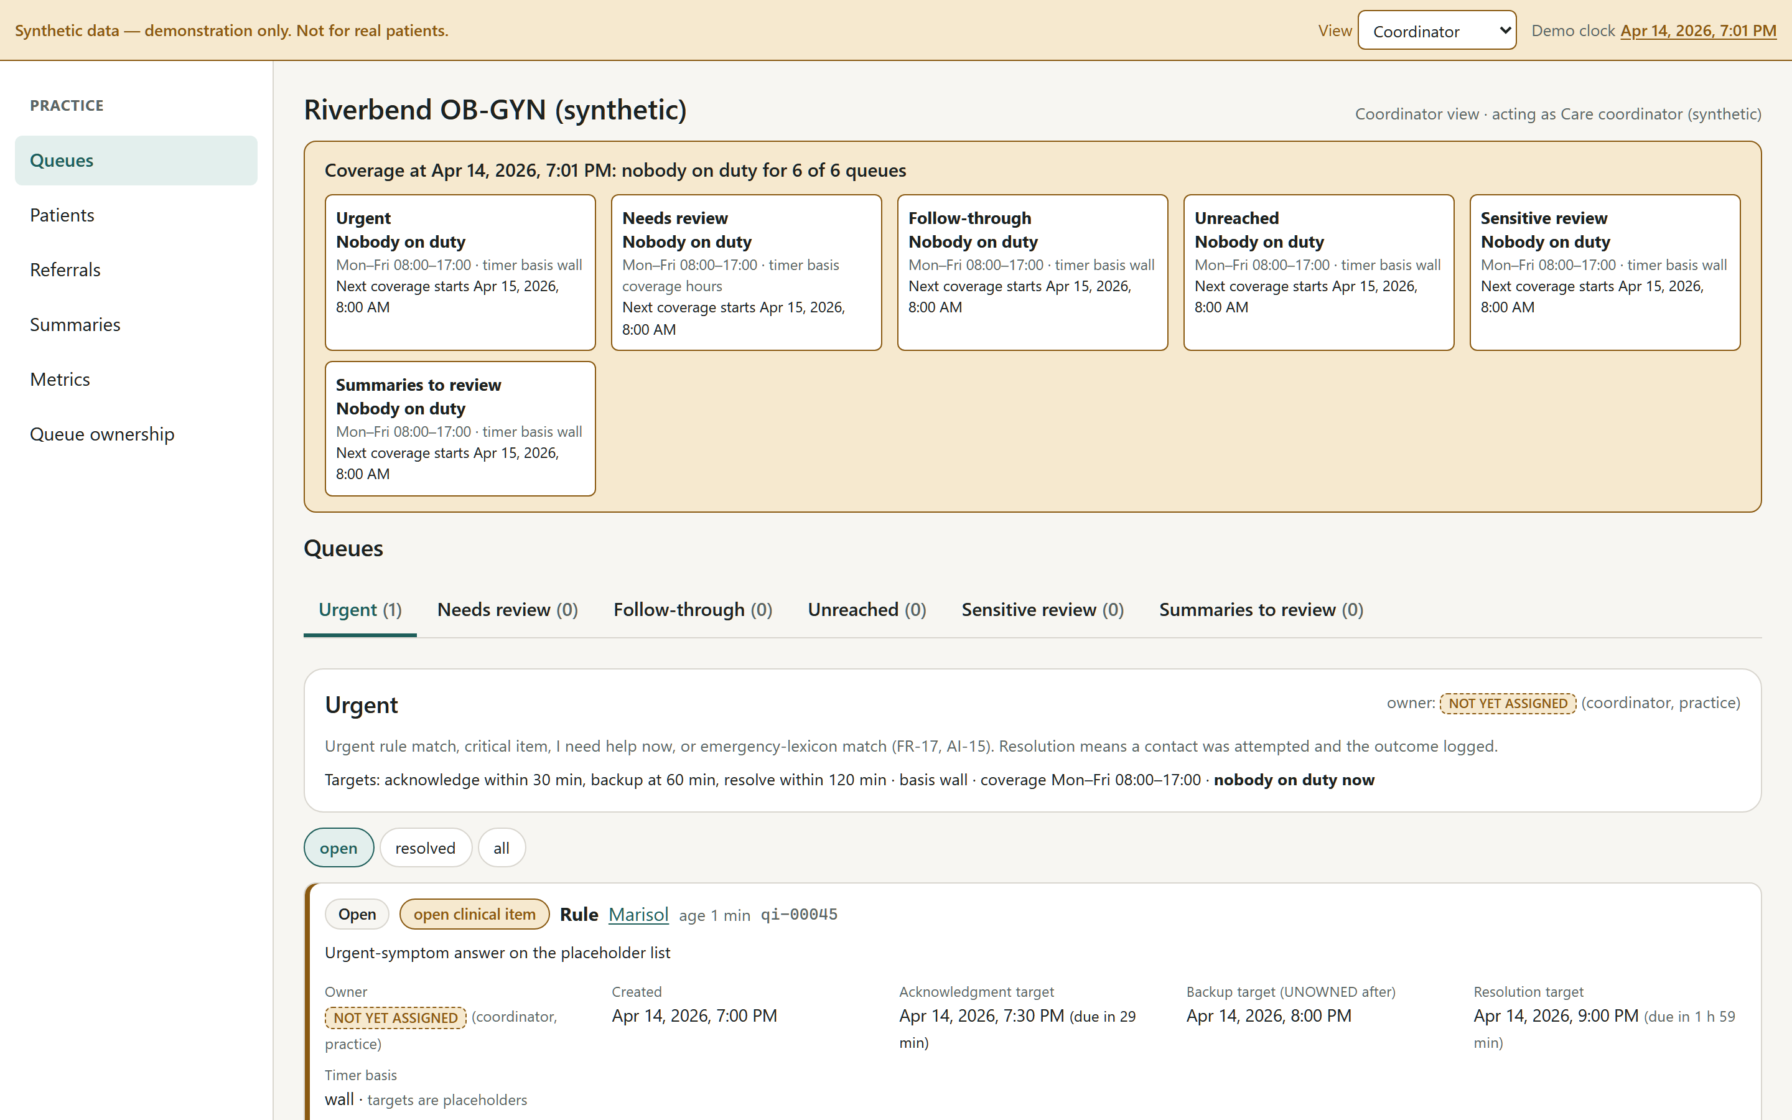
Marisol at 7:01 pm: an urgent item created outside coverage hours. The banner says nobody is on duty for all six queues, the owner reads NOT YET ASSIGNED, and the acknowledgment, backup and resolution targets are visible with their clocks. Move the demo clock past 7:32 pm and the item escalates; past 8:02 pm it goes UNOWNED and Marisol’s own screen switches to “do not wait for us — call”.
Why: the review said to define who monitors each queue, their coverage hours, how receipt is acknowledged, what happens if nobody answers, and how urgent users get help without waiting for an app. Each of those is a field in the queue configuration, with a placeholder value, and the dashboard shows the practice exactly what it is signing up to staff. No item can be closed without an outcome, and minutes are logged once, on the contact, so staff time per patient is a real number rather than a guess.

Patients and the twelve-week record
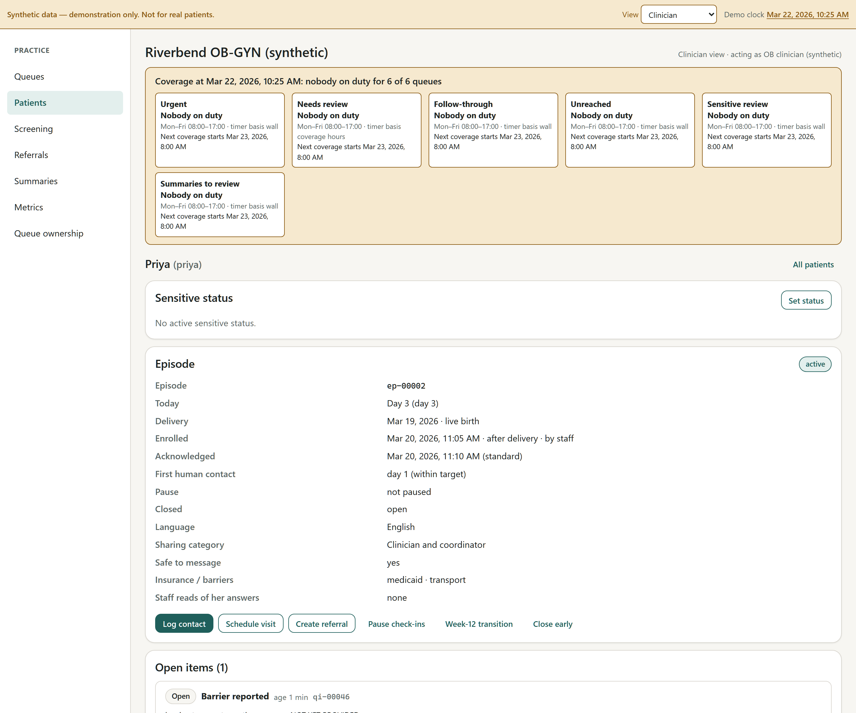
Priya’s record as the clinician sees it: check-ins with their states, the screen results this role is allowed to see, the assessment, the referral moving from sent to scheduled to kept, contacts with minutes, and the day-21 first-contact flag.
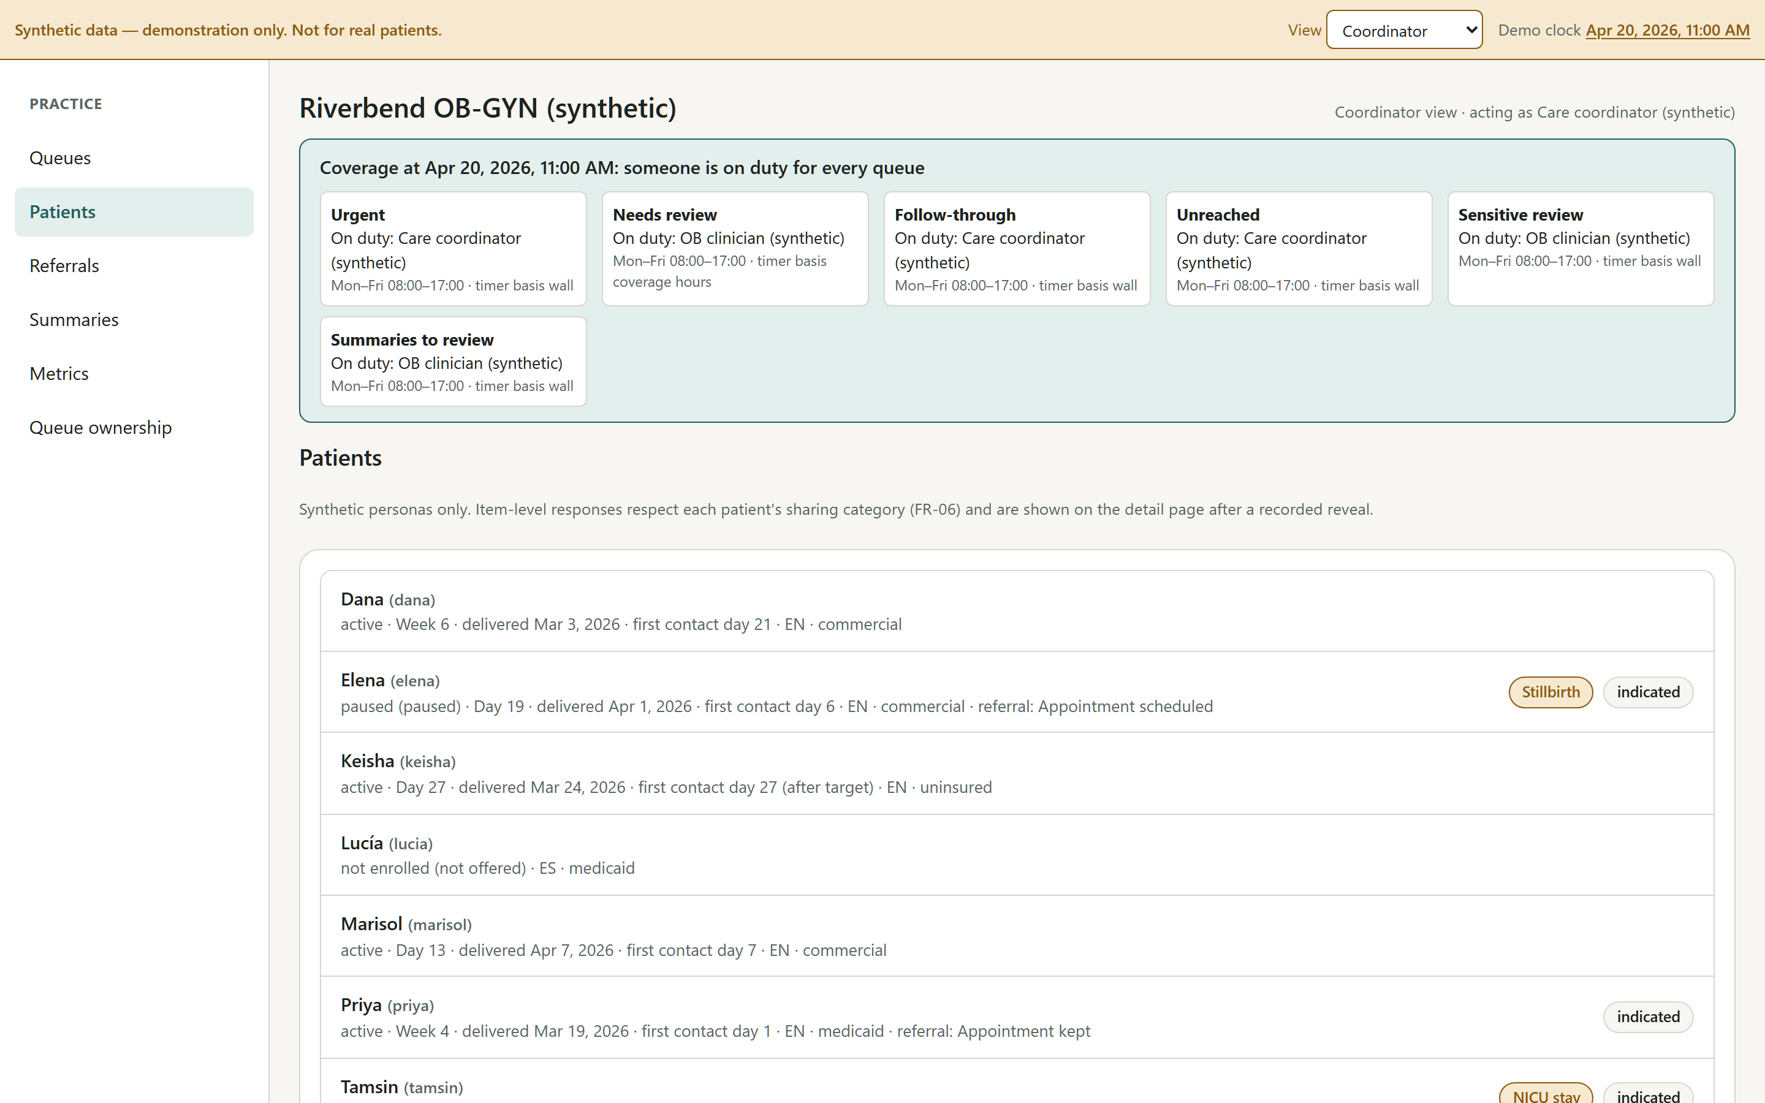
The patient list across all seven personas at the default clock: a mix of days 5 to 84, so a practice sees what a small panel looks like at once.

Screening review, referrals, summaries
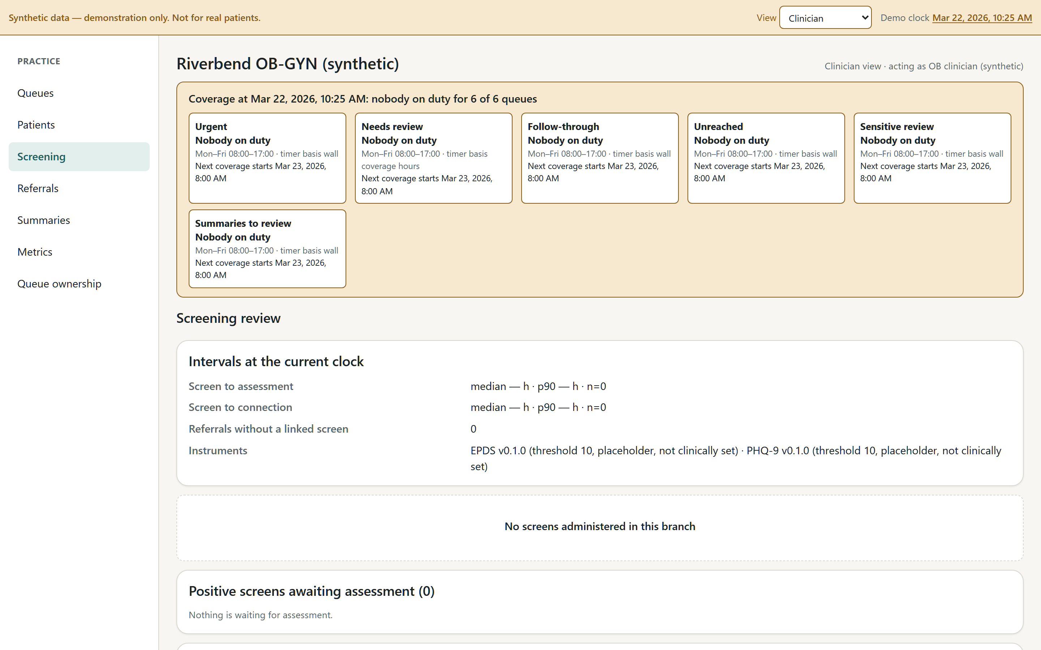
Screening review for the clinician: positive screens with the time from screen to assessment and from screen to connection — two of the measures the review asked for.
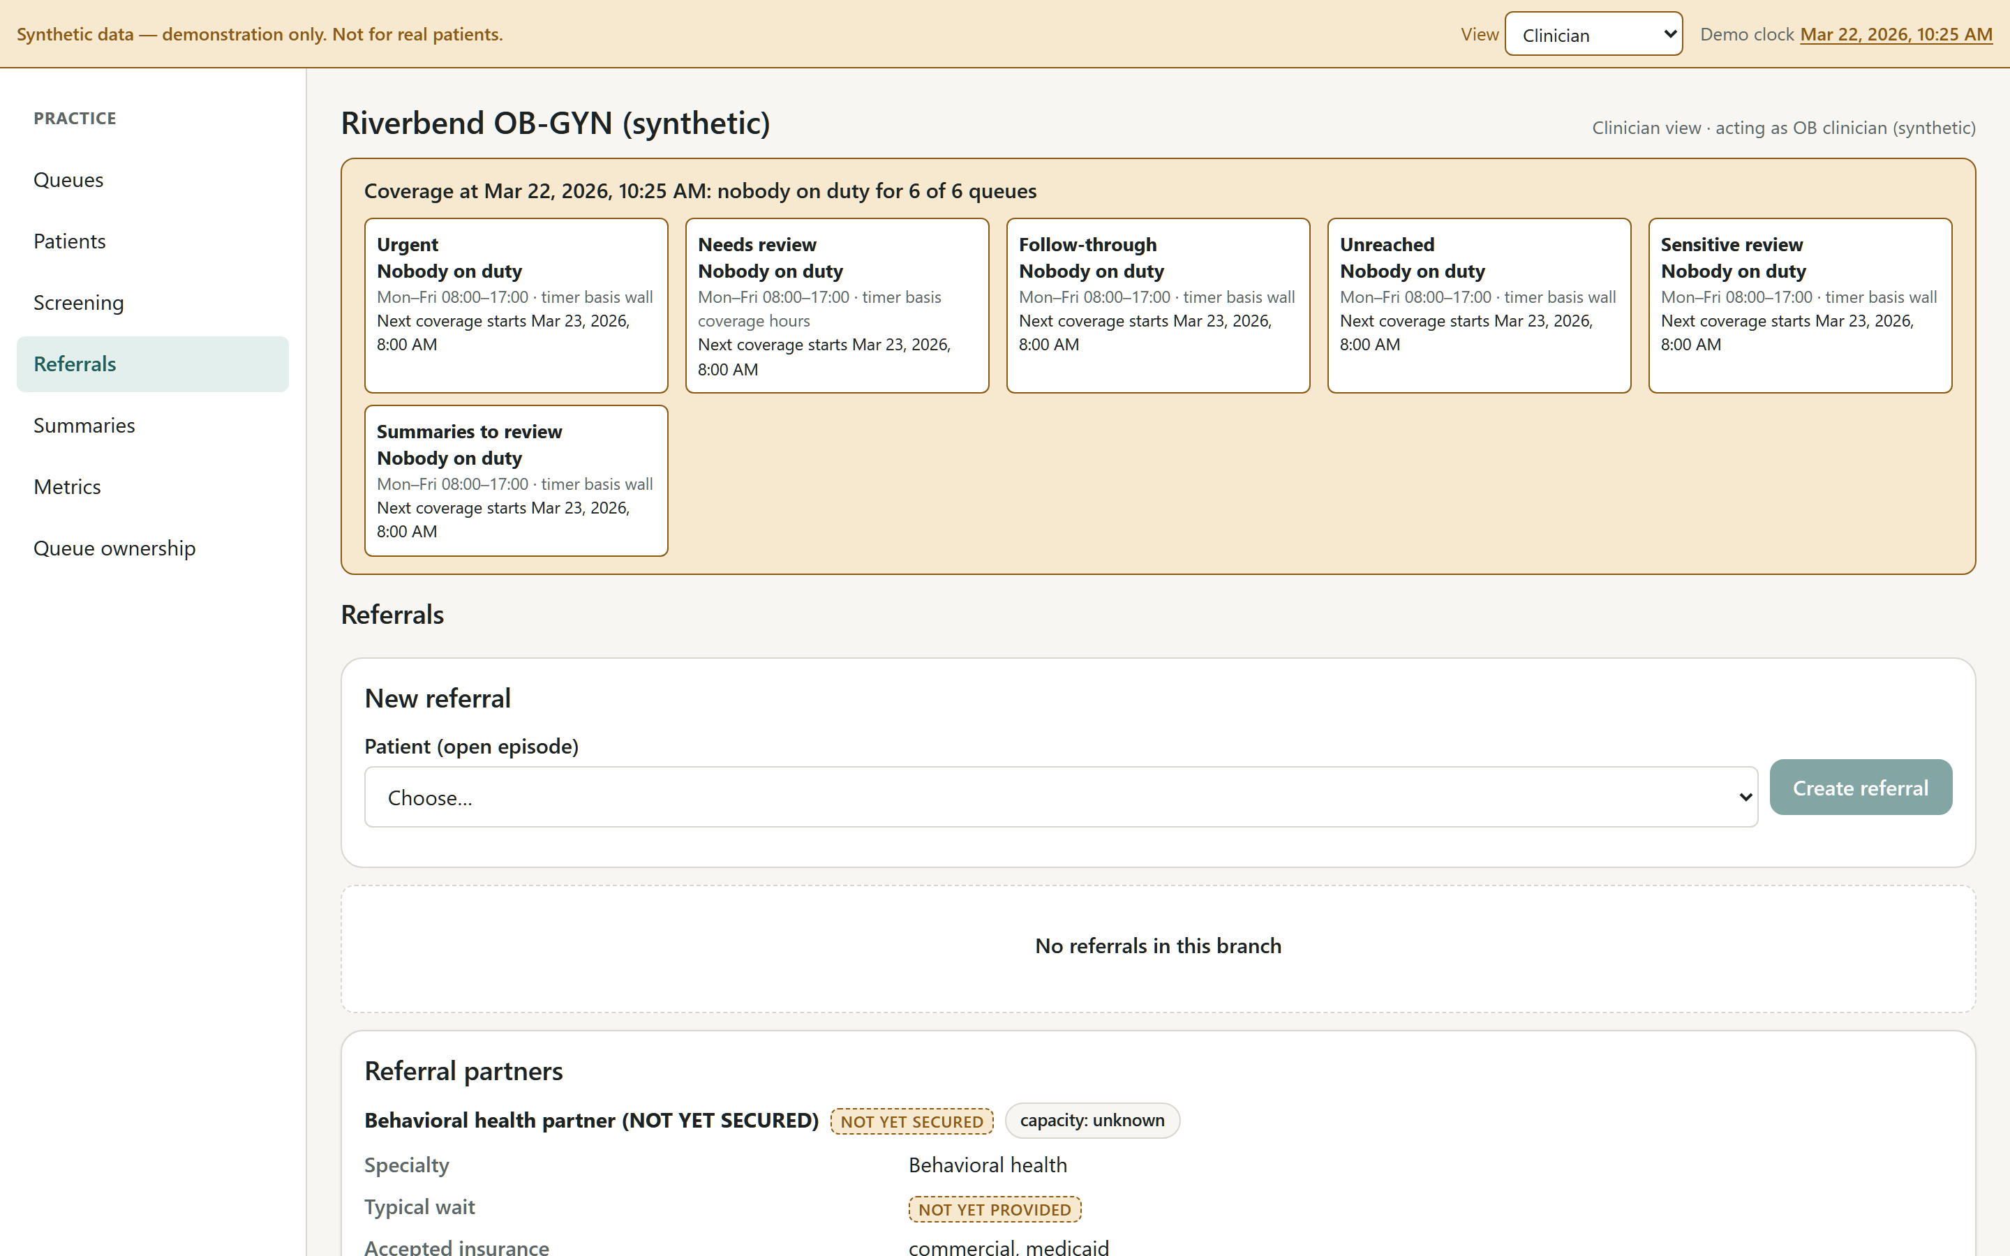
Referrals: the states are real. “Sent to partner” is not success; only “appointment completed” counts. A missed, declined or no-capacity outcome on a referral tied to a positive screen reopens a review item for the clinician.
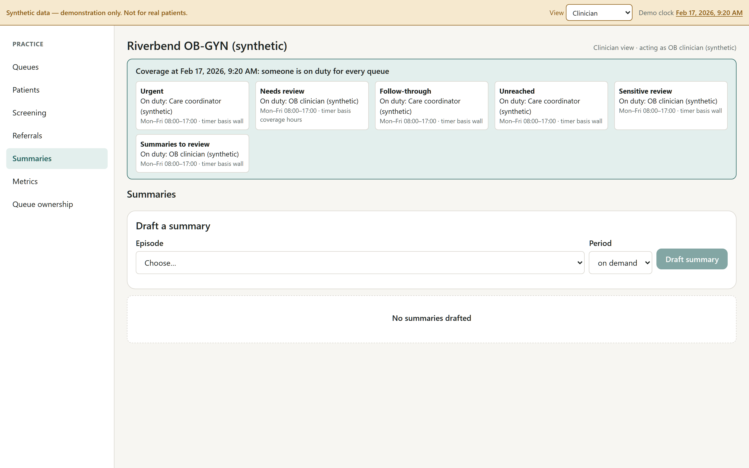
Clinician summaries: drafted from the record with a canned example of what an AI narrative would look like, reviewed by a clinician before it can be marked delivered, exported with the synthetic notice and the counsel-review marker.

Metrics and the budget owner’s view
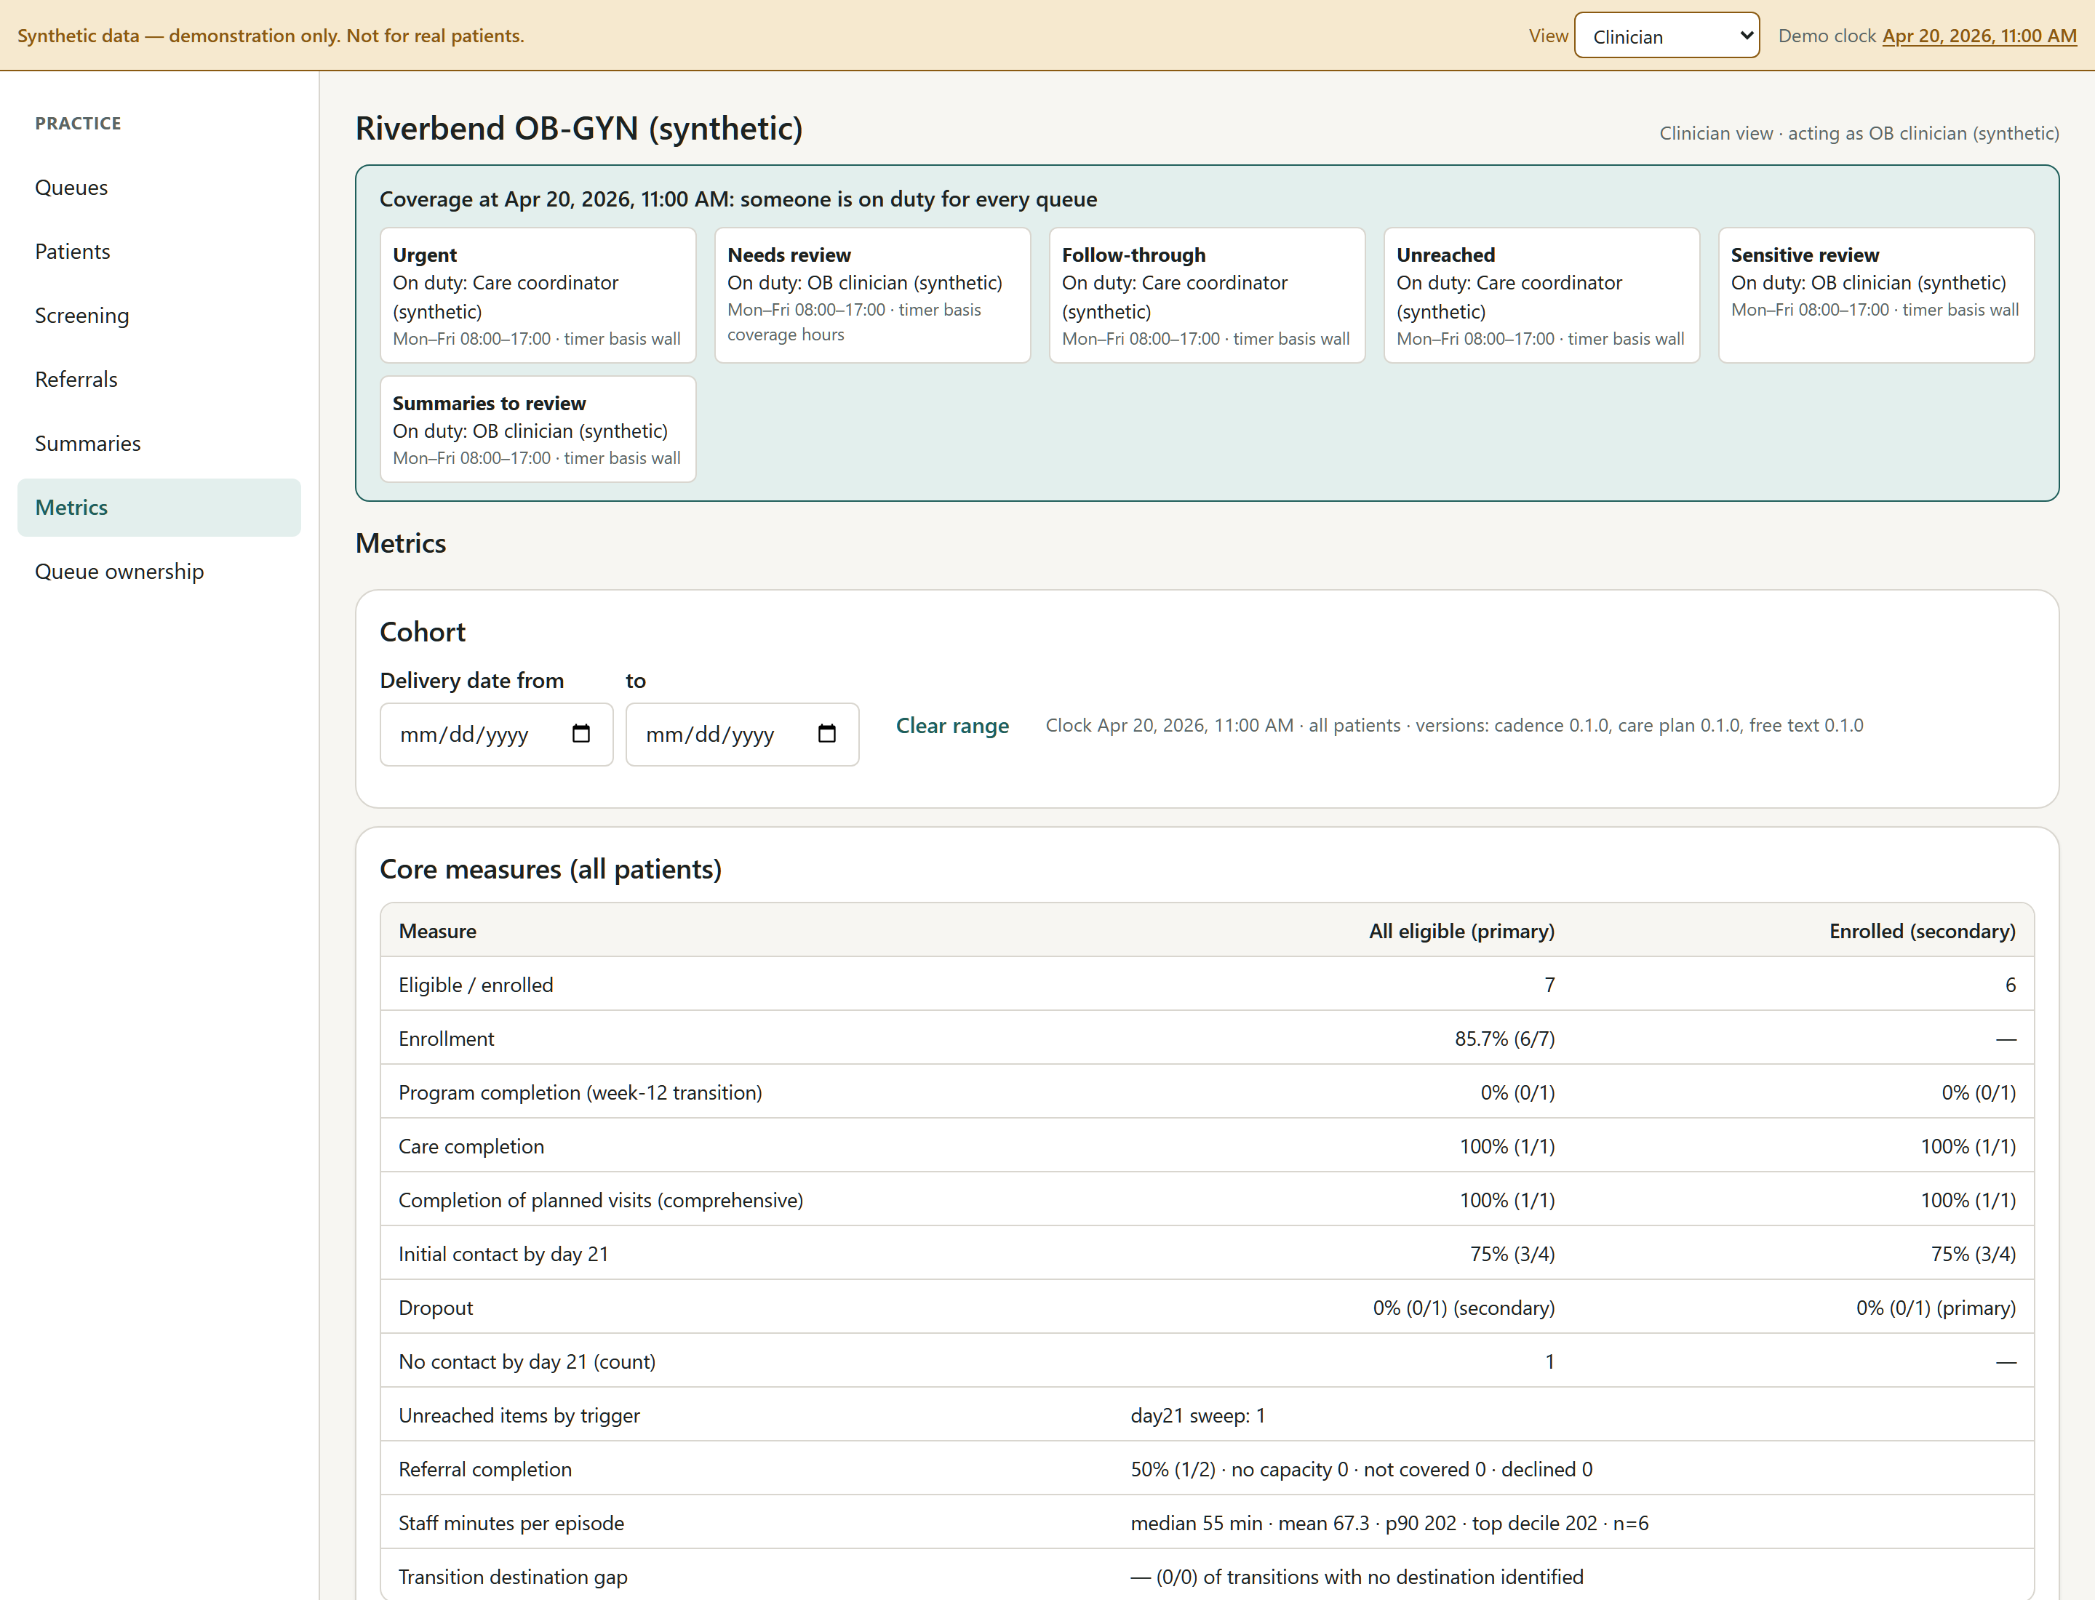
Every measure in the review’s list, recomputed from the event log: enrollment and completion with all eligible women as the denominator, screen-to-assessment time, staff minutes per patient, escalations and misses, dropout, and breakdowns by language, insurance and barriers.
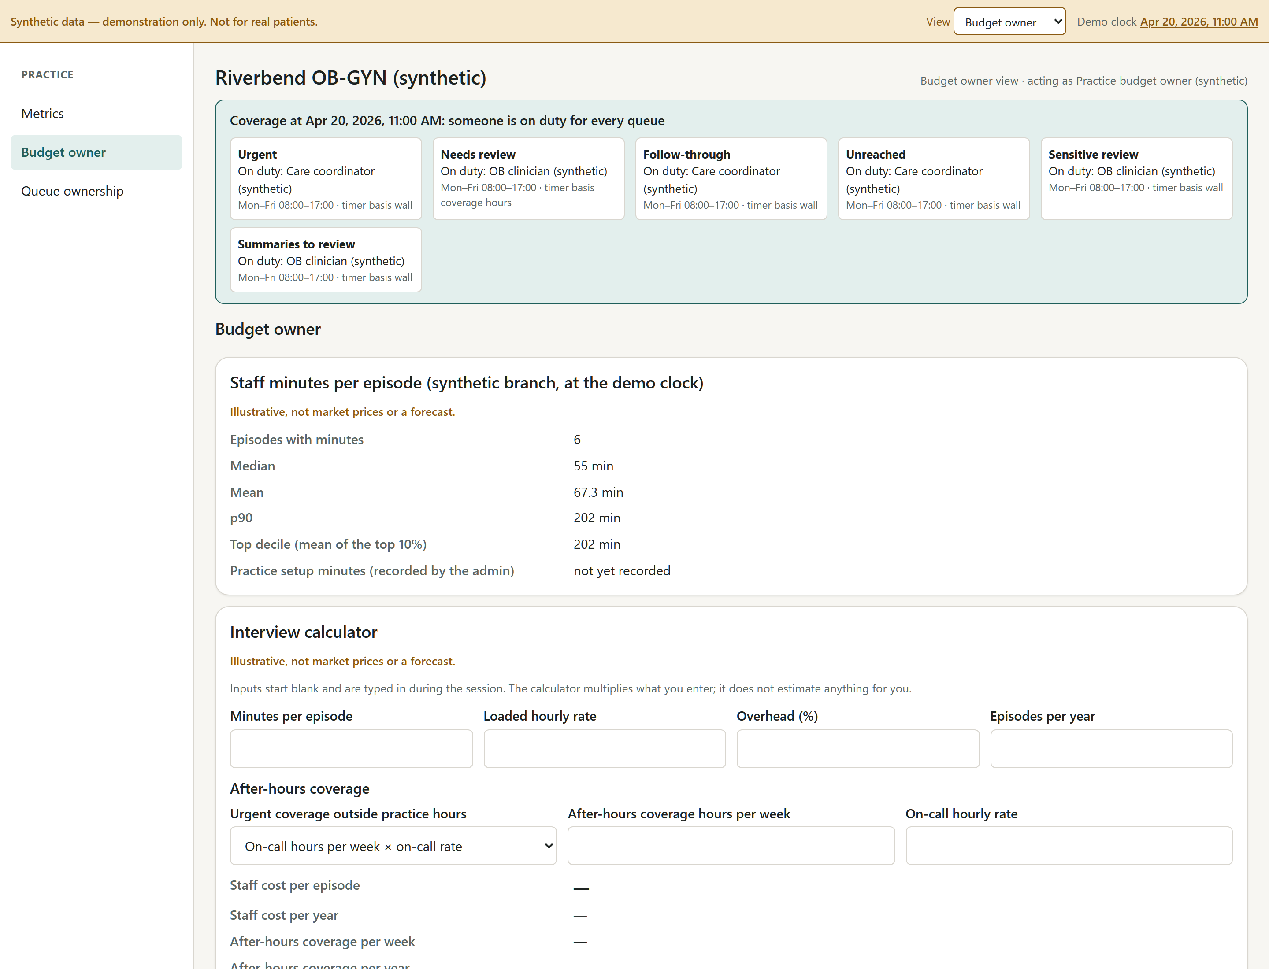
The budget owner sees aggregates only — never item-level screening data — plus an interview calculator whose inputs start blank so the practice types its own numbers, and a pilot scope sheet with the two illustrative price structures from the review. “Illustrative, not market prices or a forecast” is on every card.
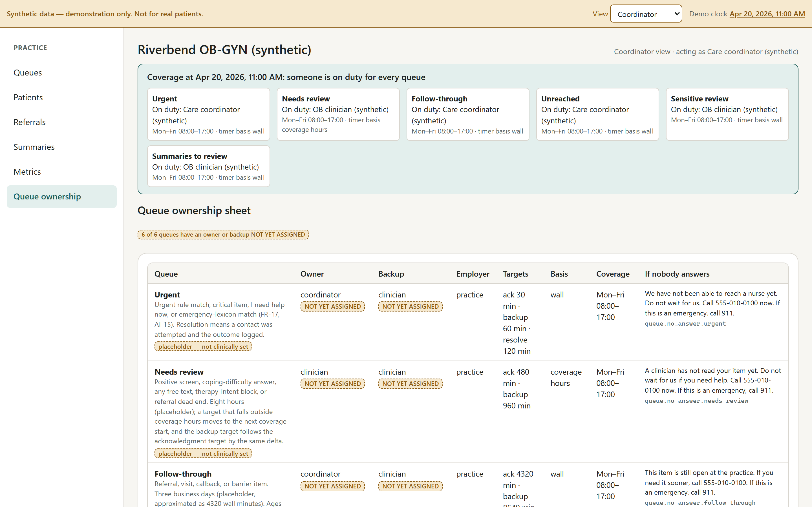
The queue ownership sheet, generated from configuration: every owner, backup, employer, coverage window and target in one place — the document a practice would sign before a pilot.

6. Where AI sits, and where it never does
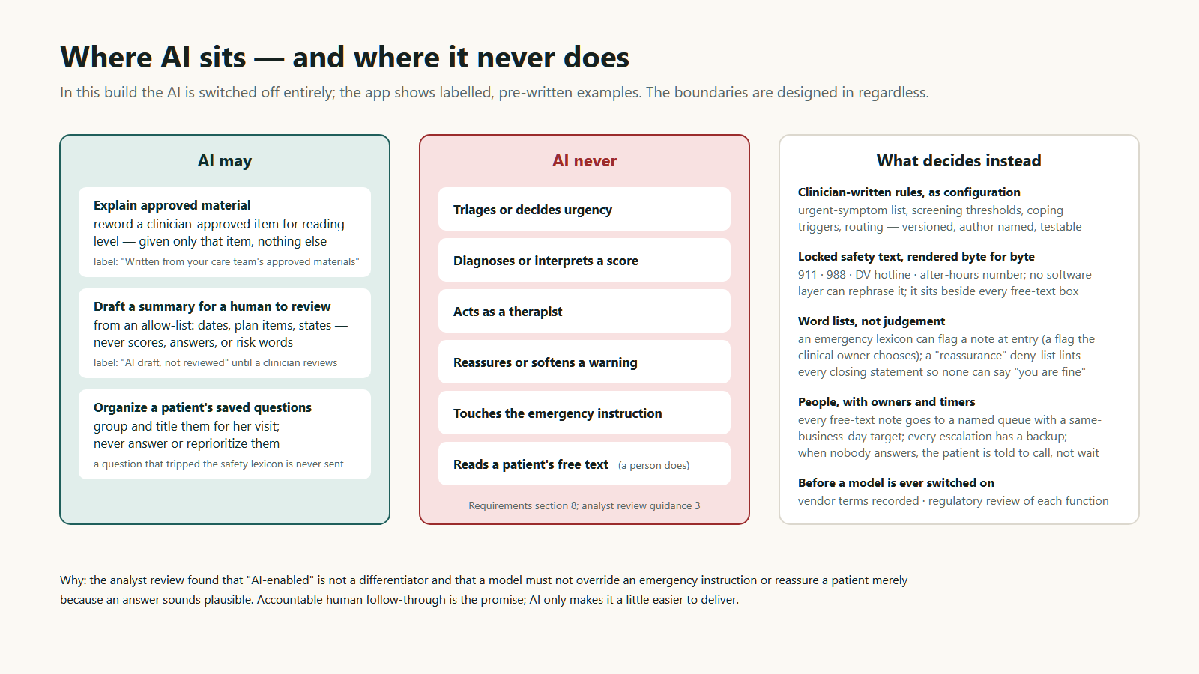
Figure 4. Three allowed uses, six prohibited ones, and what decides instead. In this build the model is switched off entirely; the app shows labelled, pre-written examples.
This follows the review’s guidance 3 to the letter. The prototype builds the boundaries in — an allow-list for the summary narrative that can never contain a score or a mood word, a deny-list that lints every closing statement so none can say “you are doing fine”, and a lexicon-based safety layer — but deliberately does not call a model. Whether to switch one on for demos is a founder decision, and the requirements list what has to be true first (vendor terms recorded, the free-text scan enabled under the clinical owner’s name, an evaluation set with zero unacceptable outputs).

7. Who sees what
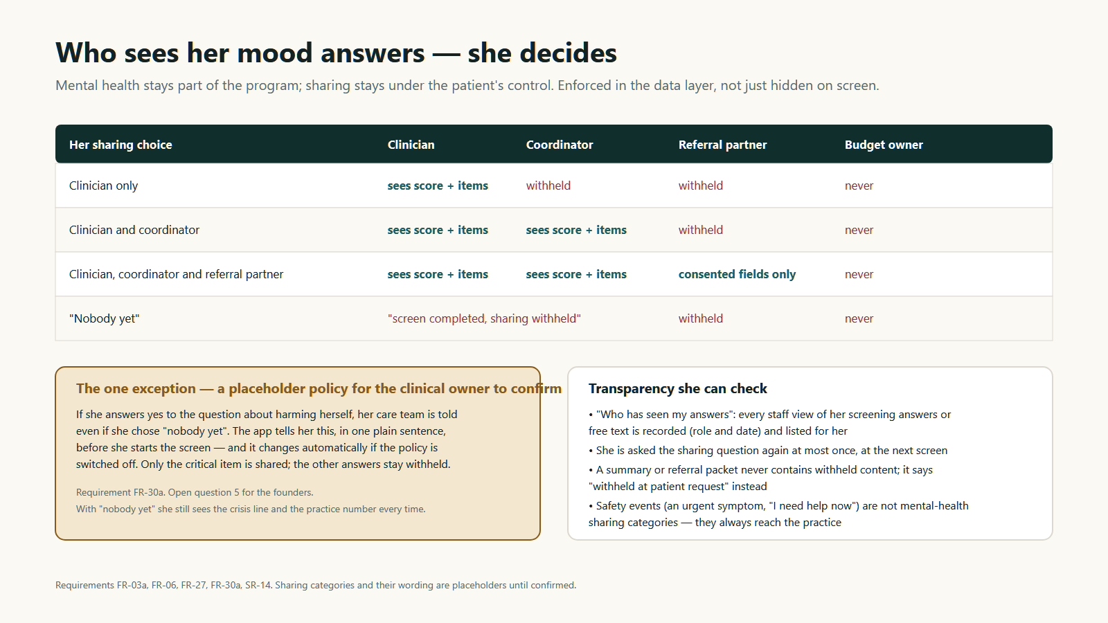
Figure 5. Sharing categories by role, the one placeholder exception for the self-harm item, and the transparency controls she can check herself.

8. Running a demo
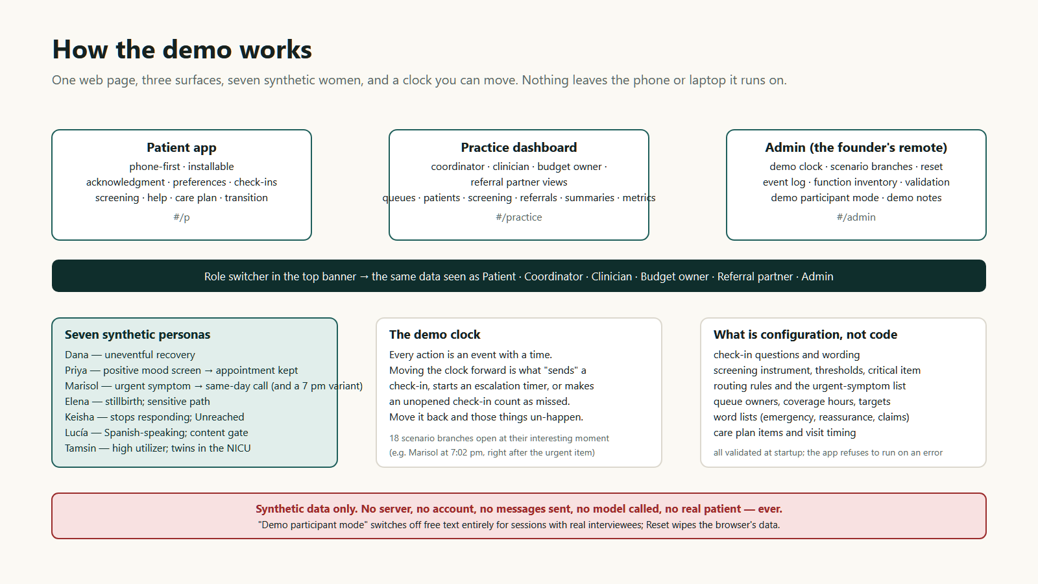
Figure 6. Three surfaces, one clock, seven synthetic women, and everything that is configuration rather than code.

The scenarios
Scenario | Who | What it shows | Show to
6.1 Dana | Vaginal birth, first child, commercial insurance, no barriers | An uneventful recovery end to end; the late-enrollment variant shows check-ins marked not-applicable and no false “unreached” | Women and practices
6.2 Priya | Cesarean, second child, Medicaid, transport barrier | A transport barrier at day 3; a positive day-14 screen; assessment; referral sent, scheduled, kept. Five variants: screen declined, sharing withheld, critical item withheld, referral declined, escalated-then-acknowledged | Women (without the critical-item variant) and practices
6.3 Marisol | Cesarean, English | An urgent symptom on the placeholder list: the locked instruction renders first; a same-day call is logged as 12 minutes; the 7 pm variant lapses to UNOWNED | Practices; women only after a content warning
6.4 Elena | Enrolled at 34 weeks; stillbirth at 36 | The sensitive path: suppression, the dialog, “not for now”, continuing care, no automatic resumption | Practices; women only after a content warning and opt-in
6.5 Keisha | Uninsured, no reliable phone | Stops responding after day 7; exactly one Unreached item at day 21; outreach logged on day 27; the paused variant creates no item | Women and practices
6.6 Lucía | Spanish-speaking, Medicaid, interpreter need | Enrollment blocked until the Spanish safety-critical text is approved; counted in the denominator; a human-only outreach item | Spanish-speaking women through an interpreter; practices
6.7 Tamsin | Twins, NICU stay, commercial | A high utilizer: help requests at most check-ins, saved questions organized by the canned AI, the free-text safety branches, top-decile staff minutes | Practices
6.8 Threshold change | — | The clinical owner edits the EPDS threshold in configuration and the routing changes without a rebuild | Practices (optional)
Each scenario has a written script in the repository under docs/demo-scripts: purpose, starting clock, ordered steps, expected events, and the discovery questions to ask each kind of stakeholder. Every practice script opens with the same block — who owns the postpartum gap today, which tools you use, what remains unresolved, who would pay — and closes with the paired questions: to the clinician, “would you recommend this?”; to the budget owner, “would you pay for it, from which budget?”

The admin panel
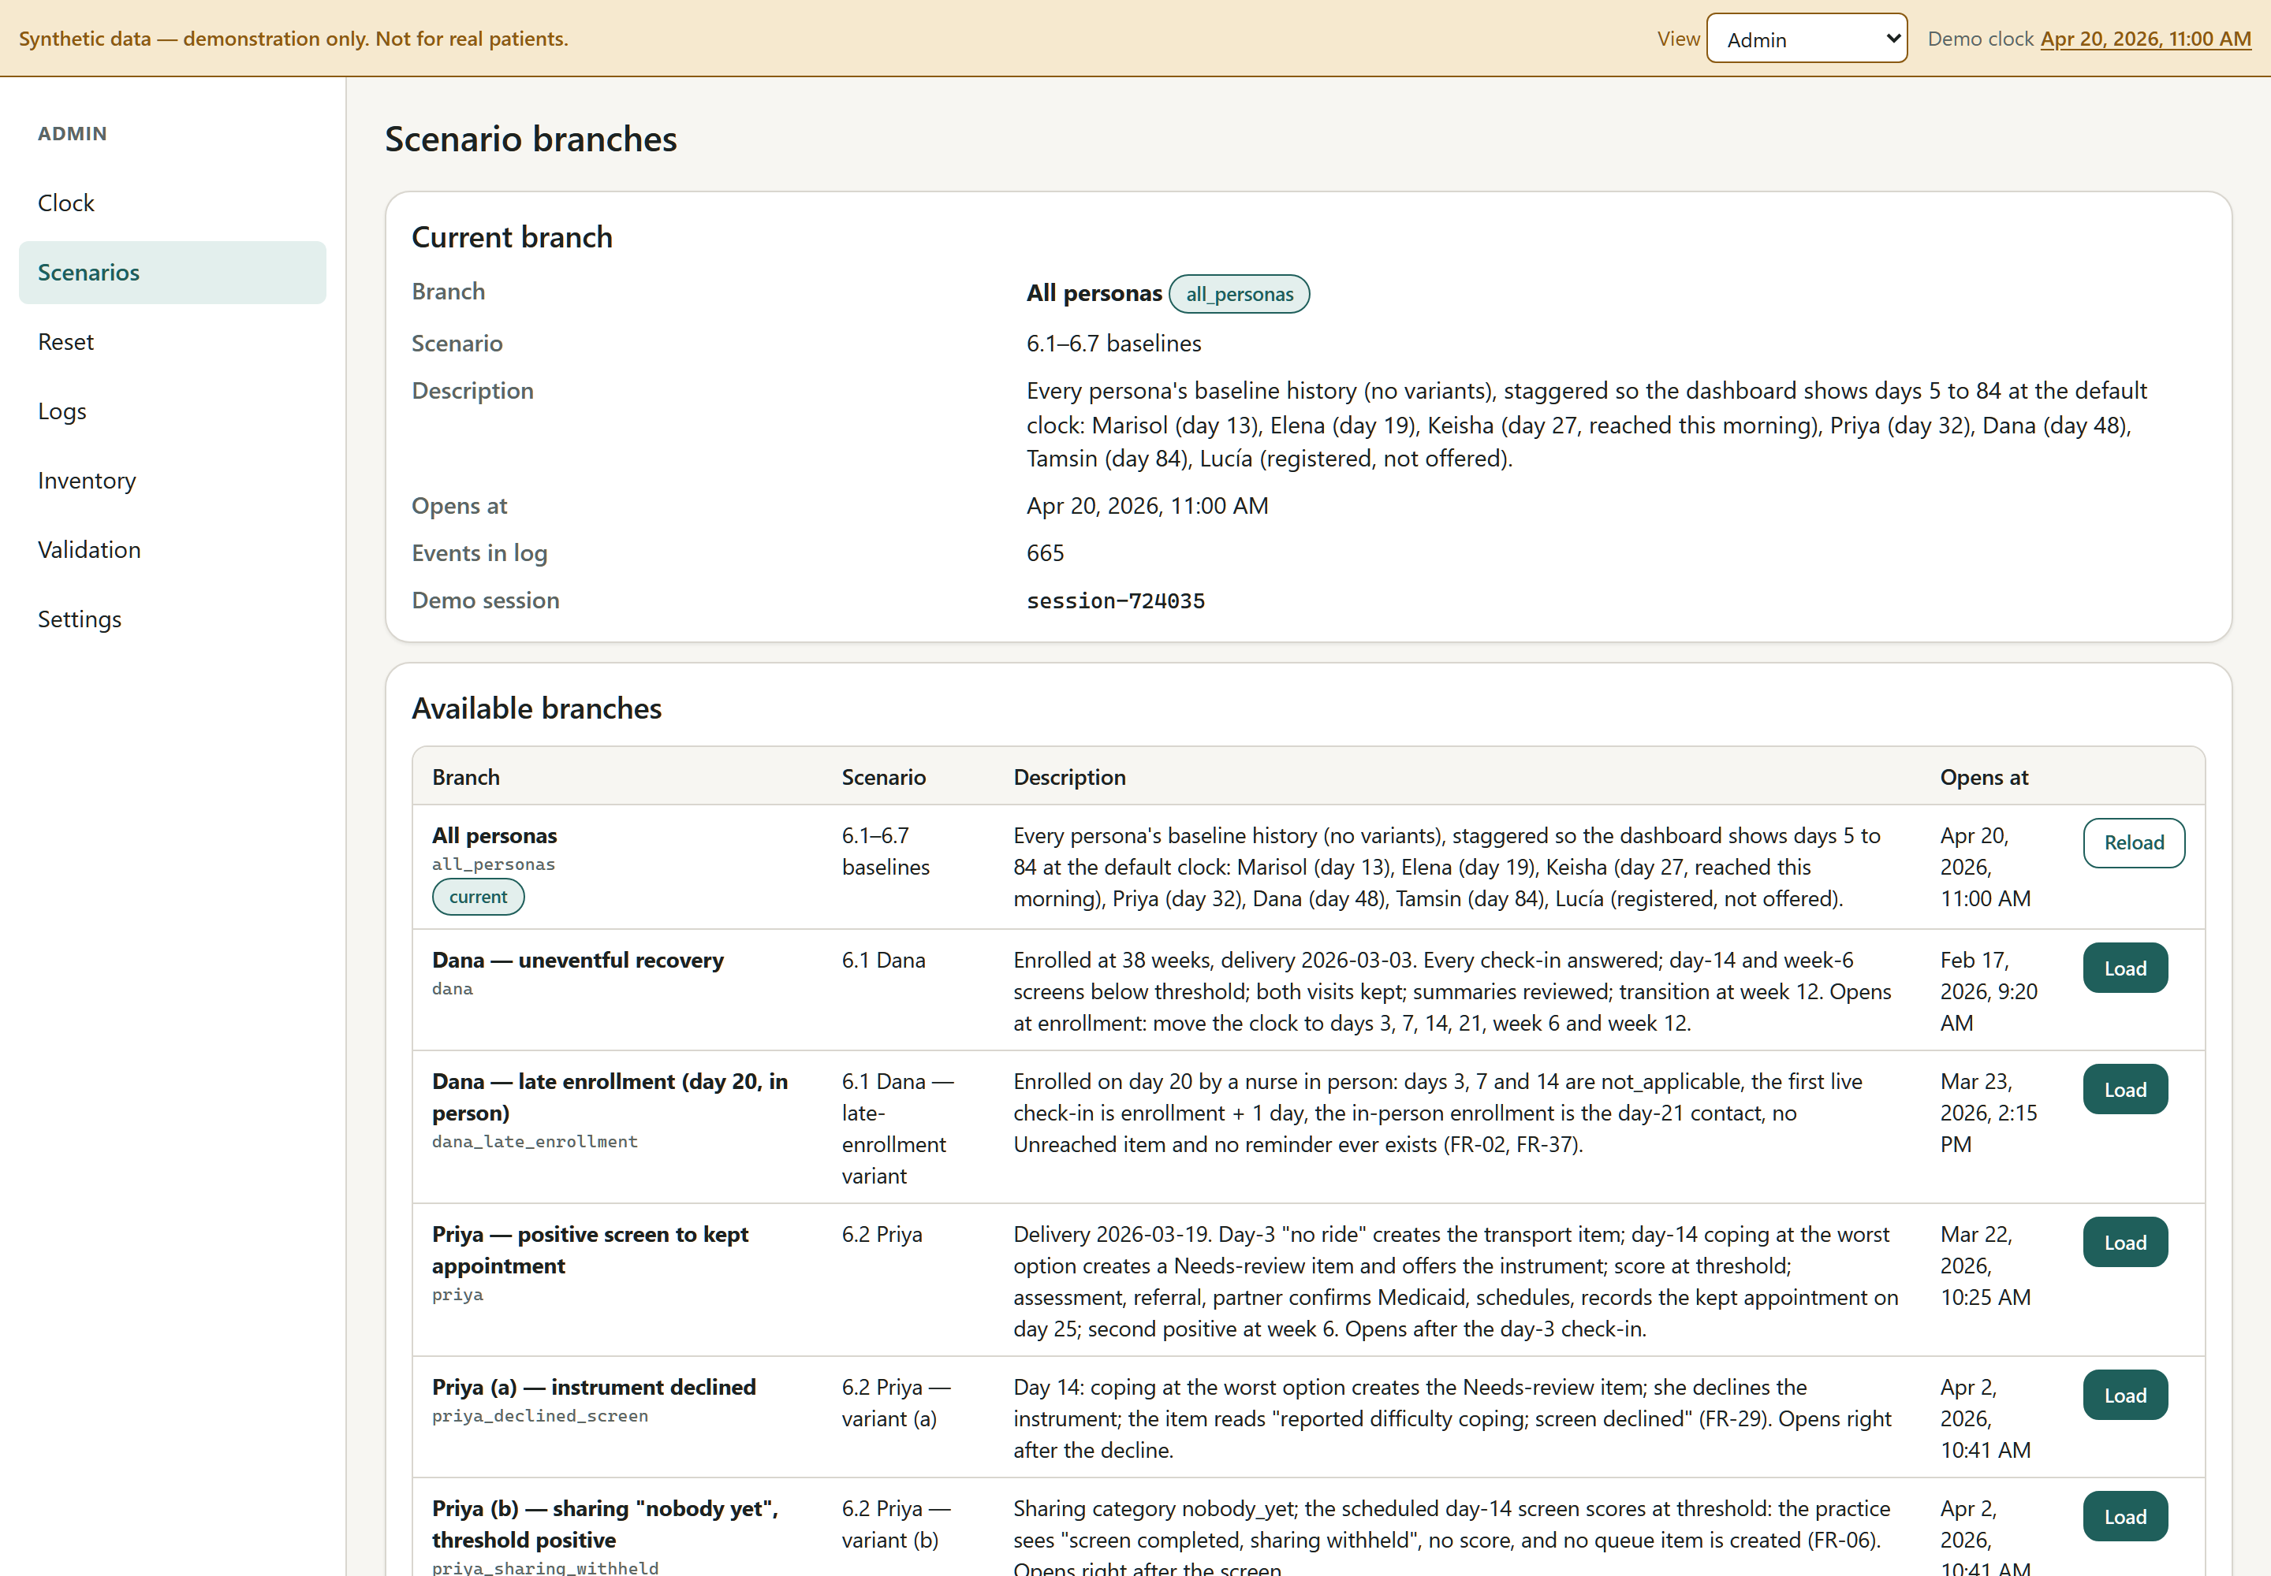
Admin → Scenarios: eighteen branches, each opening at its interesting moment. Load wipes this browser’s data and reseeds.
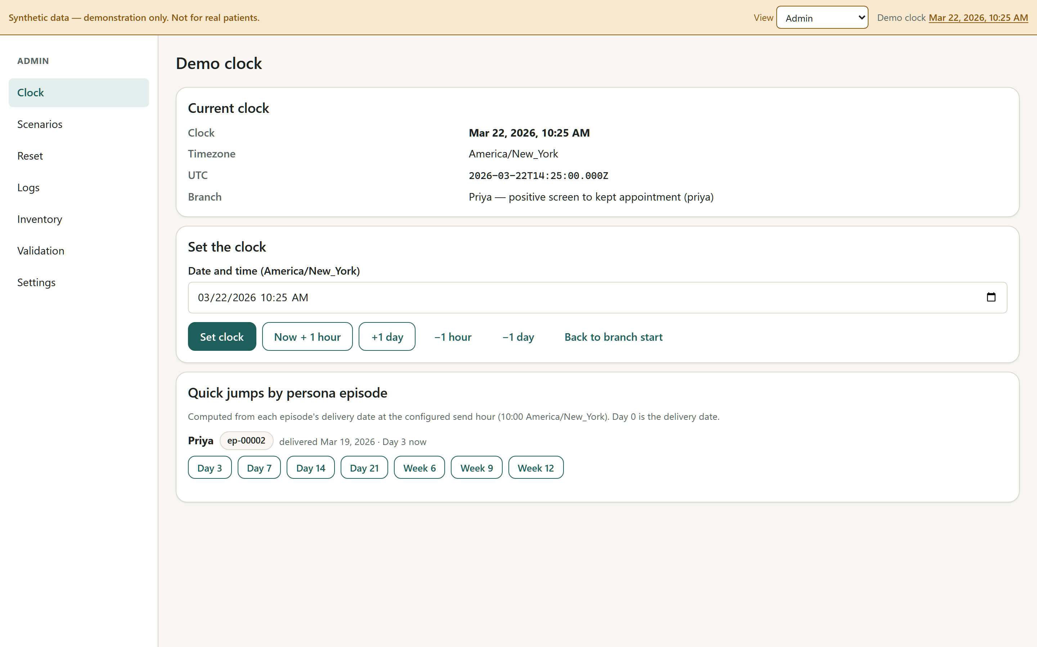
Admin → Clock: jump to any day of any persona’s twelve weeks, or nudge by an hour or a day.
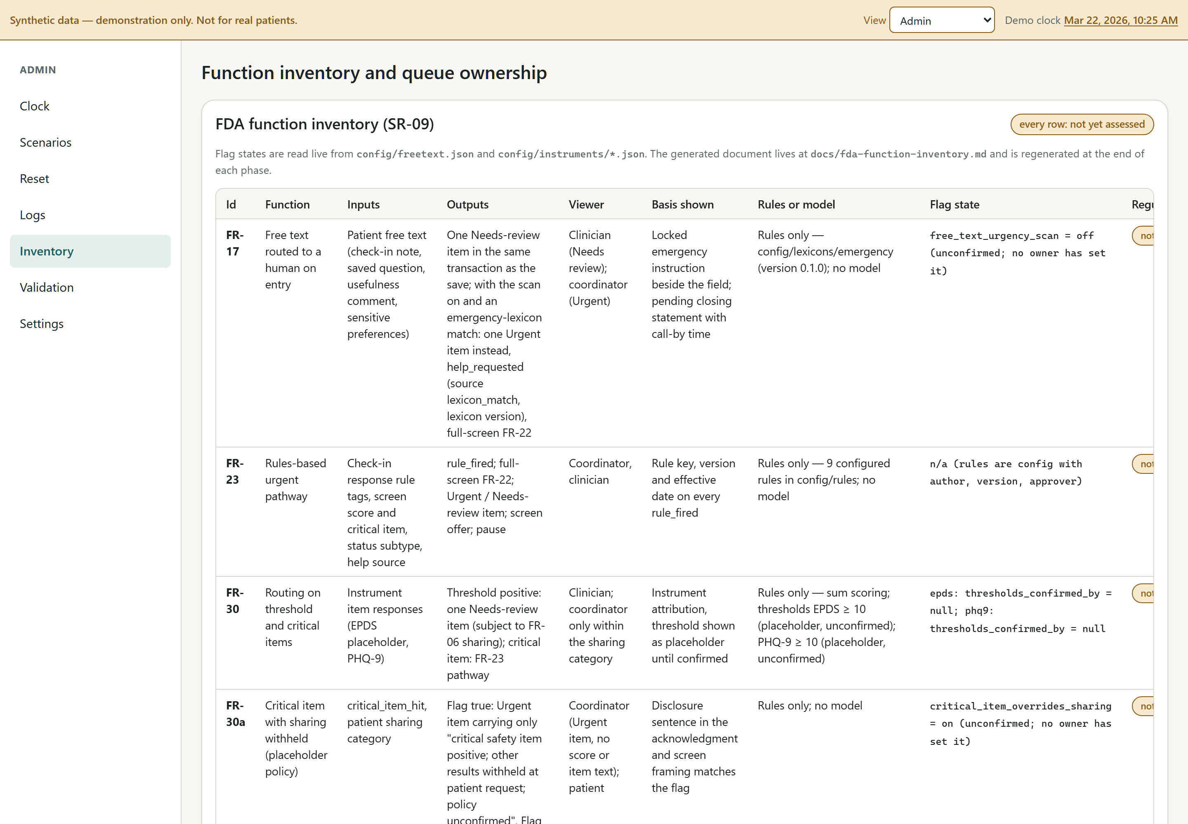
Admin → Inventory: the function inventory for the FDA clinical-decision-support assessment (every row “not yet assessed”) and the queue ownership sheet.
Sessions with real women
Turn on Demo participant mode (Admin → Settings) before a real interviewee touches the phone. It disables every free-text box, shows a statement that nothing entered is seen by a clinician, and tags the session so it can be wiped afterwards.
The requirements also call for a clinician present or reachable at every session, a printed card of real crisis resources handed over before the demo, the persona (not the participant) answering the mood screen, and the loss scenario only after a content warning and opt-in. That protocol is written but needs Sarah’s sign-off.

9. What is placeholder — and needs a clinician’s name on it
Everything below is labelled placeholder — not clinically set inside the app, and the app will keep saying so until the clinical safety owner confirms each item by name.
Item | Current placeholder | Who decides
Check-in questions and wording (7 standard sets + loss, NICU, hard-birth sets) | Drafted at a grade-6 reading level; five items each; urgent-symptom, coping, barrier, callback and free-text items on every standard set | Sarah
Screening instrument and thresholds | EPDS loaded (item 10 critical, positive at 10); PHQ-9 available (item 9 critical, positive at 10) | Sarah
Urgent-symptom list | Drafted from the CDC “Hear Her” postpartum warning signs | Sarah
Emergency instruction and after-hours wording | Real 911 / 988 / DV hotline; practice numbers are 555 placeholders | Sarah + counsel
Queue owners, coverage hours, targets | Mon–Fri 8–5 on every queue; urgent 30/60/120 minutes; needs-review same business day; owners NOT YET ASSIGNED | Amber (operations) with the practice
Self-harm item overrides “nobody yet” sharing | Yes, disclosed to the patient up front | Sarah + counsel
Free-text notes scanned for emergency words at entry | No — every note reaches a clinician the same business day, with the crisis line beside the box | Sarah
Mood check after a loss | A single mood item rather than the full instrument | Sarah
Spanish safety-critical text | Machine-drafted, unreviewed | Sarah + a qualified translator
Care-plan items, visit timing (early visit day 21, comprehensive day 42) | Ten items drafted; two visits | Sarah
Referral partner, barrier resources | NOT YET SECURED / NOT YET PROVIDED | Amber with the practice

10. Things I am still unsure about
An honest list, grouped by who can resolve it. Some of these are product judgments I made on my own that a clinician would make differently; some are engineering corners I cut; some are unknowns nobody can resolve without a practice in the room.

Clinical judgments I made that Sarah should overrule freely
- The check-in cadence (days 3, 7, 14, 21; weeks 6, 9, 12). The review is silent on cadence; I placed three touches before the ACOG three-week mark. It may be too many for a woman five days out, or too few between week 6 and 12.
- The coping item drives the mood screen: the worst answer creates a review item and offers the EPDS immediately; the middle answer twice in a row also offers it. Those triggers are mine, not evidence-based.
- Whether “body recovery getting worse” in the loss set should be an urgent trigger. I removed it after a reviewer pointed out a grieving mother reporting slower recovery would otherwise get a full-screen 911 instruction; the loss set still has the standard urgent-symptom item.
- The self-harm override and the free-text scan are the two policies with the most safety weight, and both are currently set by nobody. The app demonstrates both settings so you can choose with the screens in front of you.
- Tone of the sensitive-path wording, the closing statements, and the day-3 items. All carry a “tone review” attribute that is currently a placeholder name.

Product questions only a practice can answer
- Is business-hours coverage with an after-hours number a real arrangement, or does every practice already route to a nurse line? The whole UNOWNED design assumes the former.
- Is the “unreached” rule (two consecutive unopened check-ins) how a coordinator would actually think about a quiet patient, or would they want a simpler “no reply in N days”?
- Does anyone want a web app, or will patients only respond to text messages? The strongest evidence in the review was for text-based follow-up. The prototype simulates messages; nothing is sent.
- Whether a single-browser demo is enough for discovery, or whether interviews need the patient phone and the coordinator laptop to be live at the same time (which needs a server and real accounts).

Engineering corners I know about
- The rules “harness” is the test suite, not the command-line report the requirements describe; a threshold change shows up as changed tests rather than a “changed, unconfirmed” list.
- Configuration is JSON rather than the YAML the requirements name; functionally the same, less pleasant to edit by hand.
- Some documents the requirements ask for do not exist yet as files: the alternatives worksheet, the discovery-session safety protocol as a signed document, the acceptance-criteria record, the data-flow map, the vendor record.
- A quiet patient who is reached once and then goes quiet again can generate a second Unreached item inside the same window; the seed scripts avoid it, real use might not.
- The two founder-facing flags cannot be changed from inside the app; they are configuration edits and a reload. That is deliberate (the clinical owner’s name must be on the change) but clumsy for a live demo.

Regulatory and evidence limits nobody has resolved
- The FDA clinical-decision-support question (January 2026 guidance) has not been assessed. The urgent-symptom rule, the screening routing, and the self-harm override are all functions that read a symptom or a screen answer and produce a patient-facing action; the inventory lists them as “not yet assessed” on purpose.
- HIPAA business-associate posture, FTC health-data obligations, and the Ohio state-law review are gate items, not done. The prototype avoids the question by holding no real data at all.
- No clinician, regulatory reviewer, or lawyer has looked at this build. It has not been tested with a real user. Expect rough edges.

11. The decisions we need from you
Ranked by how much the answer changes the product. The full list of twenty is in the requirements document; these eight are the ones the prototype cannot move past without.
- Is there a candidate Ohio practice, and who there would own this? A named clinical owner (the person who owns the queue) and a budget owner willing to talk about a paid pilot. The review called this the single most consequential question.
- Which of you is the clinical safety owner, and how many hours a week can you give it? Every patient-facing sentence, rule and threshold needs that person’s sign-off before anyone outside the team sees the app — roughly twelve hours a week for five or six weeks.
- Have you checked your employer obligations? Outside-work and intellectual-property rules, whether you may use your own practice for discovery, and whether interviewing twenty women needs an IRB or quality-improvement determination.
- EPDS or PHQ-9, and at what thresholds? Instrument choice affects attribution, question burden, and the self-harm item handling.
- The two safety policies: keep the defaults or change them? Self-harm item always alerts the practice even under “nobody yet” (currently yes, disclosed); free text scanned for emergency words at entry (currently no — same-business-day human review instead).
- Who would actually take the referrals, and do they take Medicaid? The core demo is “positive screen → referral → appointment kept”. If there is no partner or the wait is weeks, the promise is not honest — and that itself is a finding.
- Does the practice already use Babyscripts or something similar? If so, every interview asks “what is still unresolved after that tool”, and “partner instead of build” stays a live answer.
- Web app plus dashboard is what you have now. Will the pilot need real text messages from day one? The design leaves room for it; it is not built.

12. Next steps for the two of you
- Install the app and run the tour in section 8 — separately, then together — and write down every place you would have said something differently to a patient. That list is the first content review.
- Name the clinical safety owner and the operations owner, and agree hours per week.
- Answer the eight decisions above in writing, even roughly. Shahab revises the requirements and the app to match.
- Review the placeholder content in the order the app needs it: emergency and after-hours wording first; then the day 3–21 check-ins; then the screening framing and thresholds; then the loss and NICU wording.
- Confirm employer, IP and recruitment rules before showing the app to anyone at your institutions, and before recruiting women for interviews.
- Secure one practice conversation: the nursing lead and the budget owner in the same room, the dashboard open, the review’s pilot pricing structures on the table. Ask who owns the postpartum gap today, what tools they have, what is unresolved, and who would pay.
- Run the discovery interviews with the scripts, in Demo participant mode whenever a real interviewee is driving, with a clinician present or reachable and a printed card of real crisis resources. Capture answers in the findings template.
- Decide continue / pause / partner against the review’s criteria: a repeated unmet problem, a reachable cohort, a responsible clinical owner, and a buyer willing to discuss a paid pilot.

Appendix A. Where everything lives
What | Where
The app (install from a phone) | https://shahablo.github.io/NestWell/ — moving to hellonestwell.com
Source code, configuration and content | https://github.com/Shahablo/NestWell
The requirements (working draft v0.1) | docs/requirements.md in the repository; also published as a web page
The independent review the scope is based on | docs/analyst-review.md
Demo scripts for every scenario | docs/demo-scripts/
What is and is not implemented, by work package | docs/BUILD-STATUS.md
The FDA function inventory | docs/fda-function-inventory.md and Admin → Inventory
Open questions (ranked) | docs/open-questions.md
The marketing website (in progress) | https://github.com/Shahablo/nestwell_website → hellonestwell.com

Appendix B. How it was built, and how it was checked
The requirements document was written first, from the analyst review, and itself went through three independent drafts, a judge panel, seven adversarial critics and two revise-and-verify rounds. The app was then built against a fixed domain contract by parallel builders (configuration and content; the domain core; the app shell; then the seven personas, the patient app and the practice dashboard), with two integration passes and a quality pass that walked every screen at phone width, walked every practice role, and reviewed the safety-critical code paths against the requirements.
- Type-check clean; 23 test files and 210 automated tests passing, including one end-to-end test per scenario, a determinism test that reseeds each branch twice and compares the logs, and a test that fails if any network call appears in the app code.
What the quality pass caught, and fixed, before this document was written. Worth knowing, because it is exactly the kind of thing a clinical reviewer should keep looking for:
- An urgent answer waited for the end of the check-in. Tapping “chest pain or trouble breathing” moved on to “how are you coping this week?” and only showed the emergency instruction four screens later. It now appears the moment the answer is given, and the urgent item is created at once.
- The emergency screen demanded an “I have read this” tap and had no tap-to-call numbers. It now gates nothing, and 911, 988 and the DV hotline are large dialable links.
- A recorded stillbirth did not hide infant content until the mother tapped “something has happened to my baby” herself. The clinician’s record now suppresses it immediately, and a bereaved patient no longer sees a staff-style status label.
- Smaller ones: “Stop the program” disappeared while check-ins were paused; two closing statements promised different call-back times on the same screen; the emergency instruction appeared twice after an urgent answer.
- A word-list lint runs over every piece of patient-facing text, every UI string and every document, and fails the build on any reassuring phrase (“you are doing fine”), any monitoring claim (“we’ll know”), any burden mechanic (“streak”), and any prohibited claim (“HIPAA compliant”, “FDA cleared”, “first-of-its-kind”, “proven”).
- No network calls exist in the application code; the only external resource is nothing. The service worker caches the whole app so the help path works offline.
Prepared by Shahab with Claude, September 16, 2026. Nothing in this document is a legal determination or a clinical protocol.

