

Sam

Project Description

Developed by



Document Prepared by  
Mohammad Shahabuddin

**About Project**

This system is developed to maintain a clothing system by admin panel body. In this system there are several module where admin can add products, items, brands, roles and so on.

The system address: <https://sam.bettahelper.com/> (This is for testing purpose)

**Wireframe**

In this section we will discuss about the wireframe of this system. The wireframe is the primary step for developing a system. In this section we will discuss the initial design of the project.

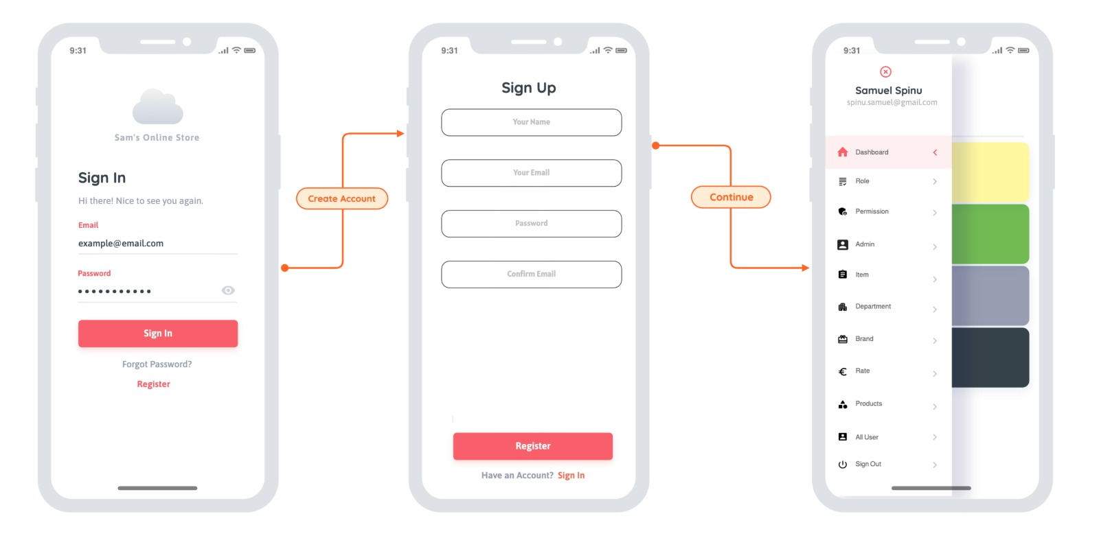

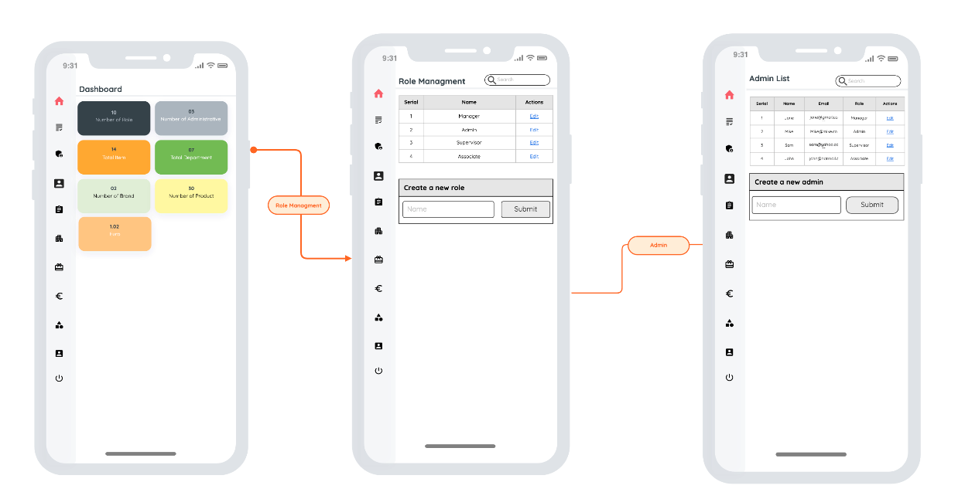

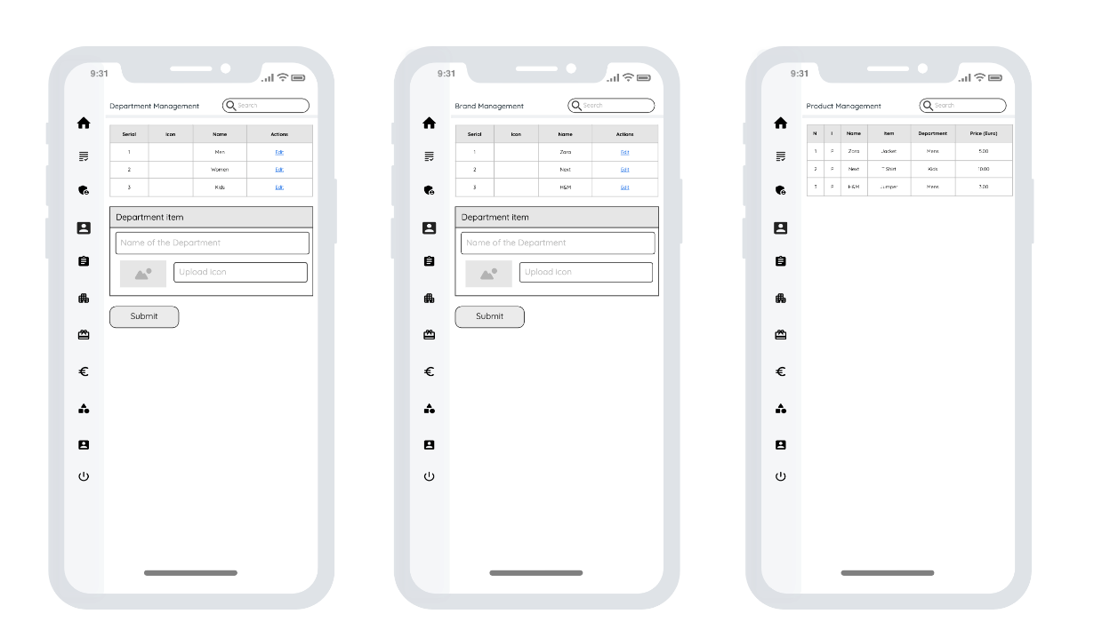

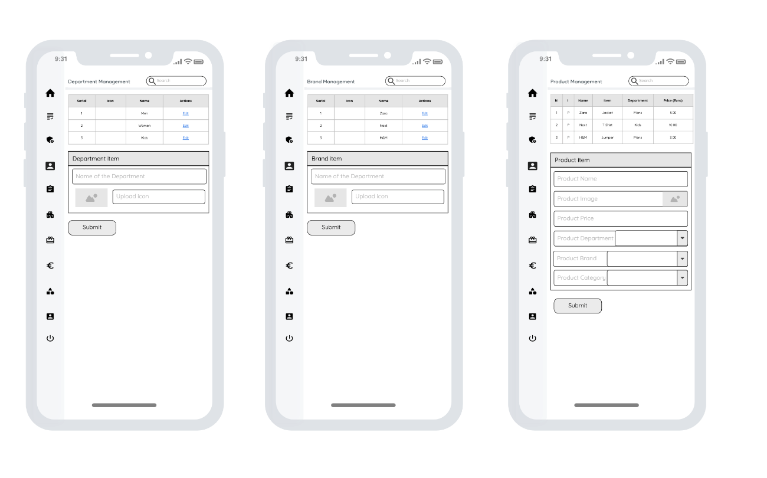

In this section we discuss the over flow and working process of the entire system. In this section we try to give an over view of the whole system.

**Required tools and software**

In this section we will discuss about required technologies about this system. We divide this project into two section. One is UI and other one is backend. In the UI section we have used html, css, bootstrap, javaScript, sweet alert etc. We have used data tables for display data in the UI. And for the backend part we used laravel. It's a frame work of php. This system is model based. We pulled data using model in the controller.

**Software details**

* PHP
* Laravel
* MySQL
* Html
* Css
* JavaScript
* Bootstrap
* JQuery

**System preview**

In the system overview section we will give you an over view and how it’s work. In this section will mainly focus about the user interface? So that you can have an over view about the entire system with its functionalities and UI.

**Login section**

In this section user/admin will have a page for login into the system

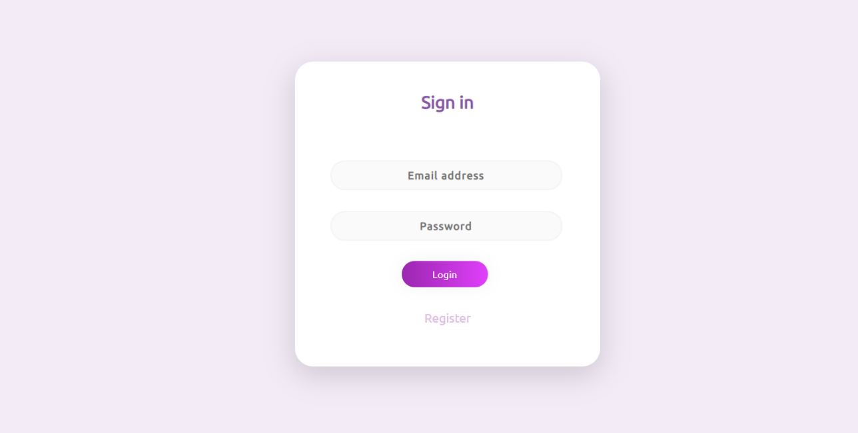

**Register section**

In this section here we discuss a user register module. Here a user can register himself for the system.

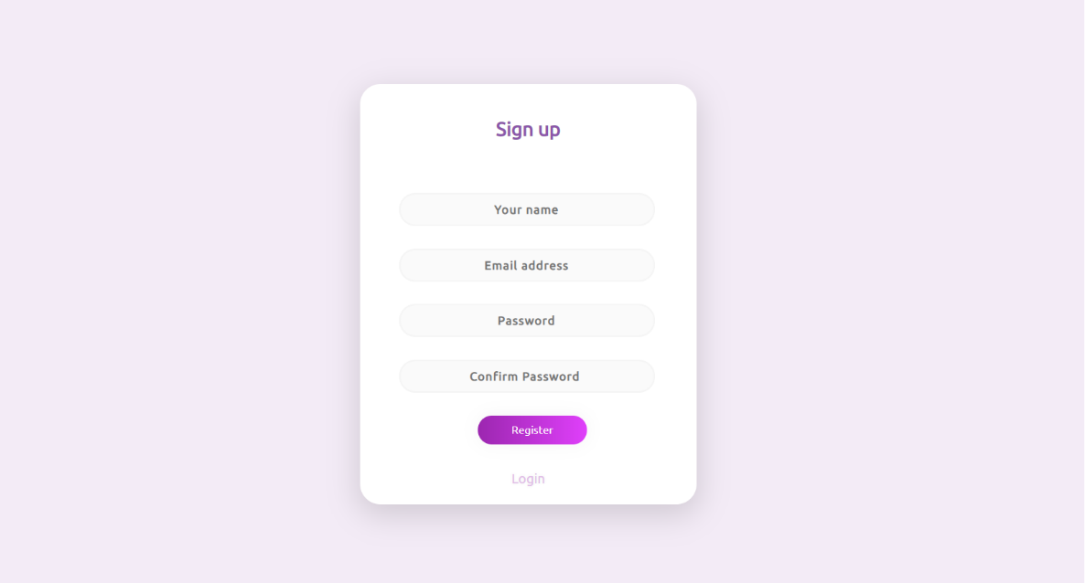

**Modules**

**Admin**

Admin module has several role to play. An admin can control the entire system. A list is given below about the functionalities that an admin can do. After login as an admin he will have an overview like this one which is given below.

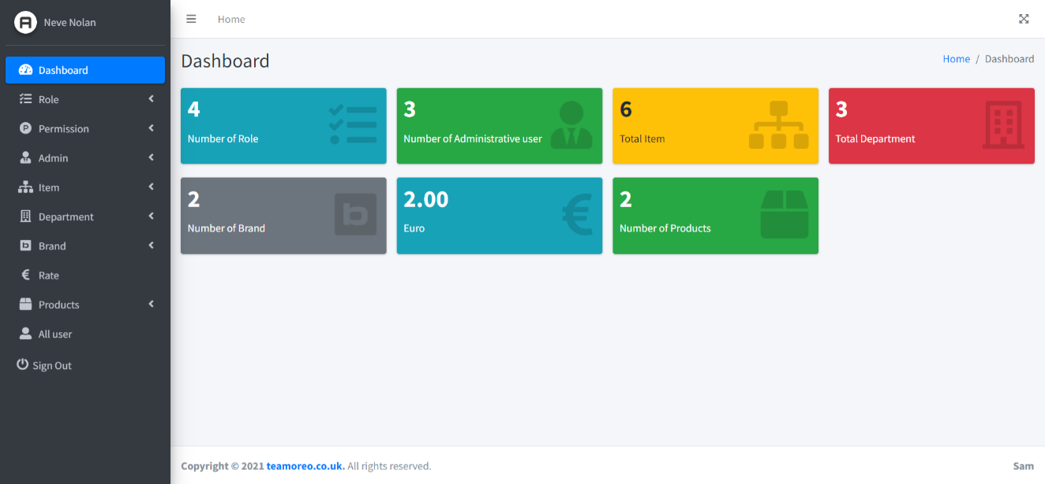

1. Role

Can create, edit and update role.

For create a new role needs to click on role tab on the side navigation bar and then it will redirect to the role section where all its functionalities are displayed.

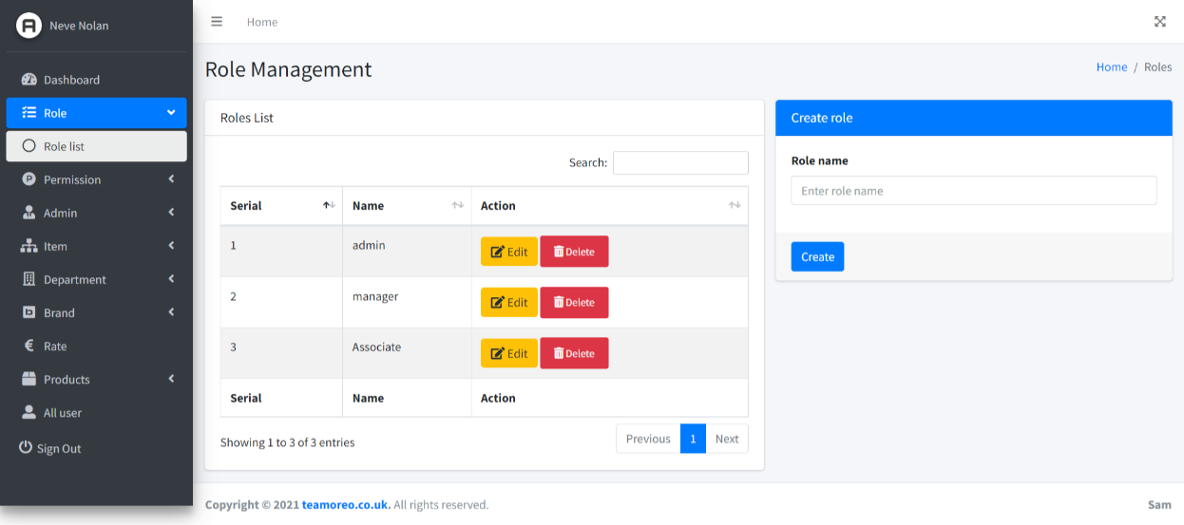

1. Permission

In this section the admin can give access to a certain section for certain user.

For example – In the product section a manager can create a product or update the product but he cannot delete the product because the admin does not give him the permission to do so.

Can create, edit and update permission.

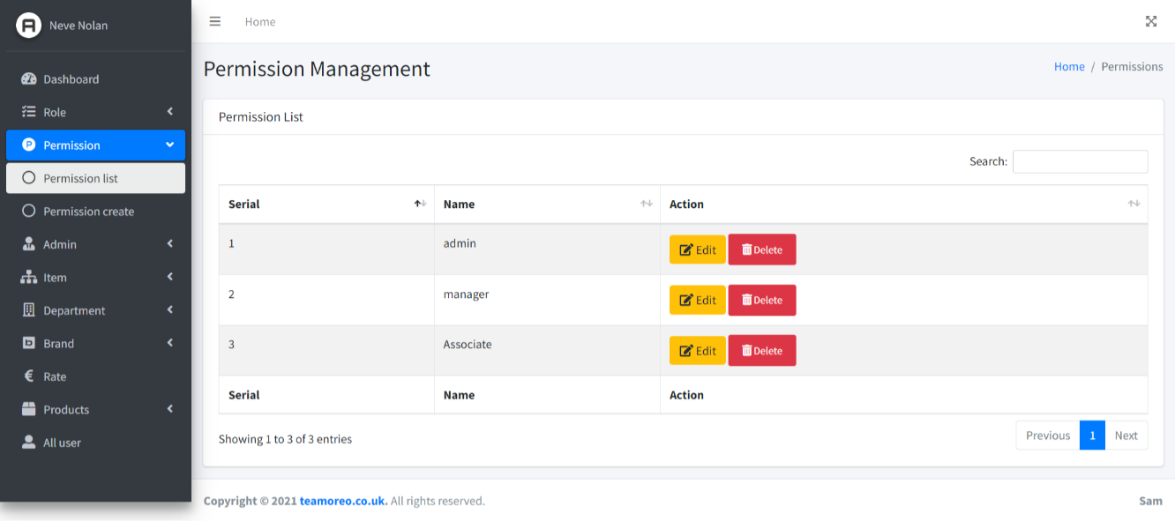

1. Admin

This section is for creating the user who can use the system.

Can create, edit and update admin.

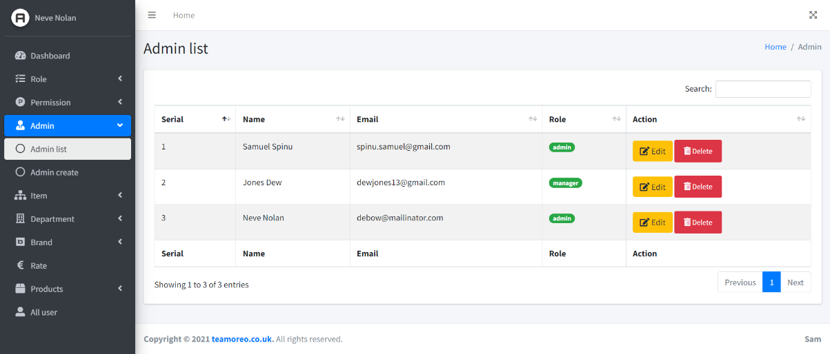

1. Item

Can create, edit and update item.

For example – tops, jackets, jeans etc.

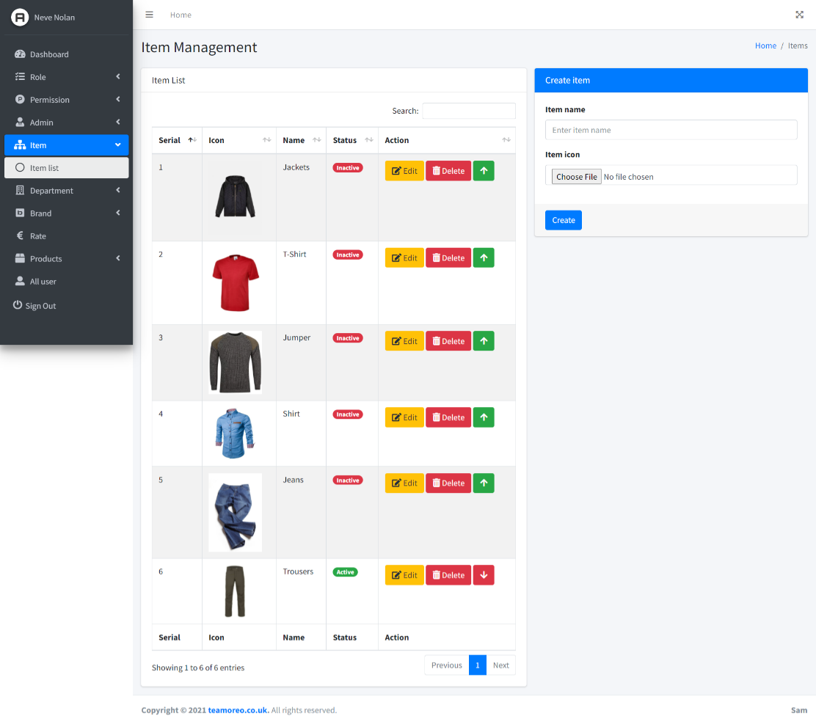

1. Department

Can create, edit and update department.

For example – men, women, kids etc.

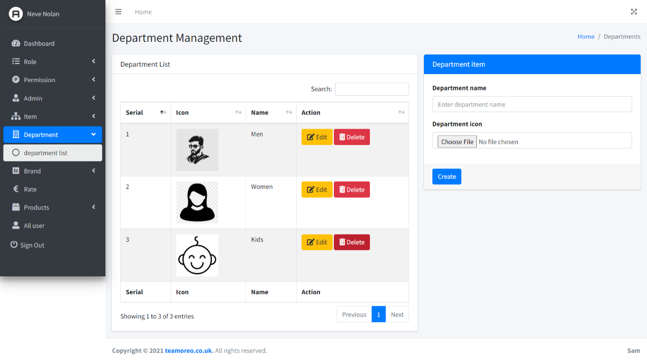

1. Brand

Can create, edit and update department.

For example – Gucci, Nike, Bay etc.

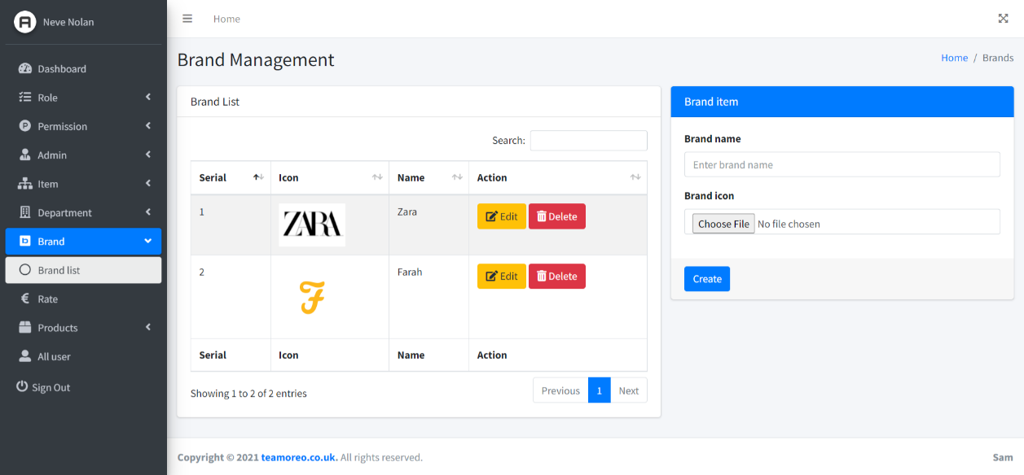

1. Rate

Can update the rate for 1 pound = what in one euro.

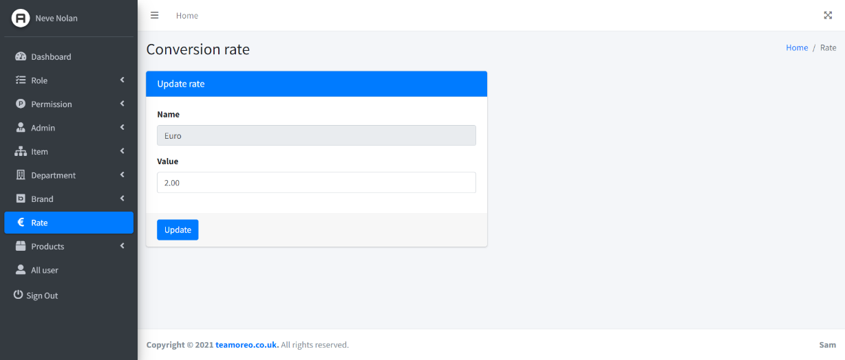

1. Product

Can create, edit and update product.

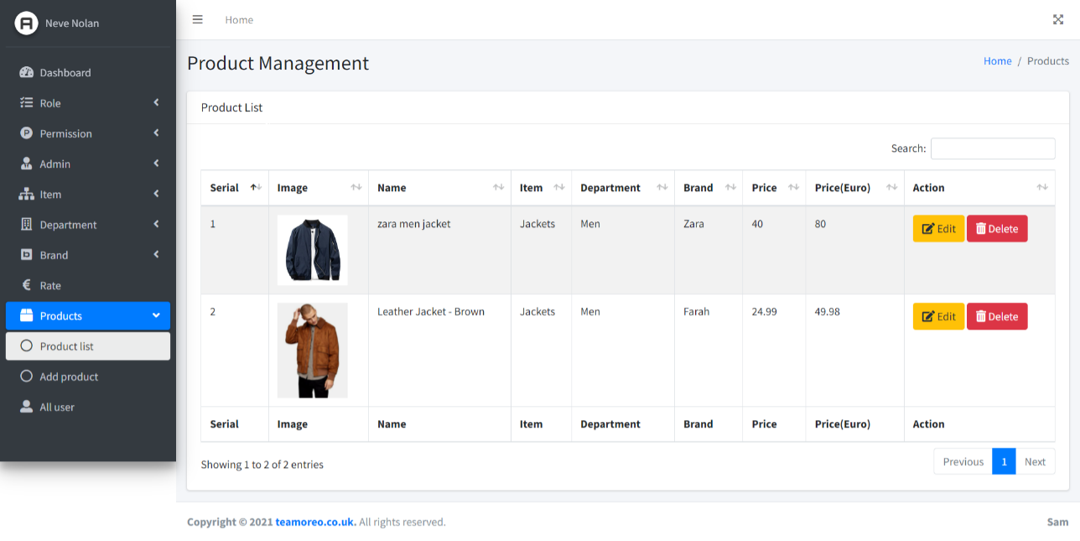

1. User list

In this page an admin can view the total user of the system.

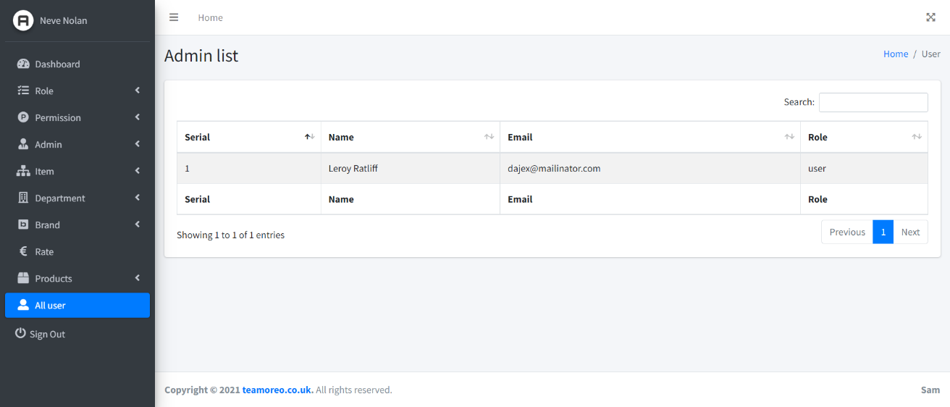

**Profile setting**

In this section an admin, user can update their profile information like email address, name and password. For accessing this section a user needs to click on his name in the top of navigation menu and then he can access this section.

