*House Renting*

*An Online Platform That Is Developed By MEAN Stack*



***B.S.C Engineering Project-II(CSE4292)***

***Part-4, Even Semester***

***Session: 2013-14***

|  |  |
| --- | --- |
| *Submitted By:* | *Submitted To:* |
| *Shahabuddin Ahmed*  *Roll: 14095415*  *Dept. of CSE*  *University of Rajshahi* | *Kazi Jahidur Rahman*  *Assistant Prof.*  *Dept. of CSE*  *University of Rajshahi* |

**Abstract**

An online based platform that is developed for Bangladesh. This will reduce the lengthy, costly. The actually traditional way to leaflet is not more efficient. House owner will be able to give the house’s ads and other users who want to rent house will be in contact with house owner throw phone number. This system is developed by MEAN technology. Angular, Angular Materials, Reactive Form and MDBBootstrap are used for fast and fluid user experience. Node.js is used for more fastest and secure backend API which is worked in asynchronously and capable of more user request handling at a time. HTTPS and JWT security features are used to secure the platform.

**INDEX**

|  |  |  |
| --- | --- | --- |
| **Chapter 1 : Introduction** | | |
| 1.1 | Introduction | 7 |
| 1.2 | Overview | 8 |
| 1.3 | Scope of the Project | 9 |
| **Chapter 2 : Background Study and Planning** | | |
| 2.1 | Background Study | 11 |
| 2.2 | Core Objective | 12 |
| 2.3 | Software Model | 13 |
| 2.4 | Planning | 15 |
| **Chapter 3 : Feasibility Study** | | |
| 3.1 | Technical Feasibility | 18 |
| 3.2 | Economic Feasibility | 18 |
| 3.3 | Environmental Feasibility | 19 |
| 3.4 | Schedule Feasibility | 19 |
| 3.5 | Application Area | 20 |
| **Chapter 4 : Design & Implementation** | | |
| 4.1 | Use Case(UML) Diagram | 22 |
| 4.2 | ER Diagram | 24 |
| 4.3 | Technology to be Used | 25 |
| 4.4 | User Interface | 30 |
| **Chapter 5 : Risk Factor & Management** | | |
| 5.1 | Risk Factor | 47 |
| 5.2 | Risk Management | 48 |
| **Chapter 6 : Testing** | | |
| 6.1 | White Box Testing | 50 |
| 6.2 | Black Box Testing | 51 |
| 6.3 | Gray Box Testing | 52 |
| 6.4 | Beta & Security Testing | 53 |
| **Chapter 7 : Conclusion** | | |
| 7.1 | Expected Outcome | 55 |
| 7.2 | References | 55 |

**Acknowledgement**

First and foremost I would like to thank our project supervisor Kazi Jahidur Rahman sir for the guidance, inspiration and constructive suggestions that help mine in the preparation of this project. I also thank my uncle who has given this idea and help to the successful completion of the project.

Chapter [1]

*Introduction*

**1.1 Introduction**

In Bangladesh there are no good house renting site. There is one existing site, but more complex and other one side is exit but it is not house renting purposes properly. In current leaflet system is not easy. The process of notifying people about house ads is lengthy and difficult process. Sometimes leaflet are damaged by different way. So we will automate the process of house-renting in Bangladesh so that people will not have to find leaflet in the physically. We will make use of single page application for fluid and fast user experience. House renter can find desire house in digitally. This is much more convenient.

**1.2 Overview**

House Renting is a platform that is house owner gives theirs house ads and house renter who want to rent house. House renter have a full customize search option that is user can search desire house by selected option. Proper authentication, authorization and security features will be provided by the site. Some option is to set default value for renter convenience. House owner can be created multiple ads and contain cover image option that is to attract house renter. For security purpose we implemented HTTPS. This platform will be made for Bangladesh.

**1.3 Scope of the Project**

The scope of the project is to build an online platform specifically for house renting purpose in Bangladesh. It also serves as an E-Commerce platform. This is complete business platform is the final goal of the project. Implementing HTTPS, JWT, API are needed for the success of the project. We will need to separately implement front end and back end for the fast page rendering of the project.

Chapter [2]

*Background Study and planning*

**2.1 Background Study**

* **Local Market**
* There are only one house renting sites in Bangladesh.
* It is no more popular and efficiency.
* Link: [www.http//:bpropartycom](http://www.http//:bpropartycom)
* **International Market**
  + In development countries about 96% people find their house in online.
  + House renting system is most popular.
  + International sides are <https://www.lacartedescolocs.fr/> and <https://www.spotahome.com/> are more popular.

**2.2 Core Objective**

In Bangladesh there are multiple platforms for online selling but there are no better platform which implements leaflet via online, which is very important for now a days. Here is our final goals.

* It is simple and easiest way to give an advertisement.
* An adviser advising his house with picture and description and other necessary things and other people view advertise who want to house rent.
* House renter and house advertiser will communicate throw phone number.
* Real time communication is included.
* It is reduced time and cost both renter and advertiser.

**2.3 Software Model**

The waterfall model is a sequential (non-iterative) design process, used in software development processes, in which progress is seen as flowing steadily downwards (like a waterfall) through the phases of conception, initiation, analysis, design, construction, testing, production/implementation and maintenance.

Requirement Definition

Coding

Integration & Test

Modeling

Design

Planning

Designing & Scheduling

Maintenance &

Support

This model some time called the classic life cycle, suggest a systematic, sequential approach to software development which begins with user specification of requirements and process through planning, modeling construction, and deployment , culminating in ongoing support of the complete software. The main approach of this model is much similar to a real waterfall that’s it called waterfall model.

**Why Choose Waterfall Model:**

Now a days we easily notice that waterfall model strong enough for most of the software industries because of its some limitation but for our purpose it is completely suitable. So here is the reasons why we choose this model except other:

* We wanted simple and easy to use model. Waterfall model is simple and easy to use.
* Requirement for the system are very well understood, clear and fixed.
* Our product definition is stable.
* There are no ambiguous requirements in the system.
* The project is not that big.
* Easy to manage due to rigidity of the model.
* When an error is identified we can instantly loop back to previous stage and problem is solved. So this is a more secure model for us.

**2.4 Planning**

The planning indicates what needs to be done, which resources must be utilized, and when the project is due. In short, it’s a timetable that outlines start and end dates and milestones that must be met for the project to be completed on time. Project planning envelops the following actions:

1. Split project into task and estimate time and resources required to complete each task.
2. To make the optimal use of workforce, we have to organize tasks concurrent.
3. It depends on project manager’s skill and experience.

**The task list and require time for this project is given below:**

|  |  |  |
| --- | --- | --- |
| **Task Name** | **Start Date** | **End Date** |
| * **Analysis** | **24-07-2018** | **12-08-2018** |
| * Requirement election | 24-07-2018 | 31-07-2018 |
| * Feasibility Study | 01-08-2018 | 06-08-2018 |
| * System Planning and Scheduling | 07-08-2018 | 12-08-2018 |
| * **Front end** | **15-08-2018** | **25-10-2018** |
| * Develop font end | 15-08-2018 | 20-10-2018 |
| * Testing Front-End | 21-10-2018 | 30-10-2018 |
| * **Backend** | **31-10-2018** | **30-11-2018** |
| * Node.js REST API | 31-10-2018 | 15-11-2018 |
| * REST API with JWT Authentication | 16-11-2018 | 21-11-2018 |
| * Testing Back-End | 22-11-2018 | 30-11-2018 |

A Gantt chart, commonly used in project management, is one of the most popular and useful ways of showing activities (tasks or events) displayed against time. On the left of the chart is a list of the activities and along the top is a suitable time scale. Each activity is represented by a bar; the position and length of the bar reflects the start date, duration and end date of the activity.

**The Gantt chart for developing the project is given below:**

|  |  |  |  |  |
| --- | --- | --- | --- | --- |
| July | August | September | October | November |
| 07 14 21 28 | 07 14 21 28 | 07 14 21 28 | 07 14 21 28 | 07 14 21 28 |
| Analysis |  |  |  |  |
|  | Requirement Election |  |  |  |
|  | Feasibility Study |  |  |  |
|  |  | System planning | and scheduling |  |
|  |  | Front-End |  |  |
|  |  |  |  | Develop Frond End |
|  |  |  |  | Testing |
|  |  |  |  | Back-End |
|  |  |  | REST API |  |
|  |  |  | REST API with JWT Auth |  |
|  |  |  |  | Testing |

Chapter [3]

*Feasibility Study*

**3.1 Technical Feasibility**

Technical feasibility, studies that if the current technological infrastructure are capable of accommodating candidate system. The [technical feasibility](https://en.wikipedia.org/wiki/Technical_feasibility) assessment is focused on gaining an understanding of the present technical resources of the organization and their applicability to the expected needs of the proposed system. It is an evaluation of the hardware and software and how it meets the need of the proposed system.

* I have experience in Node.js on backend and Angular on front end.
* I have also experience on MDBBootstrap and Angular Materials for beautiful design.
* User can use the browser from mobile, tablet or pc to browse our web site. All modern browsers are capable of running this site.

**3.2 Economic Feasibility**

The purpose of the economic feasibility assessment is to determine the positive economic benefits to the organization that the proposed system will provide. It includes quantification and identification of all the benefits expected. This assessment typically involves a cost/benefits analysis.

* There are no more competitor site. So benefits are expected to come shortly.
* HouseRenting will charge 5% for each ads. So it is profitable.
* User can view ads from anywhere. User don’t have to be there physically.

**3.3 Environmental Feasibility**

It is important to understand and analysis how the users (General People) will react towards the new online digital system. And here there is a question that is this design are capable to satisfy all users. Of course there here is a majority issue but the fundamental thing is to concern that the objective of the system to be design.

* HouseRenting will provide secure transaction.
* HouseRenting will prevent frauds.
  1. **Schedule Feasibility**

Schedule feasibility is define as the likelihood of a project begin completed within its time frame. It is necessary to determine whether the deadlines are mandatory or desirable.

* I will be able to complete the project in the time schedule.

**3.5 Application Area**

* This Project is used as business purposes.
* Actually, this project is popular in urban area.
* All class of professionals will be most popularities.

Chapter [4]

*Design & Implementation*

**4.1 UML (Use Case) Diagram**

**Admin Use Case:**



Admin

**House Owner Use Case:**



House Owner

**General user Use Case:**



**4.2 ER Diagram**

Users

Relation

Ads

relation

Image

**4.3 Technology to be used**

* **Client Side**
  + HTML
  + CSS
  + Bootstrap
  + Angular Materials
  + Angular 6
  + MDBBootstrap
* **Server Side**
  + Language
    - JavaScript
* Framework
  + Node.js
* Database
  + MongoDB

**Bootstrap:**

Bootstrap is an open-source JavaScript framework developed by the team at Twitter. It is a combination of HTML, CSS, and JavaScript code designed to help build user interface components. Bootstrap was also programmed to support both HTML5 and CSS3.

Also it is called Front-end-framework.

Bootstrap is a free collection of tools for creating a websites and web applications.

It contains HTML and CSS-based design templates for typography, forms, buttons, navigation and other interface components, as well as optional JavaScript extensions.

Some Reasons for programmers preferred Bootstrap Framework

* Easy to get started
* Great grid system
* Base styling for most HTML elements(Typography,Code,Tables,Forms,Buttons,Images,Icons)
* Extensive list of components

**Angular Material UI**:

Angular Material is a UI component library for Angular developers. Angular Material components help in constructing attractive, consistent, and functional web pages and web applications while adhering to modern web design principles like browser portability, device independence, and graceful degradation. It helps in creating faster, beautiful, and responsive websites. It is inspired by the Google Material Design.

**Node.js:**

Node.js is a server-side platform built on Google Chrome's JavaScript Engine (V8 Engine). Node.js was developed by Ryan Dahl in 2009 and its latest version is v0.10.36. The definition of Node.js as supplied by its [official documentation](https://nodejs.org/) is as follows −

Node.js is a platform built on [Chrome's JavaScript runtime](https://code.google.com/p/v8/) for easily building fast and scalable network applications. Node.js uses an event-driven, non-blocking I/O model that makes it lightweight and efficient, perfect for data-intensive real-time applications that run across distributed devices.

Node.js is an open source, cross-platform runtime environment for developing server-side and networking applications. Node.js applications are written in JavaScript, and can be run within the Node.js runtime on OS X, Microsoft Windows, and Linux.

Node.js also provides a rich library of various JavaScript modules which simplifies the development of web applications using Node.js to a great extent.

## Features of Node.js

Following are some of the important features that make Node.js the first choice of software architects.

* **Asynchronous and Event Driven** − All APIs of Node.js library are asynchronous, that is, non-blocking. It essentially means a Node.js based server never waits for an API to return data. The server moves to the next API after calling it and a notification mechanism of Events of Node.js helps the server to get a response from the previous API call.
* **Very Fast** − Being built on Google Chrome's V8 JavaScript Engine, Node.js library is very fast in code execution.
* **Single Threaded but Highly Scalable** − Node.js uses a single threaded model with event looping. Event mechanism helps the server to respond in a non-blocking way and makes the server highly scalable as opposed to traditional servers which create limited threads to handle requests. Node.js uses a single threaded program and the same program can provide service to a much larger number of requests than traditional servers like Apache HTTP Server.
* **No Buffering** − Node.js applications never buffer any data. These applications simply output the data in chunks.
* **License** − Node.js is released under the [MIT license](https://raw.githubusercontent.com/joyent/node/v0.12.0/LICENSE)

**Angular**:

Angular is a JavaScript framework that helps developers build applications. The library provides a number of features that make it trivial to implement the complex requirements of modern applications, such as data binding, routing, and animations.

Angular also provides a series of conventions for how you approach application development, which can be beneficial for large teams that need to work together on a single code base. Angular is one of the only JavaScript libraries to provide a comprehensive style guide with a number of opinionated guidelines on how you could write your code with the framework.

**Why use Angular:**

Single-Page Applications (SPAs) are Web apps that load a single HTML page and dynamically update that page as the user interacts with the app.

SPAs use AJAX and HTML5 to create fluid and responsive Web apps, without constant page reloads. However, this means much of the work happens on the client side, in JavaScript. For the traditional ASP.NET developer, it can be difficult to make the leap. Luckily, there are many open source JavaScript frameworks that make it easier to create SPAs. We choose Angular because:

* Out of box support for navigation (with almost every other framework, you need a separate library for this).
* Support for data maintenance using services.
* Support for lazy loading.
* Loads of inbuilt filters, pipes for modulating your data on UI.
* Comes with complete server configuration for development mode
* Many Options like Guards, resolvers, directives and pipes make your life hell lot easier.
* Styles encapsulation and component scopes makes it lot easier to maintain your styling.
* Angular6 is due to release soon and promises support for progressive web apps.

**4.4 User Interface**

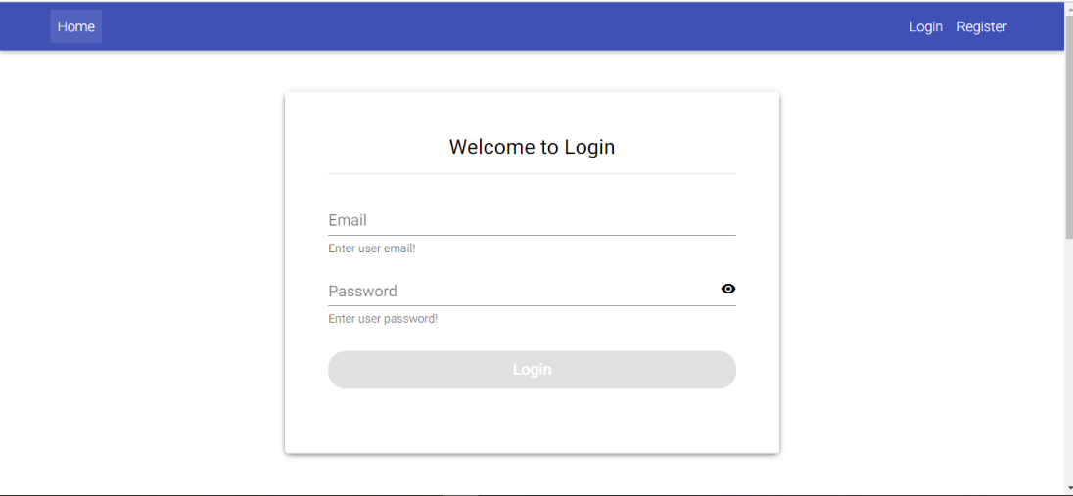**User Login:**

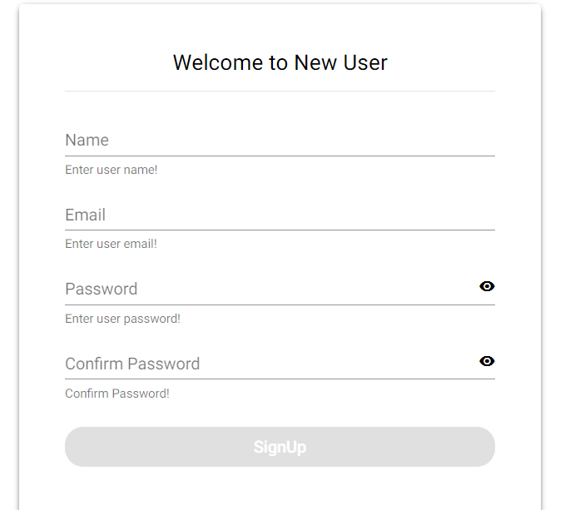**User Register:**

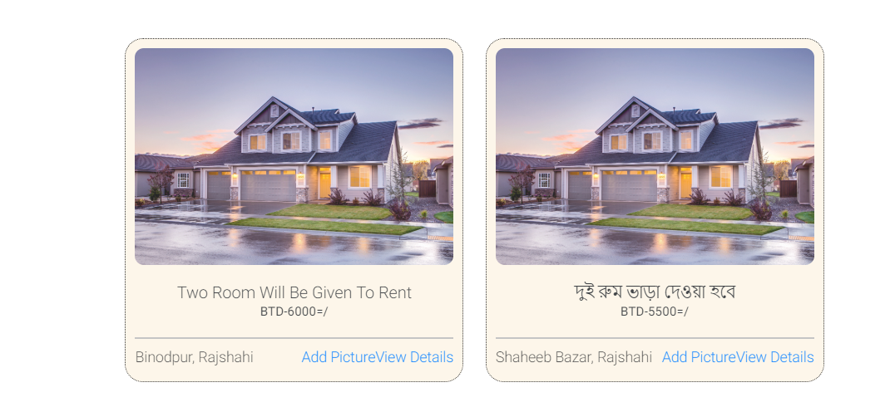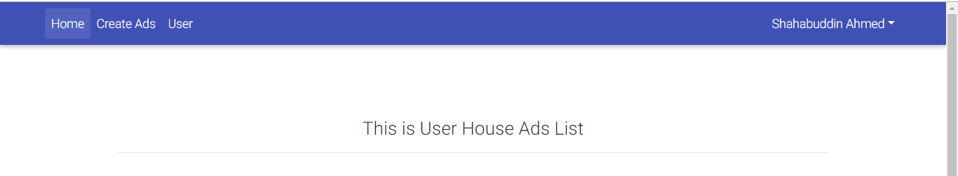**User House Ads:**

**Add House Picture:**

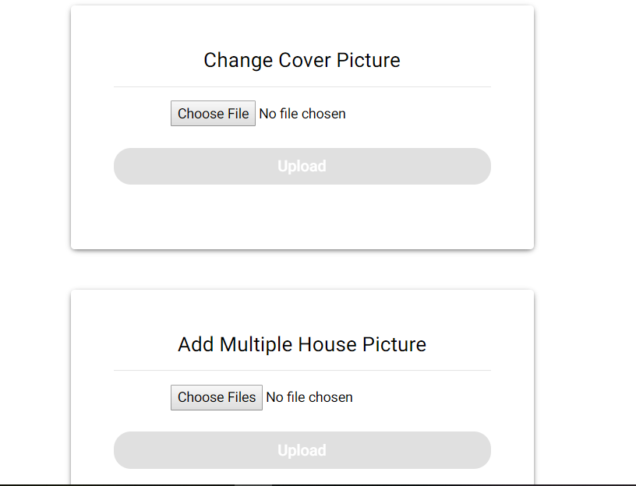

**House Ads Image Gallery:**

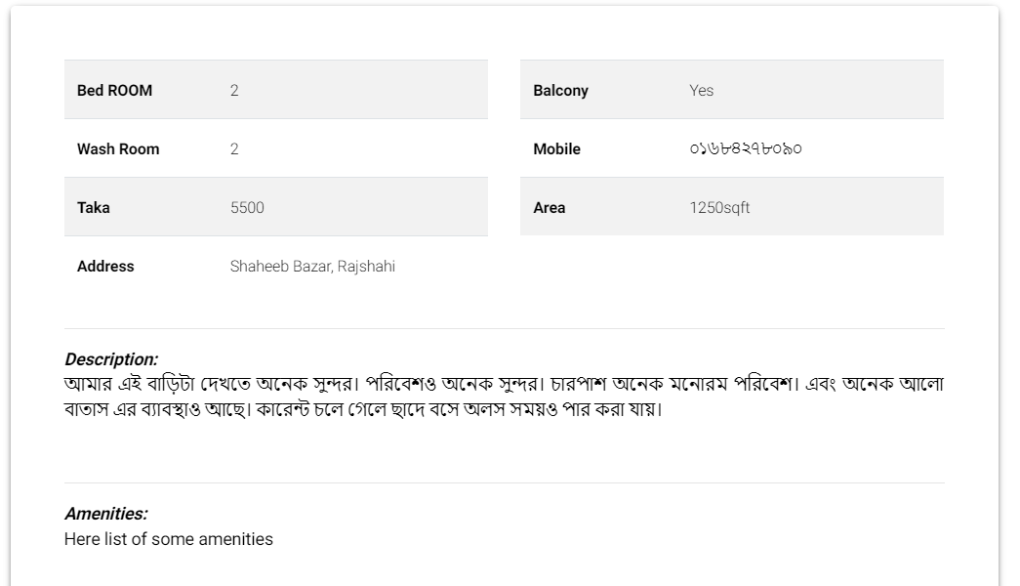 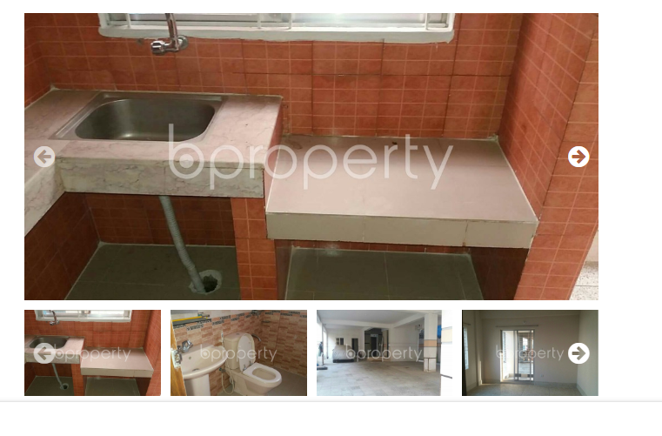**Description of Ads:**

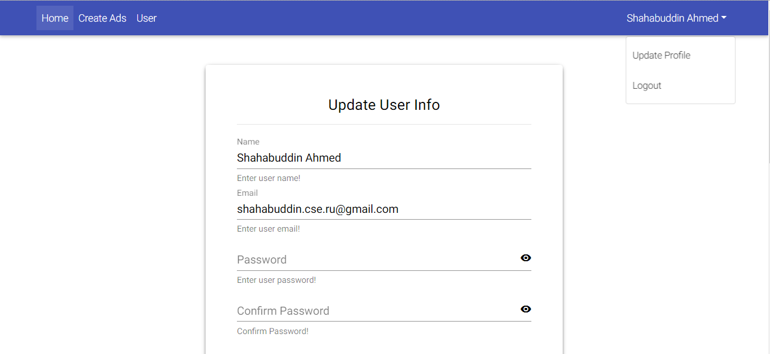**User profile:**

**Admin Profile:**

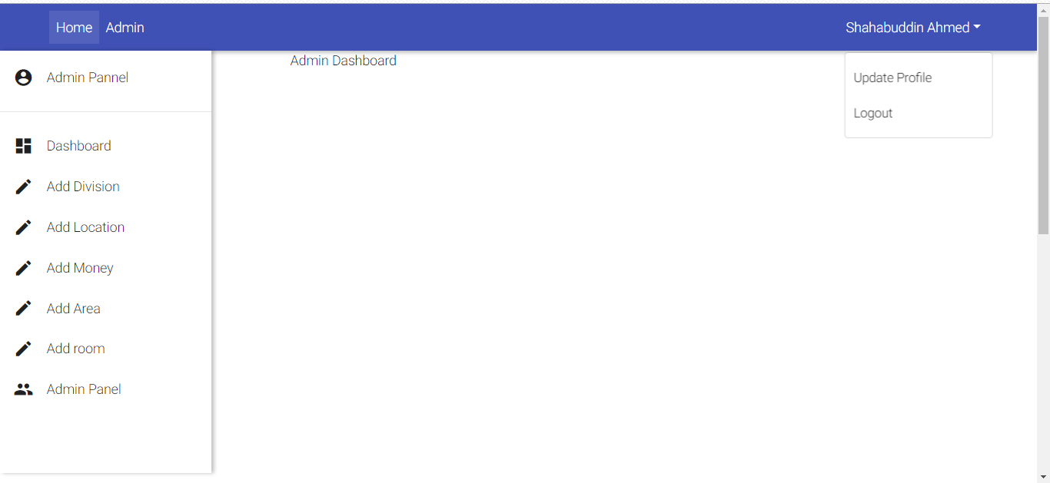 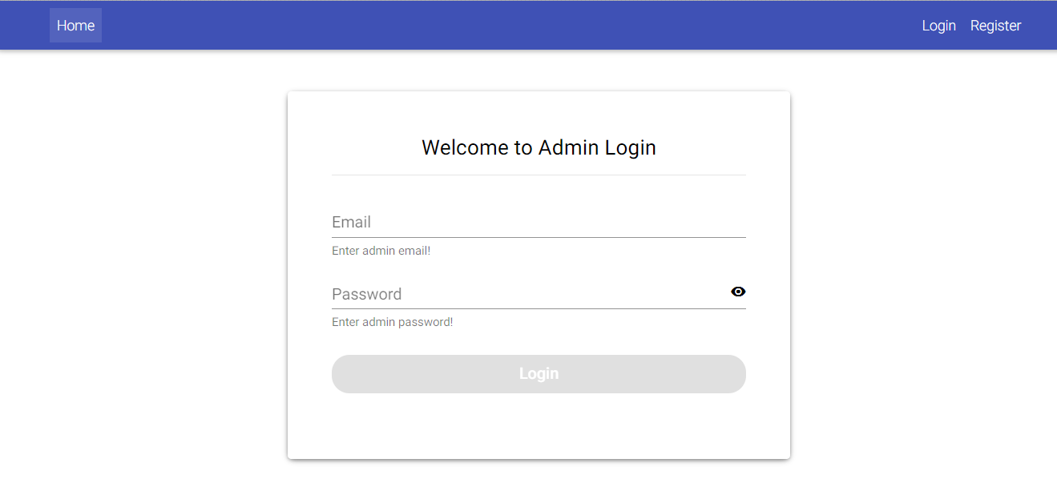**Admin Dashboard:**

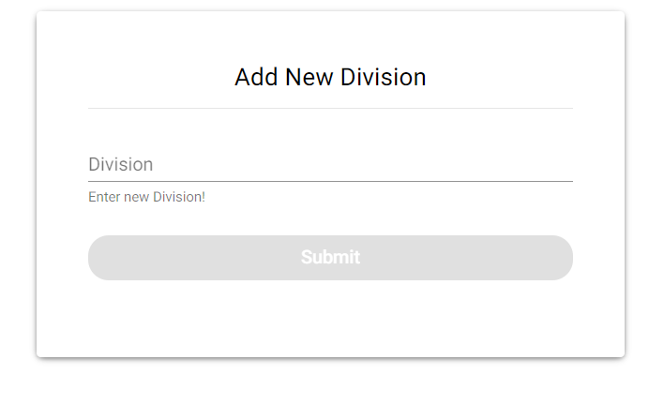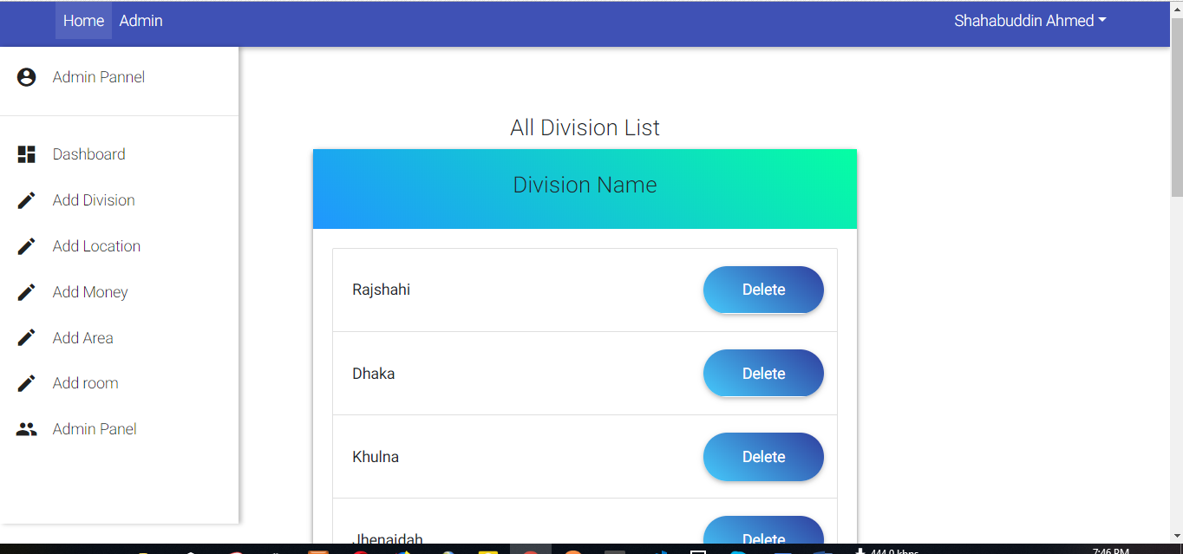**Division Section:**

**Location Section:**

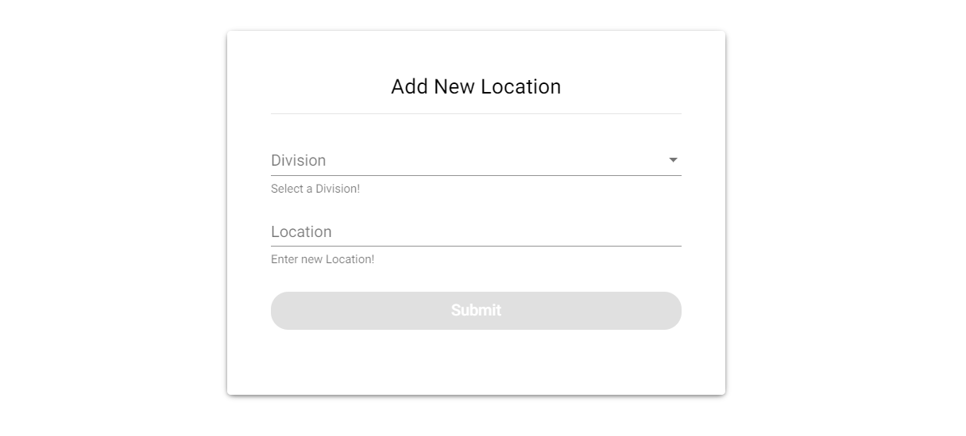 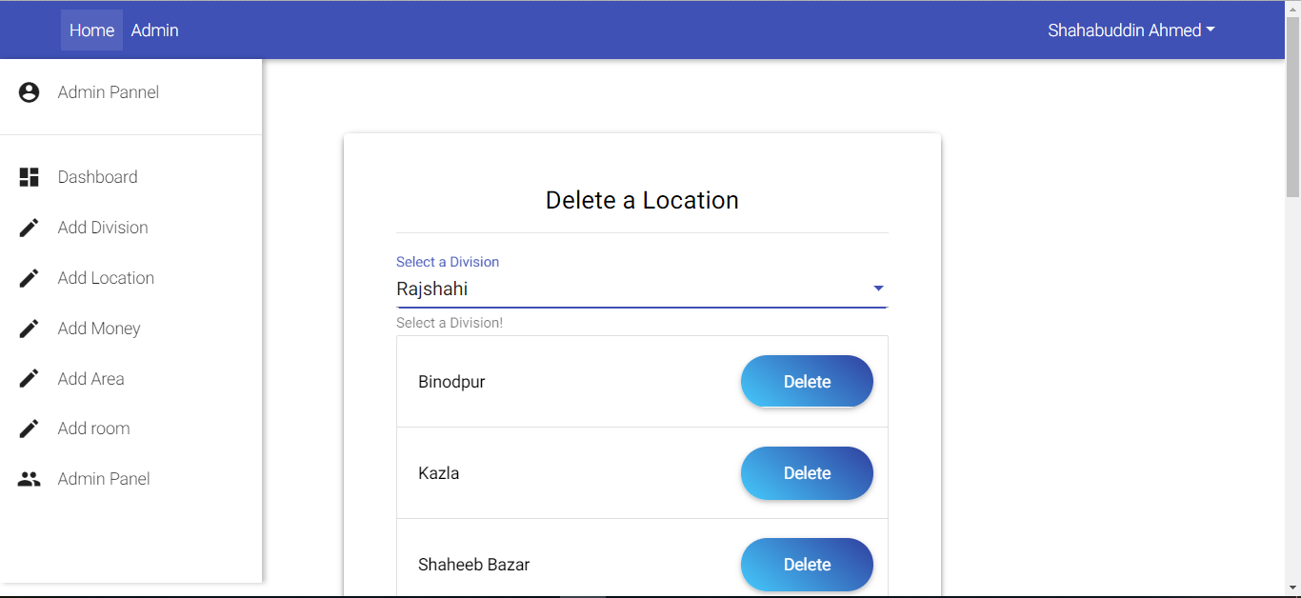

**Money Section:**

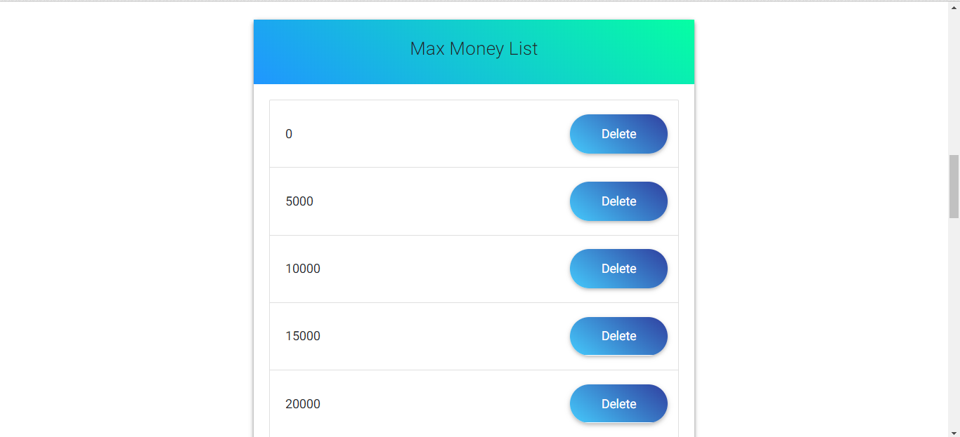 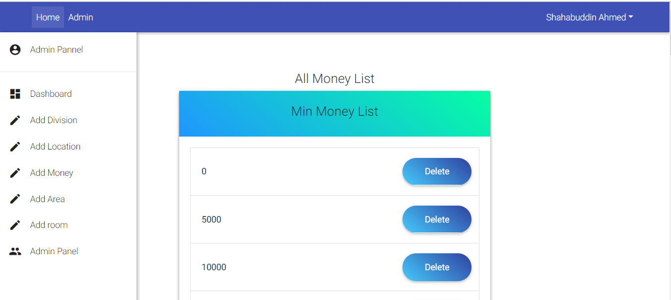

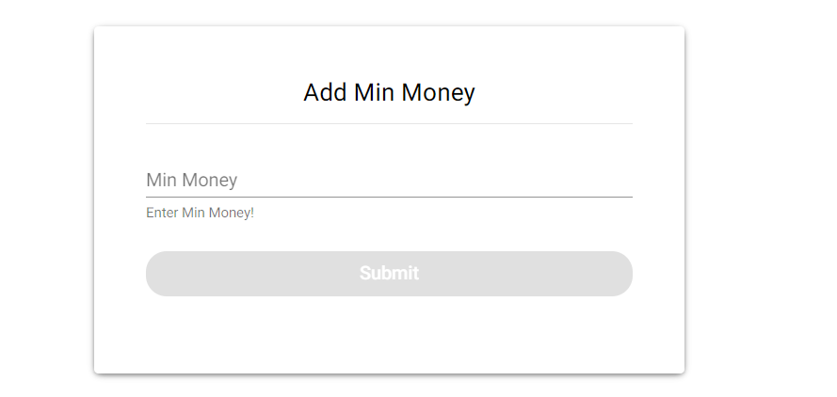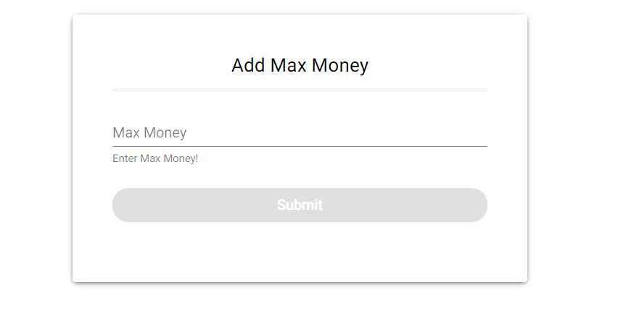

**Room Area:**

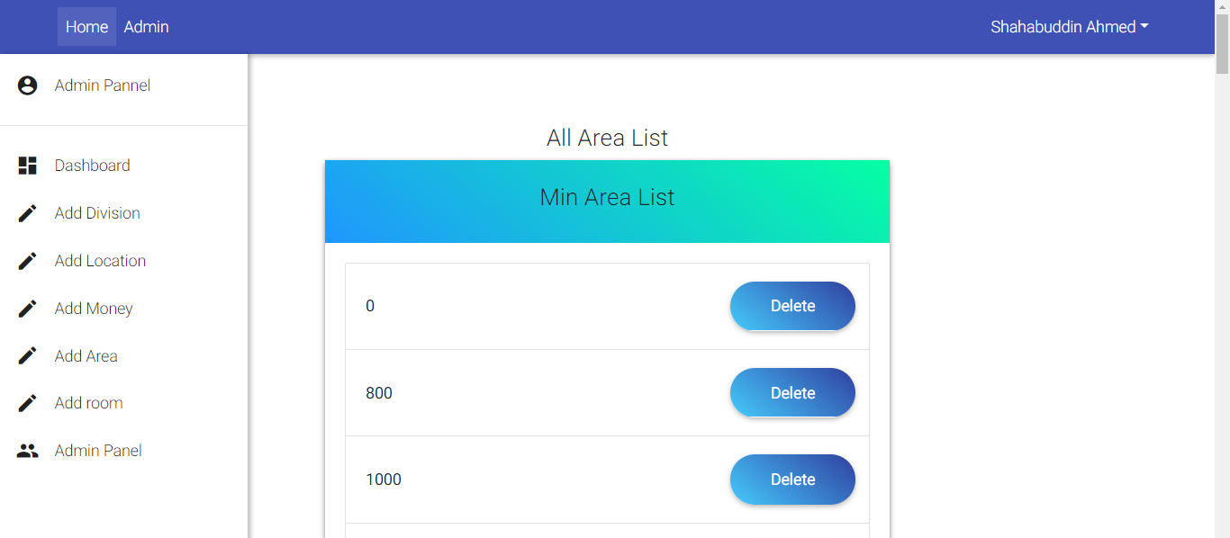

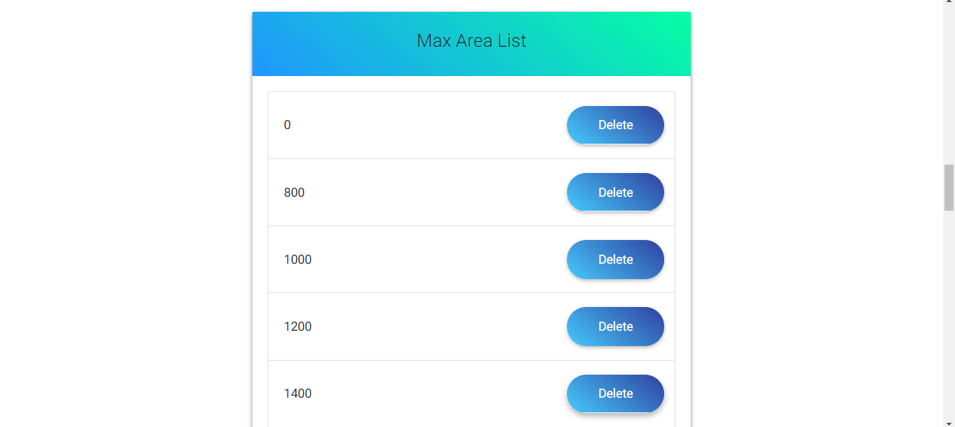

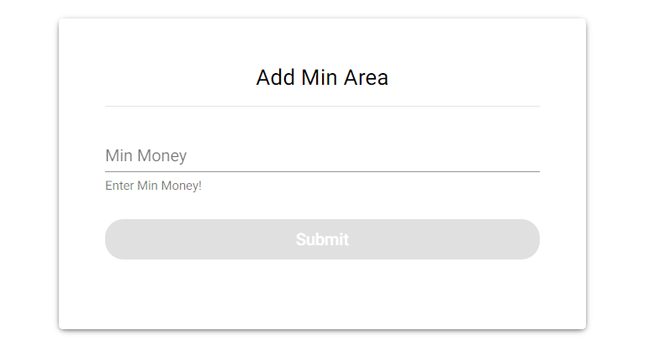

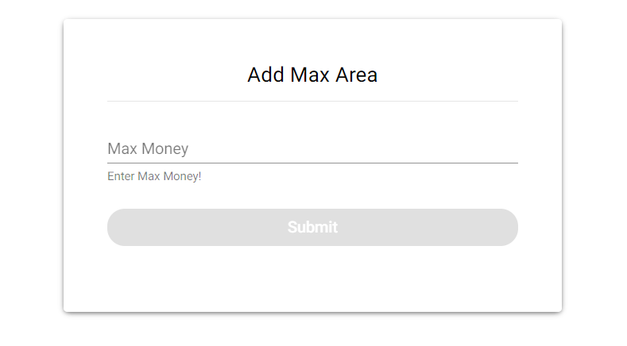

**Room Number:**

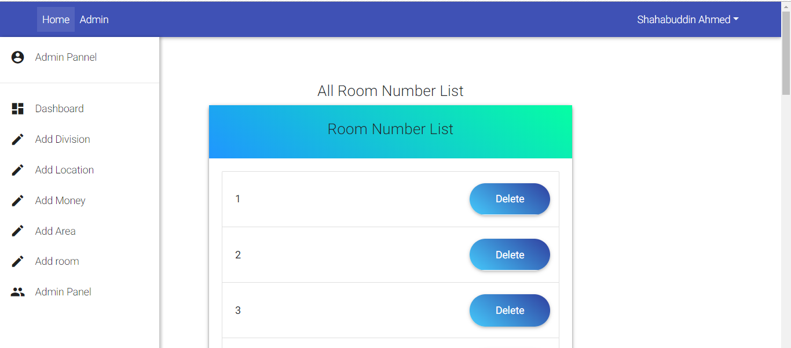

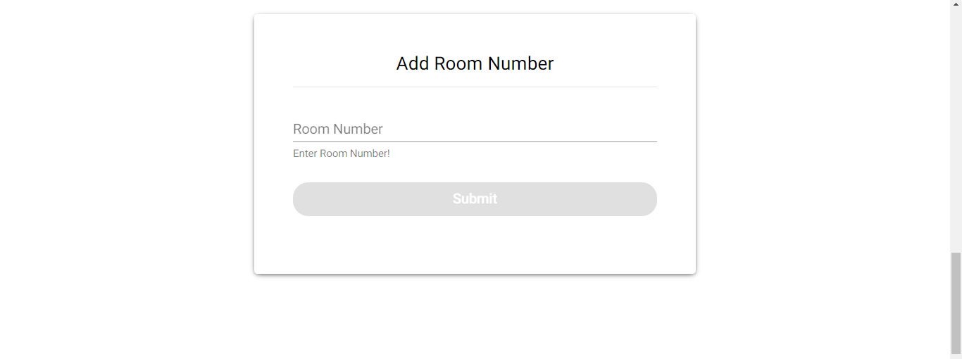

**Admin Panel:**

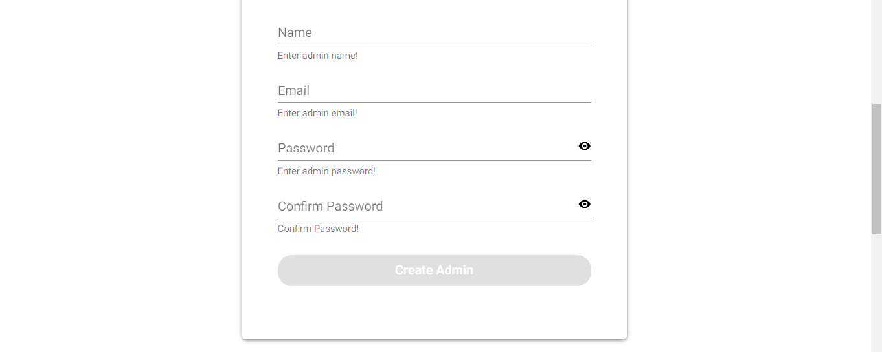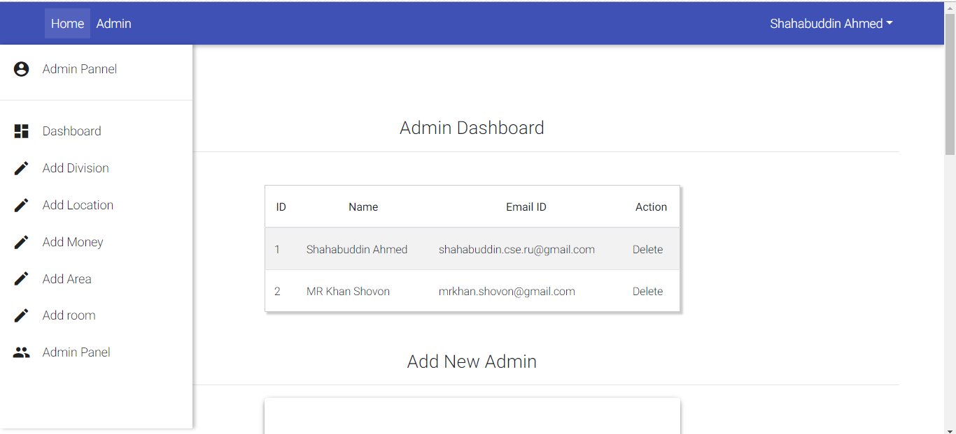

**House Renter Search Section:**

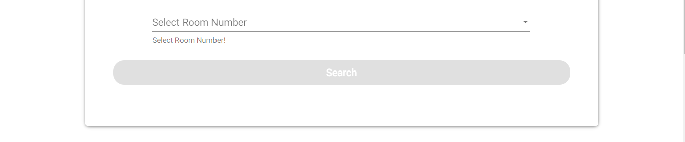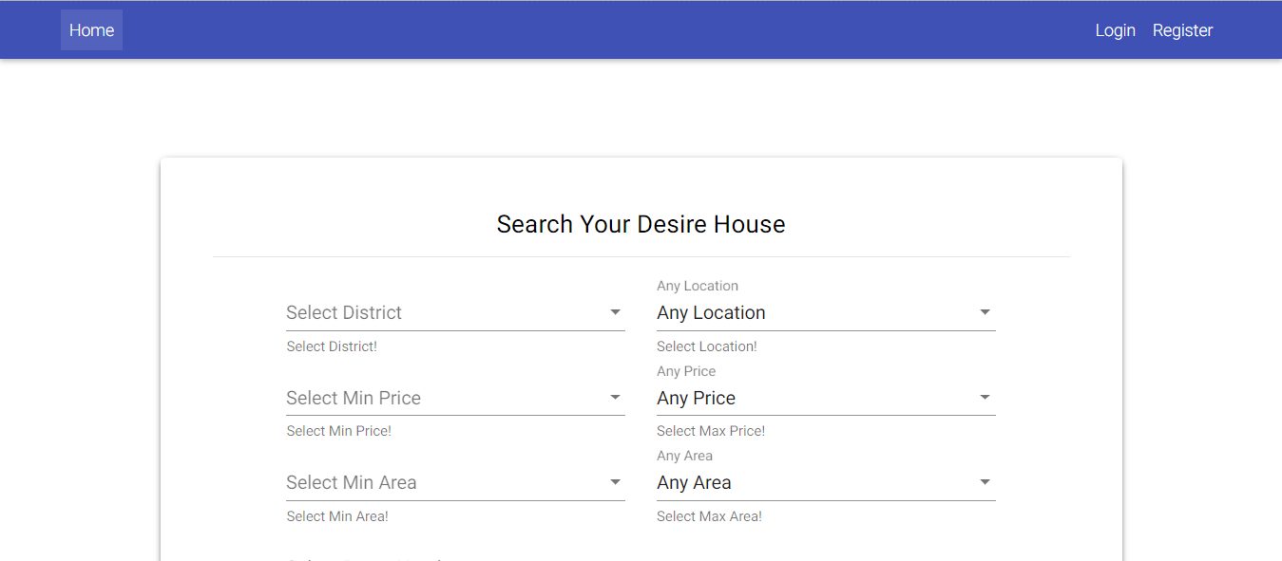

**Search Result:**

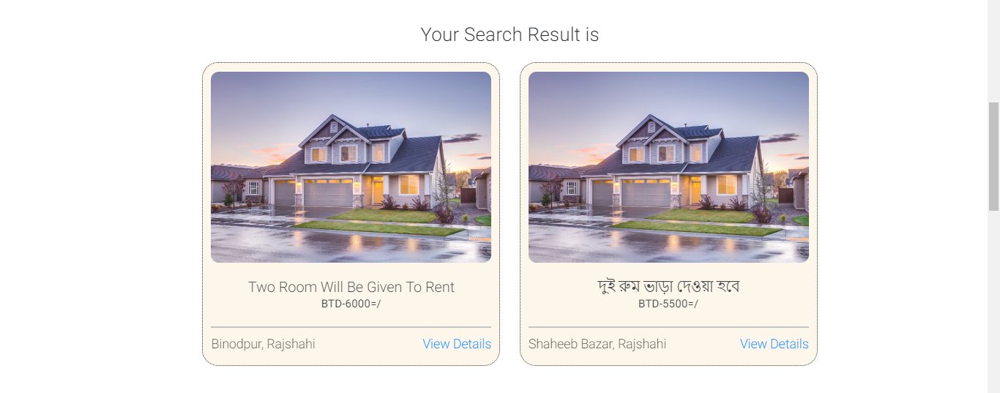

**House Ads:**

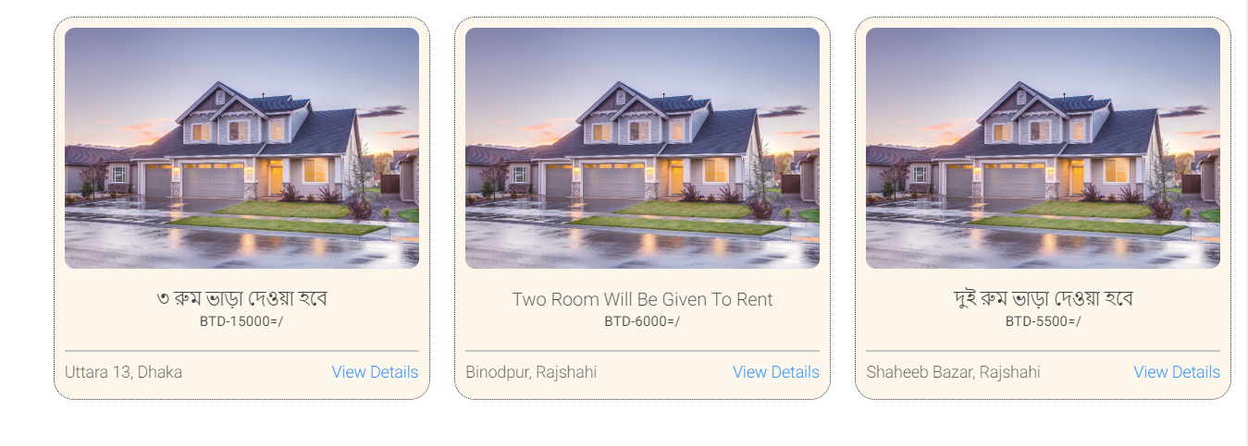

**Details Ads:**

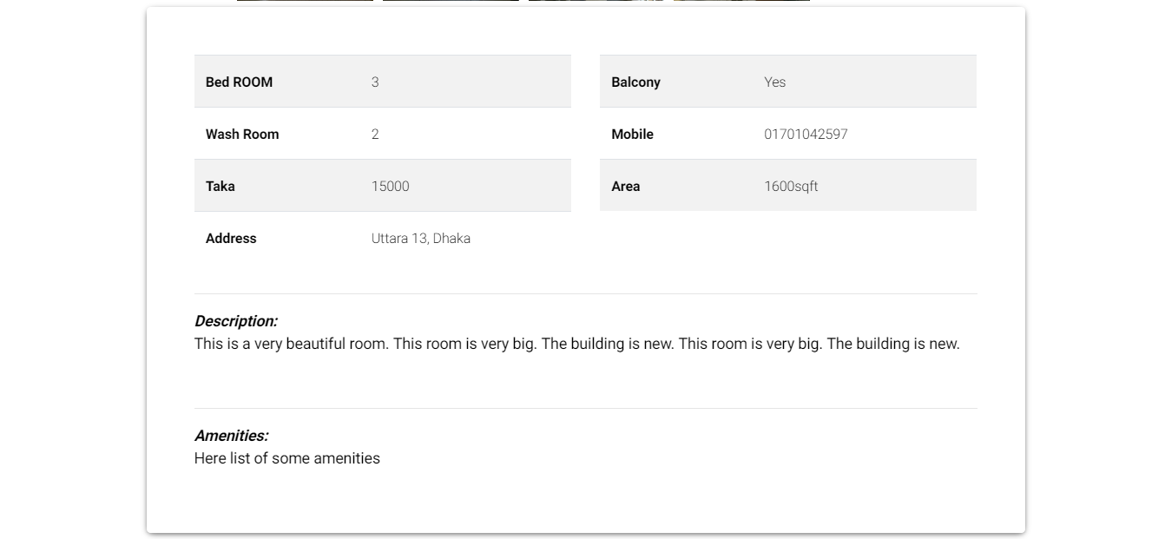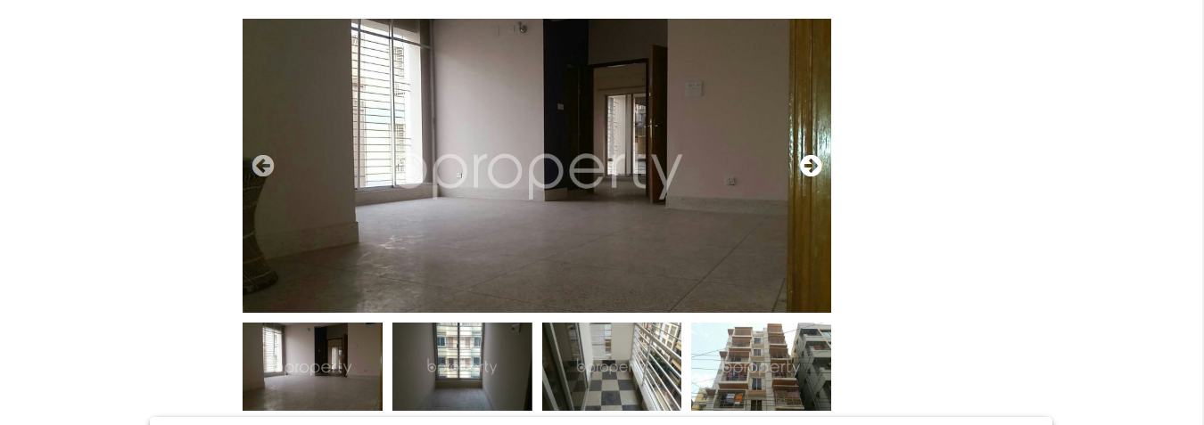

Chapter [5]

*Risk Factor & Management*

**5.1 Risk Factor**

Risk factor is very important in software development. Properly identifying and taking action for those risks to obtain the final result is very crucial work for software development. For HouseRenting our expected risks are listed below. We identify these risks according to study of our project.

* Node.js core is very recent technology. So community help is limited.
* Managing system is challenging.
* Implementing secure transaction is challenging.
* User can input invalid house info.
* User can input invalid images of room.
* User refuse to pay.
* The posted house info does not meet the house description.
* These are the important risks for our project.

**5.2 Risk Management**

Risk management (or more precisely risk avoidance) is a critical topic. Without proper management a good project never develop. Here we list all of our define action and idea about avoiding expected risks. The list is given below.

* Google has very good support for developers.
* Currently Node.js has very good documentation support as well as community support.
* Now a days we have mobile banking services like Bkash, Roket. These are practical and easy to implement for Bangladesh.
* For payment system another tools called Stripe is available for us, which help us for development as well as production.
* Admin panel can remove fraud ads upon user reports as well as monitoring.

These are the important risks for our project

Chapter [6]

*Testing*

**6.1 White Box Testing**

White-box testing is a method of testing the application at the level of the source code. These test cases are derived through the use of the design techniques, data flow testing, branch testing, path testing, statement coverage and decision coverage as well as modified condition/decision coverage.

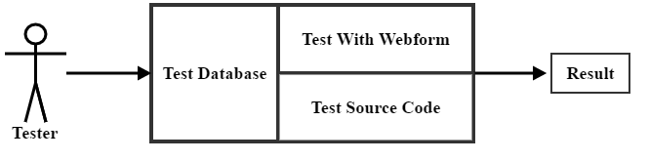

*Block Diagram of White Box Testing*.

* This testing starts in coding phase.
* In this testing tester have knowledge about both product and coding.
* All developers of this project perform this test.
* Here project manager also hire some tester who work exactly similar project for better result.
* Mainly all related tem leader of different part of this project perform this testing.

Thus white box testing will be completed.

**6.2 Black Box Testing**

Black-box testing is a method of software testing that examines the functionality of an application without peering into its internal structures or workings. This testing strategy based on requirements and specification. Here tester only check acceptable result validation. So by this testing all illegality or abnormal behavior of software are eliminate.

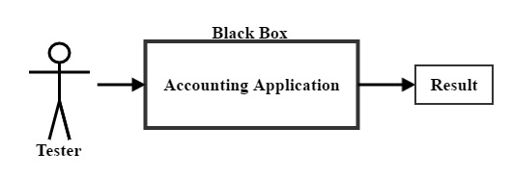

*Block Diagram of Black Box Testing*.

* This testing starts after coding phase.
* In this case tester have no knowledge about the internal data flow, functionality of software. But have a big knowledge about the technology of this project.
* For this purpose we hire some tester who are best skilled in our require technology, and also vast knowledge about our project.

Thus black box testing will be completed.

**6.3 Gray Box Testing**

Gray box testing, also called gray box analysis, is a strategy for software debugging in which the tester has limited knowledge of the internal details of the program. A gray box is a device, program or system whose workings are partially understood. This testing also hold the property of black box and white box. In other word gray box testing is, the join of black box and white box testing.

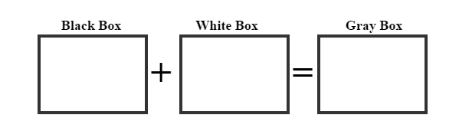

*Block Diagram of Gray Box Testing*.

* This testing starts after black box and white box testing.
* Here tester have limited knowledge about internal flow of product but have enough knowledge about all technologies used in whole project.
* For this purpose project manager hire some person who satisfy previous condition.
* All members who involved in coding phase of this project also perform this test.

Thus gray box testing will be completed.

**6.4 Beta & Security Testing**

**Beta Testing:**

In software development, a beta test is the second phase of software testing in which a sampling of the intended audience tries the product out.This testing also helps to finding runtime errors of a software. Here users enjoy a preliminary version of main project.

* This testing starts after software internally tested.
* Here for this purpose project manager target some mess and implement product there.
* After implementing product a team always observe and collect feedback form user.
* For this project beta testing time will be 1 month.

Thus beta box testing will be completed.

**Security Testing:**

Security testing is a testing technique to determine if an information system protects data and maintains functionality as intended. It also aims at verifying 6 basic principles as listed below

1. Confidentiality
2. Integrity
3. Authentication
4. Authorization
5. Availability
6. Non-repudiation

Chapter [7]

*Conclusion*

**7.1 Expected Outcome**

* Complete business platform.
* A trustworthy web platform for house rent.
* It is reduced time and cost for both renter and advertiser.
* It is help to hurry up to find a house for rent.
* Government and other organizations like Plot organization can use House Renting for easily.

**7.2 References**

* Nodejs.org
* Angular.io
* Expressjs.com
* Mongodb.com
* Mongoosejs.com
* [tutorialspoint.com](http://www.tutorialspoint.com)
* [bproperty.com/](https://www.bproperty.com/)
* [stackoverflow.com/](https://stackoverflow.com/)

|  |  |
| --- | --- |
| *Signature with date*---------------------- | *Signature & date*-------------------------- |
| Shahabuddin Ahmed  Roll: 14095415  Dept. of CSE  Session: 2013-14 | Kazi Jahidur Rahman  Assistant prof.  Dept. of CSE,  University of Rajshahi |