**CAR CONTROLLER**

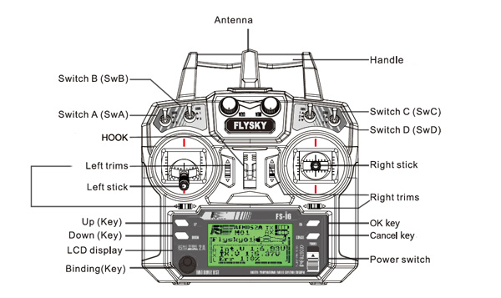

Flysky T6 Transmitter

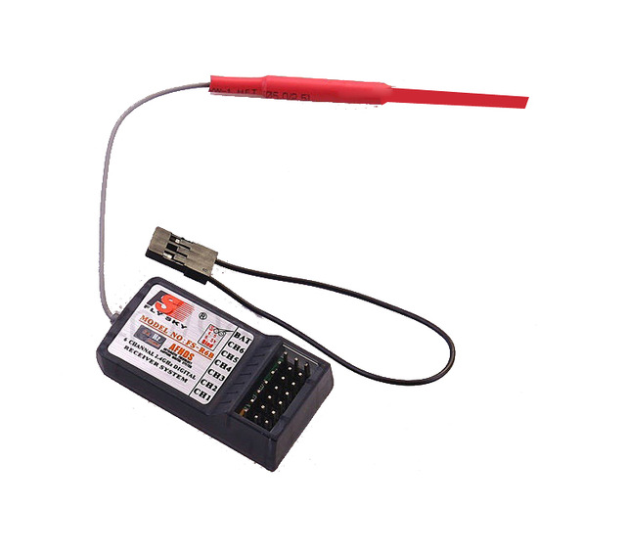

**T6 receiver**

**Connection:**

**Reciever Arduino Mega**

* Channel 1 -------------- 2
* Channel 2 -------------- 3
* Channel 3 -------------- 4
* Channel 4 -------------- 5
* Channel 5 -------------- 6

**Motor Driver Connection:**

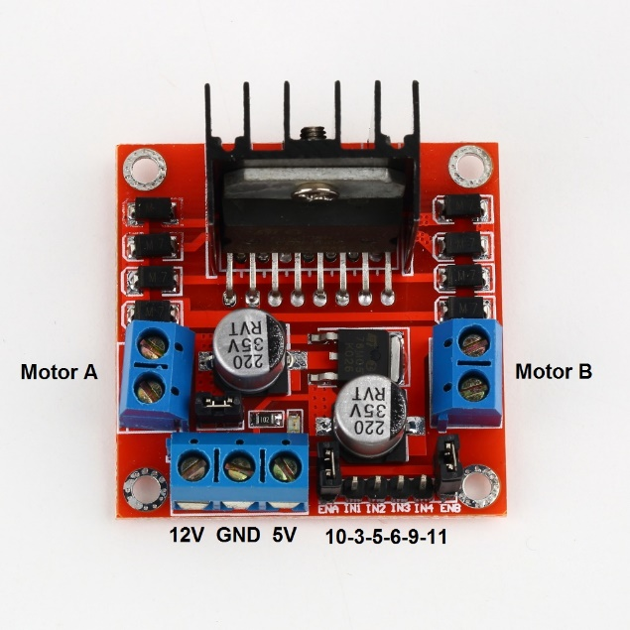

**Motor Driver Arduino Pin**

* Left Motor 1 ------------------- 10
* Left Motor 2 ----------------- 11
* Left Motor Speed ------------- 8
* Right Motor 1 ------------------- 53
* Right Motor 2 ------------------- 51
* Right Motor Speed ------------- 9

**Code:**

Code is included in zip folder