**HC-12 transceiver Connection** 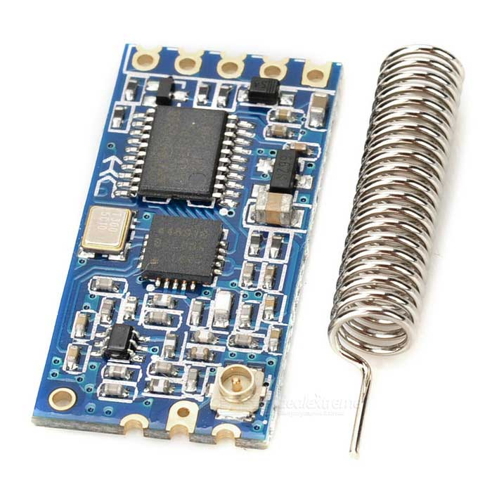

HC-12 transceiver is used to control 3D camera movement and to receive various sensors information simultaneously. The major advantage of this HC-12 module is that it can act as a master and a slave at a time.

**Processing HC-12 Signals:**

Dedicated Arduino Nano is used to process HC-12 signals and to perform various tasks. Camera movement, Sensor data reading are done by this power saving processing unit.

**Connection with Arduino:**

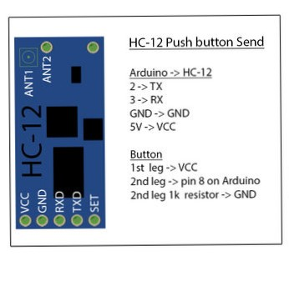

**HC-12 Arduino pin**

* TX -------- 2
* RX --------- 3
* GND -------- GND
* VCC -------- 5V

**Coding:**

Coding is provided with associated folder.