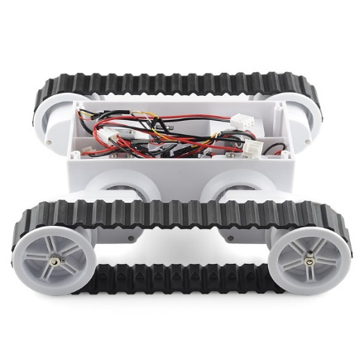

**Highlighted features :**

* Wireless Control over 1 KM
* Real time Camera View
* Can go through rough and tough surface
* Rechargeable long time battery backup
* Sensor Data Transmission

**Materials and Stuff**

* **Processing Unit :**

1. Arduino Mega
2. Arduino Nano

* **Transmission Unit**

1. NRF 24L01 with 2.4 GHz SMD antenna
2. Flysky T6 6 channel wireless controller

* **Sensors :**

1. Temperature Sensor
2. Ormon Thermal Sensor
3. Humidity Sensors
4. Gas Sensors

* **Camera :**

1. Eachine TX02 600TVL FPV camera
2. 5.8 GHz 40 channel transmission
3. Live camera view from Laptop, Monitor, Smartphone

* **Powers and others :**

1. 3400 mAh rechargeable Li-Po battery powered
2. Chain Wheel system
3. 3D camera
4. Emergency Alarm
5. Self defense