



FloraLink Secure E-Commerce Flower Store System

  - Project Full Report

Reem Alshareef 202408960
Shahad Almahmoud 202419900

4th May 2026

(545) Secure Software Development

Dr. Ahmed Alnazer

Abstract
FloraLink is a secure, web-based e-commerce platform designed to facilitate the online sale and delivery of flowers and floral arrangements. This project was developed as part of the SWE 545 Secure Software Development course, with the goal of applying security-by-design principles throughout the full software development lifecycle.
The core problem addressed by this project is the lack of a secure, specialized digital platform for flower retail that effectively protects customer data and financial transactions. FloraLink addresses this gap by providing an integrated system that enables customers to browse products, place orders, and track deliveries, while supporting back-end staff in managing inventory, orders, and delivery operations.
Key results include a fully designed system architecture, high-fidelity UI prototypes, a complete database design, managed logo integration, and a working full-stack authentication prototype. The implemented prototype now demonstrates registration, database-backed login, password reset, strong password validation, and temporary lockout behavior. Verification combined browser-based flow checks with automated backend route tests to confirm that the implemented authentication features behave correctly under valid and invalid inputs.

Table of Contents
Abstract 2
Table of Contents 3
1. Introduction 6
1.1 Background of the System 6
1.2 Problem Statement 6
1.3 Objectives 6
1.4 Scope and Limitations 7
2. Requirements Analysis 8
2.1 Stakeholders 8
2.2 Functional Requirements 8
2.3 Security Requirements 8
2.4 Non-Functional Requirements 9
3. Use Case & Misuse Case Modeling 10
3.1 Use Case Diagram 10
10
3.2 Misuse Case Diagram 11
11
3.3 Use Case Descriptions 12
UC-01: Register Account 12
UC-02: Login 12
UC-03 to UC-22: Additional Use Cases 13
3.4 Misuse Case Descriptions 14
3.5 Mitigation Use Cases 16
4. System Design 18
4.1 System Architecture 18
4.2 UI/UX Design 18
3.2.1. UC-01: Register Account 18
Alternative(s): 19
Below shows the CAPTCHA Challenge and the screen when the CAPTCHA failed. 21
3.2.2. UC-02: Login 21
The main flow of Login Form is shown in the screen below. 22
Alternative(s): 22
Pre-Lockout Warning (4th Failed Attempt) screen shows below. 24
3.2.3. UC-11: Checkout 24
Alternative(s): 25
3.2.4. UC-12: Make Payment 28
Alternative(s): 29
4.3 Database Design (ERD) 30
3.3.1: Key Legend 30
3.3.2: Entities Overview 30
3.3.3: Entity Specifications 31
3.2.4: Relationship Summary 35
3.2.5: Entity Relationship Diagram (ERD) 36
3.4 Traceability: Use Cases to Database Entities 37
4.4 Sequence / Activity Diagrams 38
5. Security Design & Controls 39
5.1 Authentication & Authorization 39
5.2 Input Validation 39
5.3 Encryption 39
5.4 Logging and Monitoring 39
5.5 Mitigation Mechanisms 39
6. Implementation 41
6.1 Technologies Used 41
6.2 Implemented Modules 41
6.3 Screenshots of System 42
7. Testing Strategy 43
7.1 Testing Approach 43
7.2 Test Plan 43
7.3 Testing Environment 43
7.4 Tools Used 43
8. Test Cases 44
8.1 Registration Module (UC-01) 44
8.2 Login Module (UC-02) 44
8.3 Strong Authentication (MIT-01) 45
8.4 Rate Limiting & Account Lockout (MIT-02) 46
9. Testing Results & Analysis 47
9.1 Summary of Testing Results 47
9.2 Identified Issues and Vulnerabilities 47
9.3 Security Testing Results 48
9.4 Fixes and Mitigations Applied 48
9.5 Discussion of Results 48
10. Challenges & Lessons Learned 49
10.1 Technical Challenges 49
10.2 Security Challenges 49
10.3 Solutions 49
11. Conclusion 51
11.1 Summary of Achievements 51
11.2 Project Outcomes 51
11.3 Future Work 51
12. References 52
13. Appendices 53
Appendix A: Detailed Test Logs 53
Appendix B: Additional Screenshots 53
Appendix C: Misuse Case to Mitigation Mapping 53

1. Introduction

1.1 Background of the System
With the increasing reliance on e-commerce platforms, there is a significant opportunity to create a specialized and reliable service for selling flowers online. The local market lacks a platform that combines high-quality flower arrangements with an excellent digital shopping experience. The FloraLink project fulfills this need by providing an integrated technical solution that focuses on security, ease of use, and customer satisfaction.
A web customer uses the proposed application to browse and purchase various flower arrangements. In order to complete a purchase, a customer must register with the system and provide personal and financial details. Customers can view products, add them to a shopping cart, proceed to checkout, and track orders through all stages of preparation and delivery.

1.2 Problem Statement
Existing online flower-retail platforms often fail to implement adequate security controls, leaving customer personal data and financial transactions vulnerable to a range of cyber threats including credential-based attacks, injection vulnerabilities, payment fraud, and insider misuse. There is a clear need for a platform that embeds security directly into its design from the earliest stages of development.

1.3 Objectives
- Design and develop a secure and reliable system for processing customer orders and financial transactions while ensuring data privacy and protection.
- Provide a seamless and enjoyable user experience that encourages repeat purchases and builds customer loyalty.
- Comply with data privacy and security requirements to protect customer information and maintain trust in the platform.
- Create an efficient back-end management system for staff to manage products, inventory, orders, and deliveries.
- Implement robust security features to prevent fraud, cyber-attacks, and unauthorized access to sensitive data.
- Enable real-time order tracking so customers can monitor the status of their orders from preparation to delivery.

1.4 Scope and Limitations
The FloraLink system covers the complete e-commerce workflow for flower retail: account management, product browsing, cart operations, checkout, payment processing, order tracking, delivery management, and administrative control. The system is designed for web-based access using client-server architecture.
Limitations include: the project is developed within a limited academic timeline; the current version is a prototype intended to demonstrate secure software development concepts rather than a full production solution; a simulated payment gateway is used instead of real banking systems due to security and cost constraints; and no persistent database is used in the implementation phase, which relies instead on in-memory state for demonstration purposes.

2. Requirements Analysis

2.1 Stakeholders
Stakeholder | Role / Interest
Customers | Register/login, browse products, add to cart/wishlist, checkout, choose pickup/delivery time, track order.
FloraLink Management Company | Revenue, customer satisfaction, operational efficiency.
Florists / Staff Team | View incoming orders, prepare arrangements, and update order status.
System Administrators | Manage users/roles, monitor logs, handle security settings, manage availability and incident response.
Bank / Financial Institutions | Approve/reject transactions, return verification response, post transaction status.
Flower Suppliers | Update stock availability and confirm supply orders.
Delivery Team | Accept delivery task, update delivery status, report issues.
Competitors | Market pressure influencing strategy (indirect stakeholder).

2.2 Functional Requirements
The system identifies 22 functional use cases across seven actor groups, covering account management (UC-01 to UC-04), product interaction (UC-05 to UC-10), order processing (UC-11 to UC-15), staff operations (UC-16 to UC-18), delivery management (UC-19 to UC-20), and administration (UC-21 to UC-22). Full use case descriptions are provided in Section 3.

2.3 Security Requirements
Security requirements were derived through structured threat analysis resulting in 12 misuse cases and 13 mitigation controls. The key security requirements are:
- Authentication: Strong password hashing and token-based session management.
- Authorization: Role-Based Access Control (RBAC) with least privilege and object-level authorization.
- Confidentiality: HTTPS/TLS encryption for all data in transit; masking of sensitive data in the UI.
- Integrity: Server-side input validation and parameterized queries to prevent injection.
- Availability: Rate limiting on critical endpoints and monitoring for abnormal request patterns.
- Audit Logging: Tamper-protected logs for all critical system actions.
- Error Handling: Generic error messages to prevent information leakage.

2.4 Non-Functional Requirements
- Performance: The system should respond to standard user requests within acceptable latency under normal load.
- Usability: The interface should be intuitive and accessible on both desktop and mobile browsers.
- Scalability: The architecture should support increasing numbers of concurrent users.
- Maintainability: Code should be modular and well-documented to allow future extension.
- Compliance: The system design adheres to data protection best practices and PCI-DSS guidelines for payment handling.

3. Use Case & Misuse Case Modeling

2.1 Executive Summary
This section presents the Software Requirements Specification (SRS) for the FloraLink Secure Flower Store System. The primary objective of this phase is to define the system at a high level from both functional and security perspectives.
The system model identifies 7 actors interacting with the platform and defines 22 functional use cases that cover the complete e-commerce workflow, including account management, product browsing, cart operations, checkout, payment processing, order tracking, delivery management, and administrative control.
To incorporate security-by-design principles, a structured threat analysis was conducted. This resulted in the identification of 12 major misuse cases, representing potential external and insider threats such as authentication attacks, payment fraud, injection attacks, session-based attacks, denial of service, and operational abuse. To mitigate these risks, 13 dedicated security controls (mitigating use cases) were specified.
Overall, this phase establishes a secure architectural foundation by defining 22 functional requirements, 12 security threats, and 13 mitigation controls, ensuring that security is systematically integrated into the FloraLink System from the requirements stage.
Part A: Use Case Model

2.2 Use Case Model

2.2.1 Actors
The following table lists all actors in the FloraLink System with simple descriptions.
Actor | Description
Guest Visitor | An unauthenticated user browsing the site.
Customer | An authenticated user who can make purchases and manage their account.
Bank/Financial Institution | An external entity that processes credit card and Mada transactions.
Florist/Staff | An employee responsible for managing orders, products, and inventory.
Delivery Team | Personnel responsible for delivering orders to customers.
System Admin | A privileged user responsible for managing system settings, users, and monitoring.
Notification Service | An external system that sends order confirmations, status updates, and security alerts to customers through email or SMS.
Table ‎0-1 Actors

2.2.2 Use Case Descriptions

Table ‎0-2 UC-01: Register Account
ID | UC-01
Name | Register Account
Description | Allows a guest visitor to create a new customer account.
Actors | Guest Visitor
Main Flow | - The guest visitor clicks the "Register" button.  - The system displays a registration form asking for name, email, password, and phone number.  - The visitor fills out the form and submits it.  - The system validates the input, creates a new customer ID/account, and hashes the password.  - The system logs the user in and redirects them to the homepage as a customer.
Alternatives | A1: Email already exists:  - Guest submits registration form.  - System checks email uniqueness.  - System detects email already registered.  - System shows error “Email already exists” and provides Login link.  A2: Invalid input:  - Guest submits form with invalid fields.  - System validates fields (email format, password strength, required fields).  - System highlights invalid fields and shows validation messages.  - Guest corrects inputs and resubmits.

Table ‎0-3 UC-02: Login
ID | UC-02
Name | Login
Description | Allows a registered user to log into their account.
Actors | Customer, System Admin, Florist/Staff, Delivery Team
Main Flow | - The user navigates to the "Login" page.  - The user enters their email and password.  - The user clicks the "Login" button.  - The system verifies the credentials against the stored hashed password.  - Upon success, the system creates a session and redirects the user to the user’s dashboard.
Alternatives | A1: Invalid credentials  - The user enters an incorrect email and/or password.  - The user clicks the “Login” button.  - The system fails to match the credentials with the stored hashed password.  - The system displays a generic error message (e.g., “Invalid email or password”).  - The system allows the customer to retry login.  A2: Account locked  - The user enters email and password and clicks “Login”.  - The system checks the account status and detects it is locked.  - The system denies access and does not create a session.  - The system displays a message that the account is locked.  - The system provides unlocking instructions (e.g., wait X minutes).

Table ‎0-4 UC-03: Logout
ID | UC-03
Name | Logout
Description | Allows a logged-in user to securely log out of their account.
Actors | Customer, System Admin, Florist/Staff, Delivery Team
Main Flow | - The user clicks the "Logout" button.  - The system destroys the user's session on the server side.  - The system redirects the user to the homepage as a visitor.
Alternatives | A1: Session already expired  - The user clicks the “Logout” button.  - The system detects there is no active session (already expired or timed out).  - The system redirects the customer to the homepage as a visitor.  - The system displays an informational message (e.g., “You are already logged out.”)

UC-04: Manage Profile
ID | UC-04
Name | Manage Profile
Description | Allows the user to view and update their personal information, such as addresses and phone numbers.
Actors | User
Main Flow | - The user navigates to their "My Profile" page.  - The system displays the user's current information.  - The user clicks "Edit" on the section they wish to change.  - The user updates the information and saves the changes.  - The system validates the new information and updates the customer's record in the database.
Alternatives | A1: Invalid input  - The user edits profile information and clicks “Save”.  - The system validates the input  - The system detects invalid/missing information.  - The system rejects the update and highlights incorrect fields with error messages.  - The user corrects the data and resubmits.

UC-05: Browse Product Catalog
ID | UC-05
Name | Browse Product Catalog
Description | Allows any user to browse the catalog of available flower products.
Actors | Guest Visitor, Customer
Main Flow | - The user navigates to the "Products" page.  - The system displays a grid of products, showing a primary image, name, and price for each.  - The user can sort the products or filter by category.  - The user clicks on a product to view more details (triggers UC-07).
Alternatives | A1: Empty category  - The user applies a category filter  - The system searches the catalog with the selected filters.  - The system finds no matching products.  - The system displays “No products found” message.  - The system provides options to clear filters or browse all products.

UC-06: Search Products
ID | UC-06
Name | Search Products
Description | Allows any user to search for specific products using keywords.
Actors | Guest Visitor, Customer
Main Flow | - The user types a search term into the search bar.  - The user presses Enter or clicks the search icon.  - The system queries the product database for names and descriptions matching the search term.  - The system displays a list of matching products.
Alternatives | A1: No results found  - The user types a search term into the search bar.  - The user presses Enter or clicks the search icon.  - The system queries the product database for names and descriptions matching the search term.  - The system finds no matching products.  - The system displays a “No results found” message.

UC-07: View Product Details
ID | UC-07
Name | View Product Details
Description | Allows a user to view detailed information about a single product.
Actors | Guest Visitor, Customer
Main Flow | - The user selects a product from the catalog (UC-05) or search results (UC-06).  - The system displays the product detail page, showing the product name, images, description, price, and an "Add to Cart" button.
Alternatives | A1: Product is out of stock:  - The user selects a product from the catalog (UC-05) or search results (UC-06).  - The system checks the product’s current stock level.  - The system detects that the product is out of stock.  - The system displays an “Out of Stock” message.  - The system disables the “Add to Cart” button

UC-08: Add Item to Cart
ID | UC-08
Name | Add Item to Cart
Description | Allows a user to add a product to their shopping cart.
Actors | Guest Visitor, Customer
Main Flow | - On a product detail page (UC-07), the user clicks the "Add to Cart" button.  - The system adds the selected product and its quantity to the user's shopping cart.  - The system displays a confirmation message showing the item has been added.
Alternatives | A1: Item out of stock  - The user clicks "Add to Cart" on a product detail page.  - The system checks the current stock level of the selected product.  - The system detects the item is out of stock.  - The system does not add the item to the cart.  - The system displays an "Out of Stock" message and disables the "Add to Cart" button.

UC-09: Update/Remove Cart Items
ID | UC-09
Name | Update/Remove Cart Items
Description | Allows a user to change the quantity of items in their shopping cart or remove items completely.
Actors | Guest Visitor, Customer
Main Flow | - The system retrieves and displays all items currently in the cart, including their quantity, unit price, and subtotal.  - The user selects an item and updates its quantity or clicks the “Remove” button.  - The system validates the requested modification (e.g., quantity is valid and within available stock).  - The system updates the cart accordingly.  - The system recalculates and displays the updated cart totals.
Alternatives | A1: Quantity set to zero  - The user changes the quantity of an item to 0.  - The system interprets the quantity value of 0 as a removal request.  - The system removes the item from the cart.

UC-10: Add Wishlist Items
ID | UC-10
Name | Add Wishlist Items
Description | Allows a logged-in customer to add products to a personal wishlist for future reference.
Actors | Customer
Main Flow | - The customer views a product from the catalog (UC-05)  - The customer clicks the “Add to Wishlist” button.  - The system verifies that the customer is authenticated  - The system stores the selected product in the customer’s wishlist.  - The system updates the interface to indicate the item has been added (e.g., button changes to “In Wishlist”).
Alternatives | A1: Remove from Wishlist  - The customer navigates to the “Wishlist” page.  - The system displays all saved wishlist items.  - The customer selects an item and clicks the “Remove” button.  - The system deletes the item from the wishlist.  - The system refreshes the wishlist page to reflect the change.

UC-11: Checkout
ID | UC-11
Name | Checkout
Description | Allows a customer to initiate the checkout process by providing delivery details and selecting a time slot.
Actors | Customer
Main Flow | - The customer clicks the “Checkout” button from the shopping cart.  - The system prompts the customer to confirm/select a delivery address.  - The customer selects/confirms the address.  - The system displays available delivery time slots.  - The customer selects a preferred time slot.  - The customer proceeds to the payment step (UC-12).
Alternatives | A1: User not logged in:  - User clicks “Checkout”.  - System detects user not authenticated.  - System prompts login (UC-02) or register (UC-01).  - After login/register, system returns user to checkout step.  A2: Cart is empty  - The user clicks “Checkout”.  - The system detects the cart is empty.  - The system displays a message: “Your cart is empty.”  - The system prevents the user from continuing.

UC-12: Make Payment
ID | UC-12
Name | Make Payment
Description | Allows the customer to securely pay for their order using a credit card or Mada through an external payment gateway.
Actors | Customer, Bank/Financial Institutions
Main Flow | - After confirming the order (UC-11), the customer selects a payment method.  - The system redirects the customer to the secure payment gateway page.  - The customer enters their card details.  - The payment gateway processes the payment.  - The payment gateway sends a success response to the system.  - The system marks the order as “Paid” and displays the order confirmation page.
Alternatives | A1: Payment Declined  - The customer enters payment details.  - The payment gateway processes the transaction.  - The payment is declined.  - The system displays a “Payment Failed” message.  - The customer can try again or choose another payment method.  A2: Payment Gateway Timeout  - The customer submits payment details.  - The system does not receive a response from the gateway.  - The system displays a message that payment could not be processed.  - The customer is asked to try again.

UC-13: Receive Notifications
ID | UC-13
Name | Receive Notifications
Description | The system sends notifications (Email/SMS) for order confirmation, status updates, and security alerts.
Actors | Customer, Notification Service
Main Flow | - A triggering event occurs (order placed/payment/status update).  - The system sends the notification to the external Notification Service.  - The Notification Service delivers the message to the customer (Email/SMS).  - The system logs the notification status.
Alternatives | A1: Notification delivery fails  - The system sends the notification to the external Notification Service.  - The Notification Service fails to deliver the message.  - The system records the failure.  - The system may retry sending the notification.

UC-14: Track Order Status
ID | UC-14
Name | Track Order Status
Description | Allows a customer to view the real-time status of their current and past orders.
Actors | Customer
Main Flow | - The customer logs in and navigates to the "My Orders" page.  - The system displays a list of customers’ orders.  - Each order entry shows the Order ID, date, total amount, and status.  - The customer can click on an order to see more detailed tracking information.
Alternatives | A1: No orders placed  - The customer navigates to the “My Orders” page.  - The system checks the customer’s order history.  - The system finds no orders.  - The system displays a message such as “You have no orders yet.”  - The system provides a link to browse products.

UC-15: Cancel Order
ID | UC-15
Name | Cancel Order
Description | Allows a customer to cancel an order if it has not yet been prepared.
Actors | Customer
Main Flow | - The customer navigates to the “My Orders” page (UC-14).  - The customer selects an order that is in “New” or “In Preparation” status.  - The customer clicks the “Cancel Order” button.  - The system confirms the cancellation request and updates the order status to “Cancelled”.  - The system initiates the refund process through the Payment Gateway (if payment was already made).
Alternatives | A1: Cancellation not allowed:  - The customer selects an order.  - The system detects that the order status is “Out for Delivery” or “Delivered”.  - The system disables the “Cancel Order” button.  - The system displays a message that cancellation is not allowed.

UC-16: View Incoming Orders
ID | UC-16
Name | View Incoming Orders
Description | Allows the florist/staff to view a list of new and ongoing customer orders to begin processing.
Actors | Florist/Staff
Main Flow | 1. The staff member logs into the system.  2. The staff member navigates to the Orders dashboard.  3. The system displays a list of all incoming and in-progress orders, sorted by order time (newest first).  4. The list includes key details: Order ID, Customer Name, Order Date, and Status.
Alternatives | A1: No new orders  - Staff opens Orders dashboard.  - System finds no incoming/in-progress orders.  - System displays “No new orders”.  - Staff may refresh later.  A2: System error retrieving orders  - Staff opens dashboard.  - System cannot fetch orders (DB/API error).  - System shows generic error message.  - System logs error for admin review and allows retry.

UC-17: Update Preparation Status
ID | UC-17
Name | Update Preparation Status
Description | Enables the florist/staff to update the status of an order as they prepare it for delivery.
Actors | Florist/Staff
Main Flow | 1. The staff member selects an order from the incoming orders list (UC-16).  2. The system displays the full details of the order, including items and customer specifications.  3. The staff member gathers and arranges the products for the order.  4. Once the order is ready for dispatch, the staff member updates the order status to "Ready for Delivery".  5. The system saves the new status and notifies the Delivery Team that a new task is available.
Alternatives | A1: Item out of stock  - Staff opens order details.  - Staff checks inventory for requested items.  - Item missing/insufficient.  - Staff sets order status = “On Hold”.  - Staff contacts customer for substitution/approval.  A2: Invalid order selected  - Staff selects an order ID.  - System cannot find order / order deleted.  - System displays “Order not found”.  - Staff returns to orders list.  A3: Staff attempts invalid status transition  - Staff tries to set status to “Ready for Delivery”.  - System checks order completeness requirements.  - System detects missing info (e.g., address not confirmed).  - System blocks status update and prompts staff to resolve missing fields.

UC-18: Manage Products and Inventory
ID | UC-18
Name | Manage Products and Inventory
Description | Allows the florist/staff to add, edit, deactivate products, and update stock levels.
Actors | Florist/Staff
Main Flow | - The staff member navigates to the Product Management page.  - The system displays a list of products with their details and stock levels.  - The staff member chooses to add, edit, deactivate a product, or update stock quantity.  - The staff member submits the form changes.  - The system validates the input and updates the database.
Alternatives | A1: Edit product  - Staff selects existing product.  - System displays edit form with current data.  - Staff updates fields and saves.  - System validates and updates product.  A2: Deactivate product  - Staff selects product.  - Staff chooses “Deactivate”.  - System marks product inactive.  - Product disappears from public catalog but remains in admin records.  A3: Invalid input  - Staff submits form with invalid data.  - System validates fields.  - System rejects submission and shows error messages.  - Staff corrects and resubmits.

UC-19: Accept Delivery Task
ID | UC-19
Name | Accept Delivery Task
Description | Allows a member of the delivery team to accept an order that is ready for delivery.
Actors | Delivery Team
Main Flow | - A delivery team member logs into the delivery portal.  - The system displays a list of available delivery tasks (orders with status "Ready for Delivery").  - The team member selects and accepts a delivery task.  - The system assigns the order to the team member and updates the order status to "Out for Delivery".  - The system sends a notification to the customer that their order is on its way.
Alternatives | A1: No available tasks  - Delivery member opens tasks list.  - System finds no “Ready for Delivery” orders.  - System displays “No tasks available”.  - Member refreshes later.  A2: Task already taken  - Delivery member selects a task.  - System detects task assigned to another member moments ago.  - System displays “Task already taken”.  - System refreshes tasks list.  A3: Delivery member not authorized  - Delivery member attempts to accept task.  - System checks role/permissions.  - System denies action if role invalid.  - System logs event for admin review.

UC-20: Update Delivery Status
ID | UC-20
Name | Update Delivery Status
Description | Enables the delivery team member to update the delivery status and upload proof of delivery once the order reaches the customer.
Actors | Delivery Team
Main Flow | - The delivery team member arrives at the customer's location.  - The team member hands over the order to the customer.  - The team member updates the order status to "Delivered" .  - The team member takes a photo of the delivered item as proof of delivery.  - The team member uploads the proof to the system.  - The system attaches proof to the order record and sends final delivery confirmation to the customer.
Alternatives | A1: Customer not available  - Delivery member arrives at address.  - Customer unreachable/unavailable.  - Delivery updates status to “Delivery Failed”.  - System schedules return/reattempt policy and informs staff/customer.  A2: Failed to upload proof  - Delivery member captures proof photo.  - Upload fails due to connectivity.  - App stores proof locally.  - App retries automatically when connection returns.  - System updates order once proof is uploaded.  A3: Wrong delivery location detected  - Delivery member reports address mismatch.  - System marks delivery “Issue Reported”.  - Staff contacts customer to confirm location.  - Delivery is reattempted after correction.

UC-21: Manage Users/Roles
ID | UC-21
Name | Manage Users/Roles
Description | Allows the System Administrator to create, modify, and delete user accounts and assign them to appropriate roles.
Actors | System Admin
Main Flow | - The administrator logs into the admin panel.  - The administrator navigates to "User Management".  - The administrator clicks "Create User".  - The administrator fills in the user's details and assigns a role.  - The system creates the user account with the specified role and permissions.
Alternatives | A1: Modify user role  - Admin selects existing user.  - Admin chooses “Edit Role”.  - System shows role list.  - Admin assigns new role and saves.  - System updates permissions.  A2: Delete/deactivate user  - Admin selects user.  - Admin chooses “Deactivate”.  - System disables account access.  - System keeps audit trail for accountability.

UC-22: View Audit Logs
ID | UC-22
Name | View Audit Logs
Description | Allows the System Administrator to view audit logs for critical system actions to monitor for suspicious activity and ensure accountability.
Actors | System Admin
Main Flow | - The administrator logs into the admin panel.  - The administrator navigates to the "Audit Logs" section.  - The system displays a chronological list of critical events (e.g., login, order modification, price change).  - Each log entry includes: Timestamp, User, Action Performed, and the target object ID.
Alternatives | A1: Suspicious activity detected  - Admin reviews audit logs.  - Admin identifies unusual pattern (e.g., repeated failed logins).  - Admin filters logs by user/time range.  - Admin takes action (lock account / investigate / notify security).  A2: Logs unavailable  - Admin opens audit log page.  - System cannot retrieve log data (system/DB error).  - System displays error message.  - System logs the failure and allows retry.

2.2.3 Use Case Diagram
The following diagram presents the complete Use Case Model for FloraLink System, showing all actors and their associations with the 22 identified use cases, along with key <<include>> and <<extend>> relationships.
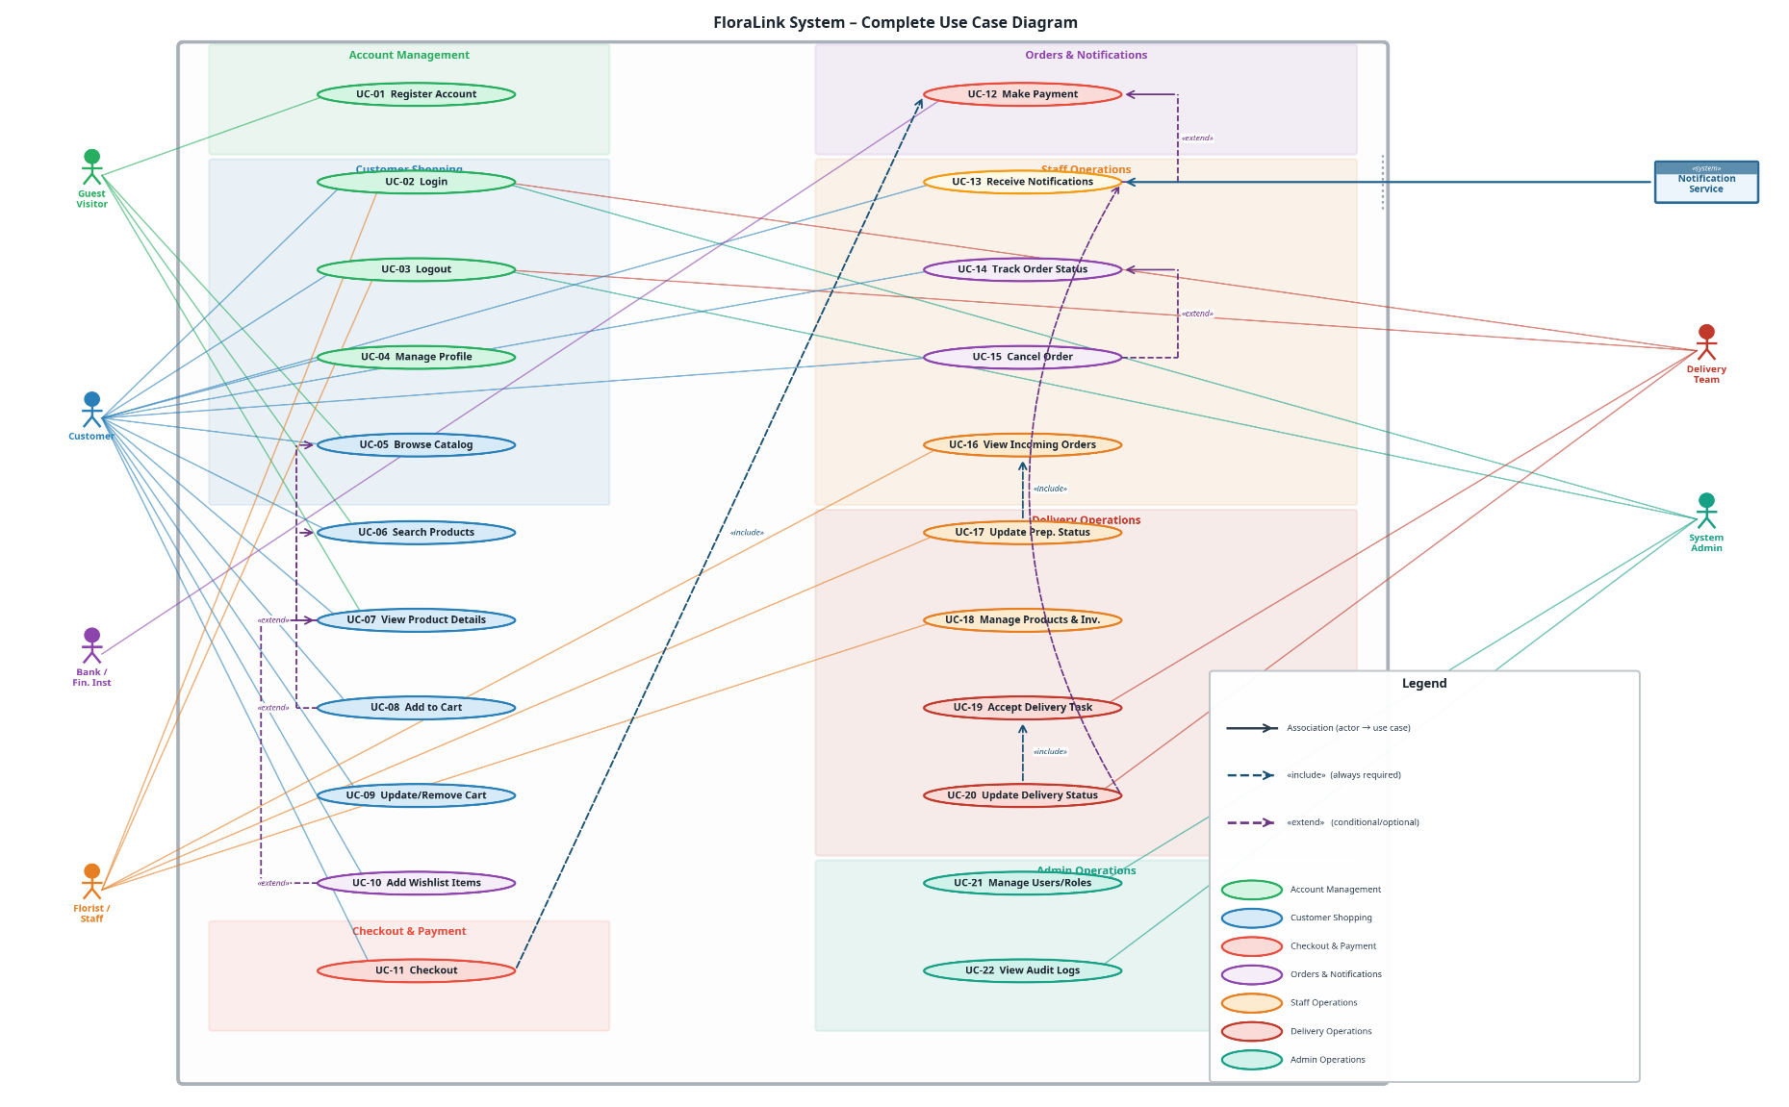

Part B: Mis-Use Cases

2.3 Misuse Case Model

2.3.1 Misuse Case Actors
Mis-Use Case Actor | Description
External Attacker | An unauthorized individual attempting to compromise the system from the outside.
Malicious Customer | A registered customer who abuses their account privileges.
Rogue Florist/Staff | A malicious insider employee with valid credentials who abuses their access privileges.
Rogue Delivery | A malicious member of the delivery team who abuses their access.

2.3.2 Misuse Case Descriptions

MUC-01: Brute Force Login
ID | MUC-01
Name | Brute Force Login
Description | An attacker repeatedly tries different passwords for a known username to gain unauthorized access to account.
Actors | External Attacker
Trigger | Repeated fast login attempts on one account with a known username.
Main Flow | - Attacker navigates to the Login page.  - Attacker submits many password attempts for the same email/username.  - System processes each attempt and checks hashed passwords.  - If a password matches, the attacker gains unauthorized access to the customer's account.
Alternatives | A1: Reverse Brute Force: The attacker uses a single common password and tries it against a large list of usernames.
Mitigation Control(s) | MIT-01 (Strong Authentication), MIT-02 (Rate Limiting & Lockout)

MUC-02: Account Takeover (Credential Stuffing)
ID | MUC-02
Name | Account Takeover (Credential Stuffing)
Description | The attacker uses leaked credential lists to log in and take over users accounts.
Actors | External Attacker
Trigger | Availability of leaked credentials, unusual login patterns.
Main Flow | 1. The attacker acquires a large list of leaked credentials.  2. The attacker uses an automated tool to try each username/password pair on the login page.  3. For every successful login, the attacker gains full control of the victim's account.  4. The attacker can steal personal information, change password, etc.
Alternatives | A1: Check for email existence: The attacker uses the registration page to verify if an email is already registered before launching the attack.
Mitigation Control(s) | MIT-01 (Strong Authentication), MIT-02 (Rate Limiting & Lockout), MIT-04 (Secure Session Management)

MUC-03: Unauthorized Data Access (IDOR)
ID | MUC-03
Name | Unauthorized Data Access (IDOR)
Description | An attacker attempts to access or modify data they are not authorized to view by manipulating object identifiers.
Actors | External Attacker, Rogue Staff, Malicious Customer
Trigger | Direct object identifiers are exposed to users and authorization checks are missing or inconsistent
Main Flow | 1. The attacker authenticates to the system with their own low-privilege account.  2. The attacker navigates to a feature that retrieves an object, such as viewing their own order history.  3. The attacker intercepts the request and changes the ID in the parameter to a different, guessed ID.  4. The system fails to verify that the user is authorized to access the requested object.  5. The system returns the data for the unauthorized object to the attacker.
Alternatives | A1: Modify data: The attacker uses the same technique to submit a request that modifies another user's data.
Mitigation Control(s) | MIT-03 (RBAC + Least Privilege), MIT-11 (Server-side Object-Level Authorization), MIT-09 (Audit Logging)

MUC-04: Checkout Tampering
ID | MUC-04
Name | Checkout Tampering
Description | A malicious customer intercepts and alters cart/checkout request to reduce total or bypass stock controls.
Actors | Malicious Customer
Trigger | Weak server validation
Main Flow | - The malicious customer adds an item to the cart.  - The malicious customer proceeds to checkout and intercepts the HTTP request.  - The malicious customer modifies the price (or quantity) parameter to a lower value.  - The malicious customer forwards the modified request to the server.  - If the server does not re-validate the price, it processes the order using the manipulated values.
Alternatives | A1: Quantity Tampering: The customer modifies the quantity of an item without the price changing.
Mitigation Control(s) | MIT-06 (Server-Side Validation) as primary, MIT-05 (SQL Injection Prevention) as support control.

MUC-05: Payment Fraud
ID | MUC-05
Name | Payment Fraud
Description | An attacker attempts to bypass the payment process by forging a payment gateway callback to trick the system into marking an order as paid.
Actors | External Attacker, Malicious Customer
Trigger | Missing signature validation.
Main Flow | 1. A malicious customer proceeds to checkout and is redirected to the Payment Gateway.  2. Instead of paying, the attacker analyzes the callback URL the gateway uses to notify the store of a successful payment.  3. The attacker manually calls this callback URL with forged parameters simulating a successful transaction.  4. If the system does not validate the callback's authenticity, it incorrectly marks the order as paid.
Alternatives | A1: Race Condition: Attacker tries to access confirmation/paid resources before real payment status is finalized.
Mitigation Control(s) | MIT-07 (Secure Payment Processing) as primary, MIT-06 (Server-Side Validation) as support.

MUC-06: SQL Injection
ID | MUC-06
Name | SQL Injection
Description | An attacker injects malicious SQL code into input fields to manipulate the backend database.
Actors | External Attacker
Trigger | Insufficient user input validation and error messages leaking DB behavior.
Main Flow | 1. The attacker finds an input field that interacts with the database, such as the product search bar.  2. The attacker enters a malicious SQL payload.  3. The backend server concatenates the user input directly into a database query without sanitizing it.  4. The malicious query alters the original SQL command, causing unintended data to be returned.  5. The system displays the extracted data to the attacker.
Alternatives | A1: Authentication Bypass: The attacker uses SQL injection on the login page to bypass the password check.  A2: Data Deletion: The attacker injects a destructive query to delete critical data.
Mitigation Control(s) | MIT-05 (SQL Injection Prevention)

MUC-07: Cross-Site Scripting (XSS)
ID | MUC-07
Name | Cross-Site Scripting (XSS)
Description | An attacker injects malicious scripts into the web application that are executed by other users' browsers.
Actors | External Attacker, Malicious Customer, Rogue Staff
Trigger | User input is displayed without output encoding.
Main Flow | - The attacker injects a malicious JavaScript payload into input field.  - The system stores/reflects the input without proper validation or encoding.  - A legitimate user visits the affected page.  - The user’s browser executes the malicious script.  - The attacker gains unauthorized access (e.g., steals session cookies or performs actions as the victim).
Alternatives | A1: Reflected XSS: Victim clicks a crafted URL where the payload is reflected and executed immediately.
Mitigation Control(s) | MIT-12 (XSS Protection), MIT-04 (Secure Session Management)

MUC-08: Cross-Site Request Forgery (CSRF)
ID | MUC-08
Name | Cross-Site Request Forgery (CSRF)
Description | An attacker tricks a logged-in user’s browser into unknowingly submitting a malicious action.
Actors | External Attacker
Trigger | No CSRF protection on state-changing requests while using cookie-based sessions
Main Flow | - The attacker creates a malicious request targeting a sensitive function.  - The logged-in user is tricked into triggering the request.  - The browser automatically sends the request with valid session cookies.  - The system processes the request as legitimate (if no CSRF protection exists).
Alternatives | A1: Change Address: CSRF modifies delivery address or account details without the user’s consent.
Mitigation Control(s) | MIT-04 (Secure Session Management), MIT-08 (CSRF Protection)

MUC-09: Fake Delivery Proof
ID | MUC-09
Name | Fake Delivery Proof
Description | Rogue delivery member marks an order as delivered and uploads fake proof without actual delivery.
Actors | Rogue Delivery
Trigger | Weak delivery proof requirements, no validation of proof.
Main Flow | 1. A rogue delivery person is tasked with delivering an order.  2. The delivery person keeps the package.  3. They take a picture of a random door and upload it as "proof of delivery".  4. They mark the order as "Delivered" in the system.  5. The system accepts the proof, and the customer is incorrectly notified of a successful delivery.
Alternatives | A1: Reuse Old Proof: The delivery member uploads a previously used delivery photo/screenshot from another order.
Mitigation Control(s) | MIT-03 (RBAC + Least Privilege), MIT-09 (Audit Logging)

MUC-10: Inventory Manipulation
ID | MUC-10
Name | Inventory Manipulation
Description | A rogue staff member intentionally provides false information about inventory levels.
Actors | Rogue Staff
Trigger | Staff has inventory update permissions, poor audit review of stock changes.
Main Flow | 1. A rogue staff member takes a physical item from the inventory.  2. To hide the theft, the staff member accesses the inventory management system.  3. They manually decrease the stock count for the stolen item, attributing it to "damage" or "spoilage".  4. The system updates the stock level, and the discrepancy goes unnoticed.
Alternatives | A1: Manipulate Incoming Stock: The rogue staff member records false receiving quantities (adds/omits items) during restocking to conceal theft or errors.
Mitigation Control(s) | MIT-03 (RBAC + Least Privilege), MIT-09 (Audit Logging)

MUC-11: Denial of Service (DoS)
ID | MUC-11
Name | Denial of Service (DoS)
Description | An attacker attempts to make the system unavailable to legitimate users by overwhelming it with a high volume of traffic.
Actors | External Attacker
Trigger | High volume repeated requests, lack of rate limiting.
Main Flow | - The attacker targets high traffic endpoints.  - The attacker uses automated scripts to send a large number of requests to this endpoint.  - The system allocates resources to handle these requests.  - Server resources become overloaded.  - Legitimate users experience slow responses or complete service unavailability.
Alternatives | A1: Login Flood: The attacker floods the login endpoint with requests, potentially locking out legitimate user accounts.
Mitigation Control(s) | MIT-02 (Rate Limiting), MIT-10 (Availability Protections)

MUC-12: Spam Account Creation
ID | MUC-12
Name | Spam Account Creation
Description | An attacker uses automated scripts to create a large number of fake accounts, potentially to abuse promotional offers or overwhelm the system.
Actors | External Attacker
Trigger | Lack of bot detection mechanisms on the registration form.
Main Flow | - The attacker creates a script to automate form submission on the registration page (UC 01).  - The script generates random user data and submits the form repeatedly.  - The system creates a large volume of fake user accounts, consuming resources and polluting the user database.
Alternatives | A1: The attacker uses the fake accounts to abuse "new user" promotions or discounts.
Mitigation Control(s) | MIT-13 (Bot Detection/CAPTCHA), MIT-02 (Rate Limiting)

2.3.3 Misuse Case Diagram
The following diagram presents the complete Mis-Use Case Model, showing all mis-use case actors, all 12 mis-use cases, all 13 mitigating use cases, and the <<mitigates>> relationships connecting each threat to its corresponding security control. It also shows which use case each misuse case threatens.
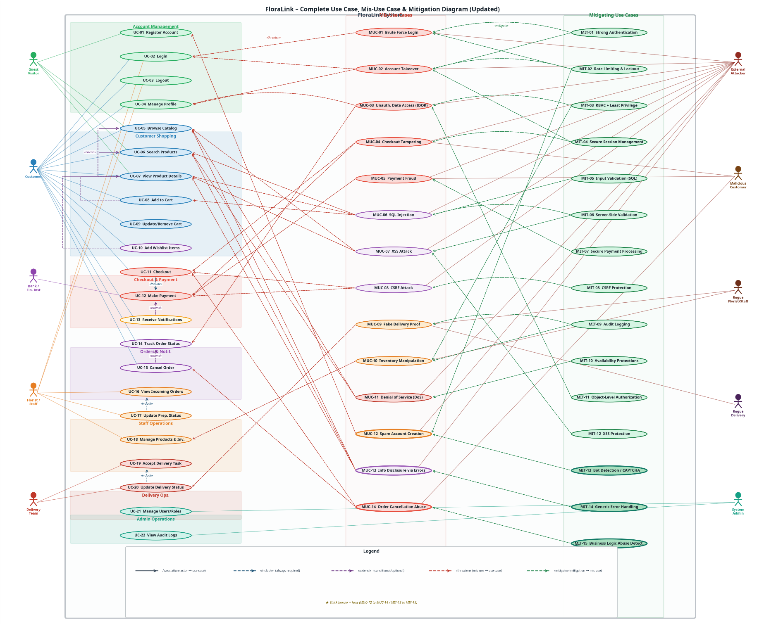

Part C: Mitigation Use Cases

2.4 Mitigating Use Cases

2.4.1 Mitigating Use Case Descriptions

MIT-01: Strong Authentication
ID | MIT-01
Name | Strong Authentication
Description | Implements strong password policies, strong hashing to protect user accounts.
Actors | System
Main Flow | - During registration, the system enforces a password policy (e.g., minimum length, complexity).  - When the user submits their password, the system uses a strong, salted hashing algorithm to store the hash.  - During login, the system hashes the submitted password and compares it to the stored hash.

MIT-02: Rate Limiting & Account Lockout
ID | MIT-02
Name | Rate Limiting & Account Lockout
Description | Protects against brute-force and account takeover attacks by limiting failed login attempts.
Actors | System
Main Flow | - The system logs every failed login attempt, tracking the source IP and the username.  - If failed attempts from one IP exceed a threshold (e.g., 100 in 1 minute), the system temporarily blocks that IP.  - If failed attempts for one account exceed a threshold (e.g., 5 in 10 minutes), the system locks the account.

MIT-03: RBAC + Least Privilege
ID | MIT-03
Name | RBAC + Least Privilege
Description | Ensures the system enforces Role-Based Access Control (RBAC) and the principle of least privilege.
Actors | System
Main Flow | 1. A user logs in and attempts to access a system function (e.g., the admin panel).  2. Before granting access, the system checks the user's assigned role.  3. The system verifies the permissions associated with that role against an access control list.  4. The system determines that the normal user role is not permitted to access the admin panel.  5. The system denies the request and redirects the user to their dashboard or shows an "Access Denied" error.

MIT-04: Secure Session Management
ID | MIT-04
Name | Secure Session Management
Description | Ensures user sessions are managed securely to prevent session hijacking.
Actors | System
Main Flow | 1. After a user successfully logs in, the system generates a new, long, and random session ID.  2. The system sends this session ID to the client in a cookie with the HttpOnly and Secure flags set.  3. The system regenerates the session ID after any change in privilege level (e.g., login).

MIT-05: Input Validation
ID | MIT-05
Name | Input Validation
Description | Prevents SQL Injection by using parameterized queries/prepared statements for all database operations and validating/sanitizing inputs on the server side. Dynamic SQL concatenation is not allowed.
Actors | System
Main Flow | 1. A user submits data to the server via a form (e.g., a product search query).  2. The backend receives the input.  3. The system validates the input against a strict allow-list or uses parameterized queries for SQL.  4. The system detects that the input is malicious or invalid.  5. The request is rejected, and a generic error is logged and returned to the user.

MIT-06: Server-side Validation
ID | MIT-06
Name | Server-side Validation
Description | Prevents price and quantity tampering in checkout by ignoring client-side prices and recalculating totals from the database.
Actors | System
Main Flow | 1. A customer submits their cart to the server for checkout.  2. The server receives the list of product IDs and quantities from the client.  3. The server ignores any price information sent from the client.  4. For each product ID, the server fetches the current, correct price from its own database.  5. The server recalculates the total based on these trusted values and proceeds to payment.

MIT-07: Secure Payment Processing
ID | MIT-07
Name | Secure Payment Processing
Description | Ensures payment processing is secure and cannot be faked by validating the payment gateway's cryptographic callback signature.
Actors | System, Bank/Financial Institutions
Main Flow | 1. After a payment attempt, Payment Gateway sends a callback request to FloraLink server.  2. This callback includes a cryptographic signature generated using a shared secret key.  3. The system receives the callback and recalculates the signature based on the received payload.  4. If the calculated signature matches the one in the request, the callback is authentic, and the order is marked as paid.  5. If the signatures do not match, the callback is discarded and an alert is logged.

MIT-08: CSRF Protection
ID | MIT-08
Name | CSRF Protection
Description | Protects against Cross-Site Request Forgery using anti-CSRF tokens.
Actors | System
Main Flow | 1. When the system renders a page with a form, it generates a unique, random anti-CSRF token.  2. This token is embedded as a hidden field in the form and stored in the user's session.  3. When the user submits the form, the token is sent along with the request.  4. The server compares the submitted token with the one stored in the session.  5. If they match, the request is processed. If not, the request is rejected.

MIT-09: Audit Logging
ID | MIT-09
Name | Audit Logging
Description | Automatically creates a detailed, tamper-protected log of all critical actions.
Actors | System
Main Flow | 1. A user performs a sensitive action, such as updating an order's status to "Cancelled".  2. The system processes the action.  3. In parallel, the system generates an audit log entry containing: User ID, Action, Target Object ID, Old Value, New Value, and Timestamp.  4. The log is written to a secure, append-only log file or a separate logging service.  5. The log files are protected with strict permissions to prevent modification.

MIT-10: Availability Protections
ID | MIT-10
Name | Availability Protections
Description | Implements protective measures to ensure the system remains available to legitimate users.
Actors | System
Main Flow | 1. The system is configured with a rate-limiting module that tracks the number of requests per IP address.  2. An attacker begins sending a high volume of requests to a specific endpoint.  3. The rate-limiting module detects that the IP address has exceeded the allowed threshold.  4. The system automatically blocks all subsequent requests from that IP address for a configured period.  5. The system returns an HTTP 429 "Too Many Requests" error to the attacker, while legitimate users remain unaffected.

MIT-11: Server-Side Object-Level Authorization
ID | MIT-11
Name | Server-side Object-Level Authorization
Description | Prevents IDOR/BOLA by enforcing server-side object-level permission checks to ensure users can access only authorized object IDs, rejecting unauthorized requests with 403 Forbidden.
Actors | System
Main Flow | 1. A user sends a request to access/modify a specific resource using an object identifier (e.g., orderId, invoiceId, fileId).  2. The server authenticates the user (session/JWT) and extracts the user identity and tenant/context.  3. The server retrieves the target object (or its access policy/metadata) and determines the required permissions for that action (view/update/delete).  4. The server checks authorization at the object level (e.g., object owner match, role-based permission, tenant isolation, ACL rules).  5. If authorized, the server processes the request and returns the result; otherwise, it rejects the request with 403 Forbidden (and logs the attempt) without exposing whether the object exists.

MIT-12 XSS Protection
ID | MIT-12
Name | XSS Protection
Description | Prevents XSS by applying output encoding/escaping before rendering user-controlled data in the browser, and enforcing safe rendering practices.
Actors | System
Main Flow | - System identifies user-controlled output points (comments, names, messages).  - System applies output encoding/escaping based on context (HTML/attribute/JS). System sanitizes rich text if allowed (allowlist).  - System rejects/flags suspicious payloads and logs events

MIT-13: Bot Detection (CAPTCHA)
ID | MIT-13
Name | Bot Detection (CAPTCHA)
Description | Protects public-facing forms like registration and login from automated abuse by bots.
Actors | System
Main Flow | - A user attempts to submit a sensitive form (e.g., registration).  - The system presents a CAPTCHA challenge that is difficult for a bot to solve but easy for a human.  - The user successfully solves the challenge.  - The system validates the CAPTCHA response on the server-side and allows the form submission to proceed.

2.4 Misuse Case to Mitigation Mapping
The following table provides a comprehensive mapping of all 12 mis-use cases to their corresponding mitigating use cases, ensuring that every identified threat has at least one security control.
Mis-Use Case ID | Mis-Use Case Name | Mitigating Use Case(s)
MUC-01 | Brute Force Login | MIT-01 (Strong Authentication)  MIT-02 (Rate Limiting & Lockout)
MUC-02 | Account Takeover | MIT-01 (Strong Authentication)  MIT-02 (Rate Limiting & Lockout)  MIT-04 (Secure Session Management)
MUC-03 | Unauthorized Data Access (IDOR) | MIT-03 (RBAC + Least Privilege)  MIT-11 (Server-side object-level authorization)  MIT-09: Audit Logging
MUC-04 | Checkout Tampering | MIT-06 (Server-Side Validation)  MIT-05 (SQL Injection Prevention)
MUC-05 | Payment Fraud | MIT-07 (Secure Payment Processing)  MIT-06 (Server-Side Validation)
MUC-06 | SQL Injection | MIT-05 (SQL Injection Prevention)
MUC-07 | Cross-Site Scripting (XSS) | MIT-12 (XSS Protection)  MIT-04 (Secure Session Management)
MUC-08 | CSRF | MIT-04 (Secure Session Management)  MIT-08 (CSRF Protection)
MUC-09 | Fake Delivery Proof | MIT-03 (RBAC + Least Privilege)  MIT-09 (Audit Logging)
MUC-10 | Inventory Manipulation | MIT-03 (RBAC + Least Privilege)  MIT-09 (Audit Logging)
MUC-11 | Denial of Service (DoS) | MIT-02 (Rate Limiting)  MIT-10 (Availability Protections)
MUC-12 | Spam Account Creation | MIT-13 (Bot Detection/CAPTCHA)  MIT-02 (Rate Limiting)

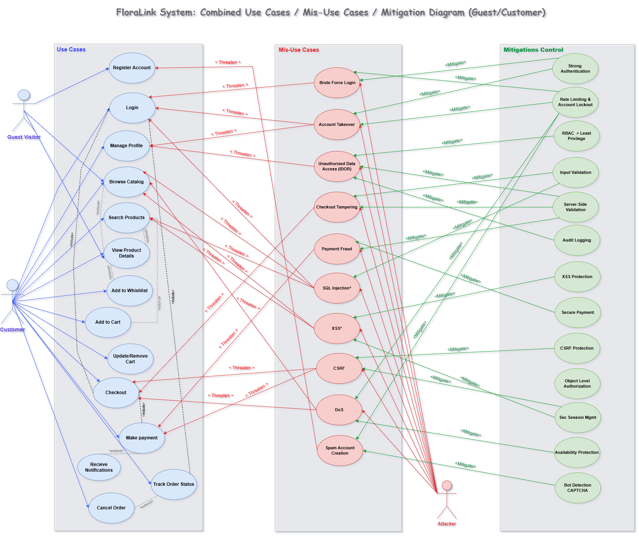

For more details, the following diagram provides a consolidated view of the functional use cases, associated misuse cases, and implemented mitigation controls relevant to the primary operational actor in the FloraLink system, the Customer.

4. System Design

4.1 System Architecture
FloraLink follows a three-tier client-server architecture: a frontend presentation layer built with React (TypeScript/TSX), a backend application layer implemented in Python handling business logic and security controls, and a relational database layer storing all persistent data. Communication between tiers is secured with HTTPS/TLS.
[Insert system architecture diagram here showing the three tiers, HTTPS communication, and external services (Payment Gateway, Notification Service)]

4.2 UI/UX Design
High-fidelity prototypes were produced using Figma and Canva for the 9 selected use cases. The UI enforces security-visible design: password strength indicators, pre-lockout warnings, server-authoritative price display, and CAPTCHA challenges are all surfaced directly in the interface.
[Insert UI prototype screenshots for UC-01 Register, UC-02 Login, UC-11 Checkout, UC-12 Payment, and associated mitigation screens]

3.2.1. UC-01: Register Account

UC-01 allows a Guest Visitor to create a new FloraLink customer account. It is directly coupled with MIT-01 (password policy), MIT-13 (CAPTCHA on the form), and MIT-02 (rate limiting on the registration endpoint).
The main flow of the registration process, including the Registration Form and the successful account creation with the welcome screen, is shown in the screens below.

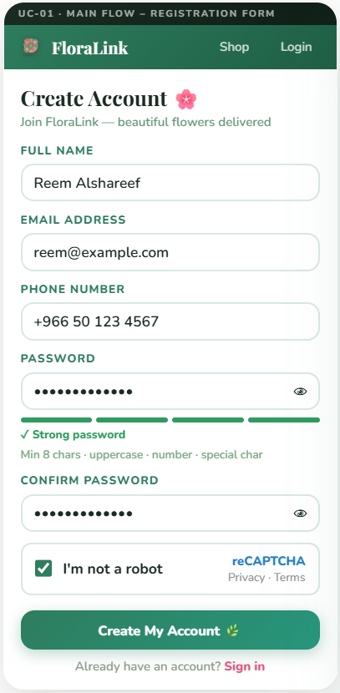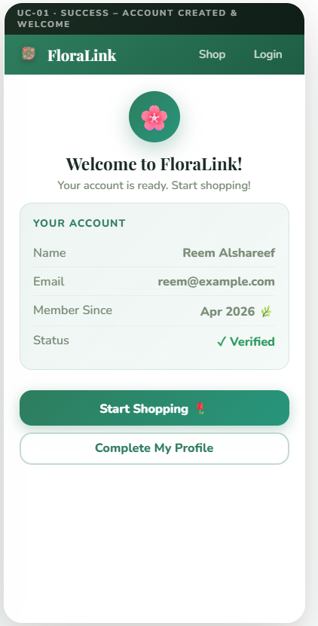

Alternative(s):
Alternative Flow A1: Email Already Exists, and Alternative Flow A2: Invalid Input Validation, are illustrated in the screens below.
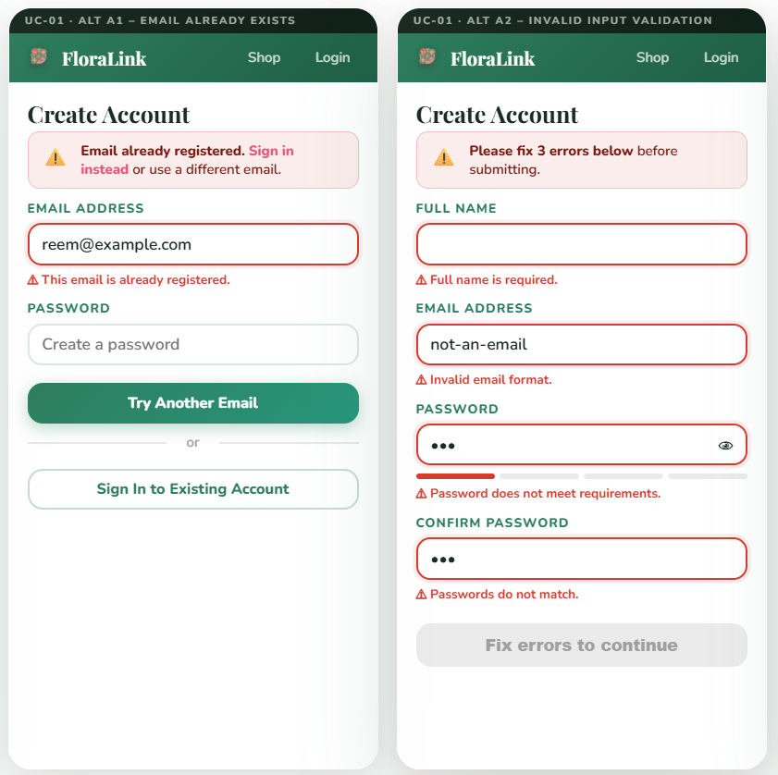

(MIT) Mitigation Use Case

MIT-13: Bot Detection / CAPTCHA

MIT-13 protects public-facing forms from automated abuse. Directly mitigates MUC-12 (Spam Account Creation) and provides a secondary layer of defence for MUC-01 (Brute Force Login).

Below shows the CAPTCHA Challenge and the screen when the CAPTCHA failed.

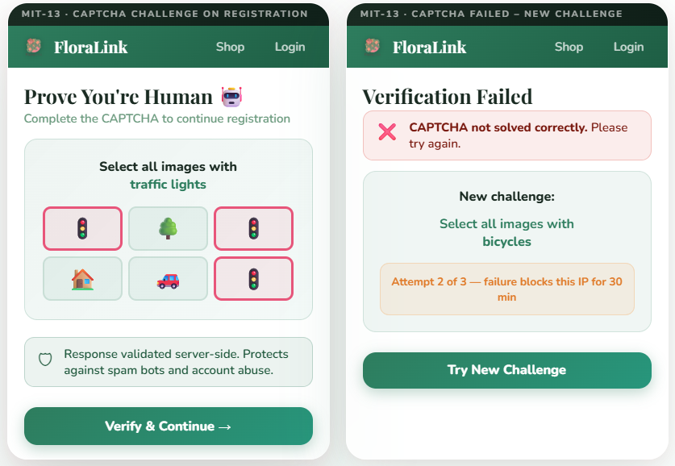

3.2.2. UC-02: Login

UC-02 allows all registered users to authenticate. The flow is protected by MIT-01 (password policy), MIT-02 (account lockout after 5 failed attempts), and CAPTCHA (MIT-13, injected on the 3rd failed attempt onwards).

The main flow of Login Form is shown in the screen below.
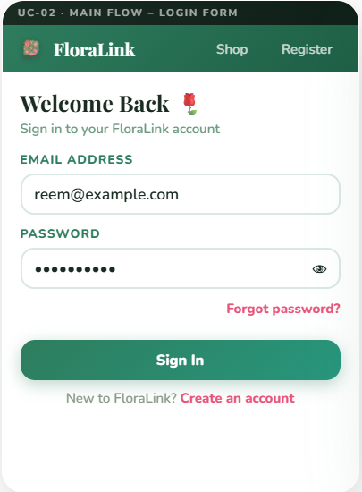

Alternative(s):
Alternative Flow A1: Invalid Credentials, and Alternative Flow A2: Account Locked, are illustrated in the screens below.
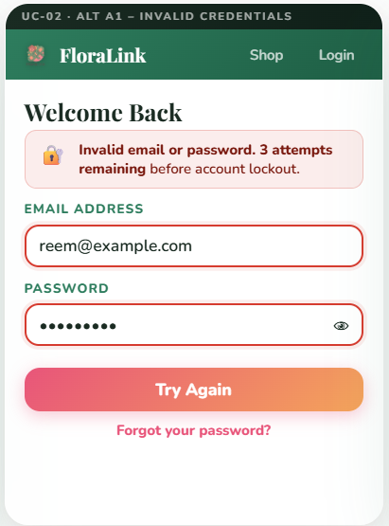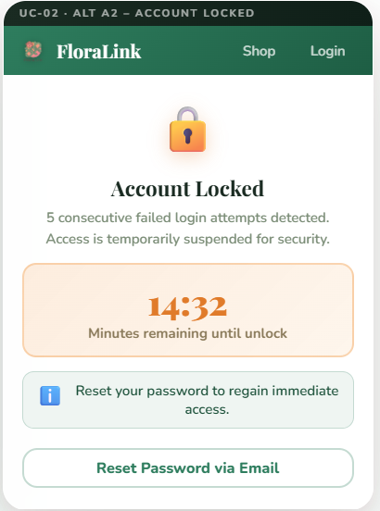

(MIT) Mitigation Use Case

MIT-01: Strong Authentication

MIT-01 enforces a 5-rule password policy. Directly mitigates MUC-01 (Brute Force Login) and MUC-02 (Account Takeover via Credential Stuffing).
Password Policy Enforcement shows in below screen.
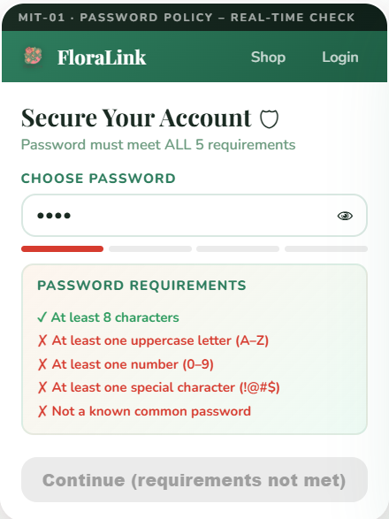

MIT-02: Rate Limiting & Account Lockout

MIT-02 mitigates MUC-01 (Brute Force). It applies per-account lockout after 5 failed attempts in 10 minutes.

Pre-Lockout Warning (4th Failed Attempt) screen shows below.
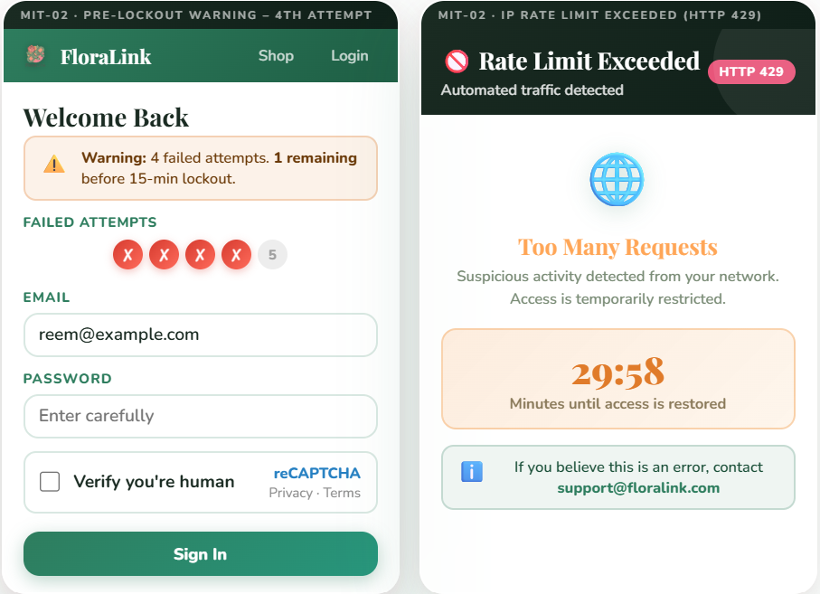

3.2.3. UC-11: Checkout

UC-11 allows authenticated customers to confirm a delivery address, select a time slot, and review the order before payment. MIT-06 ensures all prices shown are server-authoritative and cannot be manipulated. For more details, find below screens.
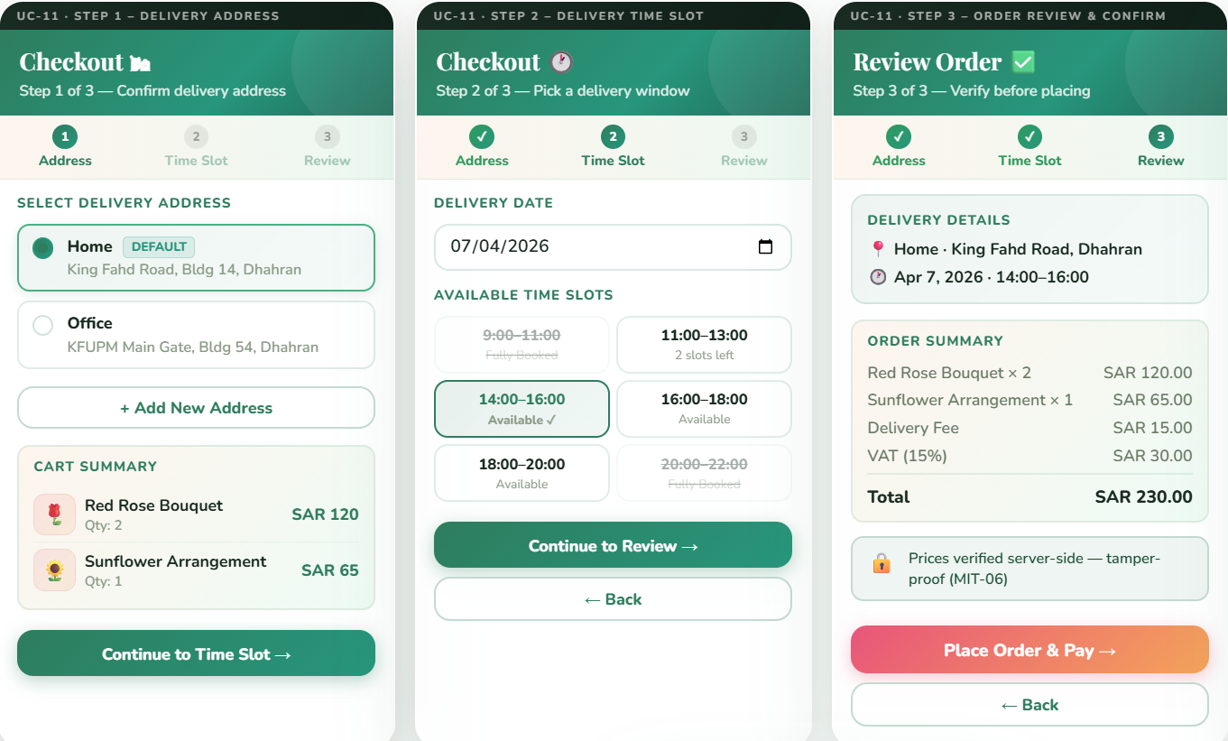

Alternative(s):
Alt A1: User Not Logged In, and Alt A2: Cart Is Empty, are illustrated in the screens below.
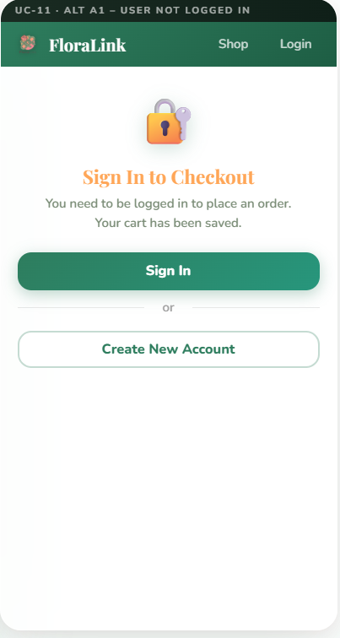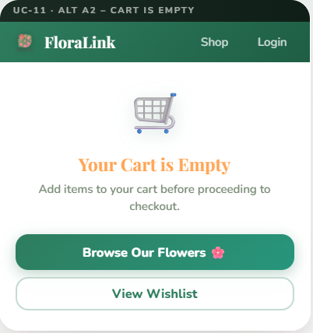

MIT) Mitigation Use Case

MIT-06: Server-Side Validation

MIT-06 mitigates MUC-04 (Checkout Tampering) and supports MUC-05 (Payment Fraud defence). The server ignores all client-submitted price data and re-fetches authoritative values from the Product table.
The screens below illustrate the detection and blocking of a price tampering attempt, along with the server-side recalculation logic presented from the system view.

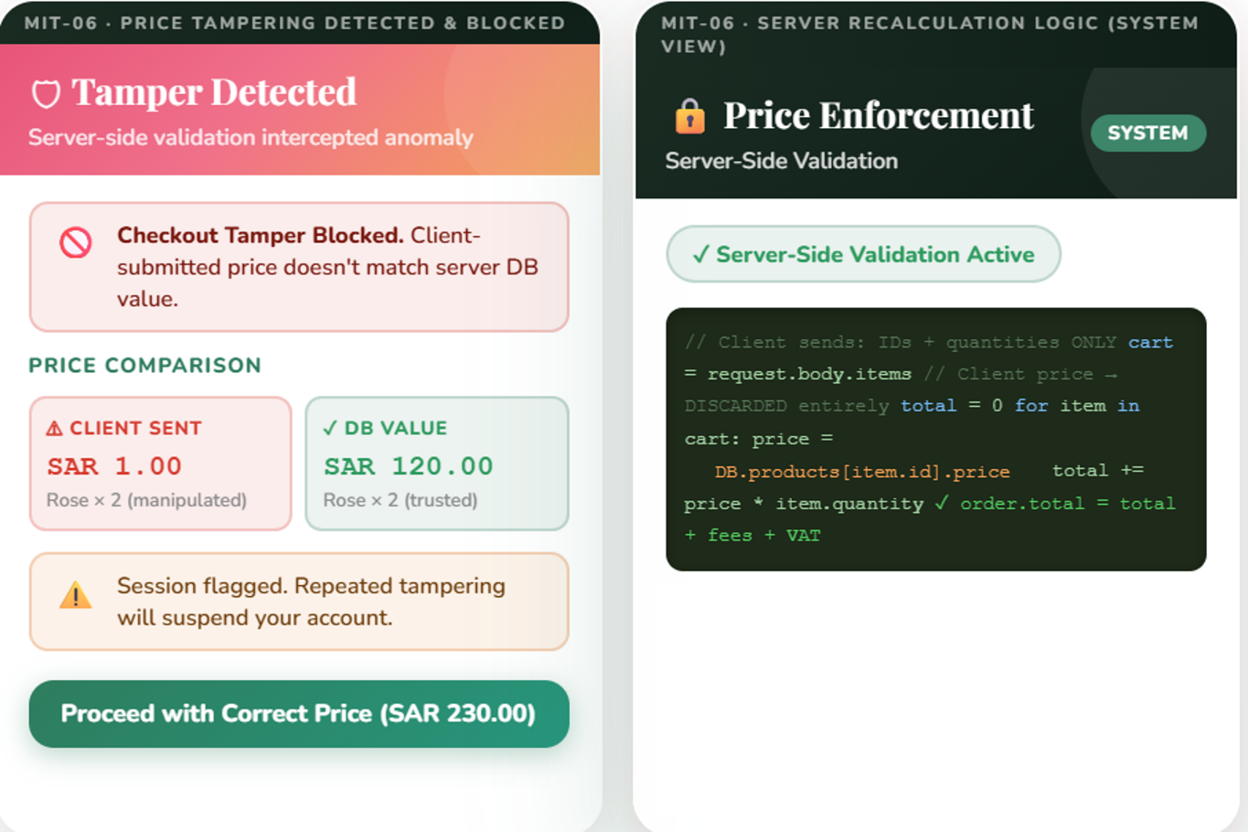

3.2.4. UC-12: Make Payment

UC-12 allows authenticated customers to complete payment for a confirmed order using a credit card/Mada through an external PCI-DSS-compliant payment gateway. MIT-07 ensures that each payment callback is cryptographically validated before the order status is updated.
The screens below illustrate the main payment flow, including the Payment Form and Payment Confirmation, indicating a successful transaction.

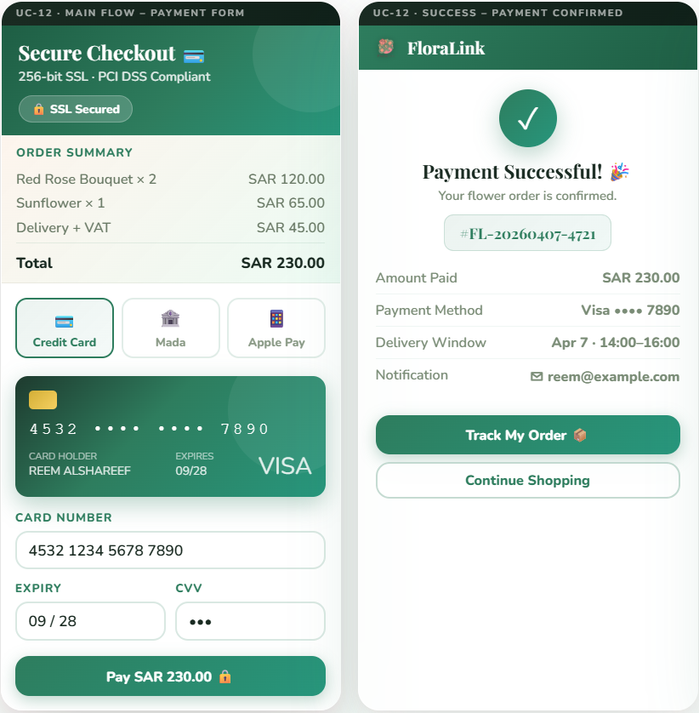

Alternative(s):
Alternative Flow A1: Payment Declined, and UC-12 Alternative Flow A2: Gateway Timeout, are shown in the screens below.

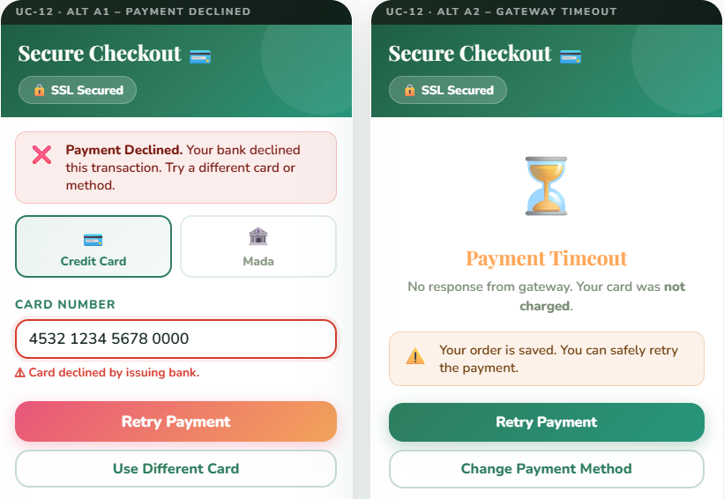
(MIT) Mitigation Use Case

MIT-07: Secure Payment Processing

MIT-07 validates the HMAC cryptographic signature on every payment gateway callback before updating any Order record. Directly mitigates MUC-05 (Payment Fraud via forged gateway callbacks). The screens below illustrate the Gateway Redirect with Security Checks and the detection and blocking of a forged callback through an Admin Alert.
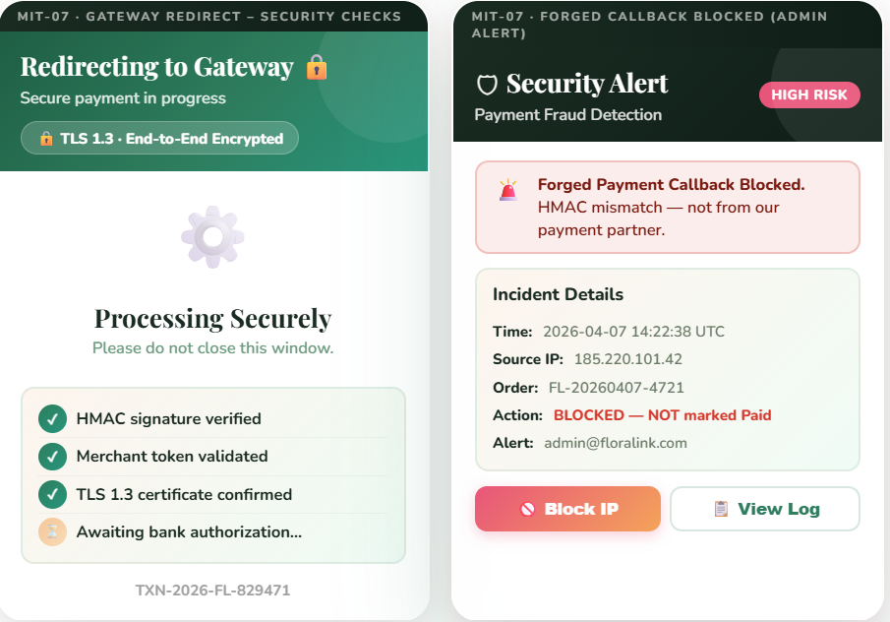

4.3 Database Design (ERD)
This section presents 9 database entities with all Primary Keys (PK), Foreign Keys (FK), and Alternate Keys (AK) explicitly identified. The design reflects the security requirements: server-authoritative pricing (MIT-06), bcrypt credential storage (MIT-01), and rate-limiting state (MIT-02).

3.3.1: Key Legend
Symbol | Key Type | Description
PK | Primary Key | Uniquely identifies each record. Auto-incrementing integer. NOT NULL.
FK | Foreign Key | References the PK of another table to enforce referential integrity.
AK | Alternate Key | A UNIQUE attribute that could serve as PK but was not chosen (Candidate Key).

3.3.2: Entities Overview
The following 9 entities are required by the 9 selected use cases:
- Customer: hashed credentials, lockout state, account status (UC-01, UC-02, MIT-01, MIT-02)
- CustomerAddress: delivery addresses per customer (UC-11)
- DeliverySlot — available time windows with capacity tracking (UC-11)
- Cart — temporary basket before checkout (UC-11)
- CartItem — products in the cart with quantities (UC-11)
- Order — confirmed purchase linking customer, address, and slot (UC-11, UC-12)
- OrderItem — products in an order with server-fetched prices (MIT-06, UC-12)
- Product — catalogue items; price is the single server-authoritative source (MIT-06)
- Payment — gateway records with HMAC signature for fraud detection (UC-12, MIT-07)

3.3.3: Entity Specifications

Entity 1: Customer
Attribute | Key | Data Type | Constraints & Security Notes
customer_id | PK | INT | Auto-increment. NOT NULL.
email | AK | VARCHAR(255) | UNIQUE, NOT NULL. Login identifier. Indexed. (never in raw SQL — MIT-01)
full_name |  | VARCHAR(100) | NOT NULL.
phone_number |  | VARCHAR(20) | NOT NULL.
password_hash |  | VARCHAR(255) | NOT NULL. bcrypt cost=12. Plain text NEVER stored. (MIT-01)
date_of_birth |  | DATE | Optional.
account_status |  | ENUM | Values: active, locked, suspended. Default: active. (MIT-02)
failed_login_count |  | INT | Default 0. Incremented on failure. Reset on success. (MIT-02)
lockout_until |  | DATETIME | NULL when active. Set when failed_login_count >= 5. (MIT-02)
created_at |  | DATETIME | Default CURRENT_TIMESTAMP.

Entity 2: CustomerAddress
Attribute | Key | Data Type | Constraints & Security Notes
address_id | PK | INT | Auto-increment.
customer_id | FK | INT | References Customer(customer_id). ON DELETE CASCADE.
street |  | VARCHAR(200) | NOT NULL.
city |  | VARCHAR(100) | NOT NULL.
postal_code |  | VARCHAR(20) | NOT NULL.
is_default |  | BOOL | Default FALSE. Only one per customer can be TRUE.
label |  | VARCHAR(30) | User-friendly name, such as Home or Work

Entity 3: DeliverySlot
Attribute | Key | Data Type | Constraints & Security Notes
slot_id | PK | INT | Auto-increment.
slot_date |  | DATE | NOT NULL.
start_time |  | TIME | NOT NULL. e.g. 14:00.
end_time |  | TIME | NOT NULL. e.g. 16:00.
capacity |  | INT | NOT NULL. Max concurrent deliveries per slot.
booked_count |  | INT | Default 0. Incremented atomically when an Order is confirmed.
is_available |  | BOOL | Computed: TRUE when booked_count < capacity.

Entity 4: Cart
Attribute | Key | Data Type | Constraints & Security Notes
cart_id | PK | INT | Auto-increment.
customer_id | FK | INT | References Customer(customer_id). One active cart per customer.
status |  | ENUM | Values: active, checked_out, abandoned. Default: active.
created_at |  | DATETIME | Default CURRENT_TIMESTAMP.

Entity 5: CartItem
Attribute | Key | Data Type | Constraints & Security Notes
cart_item_id | PK | INT | Auto-increment.
cart_id | FK | INT | References Cart(cart_id). ON DELETE CASCADE.
product_id | FK | INT | References Product(product_id).
quantity |  | INT | NOT NULL. >= 1. Validated against Product.stock_quantity. (MIT-06)
added_at |  | DATETIME | Default CURRENT_TIMESTAMP.

Entity 6: Order
Attribute | Key | Data Type | Constraints & Security Notes
order_id | PK | INT | Auto-increment.
customer_id | FK | INT | References Customer(customer_id).
address_id | FK | INT | References CustomerAddress(address_id).
slot_id | FK | INT | References DeliverySlot(slot_id). Triggers booked_count increment.
order_reference | AK | VARCHAR(30) | UNIQUE. Format: 'FL-YYYYMMDD-XXXX'.
status |  | ENUM | Values: Pending, Paid, In Preparation, Ready, Out for Delivery, Delivered, Cancelled.
total_amount |  | DECIMAL(10,2) | Server-computed from OrderItems + fees. NEVER from client. (MIT-06)
created_at |  | DATETIME | Default CURRENT_TIMESTAMP.

Entity 7: OrderItem
Attribute | Key | Data Type | Constraints & Security Notes
item_id | PK | INT | Auto-increment.
order_id | FK | INT | References Order(order_id). ON DELETE CASCADE.
product_id | FK | INT | References Product(product_id).
quantity |  | INT | NOT NULL. >= 1.
unit_price |  | DECIMAL(10,2) | Server-fetched from Product.price at checkout time. NEVER from client. (MIT-06)

Entity 8: Product
Attribute | Key | Data Type | Constraints & Security Notes
product_id | PK | INT | Auto-increment.
sku | AK | VARCHAR(50) | UNIQUE. Stock Keeping Unit.
name |  | VARCHAR(150) | NOT NULL.
description |  | TEXT | Rich text product description.
price |  | DECIMAL(10,2) | Server-authoritative price — the ONLY trusted source. (MIT-06)
stock_quantity |  | INT | NOT NULL. Default 0.
is_active |  | BOOL | Default TRUE. Set FALSE to deactivate without deletion.

Entity 9: Payment
Attribute | Key | Data Type | Constraints & Security Notes
payment_id | PK | INT | Auto-increment, NOT NULL.
order_id | FK | INT | References Order(order_id). UNIQUE, NOT NULL. Enforces 1:1 relationship.
transaction_ref | AK | VARCHAR(100) | UNIQUE. Gateway-assigned transaction reference.
amount |  | DECIMAL(10,2) | Must match Order.total_amount before order is marked Paid. (MIT-07)
method |  | ENUM | Values: CreditCard, Mada, ApplePay.
status |  | ENUM | Values: Pending, Paid, Failed, Refunded.
gateway_signature |  | VARCHAR(255) | HMAC-SHA256 signature from gateway. Verified server-side before status update. (MIT-07)
paid_at |  | DATETIME | NULL until HMAC verified. Set only after MIT-07 check passes.

3.2.4: Relationship Summary
From | Relationship | To | Cardinality | FK Attribute
Customer | HAS | CustomerAddress | 1 : N | CustomerAddress.customer_id → Customer.customer_id
Customer | OWNS | Cart | 1 : 1 | Cart.customer_id → Customer.customer_id
Cart | CONTAINS | CartItem | 1 : N | CartItem.cart_id → Cart.cart_id
Product | IN | CartItem | 1 : N | CartItem.product_id → Product.product_id
Customer | PLACES | Order | 1 : N | Order.customer_id → Customer.customer_id
CustomerAddress | USED IN | Order | 1 : N | Order.address_id → CustomerAddress.address_id
DeliverySlot | BOOKED IN | Order | 1 : N | Order.slot_id → DeliverySlot.slot_id
Order | CONTAINS | OrderItem | 1 : N | OrderItem.order_id → Order.order_id
Product | INCLUDED IN | OrderItem | 1 : N | OrderItem.product_id → Product.product_id
Order | PAID VIA | Payment | 1 : 1 | Payment.order_id → Order.order_id

3.2.5: Entity Relationship Diagram (ERD)
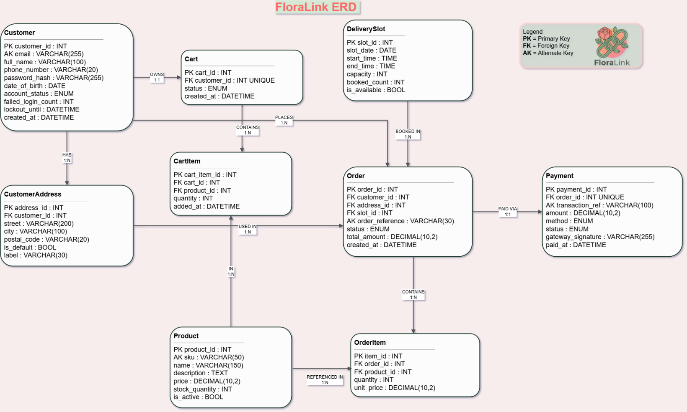

3.4 Traceability: Use Cases to Database Entities
The following table maps each of the 9 selected use cases to the database entities they read from or write to, confirming design completeness.

Use Case | Name | Reads From | Writes / Updates
UC-01 | Register Account | Customer (email uniqueness check) | Customer (INSERT with hash)
UC-02 | Login | Customer (password_hash, account_status, lockout_until) | Customer (failed_login_count, lockout_until)
MIT-01 | Strong Authentication | Customer (password_hash) | Customer (password_hash at registration)
MIT-02 | Rate Limiting & Lockout | Customer (failed_login_count) | Customer (account_status, lockout_until)
MIT-13 | Bot Detection / CAPTCHA | None (external reCAPTCHA service validates separately) | None (blocks request if failed — no DB write)
UC-11 | Checkout | Cart, CartItem, CustomerAddress, DeliverySlot, Product (price) | Order (INSERT), OrderItem (INSERT), DeliverySlot (booked_count++)
MIT-06 | Server-Side Validation | Product (price — authoritative source) | Order (total_amount), OrderItem (unit_price — server-fetched)
UC-12 | Make Payment | Order (total_amount), Payment (gateway_signature) | Order (status → Paid), Payment (INSERT with HMAC)
MIT-07 | Secure Payment | Payment (gateway_signature for HMAC check) | Payment (status, paid_at after HMAC verified), Order (status → Paid)

4.4 Sequence / Activity Diagrams
[Insert sequence/activity diagrams for key flows: Registration, Login with lockout, Checkout with server-side validation, Payment with HMAC verification]

5. Security Design & Controls

5.1 Authentication & Authorization
Authentication is implemented using email/password credentials with bcrypt (cost=12) hashing. Token-based session management (JWT) is used for maintaining user state after login. Authorization is enforced through RBAC ensuring each role (Customer, Florist/Staff, Delivery Team, System Admin) has access only to the functions required for their role.

5.2 Input Validation
All user input is validated on the server side using an allow-list approach. All database queries use parameterized statements (prepared statements) to prevent SQL injection. Client-submitted price and quantity data is ignored at checkout; only server-retrieved values from the database are trusted.

5.3 Encryption
All data in transit between client and server is encrypted using HTTPS/TLS. Sensitive data including payment details and personal identifiers are masked in the user interface where full visibility is not required. Password hashes are stored using bcrypt with a sufficient cost factor.

5.4 Logging and Monitoring
An append-only audit log records every critical action with timestamp, user ID, action type, target object ID, and old/new values. Log files are protected with strict filesystem permissions to prevent modification. The System Administrator can review logs and filter by user or time range to detect suspicious activity.

5.5 Mitigation Mechanisms
- MIT-02 – Rate Limiting & Lockout: Per-IP blocking after 100 failed requests per minute; per-account lockout after 5 failed attempts in 10 minutes.
- MIT-06 – Server-Side Price Validation: Server fetches authoritative prices from the Product table; any client-submitted prices are discarded.
- MIT-07 – HMAC Payment Validation: Every payment gateway callback is authenticated by recalculating and comparing the HMAC-SHA256 signature before updating any order record.
- MIT-08 – CSRF Tokens: Unique anti-CSRF tokens embedded in all state-changing forms.
- MIT-12 – XSS Output Encoding: All user-controlled data is context-sensitively encoded before rendering.
- MIT-13 – CAPTCHA: reCAPTCHA presented on registration and injected into login after the third failed attempt.

6. Implementation

6.1 Technologies Used
Aspect | Technology | Usage
Main programming language | TypeScript | Used across both the client and server for form logic, validation rules, database procedures, and application state.
User interface development | React + TSX/JSX | Used to build the registration, login, and reset-password screens and connect them to reactive state.
Client-server integration | tRPC + TanStack Query + SuperJSON | Used for typed frontend-to-backend mutations and query handling between the React interface and the Express server.
Interface styling | CSS3 + Tailwind CSS v4 | Used for layout, spacing, typography, colors, states, and overall visual consistency.
Development and build tool | Vite + esbuild | Used for local development, frontend bundling, and production build generation.
Server runtime | Express + Node.js | Used to host the application, mount backend middleware, and expose the /api/trpc procedures.
Database and ORM | MySQL/TiDB + Drizzle ORM | Used to persist customer accounts, run schema migrations, and query/update authentication data.
Design, testing, and workflow tools | Figma, Canva, GitHub, VS Code, Vitest | Used for UI mockups, version control, development workflow, and automated backend route testing.

6.2 Implemented Modules
The working prototype currently centers on the FloraLink authentication flow. The original four deliverable items remain visible in the interface as the main functional scope, while the final implementation was extended with persistent database-backed storage and a forgot-password/reset-password flow to make the prototype more realistic and usable.
UC-01 – Register Account: The registration form collects full name, email, phone number, password, and confirmation. Before acceptance, the system checks that no required field is empty, validates the email format, compares the password against the confirmation field, enforces the password policy, and verifies through the backend that the email is not already registered. When registration succeeds, the account is inserted into the customer_accounts table and the interface displays a success screen with the saved account details.
UC-02 – Login: The login form no longer compares credentials against a hardcoded demo account. Instead, it sends the submitted email and password to the backend authentication procedure, which retrieves the corresponding customer record from the database and verifies the stored password hash. Successful login displays a welcome screen, while invalid credentials produce a generic error message and increment the failed-attempt counter in the interface.
MIT-01 – Strong Authentication: A real-time password strength indicator and interactive checklist enforce five rules: minimum 8 characters, at least one uppercase letter, at least one number, at least one special character, and rejection of common passwords. The same password rules are also validated in the backend procedures through schema validation so weak passwords are not accepted even if the frontend is bypassed.
MIT-02 – Rate Limiting & Account Lockout: A warning is displayed on the fourth failed attempt, and on the fifth the interface places the session in a temporary 15-minute lock state with a visible countdown timer. The current version keeps this lockout behavior in the client-side interface for demonstration purposes, while the actual account credentials themselves are stored and verified through the database-backed backend.

6.3 Screenshots of System
[Insert screenshots here: Registration Form, Registration Success, Login Form, Forgot Password / Reset Password Form, Password Updated Screen, Invalid Credentials Error, Pre-Lockout Warning (4th attempt), Account Locked Screen with Countdown, Password Strength Indicator]

7. Testing Strategy

7.1 Testing Approach
Black-box testing was adopted as the primary testing approach for this phase. This approach focuses on the external behavior of the system without examining the internal source code, making it highly suitable for verifying that implemented functional and security modules produce the correct response when valid, invalid, and boundary inputs are provided. Test cases were designed based on user inputs and observable interface outputs such as error messages, success messages, lockout screens, and warnings.

7.2 Test Plan
Tests are organized into four groups corresponding to the four implemented items: the registration module (UC-01), the login module (UC-02), the password strength validation module (MIT-01), and the rate limiting and account lockout module (MIT-02). Each group targets both the happy path (valid inputs) and adversarial/edge-case paths (invalid, malformed, or attack inputs).

7.3 Testing Environment
Tests were conducted on the locally running FloraLink web application through the current Vite + Express development setup, then rechecked in the browser preview after the backend/database upgrade. The environment uses the configured database connection and the customer_accounts table created through Drizzle migrations. Verification combined browser-based end-to-end checks for registration, login, and password reset with automated Vitest tests for the backend register, login, and reset-password procedures. Payment and notification services were outside the scope of this verification cycle.

7.4 Tools Used
- Web browser preview (Chromium) – used for end-to-end validation of registration, login, lock-state behavior, and password reset flows.
- Vitest + pnpm test – used to run repeatable automated tests for the backend registration, login, and reset-password routes.
- Project verification commands (pnpm check, pnpm build, pnpm db:push) – used to confirm TypeScript integrity, production build readiness, and successful database schema synchronization.

8. Test Cases

8.1 Registration Module (UC-01)
Test ID | Module | Input | Expected Output | Result
TC-R01 | UC-01 | Valid name, valid email, phone, strong password, matching confirmation | Account creation success screen appears
TC-R02 | UC-01 | Any required field left blank | Request rejected; error highlights blank fields
TC-R03 | UC-01 | Invalid email format (e.g., reemexample.com) | Request rejected; email field marked invalid
TC-R04 | UC-01 | Weak password (short, no uppercase or special character) | Request rejected; registration cannot proceed
TC-R05 | UC-01 | Password: Bloom@2026 / Confirmation: Bloom@2027 | Request rejected; confirmation field marked invalid
TC-R06 | UC-01 | Email: reem@example.com (already registered) | Error: "Email already registered"

8.2 Login Module (UC-02)
Test ID | Module | Input | Expected Output | Result
TC-L01 | UC-02 | Correct registered email + correct password | Login succeeds; welcome screen appears
TC-L02 | UC-02 | Correct email + incorrect password | Error: invalid credentials displayed
TC-L03 | UC-02 | Non-matching email + any password | Error: invalid email or password displayed
TC-L04 | UC-02 | Incorrect credentials (4th attempt) | Warning: one attempt remains before lockout
TC-L05 | UC-02 | Incorrect credentials (5th attempt) | Account temporarily locked; countdown timer displayed
TC-L06 | UC-02 | Login attempt while account is locked | Lockout remains active; login blocked

8.3 Strong Authentication (MIT-01)
Test ID | Module | Input | Expected Output | Result
TC-SA01 | MIT-01 | Password: Ab@123 (< 8 characters) | Minimum length rule fails; registration blocked
TC-SA02 | MIT-01 | Password: bloom@2026 (no uppercase) | Uppercase rule fails
TC-SA03 | MIT-01 | Password: Bloom@Test (no number) | Number rule fails
TC-SA04 | MIT-01 | Password: Bloom2026 (no special character) | Special character rule fails
TC-SA05 | MIT-01 | Password: Password@1 or qwerty@1A | Common password rule fails; rejected
TC-SA06 | MIT-01 | Password: Bloom@2026 | All rules pass; registration can proceed

8.4 Rate Limiting & Account Lockout (MIT-02)
Test ID | Module | Input | Expected Output | Result
TC-RL01 | MIT-02 | Enter invalid credentials repeatedly | Failed-attempt counter increments after each failure
TC-RL02 | MIT-02 | Fail login one or more times | Attempts indicator appears in the interface
TC-RL03 | MIT-02 | Reach the 4th failed attempt | Warning: only one attempt remains before lockout
TC-RL04 | MIT-02 | After 4 failed attempts | "Verify you're human" checkbox appears
TC-RL05 | MIT-02 | Reach 5 failed attempts | Account temporarily locked for 15 minutes; countdown shown
TC-RL06 | MIT-02 | Wait until countdown timer expires | System returns to normal; counter reset

9. Testing Results & Analysis

9.1 Summary of Testing Results
The report defines a 24-case black-box matrix for the four Phase 3 items. In the current verified build, the core user flows were rechecked in the browser after the database upgrade, and the backend credential routes were also covered by automated Vitest tests. These checks confirmed that the implemented authentication features work correctly in the current source state, although the full 24-case matrix should still be maintained as the formal manual test set for coursework reporting.
Module | Total Tests | Pass | Fail | Notes
UC-01 Registration | 6 | - | - | Core browser flow verified after DB integration
UC-02 Login | 6 | - | - | Core browser flow verified after DB integration
MIT-01 Strong Authentication | 6 | - | - | Rules verified in UI and backend validation
MIT-02 Rate Limiting & Lockout | 6 | - | - | Warning and lock state verified in interface
Total | 24 | - | - | 24-case matrix retained; backend route tests passed

The detailed browser verification confirmed successful registration, successful login, successful password reset, and successful login with the updated password. Automated route tests also passed for successful registration, duplicate-email rejection, successful login, invalid login, successful password reset, and missing-account reset attempts.

9.2 Identified Issues and Vulnerabilities
In the current prototype, the following implementation limitations and follow-up improvements remain relevant:
- Customer account data is now stored persistently in the customer_accounts database table rather than in memory only.
- Passwords are no longer handled as hardcoded demo credentials; they are stored in the database as salted password hashes and verified on the backend.
- The human-verification step is still a simulated UI element rather than a live CAPTCHA integration such as Google reCAPTCHA.
- The temporary lockout/rate-limiting behavior is still enforced in client-side state for demonstration purposes; a production deployment should mirror this control on the server.

9.3 Security Testing Results
The security-specific verification confirmed that weak passwords are rejected at the point of entry, common passwords are identified and blocked, the temporary lockout mechanism activates on the fifth failed attempt, and the countdown timer reflects the remaining lock duration correctly. Browser verification also confirmed that the database-backed password reset flow updates the stored credentials successfully and allows login with the new password.

9.4 Fixes and Mitigations Applied
During implementation, the authentication prototype was upgraded from a demo-only frontend flow to a database-backed flow with backend validation and password reset support.

9.5 Discussion of Results
The testing phase confirms that security controls can be integrated into both the user interface and the backend service layer in a way that improves security while preserving a usable experience. In the current FloraLink build, password policy enforcement is visible in the interface and revalidated in backend procedures, while account credentials are now persisted in the database rather than kept as demo-only frontend state. The black-box testing approach therefore remains appropriate because it evaluates the system from the perspective of a user and exposes the observable effects of both functional and security decisions.

10. Challenges & Lessons Learned

10.1 Technical Challenges
- Implementing real-time password strength evaluation that is both accurate and responsive required careful state management in React.
- Ensuring that the account lockout countdown timer resets automatically without requiring a page reload involved managing timers within React component lifecycle.
- Designing the UI to surface security feedback (warnings, lockout screens, CAPTCHA) without degrading the user experience for legitimate users.

10.2 Security Challenges
- Balancing security strictness with usability: overly aggressive rate limiting or password policies can frustrate legitimate users and drive them away from the platform.
- Integrating persistent credential storage while preserving the existing interface required careful alignment between frontend mutations, backend procedures, database schema, and validation rules.
- Ensuring that generic error messages are informative enough for legitimate users while not revealing exploitable details to attackers (e.g., whether an email exists in the system).

10.3 Solutions
- Used incremental UI feedback (checklist, progress indicator) to guide users through password requirements rather than simply rejecting weak passwords.
- Designed the lockout screen as a dedicated state with an auto-resetting timer to make the temporary nature of the lockout clear to users.
- Applied the principle of security-by-design throughout: every security control was specified in the requirements phase, designed in the architecture, and verified in testing, rather than being added as an afterthought.

11. Conclusion

11.1 Summary of Achievements
The FloraLink project successfully demonstrated the application of secure software development principles across the full project lifecycle. Starting from a structured requirements analysis that identified 22 functional use cases, 12 misuse cases, and 13 mitigation controls, the team produced a complete system design including UI prototypes, a 9-entity database schema, and a working authentication prototype that now includes database-backed registration, login, password reset, strong password validation, and temporary lockout behavior.

11.2 Project Outcomes
- Comprehensive security requirements elicited through use case and misuse case modeling.
- Security controls embedded directly into the system architecture (authentication, RBAC, server-side validation, HMAC payment verification).
- Working prototype demonstrating UC-01, UC-02, MIT-01, and MIT-02 with a verified browser flow and backend-backed account persistence, together with an added forgot-password/reset-password flow.
- Black-box test suite of 24 test cases covering all implemented modules.

11.3 Future Work
- Extend the current database-backed prototype with additional business tables for products, carts, orders, and payments, and replace the direct reset form with token-based email recovery for production readiness.
- Integrate a real payment gateway (e.g., Stripe or Moyasar) with genuine HMAC callback validation.
- Implement the full 22 functional use cases including order tracking, delivery management, and admin controls.
- Conduct penetration testing on the full system to validate the effectiveness of all 13 mitigation controls.
- Add multi-factor authentication (MFA) as an additional layer beyond MIT-01.

12. References
[1] OWASP Foundation. OWASP Top Ten. https://owasp.org/www-project-top-ten/
[2] OWASP Foundation. OWASP Testing Guide. https://owasp.org/www-project-web-security-testing-guide/
[3] NIST. SP 800-63B: Digital Identity Guidelines – Authentication and Lifecycle Management.
[4] PCI Security Standards Council. PCI DSS v4.0. https://www.pcisecuritystandards.org/
[5] React Documentation. https://react.dev/
[6] Tailwind CSS Documentation. https://tailwindcss.com/docs/
[7] Vite Documentation. https://vitejs.dev/
[8] Fowler, M. (2002). Patterns of Enterprise Application Architecture. Addison-Wesley.
[Add any additional sources used throughout the project]

13. Appendices

Appendix A: Detailed Test Logs
[Insert detailed test execution logs here: date of testing, tester name, environment details, step-by-step execution trace for each test case, and actual vs. expected output comparison]

Appendix B: Additional Screenshots
[Insert any additional system screenshots not included in the main body, such as alternative flow screens, admin views, or edge-case outputs]

Appendix C: Misuse Case to Mitigation Mapping
Mis-Use Case ID | Mis-Use Case Name | Mitigating Use Case(s)
MUC-01 | Brute Force Login | MIT-01 (Strong Authentication), MIT-02 (Rate Limiting & Lockout)
MUC-02 | Account Takeover (Credential Stuffing) | MIT-01, MIT-02, MIT-04 (Secure Session Management)
MUC-03 | Unauthorized Data Access (IDOR) | MIT-03 (RBAC), MIT-11 (Object-Level Authorization), MIT-09 (Audit Logging)
MUC-04 | Checkout Tampering | MIT-06 (Server-Side Validation), MIT-05 (Input Validation)
MUC-05 | Payment Fraud | MIT-07 (Secure Payment Processing), MIT-06
MUC-06 | SQL Injection | MIT-05 (Input Validation)
MUC-07 | Cross-Site Scripting (XSS) | MIT-12 (XSS Protection), MIT-04 (Secure Session Management)
MUC-08 | CSRF | MIT-04, MIT-08 (CSRF Protection)
MUC-09 | Fake Delivery Proof | MIT-03 (RBAC), MIT-09 (Audit Logging)
MUC-10 | Inventory Manipulation | MIT-03, MIT-09
MUC-11 | Denial of Service (DoS) | MIT-02 (Rate Limiting), MIT-10 (Availability Protections)
MUC-12 | Spam Account Creation | MIT-13 (CAPTCHA), MIT-02 (Rate Limiting)

