**##6. System Modeling**

**6.1 Use Case Diagram**

* **Actors**: Donor, Recipient, Admin, Logistics Partner
* **Key Use Cases**: Register, Login, Donate Food, Request Food, Schedule Pickup, View Notifications

**6.2 Entity-Relationship Diagram (ERD)**

* **Entities**:
  + **Donor**: ID, Name, Address, Contact Info
  + **Recipient**: ID, Name, Location, Contact Info
  + **Food Donation**: ID, Food Type, Quantity, Expiration Date
  + **Pickup/Delivery**: ID, Donor ID, Recipient ID, Status

**6.3 Data Flow Diagram (DFD)**

1. **Level 0**: High-level system overview showing donors, recipients, and admin interactions with the platform.

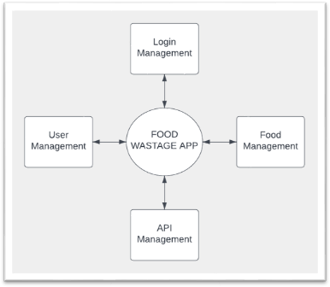

1. **Level 1**: Detailed processes for food donation, recipient request handling, and logistics scheduling.

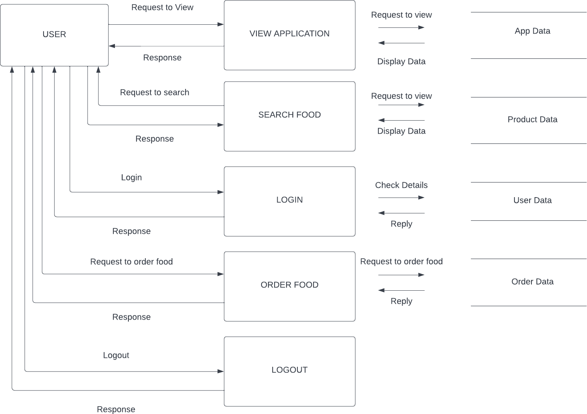

**6.4 Class Diagram**

* **Classes**:
  + User (Donor/Recipient/Admin): Login(), Register()
  + FoodDonation: AddDonation(), ViewDonations()
  + Logistics: SchedulePickup(), TrackDelivery()

**6.5 Sequence Diagram**

1. Donor posts a food donation.
2. Recipient views available donations and requests food.
3. Logistics partner picks up food from donor and delivers it to recipient.

**##7. Implementation Plan**

**7.1 Technology Stack**

1. **Frontend**: React.js
2. **Backend**: Node.js
3. **Database**: MongoDB
4. **Cloud Services**: AWS or Google Cloud for hosting and storage.
5. **APIs**: Google Maps API for geolocation and routing.

**7.2 Development Phases**

1. **Phase 1**: Core functionalities - user registration, food donation, and recipient request management.
2. **Phase 2**: Logistics and notification system integration.
3. **Phase 3**: Advanced features - AI-powered matching and analytics dashboard.

**##8. Risk Analysis**

* **Data Privacy**: Ensure user data protection via encryption and secure storage.
* **Food Spoilage**: Implement strict pickup and delivery timeframes.
* **User Adoption**: Conduct outreach programs to increase user base.

**##9. Conclusion**

The Waste Food Management & Donation project will serve as an effective solution for reducing food waste and addressing hunger issues. By leveraging modern technologies and efficient system modeling, the platform ensures the seamless collection, storage, and redistribution of surplus food.