**East West University**

Faculty of Science & Engineering

**CSE405: Computer Networks**

**Section**: **01**

**Fall 2021**

**🕮**

**COURSE TITLE**

**Dr. Maheen Islam**

Associate Professor

Department of Computer Science & Engineering

**East West University**

**SUBMITTED**

**TO**

**Md. Shahadat Anik Sheikh**

**ID NO: 2019-1-60-068**

Department of Computer Science & Engineering

**East West University**

**SUBMITTED**

**BY**

**January 23, 2022 | Sunday**

**SUBMISSION**

**DATE**

# Introduction

Internet is used to connect different computer systems (located in different geographic location). Networking has revolutionized the world and created a new arena for the overall development of every nation.[1] It is the practice of transporting and exchanging data between nodes over a shared medium in an information system. For this project, I have made a small networking system where both wire and wireless connection were used. In this project, there are 5 departments; where I have connected many devices, routers and switches through cables and many devices are also connected wirelessly. Here I have changed department A’s configuration to DHCP using a server.

The Dynamic Host Configuration Protocol (DHCP) is a network management protocol used on Internet Protocol (IP) networks for automatically assigning IP addresses and other communication parameters to devices connected to the network using client–server architecture. By setting DNS and HTTP server, Departments can send email to each other as Domain Name System (DNS) Server used for matching website hostnames (like example.com) to their corresponding Internet Protocol or IP addresses. Here I used 2 email addresses for PC5 and PC8. On the other hand, all devices can send messages to one another using IP addresses, routers and switches. Also the server hosts a website which can be browsed from all the computers configured.

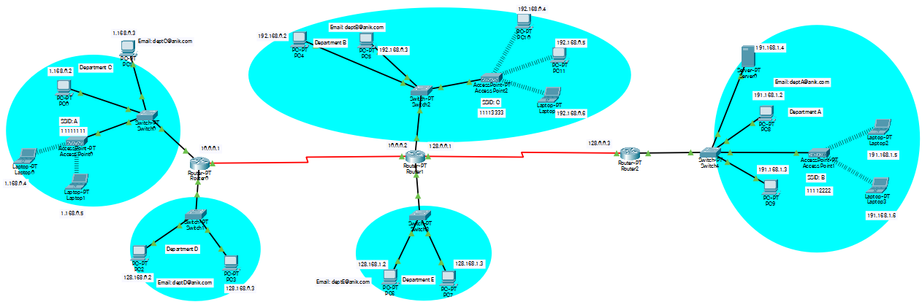

Fig: Mini Network

# Parts of the network architecture

The parts of this network are given below:

1. **Hardware**:

1. PC
2. Laptop
3. Router
4. Access Points
5. Switch
6. Custom build PC
7. Servers

2. **Transmission Media**:

1. Copper Wire
2. Wireless and Serial DTE

3. **Protocols**:

**For Routing**:

1. Static
2. RIP etc.

**For TCP/IP**:

1. HTTP
2. HTTPS
3. DNS
4. Email service etc.

# Components of the network

In this mini network, there are 5 departments started from A and ended with E. They are given below:

**Department A**:

In department A,there are 1 server (Server 0) and 2 PCs (PC8, PC9) connected with 1 switch (Switch 4) with copper straight cable. Here 2 laptops (Laptop 2, Laptop 3) are connected with 1 access point (Access Point 1) wirelessly ( SSID : B 11112222). The Access point is also connected with the Switch 4 with copper straight cable. The server contains DNS, emails and all the devices of the network can communicate with each other.

|  |
| --- |
|  |
| Fig: Department A |

**Department B**:

In department B, there are 2 PCs (PC4, PC5) connected with 1 switch (Switch 2) with copper straight cable. Here 2 Pcs (PC10, PC11) and 1 laptop (Laptop-PT Laptop 4) are connected with 1 access point (Access Point 2) wirelessly (SSID: C 11113333). The Access point is also connected with the Switch 2 with copper straight cable.

|  |
| --- |
|  |
| Fig: Department B |

**Department C**:

In department C, there are 2 PCs (PC0, PC1) connected with 1 switch (Switch 0) with copper straight cable. Here 2 laptops (Laptop 0, Laptop 1) are connected with 1 access point (Access Point 0) wirelessly (SSID: A 11111111). The Access point is also connected with the Switch 0 with copper straight cable.

|  |
| --- |
|  |
| Fig: Department C |

**Department D**:

In department D, there are 2 PCs (PC2, PC3) connected with 1 switch (Switch 1) with copper straight cable.

|  |
| --- |
|  |
| Fig: Department D |

**Department E**:

In department E, there are 2 PCs (PC6, PC7) connected with 1 switch (Switch 3) with copper straight cable.

|  |
| --- |
|  |
| Fig: Department E |

Here Department C and Department D are connected with Router 0, Department B and Department E are connected with Router 1 and Department A is connected with Router 2 with cables. Also Router 1 is connected with Router 0 and Router 2 through Serial DTE.



# Working principles of different parts of the network

1. **Connections of all devices using cables and also wirelessly**



1. **Configured the PC’s static and RIP routing**

|  |  |
| --- | --- |
|  |  |
| Fig: Static | Fig: RIP |

1. **Pinged to check the connections.**

|  |
| --- |
|  |

1. **Configured Access point with SSID and Access point connection with devices**

|  |
| --- |
|  |
| Fig: Access Point 0 |
|  |
| Fig: Laptop 0 |

1. **Configured Server to DHCP**

|  |
| --- |
|  |

1. **Configured Department A’s all devices to DHCP**

|  |
| --- |
|  |

1. **Configured the DNS**

|  |
| --- |
|  |

1. **Configured index.html in HTTP setup**

|  |
| --- |
|  |

1. **Browsed from PCs connected or configured with the server**

|  |
| --- |
|  |

1. **Created an email domain in server**

|  |
| --- |
|  |

1. **Configured the PC which will use email**

|  |
| --- |
|  |

1. **Sending emails**

|  |
| --- |
|  |

1. **Receiving emails**

|  |
| --- |
|  |

1. **Sending packets successfully from one Department to another Department**

|  |
| --- |
|  |

# Discussion and Conclusion

This mini project is little bit complex networking in between 5 departments, where all the devices are either connected with cable or wireless. Also there are RIP and static settings that I have configured successfully. Here the only server is configured with a DNS and emails which is also configured to DHCP in Department A and all the devices requested for IP addresses from server. So devices in Department A configured to DHCP from static. Therefore, every network in that server can communicate with each other.

The DHCP setting, DNS, emails and wireless connections settings are the newly introduced components in this mini project. I have learned a lot through this project. In future, it will help me work with computer networking.

# Reference

[1] <https://www.tutorialspoint.com/basics_of_computer_science/basics_of_computer_science_networking.htm#:~:text=A%20computer%20networking%20is%20a,especially%20for%20the%20business%20purpose>.