

**CSE489: Mobile Application Development**

**[Spring 2022]**

**Section: 02**

**ServiceBhai**

**Group No: 02**

**Submitted to:**

**Md Mostofa Kamal Rasel, PhD**

**Assistant Professor**

**Department of Computer Science & Engineering**

**East West University**

**Submitted by:**

|  |  |  |
| --- | --- | --- |
| **Student ID** | **Student Name** | **Contribution** |
| 2019-1-60-068 | Md. Shahadat Anik Sheikh | 33% |
| 2019-1-60-036 | Hasib Ar Rafiul Fahim | 33% |
| 2018-3-60-088 | Rashik Buksh Rafsan | 33% |

**ServiceBhai**

**Introduction:**

‘ServiceBhai’ is an android application, through which users can get different types of workers easily and fast. This is beneficial for both users and workers who are looking for workers and work. Our app routes the users to the cheapest and best available workers around his or her neighborhood. Our project is designed in a manner such that it can be deployed for commercial usage.

People are pretty much dependent on the internet in today’s world. For an example, they order food online, buy clothes online and so on. So, when they face any difficulties like needing a plumber for a broken pipe or need an electrician to fix the wearing of electronic components or need a mechanic for the broken car, they have to look for them in person. Suppose s/he is new to a city, s/he does not know where to find them. Therefore, s/he will look for them online. There are many frauds or unauthorized workers online, by them they will fall into a dangerous situation.

To avoid this, we wanted to develop a system where they can find an authorized worker to solve their problem through online. Also, during the covid-19 pandemic there was shortage of workers everywhere whom are not affected by Covid-19 and it was very difficult to move from one place to another to find the required worker to solve their problem. It was a time, mobile application like ours could have solved these problems.

**Related Apps:**

There are not a many app like ours in the google play store. In one of them is ‘Sheba.xyz’. Which is a service provider application where they supply their own registered employees for servicing whom are needed. But our application is a center point in between user and workers. In our application user can post his or her problems with having a category and our workers whom are signed up for specific category can bid the work and also both user and worker can chat with each other for further details.

**Methodology:**

We have tried to make our app as user friendly as possible. The flowchart of our application is given below.

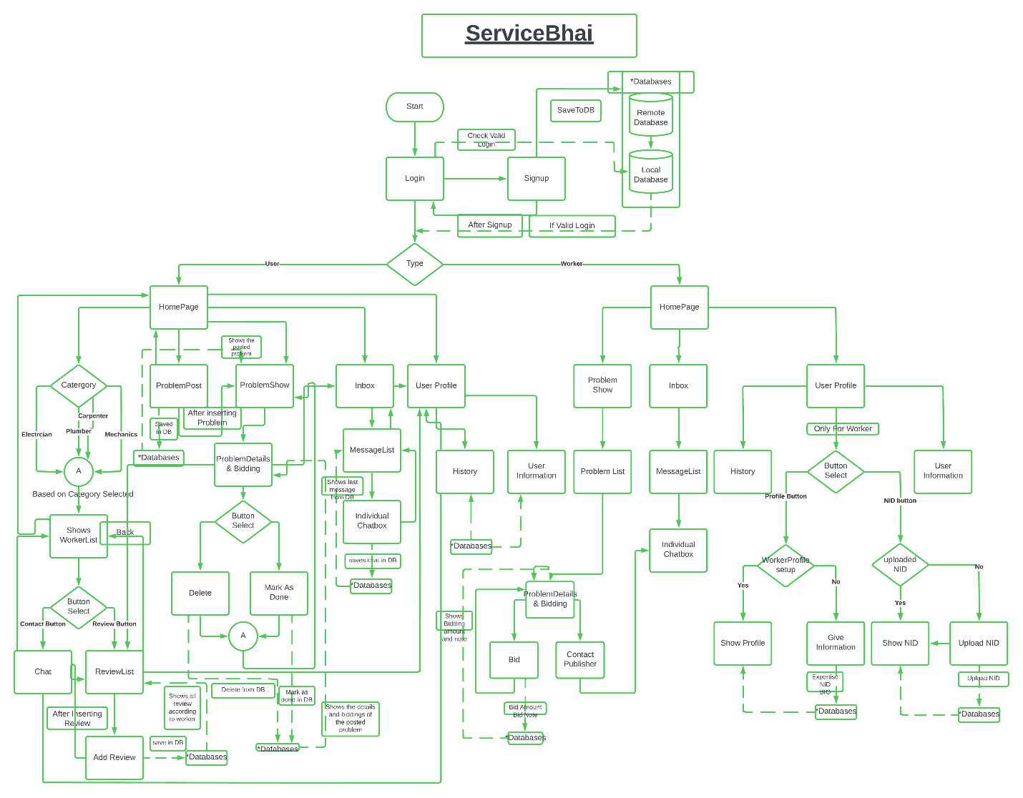

Fig 1: ServiceBhai Flowchart

We have total 19 Activities, 1 service and 6 custom views. All the wireframes are given below which has been implemented in our application.

|  |  |
| --- | --- |
|  |  |
| Fig 2: Main Activity | Fig 3: Login |

|  |  |
| --- | --- |
|  |  |
| Fig 4: Signup | Fig 5: Homepage (Worker) |

|  |  |
| --- | --- |
|  |  |
| Fig 6: Homepage (User) | Fig7: Problem Posting |

|  |  |
| --- | --- |
|  |  |
| Fig8: Problem List | Fig 9: Problem Details |

|  |  |
| --- | --- |
|  |  |
| Fig 10: Workers Information List | Fig 11: Workers Review |

|  |  |
| --- | --- |
|  |  |
| Fig 12: Post Worker Review | Fig 13: Bidding |

|  |  |
| --- | --- |
|  |  |
| Fig 14: Upload NID | Fig 15: Show NID |

|  |  |
| --- | --- |
|  |  |
| Fig 16: Inbox | Fig 17: Chat box |

|  |  |
| --- | --- |
|  |  |
| Fig 18: Create Workers Profile | Fig 19: Workers Profile |
|  |  |
| Fig 20: User Profile |  |

**Business Model:**

In present world there are several business models and our application falls into the ‘Free with advertisement’ segment. This is because we are not offering neither any purchasable features nor our application is purchasable. Also, there is no subscription options in our application. If in future our application becomes popular then we can get some sponsors for our application and from them we can generate our revenue. But as for now we are publishing our application with ‘Free with advertisement’.

**Conclusion:**

This mobile application could be the basis of a revolution. Right now, there are not many applications in the Bangladesh market trying to serve this industry. As objective, methodology and business model is so defined that we are hopeful that we could make a revaluation to this field. As we are hosting this on a free hosting site there for data retrieve is not promised all the time. We can father work on this app to improve some features of it to be more useful in practical life. This mobile application is not only great for the consumer, but also would serve the workers in advertising their best performance through this mobile application.