- Write a program in Python, C/C++ or JavaScript to take both the plaintext and the key as its input, then print out the cipher. Assume the plaintext is your name, for the key=”THISISANEXAMPLEKEYINCOMPUTERSECURITYEXAM” what is the output? Add the screenshots of your program along the input and output.
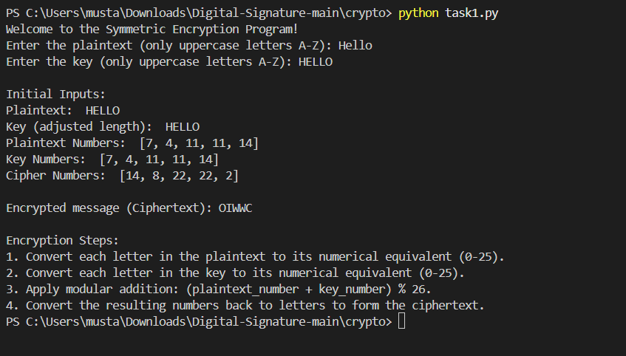

b) Decryption
To decrypt, we reverse the process by subtracting the key's numerical value from the cipher text's numerical value, then taking the result modulo 26: PlainText=(CipherText−Key)mod 26\text{PlainText} = (\text{CipherText} - \text{Key}) \mod 26PlainText=(CipherText−Key)mod26
Decryption Steps:
- Numerical Conversion:
  - Convert the cipher text and key into their numerical equivalents using the same letter-to-number mapping.
- Modular Subtraction:
  - Subtract the key's numerical value from the cipher text's numerical value for each corresponding letter. Use modulo 26 to handle wrap-around (e.g., negative results).
- Convert Back to Letters:
  - Convert the resulting numbers back into letters using the reverse mapping.
