[Description](https://docs.google.com/document/d/1gKP6RxykeekNk5bYxXIKjEitKDPdxpRyIaa9t50bLSA/edit" \l "heading=h.sm4ra97uwo11)

[Intended User](https://docs.google.com/document/d/1gKP6RxykeekNk5bYxXIKjEitKDPdxpRyIaa9t50bLSA/edit#heading=h.aws88pzfmqca)

[Features](https://docs.google.com/document/d/1gKP6RxykeekNk5bYxXIKjEitKDPdxpRyIaa9t50bLSA/edit#heading=h.zheq5430xrpq)

[User Interface Mocks](https://docs.google.com/document/d/1gKP6RxykeekNk5bYxXIKjEitKDPdxpRyIaa9t50bLSA/edit#heading=h.giquerrw6g46)

[Screen 1](https://docs.google.com/document/d/1gKP6RxykeekNk5bYxXIKjEitKDPdxpRyIaa9t50bLSA/edit#heading=h.a4jdupabry3k)

[Screen 2](https://docs.google.com/document/d/1gKP6RxykeekNk5bYxXIKjEitKDPdxpRyIaa9t50bLSA/edit#heading=h.dpcbbkx5yry)

[Key Considerations](https://docs.google.com/document/d/1gKP6RxykeekNk5bYxXIKjEitKDPdxpRyIaa9t50bLSA/edit#heading=h.gvcvmae8jn8u)

[How will your app handle data persistence?](https://docs.google.com/document/d/1gKP6RxykeekNk5bYxXIKjEitKDPdxpRyIaa9t50bLSA/edit#heading=h.v8my7nhtvz0m)

[Describe any corner cases in the UX.](https://docs.google.com/document/d/1gKP6RxykeekNk5bYxXIKjEitKDPdxpRyIaa9t50bLSA/edit#heading=h.gw69vjn1ico0)

[Describe any libraries you’ll be using and share your reasoning for including them.](https://docs.google.com/document/d/1gKP6RxykeekNk5bYxXIKjEitKDPdxpRyIaa9t50bLSA/edit#heading=h.6yqqubmw5bs)

[Describe how you will implement Google Play Services.](https://docs.google.com/document/d/1gKP6RxykeekNk5bYxXIKjEitKDPdxpRyIaa9t50bLSA/edit#heading=h.qrxg682nywe6)

[Next Steps: Required Tasks](https://docs.google.com/document/d/1gKP6RxykeekNk5bYxXIKjEitKDPdxpRyIaa9t50bLSA/edit#heading=h.v518bncmggeg)

[Task 1: Project Setup](https://docs.google.com/document/d/1gKP6RxykeekNk5bYxXIKjEitKDPdxpRyIaa9t50bLSA/edit#heading=h.8oe8zpk3qsmp)

[Task 2: Implement UI for Each Activity and Fragment](https://docs.google.com/document/d/1gKP6RxykeekNk5bYxXIKjEitKDPdxpRyIaa9t50bLSA/edit#heading=h.rzllsk6uqztx)

Task 3: Implement the image

**GitHub Username**: https://github.com/shomoukhfahad

Travel App

Description

In the Traveler application, we strive to make the experience of discovering a new city a bit like a story, telling you about the best tourist places. Browse and discover the various places in a way that is easy to use

Intended User

This App is for traveling users and families.

Features

List the main features of your app. For example:

* Saves information
* Takes pictures
* Other features

User Interface Mocks

These can be created by hand (take a photo of your drawings and insert them in this flow), or using a program like Google Drawings, [www.ninjamock.com](http://www.ninjamock.com/), Paper by 53, Photoshop or Balsamiq.

**Screen 1**

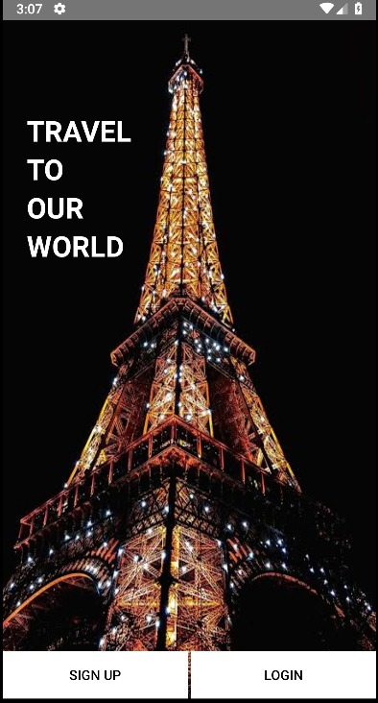

Start page and choose to log in or register for the traveler

**Screen 2**

Start page Login page

Key Considerations

**How will your app handle data persistence?**

I will use build a content Provider.

**Describe any edge or corner cases in the UX.**

Image Library - Picasso

**Describe any libraries you’ll be using and share your reasoning for including them.**

For example, Picasso or Glide to handle the loading and caching of images.

**Describe how you will implement Google Play Services or other external services.**

using the Android frameworks location finding services, can write apps that provide location-based services. these services have many uses, such as giving directions to places a user has never visited or providing information about points of interest or popular sights near the user's location.

Next Steps: Required Tasks

This is the section where you can take the main features of your app (declared above) and break them down into tangible technical tasks that you can complete one at a time until you have a finished app.

**Task 1: Project Setup**

* Configure libraries.
* Set up of the data.
* Save the data for user

**Task 2: Implement UI for Each Activity and Fragment**

* Build UI for home screen.
* Build UI for Login and Register screen.
* Build UI for other screen

**Task 3: Implement the Image**

* Implementation the image for a specific size on the screen.
* Implementation a favorite mark on the place.