Product:

<?php

include 'include/navbar.php';

include 'include/sidebar.php';

?>

<div id="page-wrapper" >

<div id="page-inner">

<div class="row">

<div class="col-md-12">

<h2>Products</h2>

<h5>Welcome, Love to see you back. </h5>

</div>

</div>

<!-- /. ROW -->

<hr />

<div class="row">

<div class="col-md-12">

<!-- Advanced Tables -->

<div class="panel panel-default">

<div class="panel-heading">

Products

</div>

<div class="panel-body">

<div class="table-responsive">

<div aria-hidden='true' aria-labelledby='newSpeakerLabel' class='modal fade speaker-form' role='dialog' tabindex='-1'>

<div class='modal-dialog'>

<div class='modal-content'>

<div class='modal-header'>

<button aria-hidden='true' class='close' data-dismiss='modal' type='button'>&times;</button>

<h4 class='modal-title' id='newSpeakerLabel'>Add Product</h4>

</div>

<div class='modal-body'>

<form enctype="multipart/form-data" action="../controller/addproduct.php" method="post">

<select name="catid" class="form-control">

<option value="">Select Category</option>

<?php

$cstmt = $admin -> ret("SELECT * FROM `category` ORDER BY `cat_name`");

while ($crow = $cstmt -> fetch(PDO::FETCH_ASSOC)) { ?>

<option value="<?= $crow['cat_id']?>"><?= $crow['cat_name']?></option>

<?php }

?>

</select><br>

<input type="text" required="" name="pname" class="form-control" placeholder="Enter Product Title"><br>

<input type="file" name="pimage"class="form-control" required=""><br>

<input type="number" placeholder="Enter Product Price" name="pprice" class="form-control" required=""><br>

<textarea name="pdesc" placeholder="Enter Product Description" required="" class="form-control" rows="4" cols="10"></textarea>

</div>

<div class='modal-footer'>

<button class='btn btn-default' data-dismiss='modal' type='button'>Close</button>

<button name="saveproduct" class='btn btn-primary' type='submit'>Save Product</button>

</div>

</form>

</div>

</div>

</div>

<div class='well bs-component'>

<fieldset>

<!-- Display each speaker -->

<!-- Link that launches the modal -->

<button class='btn btn-primary btn-sm' data-target='.speaker-form' data-toggle='modal'>Add Product</button>

</fieldset>

</div>

<table class="table table-striped table-bordered table-hover" id="dataTables-example">

<thead>

<tr>

<th>Sl no.</th>

<th>Image</th>

<th>Product</th>

<th>Category</th>

<th>Price</th>

<th>Description</th>

<th>Action</th>

</tr>

</thead>

<tbody>

<?php

$stmt = $admin -> ret("SELECT * FROM `products` ORDER BY `p_name` ASC");

$i=0;

while($row = $stmt -> fetch(PDO::FETCH_ASSOC)){

?>

<tr class="odd gradeX">

<td><?= ++$i?></td>

<td><img src="../controller/<?= $row['p_image']?>" height="100px" width="100px"></td>

<td>

<?= $row['p_name']?></td>

<td><?= $row['cat_id']?></td>

<td><?= $row['p_price']?></td>

<td><?= $row['p_desc']?></td>

<td class="center">

<a href="../controller/delete.php?productid=<?= $row['p_id']?>" class="btn btn-danger">DELETE</a>

</td>

</tr>

<?php } ?>

</tbody>

</table>

</div>

</div>

</div>

<!--End Advanced Tables -->

</div>

</div>

<!-- /. ROW -->

</div>

</div>

<!-- /. ROW -->

</div>

</div>

<!-- /. PAGE INNER -->

</div>

<!-- /. PAGE WRAPPER -->

<!-- /. WRAPPER -->

<!-- SCRIPTS -AT THE BOTOM TO REDUCE THE LOAD TIME-->

<!-- JQUERY SCRIPTS -->

<script src="assets/js/jquery-1.10.2.js"></script>

<!-- BOOTSTRAP SCRIPTS -->

<script src="assets/js/bootstrap.min.js"></script>

<!-- METISMENU SCRIPTS -->

<script src="assets/js/jquery.metisMenu.js"></script>

<!-- DATA TABLE SCRIPTS -->

<script src="assets/js/dataTables/jquery.dataTables.js"></script>

<script src="assets/js/dataTables/dataTables.bootstrap.js"></script>

<script>

</script>

<!-- CUSTOM SCRIPTS -->

<script src="assets/js/custom.js"></script>

</body>

</html>

**Add product:**

<?php

include '../config.php';

$admin = new Admin();

if (isset($_POST['saveproduct'])) {

$prod = $_POST['pname'];

$price = $_POST['pprice'];

$des = $_POST['pdesc'];

$cat = $_POST['catid'];

$targertDir ="files/";

$pimage = $targertDir . basename($_FILES['pimage']['name']);

move_uploaded_file($_FILES['pimage']['tmp_name'], $pimage);

$stmt = $admin -> ret("SELECT * FROM `products` WHERE `p_name` = '$prod'");

$num = $stmt -> rowCount();

if ($num > 0) {

echo "<script> alert('Product Already Exists');

window.location.href='../admin/product.php';

</script>";

}else{

$stmt = $admin -> cud("INSERT INTO `products` (`cat_id`, `p_name`, `p_image`, `p_price`, `p_desc`, `date`) VALUES ('".$cat."','".$prod."','".$pimage."','".$price."','".$des."',NOW())","saved");

if($stmt){

echo "<script> alert('Product Added Successfully');

window.location.href='../admin/product.php';

</script>";

}else{

echo "<script> alert('Something Went Wrong Please Try Again');

window.location.href='../admin/products.php';

</script>";

}

}

// code...

}

?>

**Category Output:**

**Add Category:**

**Product Output:**

**Add Product Output1:**

**:**

Category delete:

After Delete:

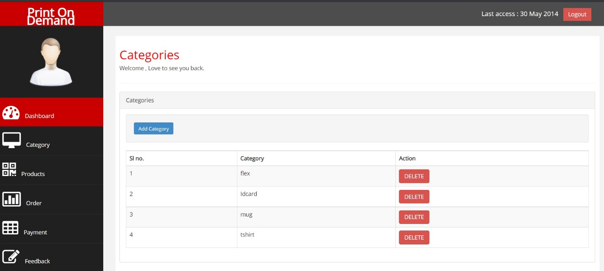

Delete Product:

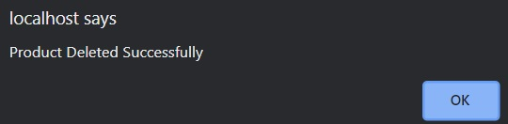

After Delete:

