My first document in Quarto
Piotr Wójcik
Oct 7, 2025

Introduction
To use Quarto/Markdown you should install the quarto program. And to use it in VS Code you need to have the Quarto VS Code Extension.
In python it would also require installing the following libraries most commonly required by quarto: jupyter, ipykernel, nbformat, nbclient, pyyaml.
Once the document is ready to generate a result just click Preview button on right hand side of the top bar of VS Code.
The text inside Quarto documents is written in Markdown. Markdown is a simple set of conventions for adding formatting to plain text.

This starts a new subchapter
Your document can be organized in (sub)capters. One can also use itemization:
- this is item 1,
- there might be a second one,
  - subitems are possible as well
  - there might be more of them,
- in fact as many as you wish.
Numbered lists are also possible:
- this is item number 1 again,
- there might be a second one,
  - subitems are possible as well
  - there might be more of them,
    - subsubitems are also allowed
- in fact as many as you wish.

Second subchapter
If you want to emphasize text – use a star * for italics or double star ** for bolded text (slash \ turns off a special meaning of characters).
For more details please check the Markdown basics, Quarto guide or Tutorials.

Subchapter no 3 – code chunks
But the most interesting feature is the possibility of creating a dynamic document – mix text with python code and python results – this is done in so called code chunks – see below for examples.

Example 1
This chunk prints the code, evaluates it and prints the results
import numpy as np
import pandas as pd
# Generate 1000 random values from a standard normal distribution
a = np.random.normal(size=1000)
# Use pandas to get a summary
summary = pd.Series(a).describe()
print(summary)
count 1000.000000
mean -0.034284
std 0.996400
min -3.821412
25% -0.712980
50% -0.069713
75% 0.620707
max 3.349810
dtype: float64

Example 2
By using an additional chunk option #|eval: false you can for example see just the code and not the results (the code is printed, but not executed/evaluated):
import numpy as np
import pandas as pd
# Generate 1000 random values from a standard normal distribution
a = np.random.normal(size=1000)
# Use pandas to get a summary
summary = pd.Series(a).describe()
print(summary)

Example 3
or the opposite – by using the option #|echo: false you can see just the results and not the code
count 1000.000000
mean -0.019300
std 1.039067
min -3.344619
25% -0.712281
50% -0.022036
75% 0.660071
max 3.168858
dtype: float64

Example 4
you can load additional packages without showing that in the output file (CAUTION! packages should be installed BEFORE, e.g. in a console window):

Example 5
If you want to avoid warnings, you can use another chunk options #/warning: false. More options can be found here: Quarto chunk execution options

Example 6
Then you can use functions from the loaded package in the following chunks, e.g.
AAPL = yf.download("AAPL", # symbol/ticker
start = "2005-01-01",
end = "2025-09-30")
AAPL.tail()
C:\Users\ptwoj\AppData\Local\Temp\ipykernel_8444\4214951745.py:1: FutureWarning: YF.download() has changed argument auto_adjust default to True
AAPL = yf.download("AAPL", # symbol/ticker
[*********************100%***********************] 1 of 1 completed
Price | Close | High | Low | Open | Volume
Ticker | AAPL | AAPL | AAPL | AAPL | AAPL
Date
2025-09-23 | 254.429993 | 257.339996 | 253.580002 | 255.880005 | 60275200
2025-09-24 | 252.309998 | 255.740005 | 251.039993 | 255.220001 | 42303700
2025-09-25 | 256.869995 | 257.170013 | 251.710007 | 253.210007 | 55202100
2025-09-26 | 255.460007 | 257.600006 | 253.779999 | 254.100006 | 46076300
2025-09-29 | 254.429993 | 255.000000 | 253.009995 | 254.559998 | 40127700

Example 7
One can also generate plots in the output document.
# lets change column names so that they are more readible
AAPL.columns = [f"{price.lower()}_{ticker}" for price, ticker in AAPL.columns]
# and make a plot
AAPL['close_AAPL'].plot(title = "Quotations of Apple (2005-2025)")
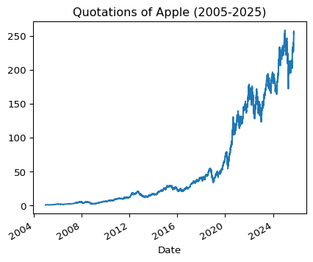

Example 8
When generating plots, one can use additional plotting options
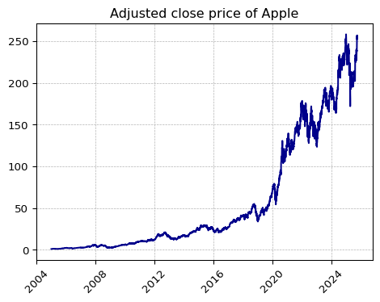
Figure 1: Adjusted close of AAPL

Example 9
One can also refer to results of Python objects inline in the text.
Inline expressions should be confined to simple values that you have pre-computed within normal code cells (rather than function calls that do non-trivial work). This is because the protocol used for inline expressions is not compatible with some Python libraries (especially those that use multi-threading or multi-processing).
For example: on 2025-09-29 Apple quotations started with the price of 254.56$ to finish a day on a level of 254.43$ with the volume of trading equal to 40127700 units.

Dollars in Quarto/Markdown
We had to mask a dollar ($) sign in the above examples as it has a special meaning in Markdown – very similar to LaTeX – it can be used to indicate a mathematical formulea, for example: $x_{1+s}^{2*d}$, $\frac{y^{2}}{x_{1t}}$, $y_{t}=α_{0}+ϕ_{1}x_{1,t}+ϵ_{t}$.
For more examples see: here or anything else.

DIY Exercises
Based on the contents of this document create presentation slides in two forms: PPTX and revealjs. Add more contents for example using graphs or tables

