MOre details Prroperty Page  
  
  
Please see instructions for more details property page below.   
  
it can fill 70% in terms of the page width so no need the contents to be fully extended  
  
ALSO make it user friendly and use the colour pallete  
  
please find good icons and have consistency

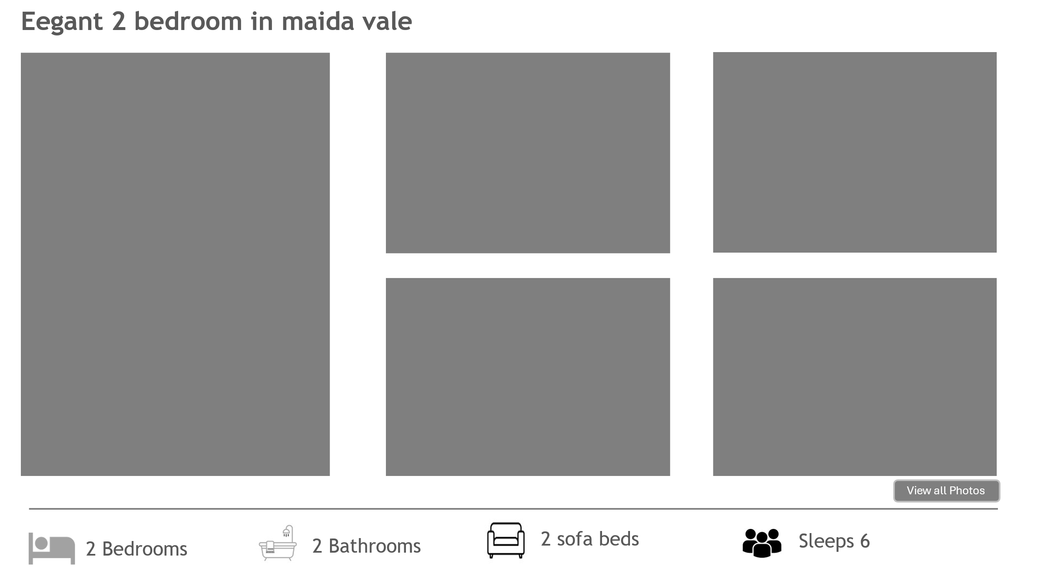

Enquire now form in formspree

Hovering box



