 | SIMATS ENGINEERING  Department of Computer Science and Engineering  CSA15 Cloud Computing and Big Data Analytics  CO2 AT3 - Capstone Cloud Infrastructure Case Analysis and Defense  Editable student template for application-based cloud virtualization and SDDC/cloud operations defense
Assessment Metadata
Course Code | CSA1517
Course Title | Cloud Computing and Big Data Analytics
Assessment | CO2 AT3 - Capstone Cloud Infrastructure Case Analysis and Defense
Submission Type | Individual digital case analysis and infrastructure defense based on the same capstone title used in CO1, CO2 AT1 and CO2 AT2
Faculty | Dr C. Rajesh Babu
Employee ID | SSETSCS415
Submission Mode | Completed DOCX template and GitHub repository link through Google Classroom
How This Template Works
- Use the same capstone title used in CO1, CO2 AT1 and CO2 AT2.
- Do not recalculate all VM sizing or repeat all configuration screenshots. Summarize the final AT1/AT2 evidence and use it for design defense.
- Answer all five questions with application-oriented reasoning connected to the capstone product.
- Include sustainable cloud operation decisions wherever relevant: right-sized resources, log retention, storage lifecycle, scheduled shutdown, API-call reduction and VM/container/serverless comparison.
- Paste the final topology diagram in the given response area. The sample diagram is only a structure; redraw it for the student's own product.
- Upload this completed document and supporting evidence to GitHub, then submit the repository link through Google Classroom.
Assessment Focus
AT1 answered what VM is required. AT2 showed configuration or simulation evidence. AT3 asks whether the student can defend the complete infrastructure design under application, security, operations and failure conditions.
Student and Capstone Details
Student Name | SHAHANA K
Register Number | 192524032
Class / Slot | Slot C
Capstone Title | GreenGuardian for Women: AI Cloud Platform for Personal Safety & Sustainable Mobility
CO1 Evidence Link | CO1 evidence: project concept/presentation (link to be added)
CO2 AT1 VM Recommendation | Proposed: 2 vCPU, 4 GB RAM, 40 GB storage, general-purpose VM; replace with final CO2 AT1 value if different
CO2 AT2 Evidence Link | CO2 AT2 practical evidence (link/screenshot to be added)
GitHub Repository Link | GitHub repository link to be added
Submission Date | 11-08-2026
Evidence Carry-Forward Summary
Evidence Source | Student Entry | How It Supports AT3 Defense
CO1 concept map / presentation | GreenGuardian project concept/presentation | Explains the safety, AI, cloud and green-mobility requirements.
CO2 AT1 sizing workbook | Proposed 2 vCPU / 4 GB / 40 GB VM sizing | Provides a starting resource baseline for the cloud prototype.
VM calibration sheet | VM calibration / resource check | Supports right-sizing and avoids unnecessary resource use.
CO2 AT2 practical evidence | Cloud/VM practical setup evidence | Shows the backend environment can be configured and tested.
Capstone architecture decision | Firebase + API + AI + Maps architecture | Connects the project modules into a modular cloud design.
Q1: Virtualization Value and Capstone Cloud Deployment Summary
Explain your capstone product, expected workload, cloud need and deployment context. Analyze how virtualization improves cost efficiency, resource utilization, workload isolation, infrastructure flexibility and cloud deployment readiness for your product.
Design Point | Student Response
Capstone product and users | The product serves women who need safe and sustainable daily travel.
Expected workload | Normal workload is route requests, AI risk checks, GPS updates, SOS alerts and green-transport calculations.
Cloud need | Cloud services provide scalable processing, storage, authentication, maps, notifications and live tracking.
Virtualization value | Virtualization provides an isolated and flexible environment for the backend and AI workload.
Cost and utilization benefit | Right-sized virtual resources reduce cost and improve CPU and memory utilization.
Isolation and flexibility benefit | Separate services improve isolation, security, maintenance and future scaling.
GreenGuardian is a cloud-based safety platform for women during daily travel.
The backend and AI services can run in a virtualized cloud environment.
Virtualization provides isolation between application workloads.
Cloud resources can scale when the number of travel requests increases.
Firebase supports authentication, database storage and push notifications.
Google Maps API provides routing and location services.
The AI engine evaluates crime history, lighting, crowd level and travel time.
Live location supports journey monitoring and emergency SOS alerts.
Right-sized resources reduce unused computing capacity and energy consumption.
Q2: Rapid Provisioning, Testing and Virtual Machine Lifecycle Case
Using your CO2 AT1 VM recommendation and CO2 AT2 practical evidence, explain how virtual machines, VM images, templates, snapshots, clones or containers support rapid provisioning, testing, deployment, rollback and maintenance for your capstone product.
Lifecycle Element | AT1/AT2 Evidence Used | Capstone Use / Justification
VM image or base environment | Python/Flask base VM image | Provides a repeatable backend and AI environment.
Template or repeatable setup | Reusable deployment template | Creates the same application environment quickly.
Snapshot / rollback | Snapshot before major updates | Allows fast rollback after a failed update.
Clone / testing copy | Testing clone of the VM | Tests AI/API changes without affecting the live service.
Container or VM decision | VM for prototype; containers later for scaling | Keeps the first deployment simple while allowing future portability.
Maintenance and update plan | Scheduled patches, backups and versioned updates | Maintains security, reliability and recoverability.
Reusable images and templates reduce deployment time.
Snapshots provide quick rollback when an update fails.
Cloned test environments prevent untested changes from reaching users.
Regular maintenance and backups reduce operational risk.
These practices make deployment more repeatable and reliable.

Q3: Final Cloud Deployment Topology and SOA/API Service Integration Case
Draw and explain the final deployment topology for your capstone product. Show frontend, backend/API, database, storage, authentication, notification, analytics and any VM/container/managed cloud service components. Explain how SOA/API-based integration connects these modules and supports modular cloud service design.
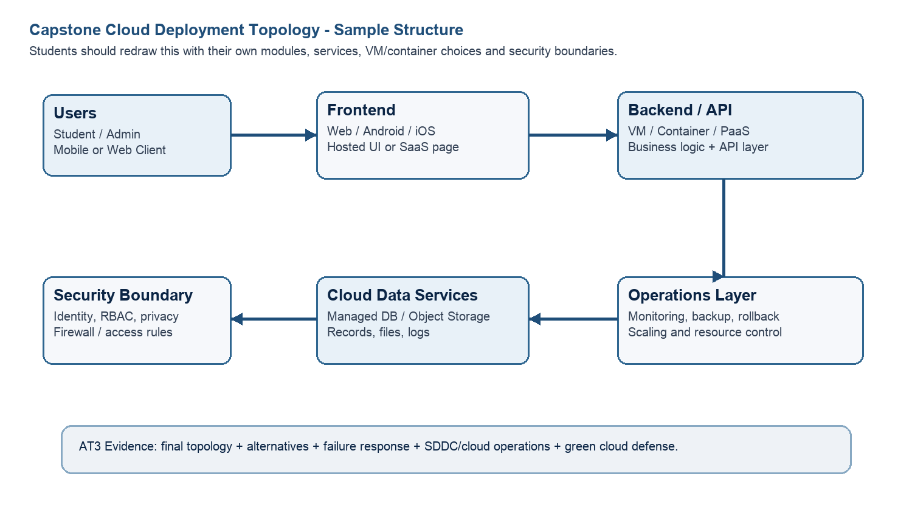
Architecture Component | Technology / Service | VM / Container / Managed Service / SaaS | Integration Method
Flutter / React Native | Managed cloud hosting | HTTPS REST API | HTTPS REST API calls to the backend
Flask / Django | VM or container | REST API | REST APIs connect the frontend with cloud services
Firebase Firestore | Managed service | Backend API | Backend API reads and writes data
Cloud Storage | Managed service | Secure API access | Secure API calls for file upload and retrieval
Firebase Authentication | Managed service | Authentication API | Authentication API with frontend and backend
Firebase Cloud Messaging | Managed service | Push notification API | Push notification API from backend to mobile app
Python + Scikit-learn | VM or container | Backend AI API | Backend API sends data to the AI model and receives risk predictions
FINAL GREENGUARDIAN CLOUD TOPOLOGY
[Women Users / Admin]
|
v
[Flutter / Web Frontend]
|
HTTPS / REST API
|
v
[Flask/Django Backend API]
/ | | v v v v
[Firebase][AI Safety][Google Maps][FCM]
Auth/DB Engine API Alerts
| | | |
+---------+-----------+--------+
|
v
[Live Location / SOS]
|
v
[Emergency Contacts / Family]
Security: Firebase Auth + RBAC + HTTPS + database rules
Green layer: Carbon calculator + green transport recommendation
Admin: Cloud dashboard + risk/green travel statistics
The frontend sends requests to the backend through REST APIs.
The backend calls Firebase, Google Maps, AI and notification services.
Each service performs one function, making the system modular.
APIs allow services to be updated or scaled independently.
This reduces maintenance effort and supports future cloud expansion.
Q4: Design Alternatives, Identity, Access and Federated Cloud Privacy Case
Compare at least two deployment alternatives for your capstone product, such as single VM, multi-tier VM, containerized deployment, managed backend, federated cloud or hybrid cloud model. Justify the selected design by analyzing identity management, role-based access control, federated access, data sharing, privacy protection and security risks.
Deployment Alternative | Advantages | Limitations / Risks |  | Identity and Privacy Impact
Single VM | Simple and low initial cost. | Limited scaling and a single main failure point. |  | All services share one environment, increasing isolation risk.
Managed Firebase + API/AI service | Less infrastructure maintenance and easy scaling. | Depends on cloud services and correct security rules. |  | Central authentication and controlled access to sensitive data.
Selected: Firebase + backend API + AI service | Modular, scalable and easier to maintain. | Requires secure API rules, monitoring and cost control. |  | Separates identity, application logic and data access.
Security Area |  |  | Student Decision
User roles |  |  | Women users, emergency contacts and administrators.
Authentication method |  |  | Firebase Authentication with secure login.
Role-based access control |  |  | Users access their own profile, routes and alerts; administrators access dashboard functions.
Federated access / partner access |  |  | Partner/emergency access is provided only through authorized APIs and permissions.
Sensitive data handled |  |  | Live location, route history, emergency alerts and profile information.
Privacy protection decision |  |  | Use HTTPS, least-privilege access, Firebase security rules and limited data retention.
The selected design provides stronger separation between users, application services and data.
Firebase Authentication controls identity and access.
Role-based permissions reduce unauthorized access to location and emergency records.
HTTPS and database security rules protect data in transit and storage.
The modular design also makes security updates and monitoring easier.
Q5: Software-Defined Datacenter and Cloud Operations Defense Case
Analyze how your infrastructure will respond to operational and failure scenarios such as VM failure, database growth, traffic spike, credential leakage, service outage, resource contention or cost increase. Explain how SDDC concepts and cloud operations practices such as automated provisioning, software-defined networking, software-defined storage, monitoring, logging, backup, rollback, scaling, resource control and maintenance improve the final infrastructure design. Include Green Computing decisions such as resource right-sizing, storage lifecycle control, log retention, API-call reduction, scheduled shutdown, VM/container/serverless comparison and carbon/energy proxy indicators where relevant.
Operational / Failure Scenario | Expected Impact | SDDC / Cloud Operations Response |  | Evidence or Control
Backend/AI may stop. | Users may lose route and risk-analysis services. | Restore a replacement VM from the image or snapshot. |  | Health monitoring and backup image.
Storage/query load increases. | Response time and storage cost may increase. | Use scalable Firestore and archive old records. |  | Usage monitoring and retention rules.
Many users request routes at once. | Latency may increase. | Scale backend resources and reduce unnecessary API calls. |  | CPU, memory and request monitoring.
Unauthorized account access. | Private location or emergency data may be exposed. | Revoke access, reset credentials and review logs. |  | Firebase Auth, RBAC and access logs.
Cloud API/service becomes unavailable. | Routing, notification or AI functions may be interrupted. | Use retries, backups and a recovery procedure. |  | Service monitoring and fallback handling.
CPU/RAM is shared by competing workloads. | Application performance may decrease. | Right-size resources and separate important workloads. |  | Resource limits and monitoring.
Cloud usage becomes expensive. | Project may exceed its budget. | Remove idle resources and optimize storage/API usage. |  | Budget alerts and usage reports.
Operational Readiness Area |  |  | Student Plan
Automated provisioning |  |  | Use reusable VM images or deployment scripts for fast provisioning.
Software-defined networking |  |  | Use HTTPS, API access rules and restricted network paths.
Software-defined storage |  |  | Use managed cloud storage with controlled access and lifecycle rules.
Monitoring and logging |  |  | Monitor CPU, memory, requests, errors, alerts and security logs.
Backup and rollback |  |  | Take regular backups and snapshots for recovery and rollback.
Scaling and elasticity |  |  | Scale backend resources when demand increases and reduce them when demand falls.
Resource control and maintenance |  |  | Patch software, remove unused resources and review access regularly.
Green Computing and sustainability control |  |  | Right-size resources, reduce storage/API use and promote public/green transport.
Green Cloud Decision |  |  | Student Justification
VM right-sizing from CO2 AT1 |  |  | Use the final CO2 AT1 VM size; proposed baseline is 2 vCPU, 4 GB RAM and 40 GB storage.
VM vs container vs serverless choice |  |  | Use a VM for the prototype; containers or serverless can be used later for event-driven scaling.
Scheduled shutdown / idle-resource control |  |  | Stop test/idle VMs when not required and avoid unnecessary always-on resources.
Log and file retention policy |  |  | Keep required security/operational logs and delete or archive old logs after a defined period.
Storage lifecycle and backup cleanup |  |  | Archive old route/incident data and remove redundant backups after the retention period.
API-call or polling reduction |  |  | Use event-driven updates or reasonable location intervals instead of continuous high-frequency polling.
Carbon/energy proxy indicator to track |  |  | Track VM CPU hours, storage growth, API calls and estimated carbon savings as energy-use proxies.
Prototype-ready cloud design with safety, AI, SOS, live tracking and green mobility functions.
Reliability will improve through backups, monitoring and scalable services.
Security will improve through strong authentication, RBAC, HTTPS and privacy controls.
Green Computing will improve through right-sizing, retention control, idle-resource shutdown and API reduction.
CO2 Reflection and Individual Defense
This section must be individually written. It should show what the student understands from the complete CO2 chain: infrastructure sizing, practical configuration evidence and final operations defense.
Reflection Prompt | Student Response
What is the strongest infrastructure decision in your capstone design? | The strongest decision is the modular cloud architecture using managed Firebase services with a backend and AI layer.
Which CO2 concept became clearer after AT1, AT2 and AT3? | Virtualization, VM lifecycle management, cloud operations and sustainable resource control became clearer.
Which risk is most serious for your capstone: failure, cost, privacy, scaling or sustainability? | Privacy is the most serious risk because the system handles live location and emergency information.
What evidence would you show during viva to defend your infrastructure design? | I would show the topology, VM sizing, cloud setup, API flow, authentication rules, AI output and backup/recovery plan.
What will you improve before final capstone deployment? | I will improve high availability, privacy controls, monitoring, route-risk accuracy and green cloud optimization.

Student-Facing Assessment Criteria
Criteria | Descriptor
Capstone continuity | The answer uses the same capstone title and connects CO1, CO2 AT1 and CO2 AT2 evidence.
Virtualization and lifecycle reasoning | VM, image, snapshot, clone, container or managed-service decisions are technically justified.
Topology and integration clarity | Architecture diagram and SOA/API explanation show clear module interaction.
Identity, access and privacy | Roles, authentication, RBAC, federated access, sensitive data and privacy decisions are defended.
SDDC/cloud operations | Failure response, monitoring, logging, scaling, backup, rollback and resource control are addressed.
Green Computing defense | Right-sizing, retention, API efficiency, idle-resource control and sustainable cloud choices are explained.
Submission quality | GitHub, template completion, evidence references and individual reflection are complete.
GitHub and Google Classroom Submission
Repository Item | Expected Content
README.md | Capstone title, student details, final VM recommendation, deployment topology summary and AT3 evidence index.
Completed AT3 document | This completed editable DOCX or exported PDF if instructed.
Diagram image | Final topology diagram if created separately.
Evidence references | Links or screenshots from CO1, CO2 AT1 and CO2 AT2 as needed.
Green Computing note | Short README section explaining sustainable cloud choices and resource-control decisions.
Google Classroom | Submit the GitHub repository link through GCR.
Student Assurance
I confirm that this case analysis, design reasoning, topology diagram and final defense statement were prepared individually by me for the stated capstone title. I have not uploaded passwords, tokens, private keys or sensitive account information.
Student Name | SHAHANA K
Register Number | 192524032
Signature
Date | 11-08-2026

Faculty Verification
Faculty Name | Dr C. Rajesh Babu
Employee ID | SSETSCS415
Constructive Feedback / Remarks
Strength Observed
Improvement Suggested
Signature / Date

