
Ethšcfin AIGftatzsdi Contzacting Gs6
Al-Muzahimiyah. Wasila. t96S8
Cn : 798T90045324
VAT NO: 123 4se74s 4B7

TAX INVOICE/ z+y„x• ztyiD

Customer Name | ABC TRADING CO.   |  | 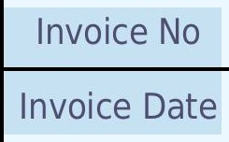  Invoice No  Invoice Date | 01-1202 | z čJl
 |  |  |  | 17-Jan-2026 | •jih mh
Customer's Address | 0345 13D AI Manar Dist DAMMAM SAUDI ARABIA  \r rz0D I I CI t 4I ,oI ZIP/Postal Code: 32273 |  | Due Date | 20-Jan-2026 | bill b
Payment Terms | 1. 10 days returns policy. 2. Risk passes to the buyer upon delivery. Ownership of goods remains with the  company until full payment is received. 3. All applicable taxes, duties, and levies will be charged extra as per prevailing laws. |  | 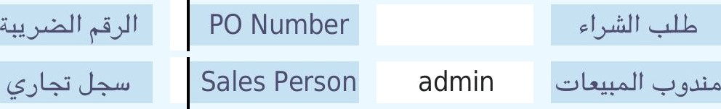  Our Ref |  | 
VATNO | 3608500000856
CRNO

 |   Item Code |   Item & Description |   ğty |   Unit |   Price |     Without  VAT |   VAT  Amount |     Total inc. VAT
 |  |  |  |  |  |  |  | 

7,000.00
899.96
u1•«=, y••w Ju‹
y==, •*l.u, zyl•=• u•+W Jug o.M¿#.°
Saudi Riyals Six Thousand Eight Hundred Ninety-Nine and Sixty-Six Halalas

Bank        Account Name | count Details | I pit L  Ethicfin AI khandi |  | 
Bank Name | SNB | 
Account Number | SN8576 | 
IBAN No | IBAN846879 | 

