**WEEK – 5(Hands-on)**

**Microservices with Spring Boot 3 and Spring Cloud**

**1. Creating Microservices for account and loan**

**Account:**

**AccountController.java**

package com.cognizant.account;

import org.springframework.web.bind.annotation.*;

import java.util.*;

@RestController

public class AccountController {

@GetMapping("/accounts/{number}")

public Map<String, Object> getAccount(@PathVariable String number) {

Map<String, Object> response = new HashMap<>();

response.put("number", number);

response.put("type", "savings");

response.put("balance", 234343);

return response;

}

}

**AccountApplication.java**

package com.cognizant.account;

import org.springframework.boot.SpringApplication;

import org.springframework.boot.autoconfigure.SpringBootApplication;

@SpringBootApplication

public class AccountApplication {

public static void main(String[] args) {

SpringApplication.run(AccountApplication.class, args);

}

}

**Output:**

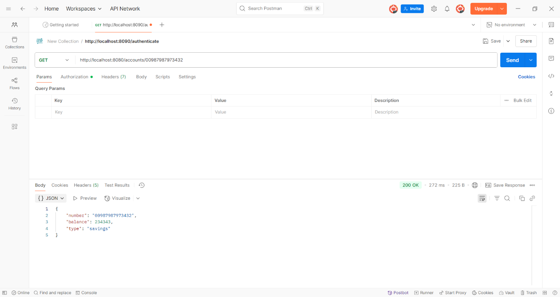

**Loan :**

**LoanApplication.java**

**package** com.cognizant.loan;

**import** org.springframework.boot.SpringApplication;

**import** org.springframework.boot.autoconfigure.SpringBootApplication;

@SpringBootApplication

**public** **class** LoanApplication {

**public** **static** **void** main(String[] args) {

SpringApplication.*run*(LoanApplication.**class**, args);

}

}

**LoanController.java**

**package** com.cognizant.loan;

**import** org.springframework.web.bind.annotation.*;

**import** java.util.Map;

@RestController

**public** **class** LoanController {

@GetMapping("/loans/{number}")

**public** Map<String, Object> getLoan(@PathVariable String number) {

**return** Map.*of*(

"number", number,

"type", "car",

"loan", 400000,

"emi", 3258,

"tenure", 18

);

} }

**Output:  
  
