What “automating” means?
Automation just means making the computer do tasks on its own instead of you doing them manually.
- Manual way: You open Chrome, type “facebook.com”, click the login box, type your email.
- Automated way: You write a script once, and then the computer does all those steps automatically whenever you run it.
So automation = computer acting like a human user, but faster and repeatable.

🔹 Selenium’s role
Selenium is the tool that lets you automate browsers.
- You tell Selenium: “Open Google, type ‘Selenium’, press Enter.”
- Selenium makes Chrome or Firefox do exactly that, without you touching the keyboard or mouse.

The Flow of Selenium Automation
- User Code (Your Java Script)
  - You write automation steps in Java (e.g., open Google, type text, click a button).
  - Example:
java
driver.get("https://google.com");
driver.findElement(By.name("q")).sendKeys("Selenium");
- Selenium Client Library
  - This is the set of JARs you added (or Maven dependency).
  - It translates your Java commands into WebDriver API calls.
  - Think of it as the “translator” between your code and the browser driver.
- WebDriver API
  - A standard interface that defines commands like get(), click(), sendKeys().
  - It doesn’t talk directly to the browser — instead, it passes instructions to the browser driver.
- Browser Driver (e.g., ChromeDriver, GeckoDriver)
  - Each browser has its own driver.
  - ChromeDriver knows how to talk to Chrome, GeckoDriver talks to Firefox, etc.
  - The driver receives WebDriver commands and converts them into native browser actions.
- Browser (Chrome, Firefox, Edge, etc.)
  - Finally, the browser executes the commands: opening a page, clicking a button, typing text, navigating, etc.
  - It then sends back responses (like page title, element text) through the driver → WebDriver API → Selenium library → your code.
🔹 Visualizing It
Think of it like a chain of communication:
Your Java Code → Selenium Library → WebDriver API → Browser Driver → Browser
And back again:
Browser → Browser Driver → WebDriver API → Selenium Library → Your Java Code
Selenium works with all major web browsers (Chrome, Firefox, Edge, Safari, Opera) and supports multiple programming languages (Java, Python, C#, Ruby, JavaScript). It uses browser-specific drivers like ChromeDriver or GeckoDriver to communicate with each browser.

package com.shahanaz.SeleniumP1;

import java.time.Duration;

import org.openqa.selenium.By;
import org.openqa.selenium.WebDriver;
import org.openqa.selenium.WebElement;
import org.openqa.selenium.chrome.ChromeDriver;
public class App
{
public static void main( String[] args ) throws InterruptedException
{
WebDriver driver=new ChromeDriver();
driver.get("https://www.facebook.com");
driver.manage().window().maximize();
driver.manage().timeouts().implicitlyWait(Duration.ofSeconds(10));

System.out.println( driver.getTitle() );
WebElement email=driver.findElement(By.name("email"));
email.sendKeys("aed@gmail.com");
WebElement password=driver.findElement(By.name("pass"));
password.sendKeys("ryt@123");
Thread.sleep(2000);
email.clear();
password.clear();

}

}

driver.manage().timeouts().implicitlyWait(Duration.ofSeconds(10));
🔹 What it means
- This tells Selenium: “Whenever I try to find an element, wait up to 10 seconds before throwing an error if the element isn’t immediately available.”
- Without it, Selenium will try to find the element instantly. If the page is still loading, you’ll get a NoSuchElementException.
- With implicit wait, Selenium keeps checking for the element until either:
  - It finds it (then moves on immediately), or
  - 10 seconds pass (then it throws an error).
The web design elements are the basic parts of every website that influence site usability, navigation, and information absorption. Here are some of the different kinds of web elements you should know:
- Headers: Provide orientation, navigation, and key access points like logos, menus, and CTAs. They are crucial for establishing brand identity and enabling fast decisions.
- Buttons: Call to Action buttons guide visitors on what to do next, such as "Buy Now," "Learn More," or "Sign Up." They aim to turn passive users into active ones and improve conversions.
- Navigation: Links and menus help users navigate through the website efficiently. They should be clear, concise, and easy to find.
- XPath in Selenium is an XML path used for navigation through the HTML structure of the page. It is a syntax or language for finding any element on a web page using XML path expression. XPath can be used for both HTML and XML documents to find the location of any element on a webpage using HTML DOM structure.
- In Selenium automation, if the elements are not found by the general locators like id, class, name, etc. then XPath is used to find an element on the web page.
- XPath Syntax
- XPath contains the path of the element situated at the web page. Standard XPath syntax for creating XPath is.
- Xpath=//tagname[@attribute='value']
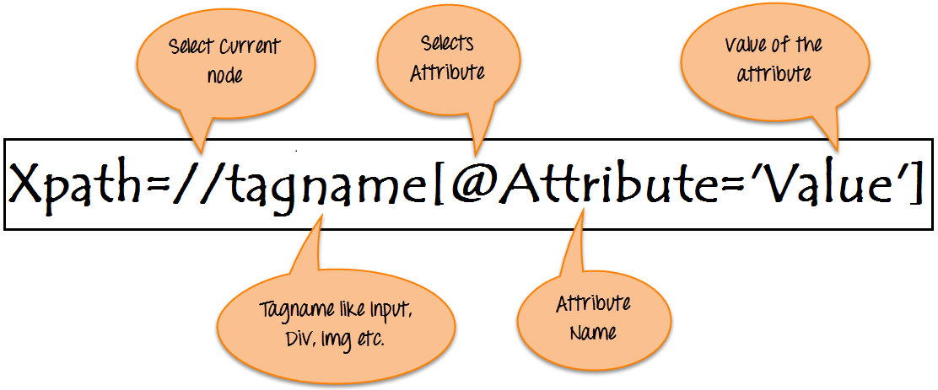
To find the element on web pages accurately there are different types of locators:
XPath Locators | Find different elements on web page
ID | To find the element by ID of the element
Classname | To find the element by Classname of the element
Name | To find the element by name of the element
Link text | To find the element by text of the link
XPath | XPath required for finding the dynamic element and traverse  between various elements of the web page
CSS path | CSS path also locates elements having no name, class or ID.

XPath in Selenium: Tutorial

